导入数据
CREATE
(nAlice:User {name: 'Alice', seed: 42}),
(nBridget: User {name: 'Bridget', seed: 42}),
(nCharles: User {name: 'Charles', seed: 42}),
(nDoug: User {name: 'Doug'}),
(nMark: User {name: 'Mark'}),
(nMichael: User {name: 'Michael'}),
(nAlice)-[:LINK {weight: 1}]->(nBridget),
(nAlice)-[:LINK {weight: 1}]->(nCharles),
(nCharles)-[:LINK {weight: 1}]->(nBridget),
(nAlice)-[:LINK {weight: 5}]->(nDoug),
(nMark)-[:LINK {weight: 1}]->(nDoug),
(nMark)-[:LINK {weight: 1}]->(nMichael),
(nMichael)-[:LINK {weight: 1}]->(nMark);
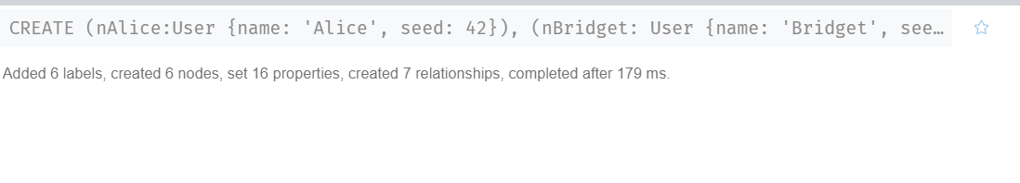

验证导入数据

match (u:User) return *

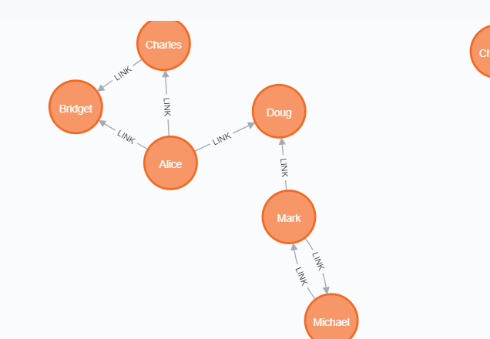
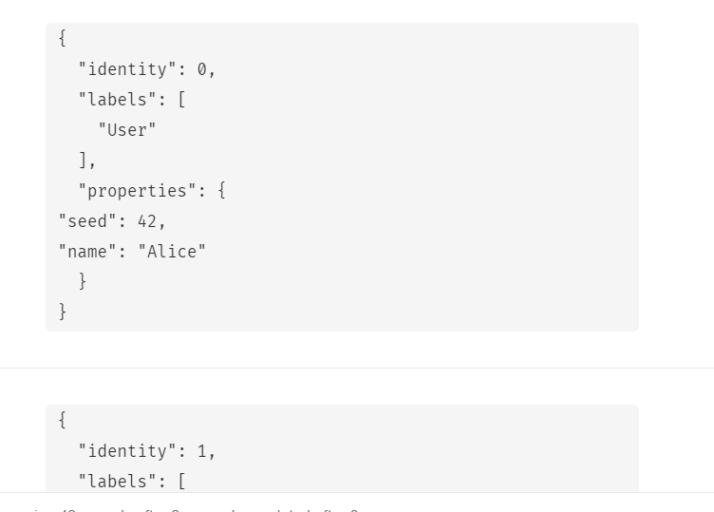准备工作

CALL gds.graph.create('myGraph', 'User',
{
LINK: {
orientation: 'UNDIRECTED'
}
},
{
nodeProperties: 'seed',
relationshipProperties: 'weight'
}
)
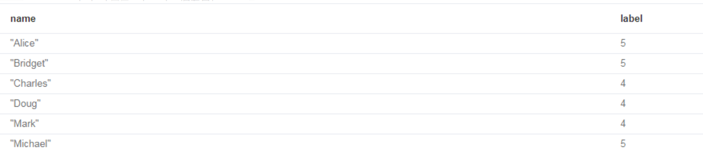

评估算法所需资源

CALL gds.louvain.write.estimate('myGraph', { writeProperty: 'community' })
YIELD nodeCount, relationshipCount, bytesMin, bytesMax, requiredMemory

运行louvain算法
返回流结果

CALL gds.louvain.stream('myGraph')
YIELD nodeId, communityId,
intermediateCommunityIds

RETURN
gds.util.asNode(nodeId).name AS
name, communityId,
intermediateCommunityIds
ORDER BY name ASC

返回社区数
CALL gds.louvain.stats('myGraph')
YIELD communityCount

返回模块度

CALL gds.louvain.mutate('myGraph',
{ mutateProperty: 'communityId' })
YIELD communityCount, modularity, modularities

