# Lab: JavaScript Basics

This document defines the lab assignment from the [“JavaScript Basics“ Course @ Software University](http://softuni.bg/courses/javascript-basics/).

### Rules

You are given **1:30 minutes** to solve the below described problems.

* During this time you should solve the problems on your own, so you're **not** allowed to help each other. There is no point in **rushing** or **cheating** – the purpose of this assignment is to practice your JavaScript coding skills.
* After the time expires, you may **freely help each other**. **Trainers** and **students** who are ready will be available for anyone who needs **assistance**/**feedback**. Directly **sharing code is not permitted**.
* Finally, one of the **trainers** will **solve the problems** in front of everyone.

## AutoComplete

Everybody hates typing text and since you've already adopted the lazy mindset of a programmer, it's time you made your life easier! Your task is to write a JavaScript program that takes a **text of words** (space-separated) and a **given keyword**, and then **autocompletes** that keyword with a **suitable match from the provided text**.

The **matched word** should follow the rules:

* It should contain the keyword from start – e.g. "***wolf***" matches "***wo***", but not "***olf***".
* If there are **multiple matches**, the **shortest word** should be returned. If two words are **equally long**, the **lexicographically lesser** word should be returned.
* Word match should be **case insensitive**.

For example, we are given the following text: "***word screamm screech speech wolf***". We are also given "***wo***" – the **keyword** which should be autocompleted. There are two words in the text which **begin** with the provided keyword – "**word**" and "**wolf**". They are equally long, but lexicographically "**wolf**" is before "**word**" – therefore **wolf** is the match.

The matched word should be **printed** on console. If there is no match, print "**-**" (dash).

|  |  |
| --- | --- |
| **Input** | **Output** |
| ['word screammm screech speech wolf',  'bas',  'wo',  'scr',  's'] | -  wolf  screech  speech |

Submit your solution to the **Judge system**.

## DOM AutoComplete

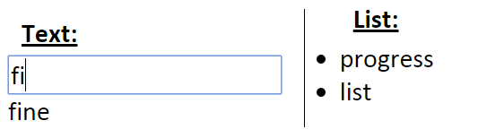**Modify** the function from the previous exercise and **apply** it to an **HTML input field**. Implement the following functionality:

* Each time a **letter is entered** the most appropriate word should be **offered** for autocompletion. Hint: use the **"keyup"** event.
* Pressing ***space* autocompletes** the **word in the text field** (if any word exists).
* Pressing ***enter*** **adds** the value from the text field to the list.