**Un-manned Vehicle: Following system**

By

Than Htut Aung ID: 5618361

Ko Ko Myo Hein Htet ID: 5558323

A report submitted in partial fulfillment of the requirements for the degree of Bachelor of Engineering in

Electrical and Electronics Engineering and Computer Engineering

Project Advisor:

Asst. Prof. Dr. Narong Aphiratsakun

Examination Committee:

Dr. Win Tin

Dr. Jeerapong Rojanarowan

Dr. Wisuwat Plodpradista

Asst. Prof. Dr. Narong Aphiratsakun

Dr. Pasd Putthapipat

Assumption University

Vincent Mary School of Engineering

Thailand

May 2017

**Chapter I**

**1.1 Introduction**

Being an age of micro robot, we have been interested in making some kind of robot based on the Arduino platform. We had got this idea by learning some gesture based Arduino projects. So, we decided to do a system which will detect and follow the particular object. We named ours project as “Un-manned Vehicle: Following System”. This project is working on the Open-Source platform so it would be easy and effective on rewriting and implementing in the future. So, that, we concentrate to work on our own design, which is an object detection system also could be semi-autonomous robot.

The system will be installed camera module and ultrasonic distance sensing in order to detect objects which covered on the way. The ultrasonic sensor will be mounted on the motor or on the sides to have the surrounding perspective. The camera module will provide the data of the object detection to the system to follow the detected object.

*Figure 1.1: ARDUINO UNO R3*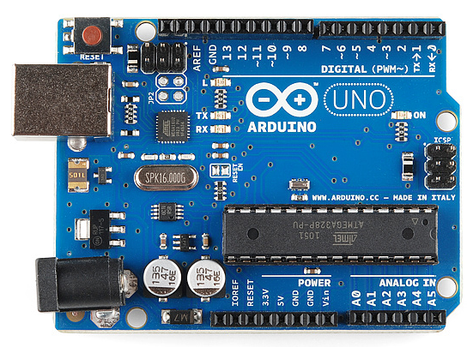

The Arduino Uno is a microcontroller board that is based on the ATmega 328P.It has 14 digitals inputs/outputs pins. Among those 14 digital inputs/outputs pins, 6 pins can be used as PWM output such as pin no. (3, 5, 6, 9, 10, 11). In addition, there is 6 analog inputs from A0 to A5. 16 MHz quartz crystal is used in Arduino Uno board. There is also USB connection, power jack, ICSP header and a reset button. It can be simply connected to a computer with USB cable or power it with AC to DC adapter or battery to get started.

**1.2 Objective**

The main objective of this proposal is described as follows:

* We intend to complete this project on Arduino UNO R3 because it becomes very popular now a day and we also study on a lot of microcontrollers. This is the most reliable system over all the tests.
* Camera Module is mounted on the system it will detects the object form image received. The video frames will be sent to computer
* We would like to install another ultrasonic sensor at the front to make sure the system is stay on a fixed distance from the detected object.
* After the camera module detected the object and the system will be calculated, the vehicle will be moving toward the object in straight line.
* If the camera module will detect the unwanted object or obstacle, the vehicle will wait until to get the detected object and follow toward the object in straight line.
* We made the object that can be easily detected from the camera module for example- red triangle, red circle or red square.
* In this system, we considered how far between the object and the camera module to get the signal. The vehicle will follow the object when the distance is more than 30cm between them till to get the distance is 30cm. If the wanted object or other obstacle objects close to the vehicle by 10cm or less than 10 cm, the vehicle will backward a little bit until the distance is more than 10cm.
* On the vehicle, there is a motor to drive two wheels for easily to control and the rest of the wheels will follow those two wheels are connected by the motor.

**Chapter II**

**Unmanned Vehicle System**

**What is our system?**

In our project system, we focused about to follow the wanted object with our vehicle. We divided into two parts those are motor controlling parts and the object detecting parts by using two main controllers which are Arduino UNO R3 controller for driving the motor of the wheel and Raspberry Pi 3 for detecting the wanted object. Those two controllers are the main parts to control the vehicle in our system. In addition, there are some necessary components such as Ultra Sonic Sensor, Motors, Motors Driver and LEDs which are connected to Arduino UNO R3 controller. For detecting part, camera module is connected with Raspberry Pi 3. After ready to be connected those two parts, two controllers are linked by using serial connection (UART). The details of the components in our system will be explained one by one as below.

**2.1 Overview of our project**

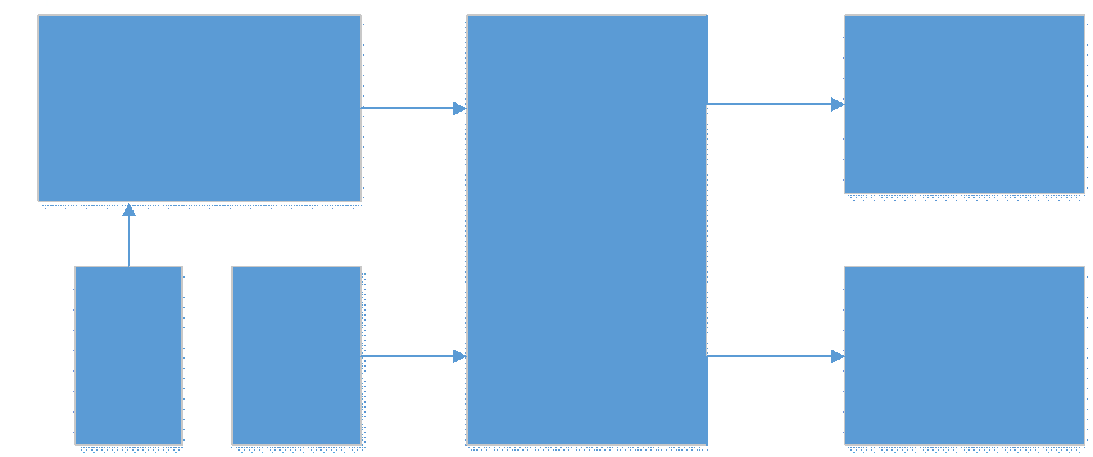

*Figure 2.1: Block Diagram*

**Explanation of block diagram**

* This is the block diagram that we are going to use in our project (un-manned vehicle: following system).
* Raspberry Pi Camera is directly connected to DMI port of Raspberry Pi 3.
* Raspberry Pi 3 will detect object and send UART Signal to Arduino UNO.
* We considered the distances between the license plate and the vehicle by using ultra sonic sensor that are connected to Arduino UNO controller.

As the output, the vehicle can be controlled by using motor to stop or follow according to the detection signal and LEDs will be light up after getting the signal.

**2.2 Controller**

There are two controllers that we use to accomplish the projects. We used Raspberry Pi as a master controller and Arduino as a slave controller.

**2.2.1 Master Controller (Raspberry Pi)**

That is the latest model (model B) which includes 802.11n Wifi, Bluetooth 4.0 and a quad-core CPU 64-bit RAM Cortex A53 running at 1.2 GHz. It is a usable desktop computer. In Raspberry Pi 3, there are 1GB of DDR2-900 SDRAM and the graphic capabilities are provided by the VideoCore IV GPU, are the same as they ever were. The input voltage and the current for this Raspberry Pi 3 is 5V and 2A. The Pi is powered by a USB Micro power supply (like most standard mobile phone chargers). For display and connectivity cable, any HDMI/DVI monitor and any TV should work as a display for the Pi to get best results by using one HDMI input.

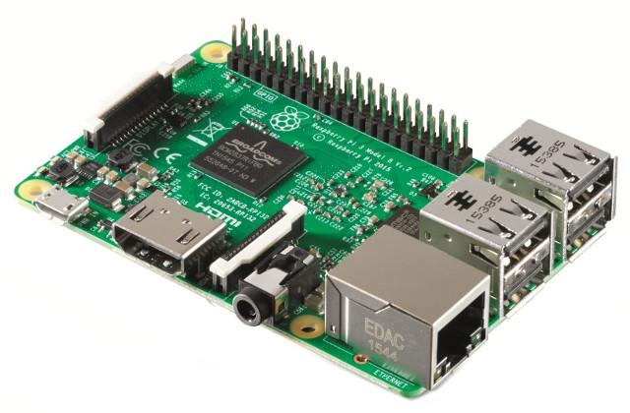

*Figure 2.2: Raspberry Pi 3 Model B Version 2*

The complete specifications for the PI 3 are as follows;

* SOC: Broadcom BCM2837 (roughly 50% faster than PI2)
* CPU: 1.2 GHZ quad-core ARM Cortex A53 (ARMv8 Instruction Set)
* GPU: Broadcom VideoCore IV @ 400 MHz
* Memory: 1GB LPDDR2-900 SDRAM
* USB ports: 4
* Network: 10/100 MBPS Ethernet,802.11n Wireless LAN, Bluetooth 4.0

**Signal Power Supply**

Since Raspberry Pi is going to be used as one of the controllers in this system. Power supply is needed for that controller. This type of power supply is called Signal Power Supply.

We decided to use 9V DC battery for the Raspberry Pi 3 microcontroller because it needs only 5V and the current is 2A. Therefore, using 9V DC power supply is more than enough it needs.

**2.2.2 Slave Controller (Arduino)**

In our system, Arduino UNO R3 controller is used as a slave controller to control the vehicle for driving the motor. As I mentioned above in introduction, this is a microcontroller board and it has 14 digital input/output pins, among those 6 pins are provided as PWM outputs. It is also one of the open-source hardware. Therefore, we can build our own board using the files such as EAGLE FILES IN.ZIP, SCHEMATICS IN.PDF and BOARD SIZE IN.DXF.

**Programming**

The Arduino/Genuino Uno can be programmed with the Arduino Software (IDE). The ATmega328 on the Arduino/Genuino Uno comes preprogrammed with a bootloader that allows we to upload new code it without using the external hardware programmer. It communicates using the original STK500 protocol.

**Power Supply**

In our project, there are two parts those are needed power supply from the DC battery. They are Signal power supply and Actuator power supply. Two controllers in this system

The Arduino/Genuino Uno board can be powered via the USB connection or with an external power supply. The power source is selected automatically.

External (non-USB) power can come either from an AC-to-DC adapter or battery. The adapter can be connected by plugging a 2.1mm center-positive plug into the board's power jack. Leads from a battery can be inserted in the GND and Vin pin headers of the power connector.

The board can operate on an external supply from 6 to 20 volts. If it supplied with less than 7V, however, the 5V pin may supply less than five volts and the board may become unstable. If using more than 12V, the voltage regulator may overheat and damage the board. The recommended range is 7 to 12 volts.

**Signal Power Supply**

Power supply for the Arduino Uno R3 is also called the signal power supply. We used this power supply is the same as the power supply for the Raspberry Pi that is 9V DC power supply. Because Arduino Uno R3 is also used as the controller like Raspberry Pi and it needs the voltage between 7 to 12 Volts supply. Therefore, 9V supply is enough for the Arduino Uno R3 controller. In addition, the ground of the both controllers to be in the same ground.

The power pins are as follows:

* Vin, the input voltage to the Arduino/Genuino board when it is using an external power source (as opposed to 5 volts from the USB connection or other regulated power source). We can supply voltage through this pin, or, if supplying voltage via the power jack, access it through this pin.
* 5V, this pin outputs a regulated 5V from the regulator on the board. The board can be supplied with power either from the DC power jack (7 - 12V), the USB connector (5V), or the Vin pin of the board (7-12V). Supplying voltage via the 5V or 3.3V pins bypasses the regulator, and can damage the board.
* 3V3. A 3.3 volt supply generated by the on-board regulator. Maximum current draw is 50 mA.
* GND, it is ground pins.
* IOREF. This pin on the Arduino/Genuino board provides the voltage reference with which the microcontroller operates. A properly configured shield can read the IOREF pin voltage and select the appropriate power source or enable voltage translators on the outputs to work with the 5V or 3.3V.

The specifications of Arduino Uno R3 are as follows;

* Microcontroller: ATmega328p
* Operating Voltage: 5V
* Input Voltage (recommended): 7-12V
* Input Voltage (limit): 6-20V
* Digital I/O Pins: 14 ( of which 6 provide PWM output)
* PWM Digital I/O Pins: 6
* Analog Input Pins: 6
* DC Current per I/O Pin: 20 mA
* DC Current for 3.3V Pin: 50 mA
* Flash Memory: 32KB (ATmega328P) of which 0.5KB used by bootloader
* SRAM: 2KB (AT mega 328P)
* Clock Speed: 16MHz
* LED_BUILTIN: 13

**Actuator Power Supply**

In DC Motor Driver, it also needs the power supply to drive the motor. This type of power supply is called Actuator Power Supply. It is different with signal power supply according to their functions. Two controllers are functioned as a brain to control the system. Therefore, we called signal power supply. But DC Motor Driver is functioned as a limb to drive the motors. Therefore, it’s named as actuator power supply. To give the power supply into this DC motor driver, 9V power supply from Arduino UNO R3 for receiving the signal to DC driver. We supplied 5 to 35V battery to the DC motor to drive the vehicle.

Pin description of L298N Dual H Bridge Motor Driver;

* Out 1: Motor A lead out 1
* Out 2: Motor A lead out 2
* Out 3: Motor B lead out 1
* Out 4: Motor B lead out 2
* GND: Ground
* 5V: 5V Logic Input
* EnA: Enables PWM signal for Motor A
* In1: Input for Motor A lead out 1
* In2: Input for Motor B lead out 2
* In3: Input for Motor B lead out 1
* In4: Input for Motor B lead out 2
* EnB: Enables PWM signal for Motor B

L298N Dual H Bridge Motor Driver- Technical Specifications

* Double H Bridge Drive Chip: L298N
* Logical Voltage: 5V
* Drive Voltage: 5V-35V
* Logical Current: 0-36mA
* Drive current: 2A (MAX single bridge)
* Max Power: 25W
* Dimensions: 43 x 43 x 26 mm
* Drives up to 2 bidirectional DC motors

**2.3 Actuator (Driver & Motor)**

**2.3.1 DC Motor Driver**

DC motor drivers are necessary like all motor drivers because of the inability of microcontrollers or other processors to provide high voltages and currents enough to drive electrically heavy loads such as motors. There are two types of DC motors, they are brushed and brushless. Those motors require different driving mechanisms because of their commutators. In brushed DC motors, commutation is done by the brush in motor. Therefore, driving those kind of motors are relatively easy. In brushless DC motors, there is no brush to commutate the current. Therefore it has to be done electrically. Therefore, driving brushless DC motors are a little bit more complex compared to driving brushed DC motors.

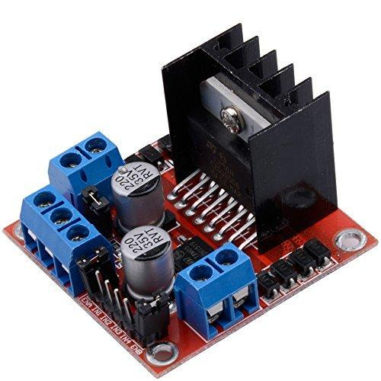

*Figure 2.3: Motor Driver L298N*

In this our project, we used L298N Dual H Bridge Motor Driver as a motor driver to the two motors of the wheel because it is easy to be connected and it can handle to drive the motor by counter clockwise and clockwise as well because of H Bridge. L298N Dual H Bridge Motor Driver is a motor controller breakout board which is typically used fro controlling speed and direction of motors. It can also be used to control the brightness of certain lighting projects such as high powered LED arrays. One more reason to choose that motor driver is that H-bridge is a circuit which can drive a current in either polarity and also be controlled by pulse width modulation (PWM).

Pulse Width Modulation means that is in controlling the duration of an electronic pulse. Motors try to imagine the brush as a water wheel and electrons as the flowing droplets of water. The voltage would be the water flowing over the wheel at a constant rate, the more water flowing makes the higher the voltage. Motors are rated at a certain voltage and can be damaged if the voltage is applied to heavily or if it is dropped quickly to slow the motor down. Take the water wheel analogy and think of the water hitting it in pulses but at a constant flow. The longer the pulses the faster the wheel will turn, the shorter the pulses, the slower the water wheel will turn. Motros will last much longer and be more reliable if controlled through PWM.

**2.3.2 DC Motor**

Tow DC Motors are attached beside the wheels to drive the vehicle’s wheels. The DC motor is a machine that transforms electric energy to the mechanical energy in form of rotation. Its movement is produced by the physical behavior of electromagnetism. DC motors have inductors inside which produce the magnetic field used to generate movement. An electromagnet, which is a piece of iron wrapped with a wire coil that has voltage applied in its terminals. If two fixed magnets are added in both sides of this electromagnet, the repulsive and attractive forces will produce a troque.

We need to consider there are two problems to solve. They are feeding the current to rotate electromagnet without the wires getting twisted and chainging the direction of the current at the appropriate time. Both of these problems are solved by using two devices: a split-ring commutator and a pair of brushes.

The commutator has two segments which are connected to each terminal of the electromagnet, besides the two arrows are the brushes which apply electric current to the rotary electromagnet. In real DC motors, it can be found three slots instead of two and two brushes. This way as the electromagnet is moving its polarity is changing and the shaft may keep rotating.

**How can a DC motor be controlled?**

DC motors have only two terminals. If we apply a voltage to those terminals the motor will run. If we invert the terminal’s positions the motor will change its direction. If the motor is running and we suddenly disconnect both terminals, the motor will keep rotating but slowing down until stopping. Finally, while the motor is running, we suddenly short-circuit both terminals the motor will stop. So there is not a third wire to control a DC motor but knowing the previous behaviors it can be designed a way to control it, and the solution is an H-bridge

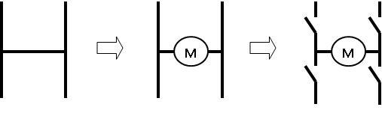

*Figure 2.4: H-Bridge*

In the last evolution of the DC motor above, we can observer that there are four gates and a motor connected between them. This is the simplest H-bridge, where the four gates represent for transistors. By manipulating these gates and connecting the upper and lower terminals to a voltage supply, we can control the motor in all the behaviors as below.

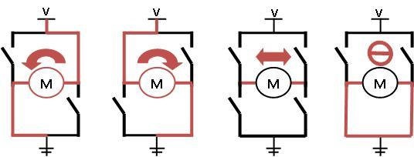

*Figure 2.5: H-Bridge*

**2.4 Sensors**

**2.4.1 Ultrasonic Sensor**

An Ultrasonic sensor is a device that can measure the distance to an object by using sound waves. It measures distance by sending out a sound wave at a specific frequency and listening for that sound wave to bounce back. By recording the elapsed time between the sound wave being generated and the sound wave bouncing back , it is possible to calculate the distance between the sonar sensor and the object.

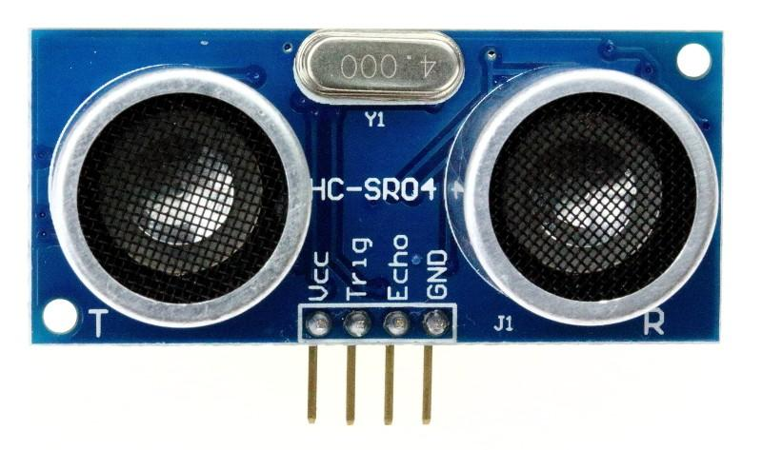

*Figure 2.6: Ultrasonic Sensor HC-SR04*

**How does an Ultrasonic Distance Sensor work?**

The Ultrasonic Sensor sends out a high frequency sound pulse and then times how long it takes for the echo of the sound to reflect back. The sensor has 2 openings on its front. One opening transmits ultrasonic waves (like a tiny speaker), the other receives them (like a tiny microphone).

The speed of the sound is approximately 341 meters (1100 feet) per second in air. The ultrasonic sensor uses this information along with the time difference between sending and receiving the sound pulse to determine the distance to an object. It uses the following mathematical equation:

Distance = Time x Speed of Sound divided by 2

Time = the time between when an ultrasonic wave is transmitted and when it is received, this number has to be divided by 2 because the sound wave has to travel to the object and back

Ultrasonic sensors can measure the following parameters without contacting the medium to be measured:

* Distance
* Level
* Diameter
* Presence
* Position

Ultrasonic sensors make accurate measurements in many difficult environments unusual materials. Measurements are unaffected by:

* Material
* Surface
* Light
* Dust
* Mist and Vapour

**2.4.2 Camera Module**

In our system, we used official Raspberry Pi camera module V2 to catch the object. It is connected with Raspberry Pi. That is a 5MP camera module that capable of 1080p video and still image and it can be connected to Raspberry Pi directly with CSI (Camera Serial Interface). When we connect to the CSI port on Raspberry Pi via ribbon cable and then boot the latest version of Raspbian and we are good to go with the camera. It is a fixed focus 5MP sensor capable of 3280 x 2464 stills but aslo 1080P30,720p60 and 640 x 480p60/90.

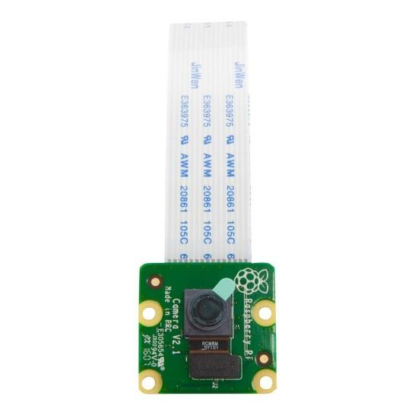

*Figure 2.7: Raspberry Pi Camera V2.1*

Features:

* Fixed focus lens on-board
* 8 megapixel native resolution sensor-capable of 3280 x 2464 pixel static images
* Supports 1080p30, 720p60 and 640 x 480p90 video
* Size 25mm x 23mm x 9mm
* Weight just over 3g
* Connects to the Raspberry pi board via a short ribbon cable (supplied)
* Camera v2 is supported in the latest version of Raspbian, Raspberry Pi’s preferred operating system

**2.5 Overall of Real Project**

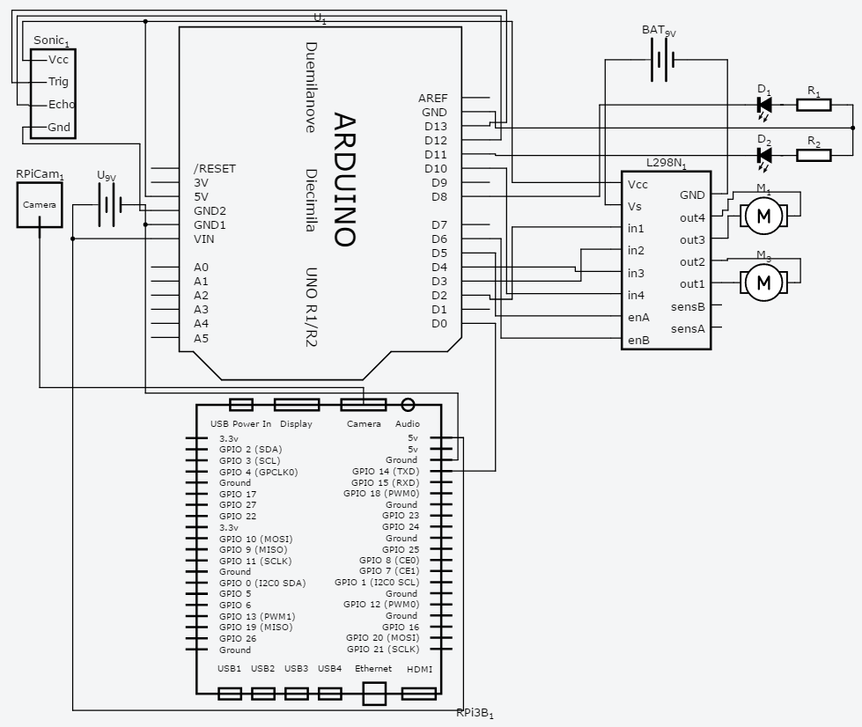

*Figure 2.8: Circuit Diagram*

**Explanation of Circuit Diagram**

According to our circuit diagram above, Raspberry Pi 3 is the most important part of our project. It will process whether wanted object is in the range or not by fetching frames from Camera which is connected on DMI port. After that, it will send UART Signal by using GPIO 14 (TXD) port. From Arduino part, it will receive UART Signal from Digital Input Pin 0 (RXD). And then it will execute to control the motors for moving depends on what receiving. There are 2 LEDs connected on Arduino Pin 8 and 11, they will indicate whether the motors are controlling by Master (Raspberry Pi) or Slave(Arduino). Ultrasonic Sensor is also communicating with Arduino to measure the distance by connecting Trig to Arduino Pin 13 and Echo to Arduino Pin 12.

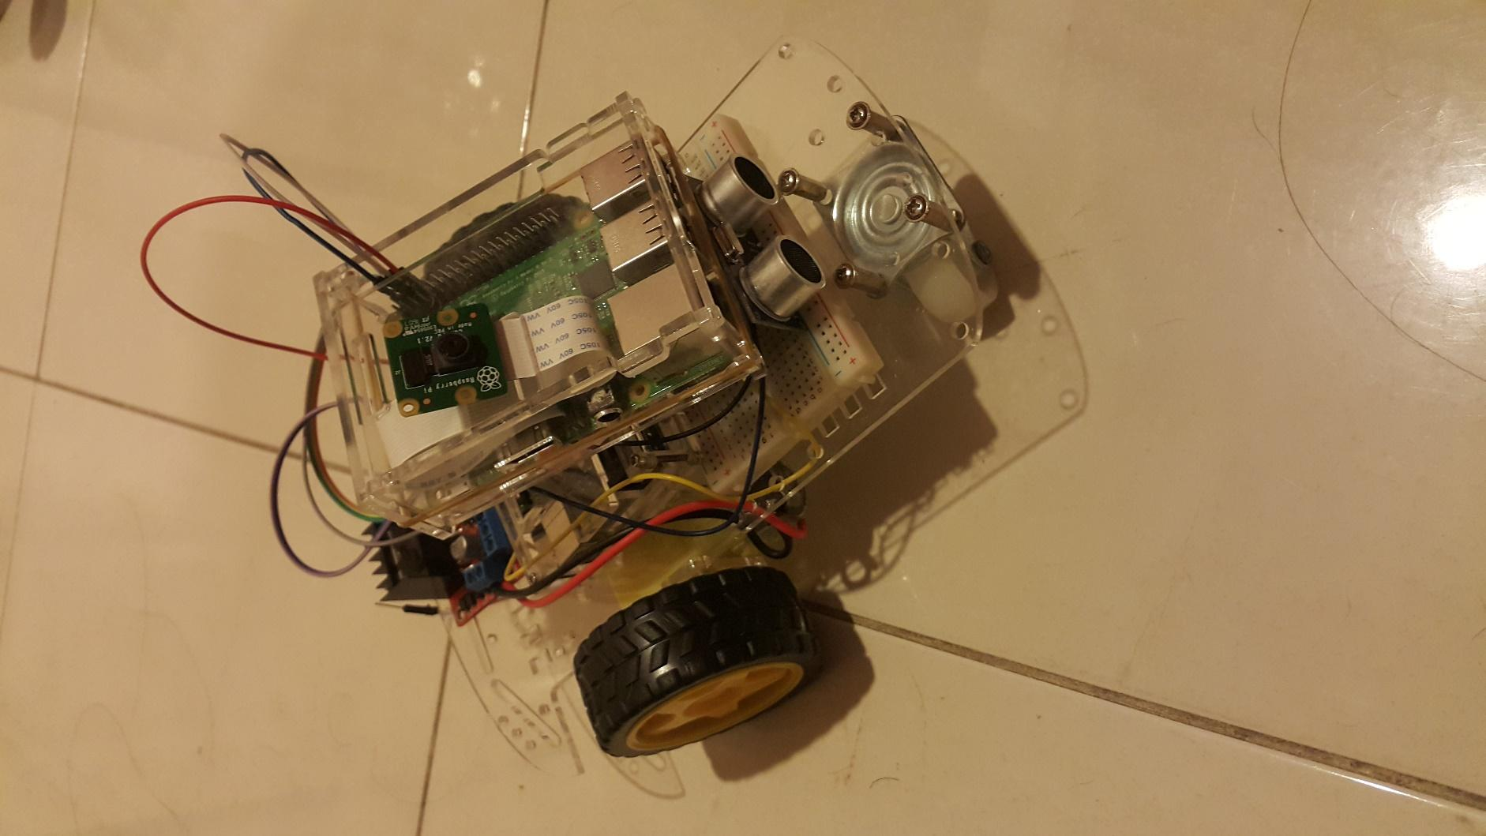

*Figure 2.9: Un-manned Vehicle: Following System*

**Chapter III**

**Methodology**

**Explanation of flow chart**

* The camera module will be ready to start at the beginning.
* It will wait for getting the camera signal.
* If there is no signal, it will turn back to the start. After getting the signal, it will go to the next step.
* The camera module will check there is any obstacle in 10cm between the object and the ultrasonic sensor or not. If there is any obstacle in front of that the vehicle will move backward until there is no obstacle in 10 cm between them If there is no obstacle, the vehicle will move forward to the detected object.
* Between 30cm and 60cm of the distance, the vehicle will keep moving forward to the detected object and at exactly 10 cm between ultrasonic sensor and object, the vehicle will stop automatically.
* More than 60cm between camera and object, the system will be terminated.

**Flowchart**

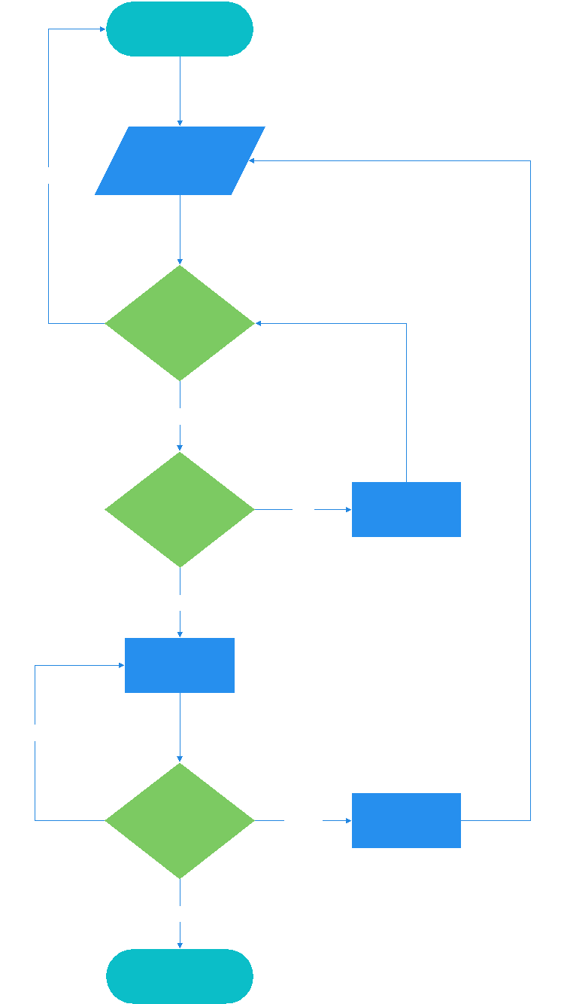

*Figure 3.1: Flowchart*

**Chapter IV**

**Experiment and Result**

**Experiment 1**

In order to understand how to use motors to move forward, backward, turn left and turn right, we try an experiment called Arduino Bluetooth RC Car. We use Arduino Uno, Robot platform, L298N Motor driver, HC-06 Bluetooth module, 9V battery and holder and Android device. We assembled the Robot platform and connect the components as shown in Fig 4.1. After that we download an application called Bluetooth RC Controller on android device and connected to Bluetooth with pairing Pin 0000. Finally, we could drive the car with Android device.

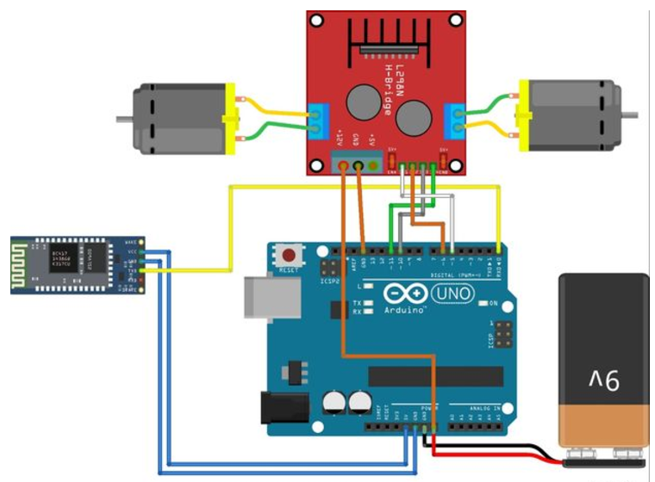

*Figure 4.1: Circuit Connection*

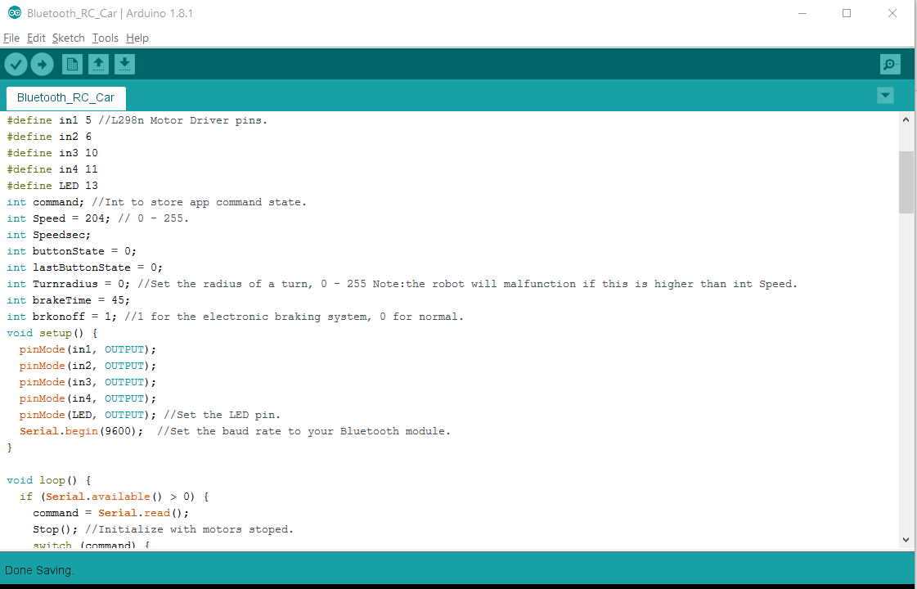

*Figure 4.2: Coding*

**Experiment 2**

In this experiment, we tried to understand how ultrasonic work and how to use. We used Arduino UNO, Ultrasonic Sensor HC-SR04, 9V Battery and holder, 2 LEDs and 2 x 1kΩ Resistors. We connected Ultrasonic Sensor, Arduino and other components as Fig 4.3. Lastly, we tested LEDs on or off according to distance between obstacle and Ultrasonic Sensor.

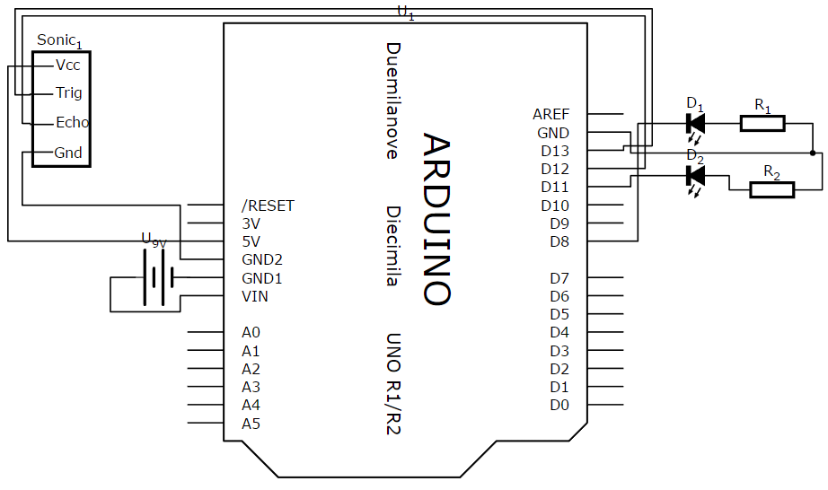

*Figure 4.3: Circuit Connection*

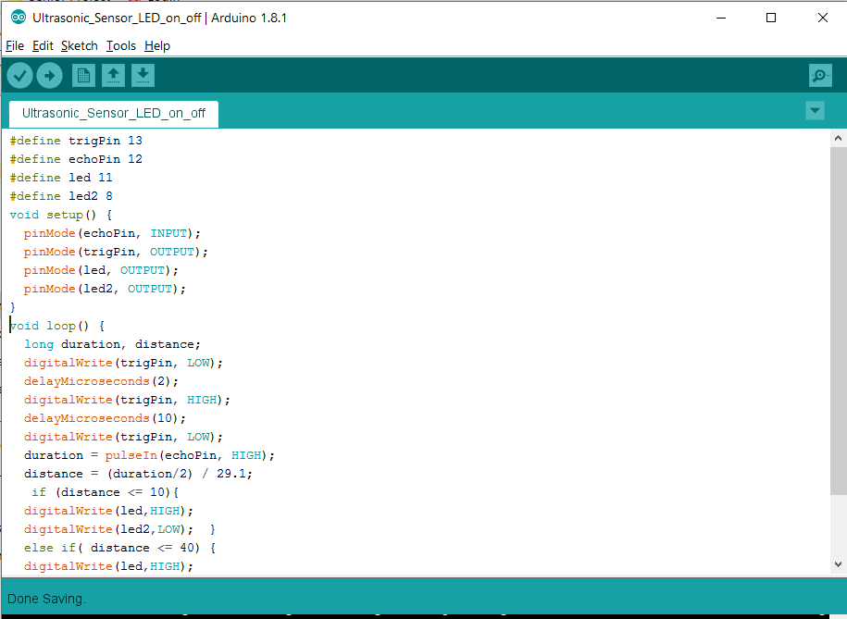

*Figure 4.4: Coding*

**Experiment 3**

We started the project with Motor Controlling Projects. We tried to connect all the necessary components to perform motor controlling process. We used Arduino to run our program to move Forward, Backward, Turn Left and Right. We also use PWM values to control the speed of motors. In this experiment, our problem was frequency on PWM. We were connecting Motor Controller L298N to PWM Pins with 100 Hz on Arduino. On that case, the motors are rotating with very fast speed. Later on, we found out the problem that we need to use 1kHz PWM. So, we changed to the Pins with 1kHz on Arduino and the problem was solved.

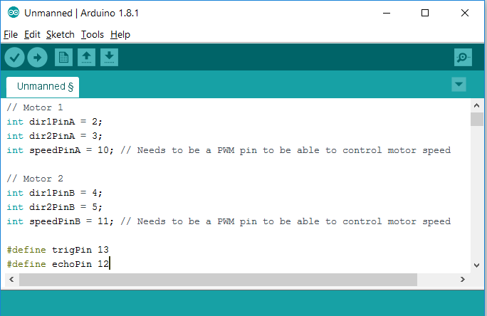

*Figure 4.5: PWM pin 10 and 11 with 100Hz*

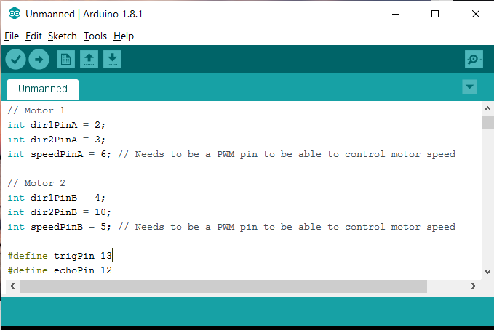

*Figure 4.6: PWM pin 6 and 5 with 1kHz*

**Experiment 4**

In this experiment, we tried to detect the wanted object on Raspberry Pi and send the signal to Arduino by using UART Communication. At first, the signal from Raspberry Pi is sent but receiving from Arduino was receiving wrong signals. That problem was occurred because of the wrong of baud rate. Arduino was using 9600 bps while we were using 19200 bps on Raspberry Pi. We could have solved that problem by simply change the baud rate of Raspberry Pi.

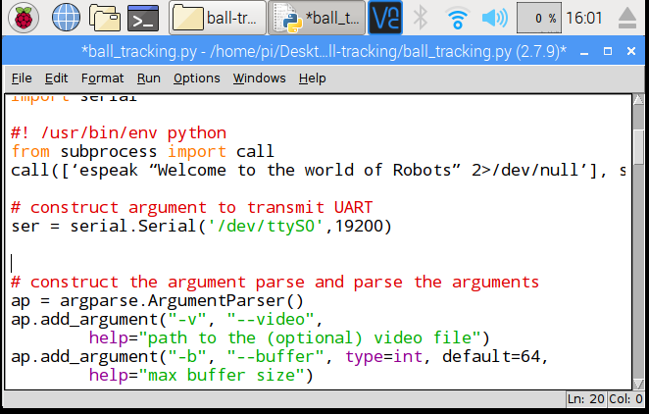

*Figure 4.7: Wrong Baud rate*

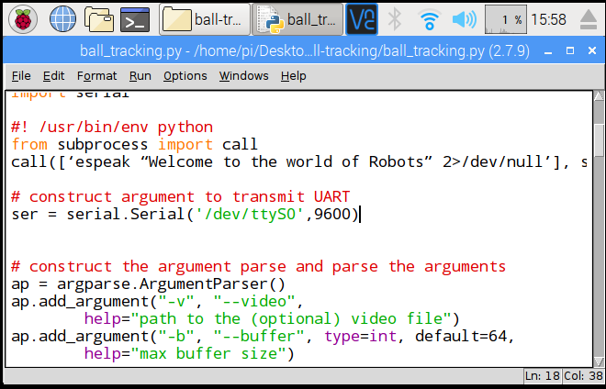

*Figure 4.8: Correct Baud rate*

**Experiment 5**

In this experiment, we tried to indicate the distance by using LED. When the Ultrasonic Sensor detect the distance between the object and vehicle is over 30cm, one LED will turn on. If distance is under 10 cm, another LED will turn on. When vehicle is stop stage, both LEDs will turn on. So that, we troubleshoot when detection has some problems.

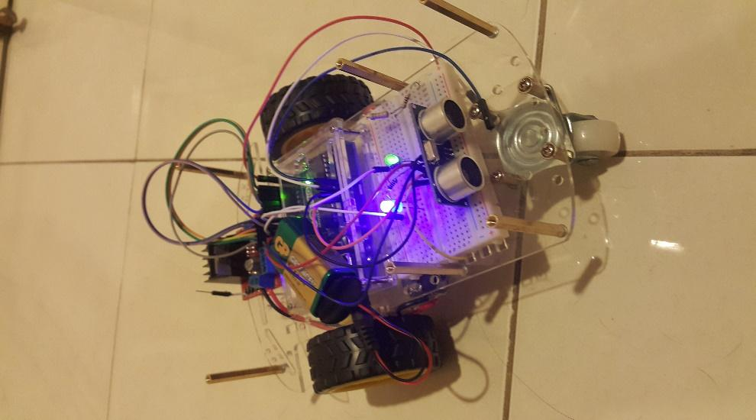

*Figure 4.9: Stop Stage both LEDs on*

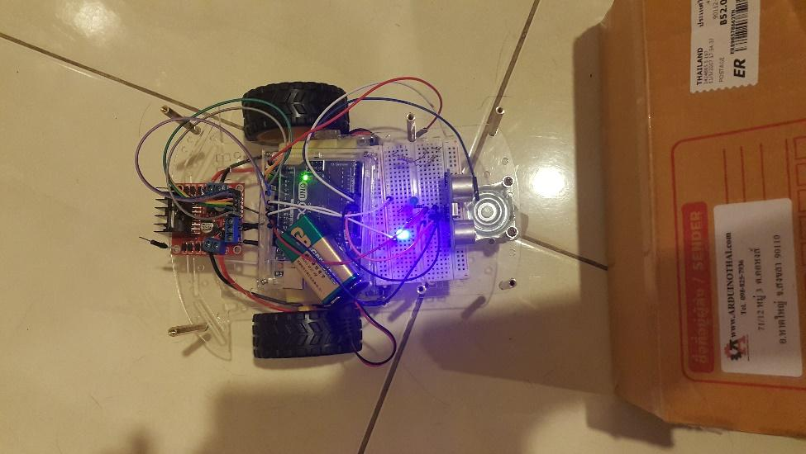

*Figure 4.10: Distance is under 10 cm, one LED on*

**Chapter V**

**Conclusion**

**5.1 Conclusion**

This project is mainly focus on detecting object and following that object. To be simple, we use yellow ball to be detected and followed. We used Raspberry Pi 3, Raspberry Camera Version 2, Arduino UNO R3, Ultrasonic Sensor HC-SR04, Motor Driver L298N and Gear Motors 48:1.

Raspberry Camera is directly connected to DMI port of Raspberry Pi 3. Raspberry Pi 3 is fetching frames from camera to detect the wanted object is in the range or not. If the wanted object is in the range, Raspberry Pi 3 will send UART Signal to Arduino. In this project, Raspberry Pi 3 is acting as Master and Arduino as Slave.

Arduino UNO R3 is being used to control the motors according to the signal send from Master. Once Arduino received signal from Master, it will perform the operation to move forward or backward. Ultrasonic Sensor is also connected to Arduino to measure the distance between the object and vehicle.

By combining those two micro-controller (Master and Slave), we could finalize our project Un-manned Vehicle Following System. It will detect the objects and follow the object right after detected the wanted object with very accurate values.

**5.2 Discussion**

After this project, we had learnt a lot of experiences concerns with Arduino and Raspberry Pi. We learnt how to use components on Arduino and how to solve the problems. We had also learnt to use Raspbian OS which is Debian based OS designed for Raspberry Pi. Most importantly, we learnt how to communicate between Raspberry Pi and Arduino. Overall, this is the most valuable project in our student life.

**Reference**

<https://circuits.io/circuits/4892476-arduino-hbridge-l298n-schematic>

<http://www.instructables.com/id/Arduino-Bluetooth-RC-car-1/>

<http://www.instructables.com/id/Arduino-HC-SR04-Ultrasonic-Rover/>

<https://www.raspberrypi.org/products/raspberry-pi-3-model-b/>

<http://www.pyimagesearch.com/>

<http://www.instructables.com/id/OBJECT-DETECTION-AND-TRACKING-USING-OPENCV-VISUAL-/>

<http://www.pyimagesearch.com/2015/09/14/ball-tracking-with-opencv/>

<http://trevorappleton.blogspot.in/2013/11/python-getting-started-with-opencv.html>

<http://docs.opencv.org/2.4/modules/core/doc/old_basic_structures.html>

<http://www.raspberry-projects.com/pi/programming-in-c/uart-serial-port/using-the-uart>

<https://en.wikipedia.org/wiki/Raspberry_Pi>

<https://en.wikipedia.org/wiki/Arduino>