
International School

Capstone Project 1
CMU-SE 450/CMU-IS 450/CMU-CS450

DataBase Design
Version 1.5
Date: 11 October 2026

SmartRegression AI

Submitted by

Huy, Nguyen Tan - 29211154944
An, Do Ha - 29211258599
Huy, Pham Phan Hoang - 29211156999
Khanh, Tran Hung - 29219065410
Viet, Dang Dai - 29211155820

PROJECT INFORMATION
Project acronym | SmartRegression AI
Project Title | SmartRegression AI: An LLM- and RAG-Based Change Impact Analysis and Regression Test Selection System
Start Date | 23 Aug. 2026 | End Date | 13 Dec. 2026
Lead Institution | International School, Duy Tan University
Project Mentor | JAN SAMUELSSON
Scrum master / Project Leader & contact details | Huy, Nguyen Tan  Email: nguyentanhuy46205@gmail.com  Tel: 0932401249  Student ID: 29211154944
Partner Organization | Duy Tan University
Project Web URL
Team members  Student ID | Name | Email | Tel
29211154944 | Huy, Nguyen Tan | nguyentanhuy46205@gmail.com | 0932401249
29211258599 | An, Do Ha | Anha0664@gmail.com | 0815737920
29211156999 | Huy, Pham Phan Hoang | phamphanhoanghuy2005@gmail.com | 0932509973
29219065410 | Khanh, Tran Hung | Thungkhanh19@gmail.com | 0783494325
29211155820 | Viet, Dang Dai | vdang9721@gmail.com | 0384165721

REVISION HISTORY
Version | Date | Comments | Author | Approval
1.0 | — | Original template. | — | —
1.1 | 10 Oct. 2026 | Initial database draft. | C1SE.26 | Pending
1.2 | 10 Oct. 2026 | Aligned forms and member details. | C1SE.26 | Pending
1.3 | 10 Oct. 2026 | Corrected keys and evaluation links. | C1SE.26 | Pending
1.4 | 11 Oct. 2026 | Refined Introduction and data rules. | C1SE.26 | Pending
1.5 | 11 Oct. 2026 | Condensed text and improved pagination. | C1SE.26 | Pending

Contents
1. Introduction: 4
1.1. Purpose: 4
1.2. Goal: 4
1.3. Scope: 4
1.4. Definitions, Acronyms and Abbreviations: 4
2. Database Design for Sprint 1: 5
2.1. Table Overview: 5
2.2. Entity Relationship Diagram: 5
2.3. Table Relationship Diagram: 6
2.4. Detail 7
3. Database Design for Sprint 2: 12
3.1. Table Overview: 12
3.2. Entity Relationship Diagram: 13
3.3. Table Relationship Diagram: 14
3.4. Detail 15
4. Database Design for Sprint 3: 21
4.1. Table Overview: 21
4.2. Entity Relationship Diagram: 21
4.3. Table Relationship Diagram: 22
4.4. Detail 23
5. Database Design for Sprint 4: 28
5.1. Table Overview: 28
5.2. Entity Relationship Diagram: 28
5.3. Table Relationship Diagram: 29
5.4. Detail 30

1. Introduction:
1.1. Purpose:
Define the database for the SmartRegression AI Capstone 1 prototype: repository analysis, existing-test selection, execution and evaluation. The design supports team implementation and mentor review.
1.2. Goal:
Preserve each run’s commit versions, configuration, evidence, test decisions and results so reports and baseline comparisons can be reproduced.
1.3. Scope:
– In scope: GitHub access, impact analysis, retrieval metadata, test selection/fallback, execution, reporting, one CI/CD integration and research evaluation (UC.01–UC.18).
– Prototype: one analyzed language, one testing framework and provisioned trial users. Excludes test generation, code repair and cross-repository analysis.
– Sections 2–5 group one cumulative schema by the four planned sprints. Baselines and evaluation follow Proposal v1.4, Project Plan v1.1 and Scrum workbook v1.4.
1.4. Definitions, Acronyms and Abbreviations:
Abbreviations | Description | Comment
PK / FK | Primary / Foreign Key | PK columns form one key; exact FK tuples are listed below each table.
UQ | Unique constraint | Cell UQ = single-column; grouped uniqueness is listed below the table.
APP | Application-generated UUID | Generated by the application.
CT | CURRENT_TIMESTAMP | Default insertion time.
Not / Yes | Nullability | Not = required; Yes = NULL allowed.
LLM / RAG | Large Language Model / Retrieval-Augmented Generation | Model reasoning using retrieved project context.
SHA | Git object identifier | Full commit ID: 40 or 64 hexadecimal characters.
MVP | Minimum Viable Product | Agreed prototype scope.
CI/CD | Continuous Integration / Continuous Delivery | One experimental pipeline integration.
UC / PB | Use Case / Product Backlog item | Scope and sprint references.

2. Database Design for Sprint 1:
2.1. Table Overview:

No | Table name | Short Description
1 | app_users | Provisioned trial accounts.
2 | repositories | Authorized GitHub repository identity and status.
3 | repository_access | Repository-scoped user roles.
4 | test_configurations | Versioned test, runner and analysis settings.
5 | analysis_runs | Frozen comparison and processing lifecycle.
6 | run_events | Stage history, warnings and measured duration.
7 | artifacts | Metadata for protected files and reports.
2.2. Entity Relationship Diagram:

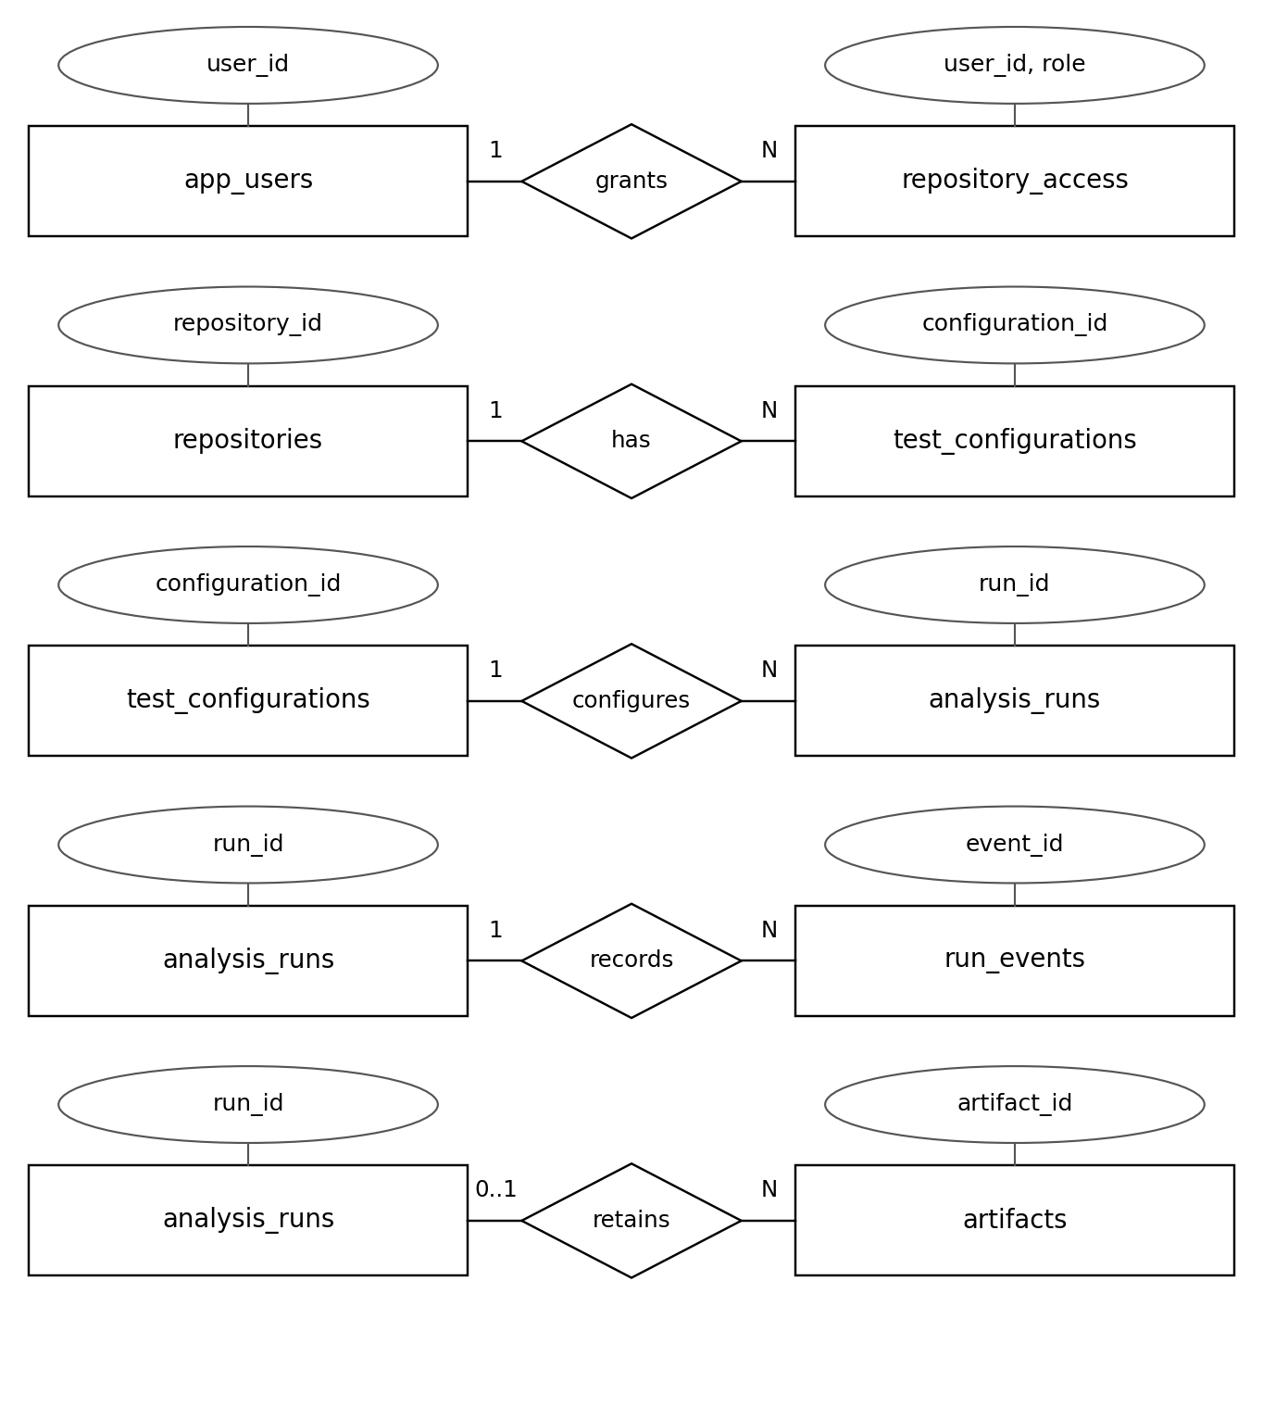
Principal relationships; N = zero or more. Full constraints appear in Detail.
2.3. Table Relationship Diagram:
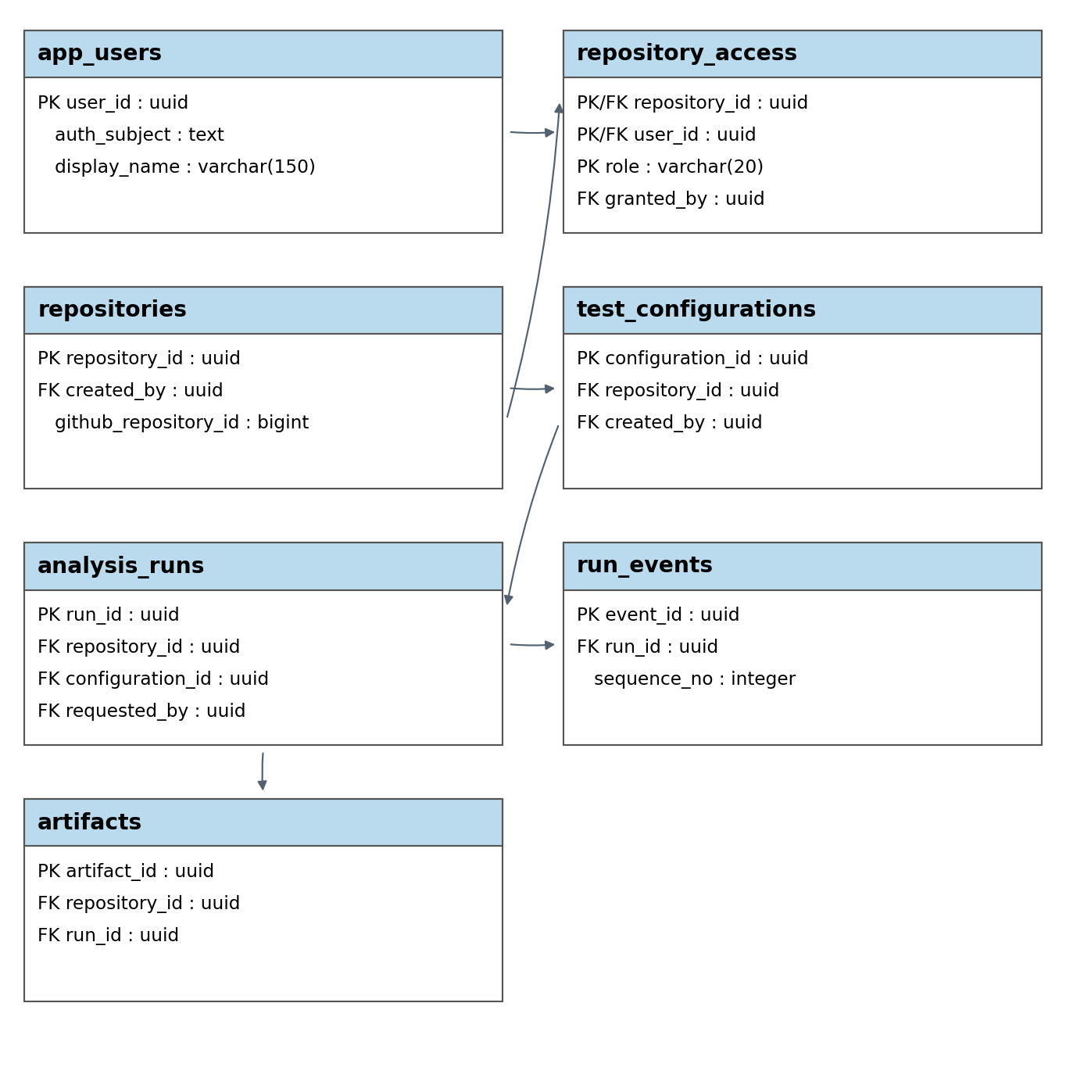
Key fields and principal dependencies; arrows point to dependent tables.
2.4. Detail
Database conventions for Sections 2–5
Target: PostgreSQL; confirm the engine before migration (Project Plan also permits SQLite). Large files use protected artifacts; embeddings remain in the retrieval index.
Notation: PK/FK/UQ follow the forms and tuples below. Default FK targets: run_id → analysis_runs.run_id; repository_id → repositories.repository_id; user_id and user attribution fields → app_users.user_id. Other/composite FKs are listed per table. Timestamps use UTC; unavailable measurements stay NULL.
Integrity: enforce keys and same-row checks in the database; validate cross-row rules transactionally before freezing records. Optional composite FKs use MATCH SIMPLE with presence checks. FK deletion/update uses RESTRICT.
Access: recheck user/repository permissions and artifact ownership. Store secret references only; keep evaluation labels/reference results outside selection inputs.
Common checks: counts, durations, tokens and costs are nonnegative; line ranges are positive and ordered; hashes use full hexadecimal identifiers.
2.4.1. app_users
Provisioned trial accounts.
Attributes | Datatype | Null | Key | Default | Extra
user_id | uuid | Not | PK |  | APP
auth_subject | text | Not | UQ
display_name | varchar(150) | Not
email | varchar(254) | Yes |  | NULL
is_active | boolean | Not |  | true
created_at | timestamptz | Not |  | CT

Rules: Disabled users lose access; historical references remain.

2.4.2. repositories
Authorized GitHub repository identity and status.
Attributes | Datatype | Null | Key | Default | Extra
repository_id | uuid | Not | PK |  | APP
github_repository_id | bigint | Not | UQ
owner_name | text | Not
repository_name | text | Not
canonical_url | text | Not
is_private | boolean | Not
credential_ref | text | Yes |  | NULL
connection_status | varchar(20) | Not |  | pending
failure_reason | text | Yes |  | NULL
created_by | uuid | Not | FK
created_at | timestamptz | Not |  | CT
updated_at | timestamptz | Not |  | CT
Rules: github_repository_id > 0. Renames retain repository_id; disconnecting preserves history. failed requires failure_reason.
Values: connection_status: pending, connected, revoked, failed.
2.4.3. repository_access
Repository-scoped user roles.
Attributes | Datatype | Null | Key | Default | Extra
repository_id | uuid | Not | PK FK
user_id | uuid | Not | PK FK
role | varchar(20) | Not | PK
granted_by | uuid | Not | FK
granted_at | timestamptz | Not |  | CT
Rules: Roles apply per repository. Removing a grant revokes that role; existing run records remain.
Values: role: maintainer, developer, qa, evaluator, viewer.
2.4.4. test_configurations
Versioned test, runner and analysis settings.
Attributes | Datatype | Null | Key | Default | Extra
configuration_id | uuid | Not | PK |  | APP
repository_id | uuid | Not | FK
version_no | integer | Not
language | varchar(40) | Not
framework | varchar(60) | Not
test_locations | jsonb | Not
approved_argv | jsonb | Not
timeout_seconds | integer | Not
cpu_limit | numeric(6,2) | Not
memory_mb | integer | Not
settings | jsonb | Not
created_by | uuid | Not | FK
created_at | timestamptz | Not |  | CT
Unique groups: (repository_id, version_no); (repository_id, configuration_id).
Rules: Positive version/resource limits; nonempty approved paths and argument arrays. Updates create new versions. settings records parser/discovery/runner versions, selection policy and processing budgets.
2.4.5. analysis_runs
Frozen comparison and processing lifecycle.
Attributes | Datatype | Null | Key | Default | Extra
run_id | uuid | Not | PK |  | APP
repository_id | uuid | Not | FK
configuration_id | uuid | Not | FK
base_sha | varchar(64) | Not
target_sha | varchar(64) | Not
request_kind | varchar(12) | Not
pull_request_no | integer | Yes |  | NULL
requested_by | uuid | Not | FK
request_key | text | Not
status | varchar(12) | Not |  | queued
current_stage | varchar(30) | Not |  | queued
failure_code | varchar(60) | Yes |  | NULL
failure_reason | text | Yes |  | NULL
queued_at | timestamptz | Not |  | CT
started_at | timestamptz | Yes |  | NULL
finished_at | timestamptz | Yes |  | NULL
attempt_count | integer | Not |  | 0
Unique groups: (repository_id, request_key); (repository_id, run_id).
FK: (repository_id, configuration_id) → test_configurations(repository_id, configuration_id).
Rules: Freeze repository, SHAs and configuration. PR requests use merge base/head and require pull_request_no. Terminal states require finished_at; failed requires a reason. New heads create new runs; retries are bounded.
Values: request_kind: commit_pair, pull_request, ci, evaluation. status: queued, running, completed, failed.
2.4.6. run_events
Stage history, warnings and measured duration.
Attributes | Datatype | Null | Key | Default | Extra
event_id | uuid | Not | PK |  | APP
run_id | uuid | Not | FK
sequence_no | integer | Not
stage | varchar(30) | Not
state | varchar(15) | Not
occurred_at | timestamptz | Not |  | CT
duration_ms | bigint | Yes |  | NULL
detail | jsonb | Not |  | {}
Unique groups: (run_id, sequence_no).
Rules: Positive, serialized sequence_no; append-only events. Do not sum overlapping durations as wall time.
Values: stage: checkout, diff, dependency, discovery, initial_index, incremental_index, retrieval, llm, selection, execution, reporting. state: started, succeeded, failed, warning, retried.
2.4.7. artifacts
Metadata for protected files and reports.
Attributes | Datatype | Null | Key | Default | Extra
artifact_id | uuid | Not | PK |  | APP
repository_id | uuid | Not | FK
run_id | uuid | Yes | FK | NULL
kind | varchar(30) | Not
storage_key | text | Not | UQ
sha256 | char(64) | Not
media_type | text | Not
size_bytes | bigint | Not
access_class | varchar(20) | Not |  | repository
schema_version | varchar(30) | Yes |  | NULL
created_at | timestamptz | Not |  | CT
FK: (repository_id, run_id) → analysis_runs(repository_id, run_id).
Rules: Immutable bytes/digest; replacement creates a new row. References must match repository, run, kind and access class.
Values: kind: snapshot, diff, prompt, response, log, manifest, report_html, report_json, evaluation, index. access_class: repository, service_only, evaluation_only.

3. Database Design for Sprint 2:
3.1. Table Overview:
Planned scope: 28 September–18 October 2026; PB05–09, PB19 and PB20.
No | Table name | Short Description
1 | changed_files | Added, modified, deleted and renamed files.
2 | code_components | Versioned modules, classes, functions and methods.
3 | dependency_edges | Supported dependency links at one snapshot.
4 | impact_candidates | Changed and potentially affected components.
5 | evidence_references | Source, dependency, commit and rule evidence.
6 | test_inventories | Discovery status and frozen target inventory.
7 | test_cases | Existing tests and source locations.
8 | knowledge_indexes | Commit-scoped retrieval index metadata.
9 | knowledge_chunks | Retrieved content locations and hashes.
3.2. Entity Relationship Diagram:
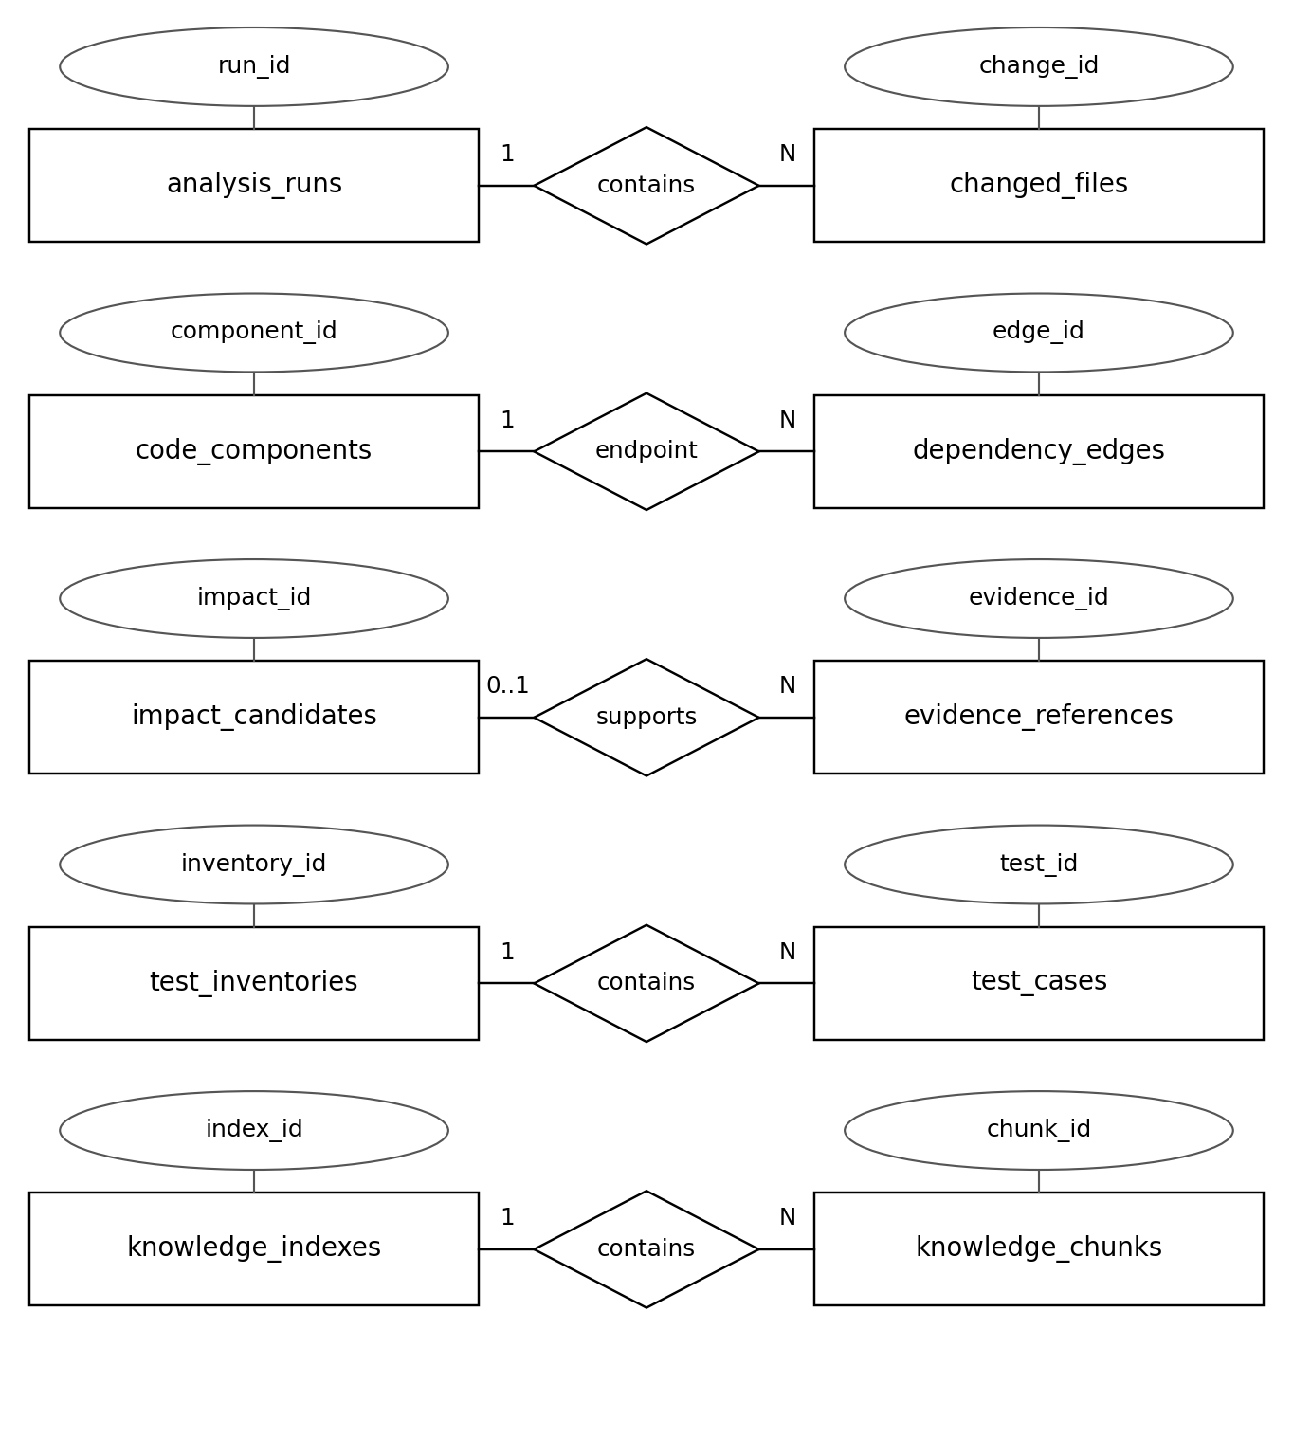
Principal relationships; N = zero or more. Full constraints appear in Detail.
3.3. Table Relationship Diagram:
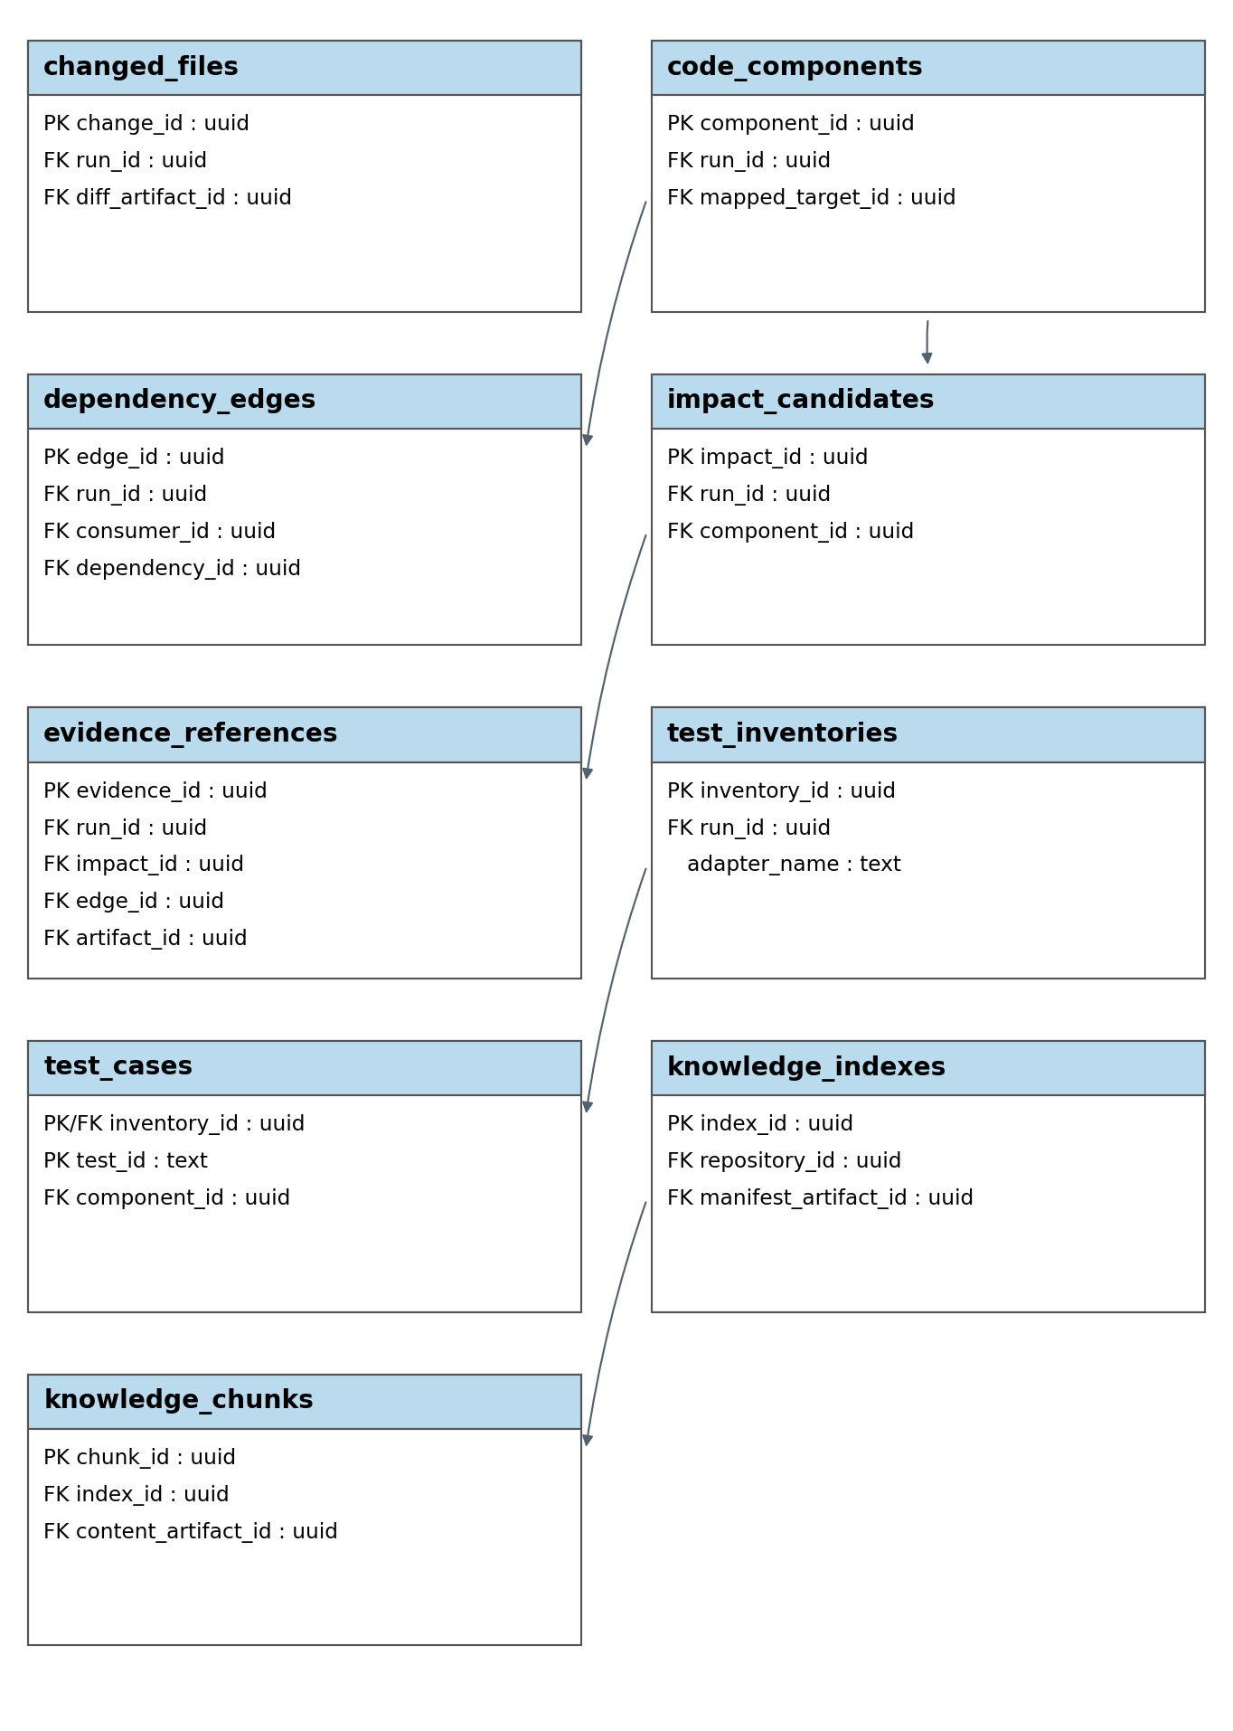
Key fields and principal dependencies; arrows point to dependent tables.
3.4. Detail
3.4.1. changed_files
Added, modified, deleted and renamed files.
Attributes | Datatype | Null | Key | Default | Extra
change_id | uuid | Not | PK |  | APP
run_id | uuid | Not | FK
change_no | integer | Not
change_type | varchar(12) | Not
old_path | text | Yes |  | NULL
new_path | text | Yes |  | NULL
diff_artifact_id | uuid | Yes | FK | NULL
analysis_status | varchar(15) | Not |  | pending
information_gap | text | Yes |  | NULL
Unique groups: (run_id, change_no).
FK: diff_artifact_id → artifacts.artifact_id.
Rules: Added: new_path only; deleted: old_path only; modified: equal paths; renamed: different paths. Unsupported/failed analysis requires information_gap.
Values: change_type: added, modified, deleted, renamed. analysis_status: pending, supported, unsupported, failed.
3.4.2. code_components
Versioned modules, classes, functions and methods.
Attributes | Datatype | Null | Key | Default | Extra
component_id | uuid | Not | PK |  | APP
run_id | uuid | Not | FK
snapshot_side | varchar(6) | Not
component_key | text | Not
file_path | text | Not
qualified_name | text | Not
kind | varchar(12) | Not
line_start | integer | Not
line_end | integer | Not
is_executable | boolean | Not
is_changed | boolean | Not |  | false
mapped_target_id | uuid | Yes | FK | NULL
Unique groups: (run_id, snapshot_side, component_key); (run_id, component_id).
FK: (run_id, mapped_target_id) → code_components(run_id, component_id).
Rules: Only base components may map to target components in the same run. Deleted/unmapped and target-side components leave mapped_target_id NULL.
Values: snapshot_side: base, target. kind: module, class, function, method.
3.4.3. dependency_edges
Supported dependency links at one snapshot.
Attributes | Datatype | Null | Key | Default | Extra
edge_id | uuid | Not | PK |  | APP
run_id | uuid | Not | FK
consumer_id | uuid | Not | FK
dependency_id | uuid | Not | FK
edge_kind | varchar(12) | Not
parser_version | text | Not
source_location | jsonb | Not
Unique groups: (run_id, consumer_id, dependency_id, edge_kind); (run_id, edge_id).
FK: (run_id, consumer_id) → code_components(run_id, component_id); (run_id, dependency_id) → code_components(run_id, component_id).
Rules: Endpoints share run and snapshot. source_location stores all line ranges for the endpoint/type relation.
Values: edge_kind: import, call.
3.4.4. impact_candidates
Changed and potentially affected components.
Attributes | Datatype | Null | Key | Default | Extra
impact_id | uuid | Not | PK |  | APP
run_id | uuid | Not | FK
component_id | uuid | Not | FK
impact_kind | varchar(12) | Not
review_rank | integer | Not
explanation | text | Not
dependency_path | jsonb | Not |  | []
information_gap | text | Yes |  | NULL
Unique groups: (run_id, component_id); (run_id, review_rank); (run_id, impact_id).
FK: (run_id, component_id) → code_components(run_id, component_id).
Rules: review_rank > 0; changed components precede direct/indirect impacts. dependency_path contains only same-run edges.
Values: impact_kind: changed, direct, indirect.
3.4.5. evidence_references
Source, dependency, commit and rule evidence.
Attributes | Datatype | Null | Key | Default | Extra
evidence_id | uuid | Not | PK |  | APP
run_id | uuid | Not | FK
impact_id | uuid | Yes | FK | NULL
evidence_kind | varchar(12) | Not
commit_sha | varchar(64) | Yes |  | NULL
file_path | text | Yes |  | NULL
line_start | integer | Yes |  | NULL
line_end | integer | Yes |  | NULL
edge_id | uuid | Yes | FK | NULL
rule_code | text | Yes |  | NULL
artifact_id | uuid | Yes | FK | NULL
reference_status | varchar(12) | Not |  | unverified
validation_note | text | Yes |  | NULL
validated_at | timestamptz | Yes |  | NULL
Unique groups: (run_id, evidence_id).
FK: (run_id, impact_id) → impact_candidates(run_id, impact_id); (run_id, edge_id) → dependency_edges(run_id, edge_id); artifact_id → artifacts.artifact_id.
Rules: Validate cited commits, paths and ranges. Source requires commit/path; dependency requires edge/commit; commit requires SHA; rule requires rule_code; historical coverage requires commit/artifact. Selection uses verified evidence only.
Values: evidence_kind: source, dependency, commit, rule, coverage. reference_status: unverified, verified, invalid.
3.4.6. test_inventories
Discovery status and frozen target inventory.
Attributes | Datatype | Null | Key | Default | Extra
inventory_id | uuid | Not | PK |  | APP
run_id | uuid | Not | FK UQ
adapter_name | text | Not
adapter_version | text | Not
inventory_version | text | Yes |  | NULL
status | varchar(20) | Not |  | pending
test_count | integer | Yes |  | NULL
failure_reason | text | Yes |  | NULL
completed_at | timestamptz | Yes |  | NULL
Unique groups: (run_id, inventory_id).
Rules: One frozen inventory per run. Pending/failed: test_count NULL. success: count > 0; success_empty: 0. Success requires inventory_version; terminal states require completed_at; failed requires a reason.
Values: status: pending, success, success_empty, failed.
3.4.7. test_cases
Existing tests and source locations.
Attributes | Datatype | Null | Key | Default | Extra
inventory_id | uuid | Not | PK FK
test_id | text | Not | PK
file_path | text | Not
line_start | integer | Yes |  | NULL
display_name | text | Not
component_id | uuid | Yes | FK | NULL
is_new_or_modified | boolean | Not |  | false
FK: inventory_id → test_inventories.inventory_id; component_id → code_components.component_id.
Rules: Use valid adapter-discovered IDs. Linked components belong to the inventory run’s target snapshot.
3.4.8. knowledge_indexes
Commit-scoped retrieval index metadata.
Attributes | Datatype | Null | Key | Default | Extra
index_id | uuid | Not | PK |  | APP
repository_id | uuid | Not | FK
commit_sha | varchar(64) | Not
index_version | text | Not
namespace_key | text | Not | UQ
embedding_model | text | Not
status | varchar(12) | Not |  | building
manifest_artifact_id | uuid | Yes | FK | NULL
build_duration_ms | bigint | Yes |  | NULL
created_at | timestamptz | Not |  | CT
Unique groups: (repository_id, commit_sha, index_version).
FK: manifest_artifact_id → artifacts.artifact_id.
Rules: ready requires committed chunks and manifest_artifact_id. Retrieval must match repository/commit.
Values: status: building, ready, failed.
3.4.9. knowledge_chunks
Retrieved content locations and hashes.
Attributes | Datatype | Null | Key | Default | Extra
chunk_id | uuid | Not | PK |  | APP
index_id | uuid | Not | FK
chunk_key | text | Not
content_kind | varchar(20) | Not
file_path | text | Not
line_start | integer | Not
line_end | integer | Not
content_sha256 | char(64) | Not
content_artifact_id | uuid | Not | FK
Unique groups: (index_id, chunk_key).
FK: index_id → knowledge_indexes.index_id; content_artifact_id → artifacts.artifact_id.
Rules: Content/artifacts match the index commit. Index source, tests and documentation only; exclude secrets, labels and reference outcomes.
Values: content_kind: source, test, documentation.

4. Database Design for Sprint 3:
4.1. Table Overview:
Planned scope: 19 October–8 November 2026; PB10–14, PB21 and PB22.
No | Table name | Short Description
1 | llm_calls | Model requests, validation, timing and available cost.
2 | selection_manifests | Frozen selection policy and test partition.
3 | selection_items | One selected/not-selected decision per test.
4 | selection_evidence | Links between test decisions and evidence.
5 | fallback_events | Fallback trigger, policy and final mode.
6 | execution_jobs | Controlled execution attempts and outcomes.
7 | test_results | Per-test attempt results and logs.
4.2. Entity Relationship Diagram:
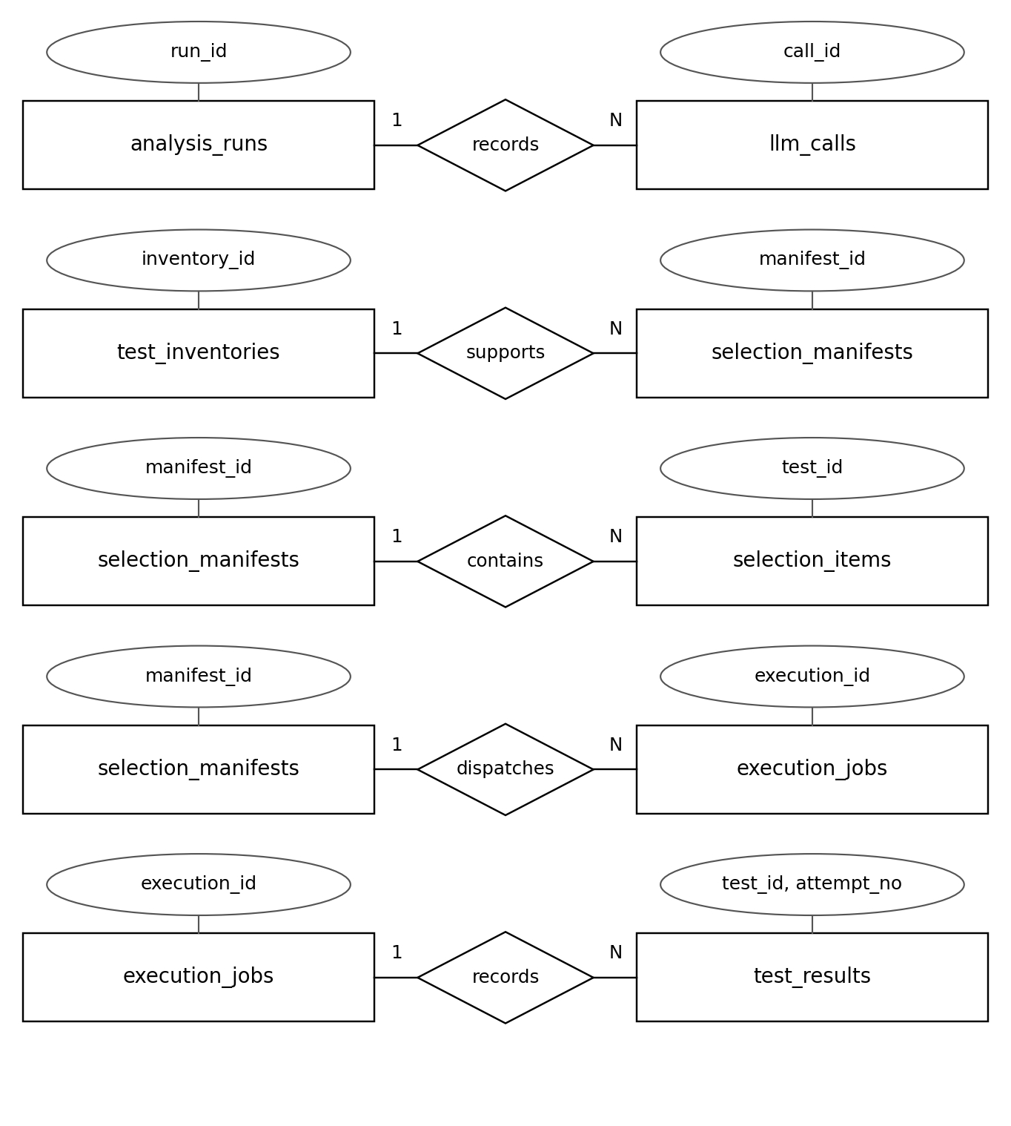
Principal relationships; N = zero or more. Full constraints appear in Detail.
4.3. Table Relationship Diagram:
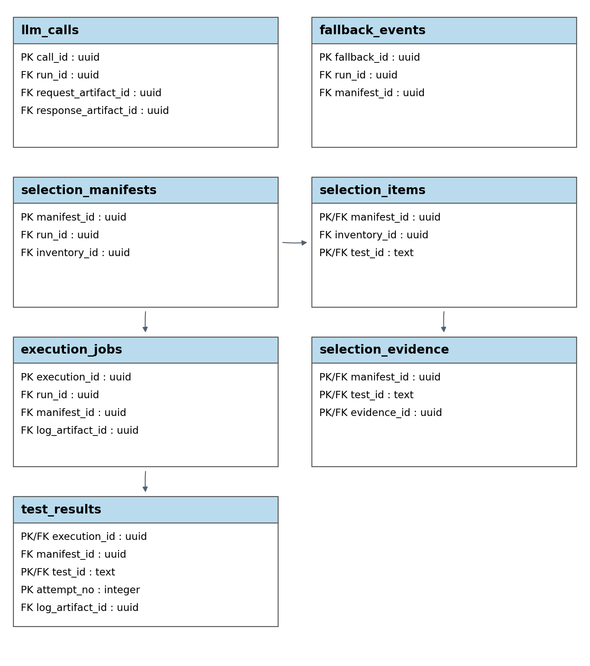
Key fields and principal dependencies; arrows point to dependent tables.
4.4. Detail
4.4.1. llm_calls
Model requests, validation, timing and available cost.
Attributes | Datatype | Null | Key | Default | Extra
call_id | uuid | Not | PK |  | APP
run_id | uuid | Not | FK
call_no | integer | Not
provider_model | text | Not
prompt_version | text | Not
inference_config | jsonb | Not
request_artifact_id | uuid | Not | FK
response_artifact_id | uuid | Yes | FK | NULL
status | varchar(12) | Not |  | pending
validation_detail | jsonb | Not |  | {}
input_tokens | bigint | Yes |  | NULL
output_tokens | bigint | Yes |  | NULL
cost_amount | numeric(18,8) | Yes |  | NULL
cost_basis | jsonb | Yes |  | NULL
started_at | timestamptz | Not |  | CT
finished_at | timestamptz | Yes |  | NULL
Unique groups: (run_id, call_no).
FK: request_artifact_id → artifacts.artifact_id; response_artifact_id → artifacts.artifact_id.
Rules: Retain every attempt and model/prompt/settings; request artifacts identify retrieved chunks. Terminal calls require finished_at. Monetary cost requires currency/price basis; missing usage stays NULL.
Values: status: pending, succeeded, failed, timeout, invalid.
4.4.2. selection_manifests
Frozen selection policy and complete test partition.
Attributes | Datatype | Null | Key | Default | Extra
manifest_id | uuid | Not | PK |  | APP
run_id | uuid | Not | FK
inventory_id | uuid | Not | FK
version_no | integer | Not
policy_version | text | Not
selection_mode | varchar(25) | Not
validation_status | varchar(12) | Not |  | draft
created_at | timestamptz | Not |  | CT
frozen_at | timestamptz | Yes |  | NULL
Unique groups: (run_id, version_no); (manifest_id, inventory_id); (run_id, manifest_id).
FK: (run_id, inventory_id) → test_inventories(run_id, inventory_id).
Rules: Validate the complete test partition and evidence before setting frozen_at. Frozen decisions are immutable; counts derive from selection_items. Only validated nonempty manifests execute.
Values: selection_mode: hybrid, dependency_modified, full_suite_fallback, full_suite_requested, no_tests, stopped, baseline. validation_status: draft, validated, rejected.
4.4.3. selection_items
One selected/not-selected decision per test.
Attributes | Datatype | Null | Key | Default | Extra
manifest_id | uuid | Not | PK FK
inventory_id | uuid | Not | FK
test_id | text | Not | PK FK
is_selected | boolean | Not
from_dependency | boolean | Not |  | false
from_modified | boolean | Not |  | false
from_llm | boolean | Not |  | false
reason_code | varchar(60) | Not
reason_text | text | Not
FK: (manifest_id, inventory_id) → selection_manifests(manifest_id, inventory_id); (inventory_id, test_id) → test_cases(inventory_id, test_id).
Rules: One decision/reason per inventory test. Hybrid: S = (D ∪ M ∪ L) ∩ T; LLM cannot remove dependency-selected or modified tests. Baselines/fallback use their stated policy.
4.4.4. selection_evidence
Links between test decisions and evidence.
Attributes | Datatype | Null | Key | Default | Extra
manifest_id | uuid | Not | PK FK
test_id | text | Not | PK FK
evidence_id | uuid | Not | PK FK
FK: (manifest_id, test_id) → selection_items(manifest_id, test_id); evidence_id → evidence_references.evidence_id.
Rules: Evidence is verified and belongs to the manifest run. Source-based selections require evidence; policy-only reasons cite policy.
4.4.5. fallback_events
Fallback trigger, policy and final mode.
Attributes | Datatype | Null | Key | Default | Extra
fallback_id | uuid | Not | PK |  | APP
run_id | uuid | Not | FK
manifest_id | uuid | Yes | FK | NULL
trigger_code | varchar(60) | Not
policy_version | text | Not
final_mode | varchar(25) | Not
reason | text | Not
created_at | timestamptz | Not |  | CT
FK: (run_id, manifest_id) → selection_manifests(run_id, manifest_id).
Rules: Record trigger/policy/final mode. LLM failure uses valid D ∪ M if permitted; incomplete analysis uses full suite. Checkout/discovery/runner failures stop; empty inventory reports no_tests.
4.4.6. execution_jobs
Controlled execution attempts and outcomes.
Attributes | Datatype | Null | Key | Default | Extra
execution_id | uuid | Not | PK |  | APP
run_id | uuid | Not | FK
manifest_id | uuid | Not | FK
request_key | text | Not
requested_mode | varchar(12) | Not
purpose | varchar(12) | Not
status | varchar(12) | Not |  | queued
outcome | varchar(20) | Yes |  | NULL
environment | jsonb | Not
runner_job_id | text | Yes | UQ | NULL
log_artifact_id | uuid | Yes | FK | NULL
queued_at | timestamptz | Not |  | CT
started_at | timestamptz | Yes |  | NULL
finished_at | timestamptz | Yes |  | NULL
duration_ms | bigint | Yes |  | NULL
exit_code | integer | Yes |  | NULL
Unique groups: (run_id, request_key); (execution_id, manifest_id).
FK: (run_id, manifest_id) → selection_manifests(run_id, manifest_id); log_artifact_id → artifacts.artifact_id.
Rules: Dispatch a frozen validated manifest; full-suite requests use an all-selected manifest. Prevent duplicate live jobs. Terminal states require finished_at; passed requires every selected test’s final outcome passed. Missing/skipped tests are incomplete; zero tests is no_tests.
Values: requested_mode: recommended, full_suite. purpose: product, reference. status: queued, running, completed, failed.
Values: outcome: passed, assertion_failed, build_failed, timeout, infrastructure_error, no_tests, incomplete.
4.4.7. test_results
Per-test attempt results and logs.
Attributes | Datatype | Null | Key | Default | Extra
execution_id | uuid | Not | PK FK
manifest_id | uuid | Not | FK
test_id | text | Not | PK FK
attempt_no | integer | Not | PK
outcome | varchar(20) | Not
duration_ms | bigint | Yes |  | NULL
failure_message | text | Yes |  | NULL
log_artifact_id | uuid | Yes | FK | NULL
is_final_attempt | boolean | Not |  | false
FK: (execution_id, manifest_id) → execution_jobs(execution_id, manifest_id); (manifest_id, test_id) → selection_items(manifest_id, test_id); log_artifact_id → artifacts.artifact_id.
Rules: Positive attempt_no; retain all attempts. Results reference selected items only. UNIQUE(execution_id, test_id) WHERE is_final_attempt permits at most one final result; completion requires exactly one per selected test.
Values: outcome: passed, assertion_failed, runner_skipped, timeout, infrastructure_error.

5. Database Design for Sprint 4:
5.1. Table Overview:
Planned scope: 9–29 November 2026; PB15–18 and PB24, completing evaluation persistence for PB23.
No | Table name | Short Description
1 | ci_integrations | One configured CI/CD adapter per repository.
2 | ci_events | Idempotent event receipt and run association.
3 | evaluation_datasets | Frozen dataset versions and protocols.
4 | evaluation_cases | Repository/commit pairs and case partitions.
5 | evaluation_labels | Independently reviewed restricted labels.
6 | evaluation_runs | Method, repetition and reference comparison.
7 | evaluation_metrics | Metric inputs, values, units and N/A reasons.
5.2. Entity Relationship Diagram:
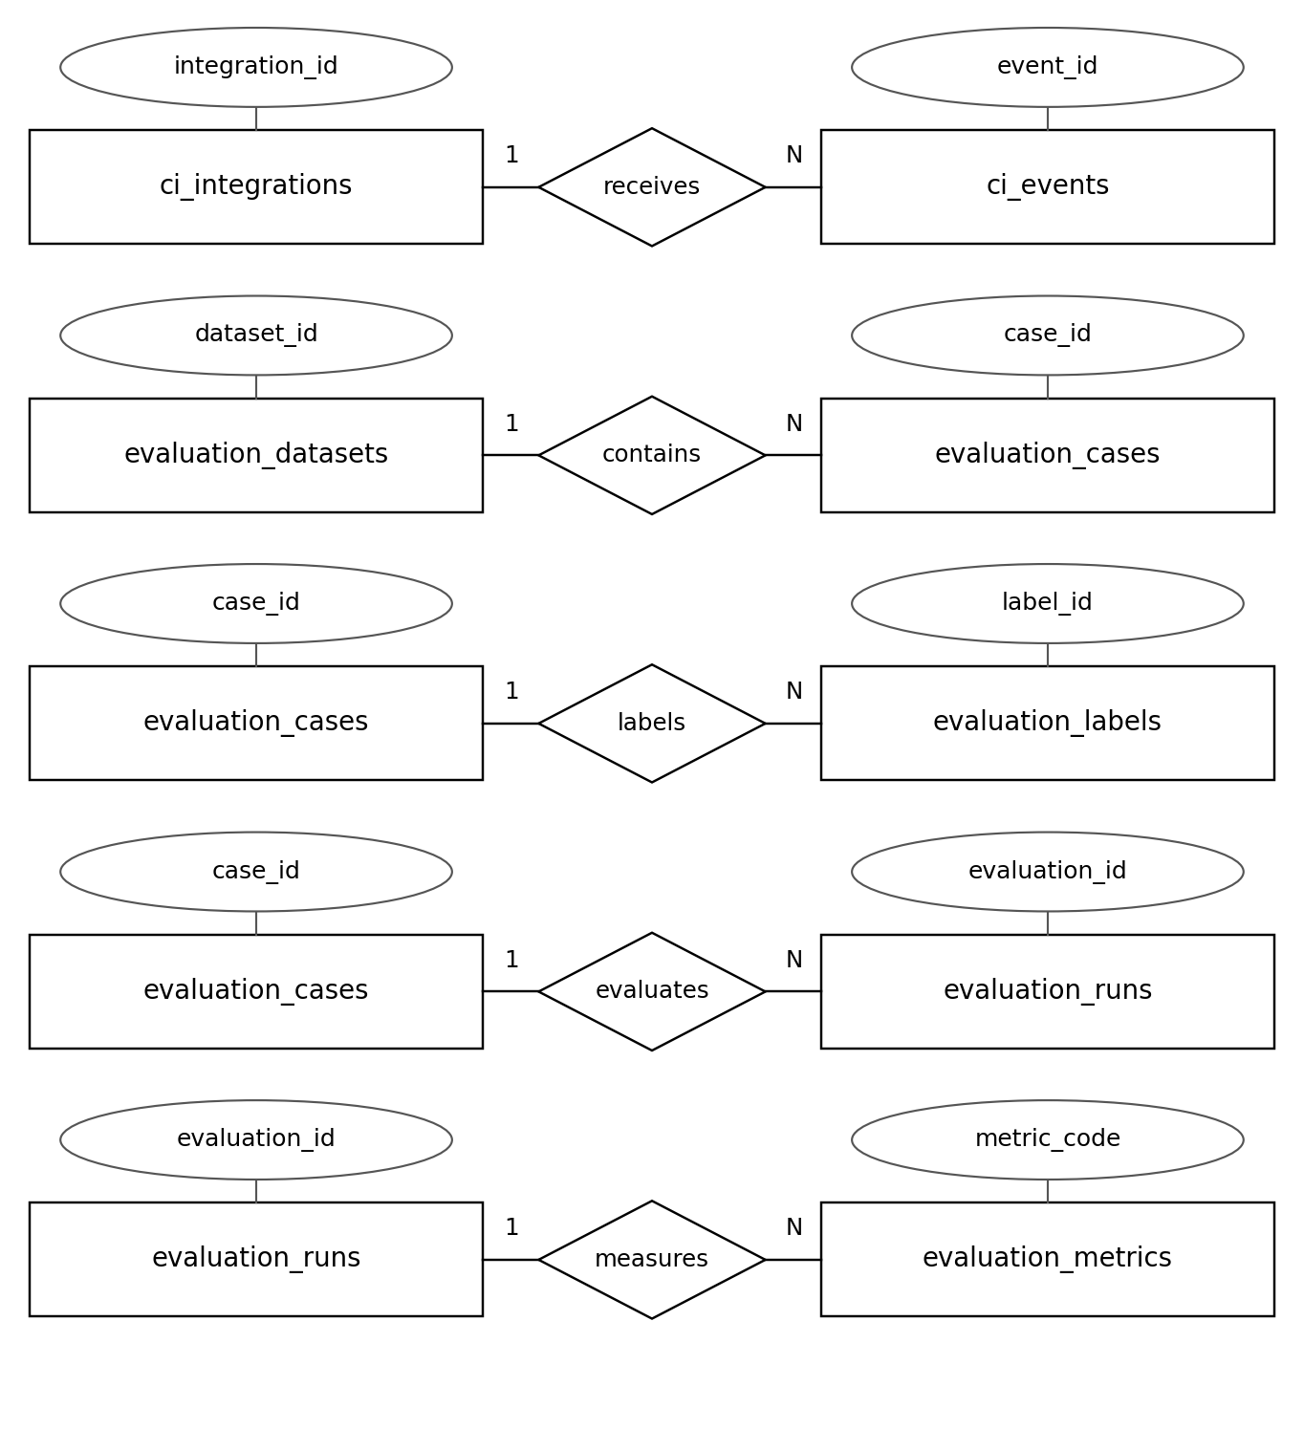
Principal relationships; N = zero or more. Full constraints appear in Detail.
5.3. Table Relationship Diagram:
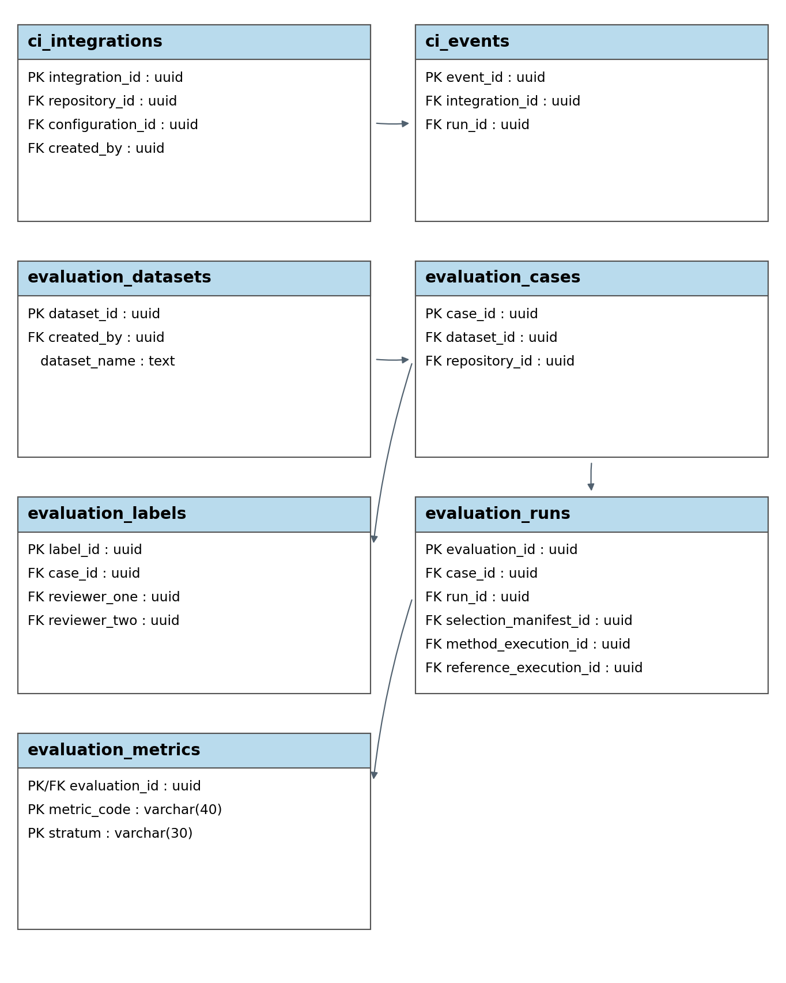
Key fields and principal dependencies; arrows point to dependent tables.
5.4. Detail
5.4.1. ci_integrations
One configured CI/CD adapter per repository.
Attributes | Datatype | Null | Key | Default | Extra
integration_id | uuid | Not | PK |  | APP
repository_id | uuid | Not | FK UQ
provider | varchar(40) | Not
configuration_id | uuid | Not | FK
event_policy | jsonb | Not
secret_ref | text | Yes |  | NULL
is_active | boolean | Not |  | true
created_by | uuid | Not | FK
created_at | timestamptz | Not |  | CT
FK: (repository_id, configuration_id) → test_configurations(repository_id, configuration_id).
Rules: One integration per repository. Configuration belongs to that repository; only maintainers may change it.
5.4.2. ci_events
Idempotent event receipt and run association.
Attributes | Datatype | Null | Key | Default | Extra
event_id | uuid | Not | PK |  | APP
integration_id | uuid | Not | FK
delivery_key | text | Not
payload_sha256 | char(64) | Not
pipeline_id | text | Yes |  | NULL
run_id | uuid | Yes | FK | NULL
status | varchar(12) | Not |  | received
response_status | varchar(32) | Yes |  | NULL
failure_reason | text | Yes |  | NULL
received_at | timestamptz | Not |  | CT
Unique groups: (integration_id, delivery_key).
FK: integration_id → ci_integrations.integration_id.
Rules: Deduplicate by delivery_key; changed replay payloads are rejected. Integration/run repositories match. accepted requires run_id; rejected/failed requires failure_reason.
Values: status: received, accepted, rejected, failed. response_status: pending, success, success_full_suite_fallback, failure, neutral_no_tests.
5.4.3. evaluation_datasets
Frozen dataset versions and protocols.
Attributes | Datatype | Null | Key | Default | Extra
dataset_id | uuid | Not | PK |  | APP
dataset_name | text | Not
version | text | Not
protocol | jsonb | Not
created_by | uuid | Not | FK
created_at | timestamptz | Not |  | CT
frozen_at | timestamptz | Yes |  | NULL
Unique groups: (dataset_name, version).
Rules: Freeze cases, partitions and independent labels before held-out evaluation. Reference-data changes require a new version. Evidence ratings are added per evaluated run afterward.
5.4.4. evaluation_cases
Repository/commit pairs and case partitions.
Attributes | Datatype | Null | Key | Default | Extra
case_id | uuid | Not | PK |  | APP
dataset_id | uuid | Not | FK
repository_id | uuid | Not | FK
case_key | text | Not
base_sha | varchar(64) | Not
target_sha | varchar(64) | Not
source_group_key | text | Not
partition | varchar(10) | Not
case_origin | varchar(10) | Not
environment | jsonb | Not
eligibility | varchar(12) | Not |  | pending
exclusion_reason | text | Yes |  | NULL
Unique groups: (dataset_id, case_key).
FK: dataset_id → evaluation_datasets.dataset_id.
Rules: Keep each source_group_key in one partition. Excluded cases require a reason. Comparisons use identical repository, SHAs and environment; retain real/mutation strata.
Values: partition: pilot, held_out. case_origin: real, mutation. eligibility: pending, eligible, excluded.
5.4.5. evaluation_labels
Independently reviewed restricted labels.
Attributes | Datatype | Null | Key | Default | Extra
label_id | uuid | Not | PK |  | APP
case_id | uuid | Not | FK
label_kind | varchar(20) | Not
subject_key | text | Not
value | jsonb | Not
reviewer_one | uuid | Not | FK
reviewer_two | uuid | Yes | FK | NULL
review_status | varchar(12) | Not |  | draft
review_note | text | Yes |  | NULL
reviewed_at | timestamptz | Yes |  | NULL
Unique groups: (case_id, label_kind, subject_key).
FK: case_id → evaluation_cases.case_id.
Rules: Agreed labels require two distinct reviewers and reviewed_at. value uses a versioned schema. Component labels identify SHA/path/name; faults identify detecting tests; evidence ratings identify run/evidence in subject_key.
Values: label_kind: affected_component, fault, flaky_test, evidence_rating. review_status: draft, agreed, disputed, uncertain.
5.4.6. evaluation_runs
Method, repetition and reference comparison.
Attributes | Datatype | Null | Key | Default | Extra
evaluation_id | uuid | Not | PK |  | APP
batch_id | uuid | Not
case_id | uuid | Not | FK
method | varchar(20) | Not
repetition_no | integer | Not
run_id | uuid | Not | FK UQ
selection_manifest_id | uuid | Yes | FK | NULL
method_execution_id | uuid | Yes | FK | NULL
reference_execution_id | uuid | Yes | FK | NULL
reference_available_at | timestamptz | Yes |  | NULL
configuration | jsonb | Not
validity_status | varchar(12) | Not |  | pending
invalid_reason | text | Yes |  | NULL
Unique groups: (batch_id, case_id, method, repetition_no).
FK: case_id → evaluation_cases.case_id; (run_id, selection_manifest_id) → selection_manifests(run_id, manifest_id); (method_execution_id, selection_manifest_id) → execution_jobs(execution_id, manifest_id); method_execution_id → execution_jobs.execution_id; reference_execution_id → execution_jobs.execution_id.
Rules: Bind the exact method execution to its manifest. valid requires an eligible case, frozen selection, completed method/reference runs and matching versions/environment. Reference uses an all-selected manifest and purpose = reference. Release reference outcomes after selection freezes. failed/excluded requires a reason; empty inventories are excluded.
Values: validity_status: pending, valid, failed, excluded.
Values: method: full_suite, dependency, llm_only, hybrid, hybrid_no_rag.
5.4.7. evaluation_metrics
Metric inputs, values, units and N/A reasons.
Attributes | Datatype | Null | Key | Default | Extra
evaluation_id | uuid | Not | PK FK
metric_code | varchar(40) | Not | PK
stratum | varchar(30) | Not | PK
numerator | numeric(20,6) | Yes |  | NULL
denominator | numeric(20,6) | Yes |  | NULL
metric_value | numeric(20,8) | Yes |  | NULL
unit | varchar(15) | Not
na_reason | text | Yes |  | NULL
definition_version | text | Not
calculated_at | timestamptz | Not |  | CT
FK: evaluation_id → evaluation_runs.evaluation_id.
Rules: Store raw inputs, definition/version and units. Missing inputs/zero denominators yield NULL with na_reason. Aggregate raw counts with sample sizes. Count distinct faults; include processing overhead in time reduction, which may be negative. Metric definitions follow Proposal v1.4 §11.5.

