

Functional Safety Concept Lane Assistance

**Document Version: [Version]**

**Template Version 1.0, Released on 2017-06-21**

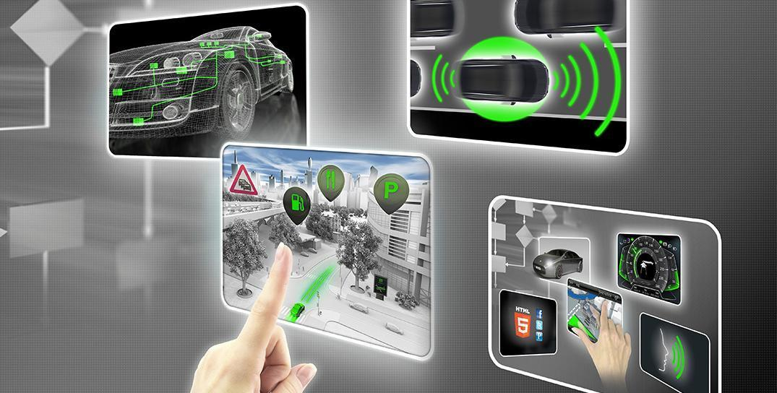

# Document history

**[Instructions: Fill in the date, version and description fields. You can fill out the Editor field with your name if you want to do so. Keep track of your editing as if this were a real world project.**

**For example, if this were your first draft or first submission, you might say version 1.0. If this is a second submission attempt, then you'd add a second line with a new date and version 2.0]**

|  |  |  |  |
| --- | --- | --- | --- |
| Date | Version | Editor | Description |
| 2017/12/31 | 1.0 | MIURA Yasuyuki | First Attempt |
|  |  |  |  |
|  |  |  |  |
|  |  |  |  |
|  |  |  |  |

# Table of Contents

**[Instructions: We have provided a table of contents. If you change the document structure, please update the table of contents accordingly. The table of contents should show each section of the document and page numbers or links. Most word processors can do this for you. In** [**Google Docs**](https://support.google.com/docs/answer/116338?co=GENIE.Platform%3DDesktop&hl=en)**, you can use headings for each section and then go to Insert > Table of Contents.** [**Microsoft Word**](https://support.microsoft.com/en-us/help/285059/how-to-create-a-table-of-contents-by-marking-text-in-word) **has similar capabilities]**

Document history

Table of Contents

Purpose of the Functional Safety Concept

Inputs to the Functional Safety Analysis

Safety goals from the Hazard Analysis and Risk Assessment

Preliminary Architecture

Description of architecture elements

Functional Safety Concept

Functional Safety Analysis

Functional Safety Requirements

Refinement of the System Architecture

Allocation of Functional Safety Requirements to Architecture Elements

Warning and Degradation Concept

# Purpose of the Functional Safety Concept

**[Instructions: Answer what is the purpose of a functional safety concept?]**

The functional safety concept looks at the general functionality of the item.

# Inputs to the Functional Safety Concept

## Safety goals from the Hazard Analysis and Risk Assessment

**[Instructions:**

**REQUIRED:**

**Provide the lane departure warning and lane keeping assistance safety goals as discussed in the lessons and derived in the hazard analysis and risk assessment.**

**OPTIONAL:**

**If you expanded the hazard analysis and risk assessment to include other safety goals, include them here.**

**]**

|  |  |
| --- | --- |
| **ID** | **Safety Goal** |
| Safety_Goal_01 | The oscillating steering torque from the LDW function shall be limited. |
| Safety_Goal_02 | The LKA function shall be time limited and the additional steering torque shall end after a given time interval so that the driver cannot misuse the system for autonomous driving. |

## Preliminary Architecture

**[Instructions: Provide a preliminary architecture for the lane assistance item. Hint: See Lesson 3: Item Definition]**

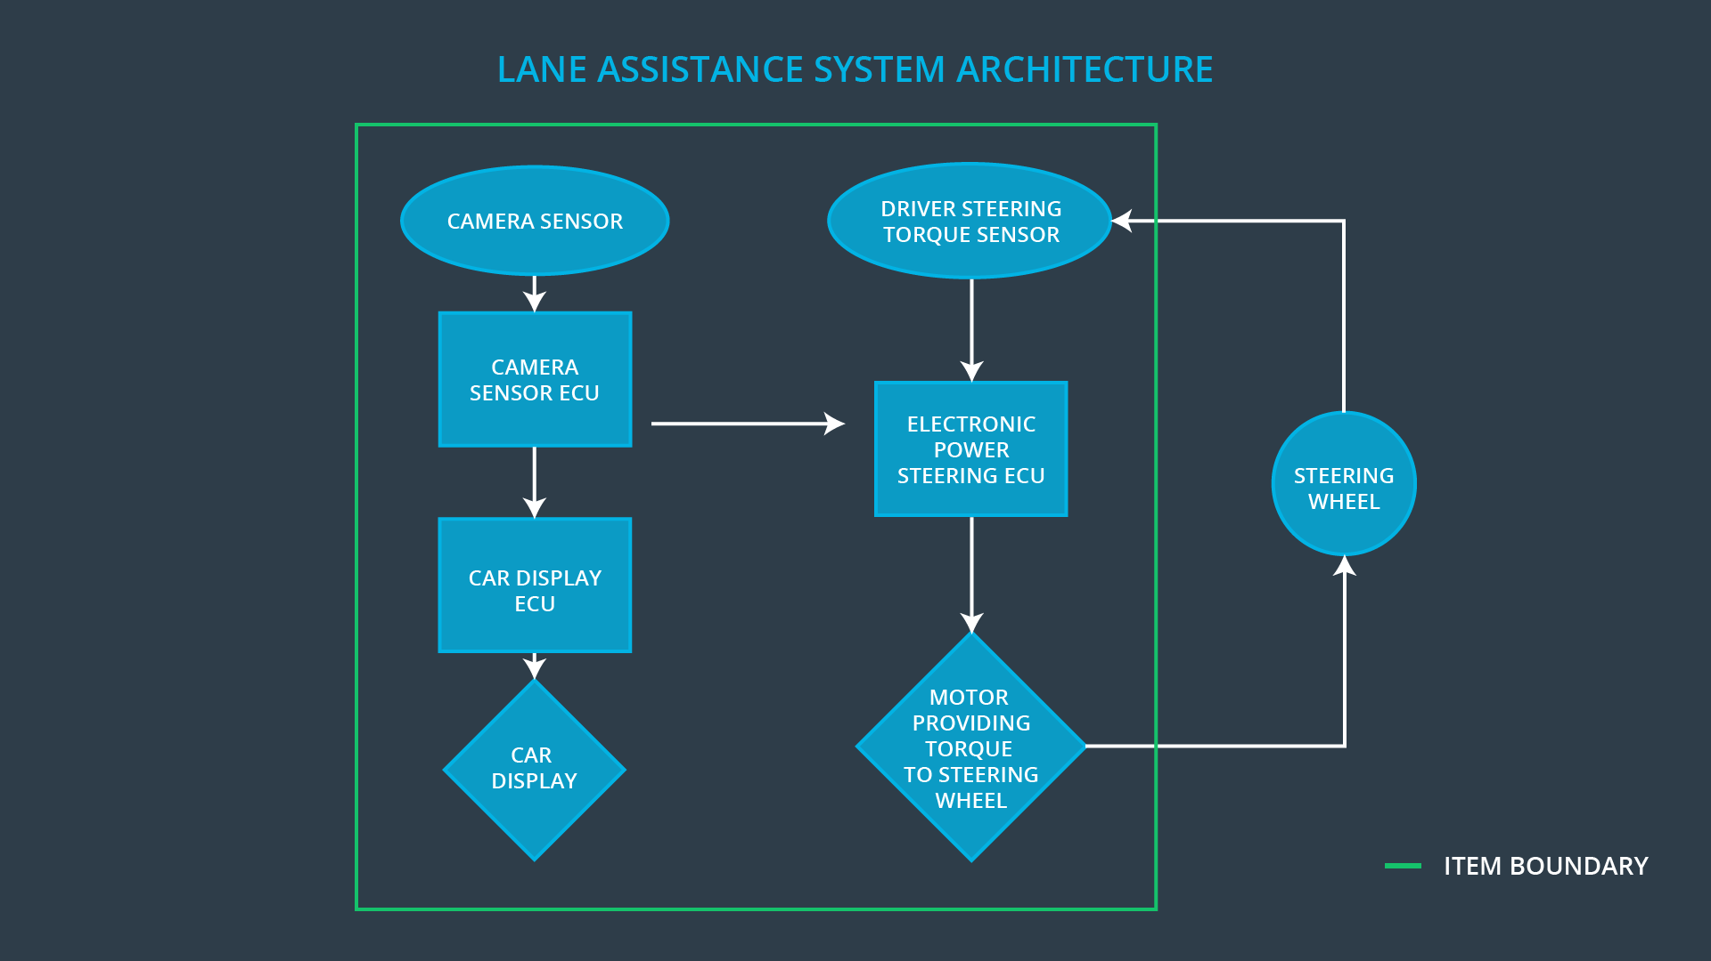

### Description of architecture elements

**[Instructions: Provide a description for each of the item elements; what is each element's purpose in the lane assistance item? ]**

|  |  |
| --- | --- |
| **Element** | **Description** |
| Camera Sensor | The Camera Sensor reads in images from the road. |
| Camera Sensor ECU | The Camera Sensor ECU identifies when the vehicle has accidentally departed its lane, and sends the appropriate messages to the Car Display ECU and the Electronic Power Steering ECU. |
| Car Display | The Car Display controls a light that tells the driver if the lane keeping item is on or off, and will control a light telling the driver that the lane departure warning is activated. |
| Car Display ECU | The Car Display ECU receives the message and display it on the display. |
| Driver Steering Torque Sensor | The Driver Steering Torque Sensor will sense how much the driver is turning the steering wheel. |
| Electronic Power Steering ECU | The Electronic Power Steering ECU will receive the vibrational torque request from the Camera ECU, and will add these torque requests together to output a final torque to the Motor. |
| Motor | The Motor moves the steering wheel. |

# Functional Safety Concept

The functional safety concept consists of:

* Functional safety analysis
* Functional safety requirements
* Functional safety architecture
* Warning and degradation concept

## Functional Safety Analysis

**[Instructions: Fill in the functional safety analysis table below.]**

|  |  |  |  |
| --- | --- | --- | --- |
| **Malfunction ID** | **Main Function of the Item Related to Safety Goal Violations** | **Guidewords (NO, WRONG, EARLY, LATE, MORE, LESS)** | **Resulting Malfunction** |
| Malfunction_01 | Lane Departure Warning (LDW) function shall apply an oscillating steering torque to provide the driver a haptic feedback | MORE | The lane departure warning function applies an oscillating torque with very high torque amplitude (above limit) |
| Malfunction_02 | Lane Departure Warning (LDW) function shall apply an oscillating steering torque to provide the driver a haptic feedback | MORE | The lane departure warning function applies an oscillating torque with very high torque frequency (above limit) |
| Malfunction_03 | Lane Keeping Assistance (LKA) function shall apply the steering torque when active in order to stay in ego lane | NO | The lane keeping assistance function is not limited in time duration which leads to misuse as an autonomous driving function. |

## Functional Safety Requirements

**[Instructions: Fill in the functional safety requirements for the lane departure warning ]**

Lane Departure Warning (LDW) Requirements:

|  |  |  |  |  |
| --- | --- | --- | --- | --- |
| **ID** | **Functional Safety Requirement** | **ASIL** | **Fault Tolerant Time Interval** | **Safe State** |
| Functional  Safety  Requirement  01-01 | The lane keeping item shall ensure that the lane departure oscillating torque amplitude is below Max_Torque_Amplitude. | C | 50 mS | Off |
| Functional  Safety  Requirement  01-02 | The lane keeping item shall ensure that the lane departure oscillating torque frequency is below Max_Torque_Frequency. | C | 50 mS | Off |

Lane Departure Warning (LDW) Verification and Validation Acceptance Criteria:

|  |  |  |
| --- | --- | --- |
| **ID** | **Validation Acceptance**  **Criteria and Method** | **Verification Acceptance**  **Criteria and Method** |
| Functional  Safety  Requirement  01-01 | For whatever value we end up choosing for the max torque amplitude, we need to validate that we chose a reasonable value. We would need to test how drivers react to different torque amplitudes and frequencies to prove that we chose an appropriate value. | when the torque amplitude crosses the limit, the lane assistance output is set to zero within the 50 ms fault tolerant time interval. For this specific case, we would probably do a software test inserting a fault into the system and seeing what happens. |
| Functional  Safety  Requirement  01-02 | For whatever value we end up choosing for the max torque amplitude, we need to validate that we chose a reasonable value. We would need to test how drivers react to different torque amplitudes and frequencies to prove that we chose an appropriate value. | when the torque amplitude crosses the limit, the lane assistance output is set to zero within the 50 ms fault tolerant time interval. For this specific case, we would probably do a software test inserting a fault into the system and seeing what happens. |

**[Instructions: Fill in the functional safety requirements for the lane keeping assistance]**

Lane Keeping Assistance (LKA) Requirements:

|  |  |  |  |  |
| --- | --- | --- | --- | --- |
| **ID** | **Functional Safety Requirement** | **ASIL** | **Fault Tolerant Time Interval** | **Safe State** |
| Functional  Safety  Requirement  02-01 | The Electronic Power Steering ECU shall ensure that the lane keeping assistance torque is applied for only Max_Duration. | B | 500 mS | Off |

Lane Keeping Assistance (LKA) Verification and Validation Acceptance Criteria:

|  |  |  |
| --- | --- | --- |
| **ID** | **Validation Acceptance**  **Criteria and Method** | **Verification Acceptance**  **Criteria and Method** |
| Functional  Safety  Requirement  02-01 | We would have to test and validate that the Max_Duration chosen really did dissuade drivers from taking their hands off the wheel. | We would verify that the system really does turn off if the lane keeping assistance every exceeded Max_Duration. |

## Refinement of the System Architecture

**[Instructions: Include the refined system architecture. Hint: The refined system architecture should include the system architecture from the end of the functional safety lesson including all of the ASIL labels.]**

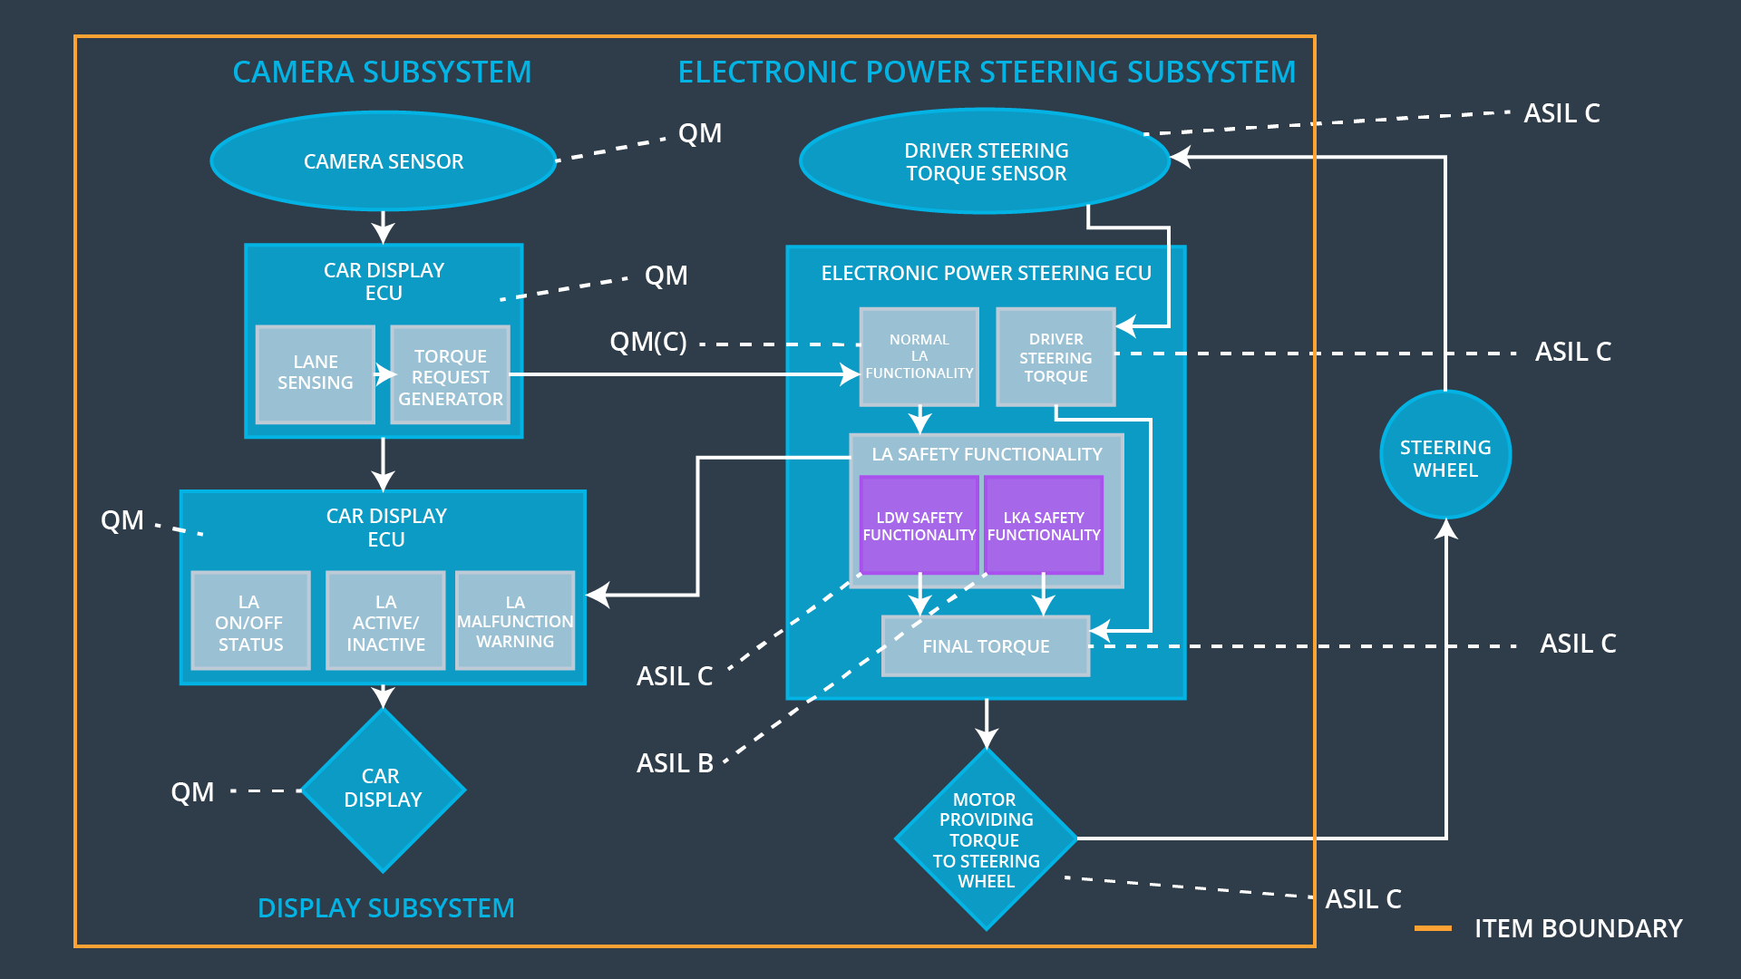

## Allocation of Functional Safety Requirements to Architecture Elements

**[Instructions: Mark which element or elements are responsible for meeting the functional safety requirement. Hint: Only one ECU is responsible for meeting all of the requirements.]**

|  |  |  |  |  |
| --- | --- | --- | --- | --- |
| **ID** | **Functional Safety Requirement** | **Electronic Power Steering ECU** | **Camera ECU** | **Car Display ECU** |
| Functional  Safety  Requirement  01-01 | The lane keeping item shall ensure that the lane departure oscillating torque amplitude is below Max_Torque_Amplitude. | **○** |  |  |
| Functional  Safety  Requirement  01-02 | The lane keeping item shall ensure that the lane departure oscillating torque frequency is below Max_Torque_Frequency. | **○** |  |  |
| Functional  Safety  Requirement  02-01 | The Electronic Power Steering ECU shall ensure that the lane keeping assistance torque is applied for only Max_Duration. | **○** |  |  |

## Warning and Degradation Concept

**[Instructions: Fill in the warning and degradation concept.]**

|  |  |  |  |  |
| --- | --- | --- | --- | --- |
| **ID** | **Degradation Mode** | **Trigger for Degradation Mode** | **Safe State invoked?** | **Driver Warning** |
| WDC-01 | we will display a warning on the driver dashboard. | when the steering wheel ECU receives a vibrational torque request beyond the allowed maximum | Yes | Beyond the lane. |
| WDC-02 | we will display a warning on the driver dashboard. | when the steering wheel ECU receives a vibrational torque request beyond the allowed maximum | Yes | Driver please drive. |