ESP8266 – Layout & Pins 1

Layout 1

Pins 2

ESP32 – Layout & Pins 3

Layout 3

Pins 4

ESP-WROOM-02 6

Layout 6

# ESP8266

## Layout

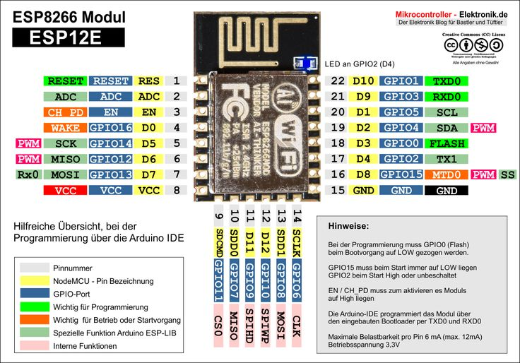

## Pins

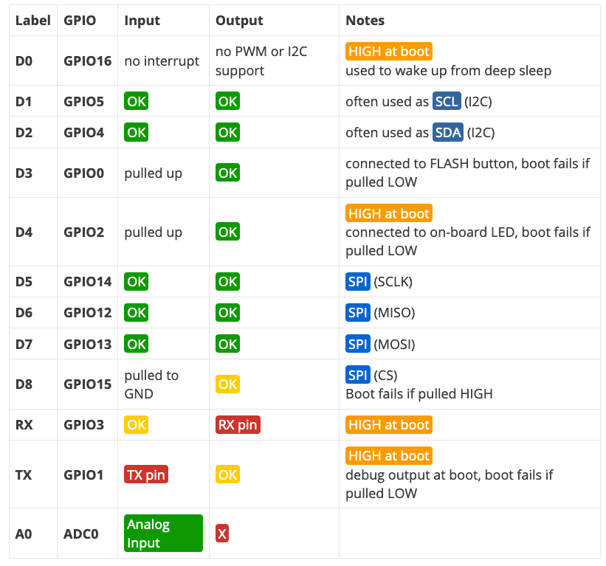

# ESP32

## Layout (32D)

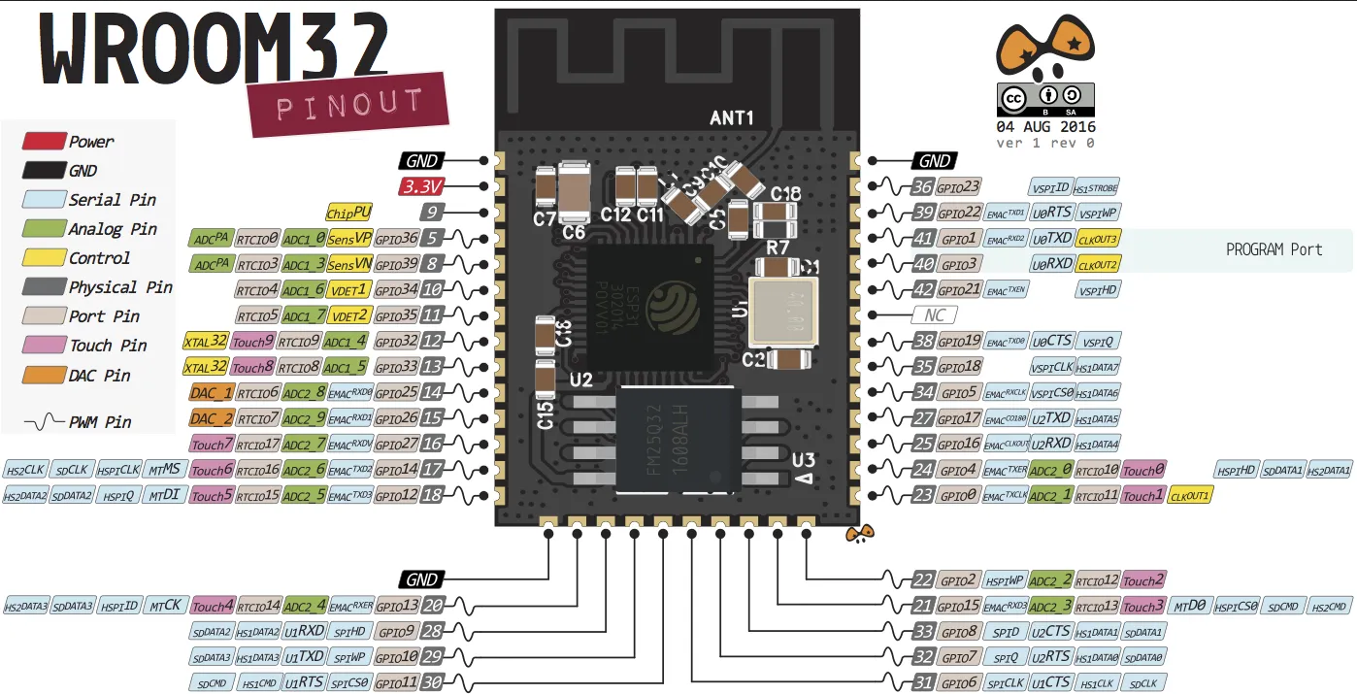

## Pins

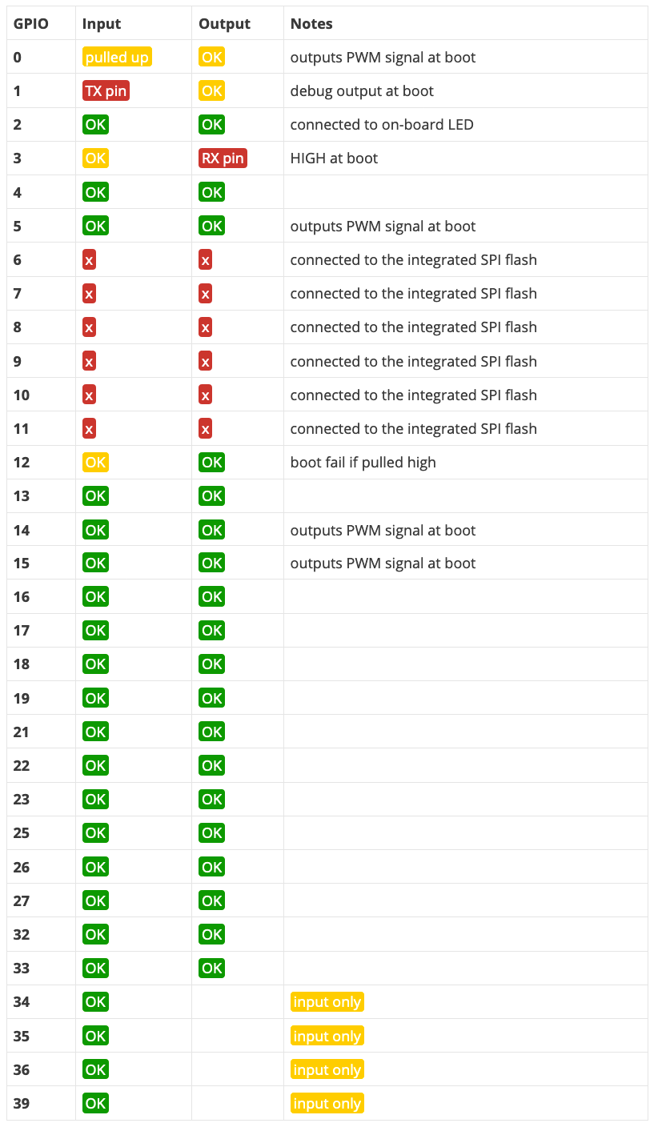

# ESP-WROOM-02

## Layout

