FINAL EVALUATION REPORT
Republic of Liberia | Project No. P174417 | RFP Ref. LR-LACE-541191-CS-CQS
Process and Ex-Post Evaluation of the
Recovery of Economic Activity for Liberian Informal Sector Employment (REALISE) Project
Components 1, 2, 5 and 6: Support to Small Businesses, Labour-Intensive Public Works, Community Livelihood and Agriculture Support, and Social Cash Transfer
A process and ex-post evaluation of how REALISE was delivered and what it contributed to beneficiary outcomes, using mixed methods and no statistical counterfactual.
REPORT VERSION AND DATE
Final Report v5 | 4 November 2026
EVALUATOR
Strategic Initiative for Transformation and Empowerment (SITE)
S.D. Cooper Road, Paynesville, Monrovia, Liberia | ntoe@siteinc.org
COMMISSIONED BY
Liberia Agency for Community Empowerment (LACE)
through the REALISE Project Management Team (PMT), on behalf of the Government of the Republic of Liberia
Implementing institutions: Ministry of Youth and Sports (MYS), Ministry of Gender, Children and Social Protection (MGCSP) and LACE
FINANCED BY
World Bank Group (IDA Credit 6848-LR and 7266-LR; IDA Grant D7830-LR)
Agence Française de Développement (AFD)
Swedish International Development Cooperation Agency (Sida)
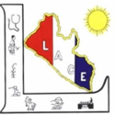





Contents

I. Disclaimer 6
II. Statement of Evaluator Independence 7
Pre-analysis plan chronology and outcome access 7
III. Acknowledgements 8
Beneficiaries 8
Communities 8
County authorities and local leaders 8
Project Management Team (PMT) 8
Ministry of Youth and Sports (MYS), Ministry of Gender, Children and Social Protection (MGCSP) and LACE 8
Service providers and other informants 8
Field teams and transcribers 8
IV. Acronyms and glossary 9
V. Executive summary 11
Part A. Context and approach 20
Chapter 1. Introduction 20
1.1 Background and rationale 20
1.2 Purpose, objectives and intended users 20
1.3 Scope 21
1.4 What the evaluation claims and does not claim 22
1.5 Reader’s guide 22
Chapter 2. REALISE Project Context and Description 24
2.1 Country and policy context 24
2.2 REALISE at a glance 24
2.3 Components and benefit packages 25
2.4 Targeting and selection design 27
2.5 Theory of change and delivery chains 27
2.5.1 Delivery structures shared by all components 28
2.5.2 Support to Small Businesses (SSB), Component 1 29
2.5.3 Labour-Intensive Public Works (LIPW), Component 2 30
2.5.4 Community Livelihood and Agriculture Support (CLAS), Component 5 31
2.5.5 Social Cash Transfer (SCT), Component 6 32
2.6 Institutional and implementation arrangements 32
2.7 Cross-cutting systems 32
2.8 Implementation timeline and coverage by round 33
2.9 Results framework indicators 33
Chapter 3. Evaluation Framework and Questions 34
3.1 Evaluation criteria and lenses 34
3.2 Key evaluation questions 34
3.3 Expectations, hypotheses and primary outcomes 35
3.4 Commitments answered without a survey measure 36
3.5 Evaluation matrix 36
Chapter 4. Methodology 38
4.1 Design overview 38
4.2 Beneficiary survey: frame and sample 39
4.3 Survey instrument and fieldwork 41
Instrument 41
Pilot and changes during fieldwork 41
Field teams and calendar 42
Case management, reserves and quality checks 42
4.4 Qualitative data collection 42
4.5 Records, documents and secondary evidence 43
4.6 Measurement and data preparation 44
4.7 Quantitative analysis 45
4.8 Qualitative analysis and contribution grading 45
4.9 Quality assurance, ethics and data protection 46
4.10 Back-check analysis 46
4.11 Scope of the evidence and departures from the plan 48
Scope of the estimates 48
Realised sample against the allocation 48
Item coverage 49
Records, observation and qualitative coverage 49
Departures from the plan 49
Part B. Findings 51
Chapter 5. Fieldwork Results, Sample and Respondent Profile 51
Key findings 51
5.1 Sample disposition and response 51
5.2 Realised precision 52
5.3 Respondent and household profile 52
5.4 Qualitative coverage and scope of interpretation 54
Chapter 6. Findings: Support to Small Businesses (SSB) 56
Key findings 56
6.1 Component overview 56
6.2 Who was reached 56
6.3 Delivery pathway 58
6.4 Outcomes 61
6.5 Mechanisms and variation 63
6.6 Records, observation and rivals 64
6.7 Contribution assessment 66
Chapter 7. Findings: Labour-Intensive Public Works (LIPW) 68
Key findings 68
7.1 Component overview 68
7.2 Who was reached 68
7.3 Delivery pathway 69
7.4 Outcomes 71
7.5 Community development fund projects 74
7.6 Mechanisms, records and rivals 74
7.7 Contribution assessment 76
Chapter 8. Findings: Community Livelihood and Agriculture Support (CLAS) 79
Key findings 79
8.1 Component overview 79
8.2 Who was reached 80
8.3 Delivery pathway 80
8.4 Outcomes 82
8.5 Climate-smart agriculture 86
8.6 Mechanisms, records, observation and rivals 87
8.7 Sustainability prospects 90
8.8 Contribution assessment 90
8.9 Weighing the explanations for the worse-off group 92
Chapter 9. Findings: Social Cash Transfer (SCT) and the National Social Protection System 95
Key findings 95
9.1 Component overview 95
9.2 Who was reached 95
9.3 Delivery pathway 96
9.4 Outcomes 99
9.5 Mechanisms, records and rivals 103
9.6 Strengthening the national social protection system (Component 6b) 105
9.7 Contribution assessment 105
Chapter 10. Cross-Cutting Findings 108
Key findings 108
10.1 Targeting, inclusion and equity 108
10.2 Women’s empowerment and financial inclusion 110
10.3 Household coping, shocks and food consumption 111
10.4 Information, grievance redress and accountability 116
10.5 Safeguards, safety and SEA/SH 117
10.6 Satisfaction 117
10.7 Coherence, other assistance and synergies 118
10.8 Unintended effects 119
Part C. Synthesis and recommendations 120
Chapter 11. Answers to the Evaluation Questions 120
11.1 Answers by evaluation question 120
11.2 Contribution grade summary 124
11.3 Results Matrix achievement 129
11.4 Triangulation with prior evidence 131
11.5 Evidence basis and data quality limits 131
Chapter 12. Conclusions 133
12.1 Overall conclusions 133
What REALISE delivered 133
What changed for beneficiaries 133
How credible is the contribution 134
12.2 Conclusions on design and delivery 134
12.3 Strengths, weaknesses, opportunities and threats by component 135
12.4 Consolidated strengths, weaknesses, opportunities and threats 137
Chapter 13. Lessons Learned 140
13.1 Design lessons 140
13.2 Delivery and learning lessons 140
Chapter 14. Recommendations 142
14.1 Recommendations for the Government of Liberia through the PMT 142
14.2 Recommendations for the financing agencies 144
14.3 Sequence of the actions and evidence that would strengthen future assessments 145
14.4 How the recommendations respond to the conclusions and evidence gaps 146
Annexes 147

I. Disclaimer
This report was prepared by the Strategic Initiative for Transformation and Empowerment (SITE) for the Liberia Agency for Community Empowerment (LACE), under the contract for the Process and Ex-Post Evaluation of the Recovery of Economic Activity for Liberian Informal Sector Employment (REALISE) Project.
The findings, interpretations and conclusions expressed in this report are those of the evaluators. They do not necessarily reflect the views of LACE, the Ministry of Youth and Sports (MYS), the Ministry of Gender, Children and Social Protection (MGCSP), the Government of the Republic of Liberia (GoL), the World Bank Group (WBG), the Agence Française de Développement (AFD) or the Swedish International Development Cooperation Agency (Sida), or of the members of their governing bodies.
The financiers and the Government of Liberia do not guarantee the accuracy of the data included in this report and accept no responsibility for any consequence of its use. Maps, boundaries, names and designations used in the report do not imply any judgement on the legal status of any territory.
The evaluation is non-experimental. It has no baseline and no statistical counterfactual. Its findings are beneficiary-reported, and differences between groups are described as associations rather than effects. The evaluation tests whether these patterns are consistent with the REALISE theory of change and delivery chain. Where they are, the strength of evidence for the project’s contribution is graded; a contribution is called plausible only where the evidence is graded Moderate. The report does not estimate an average treatment effect or a net causal impact, and readers should not quote its findings as such. Chapter 4 sets out how the evidence was gathered and analysed.
This report may be reproduced and distributed in full, with acknowledgement of the source. Extracts must not alter the meaning of the findings or omit the qualifications that accompany them.

II. Statement of Evaluator Independence
SITE carried out this evaluation as an external consulting firm engaged by LACE through a lump-sum contract. SITE did not design, manage or deliver any component of the REALISE Project, and it has no financial or other interest in the findings of this report. The fee under the contract does not depend on what the evaluation finds.
SITE has disclosed that, in 2024, it carried out a beneficiary stratification survey for LACE and the Ministry of Youth and Sports that measured beneficiaries’ satisfaction with the Community Livelihood and Agriculture Support, Social Cash Transfer and Labour-Intensive Public Works components with technical support from the World Bank team. That work was a survey of beneficiary views for the Project Management Team (PMT) mid-term review. It did not involve delivering project benefits or managing project staff.
The evaluation team designed the questions, sampling, analysis rules and grading standards within the scope of the terms of reference (TOR). The Project Management Team reviewed and approved the survey instruments, both quantitative and qualitative guides. LACE and the PMT did not direct the findings, the contribution grades or the recommendations.
There were no senior team members of the evaluation team who were directly involved in the implementation of the REALISE Project. However, SITE recruited field team members who had worked on previous evaluations of the REALISE Project. All evaluation team members were required to sign SITE’s conflict of interest form, declaring any direct involvement in implementing REALISE activities or any close relationship with an implementer or beneficiary group. No such conflicts were declared.

Pre-analysis plan chronology and outcome access
The analysis in this report follows the REALISE beneficiary-survey pre-analysis plan (PAP), version 14. Version 14 was approved on 1 October 2026 after fieldwork and outcome access had begun. The six primary outcomes, their universes, hypotheses and comparison families did not change between versions 13 and 14.
- 24 September 2026: interviews begin.
- 25 September 2026: PAP amendment 4 (respondent profile items).
- 26 September 2026: interview-level outcomes visible in the daily quality checks.
- 1 October 2026: PAP version 14 approved; primary outcomes, comparison families, sampling and weights unchanged from version 13.
The governing plan specifies:
- the evaluation design and the boundary of what the evaluation can claim;
- the sample, the sampling cells and the weighting and variance rules;
- the six primary outcomes (P1, P2, P3, P4, P5a and P5b), the hypotheses (H1, H2, H3, H4, H5a and H5b), and the comparison families with their multiple-testing rules;
- the rules for missing data, proxy respondents, small cells and sensitivity analyses;
- the qualitative analysis rules, the evidence-strength scale (Asserted, Corroborated, Triangulated) and the four-level contribution grading standard (Strong, Moderate, Limited, Insufficient); and
- the table shells used in this report, whose statistics and fields do not change after outcome review.
Only the six primary outcomes and the named comparison families are confirmatory. H3, H4, H5a and H5b are secondary mechanism contrasts, and every other analysis is labelled secondary, tertiary or exploratory. An analysis that was not listed in the plan, or that was added after data were seen, is reported as exploratory.
The pre-analysis plan and its companion files (the analysis dictionary, the operational evaluation matrix and the item analysis rules) govern the analysis. Version 14 was approved after interview-level outcome data had become visible in the daily checks. Decisions taken after 26 September 2026 carry no claim of prespecification; the timing of changes and the outcome material already available are documented in Annex L.

The outcome-access record identifies which outcome distributions had already been viewed, and when. Every change to the plan is dated and justified in the departure log (Annex L), with its approver, the first questionnaire form and collection date to which it applies, and the outcome material the analysts had already seen when it was made. A change made after analysis began to a primary outcome, an eligible universe, a denominator, a comparison family, a missing-data rule, a weighting rule or a contribution grade is disclosed in Annex L (Table L.2). The analysis is implemented in ordered, commented Stata do-files. Raw survey exports remain unaltered, and every cleaning and recoding decision is logged. The final do-files are submitted with this report.

III. Acknowledgements
SITE extends thanks and appreciation to everyone who gave their time and knowledge to this evaluation: the beneficiaries and communities who answered our questions, the county authorities and local leaders who received our teams, the Project Management Team (PMT) and the staff of the Ministry of Youth and Sports (MYS), the Ministry of Gender, Children and Social Protection (MGCSP) and the Liberia Agency for Community Empowerment (LACE), the service providers, and the field teams and transcribers who collected and prepared the evidence. Chapter 4 describes the evidence they provided.

Beneficiaries
In all, 1,477 beneficiaries gave their time to be interviewed, and women and men in every component took part in the focus groups. We thank each of them.

Communities
The 43 component-specific evaluation sites lie in 42 communities across 10 counties. Their residents welcomed our teams and gave us their time.

County authorities and local leaders
County and district authorities and local and community leaders explained how project activities were coordinated, targeted and received locally.

Project Management Team (PMT)
PMT staff gave interviews on coordination, monitoring and evaluation, safeguards and gender, and payments and delivery systems, and the operational leads of SSB, LIPW, CLAS and SCT also took part. The PMT also confirmed the evaluation sites and set the reserve minima at the sampling review, so its role as an informant is separate from its role in reviewing instruments and reports.

Ministry of Youth and Sports (MYS), Ministry of Gender, Children and Social Protection (MGCSP) and LACE
Staff of the implementing agencies (LACE, MGCSP and MYS) explained their delivery roles and where responsibilities were shared or unclear. Section 2.6 sets out which agency implements which component.

Service providers and other informants
Service providers, monitors, local delivery partners and donor representatives shared their views on training, input and payment delivery, follow-up support and the financiers’ view of the project.

Field teams and transcribers
SITE’s own field teams carried out the fieldwork: 16 enumerators and two supervisors in the quantitative teams, and two qualitative teams with their team leaders. Transcribers prepared the interviews and focus groups for analysis. We thank them for their care. Section 4.3 describes the teams.

IV. Acronyms and glossary
Acronym | Meaning
AFD | French Development Agency (Agence Française de Développement)
BFG | Beneficiary Farming Group (CLAS)
BWG | Beneficiary Working Group (LIPW)
CDS | Community Development Support
CI | Confidence interval
CLAS | Community Livelihood and Agriculture Support (Component 5)
COC | Community Oversight Committee
CRI | Corporate Results Indicator used in the Results Matrix
CSA | Climate-smart agriculture
CSC | County Steering Committee
CSI | Coping strategies items used for the coping-days score
DAC | Development Assistance Committee (OECD-DAC criteria)
FCS | Food consumption score
FGD | Focus group discussion
FMC | Farm Management Committee
GBV | Gender-based violence
GRM | Grievance redress mechanism
HDDS-12 | Household dietary diversity score, twelve food groups
HFC | High-frequency checks
IDA | International Development Association
IRB | Institutional Review Board
ISR | Implementation status report
K24, G07 and similar codes | Questionnaire item codes, defined in Annex J
KEQ | Key evaluation question
KII | Key informant interview
LACE | Liberia Agency for Community Empowerment
LHSR | Liberia Household Social Registry
LIPW | Labour-Intensive Public Works (Component 2)
LRD | Liberian dollar
M&E | Monitoring and evaluation
MFDP | Ministry of Finance and Development Planning
MGCSP | Ministry of Gender, Children and Social Protection
MIS | Management information system
MYS | Ministry of Youth and Sports
NDC | Nationally Determined Contribution
NGO | Non-governmental organisation
NIN | National identification number
OECD | Organisation for Economic Co-operation and Development (OECD-DAC criteria)
PAP | Pre-analysis plan
PDO | Project development objective
PFMU | Project Financial Management Unit
PMT | Project Management Team
POM | Project Operations Manual
PSC | Project Steering Committee
PSNP, VUP, CT-OVC | Comparable programmes as given in the technical proposal: PSNP: Productive Safety Net Programme (Ethiopia)  VUP: Vision 2020 Umurenge Programme (Rwanda)  CT-OVC: Cash Transfer for Orphans and Vulnerable Children (Kenya)
SCT | Social Cash Transfer (Component 6)
SEA | Sexual exploitation and abuse
SH | Sexual harassment
Sida | Swedish International Development Cooperation Agency
SIM | Subscriber identity module
SITE | Strategic Initiative for Transformation and Empowerment
SPO | Senior Program Officer
SSB | Support to Small Businesses (Component 1)
TPM | Third-party monitoring firm
USD | United States dollar

Glossary

Term | Meaning
Contribution grade | How strongly the evidence supports REALISE’s contribution: Strong, Moderate, Limited or Insufficient. The judgement considers delivery, other explanations, independent corroboration and data quality; it differs from the size of a reported improvement.
Claim language | The wording allowed for survey results: beneficiary-reported, associated with, consistent with and, only where graded Moderate, plausible contribution. The words caused by and impact estimate are not used.
Coping-days score (P3) | The unweighted sum of the days, over the past seven days, on which the household used each of twelve coping strategies, from 0 to 84; lower is better.
Food consumption score (FCS) | A seven-day frequency score over eight food groups, from 0 to 112, with the categories poor (21 or below), borderline (above 21 to 35) and acceptable (above 35).
HDDS-12 | The number of twelve food groups consumed the previous day, from 0 to 12.
Indicative and suppressed cells | Cells with an unweighted n from 10 to 24 are indicative and are not read as prevalence. Cells with n below 10 are suppressed.
Payment timeliness (P2) | The share of respondents with a communicated payment schedule who answer that payments always arrived by the date they were last told.
Proxy | An approved person answering for the beneficiary. Answers from proxies are excluded from the primary measures of basic-needs change, own-name accounts and women’s empowerment.
Expected benefits received | The share of respondents with at least one specific expected benefit who report receiving every benefit they expected. It does not verify the full benefit to which they were administratively entitled.
Status (of an evaluation question) | Whether the available evidence answers the whole question: answered, partly answered or not resolved. This differs from a contribution grade, which describes how strongly the evidence supports REALISE’s contribution.
Specialist definitions and the complete original glossary are in the Annex F supplement.

V. Executive summary
Purpose and design. This report presents the process and ex-post evaluation of the Recovery of Economic Activity for Liberian Informal Sector Employment project (REALISE), commissioned by the Liberia Agency for Community Empowerment and the Project Management Team. It covers four components: Support to Small Businesses (SSB, Component 1), Labour-Intensive Public Works (LIPW, Component 2), Community Livelihood and Agriculture Support (CLAS, Component 5) and the Social Cash Transfer (SCT, Component 6). It answers six evaluation questions, one for each OECD-DAC criterion.
The evaluation combines a survey of 1,477 beneficiaries with 61 qualitative transcript files, of which 60 form the analysed corpus, site and case material, and project documents. These sources describe delivery, beneficiaries’ experiences and the strength of evidence for REALISE’s contribution. The pre-analysis plan governs the evaluation questions, outcomes and decision rules. Its six primary outcomes, hypotheses and comparison families did not change between versions 13 and 14; version 14 was approved after outcome access had begun, and the departures record documents that chronology and later decisions. The survey covers the selected sites and rounds; it has no baseline or comparison group, so the findings do not measure a net causal impact. Chapter 4 explains the methods and Chapter 5 the coverage. Section 11.5 sets out the evidence limits.
Table ES.1. Evidence base
Strand | Planned | Obtained
Beneficiary survey | 1,600 main (SSB 300, LIPW 300, CLAS 600, SCT 400) and 500 reserve identities in 43 component sites | 1,477 interview records included in the analysis: 1,257 main-draw and 220 reserve interviews (SSB 268, LIPW 254, CLAS 598, SCT 357)
Key informant interviews | 60 (55 core and 5 additional) | 34 KII transcript files: 33 core identifiers and 1 conditional LIPW provider
Focus group discussions | 29 | 27 FGD transcript files for 29 planned discussions (SSB 6, LIPW 6, CLAS 7, SCT 8); 26 of these files form the analysed corpus (one could not be anonymised), and one analysed file continues an earlier discussion
Site visits | 16 (4 per component) | 17 written site records (SSB 4, LIPW 4, CLAS 5, SCT 4) covering 15 of the 16 assigned locations; the LIPW Boys Town record has an uncertain site identity (Section 7.6)
Case studies | 6 | 2 completed case observation grids (SSB, SCT) and 1 CLAS narrative; used as illustrations
Payment, payroll, delivery and grievance records | All relevant records | Partial round-level records: PMT mobile-money statements (SSB, LIPW and CLAS, and one SCT batch) and two undated initial payrolls (LIPW Round 1, SSB Round 2). No complete dated individual payment register that could be matched to respondents; no LIPW timesheets, CLAS delivery register or grievance register
Project reporting | Results Matrix, quarterly reports, handbooks | Used throughout; values differ between documents (Chapter 11)
Key Findings
- Almost every beneficiary received support, and completing the package is the next step. Between about one in three (CLAS) and three in five (SCT) beneficiaries received everything they expected. National ID support in SSB and LIPW, market linkage in CLAS and the number of SCT transfers are the main gaps to close.
- Payments were on time for most beneficiaries, and timing can be strengthened outside SSB. Nine in ten SSB beneficiaries said payments always arrived when promised, compared with about two in three in CLAS and three in five in SCT.
- Households report being better able to meet basic needs, with gains that vary by component. The average change is positive in SCT, SSB and LIPW, SCT the most. In CLAS it is close to zero and its community-clustered interval includes zero: about half say they are better off and more than four in ten say they are worse off, and an exploratory analysis finds that these answers differ widely by enumerator (Section 8.9). Food consumption is the next area to strengthen in SCT, where reported gains are largest and almost one in five households have a poor food consumption score.
- Mobile-money accounts in beneficiaries’ own names are near universal. Between 97 and 99 percent of beneficiaries answering for themselves hold one, a base for digital payments. The survey records ownership at the time of the interview, not when the account was opened, so it does not show whether REALISE created the accounts.
- Selection was seen as fair, and overlap with other assistance is small. Almost all beneficiaries rated selection as fair or very fair (95.4 to 99.5 percent across components). Few received help from government or other organisations.
- Beneficiaries describe ways to continue, and follow-up can confirm longer-term results. Businesses were operating, CLAS groups expect to keep farming and written LIPW site records describe asset condition at the visits. Clear follow-up arrangements would help protect these gains from shocks.
- Women report better delivery than men in several components. Women more often received every expected benefit in SSB (60.4 against 47.2 percent, a borderline gap, Section 6.4) and SCT (22.8 percentage points more), and more often said payments always arrived on time in LIPW (13.9 points more) and SCT (16.8 points more). In CLAS, women more often said payments always arrived on time while receipt of every expected benefit was lower (30.5 against 35.2 percent) and the change in basic needs smaller (+0.02 against +0.11); these CLAS differences are small (Section 8.4). Sex differences in coping, ability to meet basic needs and own-name accounts in SSB and LIPW are not resolved by the survey.
Figure ES.1. Receipt of every expected benefit and payment on schedule, by component
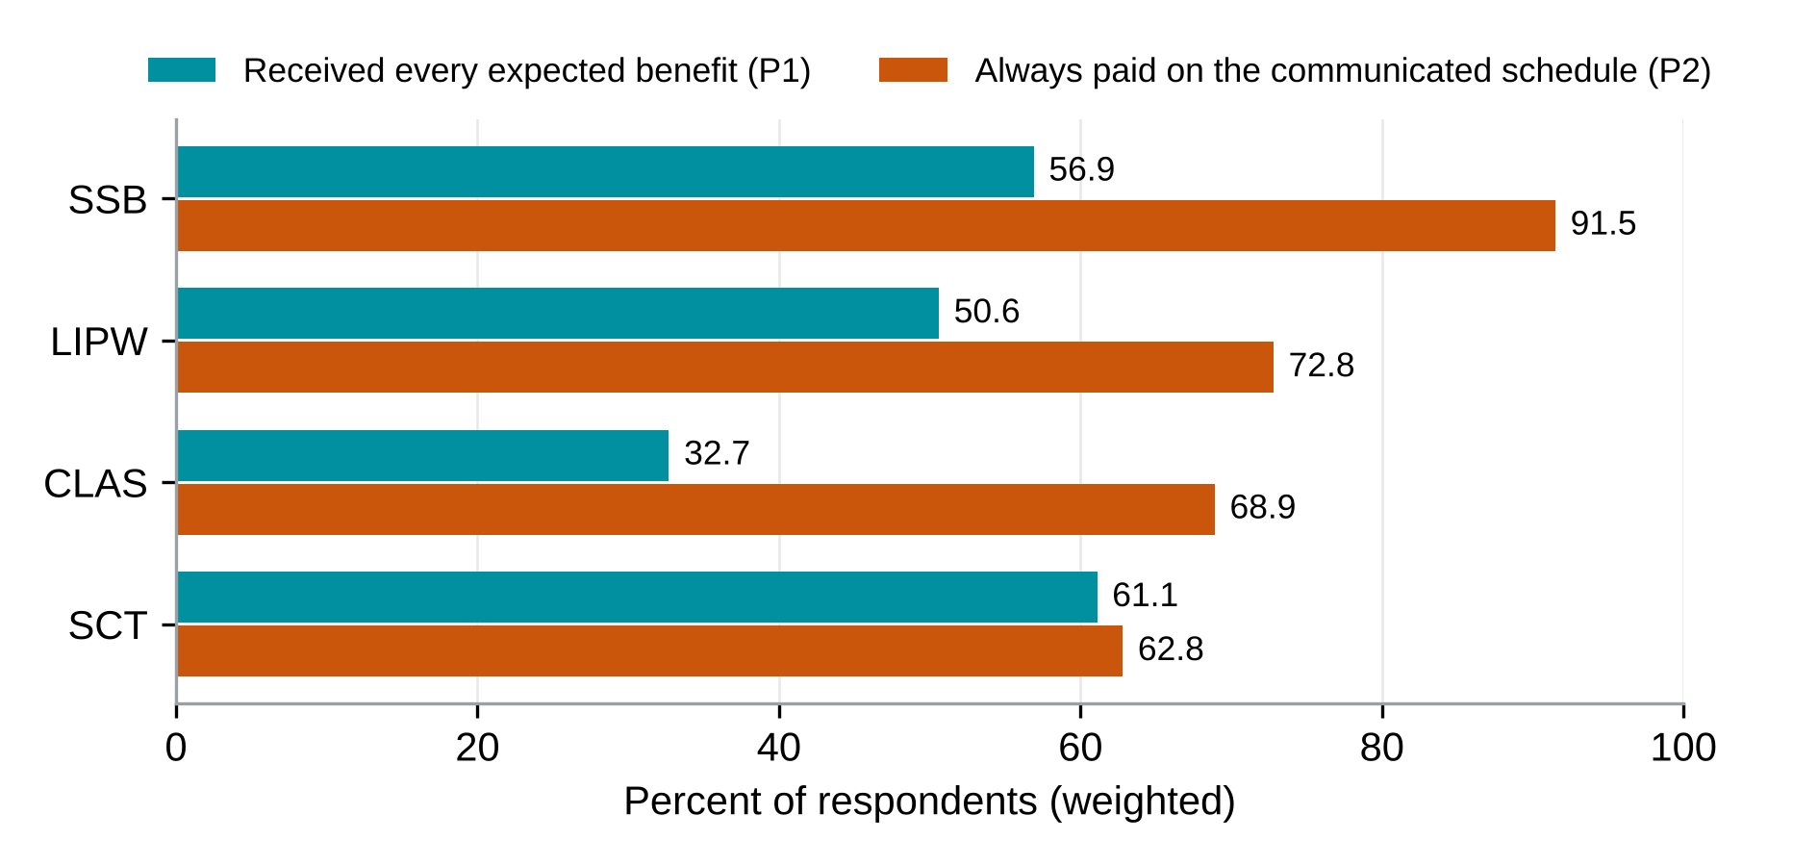
Source: Beneficiary survey, weighted; Table ES.2.
Figure ES.2. Recalled change in ability to meet basic needs, by component
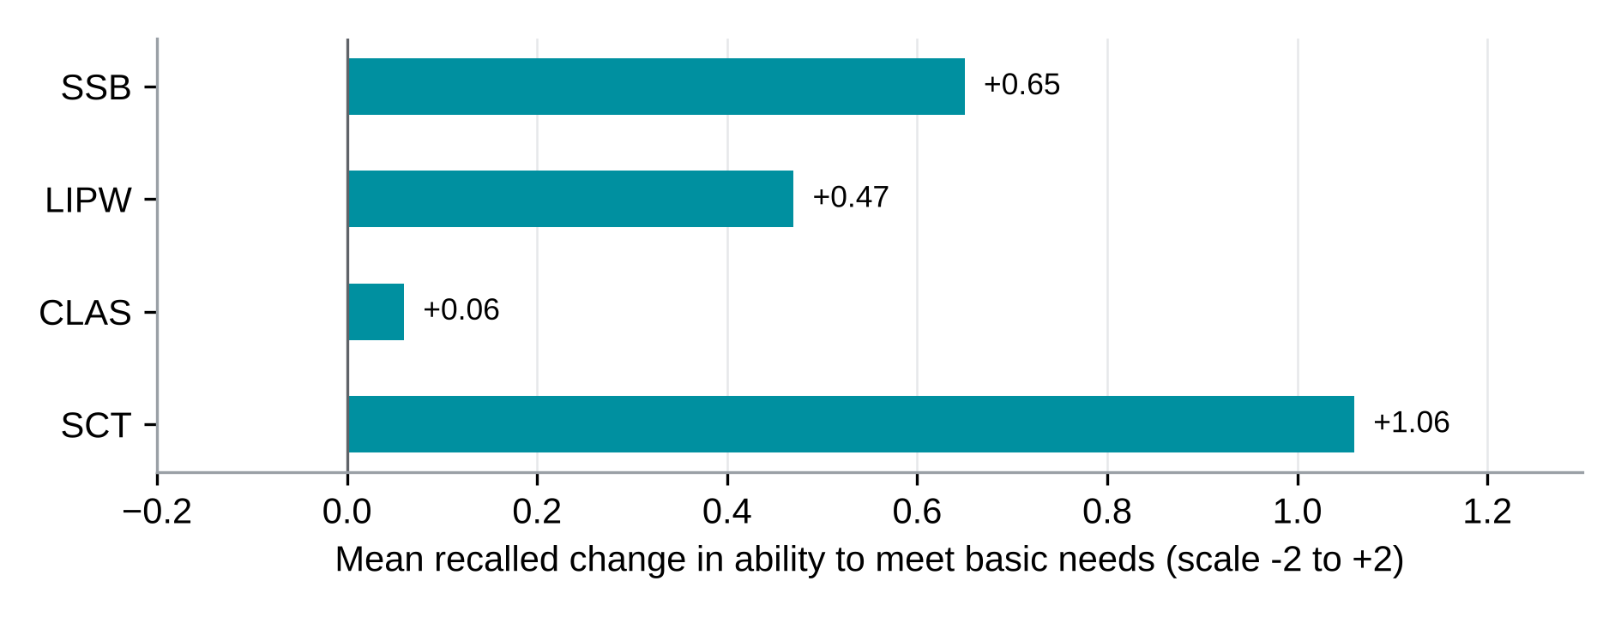
Source: Beneficiary survey, weighted; Table ES.2.
Findings by component
- Support to Small Businesses. SSB reached nearly all beneficiaries interviewed, 91.5 percent said payments always arrived on the communicated schedule, 87.3 percent used the grant on the business plan, and many described business activity and greater capacity to meet needs. The contribution assessment is Moderate for timely payments, and Limited for basic needs, full-package receipt, food coping and business activity. Completing identification and registration support is the priority.
- Labour-Intensive Public Works. LIPW gave nearly every participant paid work by mobile money; 78.6 percent know how to complain and 94.1 percent would feel safe reporting misconduct. The contribution assessment is Limited for household coping and basic needs, receipt of the full package, payment on schedule and upkeep of the works, which are the areas to strengthen.
- Community Livelihood and Agriculture Support. CLAS delivered inputs, training and group farming to almost everyone: core inputs reached 94.9 to 98.4 percent of those who expected them, 91.3 percent use at least one climate-smart practice, and 14,151 people were trained, about 141 percent of the project target. The next step is to complete the package and strengthen market linkage: 32.7 percent received every benefit they expected, and 28.1 percent of those who expected buyer support received it. The assessment is Moderate for recent reported use of climate-smart practices and Limited for continuation, delivery, coping and basic needs. Section 8.9 weighs the candidate explanations for the respondents who report being worse off.
- Social Cash Transfer. SCT transfers reached almost every household, and 90.4 percent report being better able to meet basic needs, the highest mean recalled improvement of the four components (+1.06). Payment timing is the next step to strengthen: payments were always on time for 62.8 percent of those given a schedule, the lowest of the four. Food consumption also needs attention, as 18.4 percent of households have a poor food consumption score. The evidence supports a Moderate grade for basic needs and a Limited grade for coping, receipt, timeliness and continuation.
Evaluation questions. The evaluation answers six key evaluation questions (KEQs), one for each OECD-DAC criterion: relevance, effectiveness, efficiency, impact, coherence and sustainability. The questions are:
- KEQ1 Relevance: Did support and selection match intended beneficiaries’ needs and profiles?
- KEQ2 Effectiveness: Were intended benefits delivered and were expected changes reported?
- KEQ3 Efficiency: How efficiently were resources used, how timely were delivery and internal operations, and what transaction costs fell on beneficiaries?
- KEQ4 Impact and outcome contribution: What changes in income, employment, food security, consumption, resilience and agency are observed, and how plausible is REALISE’s contribution?
- KEQ5 Coherence: How do the four components complement one another and align with other government and partner programmes, and where are synergies, duplication or coordination gaps?
- KEQ6 Sustainability: Which businesses, assets, groups, practices and household changes are likely to continue?
The beneficiary survey measures six outcomes that inform these questions. Receipt of every expected benefit and payment on the communicated schedule inform effectiveness, and payment on the communicated schedule also informs efficiency. Coping days and food access, ability to meet basic needs, own-name mobile-money accounts and women’s self-efficacy inform impact. Relevance, coherence and sustainability are answered from secondary survey measures, interviews, focus groups, site visits and records.
Table ES.2 summarises the evidence for each question, by component.
Table ES.2. Evidence summary by OECD-DAC criterion and component
OECD-DAC criterion | Status | SSB | LIPW | CLAS | SCT
KEQ1 Relevance | Answered | 98.2 percent rated selection fair or very fair (40.0 percent very fair); exclusion is not estimated. | 99.0 percent rated selection fair or very fair (53.7 percent very fair); exclusion is not estimated. | 99.5 percent rated selection fair or very fair (41.2 percent very fair); exclusion is not estimated. | 95.4 percent rated selection fair or very fair (13.7 percent very fair); exclusion is not estimated.
KEQ2 Effectiveness | Partly answered | 56.9% received every expected benefit; ID and registration support fell short | 50.6% received every expected benefit; ID support was the largest gap | 32.7% received every expected benefit; 28.1% of those expecting buyer or market-linkage support received it | 61.1% received every expected benefit; 32.1% of those expecting up to six transfers received them
KEQ3 Efficiency | Partly answered | 91.5% always paid on the communicated schedule; all payments by mobile money | 72.8% always paid on schedule; late payments in some groups | 68.9% always paid on schedule; 12.0% never paid on time | 62.8% always paid on schedule, the lowest of the four; cash-out fee covered for 67.9% of those who expected it
KEQ4 Impact and outcome contribution | Partly answered | Ability to meet basic needs improved by +0.65 on a scale of −2 to +2; larger among those who received and used the full package | +0.47; households with complete, on-time delivery cut back on food less often and reported more improvement in meeting needs | +0.06; households with complete, on-time delivery cut back on food more often, not less | Recalled basic-needs change averages +1.06, the largest point estimate of the four components. The adjusted delivery-outcome comparisons do not distinguish a difference from zero in these data; this does not establish equal outcomes or a programme effect.
KEQ5 Coherence | Partly answered | Little overlap with other assistance; 36.3% received help from family | Formal assistance categories are withheld because counts are small. | 67.6% received no other support; climate-smart agriculture training exceeds the project target (141%); the NDC farmer field school target is defined differently and is not directly comparable | 17.3% received other assistance; none from government or NGOs
KEQ6 Sustainability | Partly answered | Visited businesses were operating; theft, prices and illness threaten them | Asset upkeep depends on continued support; in one focus group, two participants describe gains fading after the work ended while a third reports continued improvement | 86.8% expect their group to keep farming | Continuation after the last transfer lies beyond a one-round survey
Reading note: Results describe the surveyed beneficiaries. Answer status and contribution strength are separate judgements, explained below.
Evidence basis. Survey results are beneficiary-reported, including recalled change; project indicator values are project-reported unless independently verified; and site records describe conditions on the visit day. Aggregate payment records support only the periods and coverage stated. Table 11.5.1 identifies the evidence basis and verification limits for each area of finding.
Each question receives one of three statuses: answered, partly answered or not resolved. A question is answered when every part can be answered with the evidence the evaluation was designed to use. It is partly answered when one part depends on evidence outside that design, such as component cost data, or on records that were not accessible at the time of this report. Table ES.2 gives the status and Table 11.1a explains each answer.
Separately, each contribution claim under effectiveness (KEQ2), efficiency (KEQ3), impact (KEQ4) and sustainability (KEQ6) receives a four-level grade of how strongly the evidence supports it: Strong, Moderate, Limited or Insufficient. The grade weighs whether the expected delivery chain held, whether other explanations such as other assistance, seasonal conditions or household shocks were ruled out, whether independent sources agree and the quality of the data. It rates the evidence, so an outcome can improve and still receive a Limited grade if REALISE’s part in it cannot be separated from other factors. Section 4.8 explains how grades are assigned.
Summary of findings by evaluation question
Quotations cite the transcript and paragraph they come from. In “SCT-KII-008, P0402”, the first part gives the component (SCT; CROSS for cross-cutting informants), the type of interview (KII, key informant interview; FGD, focus group discussion) and the file number, and P0402 is the paragraph in that transcript.
KEQ1 Relevance. Did support and selection match intended beneficiaries’ needs and profiles? (Answered)
Almost all beneficiaries rated selection as fair or very fair (95.4 to 99.5 percent across components). The survey covers people on the beneficiary lists, so it measures fairness among those selected, not who was left out, and accounts of exclusion point to inclusion gaps that registration checks can address. Staff describe universal enrolment in the visited communities, while beneficiaries and officials describe absent residents, skipped settlements, incomplete SIM registration and disputed household counts. An SCT key informant describes enrolment teams skipping small settlements: “they would jump over the town and go to the next bigger town” (SCT-KII-008, P0402). Household counts were also disputed. Participants in one SCT group say teams registered no more than five people per fire hut and left the others out (SCT-FGD-001, P0505 and P0506). Household size was checked at the home (SCT-FGD-001, P0244). One grandparent says the team asked where the children were and gave support for only one of the seven children they sent to school (SCT-FGD-003, P0212). A respondent can find selection fair and still report a concrete exclusion. The number of such cases is not estimated, and each disputed case would need checking against the entitlement, household, fire-hut, residence and five-person payment-cap rules before it counts as a targeting error.
KEQ2 Effectiveness. Were intended benefits delivered and were expected changes reported? (Partly answered)
Almost every beneficiary received support, and completing the expected package is the next step. The share who received every benefit they expected was 61.1 percent in SCT, 56.9 percent in SSB, 50.6 percent in LIPW and 32.7 percent in CLAS. The main gaps to close are national ID and registration support in SSB and LIPW, buyer and market-linkage support in CLAS (received by 28.1 percent of those who expected it) and the number of SCT transfers (32.1 percent of those expecting up to six received them). A LIPW focus group describes the ID gap: “some people didn’t get their citizen ID card” (LIPW-FGD-003, P0219). The measure records what beneficiaries report. The amounts each beneficiary received were not checked against payment records, because partial round-level records were available (PMT mobile-money statements and two undated initial payrolls, for LIPW Round 1 and SSB Round 2) but no complete dated individual payment register that could be matched to respondents. The contribution grade for receipt of every expected benefit is Limited in all four components, reflecting differences between the reported package and what records can verify.
KEQ3 Efficiency. How efficiently were resources used, how timely were delivery and internal operations, and what transaction costs fell on beneficiaries? (Partly answered)
The share always paid on the communicated schedule was 91.5 percent in SSB, 72.8 percent in LIPW, 68.9 percent in CLAS and 62.8 percent in SCT. The point estimates are highest in SSB and lowest in SCT; their community-clustered intervals overlap, so this ranking is uncertain. Timing is the area to strengthen in CLAS, where twelve percent of respondents were never paid on time. In SCT, the cash-out fee was covered for 67.9 percent of those who expected it. Paying by mobile money simplified delivery for the programme. The finance respondent describes paying beneficiaries by mobile money from the office instead of transporting cash: “We can just sit right here and pay the beneficiaries.” (CROSS-KII-004, P0242). The evidence covers beneficiary-reported timeliness, payment channels and access barriers; monetary transaction costs were not measured. Resource use and cost-effectiveness are not resolved: the component expenditure records by year and activity for 2022 to 2024 were not received from the PMT, so the report gives an indicative assessment and recommends a separate cost study (R19; Section 11.1). Payment timeliness is graded Moderate in SSB and Limited in LIPW, CLAS and SCT.
KEQ4 Impact and outcome contribution. What changes in income, employment, food security, consumption, resilience and agency are observed, and how plausible is REALISE’s contribution? (Partly answered)
Households report improved ability to meet basic needs in SCT, SSB and LIPW, while the CLAS mean is close to zero and its community-clustered interval includes zero. On a scale from −2 (much worse) to +2 (much better), where −1 is worse, 0 about the same and +1 better, the recalled change in ability to meet basic needs was +1.06 in SCT, +0.65 in SSB, +0.47 in LIPW and +0.06 in CLAS. Nine in ten SCT households (90.4 percent) say they are better off, while in CLAS about half (49.4 percent) are better off and 44.7 percent worse off. The CLAS split is read with caution because answers differ widely by enumerator (Section 8.9). In SSB and LIPW, households that received and used the full package reported more improvement (+0.44 and +0.38); in CLAS and SCT the difference is close to zero and not statistically significant (+0.05 and +0.02). Few respondents reported government or NGO assistance (Section 10.7), making this a less common competing explanation; other earnings, family support and shocks remain relevant. Food consumption is the next area to strengthen in SCT, where the reported improvement is largest and 18.4 percent of households have a poor food consumption score. One recipient says the household now eats twice a day (SCT-FGD-004, P0269); another says the transfer does not stretch to food for every day (SCT-FGD-008, P0458). Spending on food shows how the money was used, not that food deprivation fell. Two LIPW participants describe conditions slipping back after the work ended (LIPW-FGD-004, P0179 and P0184), while a third reports continued improvement (LIPW-FGD-004, P0177). These accounts illustrate reported income pathways, and the survey did not measure income or employment. Own-name mobile-money accounts are near universal (97.2 to 99.4 percent among beneficiaries answering for themselves). The survey records ownership at the interview, not when the account was opened. Women’s self-efficacy scores, on a scale from 8 to 40, were 35.8 in LIPW, 35.0 in SSB, 32.6 in CLAS and 32.1 in SCT. A woman in an SSB focus group describes deciding freely about her business while her partner decides at home: “I can make decisions for my business, but in the home, my man makes the decision.” (SSB-FGD-001, P0327). The assessment is Moderate for basic needs in SCT and Limited for basic needs in SSB, LIPW and CLAS, as well as for coping in each component. In CLAS Round 3 groups, only the first crop had been harvested at the interviews. Own-name accounts and women’s self-efficacy are graded Limited, each once across the components.
KEQ5 Coherence. How do the four components complement one another and align with other government and partner programmes, and where are synergies, duplication or coordination gaps? (Partly answered)
REALISE’s design connects the components through a common Project Management Team and the Liberia Household Social Registry. One cross-cutting interview supports the shared objectives of rural economic opportunity and protection against vulnerability, but says that a manual from another project, which the team wanted to show to the PMT, did not work out: “we wanted to show this manual to the PMT … but it really didn’t work out at the end.” (CROSS-KII-046, P0152). CLAS training is relevant to national climate commitments. Liberia has no stand-alone climate-smart agriculture policy, and its Nationally Determined Contribution (NDC 3.0, September 2025) sets a target of 100 farmer field schools and at least 5,000 farmers trained by 2028. Programme records report 14,151 people trained in life skills and climate-smart agriculture, about 141 percent of the project target of 10,063. These definitions differ, so the project count does not establish attainment of the national target (Section 8.5). Household overlap is a separate finding: reported government or NGO help was uncommon among respondents in LIPW, CLAS and SSB; the positive estimates are withheld because outcome cells are small. No government or NGO help was reported in answer to the SCT question on other assistance. In CLAS, 67.6 percent received no other support, while family help was the main other source in SSB (36.3 percent). These figures describe overlapping receipt, not how well programmes coordinate. Alignment with other programmes remains partly answered because their documents were not available.
KEQ6 Sustainability. Which businesses, assets, groups, practices and household changes are likely to continue? (Partly answered)
Beneficiaries describe plans to continue, while the durability of results needs later observation. Visited SSB businesses were operating, and theft, inflation and illness are the main risks to continuity. In CLAS, the only component asked this question, 86.8 percent expect their group to keep farming. A participant describes storing rice and saving (CLAS-FGD-001, P0237), and a key informant says communities have started reinvesting part of their income (CLAS-KII-014, P0192). Another participant says members could farm in smaller groups if the original group does not continue (CLAS-FGD-007, P0304), and a district authority reports that some groups have already regrouped and continued with less project support (CLAS-KII-024, P0173). LIPW observations describe asset and tool condition at the visits, while later upkeep needs to be checked. Two participants in one focus group describe life slipping back after the work ended: “Since the project ended, however, we have slowly been returning to the situation we were in before.” (LIPW-FGD-004, P0179; another participant describes a similar pattern at P0184), while a third participant in the same group says things have stayed good (LIPW-FGD-004, P0177; Section 7.4). A donor representative doubts that new practices will persist without follow-up (CROSS-KII-046, P0161). The evaluation took place at one point in time, so it records what people expect after support ends, and written observations at SSB, LIPW, CLAS and SCT sites give a first view of businesses, assets and group activity at selected locations. Earlier or renewed programme support may overlap with REALISE. The grade for sustained continuation is Limited in each component: intentions and reported arrangements are encouraging, but continuation after support ends remains to be observed.
Contribution grades and conclusions. Table ES.3 presents the assessments for selected claims, consistent with the 31-claim joint display in Table 11.2. The evidence is assessed through the component contribution sections and Section 11.2 for cross-cutting claims.
Table ES.3. Contribution grades by component and claim
Claim | SSB | LIPW | CLAS | SCT
Receipt of every expected benefit (KEQ2) | Limited | Limited | Limited | Limited
Payment on the communicated schedule (KEQ2 and KEQ3) | Moderate | Limited | Limited | Limited
Coping days and food access (KEQ4) | Limited | Limited | Limited | Limited
Ability to meet basic needs (KEQ4) | Limited | Limited | Limited | Moderate
Own-name mobile-money accounts (KEQ4, cross-cutting) | Limited | Graded once for all components | Graded once for all components | Graded once for all components
Women’s self-efficacy (KEQ4, cross-cutting) | Limited | Graded once for all components | Graded once for all components | Graded once for all components
Component-specific claim (SSB business and training; LIPW asset functionality; CLAS climate-smart practices) (KEQ2 and KEQ4) | Limited | Limited | Moderate | Not applicable
Sustainability and continued use (KEQ6) | Limited | Limited | Limited | Limited

Source: Table 11.2 and Chapters 6 to 9
Note: The grades rate the evidence supporting REALISE’s contribution, rather than programme performance. Own-name accounts and women’s self-efficacy are graded once across components. Relevance and coherence are descriptive findings and have no contribution grade. Table 11.2 gives 31 assessments, including a separate assessment of women’s asset ownership: 3 Moderate, 27 Limited and 1 Insufficient. A Strong grade needs corroboration by records or repeated observation, and the PMT payroll, registry, timesheet and grievance records would allow the Moderate claims to be reviewed for it.
Conclusions. Chapter 12 brings the findings and grades together. Support reached almost every beneficiary, and payment by mobile money worked across components. The next steps are to complete the package, make payment timing and cash-out more predictable, and strengthen supporting services, especially buyer access. Households report relief, most strongly in SCT, and food consumption in SCT is the area to strengthen. Own-name accounts are common. The updated claim-level assessment finds three Moderate, 27 Limited and one Insufficient grade across 31 claims. Continued benefits rest on savings, groups and local arrangements; a later visit can confirm whether they last.
Chapter 14 gives twenty recommendations in two groups. The Government and PMT priorities below concern delivery and closing records. The financing-agency priorities concern verification, follow-up and the design of future support.
Table ES.4a. Priorities for the Government of Liberia through the PMT
Number | Recommendation | Responsible actor | Timeframe
R2 | Agree a way to enrol beneficiaries without a national identity card and report national identity support as an output | PMT with MYS, MGCSP and LACE | Short term
R5 | Publish dated payment calendars, shorten the approval chain for payment requests and keep funds in Liberian dollars available | MGCSP, MYS and LACE with the Ministry of Finance Project Financial Management Unit and the payment provider | Short term
R6 | Collect cash-out fee data, settle whether recipients bear a charge, bring agents closer and act on PIN sharing | MGCSP with the PMT and the payment provider | Short term
R10 | Review CLAS market-linkage and training delivery, starting in Bomi and Grand Cape Mount, and judge results after a full cycle | LACE with the PMT and farmer-based organisations | Short term for the review; medium term for follow-up
R12 | Give SCT recipients one end date for the transfers and link them to savings groups and other programmes | MGCSP with the PMT and the financiers | Short term; linkages in the medium term
R13 and R14 | Raise awareness of the complaint channel, protect complainants, and record safeguards data systematically | PMT with the County Steering Committees, the service providers, MYS and LACE | Short term
R16 | Integrate payment, payroll, delivery, timesheet and grievance records, and prepare verified extracts for authorised evaluation use | PMT with MGCSP, MYS and LACE | Short term; new record fields in the medium term
Table ES.4b. Priorities for the financing agencies
Number | Decision for the financing agencies | Responsible actor | Timeframe
R15 | Agree one verified set of project indicator values and support an independent check against underlying records | The World Bank for the supervision record and the third-party monitor, with the PMT M&E Officer | Short term (before final acceptance)
R18 and R19 | Fund follow-up after harvest and after support ends, and a separate analysis of component costs, to guide future funding | R18: the financing agencies with the PMT and the evaluation team. R19: the World Bank with the PMT, the Project Financial Management Unit and the evaluation lead. | R18: short term to agree, medium term for follow-up. R19: medium term.
R17 and R20 | Agree how the social registry and programme records will support coordination, and build baseline measurement and record access into the next programme | R17: the World Bank with MGCSP and the PMT. R20: PSC with the World Bank, Sida and AFD. | R17: medium term. R20: long term.

Note: Chapter 14 gives all twenty recommendations, their supporting findings, responsible actors, timeframes and priorities. The same definitions apply to both groups. Short term: before project closure in December 2026 and during the completion report. Medium term: 2027, during follow-up and the design of a follow-on programme. Long term: a follow-on programme (REALISE 2.0) and the national social protection system.
Scope of the evidence. Sites were chosen on purpose, so the estimates describe eligible beneficiaries in the sites and rounds covered, not all REALISE beneficiaries. Without a baseline, change is recalled by respondents. Interviews reached 92.3 percent of the 1,600 planned (1,477), including 220 reserve interviews; no confirmed refusal is recorded, while 140 released cases have no established final outcome. Main-draw response rates were 68.3 percent in SSB, 64.0 percent in LIPW, 93.5 percent in CLAS and 74.8 percent in SCT. The questionnaire changed in the first days of fieldwork, so item coverage differs and each table gives its eligible n. Differences between components describe these selected communities. Detailed uncertainty and alternative weighting checks are in Annex G, Tables G.1 to G.7. Attrition against the plan is 7.7 percent in the survey (123 interviews), and 22 of the 55 planned core key informant interviews have no transcript in the analysed corpus.

Part A. Context and approach

Chapter 1. Introduction

1.1 Background and rationale
The Recovery of Economic Activity for Liberian Informal Sector Employment project (REALISE) is a Government of Liberia project financed by the World Bank, the Swedish International Development Cooperation Agency (Sida) and the French Development Agency (AFD). According to the Project Operations Manual (POM, version updated November 2024), it runs from October 2021 to December 2026 and aims to reach about 53,650 vulnerable workers and households in the informal sector through six components. Four of them are evaluated here: Support to Small Businesses (SSB, Component 1), Labour-Intensive Public Works (LIPW, Component 2), Community Livelihood and Agriculture Support (CLAS, Component 5) and the Social Cash Transfer (SCT, Component 6).
The POM expects evaluation work of this kind. Chapter 9 of the POM provides for process evaluations in the first year of each component, an annual beneficiary satisfaction survey, a mid-term review and a completion report due within four months after the closing date. The Liberia Agency for Community Empowerment (LACE) and the Project Management Team (PMT) issued terms of reference for a process and ex-post evaluation of Components 1, 2, 5 and 6, which the terms describe as covering 14 counties and over 46,000 beneficiaries. The Strategic Initiative for Transformation and Empowerment (SITE) carried out the evaluation under that mandate.
The label ex-post fits only in part. The project closes in December 2026, and some delivery was still going on when fieldwork started. The progress report for the first quarter of 2026 records that LIPW Round 5 preparations had begun and that 225 of 240 CLAS Round 2 community development projects were complete. The evaluation therefore looks at beneficiaries who have already received support, and it cannot observe the end state of the whole project.
There is no baseline survey and no comparison group. The terms of reference accept this: they say that findings on effectiveness and impact rely on programme monitoring data, qualitative evidence and triangulation with findings from the beneficiary data, and do not assume causal attribution, given the non-experimental design. The evaluation design in Chapter 4 follows from that choice.

1.2 Purpose, objectives and intended users
The terms of reference give the purpose as evidence on implementation processes and outcomes that can inform programme improvements, policy decisions and future social protection interventions in Liberia. They set four objectives: to assess delivery of the four components, to identify strengths, weaknesses, opportunities and threats in implementation, to evaluate performance against the six OECD-DAC criteria, and to give recommendations for programme improvement and future design.
Table 1.1 lists the users and the decisions each of them can take on the basis of the findings. The decisions are the evaluation team’s reading of the terms of reference and the POM.
Table 1.1. Users of the evaluation and the decisions it informs
User | Role in REALISE (POM Chapter 4) | Decisions the findings can inform (evaluation team reading)
Project Management Team (PMT) | Single team of consultants that coordinates day-to-day implementation, monitoring and reporting | Payment scheduling, information to beneficiaries, records and MIS quality, grievance handling
Ministry of Youth and Sports (MYS) | Overall project coordination; implements Component 2 (LIPW) | Design of public works rounds, coordination with other ministries
Ministry of Gender, Children and Social Protection (MGCSP) | Implements Component 6 (SCT) and leads the national social protection system | Use of the Liberia Household Social Registry, payment channel for transfers
Liberia Agency for Community Empowerment (LACE) | Implements Component 1 (SSB) and Component 5 (CLAS); issuing entity of the evaluation terms of reference | Business support design, farming-group support and follow-up
Project Steering Committee (PSC) | Approves annual work plans and budgets and takes high-level decisions | Priorities for any extension or follow-on programme
World Bank, Sida and AFD | Financiers; supervision missions and completion reporting | Completion reporting, design of follow-on financing

Source: POM (version updated November 2024), Chapter 4; RFP terms of reference, sections 2.2 and 13.3. The right-hand column is the evaluation team’s reading of those documents.

1.3 Scope
The evaluation combined a beneficiary survey, key informant interviews, focus group discussions, site visits and case studies. The beneficiary lists from which the survey sample was drawn cover 43 component-specific sites in 42 physical communities. The sites were chosen on purpose, so every estimate in this report describes eligible beneficiaries in those sites and in the rounds listed in Table 1.2, not all REALISE beneficiaries. Components 3 (capacity building and project implementation and coordination), 4 (Contingent Emergency Response Component) and 6b (strengthening of the national social protection system) have no survey measure. They are covered through documents and key informant interviews.
Table 1.2. Scope of the evaluation by component
Component | Counties covered | Rounds covered | Not covered
SSB (Component 1) | Montserrado, Margibi | Rounds 1, 2 and 3 | Communities outside the 6 selected sites
LIPW (Component 2) | Montserrado, Margibi | Rounds 1, 2, 3 and 4 | Round 5 communities (none selected); communities outside the 8 selected sites
CLAS (Component 5) | Bomi, Bong, Grand Cape Mount, Grand Gedeh, Lofa | Rounds 1, 2 and 3 | Gbarpolu, Nimba and Sinoe
SCT (Component 6) | Grand Bassa, Grand Kru, River Gee | No usable round field | Rivercess County
Components 3, 4 and 6b | Not surveyed | Not applicable | Treated through documents and key informant interviews

Source: PAP version 14, Table 4, Annex A and Section 3 (county exclusion). Note: CLAS Round 2 is listed as one combined group of Beneficiary Farming Group (BFG) and Community Oversight Committee (COC) members, so the two cannot be compared in that round (Section 8.1).
Three groups fall outside the scope. Non-beneficiaries were not surveyed and are therefore not represented as a statistical group in the quantitative findings; the non-beneficiary focus groups give context on targeting and spillovers but never serve as a comparison group. Counties and rounds without a selected site are not represented, and neither are people no longer on the project lists used for the sample.
The evidence combines the survey with 61 qualitative transcript files, of which 60 form the analysed corpus. Table 1.3 sets the evidence obtained against the evidence planned.
Table 1.3. Evidence base
Strand | Planned | Obtained
Beneficiary survey interviews | 1,600 main (SSB 300, LIPW 300, CLAS 600, SCT 400) and 500 reserve identities | 1,477 interview records included in the analysis (SSB 268, LIPW 254, CLAS 598, SCT 357): 1,257 from the main draw and 220 from reserves. Of the cases without an interview, 273 were not reached after three documented attempts and 140 were not interviewed in the final analysed data; no confirmed refusal was recorded; unresolved cases have no established final outcome.
Key informant interviews | 60 (55 core and 5 additional) | 34 KII transcript files: 33 core identifiers and 1 conditional LIPW provider
Focus group discussions | 29 | 27 FGD transcript files for 29 planned discussions (SSB 6, LIPW 6, CLAS 7, SCT 8); 26 of these files form the analysed corpus (one could not be anonymised), and one analysed file continues an earlier discussion
Site visits | 16 (4 per component) | 17 written site records (SSB 4, LIPW 4, CLAS 5, SCT 4) covering 15 of the 16 assigned locations; the LIPW Boys Town record has an uncertain site identity (Section 7.6)
Case studies | 6 | 2 completed case observation grids (SSB, SCT) and 1 CLAS narrative; used as illustrations
Payment, payroll, delivery and grievance records | All relevant records | Partial round-level records: PMT mobile-money statements (SSB, LIPW and CLAS, and one SCT batch) and two undated initial payrolls (LIPW Round 1, SSB Round 2). No complete dated individual payment register that could be matched to respondents; no LIPW timesheets, CLAS delivery register or grievance register

Source: survey disposition and weights; coverage against plan; inventory of sources; Annex L.

1.4 What the evaluation claims and does not claim
The survey describes the situation of beneficiaries, the change they report and associations that are consistent with the programme mechanisms. It does not estimate an average treatment effect or a net impact. Table 1.4 reproduces the claim boundary fixed in the pre-analysis plan (PAP, version 14).
Table 1.4. Claim boundary of the evaluation (PAP Table 1)
The evaluation does | The evaluation does not
Estimate beneficiary outcomes with conditional design weights and 95% confidence intervals. | Estimate net causal impact, an average treatment effect, or a national programme effect.
Test whether patterns are consistent with the REALISE theory of change and delivery chain. | Treat a favourable survey response as proof that the outcome can be attributed to REALISE.
Separate primary, secondary and exploratory analyses and define missing-data rules. | Substitute for the absent baseline, comparison group, or excluded or unavailable coverage.
Grade contribution evidence as Strong, Moderate, Limited, or Insufficient. | Use statistical significance alone to determine contribution.

Source: PAP version 14, Table 1.
Survey results describe what beneficiaries report and the associations observed; they do not estimate causal effects. Main tables give the result and the number of valid answers. Findings based on 10 to 24 answers are flagged as indicative, and results based on fewer than 10 are withheld. Contribution grades are separate from reported outcomes and cannot exceed the weakest critical dimension of the evidence. The Annex F supplement contains detailed estimates; Annex G contains uncertainty and weighting checks.

1.5 Reader’s guide
Part A (Chapters 1 to 4) explains what was evaluated and how. Part B (Chapters 5 to 10) reports the evidence: the fieldwork and respondent profile in Chapter 5, one chapter for each component in Chapters 6 to 9, and the cross-cutting findings in Chapter 10. Part C (Chapters 11 to 14) closes each evaluation question, states the conclusions and lessons, and gives the recommendations, with the evidence basis of the findings (Section 11.5), a consolidated SWOT matrix (Section 12.4) and the link from each recommendation to the evidence (Section 14.4). The annexes are bound in a separate volume.
The four component chapters follow one internal order: component overview, who was reached, delivery pathway, outcomes, mechanisms, records and rivals, contribution assessment. This lets a reader compare components, and it limits the cross-cutting chapter to constructs that are aligned across components. The overview of each component (Sections 6.1, 7.1, 8.1 and 9.1) comes from programme records and not from survey tables, because it describes what was delivered, where and when. The six evaluation questions are stated in Section 3.2. Table 1.5 shows where each question is answered in Chapters 5 to 10, and Chapter 11 closes each question, so a reader can check that none is dropped.
Table 1.5. Where each evaluation question is answered
Evaluation question | Where answered | Grade
KEQ1 Relevance | Chapters 6 to 9 (Sections 6.2, 7.2, 8.2 and 9.2) and Section 10.1 | Descriptive; no grade
KEQ2 Effectiveness | Chapters 6 to 9 (delivery pathway), Sections 11.1 and 11.3 | One grade per component
KEQ3 Efficiency | Chapters 6 to 9 (timeliness, channel) and Section 11.1 | One grade per component for delivery claims; beneficiary side only
KEQ4 Impact and outcome contribution | Chapters 6 to 9 (outcomes), Sections 10.2, 10.3 and 11.2, and Annex F | One grade per component-outcome claim
KEQ5 Coherence | Sections 10.7 and 9.6 | Descriptive; rivals resolved or unresolved
KEQ6 Sustainability | Chapters 6 to 9 (mechanisms), Sections 8.7 and 11.1 | One grade per component

Source: PAP version 14, Table 2.
Amounts are kept in the currency in which they were recorded: US dollars for programme entitlements and Liberian dollars for payments recorded in the CLAS block. The two are never added or converted. The survey has no monetary consumption or expenditure estimate.

Chapter 2. REALISE Project Context and Description

2.1 Country and policy context
Liberia ranked among the poorest countries in the world when the project was designed. The POM reports that 50.9% of the population lived in poverty in 2016 (71.6% in rural areas and 31.5% in urban areas), that the national headcount was estimated at 55.5% in 2019, and that employment is largely informal (87%) and self-employed, in agriculture or in unregistered non-farm enterprises, with women and youth more likely to work in the informal sector. Small household enterprises in Greater Monrovia, mostly in trade, make low profits and are almost never registered. The COVID-19 pandemic and the containment measures hit urban informal enterprises and workers hard. The global food and fuel price crises remained a pressure on households, government support was limited by low fiscal space, and cash transfer programmes covered about 4% of the population. REALISE was designed as the response, building on earlier youth employment and business support programmes, among them the Youth Opportunities Project co-financed by Sida. Annex F lists the indicators and their reference periods.

2.2 REALISE at a glance
REALISE is financed in two currencies and has six components, four of which this evaluation covers. Table 2.1 summarises the project, and Table 2.2 in the Annex F supplement shows how the beneficiary targets differ across the documents the evaluation received.
Table 2.1. REALISE at a glance
Element | Content
Project Development Objective | To increase access to income-earning opportunities for the vulnerable in the informal sector in response to crises, expand income and livelihood support to poor and food-insecure households, and improve efficiency in managing social protection programmes in Liberia (POM Chapter 2).
Financing | US$32.5 million (US$25 million IDA credit, US$5 million IDA grant and US$2.5 million Swedish International Development Cooperation Agency (Sida) grant) and EUR 8.8 million AFD grant. The two currencies are reported separately.
Duration | October 2021 to December 2026 (POM Chapter 2). Any adjustment needs the agreement of the Government of Liberia and the World Bank.
Beneficiaries targeted | 53,650: SSB 4,450; LIPW 17,000; CLAS 16,200; SCT 16,000 households (Results Framework sheet; Section 11.3 uses the tracking-sheet targets of 17,900 and 16,711).
Components | Six: (1) SSB; (2) LIPW; (3) capacity building and project implementation and coordination; (4) Contingent Emergency Response Component; (5) CLAS; (6) SCT and strengthening of the national social protection system. The evaluation covers Components 1, 2, 5 and 6.
Implementing entities | Ministry of Youth and Sports (MYS), Ministry of Gender, Children and Social Protection (MGCSP) and Liberia Agency for Community Empowerment (LACE), through a single Project Management Team (PMT).
Geographic coverage | 14 of the 15 counties (Maryland excluded). Urban areas of Montserrado and Margibi for SSB and LIPW; eight rural counties for CLAS (Bomi, Bong, Gbarpolu, Grand Cape Mount, Grand Gedeh, Lofa, Nimba and Sinoe); Grand Bassa, Grand Kru, Rivercess and River Gee for SCT.

Source: POM (version updated November 2024), Chapters 1 to 4.
The POM, the terms of reference and the technical proposal give different beneficiary totals (Table 2.2). This report uses the POM targets. The sample comes from the project beneficiary workbook of 5 August 2026 (4,495 SSB rows, 18,527 LIPW rows and 25,192 CLAS rows) and the combined SCT payment registry of 2 July 2026 (16,552 paid households), which list participation records and do not show who completed the programme.
The detailed table is in the Annex F supplement (Table 2.2).

2.3 Components and benefit packages
Documentation varies between sources. This report uses US$1,680 per group for the CLAS start-up grant, which is US$60 for each of 28 members (POM para 207), US$1,800 only for community development support (POM para 208), and POM paragraph 61 for the second SSB instalment.
Table 2.3. Components, target groups and benefit packages
Component | Objective | Target group | Benefit package | Implementation arrangement
SSB (1) | Recover or start small businesses threatened by shocks | Poor and vulnerable individuals running or starting non-farm enterprises with five workers or fewer, in urban Montserrado and Margibi | Cash grant of up to US$900 in two instalments of US$450, the second on proof of business registration and of 80% of the first spent on the business (POM para 61); business management and life-skills training (5 days for existing businesses, 15 days for new ones); coaching or mentoring; National ID card and mobile money set-up; certificate of participation | LACE with the PMT; service providers
LIPW (2) | Temporary employment and employability for vulnerable workers | Vulnerable informal workers in Greater Monrovia and Margibi; at least half women; one person per household where demand allows | 60 days of labour subsidy at US$4 a day (US$240; workday capped at six hours), paid monthly in the POM (para 186) and in four instalments after each 15 workdays in the handbook; group supervisors receive US$7 a day (US$420); 30 hours of life-skills and employability training; community tools and supplies | MYS; PMT Senior Program Officer; service providers or project animators
CLAS (5) | Income support and community farming for poor, food-insecure rural households | Adults aged 18 and over in poor, food-insecure rural households of selected counties; 16,200 beneficiaries | Farm start-up grant to each Beneficiary Farming Group of 28 members of US$1,680 (US$60 per beneficiary); labour subsidy of US$350 over 100 days per 12-month cycle; life-skills training of 40 days and climate-smart agriculture training; low-cost phone and SIM; community development support of up to US$1,800 per community; market linkage support through farmer-based organisations | LACE with the PMT and service providers
SCT (6) | Income support to poor, food-insecure households (6a) and strengthening of the national social protection system (6b) | Households enrolled universally within targeted communities in Grand Bassa, Grand Kru, Rivercess and River Gee; about 16,000 households | Monthly benefit of US$11 to US$49 by household size (Table 2.4), paid quarterly in Liberian dollars by mobile money, with 6 quarterly transfers over 18 months; information sessions on mobile wallets and basic financial planning; the cash recipient is a woman where possible | MGCSP; payment service provider

Source: POM (version updated November 2024), Chapter 3; component handbooks (SSB, LIPW, CLAS and SCT). Amounts are programme entitlements in US dollars. Differences between the POM and a handbook are shown as found.
The monthly SCT amounts are fixed by household size (Table 2.4). The POM pegged them at 30 percent of the national extreme poverty line at 2022 prices, which raised them from the levels used in the earlier Liberia Social Safety Nets Project.
Table 2.4. SCT benefit by household size
Household size | Monthly transfer | Quarterly transfer
1 | US$11 | US$33
2 | US$19 | US$57
3 | US$24 | US$72
4 | US$32 | US$96
5 or more | US$49 | US$147

Source: SCT handbook, Table 8; the monthly amounts match POM Table 11.
Component 6 has a second part, 6b, which strengthens the national social protection system. The POM describes support to expand the Liberia Household Social Registry (LHSR) and the functions of the management information system, technical advisory services and workshops, and digital payments. The survey has no measure for 6b. Chapter 9 of this report treats it through documents and key informant interviews.

2.4 Targeting and selection design
The POM sets two levels of targeting for SSB and LIPW, communities and then individuals (paras 31 and 141), and three for CLAS, districts, communities and then individuals (para 32). Individuals are selected with community validation and a lottery when applications exceed places. SCT is the exception: the POM enrols households universally in the selected communities, to limit stigma, avoid exclusion errors and reduce the cost of assessing individual eligibility (Table 2.5).
Table 2.5. Targeting design by component
Component | Targeting mechanism | Enrolment into the LHSR
SSB | Allocation to counties by poverty and food insecurity; proxy means test, community validation and lottery when oversubscribed; limits on business value | Yes
LIPW | Selection of clans and districts from data and consultations; proxy means test, community validation and lottery; no more than one person per household while other households have demand | Yes
CLAS | Three levels: districts, communities within districts, then individuals on demand with community validation; raffle among eligible applicants when there are more than 28 for a group | Yes
SCT | Counties, clans and communities ranked on poverty and food insecurity (Census, LHSR or poverty maps); universal enrolment of households in selected communities | Yes (universal)

Source: POM (version updated November 2024), Chapter 2 (Linkage to the Liberia Household Social Registry; Targeting) and Chapter 3.
Eligibility rules are common to the four components. Participants must be at least 18 and live in the targeted community. The POM sets no upper age limit, in anticipation that most participants in SSB, LIPW and CLAS will be young adults aged 18 to 35. It gives weight to households headed by single women, elderly people, pregnant women, women with young infants and persons with disabilities, and it aims to enrol at least 50% women among the beneficiaries of Components 1, 2, 5 and 6, and to reach persons with disabilities through quotas, for which it gives no population data. The 50 percent objective is a minimum for each component: the SSB sample sets 240 of its 300 main interviews for women and 60 for men (Section 4.2). The survey sample is drawn from the beneficiary lists this process produced, so fairness of selection, requests for informal payments and the inclusion of priority groups are treated as outcomes of the targeting design in Chapters 6 to 10.

2.5 Theory of change and delivery chains
The POM presents a theory of change in its Figure 1. This report uses the reconstruction in the technical proposal and the component chains fixed in the PAP, which follow the POM. The technical proposal reconstructs the pathway as inputs (funding, technical assistance, institutional capacity), activities (grant disbursement, public works, agricultural training and support, cash transfers), outputs (businesses supported, infrastructure built, farmers trained, cash distributed), intermediate outcomes (increased income, improved food security, enhanced skills, greater resilience) and impact (sustainable poverty reduction, economic empowerment, strengthened social protection systems). It lists five assumptions on targeting, quality and timeliness of delivery, productive use, market and institutional conditions, and gender and social inclusion.
The contribution analysis tests one delivery chain for each component and one for the cross-cutting claims (Table 2.6), and Chapters 6 to 10 grade these chains.
Table 2.6. Expected delivery chains tested in the contribution analysis
Component | Expected causal chain | Main mechanism to test
SSB | Screening and lottery → training → two grant tranches → investment and business use → livelihood and basic-needs change. | Liquidity, business capability and productive investment.
LIPW | Selection and lottery → credited workdays → four payments → wage use and training → short-term welfare and asset use; community development fund projects → services used by women and girls. | Temporary employment, cash liquidity, usable community assets and services financed by community development funds.
CLAS | Community selection → BFG activity and inputs → labour subsidy and training → adoption of climate-smart practices → production, market use, food security and environmental outcomes. | Collective production, livelihood support, climate-smart practice and market access.
SCT | Geographic targeting and validation → enrolment → quarterly transfer → household use → food security and resilience. | Consumption smoothing, basic-needs support and access to the payment mechanism.
Cross-cutting | Information, inclusion, GRM, safeguards and gender-responsive delivery → access, agency and accountability → safer and more responsive delivery. | Inclusive access, beneficiary voice, grievance response, women’s agency and safe delivery.

Source: PAP version 14, Table 11.

2.5.1 Delivery structures shared by all components
The POM builds the institutional set-up on three pillars: coordination, implementation and advice (para 321). MYS is responsible for the overall coordination of the project, and the Minister of Youth and Sports chairs the Project Steering Committee (paras 325, 327 and 339). A single Project Management Team (PMT) of consultants hired by MYS, MGCSP and LACE runs day-to-day delivery for all components (para 341). MYS is responsible for Component 2 (LIPW), LACE for Component 1 (SSB) and Component 5 (CLAS), and MGCSP for Component 6 (SCT) (paras 322 to 324 and Table 12 of the POM).
The POM and the quarterly reports name the same lead entity for each component, and this report uses them (Table 2.7). The technical proposal gives different lead entities for SSB and LIPW, and no project document supports that allocation. The five quarterly reports from the first quarter of 2025 to the first quarter of 2026 each name LACE as the entity implementing Components 1 and 5 and MYS as the entity implementing Component 2.
Table 2.7. Lead entity by component
Component | Lead entity used in this report
SSB (1) | LACE
LIPW (2) | MYS
CLAS (5) | LACE
SCT (6) | MGCSP
Source: Project Operations Manual, Chapter 4. The Annex F supplement, Table 2.7, compares the source documents.

The POM sets up these oversight and local structures.
- The Project Steering Committee (PSC) approves annual work plans and budgets, takes decisions that need high-level agreement and meets quarterly. The Minister of Youth and Sports or a designee chairs it, and the Minister of Finance and Development Planning co-chairs it (paras 44 and 339).
- The County Steering Committee (CSC) is a multi-sectoral committee chaired by the County Superintendent. It clears the recruitment report and the subprojects before each round, validates the selection of districts and communities, and supports grievance redress (paras 45, 46, 76 and 94).
- The Community Oversight Committee (COC) has at most five members drawn from community leadership. It supports targeting and recruitment, visits subprojects and is the first point of entry for grievances (paras 48 and 77).
- Service providers, and project animators under LIPW, mobilise communities, support proposals, run training and report monthly. The lead entity hires them: LACE under SSB (para 72) and MYS under LIPW (para 138).
- A third-party monitor is to be contracted to monitor the performance of the PMT and of service providers and the satisfaction of beneficiaries (paras 118, 189 and 359).
Individual selection under SSB, LIPW and CLAS is on demand, with community validation and a lottery when applicants exceed places, using the LHSR intake tool and the project management information system (MIS) (paras 82, 83, 86, 89, 145 to 151 and 211 to 213). Beneficiaries without a national identity card are enrolled in the National ID Registry and registered for mobile money, which pays grants and subsidies (paras 64, 65, 168, 169 and 294).
Grievances follow the four levels of Table 15 of the POM (Table 2.8): the COC, the CSC, the PMT and a national steering committee with the Grievance Redress Committee (GRC). All cases are expected to be resolved within 14 days (para 413). Under SSB and LIPW, issues that the COC cannot resolve pass to the CSC and then to the PSC, with the PMT as the conduit (paras 117 and 188). The POM puts the CSC before the PMT, and this report follows the POM.

2.5.2 Support to Small Businesses (SSB), Component 1
Figure 2.1. The SSB delivery chain has eight steps, from community targeting and recruitment through a grant paid in up to two tranches to a certificate at 12 months (POM paras 52 to 119). Source: POM (version updated November 2024), reconstructed by SITE.
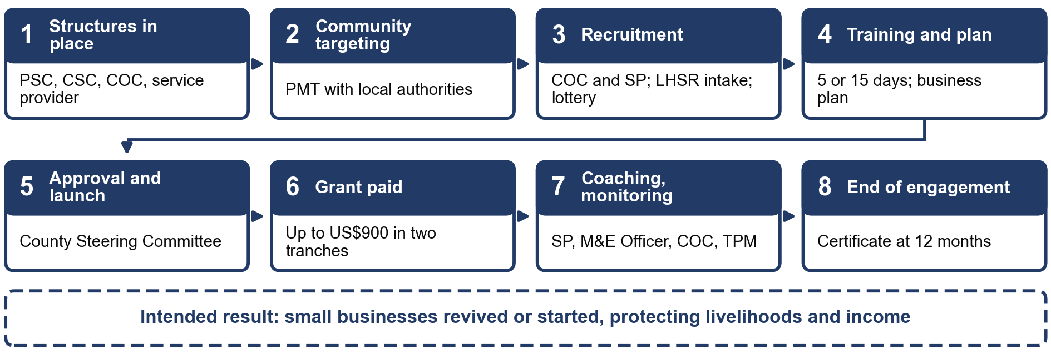
The POM gives LACE overall responsibility for SSB (paras 67, 68 and 72). The component supports poor and vulnerable people who run, or want to start, non-farm enterprises with up to five workers in urban Montserrado and Margibi. It targets 4,450 individuals in three rounds over 36 months, and each round lasts at most 12 months. Rollout is in 55 community clusters. Round 1 targeted 1,305 existing businesses in 15 community clusters in Greater Monrovia, Round 2 targets 1,720 beneficiaries in 23 communities, and Round 3 covers 18 communities, 15 in Montserrado in the new-business category and 3 in Margibi in the existing-business category (paras 79 to 108). Training lasts five days for existing businesses and fifteen days for new ones and ends in a business proposal that the CSC approves. The grant is up to US$900 in two tranches of US$450 (para 61). LACE disburses through the PMT on the authorisation of its Executive Director or a designee, and the Project Financial Management Unit (PFMU) remits it to the beneficiary’s mobile money account (para 115). The first tranche is paid if the beneficiary was not absent for three or more days of training. The second needs proof of business registration and proof that 80% of the first tranche was spent on the business. This report follows paragraph 61. Beneficiaries are certified at the end of the 12-month engagement.
The POM gives the Round 1 figure of 1,305 businesses as a target. The five quarterly reports and the SSB handbook name LACE as the implementing entity, and this report keeps LACE. The quarterly reports record that Round 3 enrolled 1,395 beneficiaries in 18 communities, 15 in Montserrado and 3 in Margibi.

2.5.3 Labour-Intensive Public Works (LIPW), Component 2
Figure 2.2. The LIPW delivery chain has nine steps, from the readiness checklist through 60 days of paid work and training to commissioning (POM paras 120 to 190). Source: POM (version updated November 2024), reconstructed by SITE.
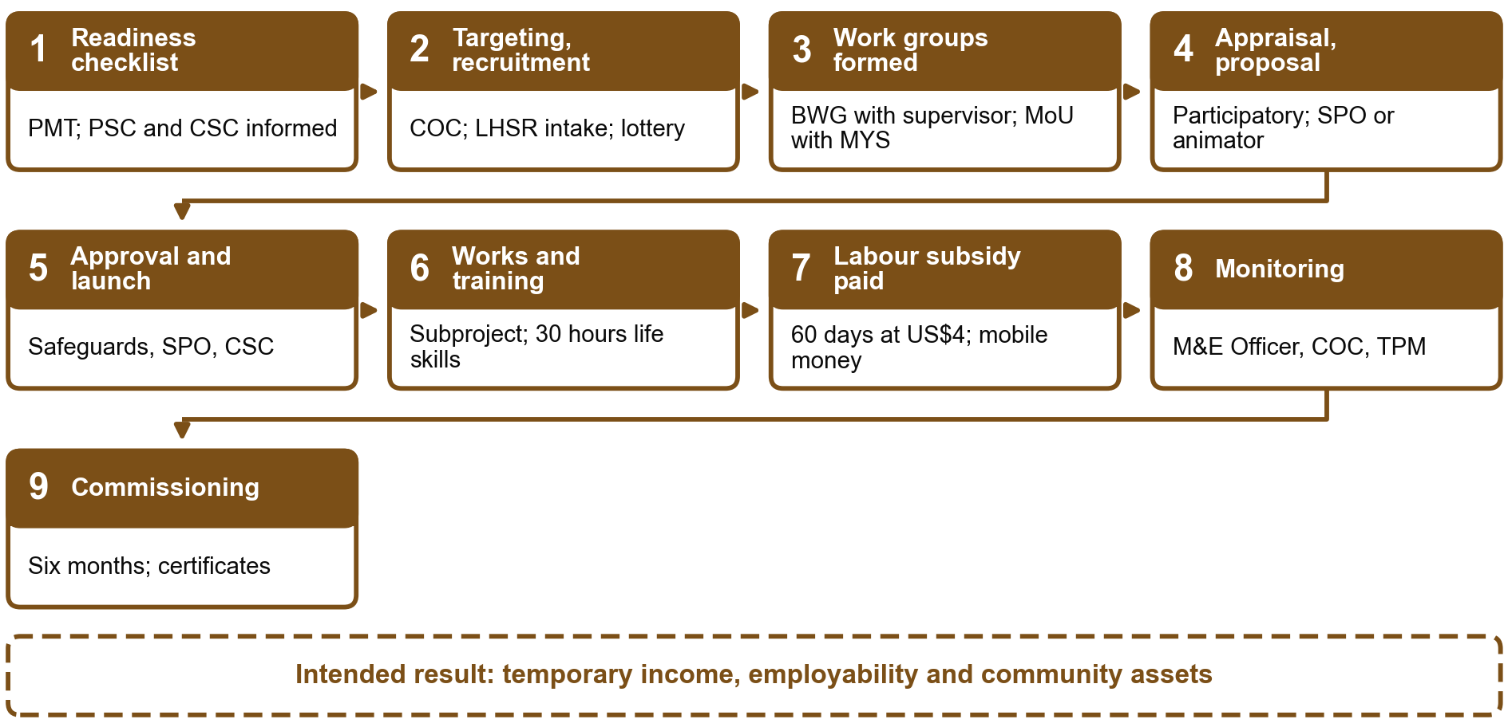
The POM gives MYS overall responsibility for LIPW (paras 129 and 322). Vulnerable informal workers form Beneficiary Working Groups (BWGs) of 25 beneficiaries, each led by a supervisor chosen from the group, and each BWG signs a memorandum of understanding with MYS. The groups carry out community public works for six months, such as drainage clearance, street cleaning, painting and care services. The component plans 17,000 beneficiary households (Results Framework sheet; Section 11.3 uses the tracking-sheet target of 17,900) in 170 communities: 150 in Montserrado over six rounds and 20 in Margibi over five rounds, with no more than two rounds a year (para 171). Each beneficiary is guaranteed 60 workdays at US$4 a day, up to US$240, and a workday is capped at six hours. Supervisors receive US$7 a day, up to US$420. Training is 30 hours and counts as workdays (paragraph 175 says 30 days, and this report uses 30 hours). Each community receives tools and supplies worth US$45 per beneficiary, or US$4,500 for a community of 100 (paras 122, 128, 166, 167, 172, 185 and 186). The POM provides for monthly payment of the subsidy (para 186). The LIPW handbook gives four instalments, each after 15 workdays, and the first quarter 2025 report records first and second tranches paid after 15 workdays. Chapter 7 tests the four-payment version used in the survey questionnaire.
MYS disburses through the PMT on the authorisation of the Minister of Youth and Sports (para 186). Labour subsidies go to the mobile money accounts of individual beneficiaries, and funds for tools and supplies go to the BWGs on the approved subproject budget, or the PMT buys the tools for the group. The POM names MYS as the paying entity, and no project document shows a change.
The POM, the LIPW handbook and the first quarter 2026 report, which places Round 4 under MYS, name MYS as lead agency, and the technical proposal lists LACE. This report keeps MYS as the implementing entity.

2.5.4 Community Livelihood and Agriculture Support (CLAS), Component 5
Figure 2.3. The CLAS delivery chain has nine steps, from hiring service providers through the grant and phone to monitoring and commissioning (POM paras 204 to 271). Source: POM (version updated November 2024), reconstructed by SITE.
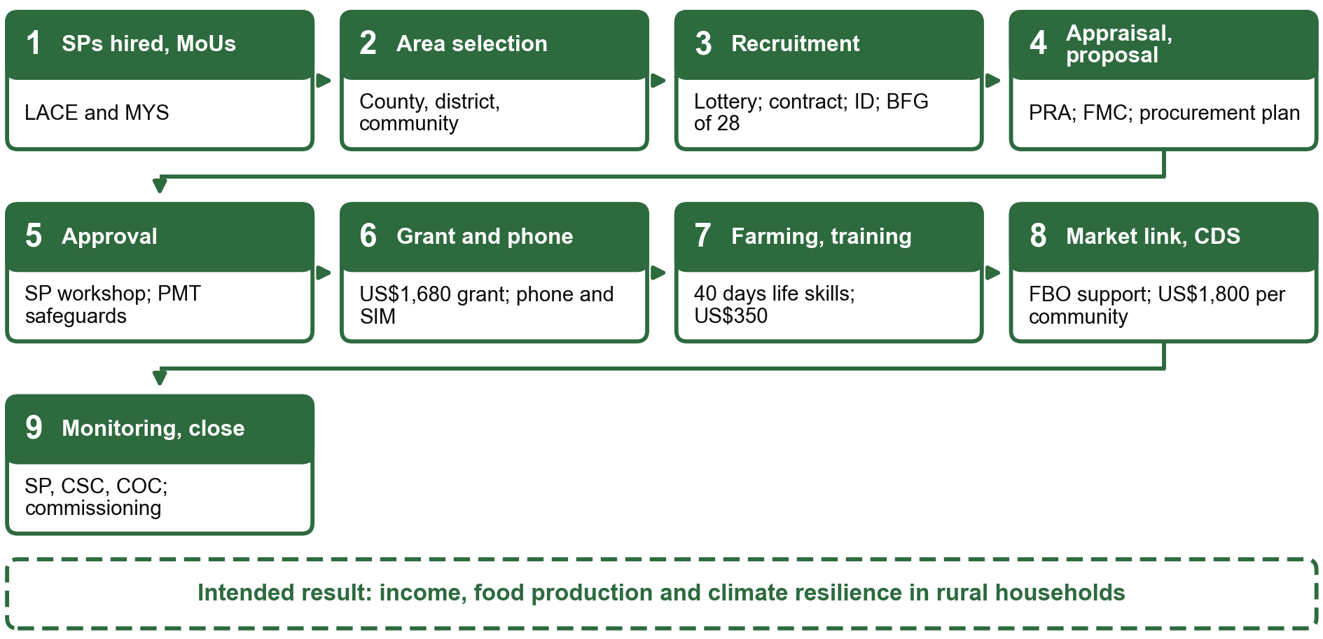
The POM makes LACE responsible for CLAS (para 324 and Table 12). In Chapter 3 of the POM, the text on targeting under Component 5 has LACE lead it, with MYS and MGCSP in support. The POM plans to support up to 16,200 households in eight counties, with a service provider in each county (paras 206 and 214). Beneficiaries form Beneficiary Farming Groups (BFGs) of 28 members, one group per community, or at most two where communities are clustered (para 222). Each group elects a Farm Management Committee of at least five members, at least two of them women (para 246), and signs an agreement with LACE (para 254). The package has a start-up grant of US$1,680 per group, which is US$60 per beneficiary, and a labour subsidy of US$350 per beneficiary for a guaranteed 100 days in a 12-month cycle (para 207). It also has 40 days of life-skills training (para 241), a low-cost mobile phone and SIM card, market linkage support through farmer-based organisations (FBOs) and Community Development Support (CDS) grants of up to US$1,800 per community (paras 207 and 208).
MYS signs memoranda of understanding with the Ministries of Agriculture and of Internal Affairs. Subprojects follow the main planting season of March to May and last about 90 days. Labour subsidies are paid to beneficiaries through mobile money, and the POM assigns funds disbursement to LACE and MYS through the PFMU. LACE approves procurement plans and signs the agreements with the groups (Table 10 of the POM and paras 217, 218, 241, 242 and 254).
The POM, the CLAS handbook, the quarterly reports and the technical proposal name LACE as the entity responsible for CLAS. The quarterly reports of 2025 and of the first quarter of 2026 describe CLAS delivery in seven counties, where the POM plans eight.

2.5.5 Social Cash Transfer (SCT), Component 6
Figure 2.4. The SCT delivery chain has eight steps, from the annual work plan through quarterly transfers and cash-out to a post-payment check (POM paras 272 to 312). Source: POM (version updated November 2024), reconstructed by SITE.
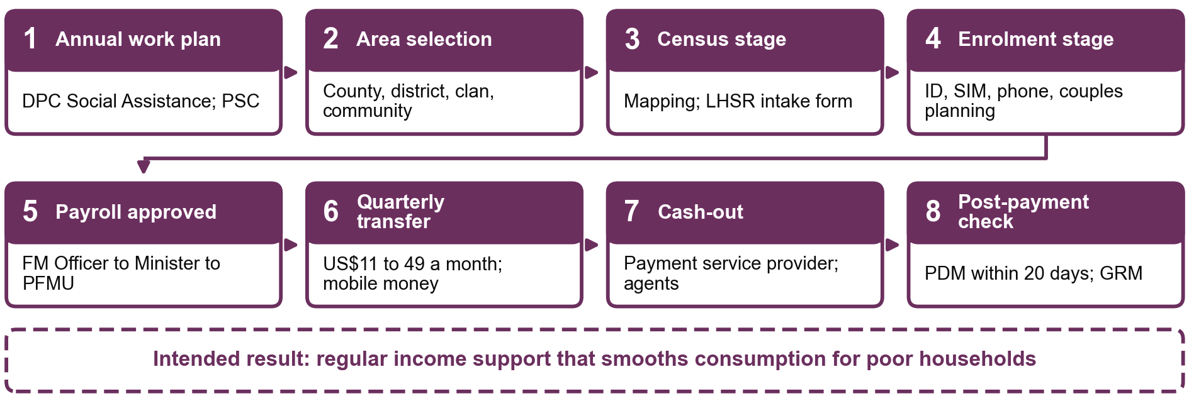
MGCSP leads Component 6 through the Deputy Project Coordinator for Social Assistance (paras 282 and 345). Sub-component 6a gives regular unconditional cash to about 16,000 poor and food-insecure households (Results Framework sheet; Section 11.3 uses the tracking-sheet target of 16,711) in four counties: Grand Bassa (7,800), Rivercess (2,600), River Gee (3,500) and Grand Kru (2,100) (paras 273 and 285). All households in the selected communities are enrolled, so there is no household-level targeting within them (paras 33 and 279). Transfers are paid in Liberian dollars by mobile money, preferably to women as cash recipients (paras 275 and 297). The monthly benefit is US$11 to US$49 depending on household size, set at 30 percent of the national extreme poverty line at 2022 prices (paras 274 and 277). Transfers are paid quarterly, with six payments per household (paras 275 and 294). No document reports a change in the lead entity of SCT.
The census stage and the enrolment stage are at least five days apart, and couples receive financial planning at enrolment. The Financial Management Officer prepares the payroll, the Deputy Project Coordinator and the Project Coordinator verify it, the Minister of MGCSP approves it and the PFMU processes it. The payment service provider lists agents within about two hours’ walk and keeps them liquid. Post-distribution monitoring surveys are done within 20 days of payment, by daily hires, at 5 to 8 surveys a day. The M&E Officer monitors the payment records and checks that the list of beneficiaries is verified before payment (paras 293 to 312 and 423).

2.6 Institutional and implementation arrangements
Three Project Implementing Entities carry out REALISE through one Project Management Team (PMT) of consultants hired by MYS, MGCSP and LACE. MYS coordinates the project and implements the public works component. MGCSP implements the cash transfer component and leads the national social protection system. LACE implements the small business and agriculture components. The Project Steering Committee oversees the work and includes MYS, MGCSP, LACE and six other ministries. The Project Financial Management Unit of the Ministry of Finance and Development Planning handles accounting, reporting and payment of beneficiaries, and county and community committees support targeting, supervision and the handling of complaints. Table K.2.8 (Annex K) sets out the roles and the PMT posts.
The technical proposal (section 2.1) assigns SSB to MYS and LIPW to LACE. This report follows the POM and the quarterly reports (Table 2.7). The POM provides for a third-party monitor, and its reports were not among the documents received.

2.7 Cross-cutting systems
The grievance redress mechanism (GRM) has four levels, from the Community Oversight Committee to a national steering committee (Table 2.8). Complaints are logged in the project management information system, and the POM expects all cases to be resolved within 14 days. The mechanism groups complaints into administrative issues, alleged corruption and rent-seeking, and sexual and gender-based violence, for which it refers complainants to service providers and does not investigate. A free hotline and electronic channels are available. The POM expectation of 14 days, the analytical threshold of 28 days in the PAP and the Results Matrix indicator of complaints addressed within four weeks are three different yardsticks; Chapter 10 keeps them apart.
Table 2.8. Grievance redress levels
Level | Committee and key actors
Level 1, community | Community Oversight Committee, led by the chief or chairman
Level 2, county | County Steering Committee, led by the Superintendent’s office
Level 3, project team | PMT, led by the Project Coordinator, with designated GRM staff
Level 4, national | Steering committee led by the Minister (MYS) and the Grievance Redress Committee of five PMT members

Source: POM (version updated November 2024), Chapter 8, Table 15.
The environmental and social standards system rates the overall risk of the project as Substantial. Eight of the ten World Bank Environmental and Social Standards apply, and every public works and agriculture subproject is screened against an environmental and social management framework. The POM also sets out measures against sexual exploitation and abuse, sexual harassment and gender-based violence, including a code of conduct, training, safe reporting channels and referral to support services. The communications strategy uses radio, community meetings and printed material. The M&E and information systems keep a digital database of all beneficiaries, track milestones and payments, and feed the Results Matrix. The POM requires quarterly progress reports to the World Bank within 45 days after each quarter, a mid-term review after about 18 months and a completion report within four months after the closing date.

2.8 Implementation timeline and coverage by round
Annex E sets the planned rollout against the delivery status reported in the first quarter 2026 report. The SSB subproject cycles run from September 2021 to May 2026 across three rounds, and the terms of reference report 4,450 beneficiaries reached as of January 2026. LIPW plans up to two rounds a year, and Round 4 closed in the first quarter of 2026 with 254 subprojects while Round 5 preparations began with community meetings in 38 communities. The CLAS quarterly reports describe three consecutive rounds, and Round 3 recruitment enrolled 9,997 participants, with seeds, tools and community grants reaching 253 of 303 communities. In SCT, 16,586 households had received at least one transfer, with women 79% of recipients. Planned rollout is a plan and does not show what was delivered. The beneficiary lists used for the survey cover fewer rounds and sites than the project as a whole (Annex D), and Annex D gives the list, the main draw and the field reserve for every combination of component, round and county.
Four coverage features bound what the survey can say. LIPW Round 5 has no selected community. LIPW Round 1 rests on a single community and Margibi on two, so neither supports a round or county contrast on its own. CLAS Round 2 is listed as one combined group of Beneficiary Farming Groups and Community Oversight Committee members, so it supports no comparison between the two. SCT has no usable round field, so there is no round analysis. Round and county comparisons are descriptive and depend on which communities were selected.
The quarterly reports document the round timeline only in part: they give no start and end dates for each LIPW and CLAS round, and SCT has transfer phases but no round. Round comparisons therefore rest on the rounds recorded in the beneficiary lists.
The SCT frame is the pay status recorded in the Combined SCT payment registry. The registry has no beneficiary-level round field, only transfer phases, so the draw is not stratified by round. Rivercess records fall outside the three SCT counties and do not enter the draw. The registry holds 16,911 records, of which 13,185 are eligible and 2,382 fall in the selected sites. The transfer amounts are those of POM Chapter 3 (Section 2.3).

2.9 Results framework indicators
Annex F, Table 2.9 gives the results-framework indicators of the project development objective (PDO), Components 1, 2, 5 and 6 and the Gender Action Plan, with their targets, the values achieved by April 2026 and the share of each target reached.
The detailed table is in the Annex F supplement (Table 2.9).

Chapter 3. Evaluation Framework and Questions

3.1 Evaluation criteria and lenses
The evaluation uses the six OECD-DAC criteria named in the terms of reference: relevance, effectiveness, efficiency, impact, coherence and sustainability. Inclusion and equity are applied to all six as a cross-cutting lens, not as a seventh criterion. Each criterion becomes one key evaluation question (KEQ) in Section 3.2.
The technical proposal anchors the evaluation in these criteria and pairs them with contribution analysis (Mayne, 2012), which it presents as recognised by the OECD-DAC for complex programmes where an experimental design is not feasible. The report applies the criteria at three levels. Table 3.3 (Section 3.5) links each criterion to its question, its evidence and the sections that answer it. Each component chapter closes with its findings by criterion (Tables 6.7.1, 7.7.1, 8.8.1 and 9.7.1). Table ES.2 and Chapter 11 bring the answers together.
The terms of reference set the frame for the whole evaluation. There is no primary counterfactual design, so assessments of effectiveness and impact rest on programme monitoring data, qualitative evidence and triangulation with existing experimental evidence. The report therefore speaks of contribution, not impact, and grades the evidence for contribution instead of estimating an effect.

3.2 Key evaluation questions
Each OECD-DAC criterion is answered by one key evaluation question (KEQ), copied here word for word from the pre-analysis plan, with the status of its answer:
Relevance (KEQ1, answered). Did support and selection match intended beneficiaries’ needs and profiles?
Effectiveness (KEQ2, partly answered). Were intended benefits delivered and were expected changes reported?
Efficiency (KEQ3, partly answered). How efficiently were resources used, how timely were delivery and internal operations, and what transaction costs fell on beneficiaries?
Impact and outcome contribution (KEQ4, partly answered). What changes in income, employment, food security, consumption, resilience and agency are observed, and how plausible is REALISE’s contribution?
Coherence (KEQ5, partly answered). How do the four components complement one another and align with other government and partner programmes, and where are synergies, duplication or coordination gaps?
Sustainability (KEQ6, partly answered). Which businesses, assets, groups, practices and household changes are likely to continue?
How to read the status. Each question receives one of three statuses, specified in the governing pre-analysis plan, with its approval and outcome-access chronology documented in Section 4.11 and Annex L: answered, partly answered or not resolved. The status records whether every part of the question can be answered with the evidence the evaluation was designed to use. It is not a judgement of REALISE’s performance and does not reflect how much fieldwork was completed. A question is partly answered when one part depends on evidence outside the evaluation’s design, such as a separate cost analysis, or on records that were not accessible at the time of this report. In each such case, Table 11.1a names the missing evidence. How strongly the evidence supports REALISE’s contribution is expressed separately, through the contribution grade (Strong, Moderate, Limited or Insufficient). A question can be fully answered and still carry a Limited grade.
Table B.3.1 (Annex B) condenses the six questions fixed in the PAP, the evidence for each and the way each is closed, and Chapter 11 gives the closure of each question. KEQ1 on relevance and KEQ5 on coherence produce descriptive findings and no grade. KEQ2 on effectiveness and KEQ3 on efficiency receive one grade per component, and KEQ4 on impact and outcome contribution one grade per component-outcome claim where a mechanism chain is defined. KEQ6 on sustainability receives one grade per component, because it examines a chain from delivery to continued use. KEQ3 is answered in part. The PAP covers delivery timing, internal processes and costs borne by beneficiaries; resource use and cost-effectiveness need component cost and budget data, not accessible at the time of this report, and a separate financial analysis. KEQ3 is therefore reported on the beneficiary side, and its resource-use part is not resolved.

3.3 Expectations, hypotheses and primary outcomes
The six primary outcomes in Table 3.1 describe delivery and reported outcomes by component. Results give weighted percentages or averages and the number of valid answers. Changes in basic needs, own-name accounts and women’s empowerment use beneficiaries answering for themselves; detailed eligibility and calculation rules are in the Annex F supplement.
Table 3.1. Six measures describe delivery and reported outcomes
Outcome | What the measure means | Who it covers | How to read it
Expected benefits received | Share reporting every benefit they expected | Respondents who expected at least one specific benefit and gave valid receipt answers | Higher is better; this does not verify administrative entitlement
Payments on schedule | Share saying payments always arrived by the date communicated | Respondents expecting a timed payment who were given a schedule and answered the timing question | Higher is better
Household coping | Days on which the household used twelve coping strategies in the past week, added together (0 to 84) | Households with valid answers, including zero for those reporting no food shortfall | Lower is better
Change in basic needs | Recalled change from much worse (−2) to much better (+2) | Beneficiaries answering for themselves | Higher is better; this is recalled change
Own-name mobile money | Share holding an account in their own name | Beneficiaries answering for themselves with a valid account response | Higher is better; prior ownership was not recorded
Women’s self-efficacy | Eight-item score from 8 to 40 | Women answering for themselves in private, with all items answered | Higher is better
Reading note: These are the primary survey measures. Their full definitions and eligible groups are in the Annex F supplement, Table 3.1.

Table 3.2 sets out six expectations. Receipt and timing are descriptive delivery checks; the other four compare reported outcomes with delivery, account access or women’s say over support use. These comparisons describe associations and do not establish causal effects. The contribution judgement weighs them with the interviews, records and other explanations. The Annex F supplement gives the planned comparisons and statistical procedures.
Table 3.2. Pre-specified expectations (PAP Table 7)
Question examined | Outcome | What would challenge the expected pathway
Did beneficiaries receive every expected benefit? | Expected benefits received | Positive survey reports contradicted by delivery records or interview accounts.
Were payments made on the communicated schedule? | Payment timing | Reported timing contradicted by payroll and payment dates.
Did complete and timely delivery go with fewer coping days? | Household coping | No clear difference, or one better explained by season, prices, shocks or other assistance.
Did receiving and using support go with improved basic needs? | Change in basic needs | Reported improvement without evidence that support reached and was used by beneficiaries, or without independent corroboration.
Did mobile-money payments go with own-name accounts? | Own-name mobile money | Ownership equally high without such payments, or most accounts already held before the programme.
Did women with a say over support report greater self-efficacy? | Women’s self-efficacy | No clear link, or a pattern better explained by earlier decision-making or household norms.
Reading note: These expectations were specified before analysis. The component chapters test them; full definitions are in the Annex F supplement, Table 3.2.

Results are labelled with one of four tiers. Primary results are the six outcomes above. Secondary results are the supporting indicators and mechanism contrasts, including the H3 to H5b contrasts, which stay secondary although they use primary outcomes. Tertiary results are the CLAS component block, which is descriptive. Exploratory results are any analysis not listed in the PAP, reported with nominal uncertainty and no confirmatory claim.

3.4 Commitments answered without a survey measure
Ten commitments have no survey measure of the change they name: change in income and employment; consumption and dietary diversity; change in business, farming and household welfare other than basic needs; component-specific outcomes; existing and new SSB businesses; transaction costs borne by beneficiaries; benefit amounts received; household headship; satisfaction; and extension and market information in CLAS. The PAP does not drop them. Table B.3.4 (Annex B) states how each is answered and what the report cannot say about it. The last column states what each commitment can support. Income and employment change, for instance, are described from interviews, focus groups and case studies, and no chapter gives a prevalence, amount or average change in income or employment, a monetary consumption estimate, or an estimate of the time or money beneficiaries spent to receive a benefit.

3.5 Evaluation matrix
Annex B reproduces the operational evaluation matrix delivered with the PAP. It has one line for each of the six evaluation questions and nine columns: the question, the hypothesis or proposition, the indicator and its priority, the variables and universe, the core or module status and assignment probability, the result produced, the qualitative and administrative evidence, the rival or contradiction to test, and the conclusion the evidence permits with its scope. The matrix is a commitment about how each question will be answered, and Table 1.3 shows the sources obtained.
Table 3.3. OECD-DAC criteria, evaluation questions and where the report answers them
OECD-DAC criterion | Key evaluation question | Main evidence | Answered in | Closure
Relevance | KEQ1. Did support and selection match intended beneficiaries’ needs and profiles? | Profile and selection items; targeting accounts in interviews and focus groups | Sections 6.2, 7.2, 8.2, 9.2 and 10.1 | Descriptive, no grade
Effectiveness | KEQ2. Were intended benefits delivered and were expected changes reported? | Receipt of every expected benefit; delivery accounts; payment records | Sections 6.3, 7.3, 8.3 and 9.3 | One grade per component
Efficiency | KEQ3. How efficiently were resources used, how timely were delivery and internal operations, and what transaction costs fell on beneficiaries? | Payment timeliness; payment channel and cash-out items; payment statements | Sections 6.3, 7.3, 8.3, 9.3 and 11.1 | Beneficiary side only; no cost data
Impact | KEQ4. What changes in income, employment, food security, consumption, resilience and agency are observed, and how plausible is REALISE’s contribution? | P3 to P5b; mechanism contrasts H3 to H5b; rival explanations | Sections 6.4, 7.4, 8.4, 9.4 and Chapter 10 | One grade per component and outcome
Coherence | KEQ5. How do the four components complement one another and align with other government and partner programmes, and where are synergies, duplication or coordination gaps? | Other assistance and overlap items; partner and official interviews; national climate commitments | Section 10.7 | Descriptive, no grade
Sustainability | KEQ6. Which businesses, assets, groups, practices and household changes are likely to continue? | Continuation items; accounts of saving, assets and groups | Sections 6.7, 7.7, 8.7 and 9.7 | One grade per component
Source: PAP version 14, Table 2 (question wording as in the plan); Table 11.1a for the closure status.

Chapter 4. Methodology

4.1 Design overview
Figure 4.1. The evaluation combines three data strands, analyses each one, integrates them and grades the contribution of the programme to each outcome.
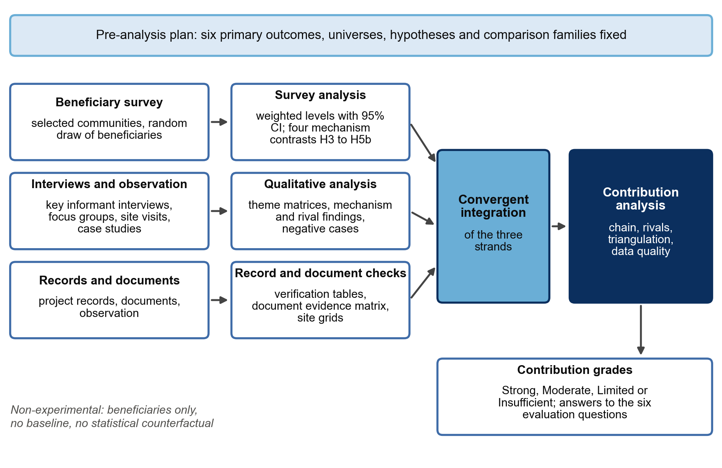
The evaluation follows the theory-based mixed-methods design of the technical proposal (Section 3.1). It is non-experimental and restricted to beneficiaries, with no baseline and no statistical counterfactual. The proposal rests the design on three pillars: contribution analysis (Mayne, 2012) as the framework that organises all collection and analysis; qualitative research (key informant interviews, focus groups, site visits, case studies and document review) as the primary evidence on how and why delivery worked; and a complementary beneficiary survey that measures reach and self-reported outcomes and triangulates the qualitative findings. The survey and the qualitative fieldwork ran at the same time in the same selected communities. Each strand was analysed on its own before the strands were brought together, with one permitted round of explanatory follow-up. Survey descriptives produced without outcome models could direct targeted follow-up interviews and the choice of the six case studies. No qualitative finding can change a primary outcome definition, universe or comparison family (Table 4.1). Figure 4.1 shows the design.
The five steps of contribution analysis in the proposal (Section 3.2.3) map onto the report as follows.
- Set out the theory of change: the expected delivery chain of each component and of the cross-cutting claims (Section 2.5, Table 2.6).
- Assess the existing evidence: project documents, monitoring reports and records (Section 4.5, Annex K), the Results Matrix (Section 11.3) and prior evaluations (Section 11.4).
- Gather new evidence: the survey (Sections 4.2, 4.3, 4.6 and 4.7) and the qualitative fieldwork (Sections 4.4 and 4.8).
- Assemble the contribution story: delivery, outcomes, mechanisms and rival explanations in each component chapter (Chapters 6 to 9) and across components (Chapter 10).
- Assess the contribution claim: the contribution assessment closing each component chapter and the grades in Chapter 11.
Two points differ from the proposal and change how results are read. The qualitative work took place in a subset of the survey sites, which reverses the order the proposal described (Section 4.4). Contribution grading follows the more detailed rubric of the PAP, with eight steps and four critical dimensions (Section 4.8). The survey kept the size set in Section 3.4.2 of the proposal: the PAP allocated 1,600 interviews and 1,477 interview records were included in the analysis. Section 4.11 lists the other departures.
Table 4.1. Each strand of evidence has a distinct role in the design
Strand | What it establishes | Main product
Beneficiary survey | Estimates how many beneficiaries received what they expected, on time, and what they report about coping, basic needs, financial inclusion and women’s self-efficacy; establishes prevalence and cascade shares | Weighted levels with confidence intervals; four mechanism contrasts H3 to H5b
Key informant interviews, focus groups, site visits and case studies | Explains how and why each link held or failed, for whom, and which competing explanations apply; tests mechanisms and rivals | Theme matrices, mechanism findings, negative cases, contradiction log
Records, documents and observation | Checks whether receipt, timing and functionality can be verified independently of self-report | Verification tables, document evidence matrix, site evidence grids

Source: PAP version 14, Sections 2 and 8.3 and Table 8C.
The plan that governs the analysis is the pre-analysis plan (PAP). Its version 14 was approved one week after the first survey interview and consolidated amendments made after the pilot. A paragraph-level comparison with version 13 found no change to the six primary outcomes, the hypotheses, the comparison families, the sampling allocation, the response weights or the rotation rule. Section 4.11 and Annex L list the later changes and the outcome material the analysts had already seen when each was made.
Contribution analysis tests whether an outcome pattern fits the expected delivery chain and weighs rival explanations. Outcome materialisation and contribution strength are assessed separately. The claim display in Annex I assembles the evidence for each claim.

4.2 Beneficiary survey: frame and sample
Figure 4.2. The analysis includes interview records for 1,257 of the 1,600 main-draw cases and for 220 of the 500 reserve cases drawn.
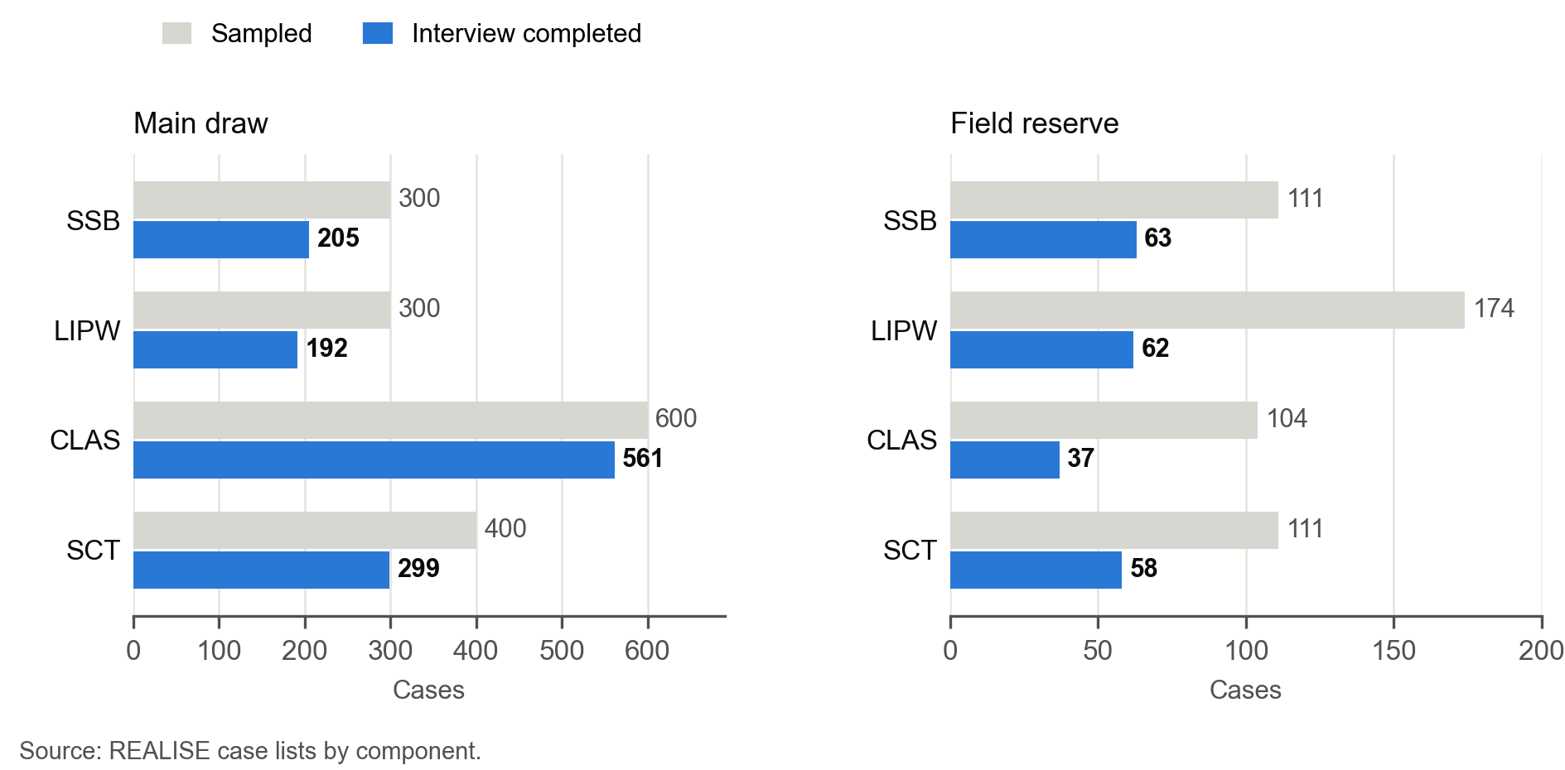
Figure 4.3. Of the 2,100 sampled cases, 1,477 have interview records included in the analysis and 273 were not reached after three documented attempts; 210 reserves were never needed. In Figures 4.2 and 4.3, the chart label “Interview completed” refers to interview records included in the analysis, not confirmed administrative closure of every record. One SCT record remains marked active and its administrative status requires confirmation; no record is excluded or declared invalid.
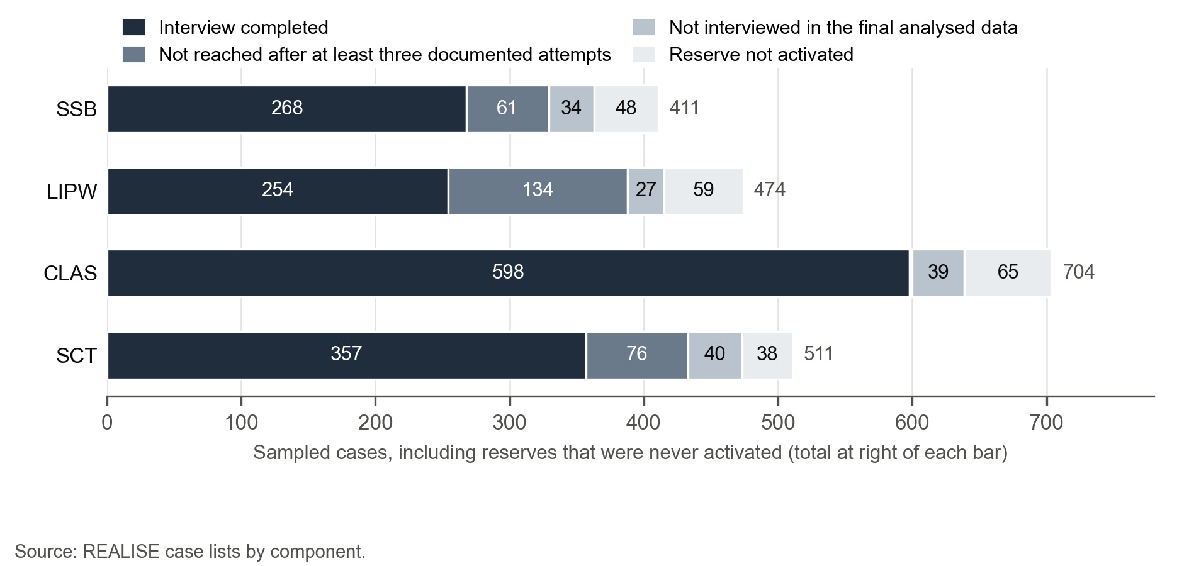
The first stage of the sample is purposive. The 43 component-specific sites sit in 42 physical communities across 10 counties because Stephen Tolbert Estate serves both SSB and LIPW. The site list was fixed before the beneficiary draw. The PMT confirmed 35 of the sites on 26 July 2026, and SITE selected the other eight to implement PMT decisions on components, counties and rounds. The second stage is random. One registration for each operational identity group is drawn at random inside exact sampling cells defined by component, physical community, round, implementation group, gender and beneficiary status, without replacement and with a fixed seed in Stata 17.
The frame is the project beneficiary workbook of 5 August 2026 for SSB, LIPW and CLAS and the Combined SCT paid-household registry of 2 July 2026 for SCT, whose respondents are the registered cash recipients of paid households. Identity resolution links identical normalised full-name tokens across all components and identical administrative identifiers within a component, including transitive links, and reduces 5,081 eligible registrations to 4,523 identity groups. The rule is conservative: it may merge homonyms, cannot detect every unobserved alias, and does not certify civil identity. The main sample is 1,600 identities and the reserve is 500 identities, selected without overlap. Main gender allocations are fixed at 240 / 60 for SSB, 150 / 150 for LIPW, 300 / 300 for CLAS and 300 / 100 for SCT, and cells are filled by the largest-remainder rule. Reserves follow a documented project arbitration (Annex D). The PMT asked for at least 500 reserves overall, including 150 for CLAS. CLAS has only 704 identity groups, so 104 remain after its main draw, 46 below the PMT minimum, and LIPW takes the difference so that the total stays at 500. The arbitration prioritises uniqueness and is not a new PMT approval. As a result 23 CLAS cells, with 52 main cases, have no reserve, and all of them are censuses of their resolved identity group. Reserve activation stays inside the exact cell and follows the fixed rank.
Table 4.2 compares the PAP allocation with the realised sample. The final data contain 1,477 interview records included in the analysis, 1,257 from the main draw and 220 from reserves, or 92.3 percent of the 1,600 planned. Reserve interviews were drawn within sampling cells; Section 4.11 and Annex L describe activation decisions and departures. No confirmed refusal is recorded; the final outcome remains unknown for unresolved cases. This attainment rate is not the completion rate among the 1,890 released cases. The case list holds 2,100 identities, including reserves never activated.
The final analysis includes eligible interview records in the final analysed data. Cases without a confirmed final outcome remain in the non-interviewed category; they are not treated as confirmed refusals or ineligible cases.
Table 4.2. The analysis includes 1,477 interview records against 1,600 planned interviews
Component | Frame | Main draw / reserve | Interviewed, main draw | Interviewed, reserves | Interviewed, total
SSB | 470 | 300 / 111 | 205 | 63 | 268
LIPW | 967 | 300 / 174 | 192 | 62 | 254
CLAS | 704 | 600 / 104 | 561 | 37 | 598
SCT | 2,382 | 400 / 111 | 299 | 58 | 357
Total | 4,523 | 1,600 / 500 | 1,257 | 220 | 1,477
Reading note: Counts of interview records included in the analysis from the main draw and reserves. The Annex F supplement, Table 4.2, gives the sampling-frame detail.

Main-draw response rates are 93.5 percent in CLAS, 74.8 percent in SCT, 68.3 percent in SSB and 64.0 percent in LIPW; among all released cases the completion rates are 93.6, 75.5, 73.8 and 61.2 percent (Table 5.1.2). Of the 1,890 released cases, 273 were not reached after three documented attempts and 140 were not interviewed in the final analysed data: 91 had fewer than three documented attempts, 20 had an eligibility or death report that was not confirmed and 29 were in another situation recorded in the case list. A further 210 reserves were never activated. Cases of unknown eligibility are not counted as ineligible, and reserves never activated are left out of the released-case denominator. Interviews cover all 134 sampling cells, so no cell of the frame is uncovered.
The LIPW estimates give different weights to respondents to represent the beneficiary groups in the selected communities. Every one of the 18 sampling groups has at least one completed interview, so the weights cover the 967 beneficiaries on those lists. Some interviews carry much more weight than others; findings for small groups therefore require caution. Annex G, Tables G.1.2 and G.10.2, gives the weight distribution and checks on its influence.

4.3 Survey instrument and fieldwork

Instrument
Every interview administers the common core, which carries all six primary outcomes P1 to P5b. The rotation therefore does not change the universe, weighting or precision of any primary outcome. Core items keep their own eligibility and skip rules: the self-efficacy questions go only to women answering for themselves who can answer in private, and the coping questions only where the food-insufficiency filter is Yes. The shocks and other-assistance items, the eight seven-day food frequency items, the sixteen yesterday food items and the CLAS block are in the core. One module rotates, the detailed women’s empowerment battery on assets, decision participation and sharing of housework. A woman answering for herself is drawn with equal probability across three arms, one of which opens the module. About 330 women were expected to receive it, so its estimates carry a weight factor near 3 and wide intervals. The consent script announces about 40 minutes. The Word questionnaires, the SurveyCTO forms and the back-check forms are inventoried in Annex C. Interviews were taken on tablets with SurveyCTO and uploaded to a project server.

Pilot and changes during fieldwork
A pilot in Montserrado before fieldwork measured median interview times of 60.5 minutes in SSB and 65.7 minutes in LIPW, well above the announced 40 minutes. The PAP was amended before any outcome data existed, and the post-pilot forms withdrew the rotating module, the shocks block, the profile items and the food items. These were restored in the first days of fieldwork, the food items and the CLAS block last. Nine form versions were in use during these first days (Annex E). An interview recorded on an earlier version lacks the items added later and stays in every measure for which it is eligible. A telephone recall collected 201 complete and sixteen incomplete submissions. Complete recall answers are merged into the interview they belong to under the linkage and eligibility rules and do not count as new interviews. Each table gives its valid sample and missing share after the merge.

Field teams and calendar
The deployment plan used five quantitative sub-teams under two supervisors, sixteen enumerators and two qualitative teams of three. Team One covered SSB and SCT: Team 1A (3 enumerators) worked in the six SSB sites in Montserrado and Margibi, and Team 1B (4 enumerators) in the nine SCT sites in Grand Bassa, Grand Kru and River Gee. Team Two covered LIPW and CLAS: Team 2A (3 enumerators) worked in the eight LIPW sites, Team 2B (4 enumerators) in Bong, Lofa and Grand Gedeh, and Team 2C (2 enumerators) in Bomi and Grand Cape Mount. Interviewing started on 24 September 2026. Table 4.3 gives the last recorded interview in each component. Elapsed form time includes pauses, so it is not a measure of interview length.

Case management, reserves and quality checks
Enumerators worked from SurveyCTO preloads of the main cases, and each case was tracked in the case-management forms (Case Operations and Contact Outcomes), with supervisors managing reserve use within sampling cells. Ordinary non-contact needs three dated attempts before a reserve is activated. A confirmed repeat, an established ineligibility or an explicit refusal may be closed after one documented determination. During fieldwork the study lead decided that every main case that would not be interviewed is replaced by the next reserve of its cell, with a goal of 1,600 completed interviews. Later in fieldwork a supervisor could undo a replacement while its reserve had no interview.
High-frequency checks ran on the daily exports of each component. Back-checks, reported in Section 4.10, were drawn from the interviews eligible for a telephone check, so they are not a random validation sample of the 1,477 interview records included in the analysis. They include at least one back-check for each of the 16 enumerators.
Field quality indicators. The daily high-frequency checks also tracked interview length and GPS capture. Interviews shorter than 20 minutes numbered 40 in SSB, 13 in LIPW, 35 in CLAS and 12 in SCT (100 of 1,477, or 6.8 percent), and interviews longer than 60 minutes numbered 4, 3, 5 and 4. The GPS reading was missing or invalid in 9 percent of SSB interviews, 9 percent of LIPW, 1 percent of CLAS and 12 percent of SCT. All 1,477 interviews remain in the analysis data.
Supervisor decisions on back-check differences. Each supervisor received a workbook listing every field in which a back-check answer differed from the main interview, compared exactly with no tolerance: 372 fields for 49 back-checked respondents. Supervisors recorded a decision for 292 fields. They confirmed the main-survey answer for 228, the back-check answer for 31 (including 3 entry errors acknowledged by the enumerator) and neither answer for 18; 15 could not be decided, and for the other 80 no decision was recorded. This is the earlier supervisor-workbook subset; the analysis data keep the main-survey answers. Section 4.10 gives the decisions and their reconciliation with the final data.
Table 4.3. Interview dates by component
Component | Interview records | Earliest recorded interview | Latest recorded interview
SSB | 268 | 24 September 2026 | 21 October 2026
LIPW | 254 | 24 September 2026 | 28 October 2026
CLAS | 598 | 24 September 2026 | 10 October 2026
SCT | 357 | 24 September 2026 | 23 October 2026

Source: cleaned component records (interview start time).

4.4 Qualitative data collection
The qualitative sample is purposive and based on roles. It tests mechanisms, context, negative cases and rival explanations, and does not estimate prevalence. The core design has 55 key informant interviews (KIIs), 29 focus group discussions (FGDs), 16 site visits (4 for each component) and 6 case studies (Annex H). Three more CLAS KIIs, with a farmer-based organisation, a district agriculture officer and a Ministry of Internal Affairs monitor, implement a PMT decision and are additional to the core. Up to two LIPW service-provider KIIs are conditional on the availability of the providers. The FGDs are 8 female beneficiary groups, 8 male beneficiary groups, 4 non-beneficiary groups, 3 youth groups, 3 community leader groups, 2 specialist groups and 1 CLAS Round 2 group. Non-beneficiary groups give context on targeting, spillovers and rival explanations and are never a statistical comparison group. The qualitative work took place in a subset of the survey sites, which reverses the order described in the technical proposal.
Instruments are component-specific KII and FGD suites for SSB, LIPW, CLAS, SCT and the cross-cutting roles, KII suites for the World Bank, AFD and Sida, a site-visit observation checklist, a case-study protocol and a note-taking template (Annex C). Two qualitative teams worked in parallel with the survey teams, Team One for SSB and SCT and Team Two for LIPW and CLAS, each with a facilitator, a note taker and a team leader. Team One held 14 focus groups and 16 component interviews and Team Two 12 focus groups and 11 component interviews; the seven cross-cutting interviews, with the PMT, donors and national or cross-component informants, were shared between the two teams. One named interviewer conducted each KII and a lead and a note taker each FGD. Transcripts and expanded notes were de-identified before coding.
The documentary inventory contains 61 transcript files: 34 KII files and 27 FGD files; 60 form the analysed corpus. Thirty-three KII files match core roster identifiers, and one matches a conditional LIPW provider slot. By source label, the files comprise SSB five KIIs and six FGDs, LIPW five KIIs and six FGDs, CLAS six KIIs and seven FGDs, SCT eleven KIIs and eight FGDs, and seven cross-cutting KIIs. Three SCT-labelled KII files have cross-cutting core identifiers in the roster. These are file counts, not a count of distinct or complete sessions. The 60-unit analytic register includes 34 KII units and 26 FGD units, one a continuation. One transcript that could not be anonymised is excluded from the analysed corpus. The CLAS Laworta FGD file is a partial continuation. Written site observations cover SSB, LIPW, CLAS and SCT; two completed case grids and one CLAS narrative add illustrations outside the transcript count. The planned sessions without a transcript are listed in Table 4.4; findings that would rely on them say so.
The design assigned four site visits to each component, to compare accounts with the condition of activities at selected locations; the visit register is in Annex E. It also specified six case studies: CS-01 (SSB), contrasting business trajectories at Wood Camp and White Plains (Mount Coffee); CS-02 (LIPW), infrastructure sustainability and community maintenance at Duala Market; CS-03 and CS-04 (CLAS), success and a challenge in adopting climate-smart agriculture at Kelema Bendu Town and Gbalasuah; CS-05 (SCT), ultra-poor households in remote areas at Tartuken; and CS-06 (cross-cutting), gender and women’s economic agency at Grandcess Wedabo Gbarken (Annex H).
Table 4.4. Qualitative material covers all four components
Planned strand | Core KIIs planned | Core IDs matched | Other KII files | FGDs planned | FGD files
SSB | 8 | 5 | 0 | 6 | 6
LIPW | 8 | 4 | 1 conditional | 6 | 6
CLAS | 14 | 6 | 0 | 9 | 7 (documentary; 6 analytic units)
SCT | 8 | 8 | 0 | 8 | 8
Cross-cutting | 17 | 10 | 0 | 0 | 0
Total | 55 | 33 | 1 | 29 | 27 (documentary; 26 analytic units)
Reading note: Counts describe transcripts matched to planned roles, not a certification that every planned interview was conducted. The conditional LIPW provider interview is additional to the core.

Annex F, Table 4.5 lists the 29 planned focus group discussions with their component, respondent group and location.
The detailed table is in the Annex F supplement (Table 4.5).

4.5 Records, documents and secondary evidence
The document review draws on the project documents listed in Table 4.6. The PAP requires one structured record and a reliability rating of High, Medium or Low for each document, and Annex K holds the register and the ratings. The PAP also requires checks of identity linkage, definition, period and completeness before an administrative, payment or grievance record is used, and such a record cannot upgrade a claim when coverage, definition, timing or identity linkage is inadequate.
Partial payment records were available: PMT mobile-money statements at round level for SSB (Rounds 1 and 2), LIPW (Rounds 1 to 3) and CLAS (April 2024 to June 2025), one SCT batch of 904 transfers in Grand Kru, and two initial payrolls without payment dates (LIPW Round 1 and SSB Round 2). No complete dated individual payment register that could be matched to respondents was available. There are also no LIPW timesheets, no CLAS delivery register and no GRM register. Where a chapter needs receipt, timing or functionality verified outside self-report and no record exists, that dimension of the contribution grade is capped, and the chapter says so. The share of LIPW workers paid within 14 days of the 60th credited workday can be computed for Round 1 at most, and only where both dates exist. The grades use the records held at the close of the evaluation. Self-reports and interviews support the grades; receipt and timing are not verified independently (Section 4.11).
The available payment statements provide aggregate documentary evidence for the periods and rounds they cover. They do not establish that every surveyed beneficiary received the full amount due by the scheduled date. The beneficiary lists used for sampling do not by themselves verify delivery. Where a record cannot be linked to the relevant respondent, entitlement and period, the report retains the finding as beneficiary-reported or project-reported, with the limitation stated in Table 11.5.1. Claims about delivery, payment timing and grievance closure require a separate record-level check before they can be presented as independently verified.
Table 4.6. Design, results and beneficiary records were available; payment records were partial and delivery and grievance records were not
Type | Items | Availability
Programme design | Project Operations Manual (version updated November 2024); component handbooks for SSB, LIPW, CLAS and SCT; M&E handbook | Available
Results and reporting | Results Matrix of the February 2026 mission; quarterly reports for the first quarter 2025 to the first quarter 2026 (five reports) | Available; no World Bank aide-memoire, implementation status report, mid-term review or annual report
Evaluation documents | Request for proposal with terms of reference; accepted technical proposal; inception report | Available; the negotiated terms of reference and signed contract are not in the files
Beneficiary data | Project beneficiary workbook of 5 August 2026; combined SCT payment registry of 2 July 2026 | Available; used as the sampling frame
Payment records | PMT mobile-money statements at round level (SSB, LIPW, CLAS; one SCT batch); initial payrolls for LIPW Round 1 and SSB Round 2, without payment dates | Partial; no complete dated individual payment register that could be matched to respondents
Delivery and timesheet records | LIPW timesheets; CLAS delivery register | Not available
Grievance records | GRM register | Not available
Comparable evaluations | Evaluations of earlier REALISE iterations and of comparable programmes cited in the technical proposal | None available

Source: inventory of sources and gaps; project documents received.

4.6 Measurement and data preparation
The six primary outcomes are rebuilt in Stata from the raw questionnaire items. A calculation exported by the tablet form serves only as a check: every disagreement is logged, and the rebuild governs. Annex J gives the coding rule of every measure by raw field, and its section J.1 details the rules below.
Three rules shape most denominators. First, Don’t know, Refused, invalid and out-of-range answers are missing, never zero. The only derived zero is the coping score P3, which is zero when the household reports no food insufficiency at the filter question. Second, each indicator has its own eligible universe: P1 requires at least one specifically expected benefit and a valid receipt answer, P2 a communicated payment schedule, and P5b a woman answering for herself, in private, with all eight items observed. Third, an item that the questionnaire version used for an interview did not carry is treated as not collected for that interview, never as a negative answer. Nine form versions were in use during fieldwork (Annex E), so coverage differs by item, and every table gives the eligible n and the missing share.
Proxy answers are kept apart where the measure concerns the beneficiary’s own judgement. P4, P5a and the women’s empowerment indicators leave them out of the primary estimate (Annex L); for P5a, an account held by a proxy is not the beneficiary’s account. Food scores are rebuilt from the raw items, and harvest quantities keep their recorded units in the main tables, with standard 25 kg and 50 kg bags converted to kilograms in the supplementary harvest exhibit (Section 8.4). The respondent analysis uses reported sex, while registry sex defines the sampling cell and weight. Follow-up recalls filled missing answers in all four components and were linked to existing interviews: 12 SSB, 37 LIPW, 135 CLAS and 17 SCT records received at least one recalled answer. Food-consumption and shock responses recovered at follow-up refer to the period of that follow-up.
Open-text answers are coded to existing categories only under rules approved by the study lead and logged in Annex L. The original text is kept, and a new answer does not inherit an earlier approval. The approved rules cover 38 entries derived from 31 rules, 59 response-specific decisions and 30 further decisions that reclassify Other answers in the delivery pathway. Examples are expected benefits that describe what the household planned to do with the money, which are no longer counted as a package item, so a case with no listed expectation left leaves the P1 universe. Other expectation texts that name a listed benefit are recoded to that item, and Other receipt texts that say a listed benefit was not received are no longer counted as a receipt. Values of 98 or 89 entered as amounts for the open count items of the CLAS block are set to missing, because 98 is the Don’t know code. Annex L lists each decision with its effect on the indicators.
Registry sex check. For proxy and other-household-member interviews, the questionnaire records the respondent’s sex and not the beneficiary’s, so a comparison with the registry sex would test nothing. The rule is therefore that no registry check applies to these interviews (Annex L). Registry sex defines the sampling cell and weight; respondent comparisons use the sex reported in the interview.

4.7 Quantitative analysis
Survey percentages and averages use weights so that interviewed beneficiaries represent the covered beneficiary lists. Groups with no completed interview are reported as uncovered. Uncertainty accounts for the way the sample was drawn, while the purposive choice of communities limits wider generalisation. Comparisons of delivery and outcomes also account for county, round, sex and age group; they remain associations. Results from 10 to 24 respondents are indicative and fewer than 10 are withheld. Detailed primary intervals, alternative weighting checks and model diagnostics are in Annex G, Tables G.1 to G.12. Community-clustered intervals and interviewer-omission checks are in Annex G, Tables G.2 and G.10; some conclusions are sensitive to these alternatives. Global tests and pairwise contrasts are adjusted for multiple comparisons as approved on 21 October 2026 (Annex L). Comparisons with sparse outcome cells are not reported as confirmed inferential findings. For SCT, functional difficulty refers to at least one household member; in the other components the corresponding measure refers to the respondent.
The PAP suppresses estimates for valid domains below 10 and treats domains of 10 to 24 as indicative. As an additional reporting precaution, sensitive categorical responses with 1 to 9 observations are grouped or withheld together with complementary cells where the displayed totals would recover them. This applies consistently to text, tables, figures and alternative text. It is not a universal PAP rare-event rule. The pre-defined primary component aggregate P5a is retained as an explicit exception; sparse subgroup contrasts remain withheld. Non-sensitive expectations and ordinary food-group items are not automatically suppressed merely for a small complement. Published aggregates cannot prevent reconstruction by authorised recipients of the underlying microdata.
The quantitative tables follow the analytical questions and chapter sequence agreed within the evaluation team. The estimates use the final data and its response weights. Additional descriptive subgroups, fieldwork-quality sensitivities, full coefficients and global interaction tests are in Annexes E, F and G.
The Annex F supplement explains how the main draw, interviewed reserves and women’s rotating module enter the weights. Alternative weighting checks are in Annex G, Tables G.3 to G.7.

4.8 Qualitative analysis and contribution grading
The available anonymised corpus comprises 60 source files, 34 KII and 26 FGD including a continuation. Direct reading closed 396 question records and 1,463 question-source pairs, preserving source absences, nonresponses, scope limits and ambiguities. The individual text register identifies 3,771 segments: 3,544 coded substantively, 79 non-substantive, 30 ambiguous/unexploitable and 118 guide/interviewer exclusions. Source, paragraph, speaker labels, offsets, hashes and decisions remain linked. The earlier 822 excerpts and 69 proposed themes describe a historical selection, not exhaustive coding or prevalence. Transcripts were coded against a 147-code framework. A 10 percent sample of coded segments was recoded independently by members of the evaluation team, and differences were discussed and resolved before the codes were frozen.
The PAP turns the contribution analysis into eight steps and four critical dimensions for each claim. The overall grade cannot exceed the weakest dimension, and an unresolved major contradiction caps it at Limited. A strand with no evidence on a claim counts as a gap. Of the 31 assessments, 3 are Moderate, 27 Limited and 1 Insufficient; Chapter 11 gives their evidence and limitations. Quotations are reproduced as transcribed. “One participant” refers to a single source and “some” to at least two interviews or groups. Quotations illustrate a finding; they do not measure how common it is.
No record confirming that the stakeholder validation session required by the PAP took place was identified in the available documentation. The claim matrix in Annex I records the survey result, exact passages, disagreements and evidence gaps for each claim. Survey prevalence, process accounts and administrative verification keep separate roles. One transcript that could not be anonymised is excluded from the analysed corpus.

4.9 Quality assurance, ethics and data protection
Ethics. The ACRE Institutional Review Board of the University of Liberia approved the evaluation (protocol 26-08-514) after an initial expedited review on 31 July 2026. The approval runs from 7 August 2026 to 6 August 2027. The board’s questions covered inference limits, the choice of the individual as primary sampling unit, the grievance time standard, consent for respondents who cannot read, proxy consent, referral after disclosure of abuse or extortion, and retention of personal data. Annex N lists the approvals and the procedures.
Consent. Each instrument has its own consent form and script. The survey script is read in a language the respondent understands, confirms that the respondent is at least 18 years old, announces about 40 minutes, and states that taking part is voluntary and does not affect programme benefits. No recording or photograph is taken in the survey. Permission to contact the respondent for clarification or a back-check is separate from permission to keep a phone number for a later study round. In the qualitative work, participation, recording and re-contact are three separate decisions, and recording starts only when every participant agrees.
Safeguarding. A referral card routes disclosures of sexual exploitation, harassment or gender-based violence to approved channels, and incident narratives are never entered in a research transcript or in the field monitoring log. For counties outside Montserrado and Margibi, the card routes referrals to the national and SITE channels.
Data protection. Direct identifiers are stored apart from analysis data, and analysis uses de-identified files. Phone numbers are excluded from analysis outputs and from the sheets published to the PMT, and a one-way code replaces them in the back-check comparison. Transcripts use activity codes and neutral brackets in place of names, phone numbers and exact addresses, a control log records the translator, transcriber, date, language, quality reviewer and version of each, and the source files are held on project-controlled encrypted devices (Annex N). The shared package includes de-identified transcripts. Annex N lists the retention procedure.
One data-handling issue found in the final run is recorded in Annex L. No registry name appears in the de-identified data files, but two cleaning review files had copied free-text Other answers that contained personal names, for 7 cases. The decision adds a name-masking step for every free-text field before any sharing.
Reproducibility and quality control. Cleaning and analysis run in ordered Stata do-files from the unaltered raw exports of the 1,477 interview records included in the analysis. The do-files, the decision tables and the Stata logs record what was run, and a full replay reproduces the outputs. High-frequency checks and back-checks concern the survey only; the qualitative checks are described in Section 4.8.

4.10 Back-check analysis
Design. Back-checkers telephoned respondents after the main interview to confirm that the right person had been interviewed against the right assignment and to measure how consistently key questions were recorded. About 10 percent of each enumerator’s eligible interviews were drawn at random. The back-checks covered four components: Support to Small Businesses (SSB), Labour-Intensive Public Works (LIPW), Community Livelihood and Agriculture Support (CLAS) and Social Cash Transfer (SCT). In total 75 back-check interviews were completed, covering 74 respondents (SSB 18, LIPW 15, CLAS 20 and SCT 21; one SSB respondent was checked twice), or 5.0 percent of the 1,477 interview records included in the analysis, a median of 11 days after the main interview. Each back-check was matched to its completed interview in the final data by sample identifier, and the two sets of answers were compared field by field with no tolerance.
Headline findings. Respondent verification was complete: in all 75 back-checks the respondent was eligible, had consented, confirmed taking part in the programme and confirmed the component, county and community, so no case failed an identity or assignment check. Enumerator, supervisor, rotation arm, interview date, component, county and community matched the final data in all 75 cases, so every back-check was run against the correct original interview. Agreement on the core profile items was highest in SSB (78.9 percent), then SCT (76.2), LIPW (72.0) and CLAS (59.0). Opinion items moved by one scale point in 82 of 108 differences and in both directions, with 54 higher and 53 lower on the back-check (in one, the main interview had no answer).
Respondent verification. Every back-check applied the same gatekeeping questions (Annex F, Table 4.10.1). The telephone number recorded in the main interview was confirmed in 67 of 75 back-checks (89.3 percent). A completed back-check shows that the interview was finished, not that every answer agreed, which is why the consistency of answers is compared next.
The detailed table is in the Annex F supplement (Table 4.10.1).
Data consistency across components. Table 4.10.2 summarises agreement on the comparable variables, which exclude telephone numbers and multiple-select items. The core profile is the five facts that should not change between two interviews: sex, age, education, household size and marital status. Core profile agreement was 78.9 percent in SSB, 76.2 in SCT, 72.0 in LIPW and 59.0 in CLAS (71.5 percent overall, 375 comparisons). The share of all comparable answers that differed was 26.8 percent in SSB, 27.6 in SCT, 30.9 in LIPW and 45.5 in CLAS.
Table 4.10.2. Agreement on core profile items was highest in SSB and lowest in CLAS
Component | Completed interviews | Back-checks (respondents) | Core profile agreement | Age differs | Variables with a mismatch
SSB | 268 | 19 (18) | 78.9 percent | 6 of 19 (32 percent) | 11 of 12
SCT | 357 | 21 | 76.2 percent | 8 of 21 (38 percent) | 12 of 12
LIPW | 254 | 15 | 72.0 percent | 8 of 15 (53 percent) | 9 of 11
CLAS | 598 | 20 | 59.0 percent | 17 of 20 (85 percent) | 17 of 20
All | 1,477 | 75 (74) | 71.5 percent | 39 of 75 (52 percent) | -
Reading note: Unweighted back-check counts and agreement rates. The Annex F supplement, Table 4.10.2, gives all compared items.
Core profile agreement is the share of sex, age, education, household size and marital status answers that were identical in both interviews. Age differs counts back-checks in which age differed by any amount.
SSB. The profile items agreed most closely. Age differed in 6 of 19 back-checks by one to eleven years, with no pattern, education in 6 and household size in 4, by one or two people. The awareness question on complaint mechanisms differed in 14 of 19 back-checks, moving up in 7 and down in 7. Fairness and satisfaction moved by one point in 15 of their 16 differences.
SCT. Age differed in 8 of 21 back-checks: by two years or less in 5, by a larger gap in 2 and not recorded in the back-check in 1. Marital status moved in 7 and household size in 5. The payment rating differed in 7 back-checks, one of them because the main interview held a don’t-know code where the back-check held an answer. Satisfaction differed in 12, by one point in 11.
LIPW. Age differed in 8 of 15 back-checks, and in 4 of the 8 the gap was exactly ten years. Household size differed in 6 back-checks (by one to three people), education in 4 and marital status in 3. Fairness and satisfaction moved by one point in all 14 differences; wellbeing differed in 9 back-checks and was lower on the back-check in 8.
CLAS. Profile items agreed least. Age differed in 17 of 20 back-checks: by two years or less in 4 and by ten years or more in 6, up to 17 years. Household size differed in 9 back-checks, marital status in 8 and education in 7, more than in any other component. The payment rating differed in 14, and was lower on the back-check in 11. The open count questions on workdays and on training days scheduled and attended differed in 16 to 18 back-checks, and six main-interview answers carried a special code for don’t know, refused or other. Age is a fixed fact, so recall of events does not explain its differences; for the 15 CLAS age differences that supervisors decided, the main-interview age was confirmed in 12 and the back-check age in 2, and 1 could not be decided.
Supervisor decisions and actions taken. The 372 differing fields for 49 respondents come from the 50 back-checks received before the supervisor workbooks were issued. Supervisors recorded the answer they had verified for 292 fields (78.5 percent): the main-survey answer for 228 (78.1 percent of those decided), the back-check answer for 31 (10.6 percent, including 3 entry errors acknowledged by the enumerator), neither for 18, and 15 could not be decided; 80 fields carry no decision. The other 25 back-checks, with 151 differing fields, are included in the consistency rates above and have no supervisor decision. Table E.2a (Annex E) gives the counts by component.
Reconciliation with the final data. No value in the final data was changed on the basis of a back-check. Of the 1,372 fields compared, 1,290 are identical in the final data, 71 are telephone numbers that the analysis files do not hold, 5 were blank in the main interview, 5 were don’t-know codes set to missing in cleaning and 1 was recoded in cleaning. The seven answers that enter a primary outcome and were confirmed in favour of the back-check are bounded in Section 4.11.
Scope. Each component had 15 to 21 back-checked respondents, so the rates indicate the level of agreement rather than measuring it precisely. They show whether two interviews agree; where they differ, they do not by themselves show which answer is correct.

4.11 Scope of the evidence and departures from the plan
This section sets out the scope within which the findings are read and the departures from the PAP that change how a result is read. The main limitation of the design is that it has no baseline and no statistical counterfactual, so change is recalled by respondents and differences between groups are associations, not effects. Annex L holds the full register of every change to the plan and every arbitration, with its reason, approver, the outcome material the analysts had already seen and its effect on interpretation.

Scope of the estimates
Sites were selected on purpose, so the estimates describe eligible beneficiaries in the 43 component sites and the represented rounds, not all REALISE beneficiaries or the national population, and the sampling weights do not correct the first-stage site selection. LIPW Round 5 communities and Rivercess (SCT) are outside the frame, SCT has no usable round field, LIPW Round 1 rests on one community and LIPW Margibi on two, and CLAS Round 2 is a single combined list. Proxy answers are kept out of P4, P5a and the empowerment indicators. The frame lists selected or paid beneficiaries and has no field for completion, dropout or administrative replacement, so the report makes no claim about exclusion. Respondent type is recorded twice in the questionnaire, at the identity check and in the respondent profile, and the two disagree for a small number of interviews (Annex E); the rule keeps the profile record and reports the count.

Realised sample against the allocation
The final data contain 1,477 interview records included in the analysis, 1,257 from the main draw and 220 from reserves. The difference from the planned 1,600 is 123: 32 in SSB, 46 in LIPW, 2 in CLAS and 43 in SCT. This is attrition of 7.7 percent against the plan: 10.7 percent in SSB, 15.3 percent in LIPW, 0.3 percent in CLAS and 10.8 percent in SCT. In the full case file, 273 cases were not reached after three documented attempts and 140 released cases have no established final outcome; no confirmed refusal is recorded. The cell weights scale interviewed households to the frame count of their cell, which assumes that households not interviewed resemble those interviewed in the same cell. The data cannot test this assumption. The primary weighting rule keeps interviewed reserves in their cells (Section 4.7).
Reserve activation checks. 88 reserve records fail the attempt-or-reason check: SSB 26, LIPW 18, CLAS 32 and SCT 12. They refer to 86 distinct replaced main cases. A failure means that the recorded activation reason is outside the accepted categories or the replaced case has fewer than three documented attempts; it does not establish the timing of every contact attempt. Completed interviews are retained in the primary estimates, with a separate sensitivity restricted to rule-compliant activations. Earlier activation may favour people who are easier to reach, and the data cannot quantify that selection.
Back-check decisions and primary outcomes. For seven answers that enter a primary outcome, supervisors confirmed the back-check answer rather than the main interview: three on payment timeliness (P2; one each in SSB, SCT and CLAS), three on benefits received (P1; two in SCT and one in CLAS) and one on the mobile-money account (P5a; LIPW). The main answers are kept. Changing any one of them would move its component estimate by 0.15 to 0.56 percentage points under the analysis weights.

Item coverage
Item coverage is uneven because the questionnaire was revised in the first days of fieldwork (Annex E). Annex E gives, for each block, the interviews, the communities and the period outside its universe, and telephone recalls filled part of the gap in all four components for a subset of interviews. Interviews stay in every measure for which they are eligible, and each table gives its eligible n. The registry sex check and the phone-number items start with the later form versions. The CLAS harvest and market-linkage items are not comparable across the form versions before and after the revision of the harvest block. Of the CLAS harvest quantities, 116 have a unit that cannot be interpreted and are excluded from harvest summaries. No interview is dropped.

Records, observation and qualitative coverage
The 60 available anonymised transcription units have been read and their identified responses coded individually, with explicit exclusions and ambiguities (Section 4.8). One transcript that could not be anonymised is excluded. Missing planned roles, incomplete source matches and speaker/population limits are documented rather than treated as agreement or silently filled by another strand. The claim matrix records evidence and gaps. Without a complete matched dated individual payment register, receipt and timing remain beneficiary reports and process testimony, not administrative verification.

Departures from the plan
The six primary outcomes, their universes, the hypotheses and the comparison families did not change between PAP version 13 and version 14. Table 4.7 lists the departures that change how a result is read. The outcome access record (Annex L, L14) lists the outcome material the analysts had seen before each decision: interview-level values of P1 to P5b in the daily checks, primary-outcome aggregates in the PMT monitoring workbooks, and rehearsal tables Q1 to Q7 and H3 to H5b on earlier exports. No claim of prespecification is made for decisions taken after that access.
The evaluation treats two issues as follows (Annex L, O3 to O5):

- Cost-effectiveness: beneficiary-reported timeliness, payment channels and access barriers are described; monetary transaction costs were not measured. The component expenditure records by year and activity for 2022 to 2024, needed for a cost-effectiveness analysis, were not received from the PMT. The report therefore gives an indicative efficiency assessment (Table 11.1c) and recommends a separate cost study (R19). The financial documents received from the PMT were the Project Operations Manual, five quarterly reports and two mobile-money account files (2024 and 2025). They record budgets and expenditure by component for 2025 and the first quarter of 2026, with no expenditure records for 2022 to 2024 and no costs by activity or by beneficiary.
- Greenhouse gas reductions: not assessed in this evaluation.
Table 4.7. Analysis decisions and departures that affect interpretation
Departure | Annex L rows | Effect on interpretation
Fieldwork began before PAP v14 was approved | L12 | Primary outcomes, comparisons, allocation, weights and rotation rule did not change.
Questionnaire updates during fieldwork | L3 to L13 | Questions have different availability periods; each table gives the valid base.
Interviewed reserves included in primary estimates | L17, D21 | Strict-weight results excluding reserves outside the activation rule are in Annex G, Table G.4.
Additional coding decisions | L16 to L22 | Age bands were fixed before mechanism models; other specified decisions were made after outcome tables were available.
Other responses classified under the receipt rule | L23, D02 to D05 | Receipt classifications and some exposure groups change.
P5a primary estimate limited to non-proxy respondents | D20 | In CLAS the non-proxy estimate exceeds the all-respondent estimate by 0.10 percentage points. The SCT comparison is withheld to protect a small group.
Comparison groups, weighting and precision checks | D22 to D24 | Changes concern presentation and sensitivity; these estimates are not causal effects.
Visits and case studies below plan | O6 (Table L.9) | The achieved evidence is described in the source inventory; qualitative findings are not representative estimates.
Stakeholder validation session | O7 (Table L.9) | No record confirming that the session took place was identified in the available documentation.
Interviewer omission diagnostic added after outcomes | L34 | Omitting an interviewer also changes respondent composition and site coverage; these influences cannot be separated.
SSB county comparison within Round 3 | L35 | The post-outcome comparison is exploratory; intervals are nominal and are not causal.
Small-cell and complementary disclosure protection | Annex L | Some breakdowns and related values are suppressed to protect small groups.
Multiple-testing families | L31 | The reported adjusted values use the stated indicator-specific families; exploratory comparisons are labelled separately.
LIPW weight-concentration sensitivity | L36 | The influence of the largest weight is reported in Annex G.
CLAS exploratory deep dive | L39 | Associations only, post hoc: the interviewer pattern is an inference that the tables do not prove, and no multiple-testing adjustment was applied.
Reading note: The Annex F supplement preserves the full decisions, timing and links to the departure register.

Annex L gives, for each departure, the outcome material the analysts had seen before the decision.

Part B. Findings

Chapter 5. Fieldwork Results, Sample and Respondent Profile

Key findings
- The analysis includes 1,477 interview records, 92.3 percent of the 1,600 planned: SSB 268, LIPW 254, CLAS 598 and SCT 357 (Section 5.1).
- Main-draw response rates were 93.5 percent in CLAS, 74.8 percent in SCT, 68.3 percent in SSB and 64.0 percent in LIPW. The final sample includes reserve interviews within the sampling cells; Section 4.11 describes activation departures. No confirmed refusal is recorded, and unresolved cases remain unclassified (Section 5.1).
- In LIPW, 192 of the 300 main cases and 62 of the 115 activated reserves were interviewed, and all 18 sampling cells have at least one interview (Section 5.1).
- The documentary inventory has 61 transcript files; the analytic register covers 60 units, including one continuation. These are not counts of distinct respondents (Section 5.4).

5.1 Sample disposition and response

The detailed table is in the Annex F supplement (Table 5.1.1).

Only consenting respondents are analysed. Sampled beneficiaries who were never reached produce no record; disposition and response rates follow in Table 5.1.2.
Table 5.1.2. Response was highest in CLAS (93.5 percent) and lowest in LIPW (64.0 percent)
Item | SSB | LIPW | CLAS | SCT | Total
Main cases released | 300 | 300 | 600 | 400 | 1,600
Interviewed, main draw | 205 | 192 | 561 | 299 | 1,257
Reserves activated | 63 | 115 | 39 | 73 | 290
Interviewed, reserves | 63 | 62 | 37 | 58 | 220
Not reached after three documented attempts | 61 | 134 | 2 | 76 | 273
Not interviewed in the final analysed data | 34 | 27 | 39 | 40 | 140
Main-draw response rate (percent) | 68.3 | 64.0 | 93.5 | 74.8 | 78.6
Final completion rate (percent) | 73.8 | 61.2 | 93.6 | 75.5 | 78.1
Reading note: Unweighted case counts and response rates. Never-activated reserves are excluded from the completion-rate denominator. The Annex F supplement, Table 5.1.2, gives the full disposition.
The analysis includes 1,477 interview records: SSB 268, LIPW 254, CLAS 598 and SCT 357. In LIPW, 192 of the 300 main cases and 62 activated reserves were interviewed. In the final analysed data, 134 LIPW cases were not reached after three documented attempts and 27 had no established final interview outcome. The LIPW main-draw response rate is 64.0 percent and the final completion rate 61.2 percent; all 18 sampling cells contain an interview. Across components, 273 cases were not reached after three documented attempts and 140 released cases remained unresolved. No confirmed refusal, partial interview or ineligible outcome appears in the reconstructed case list; unresolved cases retain an unknown final outcome.

Response rate = completed main interviews / main cases released; completion rate = all completed interviews / (main cases released + activated reserves); inactive reserves are excluded (PAP 7.3). Cases not interviewed in the final analysed data stay in the denominators and are not assumed to be refusals or ineligible, so the rates do not overstate response. Annex F gives the cell-level disposition.

5.2 Realised precision
Table 5.2.1. Every primary outcome rests on at least 134 valid answers in each component

Primary outcome | SSB | LIPW | CLAS | SCT
Received every expected benefit | 267 | 250 | 593 | 313
Payments always on schedule | 264 | 253 | 488 | 350
Coping-days score (0 to 84) | 268 | 254 | 598 | 357
Basic-needs change (−2 to +2) | 267 | 252 | 553 | 356
Mobile money in own name | 268 | 252 | 553 | 356
Women’s self-efficacy (8 to 40) | 217 | 134 | 290 | 271
Reading note: Each cell gives the number of valid answers. Question eligibility and missing responses explain why the counts vary; precision diagnostics are in Annex G, Tables G.1 and G.9.3.

Some LIPW interviews carry much more weight than others. The main findings should therefore be read with the checks on influential interviews and small groups in Annex G, Tables G.1.2 and G.10.2, rather than treated as equally precise for every subgroup.

Figure 5.2.1 in the Annex F supplement shows the precision of the estimates.

5.3 Respondent and household profile
Table 5.3.1. Women were the majority of respondents in all four components
Characteristic | SSB | LIPW | CLAS | SCT
Respondents (n) | 268 | 254 | 598 | 357
Women (percent, weighted) | 73.5 | 53.6 | 52.3 | 77.9
Mean age (years) | 44.4 | 36.4 | 42.2 | 41.4
No schooling or primary incomplete (percent; self-respondents) | 42.7 | 15.9 | 68.9 | 62.6
Senior secondary, vocational or tertiary (percent; self-respondents) | 41.5 | 53.8 | 9.7 | 16.3
Self-employed or own farm in the past 7 days (percent; self-respondents) | 79.1 | 44.5 | 90.0 | 71.8
Any functional difficulty (percent; SCT: anyone in the household) | 37.2 | 11.4 | 21.6 | 33.9

Education and work describe the person answering and are shown for self-respondents. Functional difficulty has no severity scale and is not a disability prevalence. The Annex F supplement gives the full distribution of every item by sex.

Figure 5.3.1. Age distributions in the pre-existing analytical age bands; broad upper bands replace individual extrema.
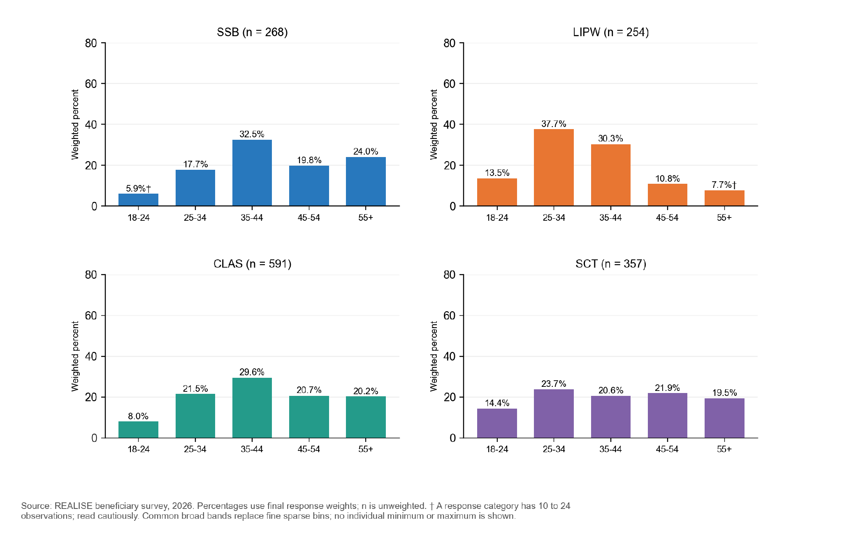
Figure 5.3.2. Education responses are presented in three broad categories, with the original item-specific valid denominators.
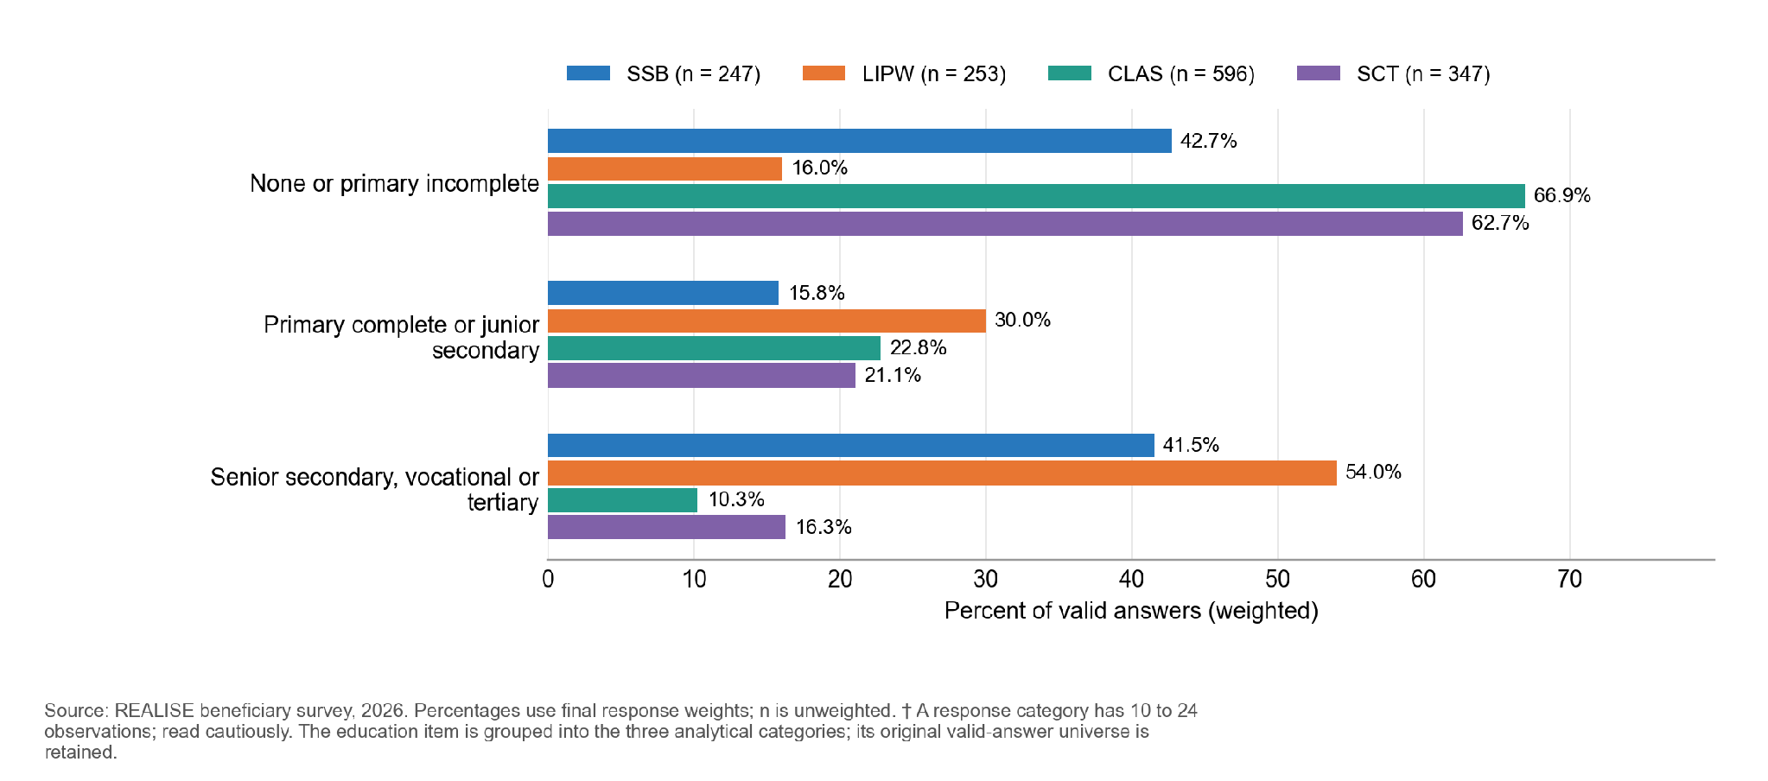

Table 5.3.2. Farming is the main livelihood in CLAS, and business and petty trade in SSB and LIPW
Characteristic | SSB | LIPW | CLAS | SCT
Households with 1 to 3 members (percent) | 14.0 | 20.7 | 13.5 | 23.2
Households with 7 or more members (percent) | 35.9 | 26.6 | 33.9 | 25.8
Main livelihood: farming or agricultural sales | 6.1 | 2.1 | 83.9 | 47.2
Main livelihood: business, self-employment or petty trade | 72.3 | 55.1 | 12.4 | 37.8
Main livelihood: casual wage labour, public works or salaried work | 14.1 | 24.6 | 1.5 | 10.0
Main livelihood: remittances, transfers or no regular cash income | 5.2 | 17.8 | 2.2 | 4.7
Main livelihood: other | 2.2 | 0.3 | 0.0 | 0.3

Household items are weighted among the households that answered (n = 247 in SSB, 253 in LIPW, 596 in CLAS and 347 in SCT, because some items start with a later form version). The Annex F supplement gives the full distribution of every item.
Women make up most respondents in every component: SCT 77.9 percent, SSB 73.5 percent, LIPW 53.6 percent and CLAS 52.3 percent (weighted shares, which restore the frame and so differ from unweighted counts).
No schooling or incomplete primary education is reported by 68.9 percent of CLAS respondents, 62.6 percent in SCT, 42.7 percent in SSB and 15.9 percent in LIPW. These describe the profile at interview, not an effect of support.
Farming is the main household livelihood for 83.9 percent in CLAS and 47.2 percent in SCT; petty trade or retail alone is the main livelihood for 62.8 percent in SSB (72.3 percent including other non-farm business and self-employment, Table 5.3.2). These were measured at interview, may have changed after support, and are not used as pre-programme covariates.
Functional difficulty is reported by 37.2 percent in SSB, 33.9 percent in SCT, 21.6 percent in CLAS and 11.4 percent in LIPW. The SCT item concerns anyone in the household, the others the respondent. The item has no severity scale and is not a Washington Group measure of disability prevalence.
The primary P4 and P5a estimates exclude proxies, so the CLAS valid sample is 553 for each. A record labelled proxy or trustee in a separate profile field is not necessarily an approved proxy. Household headship is not asked.

5.4 Qualitative coverage and scope of interpretation
The documentary inventory contains 61 transcript files, 34 KII and 27 FGD files, across the four components and cross-cutting roles; 60 form the analysed corpus. Thirty-three KII files match core roster identifiers (of 55 planned core interviews); one matches a conditional LIPW provider slot. Twenty-seven of the 29 planned FGD slots have files. The CLAS Laworta file is a partial continuation, so the file count is not a count of complete, independent sessions. Table 4.4 gives the component breakdown. The working analytic register covers 60 transcription units under the common coding framework. One transcript that could not be anonymised is excluded from the analysed corpus; the other sources are individually coded, while missing planned sources and scope ambiguities remain documented.
The final analytical corpus gives substantial evidence about delivery and beneficiary experience. Against the plan, 33 of the 55 core key informant interviews (22 roles not represented) and one additional LIPW provider interview (of 5 planned additional interviews) have a transcript, and 27 transcript files exist for 29 planned focus group discussions, of which 26 form the analysed corpus because one could not be anonymised, and one analysed file continues an earlier discussion (Table 4.4). The 22 core interviews and two group discussions without a transcript are qualitative attrition: the views of those roles are not in the corpus, no other source replaces them, and a finding that would have relied on one of them says so. Annex L, Table L.11 reconciles the planned and completed sources and states how each deviation is treated.
Written site records cover four SSB, four LIPW, five CLAS and four SCT sites and represent 15 of the 16 assigned locations; the identity of the LIPW Boys Town record is uncertain (Section 7.6). Kings Farm and Gbalasuah provide additional observations.
Two completed case observation grids, for SSB and SCT, and one CLAS narrative from Mawayasu in two versions add local detail to the component findings. The linked interviews and document reviews for the six protocol cases are not in the corpus, so these materials illustrate experience and are not read as complete cases. Accounts from the same institution or visit may share one evidence stream, so source strength depends on independence as well as the number of files. The available survey may illuminate a related topic where a qualitative module has limited coverage, but it does not replace an unanswered qualitative question or a missing perspective. Non-beneficiary groups give context on selection and rival explanations; they are not an impact comparison.
The other planned case studies were not completed. Their questions on delivery mechanisms, use of support and continuation are covered by the focus groups, key informant interviews and 17 site records, and the available case materials are used as illustrations only.
The findings use the interviews, focus groups, observations and case material to describe mechanisms and experiences. Where a planned role, group or location is not represented, the relevant conclusion is bounded to the documented sources, and no population prevalence or programme effect is inferred from the purposive qualitative sample.
Table 5.4. Qualitative records cover every component, with some planned slots outside the final corpus
Activity | Planned | Evidence located | Scope for interpretation
Core KII slots | 55 | 33 transcripts | 22 roles not represented in the analysed corpus
Additional CLAS KIIs | 3 required | No transcript in the analysed corpus | Not part of the analysed corpus
Conditional LIPW KIIs | Up to 2 | 1 transcript | One further provider interview is not part of the analysed corpus
FGD slots | 29 | 27 transcript files for 29 planned discussions; 26 form the analysed corpus (one could not be anonymised); one analysed file continues an earlier discussion | Laworta file partial; the transcript that could not be anonymised is outside the analysed corpus
Site locations | 16 assigned | 17 written site records | 15 assigned locations represented; Boys Town site identity uncertain (Section 7.6)
In-depth cases | 6 | 2 grids; 1 narrative | Materials are used as illustrations only; the other planned case studies were not completed (see text)
Reading note: The inventory uses identifiers, file titles, dates and activity type. A file match does not by itself certify a complete session or an approved site substitution.

Chapter 6. Findings: Support to Small Businesses (SSB)

Key findings
- Most beneficiaries reported receiving support and using the grant; rare non-receipt and complementary shares are withheld. The full package they expected reached 56.9 percent, and completing it is the next step, mainly National ID support (received by 70.7 percent of those who expected it) and business registration (83.4 percent) (Section 6.3).
- Payments were on time for nine in ten: 91.5 percent said they always arrived by the communicated date, and every payment was made by mobile money (Section 6.3).
- Households report being better able to meet basic needs (+0.65 on a -2 to +2 scale), with 71.6 percent better or much better off, and a low coping score (4.0 on a 0 to 84 scale). About one in four (24.3 percent) say they are worse off (Section 6.4).
- The grant went mainly into the business: 87.3 percent spent at least part of it on approved business-plan expenses, and 98.4 percent have a mobile-money account in their own name (Sections 6.3 and 6.4).
- Women were 13.2 percentage points more likely than men to receive every expected benefit (60.4 against 47.2 percent), a borderline gap. Sex comparisons for timeliness and account ownership rest on sparse cells, and the coping and basic-needs comparisons do not resolve a difference (Section 6.4).
- The SSB county comparison is exploratory and restricted to Round 3, the only round represented in both counties. Selected receipt, timeliness and account contrasts are withheld to protect small cells (Section 6.4).
- The grade is Moderate for timely payments, and Limited for improved basic needs, food coping, business activity, continuation after support ends and the origin of own-name accounts. Recipients describe business activity and some expansion; sustained growth is not independently measured. Completing the package, above all identification and registration support, is the main action point (Sections 6.6 and 6.7).

6.1 Component overview
Against the programme targets, 4,132 small businesses had been invested in (93 percent of 4,450, 81 percent of them women-led), and all 4,450 households received grant support and business skills training. Annex F, Table 2.9 gives the results-framework indicators for every component.
The survey covers 268 SSB beneficiaries, all answering for themselves: 226 in Montserrado (84.0 percent weighted) and 42 in Margibi (16.0 percent). Round 3 is about half of the weighted sample (49.1 percent); Rounds 1 and 2 are 24.5 and 26.4 percent.
Every Margibi respondent was enrolled in Round 3, whereas Montserrado respondents come from all three rounds, so a county difference in this chapter is partly a round difference. Annex F gives the respondents by county, round and respondent type.

6.2 Who was reached
Women were 218 of 268 respondents (81.3 percent), in line with the 80 percent allocation; weighted to the beneficiary list they are 73.5 percent, with almost the same share in both counties.
Mean age is 44.4 years, and 23.7 percent are aged 18 to 34. Margibi beneficiaries are younger (40.1 against 45.2 years in Montserrado). 88.8 percent worked in the past 7 days.
Education is the clearest difference between women and men: 66.2 percent of men completed senior secondary, vocational or tertiary education, against 32.2 percent of women. 37.2 percent of respondents report at least one functional difficulty; the item has no severity scale, so this is not a disability prevalence.
Margibi respondents are more often partnered (76.2 against 56.4 percent in Montserrado), partly a round difference.
The detailed table is in the Annex F supplement (Table 6.2.1).

Households have a mean of 5.8 members. Business, self-employment or petty trade is the main livelihood for 72.3 percent (79.1 percent where a woman responded, 54.3 percent where a man responded), and farming for only 6.1 percent. Households of male respondents rely more on casual wage, public-works or salaried work (25.1 against 10.0 percent). The Annex F supplement gives the household profile in full.

Figure 6.2.1. Share choosing "Very fair", by respondent sex. The other response categories are not displayed separately.
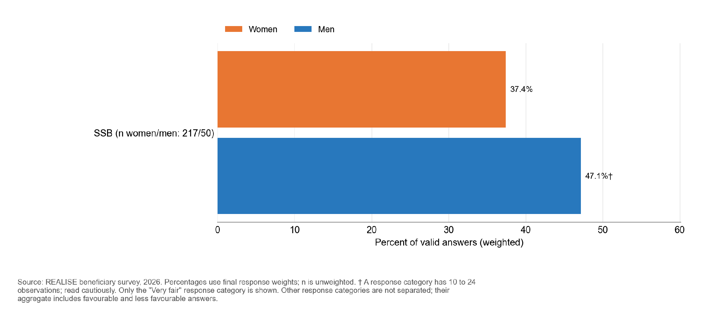

Among 267 valid SSB answers, 98.2 percent rated selection as fair or very fair, and 40.0 percent chose specifically very fair: 37.4 percent of women and 47.1 percent of men. The remaining response categories are withheld because some sensitive cells are small. This describes selected beneficiaries rather than exclusion.
No SSB respondent reported being asked for an informal payment, gift, favour or political support to apply, be selected, attend training or receive the benefit (267 valid answers: 217 women, 50 men; 0 don’t know or refused). The table is in Section 10.1.
Fairness ratings come from selected beneficiaries: applicants who were screened out or lost the lottery are outside the survey, and requests for informal payments may be under-reported. Interview accounts describe the lottery and recruitment as legitimate, with some information and access problems. One recruitment informant reports that the priority for women was understood in some communities as female-only eligibility, and the teams explained the rule: “for certain communities they were only accepting women and we have to explain that women are only privilege but men are also included” (SSB-KII-038, P0154). A focus group describes priority for vulnerable and older people: “They made them a priority. They also considered the older people who were there.” (SSB-FGD-004, P0199). The accounts show the targeting message had to be repeated in some communities, and the survey finds no sign that selection was disputed by those it reached.

6.3 Delivery pathway
Most SSB beneficiaries reported receiving support and using the grant; rare non-receipt and complementary stage shares are withheld. Among those expecting a specific benefit, 56.9 percent received every benefit they expected. The package was often incomplete despite broad reported access.
Of 264 valid answers, 246 respondents (91.5 percent) said payments always arrived by the communicated date; the combined not-always share was 8.5 percent (18 answers, indicative category). Finer timing categories are withheld. Every respondent expecting a time-bound payment reported that a schedule had been communicated.
Table 6.3.1. Nearly every SSB beneficiary received and used the grant, but 57 percent received everything they expected
Indicator | Value % (n) | Women | Men | Note
Expected at least one benefit | 99.6 (268) | - | -
Received at least one benefit | Suppressed | - | - | Rare non-receipt and complementary stage shares are withheld.
Used the grant | Suppressed | - | - | Rare non-receipt and complementary stage shares are withheld.
Received every benefit expected | 56.9 (267) | 60.4 | 47.2 | Women 13.2 points higher
Payments always on the communicated schedule | 91.5 (264) | Suppressed | Suppressed | Sex comparison limited by sparse outcome cells
Reading note: the first three rows are shares of all respondents; full receipt and on-time payment use their own valid answers. Annex F gives the stage-by-stage transitions.

Figure 6.3.1. In SSB, 56.9 percent of beneficiaries received every expected benefit, and 91.5 percent were always paid on schedule.
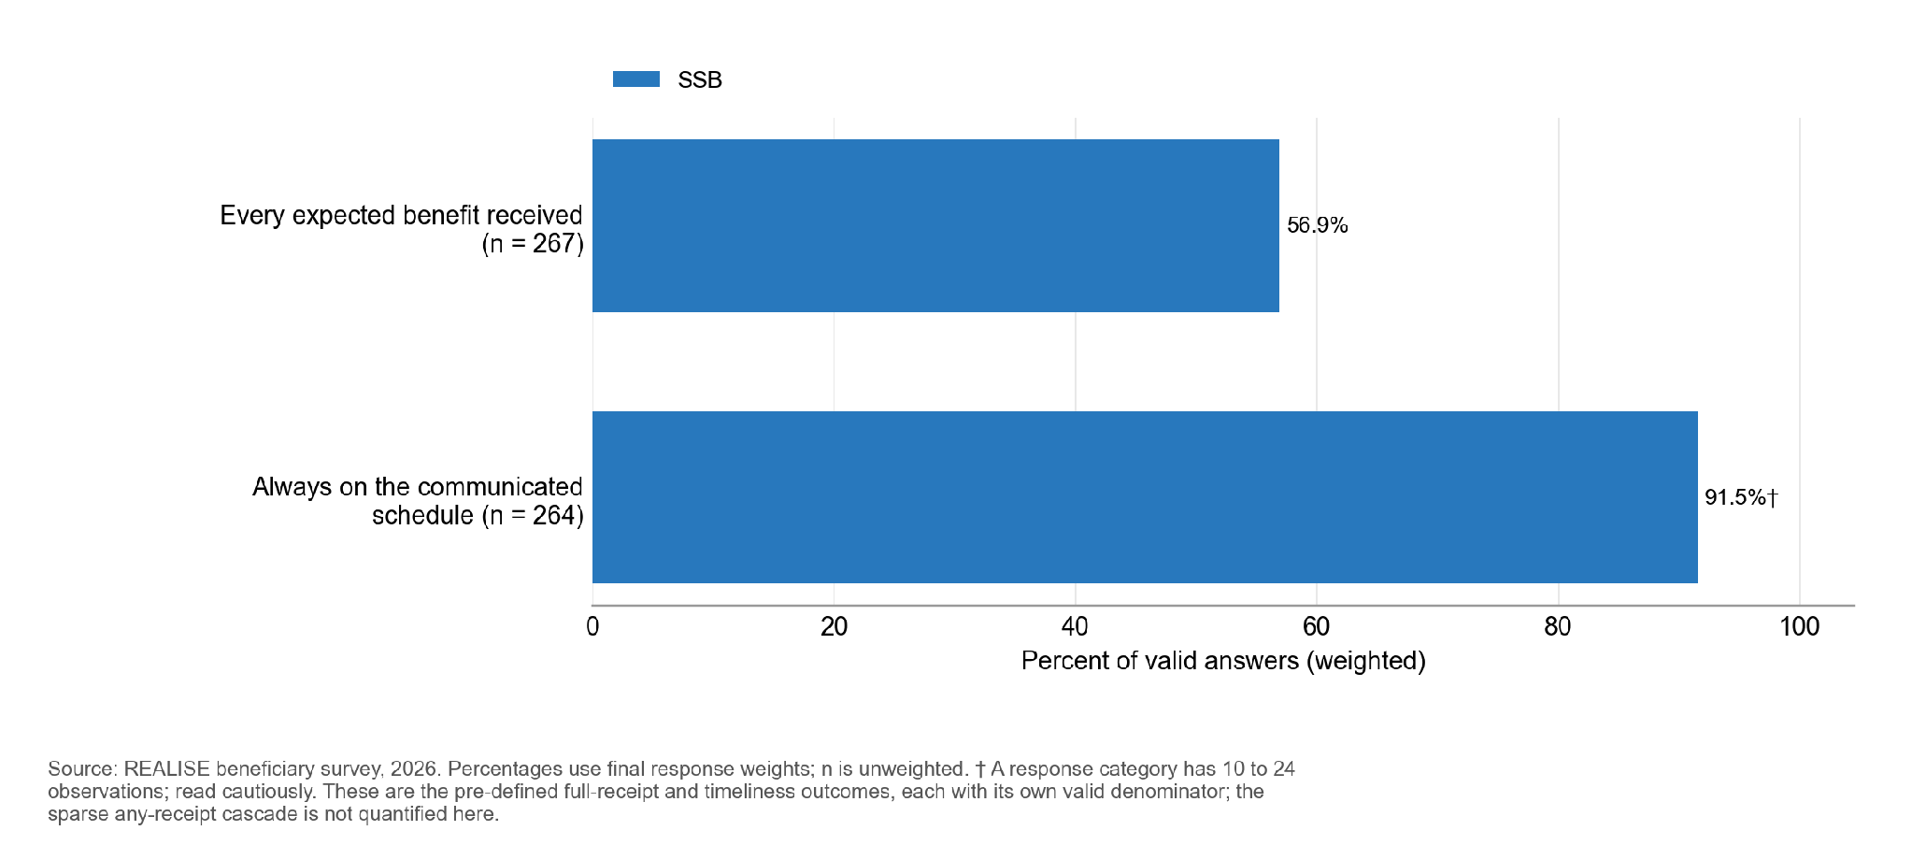
Annex F, Table 6.3.2 shows where the package was incomplete. Among those who expected each benefit, receipt was highest for the second grant tranche (95.9 percent), mentoring and follow-up (95.5 percent) and business-plan support (95.3 percent), and lowest for National ID or NIN support (70.7 percent), business registration or formalisation (83.4 percent), the first tranche (84.4 percent) and the completion certificate (84.8 percent). Identification and formalisation services, the least tied to the grant itself, account for most of the shortfall. Training reached most beneficiaries: 92.3 percent received business management and financial literacy training, including 93.7 percent of those who expected it. Recipients describe the identification service where it was delivered: “for me I never had a citizen ID card, but we were able to get it through them” (SSB-FGD-001, P0226); another group says the programme “brought the service here for those who did not have it” (SSB-FGD-003, P0297). An implementer notes that the identification card and a mobile-money number verified in the owner’s name are also what allow a business to be registered (SSB-KII-010, P0138), which links the two largest gaps.
Two patterns reflect how respondents recalled the package. First, more respondents report receiving the second tranche (90.7 percent) and the completion certificate (80.1 percent) than report expecting them at joining (68.6 and 67.9 percent), and most of the others still received them (79.2 and 70.2 percent), which suggests that many beneficiaries learned of the later stages after joining. Second, fewer report receiving the first tranche (82.8 percent) than the second, although the second depends on the first. Most of those who did not report the first tranche report the second (68 percent), and 10 of the 14 who listed neither report an SSB mobile-money payment elsewhere in the interview. The first-tranche gap is consistent with some respondents treating the two payments as one; dated individual payment records by round would show the exact dates.
The detailed table is in the Annex F supplement (Table 6.3.2).
Figure 6.3.2. The largest gap between benefits expected and received in SSB is national ID or NIN support (69.5 percent expected, 50.1 percent received).
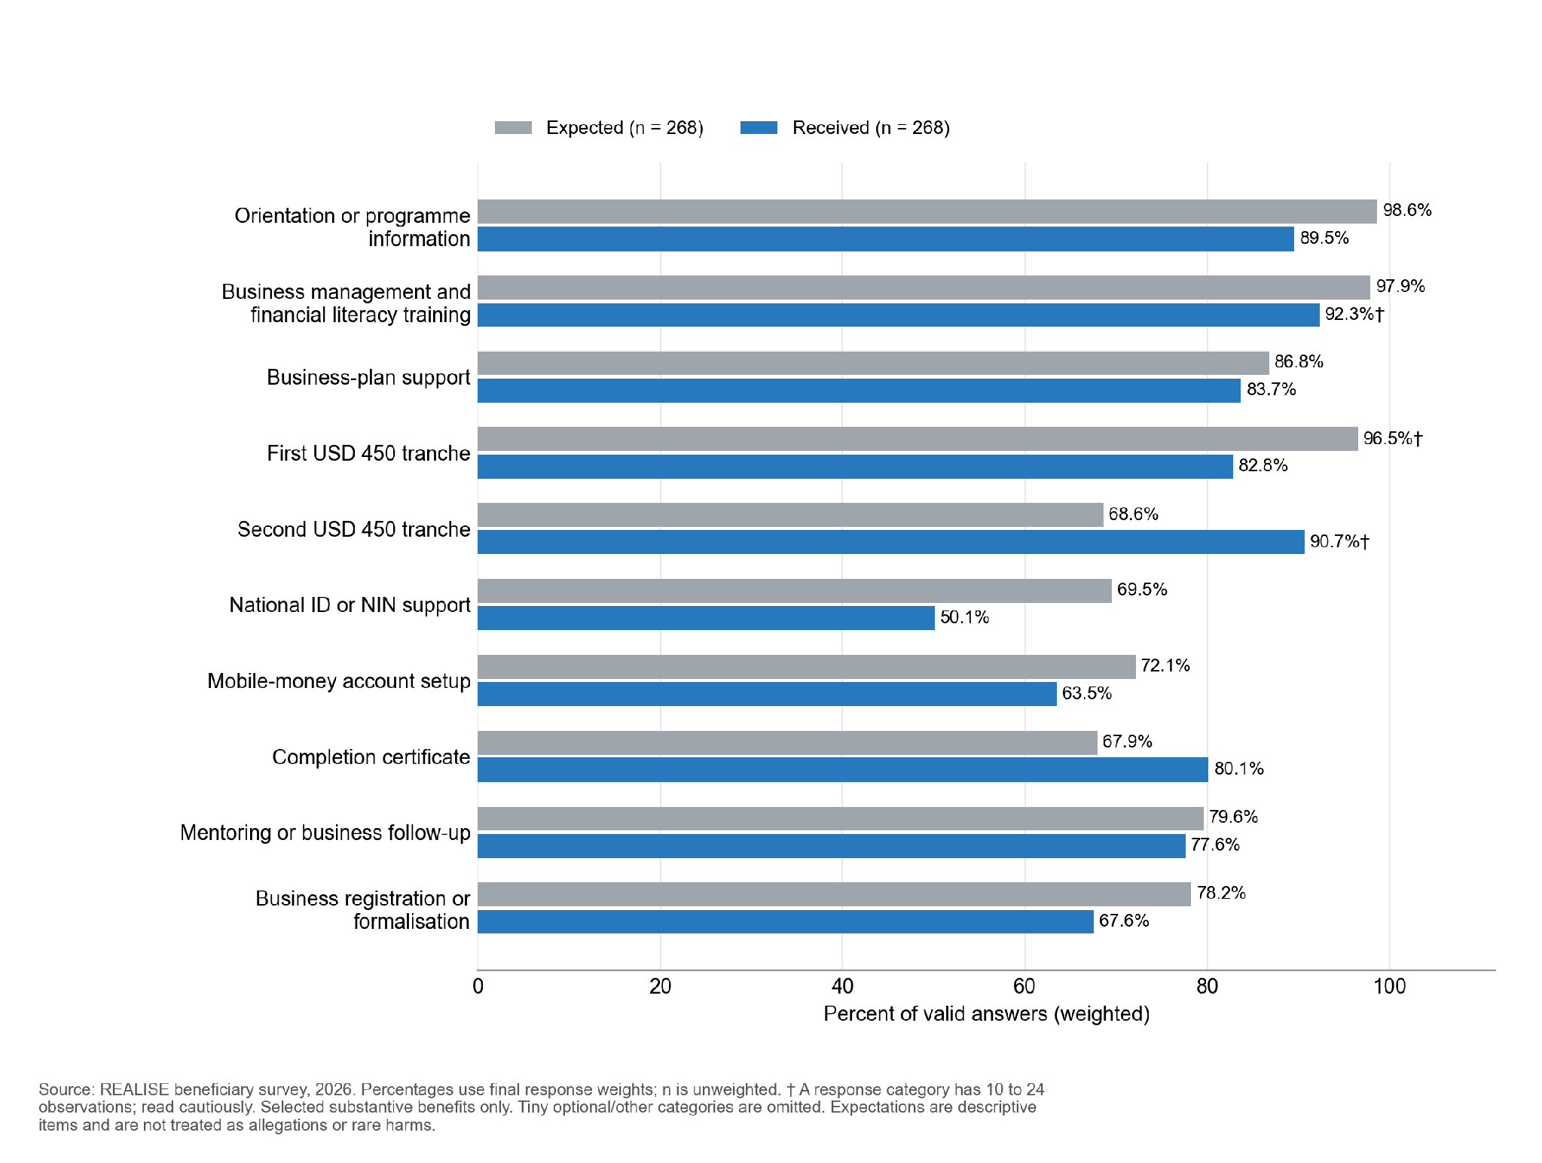
Mobile money was the reported channel among SSB payment recipients. Rare non-receipt is not quantified. No respondent reported cash, bank or other channels. None selected in-person training or service delivery either, which suggests respondents read the payment-channel question as one about grant payments only.
Figure 6.3.3. Payment timeliness is grouped into always on time and the combined remaining timing responses.
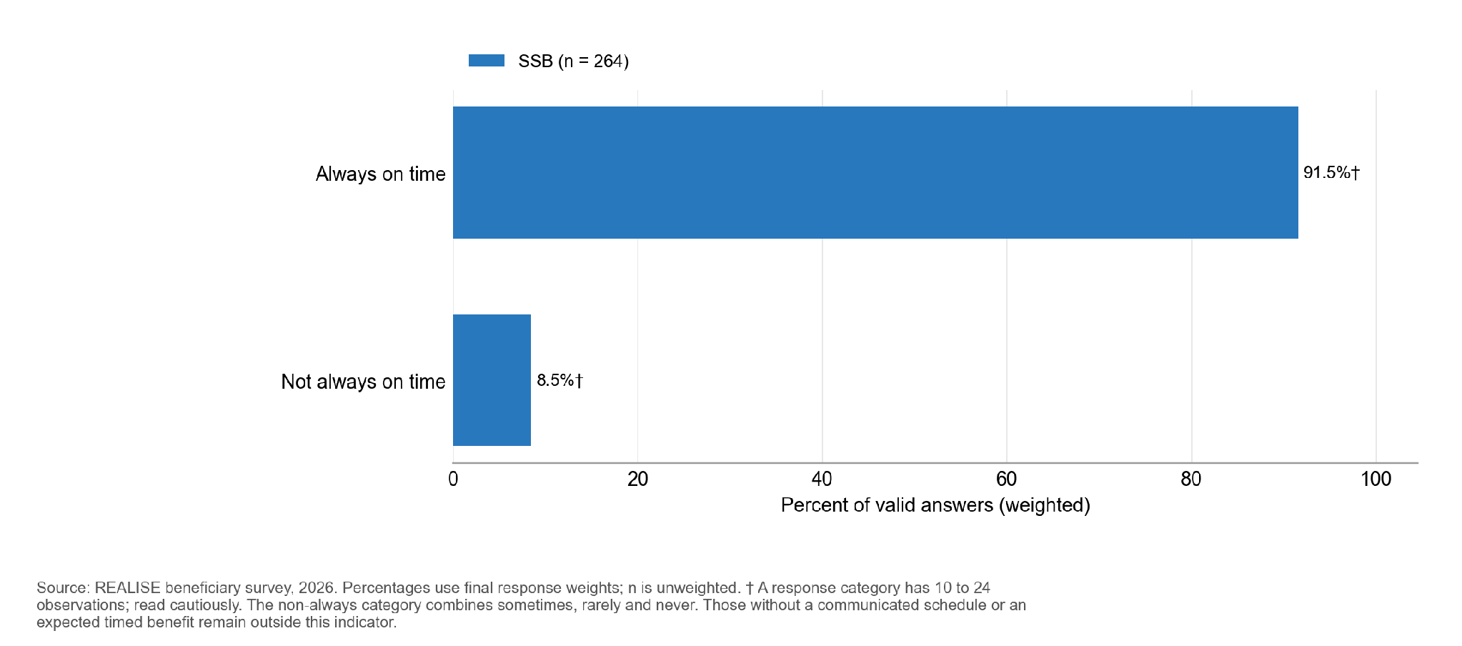
Most respondents used the grant for their business: 87.3 percent spent at least part of it on approved business-plan expenses (89.6 percent of women and 80.9 percent of men) and 32.6 percent on other business expenses. 27.4 percent spent some on health or education, 26.8 percent on household food or consumption and 23.7 percent saved some or all of it; shares overlap. Business uses are 57.5 percent of all uses mentioned. The survey records whether each use occurred, not how much was spent, so it does not show what share of the grant went to the business. The high share spending on approved business-plan items is consistent with beneficiaries having taken up the programme’s message that the grant was for business investment.
The detailed table is in the Annex F supplement (Table 6.3.3).
Figure 6.3.4. Selected substantive uses of the SSB grant; rare no-receipt and other categories are withheld.
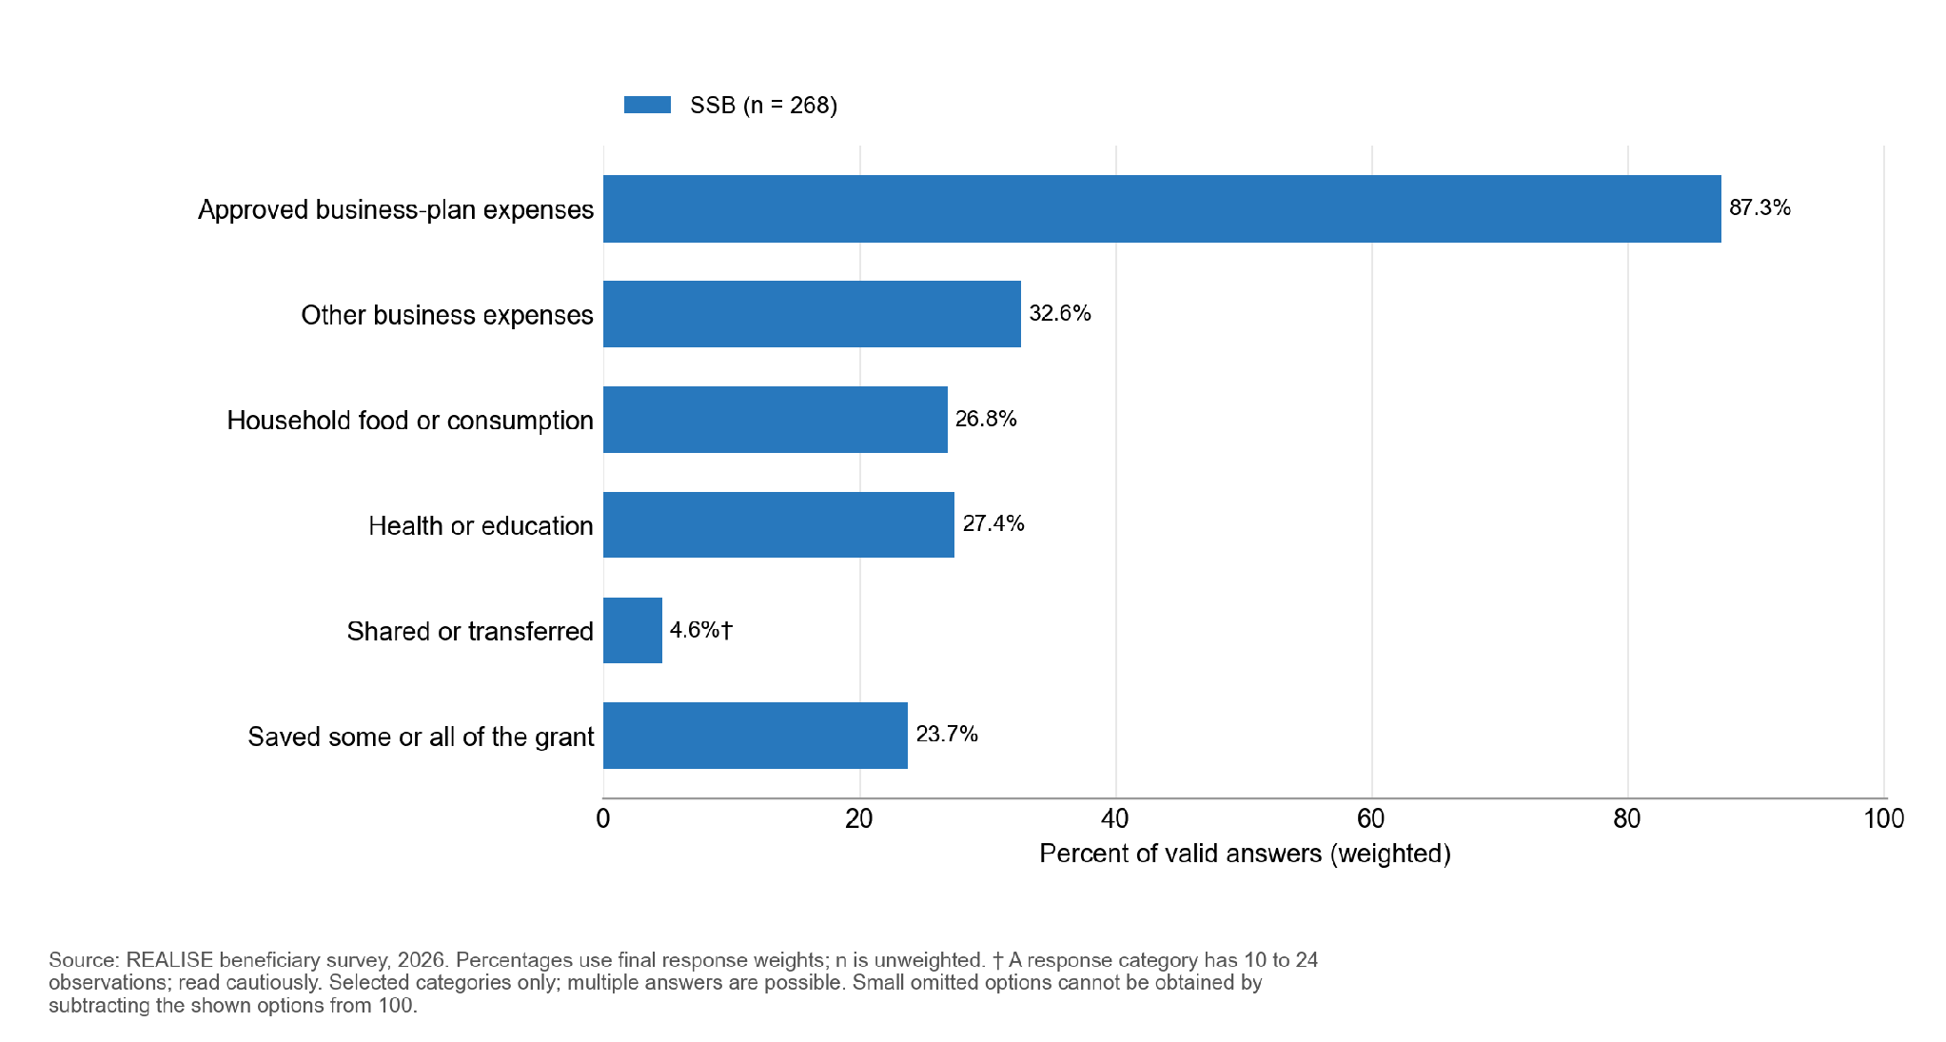

Among 264 valid SSB answers, 83.3 percent said the respondent alone made the final decision on grant use. The corresponding weighted shares are 85.6 percent in Rounds 1 and 2 combined (n=124) and 80.9 percent in Round 3 (n=140). These are descriptive comparisons. Separate round and sex decompositions, joint decisions and other deciders are withheld to protect small categories. The women’s empowerment measures are in Section 10.2.

6.4 Outcomes
Table 6.4.1. SSB households report better ability to meet basic needs, and almost all hold their own mobile-money account
Outcome | Value (n) | Women | Men | Note
Coping-days score, 0 to 84 (lower is better) | 4.0 (268) | 3.9 | 4.4 | No significant difference by sex
Change in ability to meet basic needs, -2 to +2 (higher is better) | +0.65 (267) | +0.64 | +0.66 | No significant difference by sex
Better or much better off (%) | 71.6 (267) | 72.7 | 68.6
Worse or much worse off (%) | 24.3 (267) | 24.1 | 24.7 | About one in four
Mobile-money account in own name (%) | 98.4 (268) | Suppressed | Suppressed | 89.1 percent of these accounts are active
Women’s self-efficacy, 8 to 40 | 35.0 (217) | 35.0 | - | Women only
Reading note: the change in basic needs excludes proxy interviews. Table 6.4.2 gives the differences by sex and county with their tests.
Few SSB households used food coping strategies in the past week. The mean coping-days score is 4.0 on a 0 to 84 scale, and about two-thirds of households score below 3 (Figure 6.4.1), with a highest score of 36. The most common strategy was cheaper, less preferred food (32.2 percent), followed by reduced portions (29.0 percent) and fewer meals (26.8 percent); 7.2 percent spent whole days without eating. Annex F gives all twelve strategies.
Households report a net improvement in their ability to meet basic needs since receiving SSB support: the mean change is +0.65 on a -2 to +2 scale. About seven in ten (71.6 percent) say they are better or much better off, and about one in four (24.3 percent) say they are worse off (Table 6.4.1). Interviews give some reasons: an informant describes a business that closed because the grant was not enough to keep it going (SSB-KII-052, P0182), and focus group participants describe theft, a demolished market table and illness as setbacks (SSB-FGD-006, P0205; SSB-FGD-004, P0365; SSB-FGD-003, P0258). The survey cannot say how many of the worse-off households these reasons cover. The change in basic needs is a retrospective self-report, so it is read together with the interview accounts rather than alone. Rival explanations are in Section 6.6.
Almost every respondent has a mobile-money account in their own name: 98.4 percent, and 89.1 percent of these are active. The survey measures current ownership, so it does not show how many accounts SSB created (Section 6.6).

Figure 6.4.1. The coping-days distribution is shown in broad common score bands, preserving the original primary outcome and valid-answer universe.
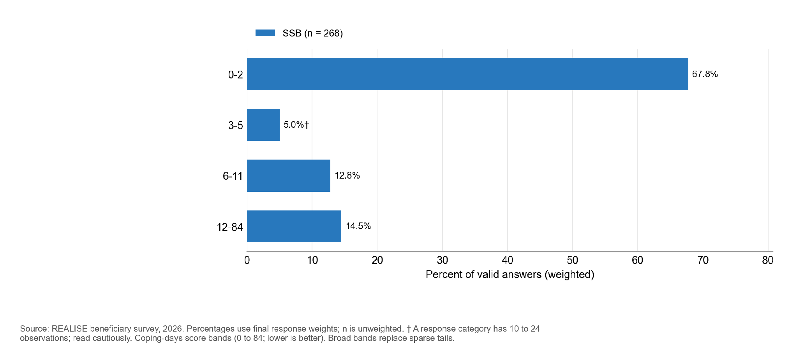

For timeliness and own-name account ownership, sparse outcome cells limit the sex comparison. The coping and basic-needs comparisons do not resolve a difference. The largest difference is in whether beneficiaries received every benefit they expected: 60.4 percent of women did, against 47.2 percent of men, a gap of 13.2 percentage points. The gap is borderline: it is distinguishable from zero with the finite-population correction of the sampling plan (95% interval 1.7 to 24.7 points; q = 0.028) and not without it (95% interval -1.6 to 28.1 points), so it is read as suggestive (Table 6.4.2).
The exploratory within-Round-3 comparison shows a lower reported basic-needs change in Montserrado than Margibi by 0.57 points. The full-receipt, timeliness and account comparisons are withheld to protect small cells.
These county comparisons are descriptive. Round, service provider or time since support may explain them as much as county, and they are not programme effects. Receipt of the full package also rises across rounds, from 34.5 percent in Round 1 to 62.0 and 65.4 percent in Rounds 2 and 3, and the basic-needs change from +0.24 to +0.67 and +0.84.
Table 6.4.2. Women received the full package more often than men; Round 3 county contrasts are exploratory
Outcome | Women compared with men | Montserrado compared with Margibi (Round 3)
Received every expected benefit | +13.2 percentage points; clear only with the finite-population correction | Withheld: small cells
Payments always on schedule | Withheld: small cells | Withheld: small cells
Coping-days score (0 to 84) | -0.44; uncertain difference | +0.86; uncertain difference
Change in basic needs (-2 to +2) | -0.02; uncertain difference | -0.57; nominal interval excludes zero
Mobile money in own name | +0.5 percentage points; comparison limited by sparse cells | Withheld: small cells
Women’s self-efficacy (8 to 40) | Not reliably estimated | +0.18; uncertain difference
Reading note: A clear difference remains distinguishable from zero after allowing for the number of comparisons; an uncertain difference is not proof of equality. The women-minus-men gap in full receipt is clear with the finite-population correction of the sampling plan and uncertain without it. The Round 3 county contrasts are exploratory and their intervals are nominal. Full intervals and tests are in the Annex F supplement.
Of 223 households with a food consumption score, 69.9 percent are in the acceptable category (a score above 35 on the standard food consumption scale), 15.9 percent borderline (above 21 to 35) and 14.3 percent poor (21 or below): about one in seven has poor food consumption. The mean score is 48.9, and households ate from 6.6 of 12 food groups on average (HDDS). Annex F gives the scores, the coping strategies and the source of each food group.

Figure 6.4.2. An acceptable food consumption score is recorded for 69.9 percent of SSB households, a borderline score for 15.9 percent and a poor score for 14.3 percent.
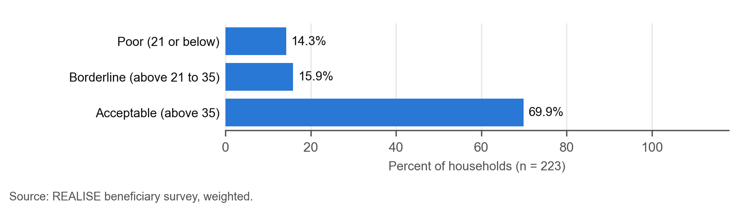

6.5 Mechanisms and variation

The synthesis of the 60 registered transcription units (SSB: five key informant and six focus group files), read with four site-visit sheets and one case grid, gives accounts for each of the three SSB mechanisms: liquidity, business capability and productive investment. Counts describe files, not confirmations.
Liquidity. The grant arrived mostly on time and entirely by mobile money. Direct recipients describe two payments of USD 450 each: “the money we got two times. It was by installment and it was $450 each. For me I had a mobile account” (SSB-FGD-001, P0220). Some describe a late second tranche: “the second payment did not come at the expected time. It was delayed. It was delayed completely, but eventually it came.” (SSB-FGD-004, P0222; SSB-FGD-003, P0279). The interviews do not explain why part of the grant went to items outside the approved plan or to household consumption.
Business capability. 92.3 percent report receiving business management and financial literacy training. A recipient describes a specific business skill applied after training: “If I notice that five people keep asking for the same specific product, I track it, and at the end of the day I go to the market and purchase it.” (SSB-FGD-003, P0213). Accounts of continuing mentoring differ between institutional and beneficiary sources.
Productive investment. 87.3 percent report spending on approved plan items, but amounts, business status, sales, profit and survival were not surveyed. Four visit sheets and one case grid record businesses operating at the visit, which supports a statement about current activity (Section 6.6).
Income and employment. Recipients link the business to income they can plan with. One says “I was able to buy half a block of land and I am still doing my business” (SSB-FGD-001, P0198); another that “the business has improved” and her children are in school (SSB-FGD-001, P0235); a third built a bedroom house and no longer pays rent (SSB-FGD-001, P0271). Key informants describe work created around the businesses: women making bricks with one or two paid helpers, and mobile-money booths left in someone’s charge (SSB-KII-009, P0171). A programme informant expects owners to take on one person first and more as the business grows (SSB-KII-010, P0249 and P0250). The survey did not measure sales, profit or the number of paid helpers, so these accounts illustrate the income and employment pathway without sizing it.
Women’s self-efficacy. On the eight-item scale (8 to 40), women score 35.0 and 93.7 percent score 32 or higher; the score is the same in Margibi and Montserrado. Accounts of decision-making vary by household. A single mother says she decides everything: “As a single mother I make decisions on everything because I am the husband and the mother.” (SSB-FGD-001, P0319). A married participant decides for her business but not at home: “I can make decisions for my business, but in the home, my man makes the decision.” (SSB-FGD-001, P0327). Men in another group describe shared control: “So no one person has all the control.” (SSB-FGD-004, P0325).
Negative cases. Adverse accounts exist. One informant describes a closure: “he had to leave the business and the business shut down and he went back in the bush to go and hustle.” (SSB-KII-052, P0182). The synthesis also records theft, insecure selling space, inflation and illness as threats to continuity. These accounts do not estimate frequency.
Existing versus new businesses. The survey cannot tell them apart. Interviews and visit sheets describe both, but no strand or record separates them systematically. A case grid notes reinvestment as self-reported and without written financial records (CASE-SSB-01, P0093).

6.6 Records, observation and rivals

The survey adds how common shocks, remittances and other assistance are (rival explanations), current own-name account ownership, and comparisons of delivery and outcomes that the evaluation expected to see if the programme pathway held (the mechanism contrasts). The expectation was a lower coping score where receipt and timing held, a larger change in basic needs where support was received and used, and higher own-name account ownership and women’s self-efficacy where the matching exposure occurred (Table 3.2).
Site visits. Four visit sheets (three in Montserrado, one in Margibi) and one case grid record what was observed on the day. All four businesses were open with goods displayed, and the owners were serving customers (SV-SSB-01, P0033; SV-SSB-02, P0034; SV-SSB-03, P0034; SV-SSB-04, P0034). Owners at two visits and in the case grid reported using sales proceeds to restock (SV-SSB-03, P0052; SV-SSB-04, P0052; CASE-SSB-01, P0093), and a woman was observed managing the business and serving customers (CASE-SSB-01, P0097). At two visits, customers had difficulty reaching the business for safety reasons (SV-SSB-02, P0057; SV-SSB-03, P0057). The visits show businesses in operation; they do not measure sales, profit or survival.
Shocks and other support were common. In the past 12 months, 86.6 percent of households experienced at least one shock, most often illness (52.9 percent), food or input price rises (44.5 percent), theft or loss of assets (28.3 percent) and flood or weather shocks (24.4 percent). Since joining SSB, 36.3 percent received remittances or help from family or friends and 21.7 percent had wage or public-works income. Few respondents reported formal assistance; the estimates for government or NGO help and support from another REALISE component are withheld because outcome cells are small (Annex F, Table 6.6.1).
Other programmes are therefore a weak rival for SSB outcomes, but family support and other earnings are not. Widespread shocks make a general improvement in conditions an unlikely explanation for the favourable basic-needs result, but do not rule out other income sources. The survey measures current business activity and account ownership, not prior business strength (the main rival for business outcomes) or mobile-money ownership before SSB (the main rival for own-name account ownership); interviews describe both. Interviews name inflation, insecure selling space, theft and illness as conditions that affect continuity (SSB-FGD-006, P0205). Seasonality and prices are not measured in the survey.

The detailed table is in the Annex F supplement (Table 6.6.1).
Figure 6.6.1. Selected shocks reported over the past 12 months; small categories are withheld.
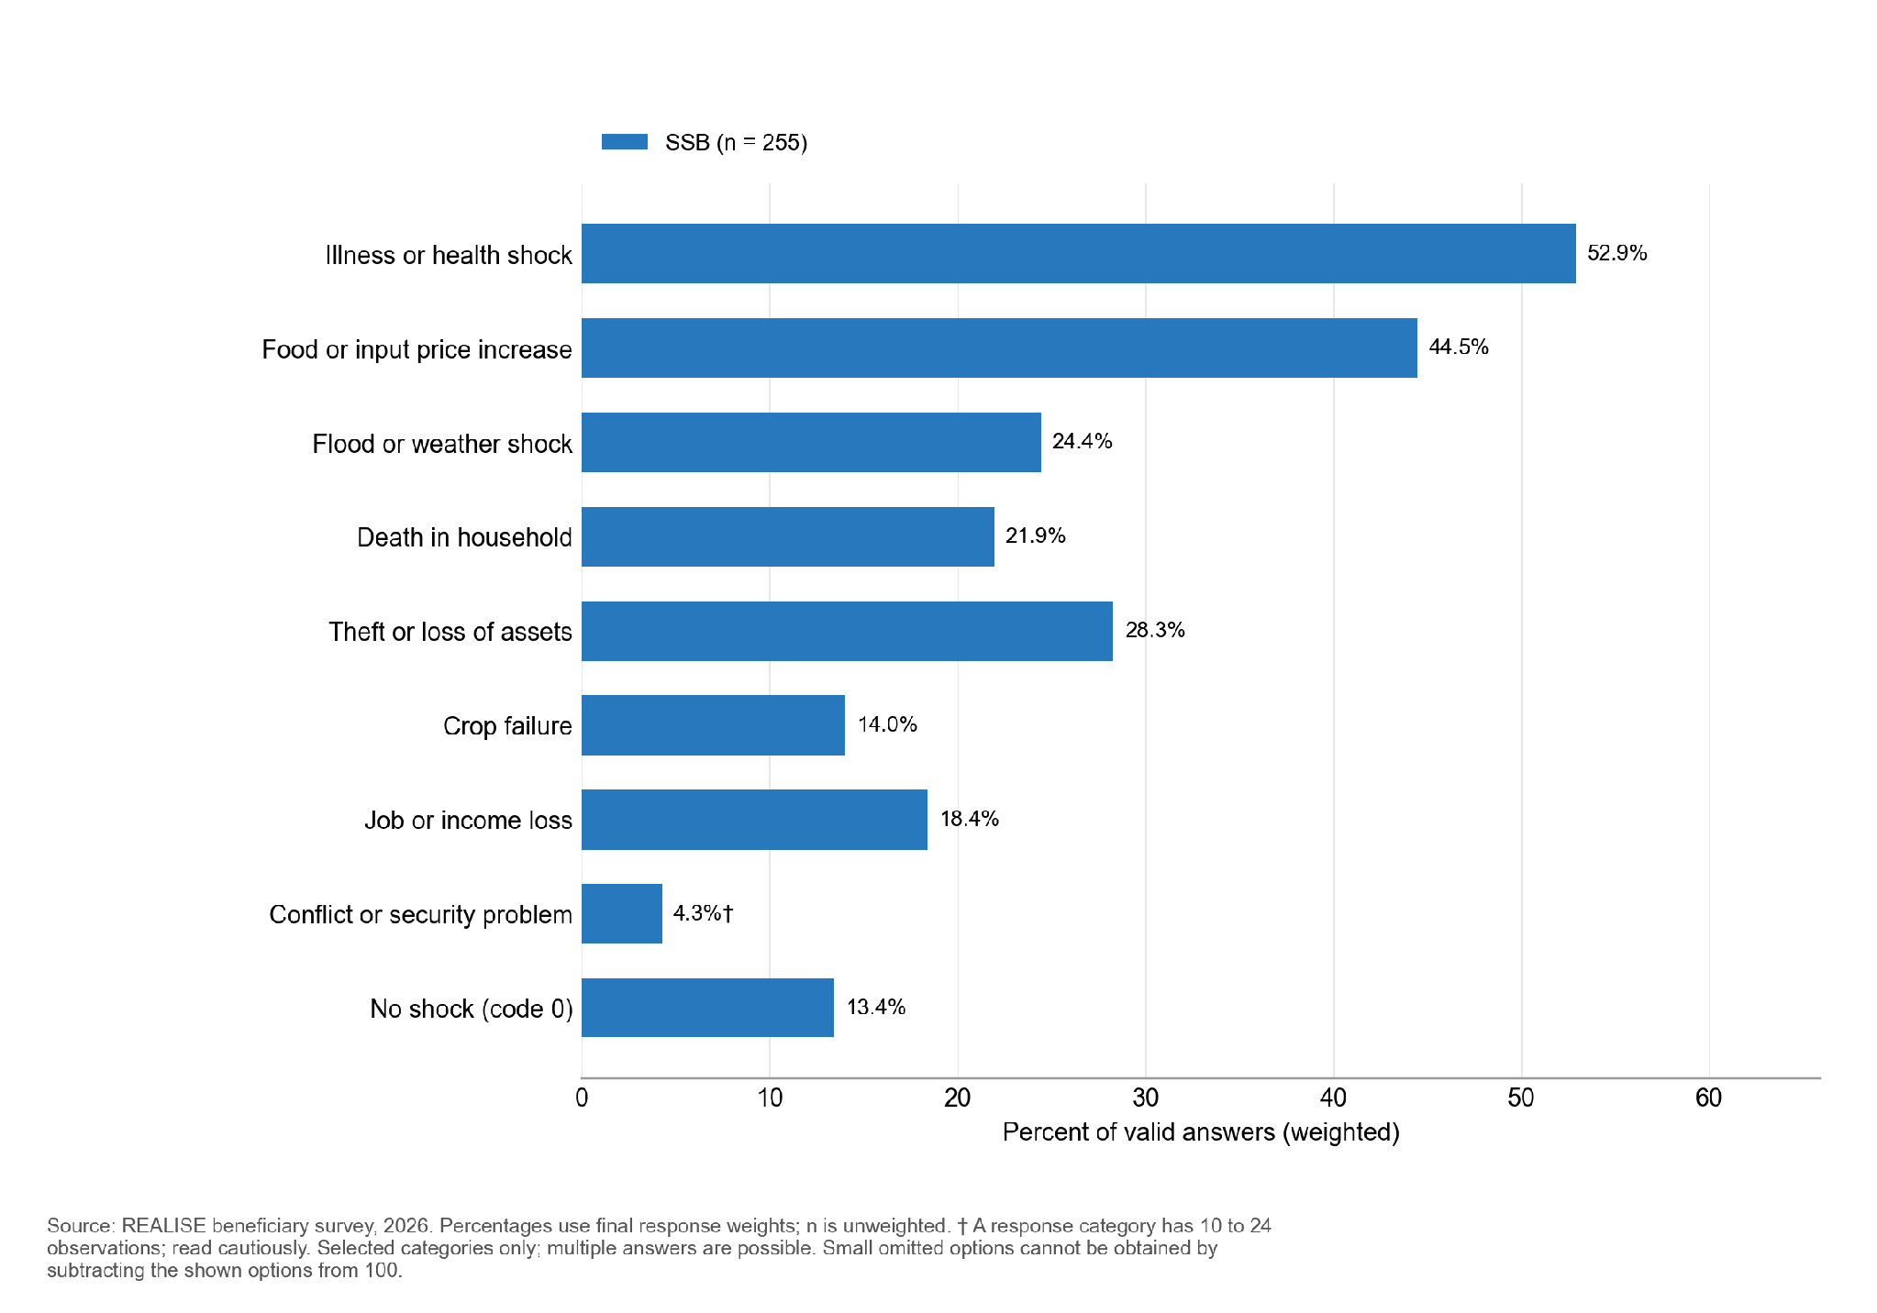
Figure 6.6.2. Since joining, SSB respondents most often received other support from remittances or help from family or friends (36.3 percent); 36.3 percent received none.
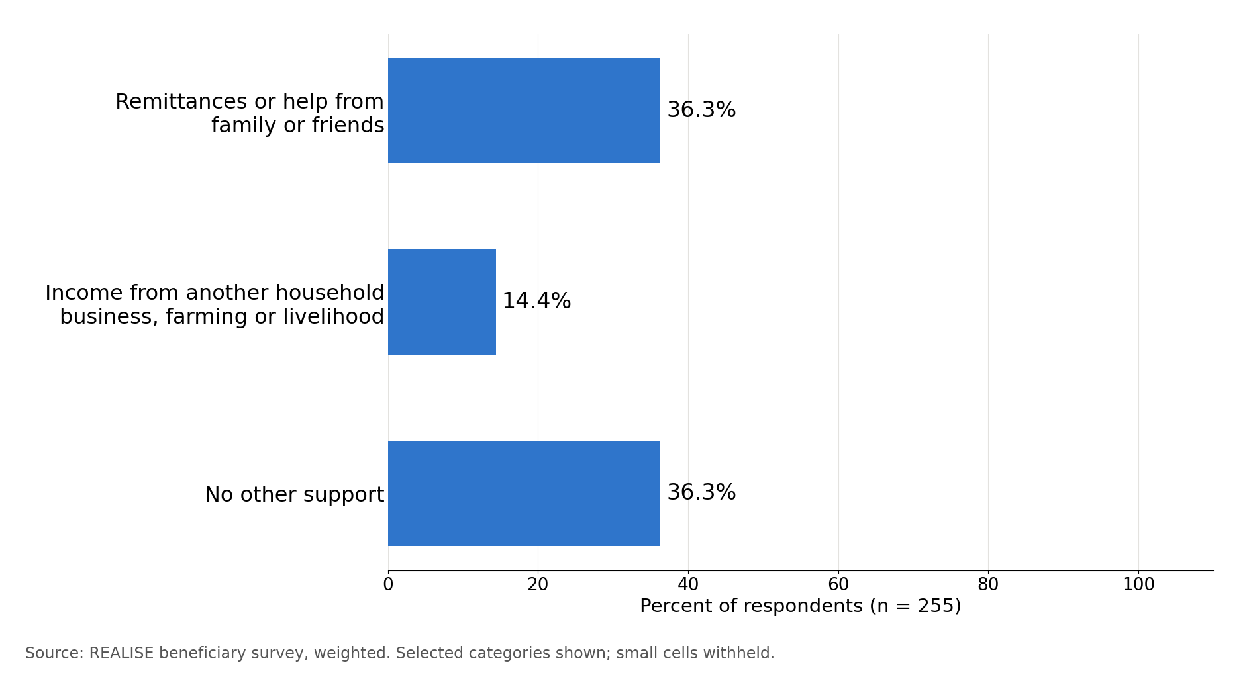
Within SSB, respondents who received every expected benefit and used the support reported an improvement in basic needs larger by 0.44 points, after allowing for county, round, sex and age group. The community-clustered interval includes zero, from -0.01 to +0.90 (Annex G). Complete and timely delivery was associated with a coping score 0.89 points lower, but that difference is uncertain. The patterns differ across components. These are associations, and the Annex F supplement gives the unadjusted results, intervals and tests (Tables 6.6.2 and 6.6.3).
The own-name account contrast cannot be assessed in SSB: one payment-exposure arm is below 10, with its exact size withheld. The self-efficacy contrast compares women’s self-efficacy between the 194 women who had their own or joint say over the use of the grant (average score 34.9) and the 19 women where someone else decided (37.7). The comparison runs opposite to the expectation, but with only 19 women in the second group it is descriptive and is not read as evidence either way.
These associations are consistent with a link from delivery to basic needs but do not establish it: exposure and outcome are both self-reported in the same interview.
The detailed table is in the Annex F supplement (Table 6.6.2).
Table 6.6.3. After adjustment, the SSB association between complete delivery and basic needs is positive, but its community-clustered interval includes zero
Hypothesis and outcome | Exposed n | Not exposed n | Adjusted difference (95% CI) | p | Interaction p
H3. Coping score (P3) | 150 | 114 | -0.89 (-2.12, 0.34) | 0.155 | <0.001
H4. Basic-needs change (P4) | 158 | 109 | +0.44 (0.24, 0.65) | <0.001 | <0.001
H5a. Own-name mobile money (P5a) | Withheld (sparse comparison) | Withheld (sparse comparison) | - | - | <0.001
H5b. Women’s self-efficacy (P5b) | 194 | 19 | - | - | <0.001
Reading note: Coping compares complete, timely delivery with other delivery experiences; basic needs compares receipt and use with incomplete receipt or non-use. Account ownership compares payment by mobile money with no payment; self-efficacy compares women with their own or joint say over support use with women without it. These are adjusted associations, not causal effects. Full estimates and the overall comparison across components are in the Annex F supplement.

6.7 Contribution assessment
Claim. SSB contributed to improved ability to meet basic needs among beneficiary households, through training and grants that were delivered completely and on time and used in the business. Financial inclusion is graded as a separate claim.
Reported outcomes. Households report a net improvement in basic needs (+0.65) and low coping scores (4.0), but 14.3 percent have poor food consumption and about one in four report being worse off. Visit sheets and the case grid record businesses open and selling at the visit; they do not establish survival, net jobs or sales (CASE-SSB-01, P0086).
How the support may have contributed. Access is met: most respondents received support and used it. Completeness is partly met: full receipt is 56.9 percent, with shortfalls in national ID support, formalisation and reported first-tranche receipt. Timeliness is met (91.5 percent). Business use is reported by 87.3 percent. Households that received and used the full package report more improvement (+0.44); the community-clustered interval (−0.01 to +0.90) includes zero, so the link is suggestive; the link to coping is inconclusive. Interviews describe two grant payments with variable timing, training applications and reinvestment (Section 6.5).
Rivals and contradictions. Shocks affected 86.6 percent of households. Family support (36.3 percent) and other earnings are possible contributors; other programmes are rare. Prior business strength cannot be tested in the survey. Interviews add theft, closures, inflation and reliance on further assistance as threats to continuity, and describe pre-existing businesses; payment and delivery records by round would help separate these.
Evidence used. Survey (this chapter) + SSB key informant interviews and focus groups (five KII and six FGD files) + partial round-level PMT mobile-money records for Rounds 1 and 2 and the undated initial payroll for Round 2, with no complete dated individual payment register that could be matched to respondents; delivery and grievance records are under Recommendation R16; site observation (four visit sheets and one case grid).
Reviewed contribution assessment. The assessment is Moderate for reported payment timing, and Limited for basic needs, receipt of every expected benefit, food coping, business activity and continuation. Recipients connect grants and trade to household expenditure, and some report delays or remaining needs. Prior business activity, other income and shocks remain relevant explanations.
Conclusion. SSB recipients describe timely initial payments, business activity and using proceeds for household needs. The contribution evidence is graded Moderate for timing, and Limited for basic needs, the complete package, food coping and business activity; these are contribution assessments, not estimates against a comparison group.
Financial inclusion. 98.4 percent of beneficiaries have an own-name mobile-money account, and 89.1 percent of these are active. Without evidence on ownership before SSB, the survey cannot attribute ownership to the component. Interviews differ: some participants already held an own-name account, others recall opening one at registration (see Section 10.2). Account-opening records would show which accounts SSB created; the account-ownership claim is graded Limited (Table 11.2).
Delivery priority. The survey shows that the main gap was not getting into the programme or receiving support on time. It was that many respondents did not report receiving every benefit they expected. The gaps were largest for help getting ID documents and registering businesses. Many beneficiaries also seem not to have known, when they joined, that the programme had later stages, which suggests it did not explain clearly enough what it would provide. Delivery records by county and round (Recommendation R16) would show where in the process the package was lost.
Finding. SSB reached nearly all beneficiaries interviewed and recipients describe using business proceeds for household needs. The assessment is Moderate for timely payments, and Limited for basic needs, full-package receipt, food coping and business activity. Identification and registration support are priorities to strengthen.
Findings by OECD-DAC criterion. Table 6.7.1 reads the SSB findings against the six criteria. Grades are in Table 11.2.
Table 6.7.1. SSB reached nearly everyone and paid on time; completing the package, above all identification and registration support, is the area to strengthen
OECD-DAC criterion and evaluation question | Finding | Grade | Where in this chapter
Relevance (KEQ1). Did support and selection match intended beneficiaries’ needs and profiles? | The very-fair response was chosen by 37.4 percent of women and 47.1 percent of men. The survey covers selected beneficiaries and cannot estimate exclusion. | Descriptive | 6.2
Effectiveness (KEQ2). Were intended benefits delivered and were expected changes reported? | Most respondents reported receiving support, but 56.9 percent received every expected benefit; national ID support (70.7 percent) and business registration (83.4 percent) fell short most. | Limited (receipt) | 6.3
Efficiency (KEQ3). How efficiently were resources used, how timely were delivery and internal operations, and what transaction costs fell on beneficiaries? | Payments were always on the communicated schedule for 91.5 percent, and every payment was made by mobile money. The survey covers timeliness for beneficiaries, not programme cost. | Moderate (timeliness) | 6.3
Impact and contribution (KEQ4). What changes in income, employment, food security, consumption, resilience and agency are observed, and how plausible is REALISE’s contribution? | Reported change in basic needs is +0.65, with about one in four worse off. Complete receipt and use goes with a higher score (+0.44), an association. Sales and profit were not surveyed. | Limited (basic needs, coping, business activity) | 6.4, 6.6
Coherence (KEQ5). How do the four components complement one another and align with other government and partner programmes, and where are synergies, duplication or coordination gaps? | Family help was the main other source of support (36.3 percent). Small formal-assistance and cross-component categories are withheld. | Descriptive | 6.6, 10.7
Sustainability (KEQ6). Which businesses, assets, groups, practices and household changes are likely to continue? | Businesses were operating at the visits, but theft, insecure selling space, inflation and illness threaten continuity; persistence after support is not observed. | Limited | 6.5
Source: Sections 6.2 to 6.6 of this chapter and Section 10.7; final survey data, weighted. Contribution grades are in Table 11.2.

Chapter 7. Findings: Labour-Intensive Public Works (LIPW)

Key findings
- All LIPW respondents reported receiving at least one benefit; rare non-use and its complement are withheld (Section 7.3).
- About half received every benefit they expected (50.6 percent), and National ID or NIN support is the main gap to close, received by 50.0 percent of those who expected it (Section 7.3).
- Payments were on the communicated schedule for 72.8 percent, and women reported higher shares than men (79.2 against 65.3 percent); making timing reliable for all respondents is the next step (Section 7.3).
- Households report a modest improvement in their ability to meet basic needs (+0.47 on a -2 to +2 scale); 59.1 percent say they are better or much better off and 31.9 percent worse or much worse off (Section 7.4).
- Complete and always-timely delivery goes with a coping score lower by 4.82 points, and complete receipt with use goes with a basic-needs score higher by 0.38; these are associations, not effects (Section 7.6).
- LIPW contribution to household coping and basic needs is graded Limited. In addition, receipt of every expected benefit, payment on schedule, the community asset and continuation are graded Limited. Shocks affected 89.6 percent of households (Sections 7.6 and 7.7).

7.1 Component overview
The survey covers 254 LIPW beneficiaries: 198 in Montserrado (79.7 percent weighted) and 56 in Margibi (20.3 percent). Some interviews used an approved proxy. Round 4 accounts for 49.6 percent of the weighted sample, Round 3 for 30.7 percent, and Rounds 1 and 2 for 9.9 and 9.7 percent. Annex F gives the respondents by county, round and respondent type.
Margibi respondents come only from Rounds 3 and 4 and rest on two communities; Round 1 rests on one. County and early-round results therefore reflect particular communities.

7.2 Who was reached
Women are 135 of the 254 respondents (53.6 percent weighted), close to the 50:50 allocation of the programme (Annex F, Table 7.2.1).
Mean age is 36.4 years and 51.2 percent are aged 18 to 34 (Table 7.2.1). About one in nine (11.4 percent) reports a functional difficulty; the item has no severity scale, so this is not a disability prevalence.
Education differs most by sex: 75.5 percent of men completed senior secondary, vocational or tertiary education, against 34.9 percent of women. Women are also less often partnered (42.3 against 63.1 percent).
Households average 5.3 members. Business or petty trade is the main livelihood for 55.1 percent and wage or public-works work for 24.6 percent; business is more common where a woman responded (67.9 against 40.5 percent) and wage work where a man responded (38.1 against 12.8 percent). Public works sits in the wage category, so some of this may be LIPW work itself. Only 2.1 percent mainly farm, and 17.8 percent depend on remittances or transfers or have no regular cash income. The Annex F supplement gives the household profile in full.

The detailed table is in the Annex F supplement (Table 7.2.1).
Overall, 99.0 percent of LIPW respondents rated selection as fair or very fair, and 53.7 percent chose specifically very fair: 54.8 percent of women and 52.5 percent of men (Figure 7.2.1). Other response categories are not separated.
Figure 7.2.1. Share choosing "Very fair", by respondent sex. The other response categories are not displayed separately.
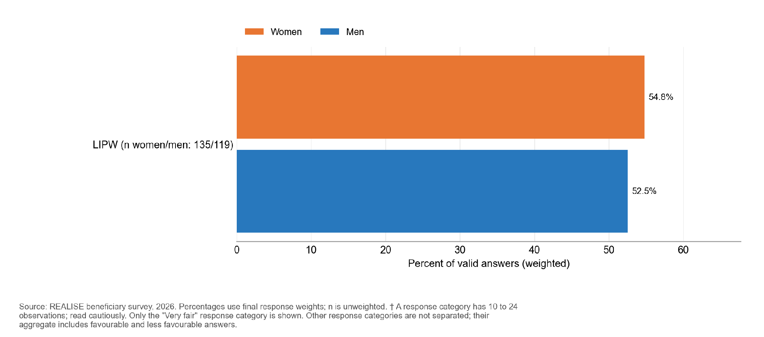
Very-fair responses use 119 valid answers from men and 135 from women. Percentages are weighted and n is unweighted; don’t know and refused answers are excluded.
A small number of selected respondents reported requests for an informal payment, gift, favour or political support. Estimates by sex are withheld because outcome cells are small.

Requests for informal payments can be under-reported; the survey does not cover non-beneficiaries. Interviews describe automatic inclusion of eligible people with disabilities before the lottery: “we identified eligible people with disabilities and included them automatically among the 100 beneficiaries before conducting the lottery for the remaining places.” (LIPW-KII-001, P0180). A focus group differs: “they said, disable people can’t work so they didn’t add them to the program.” (LIPW-FGD-002, P0331). The accounts differ on how consistently people with disabilities were included.

7.3 Delivery pathway
Almost every respondent reached each stage: 98.5 percent expected at least one benefit and all reported receiving one; the rare non-use category and its complement are withheld. Completeness and timeliness were lower. 50.6 percent received every benefit they expected and 72.8 percent said payments always arrived on the communicated schedule. Women reported higher shares than men on both (full receipt: 57.0 against 43.2 percent; on-time payment: 79.2 against 65.3 percent). Omitting the interview with the largest weight gives full receipt of 47.8 percent and a basic-needs change of 0.39; these sensitivities are reported in Annex G, Table G.12. All who expected a time-bound payment were told a schedule.

Table 7.3.1. Every LIPW participant received support, but half received everything they expected and a quarter were not always paid on time
Indicator | Value % (n) | Women | Men | Note
Expected at least one benefit | 98.5 (254) | - | -
Received at least one benefit | 100.0 (254) | - | - | All who expected one received one
Used the wages | Suppressed | - | -
Received every benefit expected | 50.6 (250) | 57.0 | 43.2 | Women 13.8 points higher
Payments always on the communicated schedule | 72.8 (253) | 79.2 | 65.3 | Women 13.9 points higher
Reading note: the first three rows are shares of all respondents; full receipt and on-time payment use their own valid answers. Annex F gives the stage-by-stage transitions.

Figure 7.3.1. In LIPW, 50.6 percent of beneficiaries received every expected benefit, and 72.8 percent reported wages always paid on schedule.
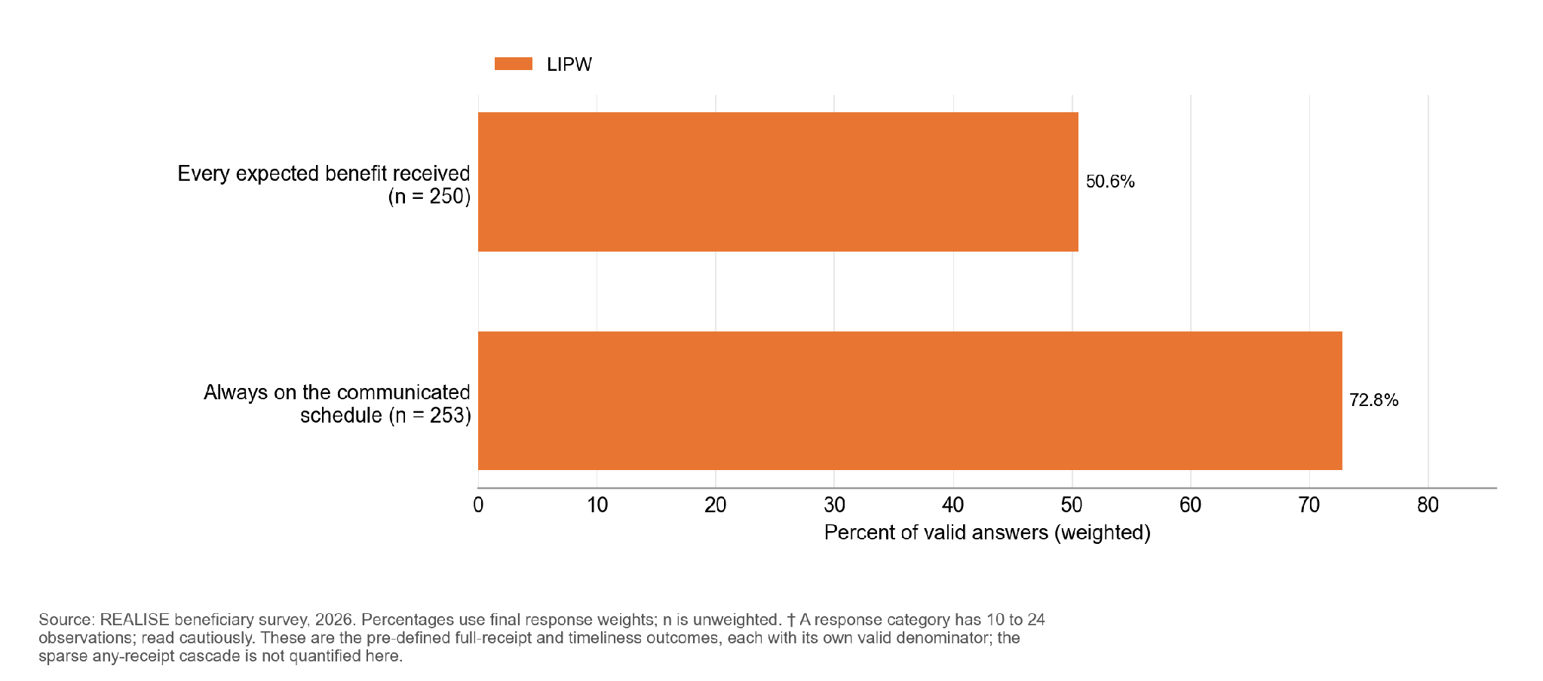
The largest shortfall is National ID or NIN support: 77.2 percent expected it, but only 50.0 percent of those received it (Annex F, Table 7.3.2). Receipt was also lower for reasonable accommodation or childcare support (82.9 percent of 82 who expected it), the completion certificate (86.4 percent), complaint or feedback information (90.8 percent) and life-skills training (91.6 percent); other benefits reached at least 95 percent. About one in ten (9.7 percent) did not report receiving the 60 paid workdays.
More respondents report receiving than expecting most benefits (Table 7.3.2), which reflects how respondents recalled their expectations; the receipt question also counts benefits delivered to the work group or community.
Participants in different LIPW groups described uneven access to identification cards. In one group, a participant said “they provide citizen ID card for us” (LIPW-FGD-001, P0240); in another, a participant said “I didn’t receive mine” (LIPW-FGD-003, P0217). Accounts in the latter group also differed on cost. One participant was told “the citizen ID card was not free and we had to pay for it” (LIPW-FGD-003, P0219), while another said “it was not force. For me I did not pay anything” (LIPW-FGD-003, P0221). The survey did not ask whether a fee was requested, so the cost of the card is an open question for the programme to settle.
The detailed table is in the Annex F supplement (Table 7.3.2).
Among those given a payment schedule, 72.8 percent said payments were always on time and 27.2 percent not always (Figure 7.3.2). Finer timing categories are withheld. Mobile money was the main payment channel. A third (34.9 percent) also listed in-person training or service delivery and 29.4 percent in-kind tools or materials, so some read the payment question as covering non-cash support.
Figure 7.3.2. Payment timeliness is grouped into always on time and the combined remaining timing responses.
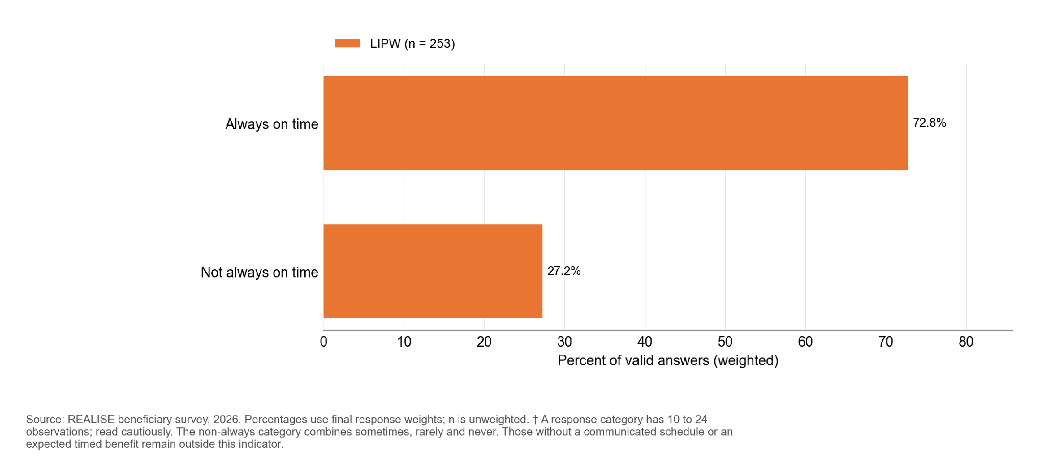

Wages went mainly to household needs (Annex F, Table 7.3.3): 81.6 percent reported spending on food and daily needs, 64.5 percent on school expenses and 55.0 percent on health, and 58.0 percent used some for a business or another income-generating activity. The question records whether each use occurred, not how much was spent.
Men and women reported using wages for businesses and other household or livelihood purposes. Rare uses and complementary sex comparisons are withheld; the selected-use results are descriptive and were not tested.
The detailed table is in the Annex F supplement (Table 7.3.3).
Women more often reported deciding alone how LIPW wages were used (80.7 percent, against 48.8 percent of men) (Figure 7.3.3). Joint decisions and other deciders are not separated because small complementary categories could be reconstructed. These are descriptive comparisons.
Figure 7.3.3. Share reporting that the respondent alone made the final decision on use; other decision categories are not displayed separately.
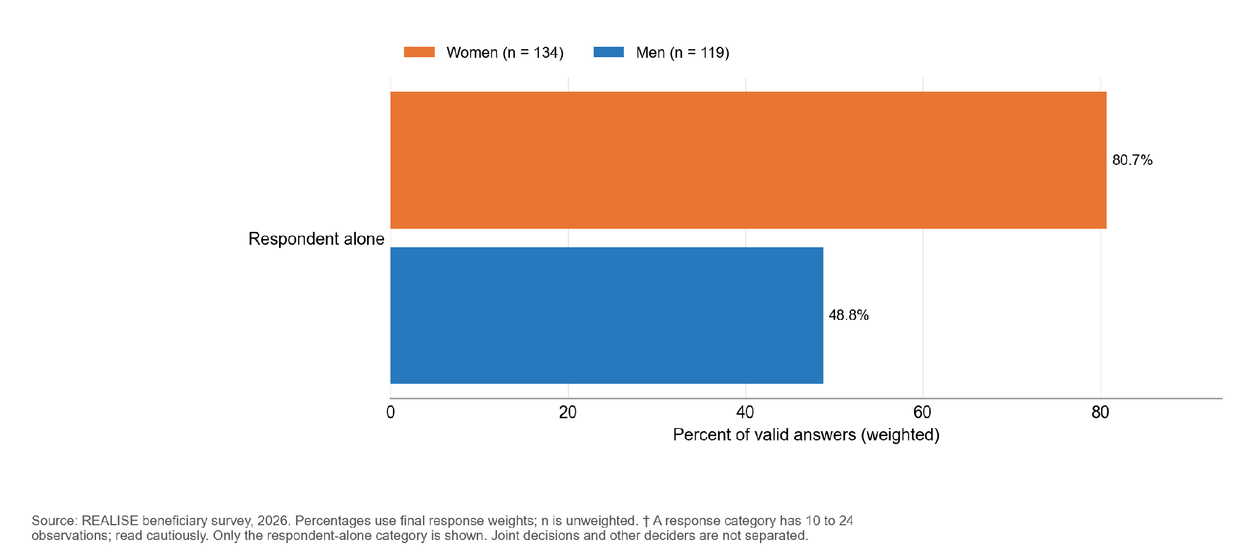

7.4 Outcomes
The mean coping-days score (lower is better) is 5.91 on a 0 to 84 scale (Table 7.4.1). The most common strategies were cheaper food (45.4 percent of households), smaller portions (44.5 percent) and fewer meals (41.6 percent), and 7.1 percent spent whole days without eating. Annex F gives all twelve strategies.
Households report a modest net improvement in their ability to meet basic needs since their first LIPW workday (+0.47 on a -2 to +2 scale; Table 7.4.1). Omitting one interviewer gives -0.02, with an interval from -0.15 to +0.12; interviewer, respondent-composition and site effects cannot be separated by this diagnostic (Annex G, Table G.10.2). The average hides a split: 59.1 percent are better or much better off, but 31.9 percent are worse or much worse off. Women report a smaller gain than men (+0.36 against +0.61), a difference that is not statistically significant. The change in basic needs is a retrospective self-report, and after only 60 days of work a worse position now may reflect conditions after the work ended. Two participants in one focus group say that life has slowly slipped back since the work ended: “Since the project ended, however, we have slowly been returning to the situation we were in before.” (LIPW-FGD-004, P0179; another participant describes a similar pattern at P0184). A third participant in the same group says things have stayed good since then (LIPW-FGD-004, P0177).
Almost every respondent has a mobile-money account in their own name (98.9 percent), and 99.6 percent were paid through mobile money. The survey measures current ownership, so it does not show how many accounts LIPW created (Section 7.6).
Income and employment. Participants describe turning wages into small trade. One began selling food from her first pay (LIPW-FGD-001, P0123); another added soft drinks and energy drinks to a cold-water business (LIPW-FGD-001, P0138); a third put the first payment into an oil business (LIPW-FGD-001, P0140); a man says “I used it to empower my wife in baking and cooking” (LIPW-FGD-004, P0258). Not everyone saw a change: “nothing improve really because the same struggle that it I still going through” (LIPW-FGD-001, P0119). The survey records that 58.0 percent used some of their wages for a business or another income-generating activity; it does not measure the income or jobs that followed.
Women’s self-efficacy. The average score is 35.8 on the 8 to 40 scale, and the score is similar in Montserrado (35.9) and Margibi (35.5). Most LIPW women score 32 or higher; the exact share is withheld to protect small cells. Women in the focus groups describe personal decisions and negotiation at home: “yes I am the one now making the decision and it is I and my children” (LIPW-FGD-001, P0382), and “so I can make any decision I want to make” (LIPW-FGD-001, P0386). Another describes supporting a husband’s decisions: “The man is the head of the home, but he made a decision I will back it up.” (LIPW-FGD-002, P0306). A participant describes the change as shared: “men and women are equal. If you want to undertake something, you have to discuss it with your partner” (LIPW-FGD-004, P0318).
Table 7.4.1. LIPW households report a modest gain in meeting basic needs, and almost all hold their own mobile-money account
Outcome | Value (n) | Women | Men | Note
Coping-days score, 0 to 84 (lower is better) | 5.9 (254) | 5.8 | 6.1 | No significant difference by sex
Change in ability to meet basic needs, -2 to +2 (higher is better) | +0.47 (252) | +0.36 | +0.61 | Not significant
Better or much better off (%) | 59.1 (252) | 53.1 | 66.1
Worse or much worse off (%) | 31.9 (252) | 35.6 | 27.5 | About one in three
Mobile-money account in own name (%) | 98.9 (252) | Suppressed | Suppressed
Women’s self-efficacy, 8 to 40 | 35.8 (134) | 35.8 | - | Women only
Reading note: the change in basic needs excludes proxy interviews. Table 7.4.2 gives sex comparisons and descriptive county estimates.
Figure 7.4.1. The coping-days distribution is shown in broad common score bands, preserving the original primary outcome and valid-answer universe.
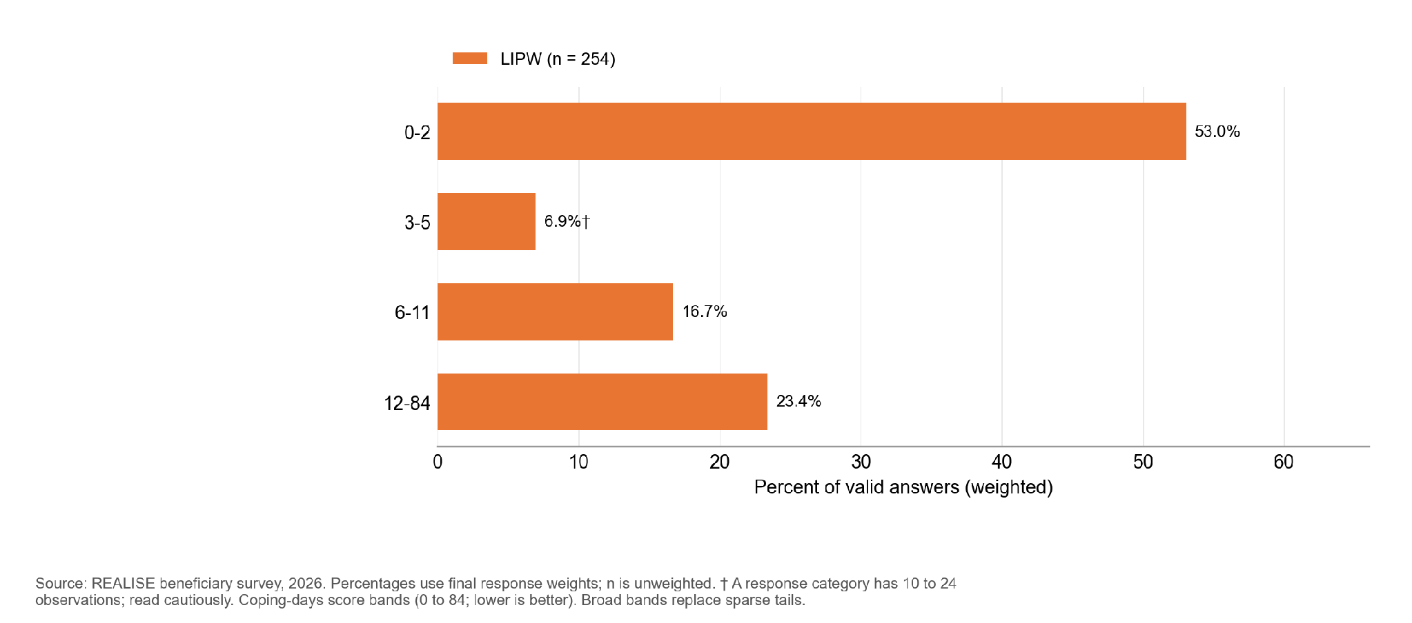

Figure 7.4.2. Retrospective basic-needs change is shown as better or much better versus the combined same-or-worse category.
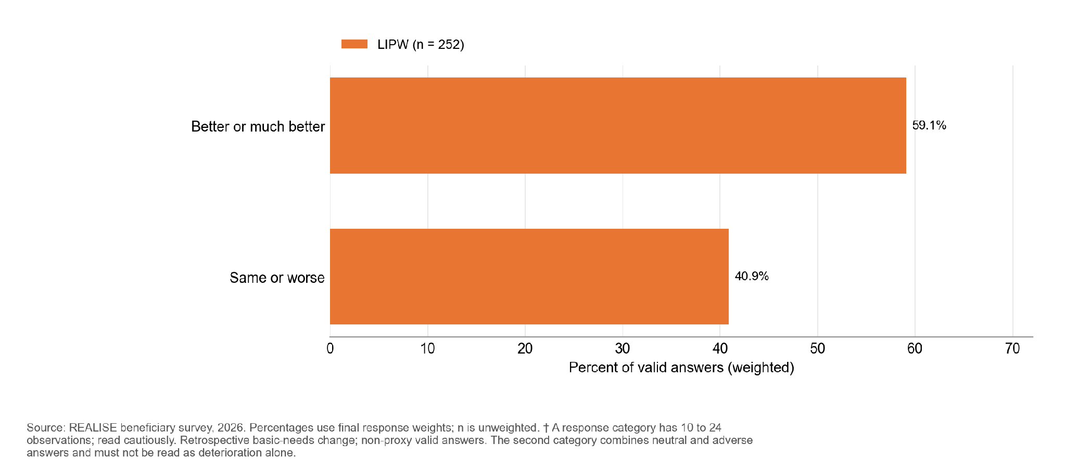
Women reported receiving every expected benefit 13.8 percentage points more often than men, but this difference is uncertain. Their reported payment timing was 13.9 points higher, a difference that remains clear after allowing for the number of comparisons. No other sex difference in the primary outcomes is clearly established (Table 7.4.2). The comparisons remain descriptive and sensitive to a small number of cases.
Montserrado respondents were more likely than Margibi respondents to report every expected benefit (54.0 against 36.8 percent). Payment timing (73.4 against 70.4 percent) and basic needs (+0.42 against +0.67) also vary descriptively across the sampled communities. Margibi rests on two communities, so these findings describe the sampled communities. Full receipt was reported by 71.2 percent in Round 1 (n = 11), 76.4 percent in Round 2 (n = 19), 58.4 percent in Round 3 (n = 81) and 36.3 percent in Round 4 (n = 139). The first two estimates are indicative because each has fewer than 25 valid answers. The round pattern compares different cohorts and sites, and does not measure a change over time in the same people.
In Round 4, Montserrado respondents report little average change in their ability to meet basic needs (+0.03; n = 113), against +0.80 in Margibi (n = 27) and +0.47 for LIPW overall. Within Montserrado, the point estimates are +0.85 in Round 1, +1.24 in Round 2 and +0.58 in Round 3. The first two are based on 11 and 19 respondents and are indicative. The Montserrado Round 4 group accounts for 113 of the 252 valid LIPW answers. These results show heterogeneity between cohorts and communities. Focus group accounts differ on whether gains faded after the work ended (LIPW-FGD-004, P0179 and P0184), and the gradient runs against a simple fading explanation, since the earliest rounds report the largest gains; round, site and recall cannot be separated. Round 4 also has the lowest receipt of the full package (36.3 percent), and complete receipt and use goes with a larger gain (+0.38, 95% interval 0.11 to 0.65), so incomplete delivery may account for part of the Round 4 result; among participants who described gains slipping back, one participant says the second month’s wages never arrived (LIPW-FGD-004, P0224).
Table 7.4.2. Women more often reported punctual payment than men; the full-package difference is not statistically clear; Montserrado reported higher receipt than Margibi
Outcome | Women compared with men | Montserrado compared with Margibi
Received every expected benefit | +13.8 percentage points; uncertain difference | +17.2 percentage points; descriptive only
Payments always on schedule | +13.9 percentage points; clear difference | +3.0 percentage points; descriptive only
Coping-days score (0 to 84) | -0.31; uncertain difference | +0.80; descriptive only
Change in basic needs (-2 to +2) | -0.25; uncertain difference | -0.24; descriptive only
Mobile money in own name | Withheld: small cells | Withheld: small cells
Women’s self-efficacy (8 to 40) | Not reliably estimated | +0.41; descriptive only
Reading note: A clear difference remains distinguishable from zero after allowing for the number of comparisons; an uncertain difference is not proof of equality. The LIPW comparisons describe small groups in the surveyed communities and are sensitive to a small number of cases. The PAP does not support a standalone LIPW county test because Margibi covers two communities.
Food consumption is mostly acceptable: of 242 households with a score, 90.3 percent are in the acceptable category (a score above 35 on the standard food consumption scale), and 9.7 percent are in the combined borderline or poor category. The mean Food Consumption Score is 56.3 and households ate from an average of 7.9 of 12 food groups (Household Dietary Diversity Score; n = 239). Coping strategies are nonetheless common.
Households bought most of their food (66 to 99 percent, depending on the food group). Own production matters mainly for dark green leafy vegetables (26.0 percent) and vitamin A-rich fruits (13.3 percent). Annex F gives the scores and the source of each food group.

Figure 7.4.3. An acceptable food consumption score is recorded for 90.3 percent of LIPW households and a borderline or poor score for 9.7 percent.
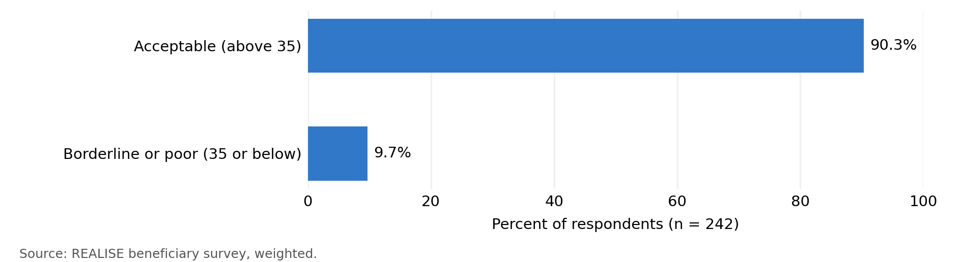

7.5 Community development fund projects

Community development fund projects were discussed in the LIPW focus groups and interviews; the accounts below describe what participants saw and used. A focus group participant describes a cleaner paid by the community: “our community chairman assigned someone to be cleaning the road, so we can collect money to pay the man every month.” (LIPW-FGD-002, P0325). Another informant ties continuation to resources: “the continuation is based on support. If the support is available then we can continue” (LIPW-KII-029, P0151). Upkeep in practice rests on community arrangements and on continued support; the survey records whether the asset was completed, not its condition.
The survey adds one relevant point: 68.7 percent of respondents report a completed community asset, including 95.9 percent of the 118 who expected one (Annex F, Table 7.3.2).

7.6 Mechanisms, records and rivals

The survey supplies rival-explanation evidence (shocks, remittances and other assistance), current own-name account ownership, and comparisons of delivery and outcomes that the evaluation expected to see if the programme pathway held. Complete and timely delivery is expected to go with lower coping scores, complete receipt and use of the support with a larger improvement in basic needs, and payment by mobile money with an own-name account. Women who had their own or joint say over how the wages were used are expected to report higher self-efficacy.
Site observation. Written records for Stephen Tolbert, Duala, Boys Town and Kings Farm describe cleanliness, the presence of road signs and the condition or storage of tools on the visit day. At Stephen Tolbert the tools could not be inspected because the key holder was unavailable; at Duala and Kings Farm the notes describe deteriorated tools despite positive functionality boxes. The Boys Town record also names Kings Farm in its activity field, so its site identity remains uncertain. These observations complement participant and implementer accounts without establishing later maintenance; wage dates still require payroll and timesheet linkage (Recommendation R8).
Shocks were almost universal: 89.6 percent of households had at least one in the past 12 months, most often illness (46.4 percent), food or input price rises (42.4 percent), flood or weather shocks (34.5 percent) and a death in the household (21.2 percent). Since their first LIPW workday, 41.3 percent had income from a household business, farming or another livelihood, 26.6 percent from other wage or public-works employment and 23.0 percent from remittances or family help. Few respondents reported government or NGO assistance, and none reported support from another REALISE component; the positive estimate is withheld because the outcome cell is small (Annex F, Table 7.6.1).
Other programmes are a weak rival for LIPW outcomes, but other earnings and family support are not, particularly for the change in basic needs. The survey does not measure seasonality, prices or mobile-money ownership before LIPW (the main rival for own-name account ownership); interviews and records would speak to them.
The detailed table is in the Annex F supplement (Table 7.6.1).

Figure 7.6.1. Selected shocks reported over the past 12 months; small categories are withheld.
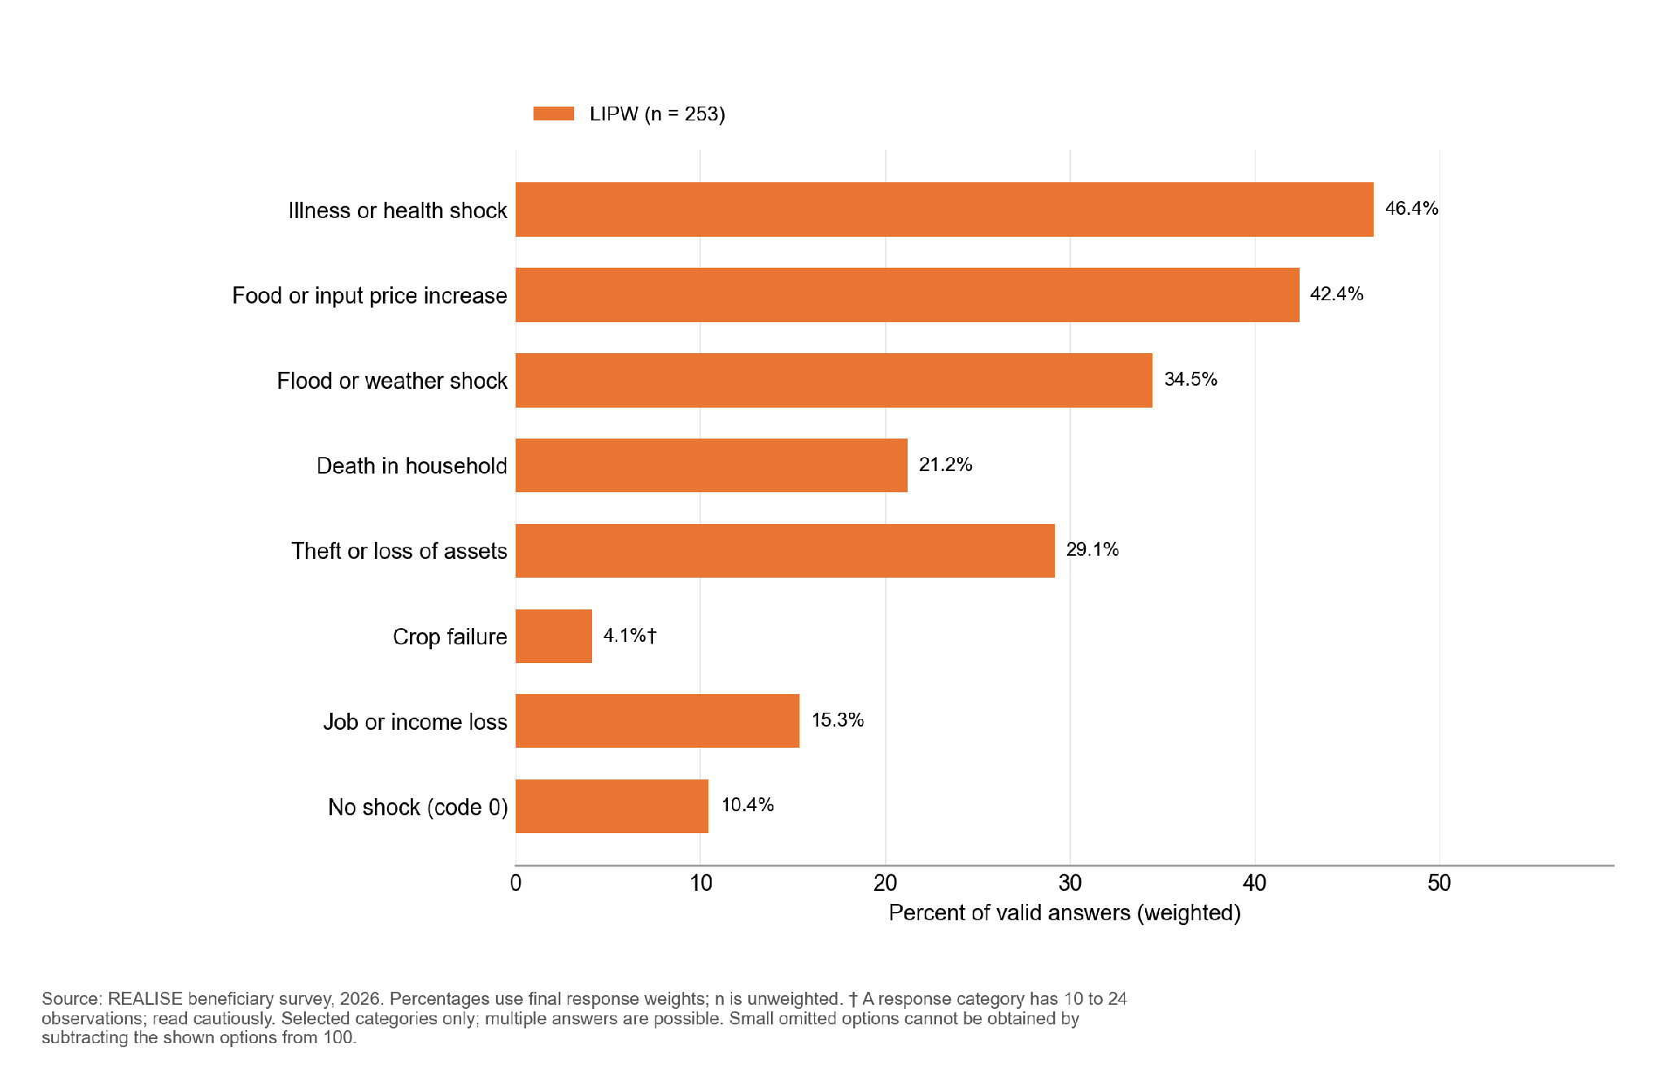

Figure 7.6.2. Since joining, LIPW respondents most often received other support from income from a household business, farming or another livelihood (41.3 percent); 31.7 percent received none.
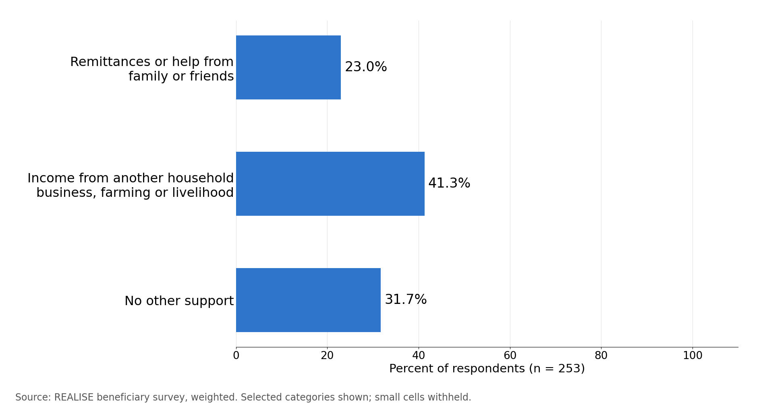
Within LIPW, complete and timely delivery was associated with a coping score 4.82 points lower, and complete receipt and use with a basic-needs score 0.38 points higher, after allowing for county, round, sex and age group. The coping comparison across all components combined is uncertain after allowing for the number of tests. These associations do not establish a delivery effect: both answers came from the same interview, and households coping well may rate timing more favourably. Account ownership and self-efficacy comparisons are not reliable because one arm of each comparison is below 10, with sparse sizes and their complements withheld. Full comparisons are in the Annex F supplement (Tables 7.6.2 and 7.6.3).
The detailed table is in the Annex F supplement (Table 7.6.2).
Table 7.6.3. After adjustment, the LIPW associations with coping and basic needs hold
Hypothesis and outcome | Exposed n | Not exposed n | Adjusted difference (95% CI) | p | Interaction p
H3. Coping score (P3) | 82 | 167 | -4.82 (-6.68, -2.96) | <0.001 | <0.001
H4. Basic-needs change (P4) | 113 | 135 | +0.38 (0.11, 0.65) | 0.006 | <0.001
H5a. Own-name mobile money (P5a) | Withheld (sparse comparison) | Withheld (sparse comparison) | - | - | <0.001
H5b. Women’s self-efficacy (P5b) | Withheld (sparse comparison) | Withheld (sparse comparison) | - | - | <0.001
Reading note: Coping compares complete, timely delivery with other delivery experiences; basic needs compares receipt and use with incomplete receipt or non-use. Account ownership compares payment by mobile money with no payment; self-efficacy compares women with their own or joint say over support use with women without it. These are adjusted associations, not causal effects. Full estimates and the overall comparison across components are in the Annex F supplement.

7.7 Contribution assessment

Claim. LIPW contributed to household coping and ability to meet basic needs through 60 days of paid work, paid on time by mobile money. Financial inclusion is graded as a separate claim. The community asset claim is graded in its own row.
Reported outcomes. Households report a modest net improvement in basic needs (+0.47), but 31.9 percent report being worse off and Montserrado Round 4 shows little average change (Section 7.4).
How the support may have contributed. Access is met: all respondents received support and most used it. Completeness is partly met: full receipt is 50.6 percent, with the largest shortfall in national ID support, and 9.7 percent did not report the 60 paid workdays (Section 7.3). Timeliness is partly met: on-time payment is 72.8 percent. Both mechanism contrasts are consistent with the expected links (Section 7.6). Interviews describe late or reportedly reduced payments in some groups and timely receipt in others (LIPW-KII-023, P0175; LIPW-FGD-004, P0224); payroll dates would settle this.
Rivals and contradictions. Shocks were almost universal. Other livelihood income (41.3 percent), other wage work (26.6 percent) and family support (23.0 percent) are possible contributors; formal assistance is almost absent (Section 7.6). Interviews add pre-existing businesses, household earners and saving clubs, and, in one focus group, accounts of gains slipping back after the work ended (Section 7.4). Records would help separate these.
Evidence used. Survey (this chapter), five LIPW KII and six FGD files, partial round-level PMT mobile-money records for Rounds 1 to 3 and the undated initial payroll for Round 1, and written observations at four LIPW sites. No complete dated individual payment register that could be matched to respondents was available. The observation notes on tool condition and access are read with the positive status boxes. Timesheets and grievance records remain the checks under Recommendations R8 and R16.
Reviewed contribution assessment. The evidence is Limited for coping and basic needs. Accounts support short-term food access, while seasonal and alternative income pathways cannot be separated from changes in coping. Participants describe starting small businesses and meeting household costs with wages; the survey records a mean change of +0.47 in basic needs. The basic-needs estimate is sensitive to omission of an interviewer group, which also changes respondent composition and site coverage; these influences cannot be separated by that check. Other livelihood income (41.3 percent), other wage work (26.6 percent) and family support (23.0 percent) remain possible contributors. Receipt and timeliness are Limited because accounts describe some shortfalls or delays and dated individual payroll evidence was not available to reconcile them. Asset functionality and upkeep are Limited (Table 11.2).
Conclusion. The contribution evidence is Limited for household coping and meeting basic needs. Receipt of every expected benefit, payment on schedule, the community asset and the sustainability of gains are supported with limited confidence. These are contribution claims for the participants covered by the survey and the interviews, not impact estimates against a comparison group.
Financial inclusion. Almost all beneficiaries have an own-name mobile-money account (98.9 percent) and 99.6 percent were paid through mobile money, but without evidence on ownership before LIPW the survey cannot attribute it to the component. Interviews do not separate prior from new accounts, so account-opening records would settle the point; the account-ownership claim is graded Limited (Table 11.2).
Delivery priority. More than a quarter of respondents did not report payments as always on time, and the shortfall in full receipt is concentrated in national ID support. The split in the change in basic needs, concentrated in Montserrado Round 4 (Section 7.4), is the main open question on outcomes. Payroll dates by round, showing time to payment after the 60th workday, would most change the grade.
Finding. LIPW gave almost every participant interviewed paid work by mobile money and contributed to household coping and basic needs with Limited evidence; receipt of the full package, payment on schedule and upkeep of the works are supported with Limited evidence and are the areas to strengthen.
Findings by OECD-DAC criterion. Table 7.7.1 reads the LIPW findings against the six criteria. Grades are in Table 11.2.
Table 7.7.1. LIPW gave nearly every participant paid work; receipt of the full package, payment on schedule and upkeep of the works were weakest
OECD-DAC criterion and evaluation question | Finding | Grade | Where in this chapter
Relevance (KEQ1). Did support and selection match intended beneficiaries’ needs and profiles? | The very-fair response was chosen by 54.8 percent of women and 52.5 percent of men. The survey covers selected beneficiaries and cannot estimate exclusion. | Descriptive | 7.2
Effectiveness (KEQ2). Were intended benefits delivered and were expected changes reported? | About half received every expected benefit (50.6 percent). National ID support reached 50.0 percent of those who expected it. | Limited (receipt) | 7.3
Efficiency (KEQ3). How efficiently were resources used, how timely were delivery and internal operations, and what transaction costs fell on beneficiaries? | Wages came always on schedule for 72.8 percent. Interviews describe late or reduced payments in some groups; payroll dates would settle the difference. | Limited (timeliness) | 7.3, 7.7
Impact and contribution (KEQ4). What changes in income, employment, food security, consumption, resilience and agency are observed, and how plausible is REALISE’s contribution? | Reported change in basic needs is +0.47, and 31.9 percent report being worse off. Both mechanism contrasts point the expected way, as associations: complete, on-time delivery goes with a coping score 4.82 points lower, and complete receipt and use with a basic-needs change 0.38 points higher. | Limited (coping and basic needs) | 7.4, 7.6
Coherence (KEQ5). How do the four components complement one another and align with other government and partner programmes, and where are synergies, duplication or coordination gaps? | Other livelihood income (41.3 percent) and other wage or public-works employment (26.6 percent) were more common sources of support. Small formal-assistance categories are withheld. | Descriptive | 7.6
Sustainability (KEQ6). Which businesses, assets, groups, practices and household changes are likely to continue? | A completed community asset is reported by 68.7 percent; upkeep depends on support, and participants in one focus group disagree on whether their gains have lasted since the work ended. | Limited (community assets, continuation) | 7.4, 7.5
Source: Sections 7.2 to 7.7 of this chapter; final survey data, weighted. Contribution grades are in Table 11.2.

Chapter 8. Findings: Community Livelihood and Agriculture Support (CLAS)

Key findings
- Delivery reached almost everyone; expectation, receipt and use are described without quantifying rare complementary groups (Section 8.3).
- Core inputs reached 94.9 to 98.4 percent of those who expected them. About one in three respondents (32.7 percent) received every benefit they expected, and the main gaps to close are national ID support (28.6 percent of those who expected it received it) and market-linkage or buyer support (28.1 percent) (Section 8.3).
- More than two in three of those given a payment schedule (68.9 percent) said payments always arrived on time, and 12.0 percent of all respondents said payments never arrived on time (Section 8.3).
- Ability to meet basic needs shows almost no net change (+0.06 on a scale from -2 to +2): 49.4 percent say they are better or much better off and 44.7 percent worse or much worse off (Section 8.4; Section 8.9 weighs the explanations).
- Results differ widely between counties: full receipt is 42.5 percentage points higher in Bong than in Bomi, and Bomi and Grand Cape Mount, with the lowest full receipt and basic-needs change, are the priority areas for review. These differences are descriptive, and the county gap cannot be separated from two enumerators (Sections 8.4 and 8.9).
- Women and men differ by small amounts: women report more punctual payment and fewer coping days, with less complete receipt (30.5 against 35.2 percent) and a smaller change in basic needs (+0.02 against +0.11). Four reported primary-outcome contrasts fall below the implemented multiple-testing threshold, and the account-ownership comparison is limited by sparse cells (Section 8.4).
- Recent reported climate-smart practice use is graded Moderate, with 91.3 percent using at least one practice. The comparisons between delivery and outcomes in CLAS (coping, basic needs and self-efficacy) do not show the expected links, and market linkage reached 19.4 percent of those asked, so strengthening it is the priority. Continuation, delivery, coping and basic needs are graded Limited (Sections 8.5, 8.6, 8.8).
Annex F gives the remaining tables for this chapter: respondent counts by county and round, the full household profile, the stages of the delivery pathway, payment channels, how the support was used, food consumption and coping detail, harvest and safeguarding items, and the full delivery-to-outcome models.

Every table and figure in this chapter shows CLAS respondents only; Chapter 10 and Annex F set the four components side by side. Estimates are weighted so that they represent CLAS beneficiaries on the beneficiary list (Section 4.7).

8.1 Component overview
Administrative records show what was delivered, where and when. The survey shows where and when the CLAS respondents were enrolled.
PMT Mobile Money statements show CLAS payments from April 2024 to June 2025 in Bomi, Bong, Gbarpolu, Grand Cape Mount, Grand Gedeh, Lofa, Nimba and Sinoe: tool grants, community development support, grants to farmer-based organisations (FBOs) and the COC and BFG labour subsidies. These are partial round-level records, and no complete dated individual payment register that could be matched to respondents was available. Input, extension and market-linkage delivery records by round and county are covered by Recommendation R16.
The survey covers 598 CLAS beneficiaries in five counties, from Bong (147 respondents; 24.3 percent weighted) to Bomi (104; 17.2 percent); Annex F gives the breakdown by county, round and respondent type. Round 3 accounts for two-thirds of the weighted sample (68.2 percent). Round 2 is concentrated in Bong (47.9 percent of the round) and is listed as one combined group, so Beneficiary Farming Group (BFG) and Community Oversight Committee (COC) members cannot be compared within it.
Proxy interviews, where a trustee answered for the beneficiary, were more common in CLAS than in the other components: 45 respondents (7.6 percent weighted), across the covered counties. Person-level outcomes such as the change in basic needs are therefore reported for the 553 beneficiaries who answered for themselves.

8.2 Who was reached
CLAS reached women and men about equally. Women make up 52.8 percent of beneficiaries on the beneficiary list, in line with the 50:50 allocation, and the share is similar in every county (49.6 to 54.0 percent). By their own report, 302 respondents were women and 296 men.
The mean age is 42.2 years and 29.5 percent are aged 18 to 34, more in Bomi (41.6 percent) and Lofa (39.3 percent) than in Grand Gedeh (17.9 percent). Almost all (96.4 percent) worked in the past 7 days.
Formal education is low: 9.7 percent completed senior secondary, vocational or tertiary education, 17.7 percent of men and 2.9 percent of women. One in five (21.6 percent) reports a functional difficulty; the survey item has no severity scale, so this is not a disability rate (Annex F, Table 8.2.1).
CLAS households are large (mean 6.0 members) and mainly farm (83.9 percent). Bomi and Grand Cape Mount rely less on farming (69.4 and 72.2 percent) and more on business or petty trade (24.5 and 23.0 percent); in the other three counties farming exceeds 89 percent.
The detailed table is in the Annex F supplement (Table 8.2.1).

Among CLAS respondents, 99.5 percent rated selection as fair or very fair, and 41.2 percent chose specifically very fair: 34.4 percent of women and 48.6 percent of men. Other response categories are not separated.
A small number of selected respondents reported requests for an informal payment, gift, favour or political support to join CLAS or receive its support. Estimates by sex are withheld because outcome cells are small.
Interviews describe selection as open: in one focus group, names were drawn from tickets in a container and registration was free. “The process was transparent: they put the tickets in a container, and people picked them.” (CLAS-FGD-003, P0234). Some accounts describe selection-related jealousy: “When some people are selected for assistance and others are not, there can be jealousy.” (CLAS-FGD-001, P0295), and an oversight committee of five men: “However, the Community Oversight Committee was established with five men.” (CLAS-KII-014, P0233). Equal numbers of beneficiaries do not establish equal control or leadership. Respondents may not report every request for a payment, so the low reported rate is a minimum.

8.3 Delivery pathway
Most CLAS respondents reported receiving and using some support; sparse non-receipt and complementary cascade shares are withheld. Completeness was much lower: about one in three (32.7 percent) received every benefit they expected, and 68.9 percent of those given a schedule said payments always arrived on time (Table 8.3.1).
A further 13.5 percent of the 566 valid respondents expecting a time-bound payment (out of 598 eligible) said no schedule was ever communicated; they are outside the on-time payment base. All of them are in Bomi and Grand Cape Mount (21 of 88 and 57 of 96 respondents expecting a time-bound payment there) and none in Bong, Grand Gedeh or Lofa, which points to how payment dates were communicated or asked about in those two counties; the county cannot be separated from the interviewers (Section 8.9).
Table 8.3.1. About one in three CLAS respondents received every benefit they expected
Indicator | Value % (n) | Women | Men | Note
Payments always on the communicated schedule | 68.9 (488) | 71.1 | 66.5 | Among respondents given a payment schedule
Received every benefit they expected | 32.7 (593) | 30.5 | 35.2 | Largest gaps: national ID and market-linkage support

Reading note: more than two in three respondents given a schedule were paid on time, but only one in three received the whole package. Women were paid on time slightly more often than men (71.1 against 66.5 percent), and men received the whole package slightly more often (35.2 against 30.5 percent). Percentages are weighted; n is the number of valid answers.

The core farming package reached almost everyone who expected it, from farming tools and planting materials (98.4 percent) to the community development support grant (94.9 percent) (Annex F, Table 8.3.2). The shortfall is in the services around it: national ID support reached 28.6 percent of the 244 who expected it and market-linkage or buyer support 28.1 percent of 336, the largest shortfalls behind the low share receiving every expected benefit.
The detailed table is in the Annex F supplement (Table 8.3.2).

Interviews describe the same gaps from the delivery side. A programme informant names the national identification cards as the main weakness of the project: “because of the government stop order on those ID cards, we were not able to deliver those national ID cards.” (CROSS-KII-001, P0284). On market linkage, programme managers describe farmer-based organisations contracted for one year in each county to give price information, with farmers free to decide when and to whom to sell (CLAS-KII-007, P0197). A key informant reports that “some beneficiaries still have harvested rice stored in their rural kitchens because they have not found buyers to purchase it.” (CLAS-KII-024, P0193), and a donor-side informant observes that “there was not much linkage” (CROSS-KII-047, P0123). Expectations also differed at the start: “some people thought they would receive money before doing any work” (CLAS-FGD-007, P0236).

Counting all 597 valid answers, including those without a communicated schedule, 56.3 percent said payments were always on time, against 68.9 percent of those given a schedule and 12.0 percent never (Annex F, Table 8.3.3); 12.8 percent said no schedule was communicated and 5.5 percent had no timed payment due.
Payment was mainly by mobile money (95.3 percent), with 2.8 percent reporting cash. A further 4.7 percent (27 respondents) reported no CLAS payment or benefit through any channel, although almost all reported receiving at least one benefit. The role breakdown of these 27 respondents is withheld because categories are small. Programme staff describe a risk in mobile payments: “Even though we told them not to share their PIN codes with anyone, some beneficiaries shared their PIN codes, and in some cases family members took their money.” (CLAS-KII-007, P0239).
The detailed table is in the Annex F supplement (Table 8.3.3).

Nearly all respondents used the farming tools or inputs on the supported plot (96.9 percent) and most applied the training or climate-smart practices (88.1 percent); 29.5 percent reinvested a grant, harvest or sales in group farming. The question records whether each use occurred, not how much was spent.
Women more often than men used the labour subsidy for food or other participation needs (91.1 against 84.3 percent), a descriptive comparison.
Labour-subsidy decisions were often shared: women decided alone in 45.6 percent and jointly in 41.3 percent; men alone in 38.9 percent and jointly in 48.4 percent.
Most respondents were BFG members (84.6 percent), with 10.8 percent COC members and 3.3 percent Farm Management Committee (FMC) chairs or officers. Rice was the main supported crop for 70.5 percent and mixed crops for 25.1 percent.
BFG members and FMC officers report a median of 48 completed workdays (mean 52). This is about half of the 100 subsidised days the Project Operations Manual plans per 12-month cycle, which a programme manager describes as 60 days on the farm and 40 in training (CLAS-KII-007, P0148). Payments received fall well short of expectations: the median expected total was 59,500 LRD and the median received 17,000 LRD (means 60,099 and 30,795 LRD), in Liberian dollars. The gap may reflect fewer workdays than planned, outstanding payments or recall. At respondent level, the median received per completed workday is 425 LRD. The partial round-level PMT Mobile Money statements show a median of US$204 per account for the Round 1 labour subsidy, in two payments, against the US$350 the Project Operations Manual plans per cycle; Round 3, which most respondents joined, falls after the statements end. The interquartile ranges are 30 to 83 workdays, 52,500 to 59,500 LRD expected and 15,000 to 34,000 LRD received; these are distributions, not confidence intervals.

Group-level inputs were delivered almost universally: 99.4 percent said their group received all the farming tools, inputs or planting materials and 95.4 percent the full farm-input package. Training was less complete: 77.4 percent completed the package, 11.6 percent partly and 10.9 percent not. Respondents attended a median of 6 of a median 7 scheduled days, 88.3 percent of scheduled days on average.

8.4 Outcomes
Households report on average 5.4 coping days (on a scale from 0 to 84; lower is better). Ability to meet basic needs shows almost no net change since CLAS support began (+0.06 on a scale from -2 to +2; the community-clustered interval is -0.18 to +0.30), and the average hides an even split: 49.4 percent are better or much better off and 44.7 percent worse or much worse off (Tables 8.4.1 and 8.4.2). Section 8.9 shows that answers differ widely by enumerator, so the estimate is read with caution.
Almost every beneficiary who answered for themselves has a mobile-money account in their own name (97.2 percent). Among the 45 proxy respondents, 95.8 percent hold such an account, but it is the proxy’s, not the beneficiary’s. The survey measures current ownership, not whether the account existed before CLAS (Section 8.6).
Table 8.4.1. Almost all CLAS beneficiaries hold a mobile-money account, but basic needs show almost no net change
Indicator | Value (n) | Women | Men | Note
Mobile-money account in own name, % | 97.2 (553) | Suppressed | Suppressed | Current ownership; beneficiaries answering for themselves
Coping-days score, 0 to 84 (lower is better) | 5.4 (598) | 5.0 | 5.7 | Men report about 0.6 more coping days
Change in ability to meet basic needs, -2 to +2 | +0.06 (553) | +0.02 | +0.11 | 49.4 percent better or much better off; 44.7 percent worse or much worse off

Reading note: ownership of a mobile-money account is near universal, while the average change in basic needs is close to zero because half of the respondents report improvement and almost as many report a decline. Percentages and means are weighted; proxy interviews are excluded from the change in basic needs and own-name accounts.

Figure 8.4.1. The coping-days distribution is shown in broad common score bands, preserving the original primary outcome and valid-answer universe.
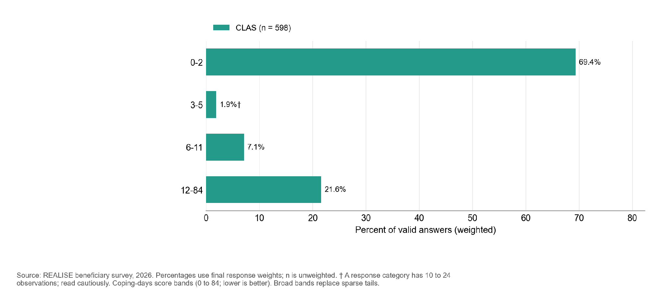
n by component: CLAS 598. Bars and their labels show weighted percentages; n gives the unweighted number of valid respondents. Households with no food shortage score 0.
Figure 8.4.2. In CLAS, 49.4 percent of respondents say they are better or much better able to meet basic needs and 44.7 percent worse or much worse.
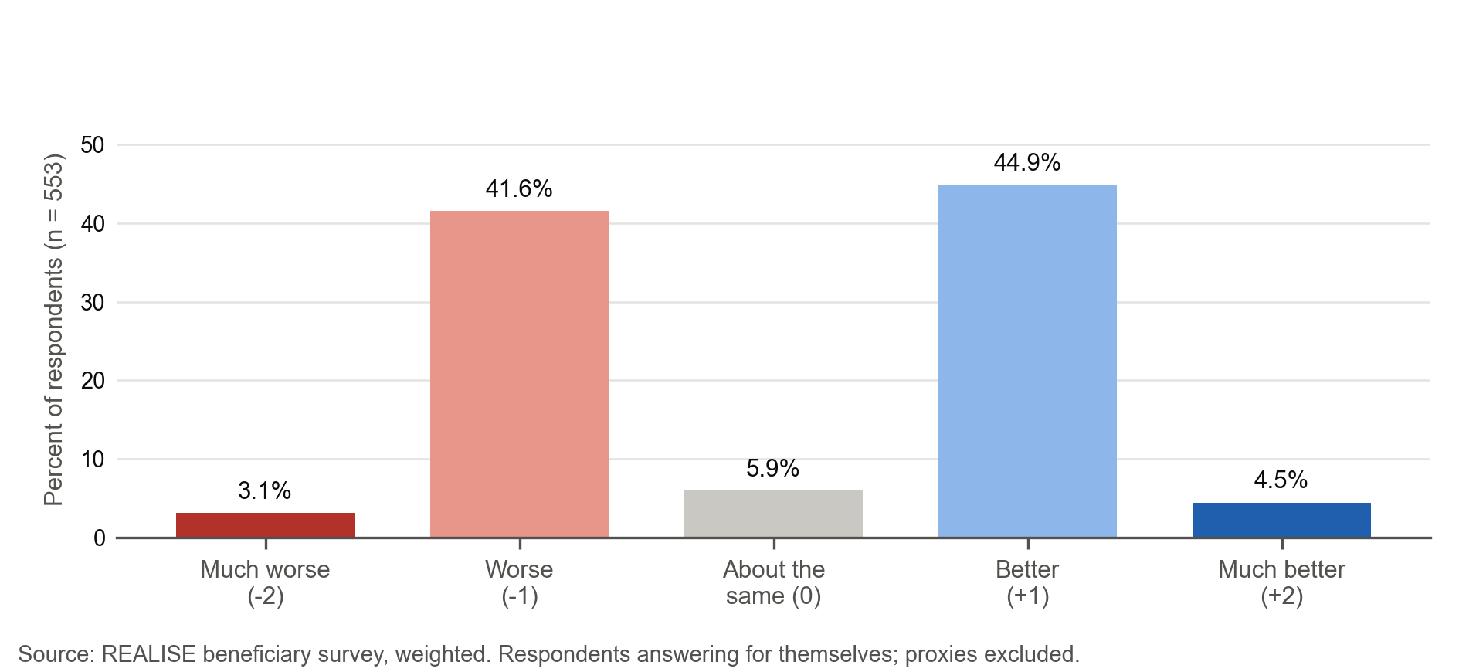
n by component: CLAS 553. Bars and their labels show weighted percentages; n gives the unweighted number of valid respondents. Recoded so that positive values mean improvement. Retrospective self-report; proxy interviews excluded.
The detailed table is in the Annex F supplement (Table 8.4.2).

Women and men reported small differences in CLAS, four of which remain clear after allowing for the number of comparisons (Table 8.4.3). Men more often received every expected benefit (35.2 against 30.5 percent) and reported a slightly larger improvement in basic needs (+0.11 against +0.02). Women more often said payments always arrived on time (71.1 against 66.5 percent among those given a schedule) and reported slightly fewer coping days (5.0 against 5.7). The difference in own-name mobile-money ownership is uncertain.
County estimates vary across outcomes. Sparse outcome cells limit inference for full receipt and account ownership; other global comparisons are interpreted under the implemented multiple-testing family. Bomi and Grand Cape Mount have the lowest full receipt (8.4 and 9.3 percent) and basic-needs change (-0.41 and -0.65). Compared with Bomi, full receipt is 42.5 percentage points higher in Bong, about 41 in Grand Gedeh and 25.7 in Lofa, with no statistically resolved pairwise difference for Grand Cape Mount; the basic-needs change follows the same order. Households in Bong report the most coping days, 4.5 more than Bomi and 7.7 more than Grand Cape Mount.
These differences are descriptive and depend on sample composition; they may reflect round, crop, implementing partner or the less farm-dependent livelihoods in Bomi and Grand Cape Mount. The county gap also cannot be separated from the interviewers: two enumerators were the only interviewers in the eight Bomi and Grand Cape Mount communities, and neither worked in any other county (Section 8.9). CLAS site records describe farm activity and upkeep at visited locations, but they do not test the county differences or independently verify specific climate-smart practices. The reports that no payment schedule was communicated also come only from Bomi and Grand Cape Mount (Section 8.3), so the same confounding applies to them. No interview passage cited in this chapter speaks to the county pattern, so the survey results above stand without a qualitative reading.
Table 8.4.3. Women reported more punctual payment and fewer coping days, but less complete receipt and a smaller gain in basic needs, than men
Outcome | Women compared with men | How to read the difference
Received every expected benefit | -4.7 percentage points | Clear after allowing for the number of comparisons
Payments always on schedule (among those given a schedule) | +4.6 percentage points | Clear after allowing for the number of comparisons
Coping-days score (0 to 84) | -0.65 | Clear after allowing for the number of comparisons
Change in basic needs (-2 to +2) | -0.10 | Clear after allowing for the number of comparisons
Mobile money in own name | Suppressed because outcome cells are small | Comparison limited by sparse outcome cells
Reading note: Results use the final survey weights; n is the number of valid answers. The Annex F supplement, Table 8.4.3, gives the full detail.
Food consumption is mostly acceptable: of 556 households with a score, 88.6 percent are in the acceptable category, which means a Food Consumption Score (FCS) above 35. The mean FCS is 54.9 and households ate from an average of 7.7 of 12 food groups (Household Dietary Diversity Score, HDDS). The 42 households without a score (7 percent) were interviewed before the food consumption module was added to the form.
Households that faced a food shortage used several coping strategies: cheaper food (30.3 percent of all households), smaller portions (28.4 percent), fewer meals (28.3 percent), wild food or early harvesting (21.9 percent) and seed stock saved for the next season (17.5 percent); 10.9 percent spent whole days without eating. Eating seed stock may affect next season’s production and merits follow-up in the field.
Unlike other components, CLAS households produce much of what they eat: own production is the main source for dark green leafy vegetables (85 percent), vitamin A-rich fruits (80 percent), other fruits (74 percent) and vitamin A-rich vegetables (63 percent), while cereals are bought more often than grown (57 against 39 percent). Annex F gives the source of each food group.
Figure 8.4.3. An acceptable food consumption score is recorded for 88.6 percent of CLAS households, a borderline score for 8.9 percent and a poor score for 2.5 percent. Some displayed response categories contain 10 to 24 observations and are indicative.
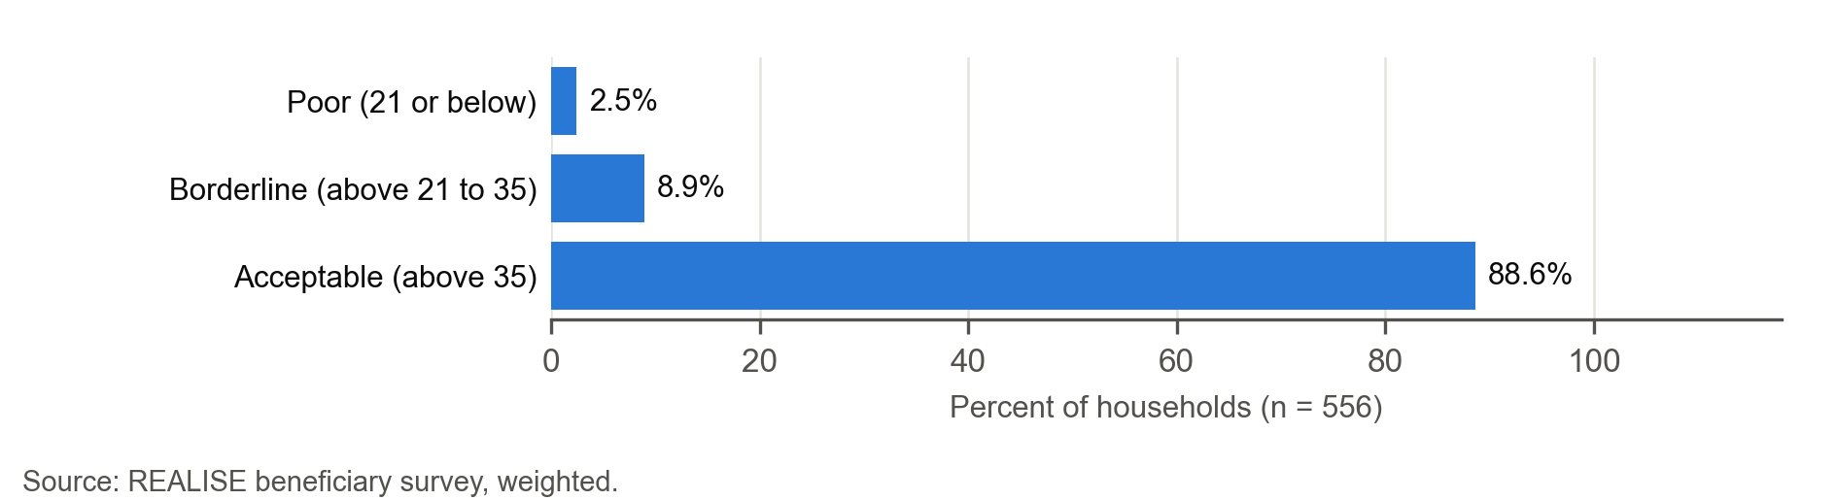

Figure 8.4.4. The most common coping strategy of CLAS households in the past week was relying on less preferred, cheaper food (30.3 percent), followed by reducing portion size (28.4 percent).
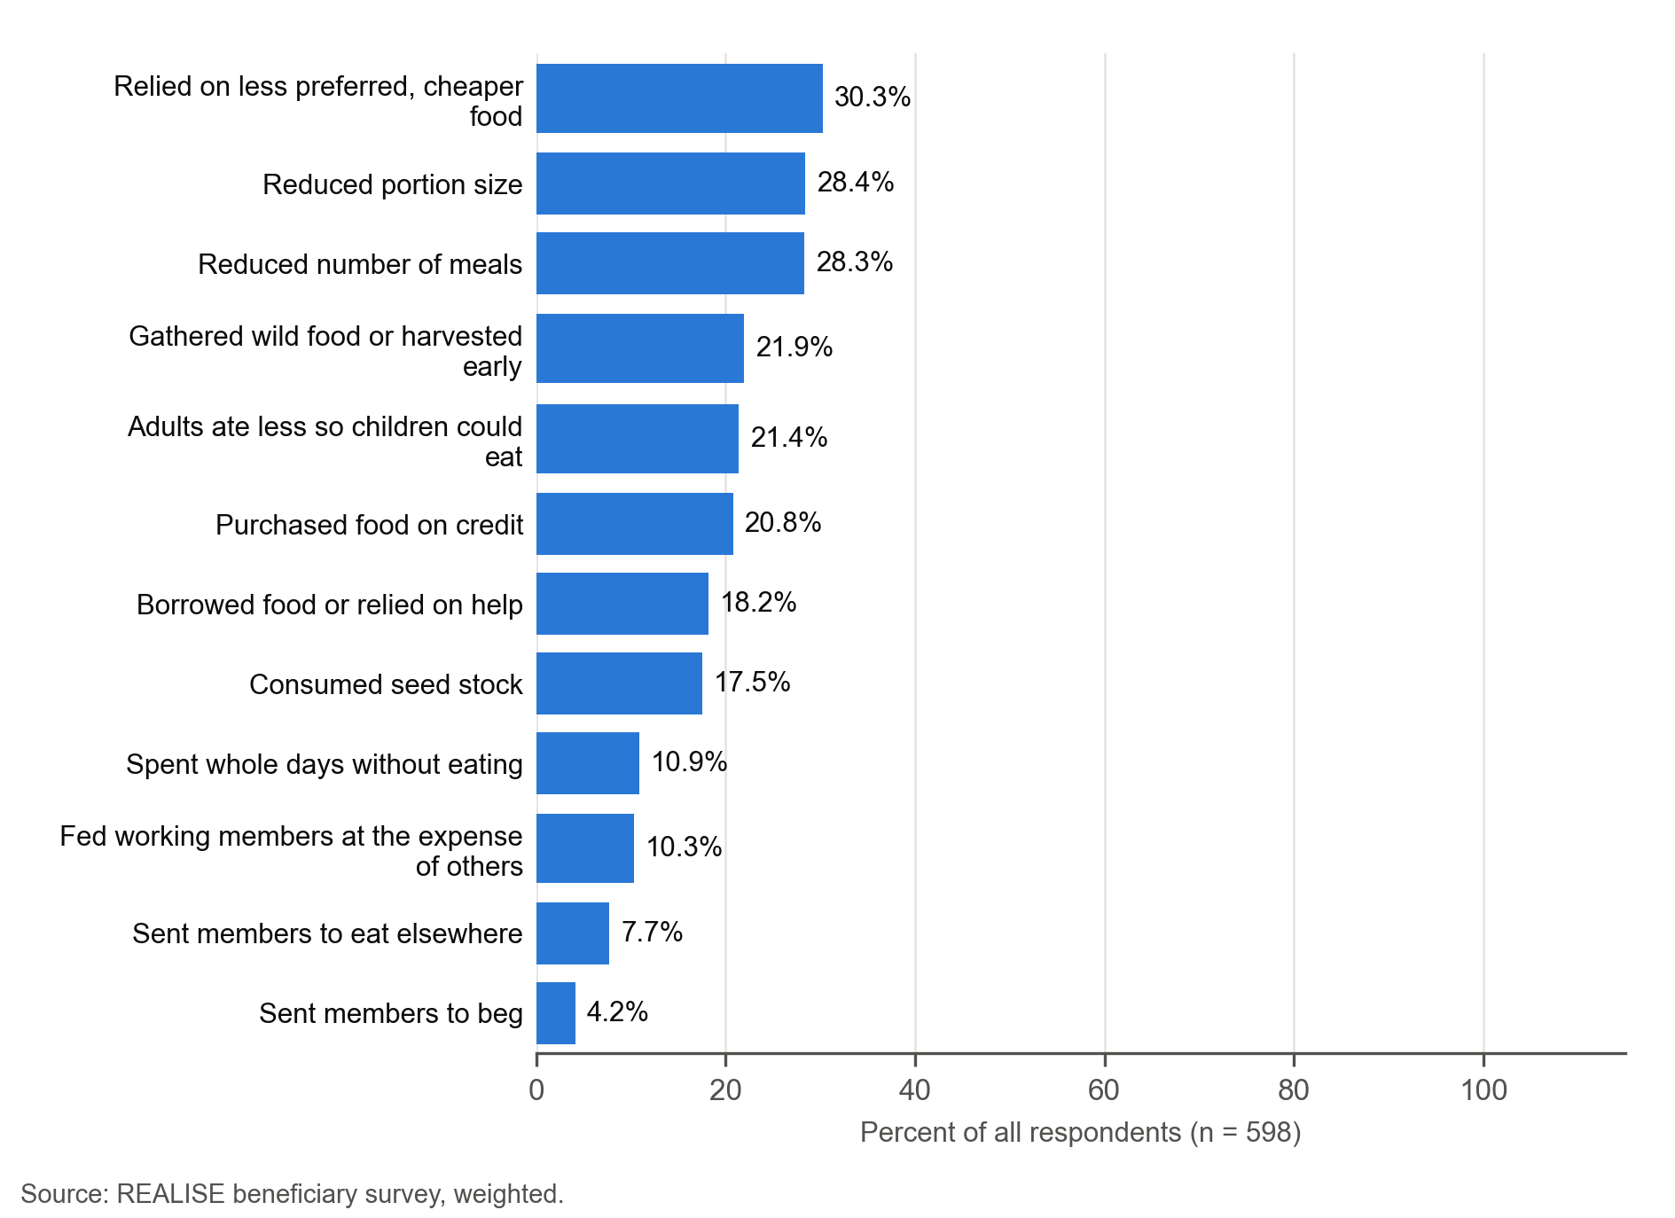
Most respondents (91.3 percent) adopted at least one climate-smart practice, and 86.8 percent think their group is likely or very likely to continue farming after support ends. Both are reports by respondents: attributing adoption to CLAS is the respondent’s own judgement, and the continuation figure is a belief about the future, not observed continuation.
A third of respondents (32.8 percent) reported that they or another group member had an injury or illness linked to CLAS farm work, tools or chemicals; this safeguarding finding calls for follow-up through grievance records and field monitoring (Section 10.5). No respondent reported children under 15 working on the subproject farm, although self-reports on child work may understate it.
Harvest quantities were reported in the units respondents used, most often bundles (184 respondents); for the 47 whose units have a kilogram equivalent the median harvest is 1,500 kg. These are not yields or before-and-after estimates.

Figure 8.4.5. Most CLAS respondents completed the training (77.4 percent) and adopted at least one climate-smart practice (91.3 percent), and 86.8 percent expect their group to continue farming.
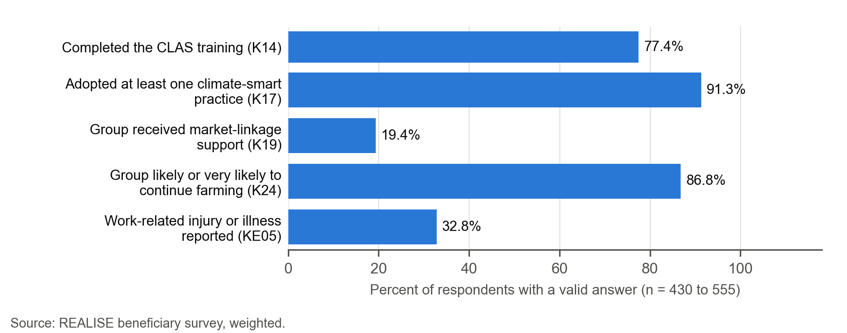

8.5 Climate-smart agriculture
REALISE trained 14,151 people in life skills and climate-smart agriculture (48 percent women), 141 percent of the project target of 10,063. This count is numerically above the target in Liberia’s national climate commitment (NDC 3.0, September 2025) of at least 5,000 farmers trained through farmer field schools by 2028, but the two definitions differ, so attainment of the national target cannot be inferred.
Liberia has no stand-alone climate-smart agriculture policy. The agriculture plans (the second Liberia Agriculture Sector Investment Plan, 2018 to 2022, and the National Agriculture Development Plan, 2024 to 2030) state the intention without measurable targets, while the NDC sets dated farm targets, including agriculture emissions 40 percent below business as usual by 2035. The practices respondents most often reported adopting, conservation agriculture, soil or water conservation and crop diversification, are of the kind the NDC supports through its incentives for conservation farming, composting and crop rotation. A key informant describes market information without pressure to sell: “the beneficiaries have access to price information and market-linkage support, but they are not pressured to sell at a particular time or to a particular buyer.” (CLAS-KII-007, P0197).
Respondents adopted an average of 3.0 practices, most often conservation agriculture (56.8 percent), soil or water conservation (56.1 percent) and crop diversification (54.3 percent), followed by precision farming (31.4 percent). Agroforestry was least common (16.6 percent) and 8.7 percent adopted none.
Two-thirds (66.5 percent) reported no barrier to applying the practices; the most frequent barriers were bad weather (15.8 percent) and not enough labour (15.7 percent).
Market linkage is the weakest part of the package: only 19.4 percent of the 430 respondents with valid answers said their group received market-linkage support, and 28.1 percent of those who expected buyer support received it (Section 8.3). The survey records adoption of practices, not whether they persist or reduce emissions. This estimate concerns 430 valid answers among 434 eligible interviews; 135 values were filled from recalls. Another 122 interviews were routed out and 42 remained unavailable because of the form version. Reports differ between recall and main-interview responses, but differences in groups, routing and timing prevent attributing the contrast to recall itself. Training and practice accounts show how some farmers applied spacing and other techniques, while another informant describes uneven use (CLAS-KII-014, P0156). These reports do not verify sustained adoption, yield or income.

Figure 8.5.1. Selected climate-smart practices; the rare other category is withheld.
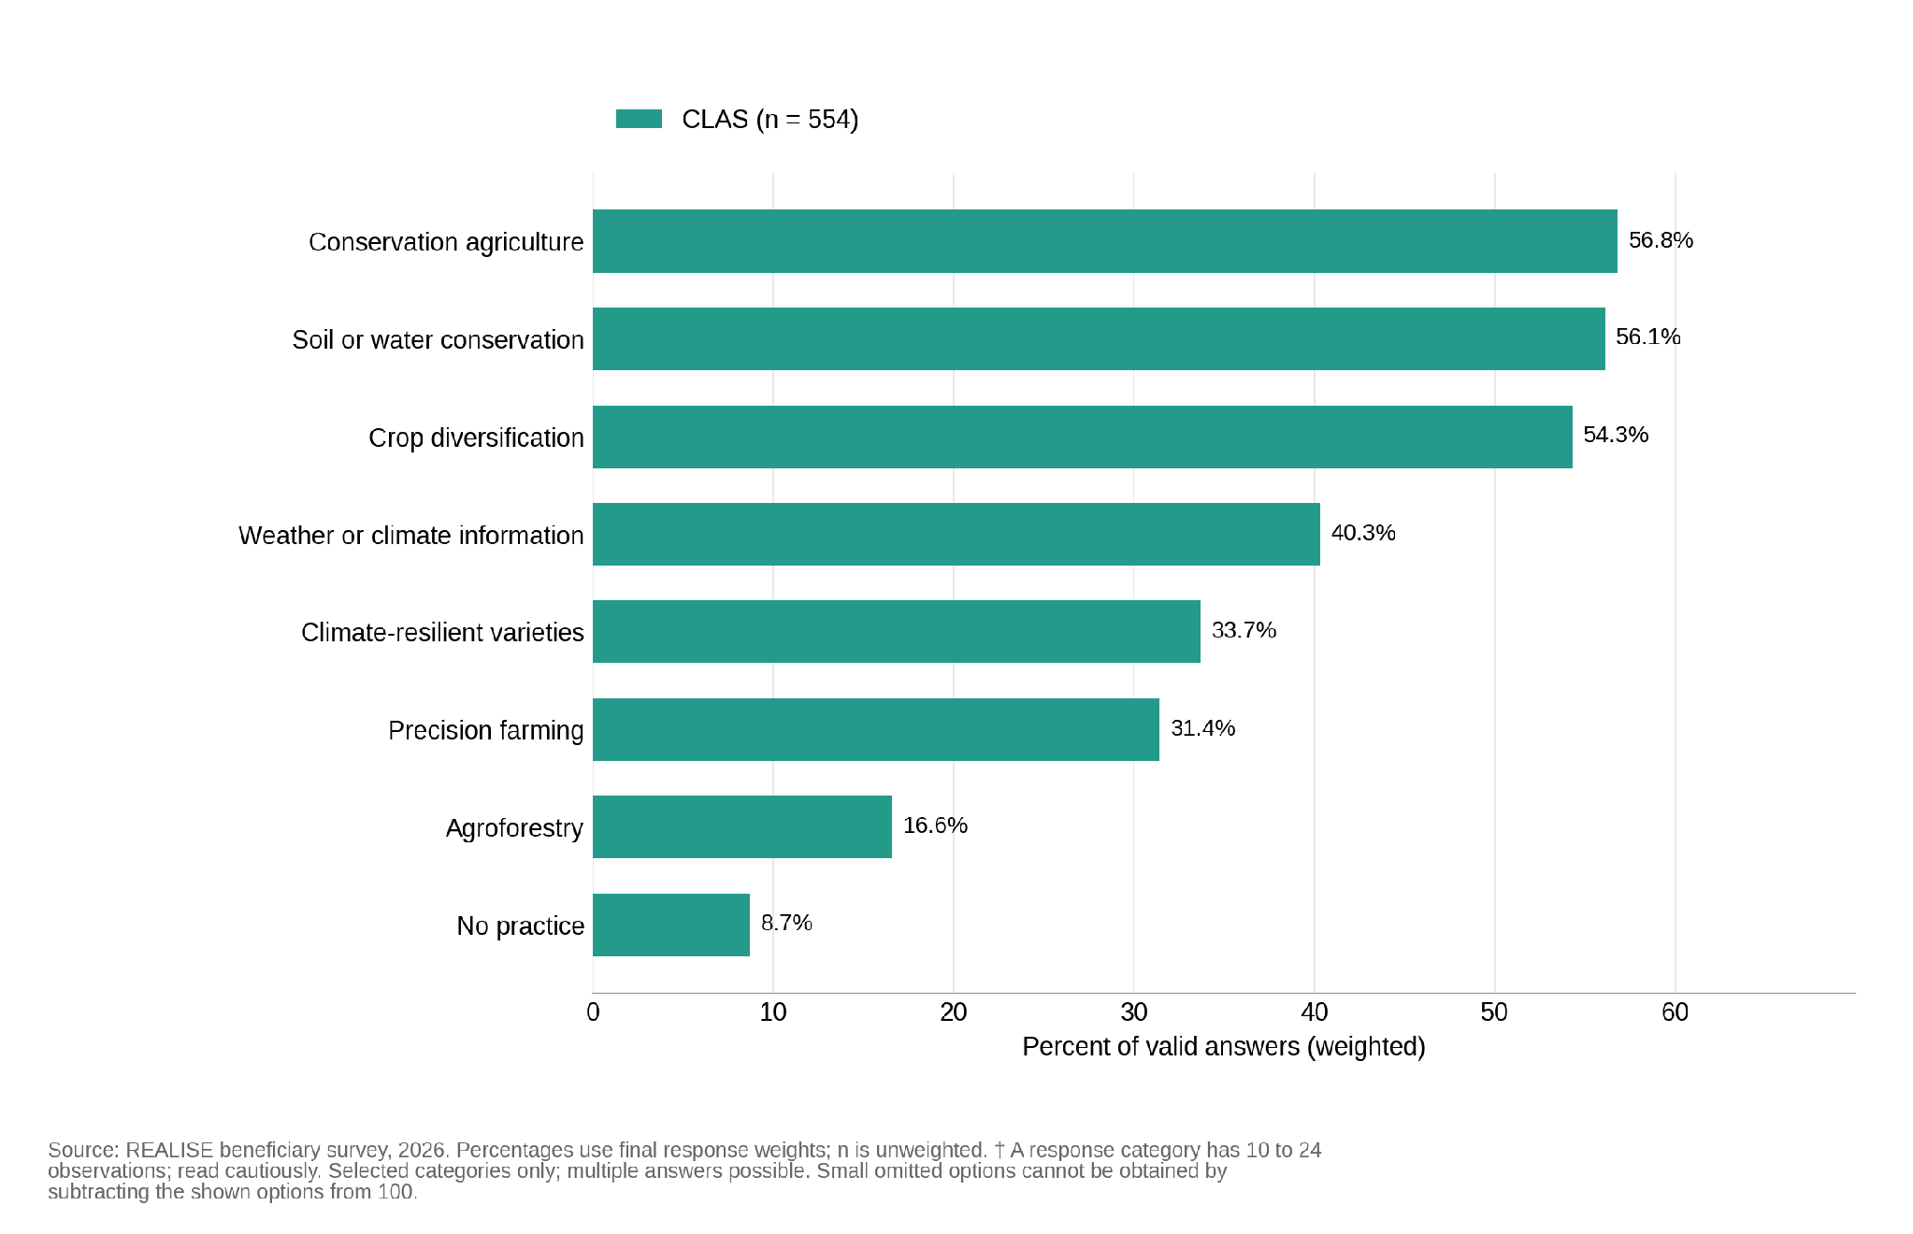

Figure 8.5.2. Selected barriers to applying climate-smart practices; small categories are withheld.
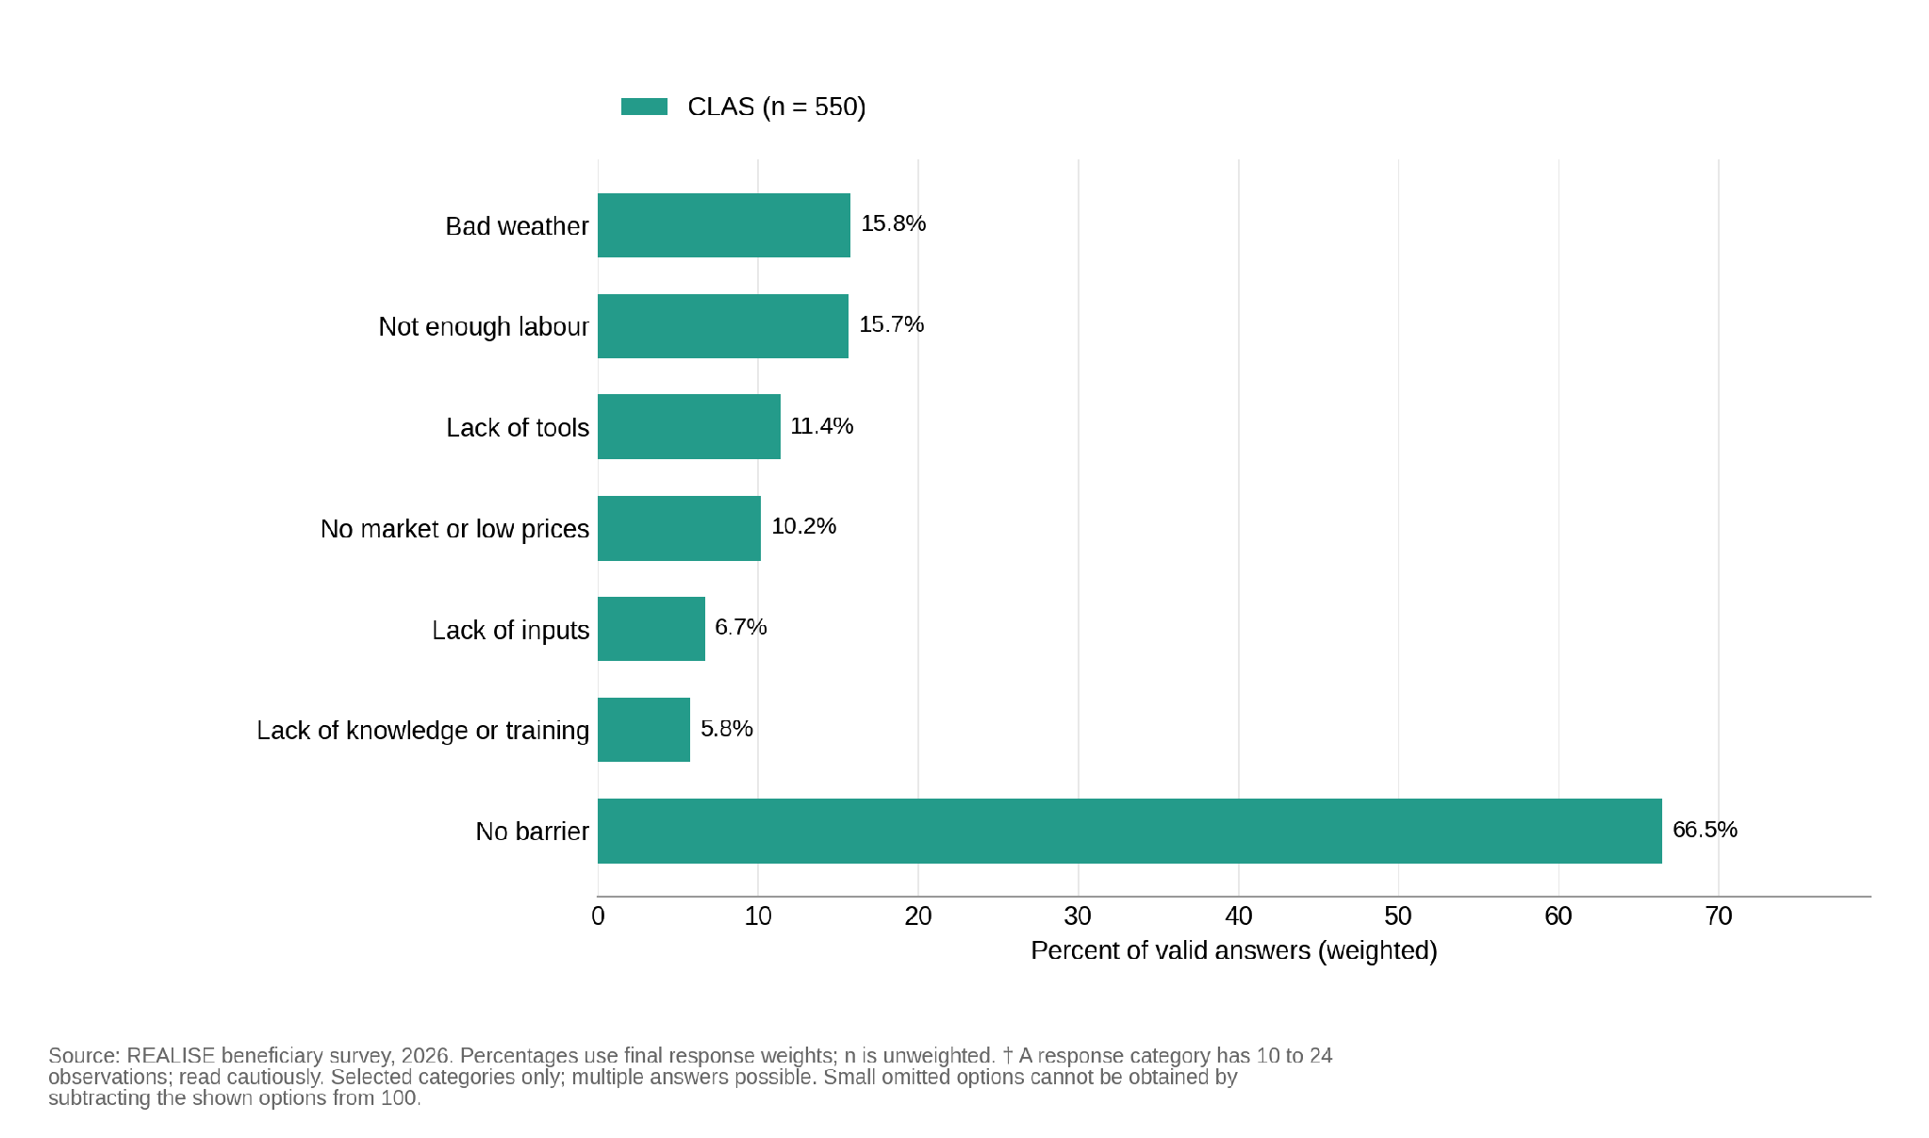

8.6 Mechanisms, records, observation and rivals
The survey records shocks, remittances and other assistance, which could also explain outcomes, and it compares outcomes between respondents with and without the expected delivery (the mechanism contrasts). These comparisons are associations and give supporting evidence only. Complete and timely delivery is expected to go with lower coping scores, complete receipt and use of the support with a larger improvement in basic needs, and payment by mobile money with an own-name account. Women who had their own or joint say over how the payments were used are expected to report higher self-efficacy.
This assessment draws on the survey, the CLAS interviews and focus groups and the partial round-level PMT Mobile Money statements of April 2024 to June 2025. The statements show the Round 1 labour subsidy reaching 9,280 accounts, with a median of US$204 in two payments (US$51.5 and US$152.5), and a median Round 2 payment of US$152.5 reaching 1,419 accounts by 17 March 2025. Round 3, 410 of the 598 respondents, falls after the statements end. The statements are not a complete dated individual register and could not be matched to respondents. CLAS site records describe active farming and upkeep at Kelema Bendu, Howard, Zuanii, Jaibo and Gbalasuah on the visit day. Their generic environmental descriptions do not independently establish particular climate-smart practices or their continuation after support. A Mawayasu case narrative describes training and mixed cropping, but its linked interviews and documentary support are not in the analysed corpus; its totals and adoption claims are therefore not used as estimates. Checking delivery and extension records is part of Recommendation R16.
Most households (78.1 percent) had at least one shock in the past 12 months, most often illness (61.6 percent), a death in the household (30.6 percent) and crop failure (27.4 percent). Two-thirds (67.6 percent) received no other support since joining CLAS, and 12.7 percent had income from another household business or livelihood; few respondents reported government or NGO assistance, and none reported support from another REALISE component; the positive estimate is withheld because the outcome cell is small.
Formal assistance from other programmes was uncommon, but this does not settle rival explanations for CLAS outcomes. Interviews name weather as an influence on harvests, including rainfall and drought (CLAS-KII-024, P0143; CLAS-KII-025, P0153). Prices and mobile-money ownership before CLAS were not measured: the survey asked about current ownership only.
The detailed table is in the Annex F supplement (Table 8.6.1).

Figure 8.6.1. Selected shocks reported over the past 12 months; small categories are withheld.
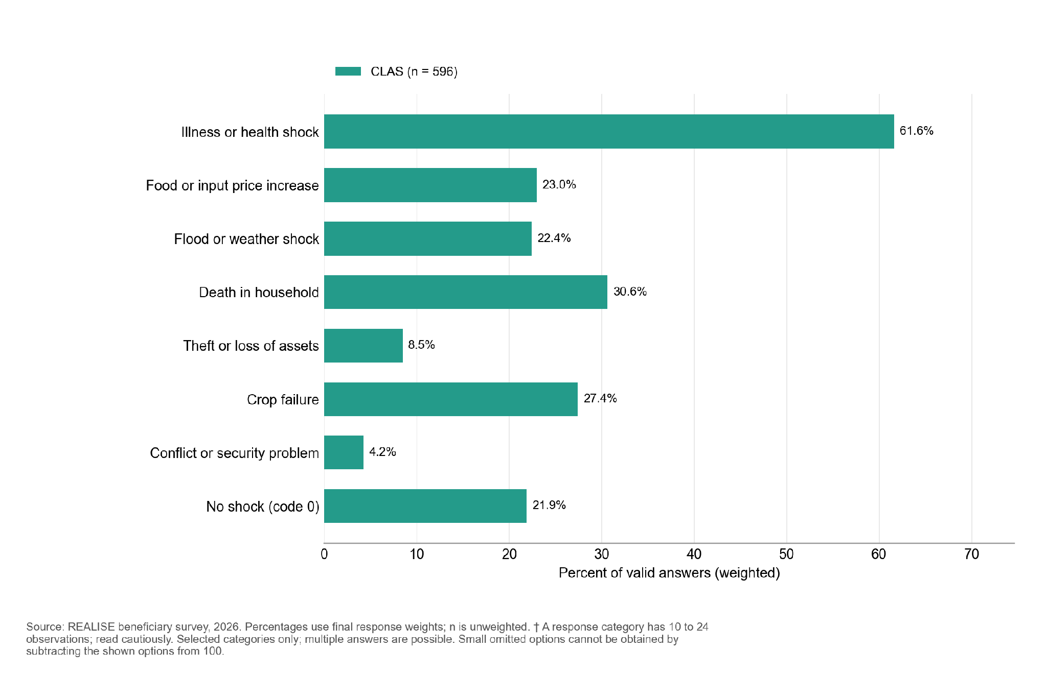

Figure 8.6.2. Since joining, CLAS respondents most often received other support from remittances or help from family or friends (18.5 percent); 67.6 percent received none.
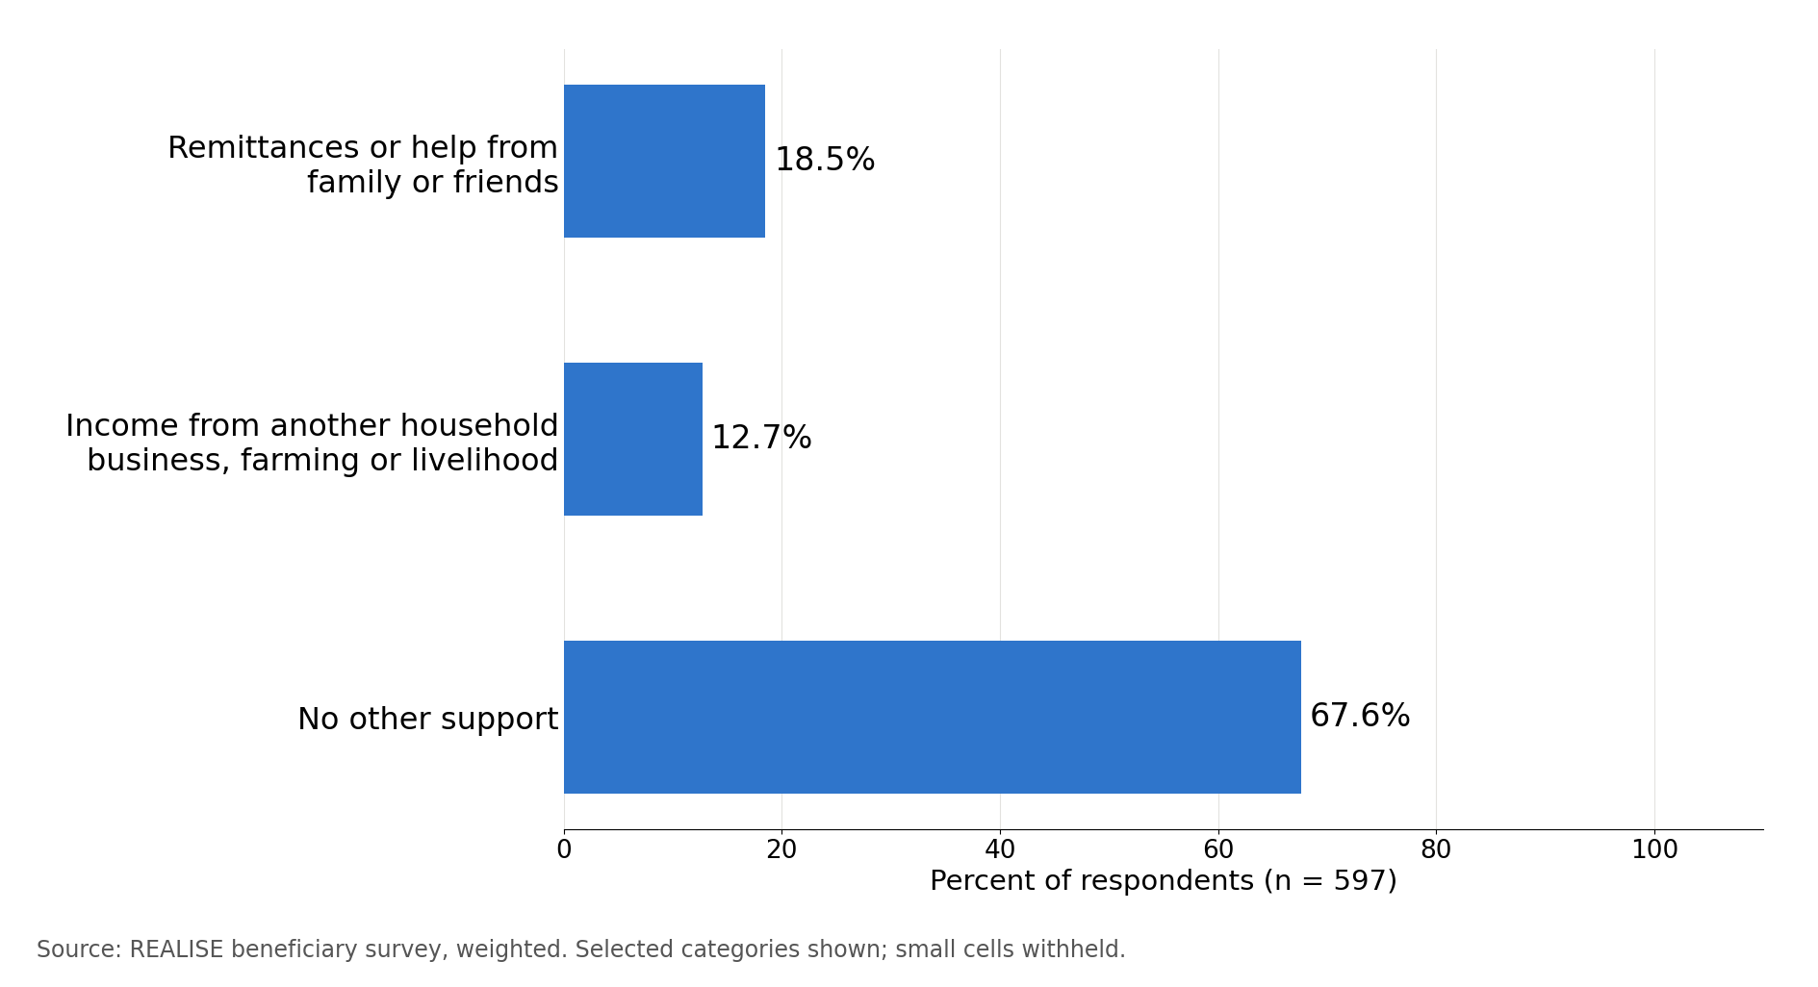
The comparisons between delivery and outcomes do not show the expected links in CLAS (Table 8.6.2). Households with complete and always-timely delivery report more coping days, not fewer: the adjusted difference is +1.45 days, against the expected direction. For basic needs, the adjusted difference in the change is +0.05, in the expected direction but not distinguishable from zero. For self-efficacy, women with their own or joint say over the use of the support report slightly lower self-efficacy (-0.50 points), also not distinguishable from zero. The own-name account contrast cannot be assessed within CLAS, because only 24 respondents in the comparison were not paid by mobile money, fewer than the 25 needed. No interview passage cited here explains why delivery and outcomes are not linked in CLAS.
Across the four components, respondents paid by mobile money are 11.5 percentage points more likely to hold an own-name account. The unexposed group reports no payment, so this contrasts payment with non-payment rather than two payment channels. Sparse component counts are withheld. Comparisons for coping, basic needs and self-efficacy differ across the components. Results against the expected direction weaken the support for the links without ruling them out. In the pooled linear probability model, 384 of 1,392 predictions fall outside zero to one (range 0.788 to 1.034). This diagnostic does not by itself establish model failure; the logistic sensitivity has limited support and does not confirm robustness.
Table 8.6.2. In CLAS, comparisons between delivery and outcomes do not show the expected links
Expectation | Exposed: n (mean) | Not exposed: n (mean) | Adjusted difference (95% CI) | p | Direction
H3 Coping score (P3); lower expected in exposed group | 130 (7.0) | 353 (5.3) | +1.45 (0.64 to 2.25) | <0.001 | Opposite to expected
H4 Basic-needs change (P4); higher expected | 173 (+0.37) | 376 (-0.07) | +0.05 (-0.02 to 0.12) | 0.173 | Expected direction; not distinguishable from zero
H5a Own-name mobile money (P5a, %); higher expected | 499 (percentage withheld) | 24 (percentage withheld) | Not estimated | n/a | Descriptive only: fewer than 25 in one group
H5b Women’s self-efficacy (P5b); higher expected | 250 (32.5) | 33 (33.0) | -0.50 (-1.03 to 0.03) | 0.066 | Opposite to expected; not distinguishable from zero
Reading note: Coping compares complete, timely delivery with other delivery experiences; basic needs compares receipt and use with incomplete receipt or non-use. Account ownership compares payment by mobile money with no payment; self-efficacy compares women with their own or joint say over support use with women without it. These are adjusted associations, not causal effects. Full estimates and the overall comparison across components are in the Annex F supplement.

8.7 Sustainability prospects
Most respondents expect their group to keep farming after support ends: 49.6 percent think it likely and 37.2 percent very likely, while 9.4 percent think it unlikely or very unlikely. This is a belief about the future, not observed continuation, and sits alongside low reported market-linkage support (Section 8.5). A participant describes saving together as a reason to stay organised: “We are beginning to save money. If we continue saving together, we will have a reason to remain organized and work towards a common goal.” (CLAS-FGD-007, P0306). Not every informant shares this expectation. A key informant says few communities have agreed to repeat their farm projects in the following years, as the design expects: “farmers or beneficiaries are not interested in repeating their projects, not at all” (CLAS-KII-025, P0187). The survey records members’ intentions, and this account concerns what communities have agreed to do. A linkage provider is described as having done poorly: “the group that was in charge or that was linking them to the market, did not do well.” (CLAS-KII-025, P0136).

Figure 8.7.1. Most CLAS respondents think their farming group is likely or very likely to continue after project support ends (86.8 percent). Some displayed response categories contain 10 to 24 observations and are indicative.
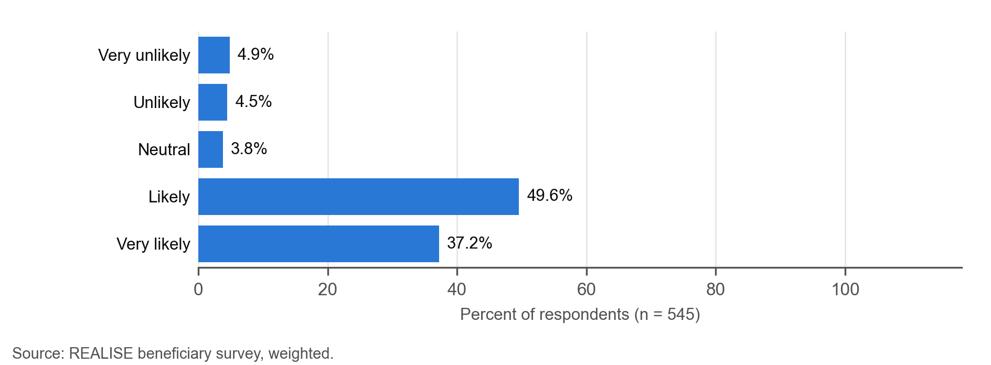

8.8 Contribution assessment
This section brings together the survey, interview and site evidence for the CLAS contribution claims. Table 11.2 lists the grade of each claim.
Claim. CLAS contributed to household coping and ability to meet basic needs through collective farming, inputs, the labour subsidy and training. Financial inclusion and climate-smart practice adoption are graded as separate claims. Table 11.2 grades the six CLAS claims: full receipt, on-time payment, coping, basic needs, climate-smart practices and continuation.
Outcome materialisation. Minimally observed (survey). Net change in basic needs is close to zero (+0.06), with respondents split almost evenly between better and worse off. Food consumption is mostly acceptable (88.6 percent), but seed-stock consumption is more common than in any other component.
Causal-chain evidence. Access is met: almost everyone received and used support. Completeness is partly met: full receipt is 32.7 percent, with large shortfalls in market linkage and ID support, and payments received fall well below expected amounts. Timeliness is partly met (68.9 percent of those given a schedule; 13.5 percent of those expecting a time-bound payment were given none). The coping, basic-needs and self-efficacy contrasts do not support the expected links, and the own-name account contrast cannot be assessed within CLAS. A participant describes a specific farming practice: “We learned how to arrange the planting beds and channels so that water flows to the side rather than damaging what we have planted.” (CLAS-FGD-001, P0249). Delivery accounts include delayed materials: “Like round three, the supplying of materials was delay and people have to use their materials like boots, cutlasses to work until REALISE could supply them with materials.” (CLAS-KII-025, P0136).
Rivals and contradictions. Shocks affected 78.1 percent of households, most often illness, death and crop failure; formal assistance is almost absent. Interviews name weather and market conditions as affecting results, and one informant notes continued shifting cultivation: “The practice they have not yet abandoned is moving from one place to another to farm.” (CLAS-KII-030, P0173). Weather, prices and prior mobile-money ownership were not measured in the survey and remain possible explanations.
Evidence bundle. Survey (this chapter); CLAS key informant interviews and focus groups (six interview units and six focus group units in the analysed corpus; the documentary inventory contains seven CLAS focus group files, including one file that could not be anonymised and is outside the analysed corpus); partial round-level PMT Mobile Money statements for Rounds 1 and 2 (no complete dated individual payment register that could be matched to respondents), with delivery and extension records under Recommendation R16.
Reviewed contribution assessment. The assessment is Moderate for recent reported use of climate-smart practices and Limited for continuation, receipt, timeliness, coping and basic needs. Groups describe applying practices and saving together, and 86.8 percent of members expect their group to continue. A district authority reports some regrouping, while another informant describes limited willingness to repeat projects; expectations do not establish continuation after support ends. Table 11.2 gives the grades.
Reporting statement. Recipients describe applying climate-smart practices, with Moderate evidence of contribution to recent reported use. The assessment is Limited for sustained continuation, delivery outcomes, coping and basic needs. These assessments apply to covered group members and do not estimate an impact against a comparison group.
Weakest link. Between delivery and household outcomes: core inputs reached almost everyone, but the labour subsidy was paid well below the expected amount, market linkage largely did not happen, and households report no average improvement. The county pattern (Bomi and Grand Cape Mount lowest on full receipt and the change in basic needs) cannot be separated from two enumerators (Section 8.9) and is not a verified place effect. Payroll records of labour-subsidy payments by county would most change the grade.
Findings by OECD-DAC criterion. Table 8.8.1 reads the CLAS findings against the six criteria. Grades are in Table 11.2.
Table 8.8.1. CLAS delivered inputs and farming support to almost everyone; market linkage and basic-needs gains were weakest
OECD-DAC criterion and evaluation question | Finding | Grade | Where in this chapter
Relevance (KEQ1). Did support and selection match intended beneficiaries’ needs and profiles? | The very-fair response was chosen by 34.4 percent of women and 48.6 percent of men. The survey covers selected beneficiaries and cannot estimate exclusion. | Descriptive | 8.2
Effectiveness (KEQ2). Were intended benefits delivered and were expected changes reported? | Core inputs reached 94.9 to 98.4 percent of those who expected them, but market linkage reached 28.1 percent of those who expected it. Full receipt is 32.7 percent, the lowest of the four components. | Limited (receipt) | 8.3
Efficiency (KEQ3). How efficiently were resources used, how timely were delivery and internal operations, and what transaction costs fell on beneficiaries? | Among those given a schedule, payments were always on time for 68.9 percent; among all respondents, 12.0 percent were never paid on time. The median labour subsidy received was 17,000 Liberian dollars, against 59,500 expected. | Limited (timeliness) | 8.3
Impact and contribution (KEQ4). What changes in income, employment, food security, consumption, resilience and agency are observed, and how plausible is REALISE’s contribution? | Reported change in basic needs is +0.06: 49.4 percent better and 44.7 percent worse off. Households with complete, on-time delivery report more coping days, not fewer. 91.3 percent adopted at least one climate-smart practice. | Limited (coping, basic needs); Moderate (climate-smart practices) | 8.4, 8.5, 8.6
Coherence (KEQ5). How do the four components complement one another and align with other government and partner programmes, and where are synergies, duplication or coordination gaps? | 67.6 percent of households received no other support. Small formal-assistance categories are withheld. REALISE trained 14,151 people in life skills and climate-smart agriculture; Section 8.5 sets this against the NDC target. | Descriptive | 8.5, 8.6
Sustainability (KEQ6). Which businesses, assets, groups, practices and household changes are likely to continue? | 86.8 percent expect the group to keep farming, a belief rather than observed continuation; groups that save together describe a reason to stay organised. | Limited | 8.7
Source: Sections 8.2 to 8.8 of this chapter. Table 11.2 gives the contribution grades.
Finding. CLAS delivered inputs, training and group farming to almost everyone interviewed. Complete receipt of every expected benefit was 32.7 percent, and 28.1 percent of those expecting buyer support received it. Recent reported climate-smart practice use has a Moderate grade; continuation, delivery, coping and basic-needs contribution have Limited grades.

8.9 Weighing the explanations for the worse-off group
In CLAS, 44.7 percent of respondents say they are worse or much worse able to meet basic needs, and 49.4 percent say they are better or much better able. The survey does not say why. Table 8.9.1 sets the candidate explanations against the evidence in this report: interviewer and measurement effects, delivery shortfalls, external shocks, weather and market conditions, production constraints, differences between counties and other support. None is tested against a comparison group, so the table weighs how well each is supported and says what would settle it. The interviewer reading comes from an exploratory analysis decided after outcome access, and it reports associations only (Annex G, Section G.13).
Table 8.9.1. Candidate explanations for the CLAS worse-off group: exploratory associations, evidence gaps and checks needed
Candidate explanation | Evidence in favour | Evidence against or missing | What would settle it | Reading
Interviewer and measurement effects | Enumerator indicators account for 52 percent of observed basic-needs variation in the weighted model. The within-community p < 0.001 is from a separate unweighted OLS test without cluster-robust standard errors; both are exploratory associations, not causal effects. Responses differ by interviewer, while interviewer assignment and geography cannot be separated in some counties. Detailed interviewer and form-version profiles are withheld from the external reporting package. | The way the basic-needs question (W01) was read out cannot be checked. Delivery and basic-needs responses need not follow the same pattern. Full receipt also differs by enumerator (R-squared 0.22, Annex G, Table G.13.D5b). The sensitivity analysis in Annex G, Table G.10.3, does not establish that interviewer differences caused the reported outcomes. | Analysis of the existing back-check and form-version data on the basic-needs question (the CLAS back-check asked the basic-needs question in 20 comparisons, with 35.0 percent agreement overall; the 59.0 percent profile agreement in Section 4.10 covers five profile items and excludes that question) | Consistent with interviewer or form administration effects; exploratory, decided after outcome access; associations only
Delivery shortfalls | Full receipt is 32.7 percent. The median labour subsidy was 17,000 Liberian dollars against 59,500 expected. 13.5 percent of those expecting a time-bound payment say no payment schedule was ever communicated. Buyer support reached 28.1 percent of those who expected it. | In the common sample of 175 BFG members and FMC officers with complete answers, the share of expected payment received, workdays, market linkage and completed training show no statistically clear association with the change in basic needs after adjustment for county and round, whether entered separately or together (Table G.13.D12). These models do not include enumerator fixed effects. The common sample requires a valid harvest answer as well as the delivery items; observations without a valid harvest answer are excluded. The harvest coefficient is not reported, and the output does not establish why it is non-estimable. The basic-needs contrast is +0.05 after county adjustment and +0.04 in the within-community comparison, with intervals including zero (Table G.13.D13). | Payroll and delivery records by county (R16) | No clear association is detected in these restricted adjusted models. Their uncertainty and coverage do not rule out a contribution from delivery shortfalls.
External shocks | 78.1 percent had a shock in the past 12 months: illness 61.6, death 30.6 and crop failure 27.4 percent. | After adding enumerator fixed effects, the crop-failure and illness associations weaken and are no longer nominally significant. The price-increase association changes sign but remains nominally significant: -0.21 points in the change in basic needs (p=0.005) and +6.0 percentage points in the worse-off share (p=0.036), in models using the same 539 respondents and 20 community clusters (Tables G.13.D10 and G.13.D11, M6). These post hoc tests are not adjusted for multiple comparisons. | Shock questions verified against local weather and health data | The results differ by shock. They do not establish a causal explanation of the worse-off group, and they do not support a blanket conclusion that shock associations disappear after adjustment for enumerator.
Weather and market conditions | Interviews name rainfall, drought and market conditions as influences on harvests (CLAS-KII-024, P0143; CLAS-KII-025, P0153). Bad weather is the most frequent barrier (15.8 percent). Market linkage reached 19.4 percent of those asked. | Prices, rainfall and harvest value were not measured. Harvest quantities are in respondents’ own units and are not yields. | Rainfall and price data for the sites and seasons | Possible; named by informants, not measured
Production constraints | Too little labour is the second barrier (15.7 percent). Shifting cultivation continues (CLAS-KII-030, P0173). 32.8 percent report a work-related injury or illness. | No yield, input-use or area record. 66.5 percent report no barrier to applying practices. | Delivery and extension records; yields after a full farming cycle (R10, R16) | Possible for some groups; not shown for the worse-off group
County and sample composition | Bomi and Grand Cape Mount have the lowest full receipt (8.4 and 9.3 percent) and the lowest basic-needs change (-0.41 and -0.65). Reports of no payment schedule come only from these two counties. Exploratory weighted worse-off shares: Grand Cape Mount 74.5 percent (n=106), Bomi 65.9 percent (n=104), Lofa 36.6 percent (n=87), Grand Gedeh 31.4 percent (n=118) and Bong 22.2 percent (n=138); CLAS average 44.7 percent (n=553). By round: Round 1 41.8 percent (n=80), Round 2 41.7 percent (n=92), Round 3 46.1 percent (n=381). | County and interviewer assignments overlap completely in part of the sample. The county gap cannot be separated from interviewer differences. Detailed assignment profiles are withheld from the external reporting package. | Payroll by county and a county-level qualitative follow-up (R10, R16) | Confounded with enumerator assignment; not a verified place effect
Other support or income | 67.6 percent received no other support, and 12.7 percent had income from another business or livelihood. Formal assistance is almost absent. | Remittances and help from family or friends reach 18.5 percent. Prices and prior mobile-money ownership were not measured. | Questions on other income, asked of the same households | Weak as a sole explanation
Reading note: Percentages and means are weighted. The change in basic needs is recalled by respondents. The table weighs each explanation from descriptive evidence and does not estimate the effect of any explanation. The interviewer and form-version rows come from an exploratory analysis decided after outcome access (Annex G, Section G.13). It reports associations only and applies no multiple-testing adjustment.
The status of each explanation is distinguished as statistically examined, described qualitatively, or not directly measured. A variable that is not statistically distinguishable from zero is not ruled out as an explanation. County, enumerator, form version and fieldwork timing overlap, and the exploratory models do not fully separate them.
Source: Sections 8.3 to 8.8 and 10.3; Table 11.2; Recommendations R10, R16 and R18.
Exploratory county and round results (Annex G, Table G.13.D15; weighted; decided after outcome access, with no multiple-testing adjustment): the worse-off share is 74.5 percent in Grand Cape Mount (n=106) and 65.9 percent in Bomi (n=104), against 36.6 percent in Lofa (n=87), 31.4 percent in Grand Gedeh (n=118) and 22.2 percent in Bong (n=138). By round it is 41.8 percent in Round 1 (n=80), 41.7 percent in Round 2 (n=92) and 46.1 percent in Round 3 (n=381). Among respondents who said no payment schedule was communicated, 73.9 percent were worse off (n=78). County differences remain significant with enumerator held fixed in that test (p<0.001), but county and interviewer assignment overlap in Bomi and Grand Cape Mount, so a place effect is not established.
Figure 8.9.1. Share of CLAS respondents reporting being worse off, by county (exploratory).
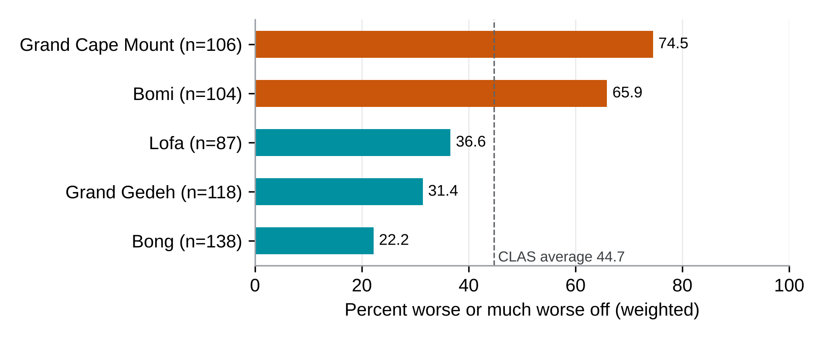
Source: Beneficiary survey, weighted; exploratory cross-tabulation decided after outcome access; Annex G, Table G.13.D15.
The available evidence does not identify a single cause of the CLAS split. In the exploratory analysis, enumerator indicators account for 52 percent of the observed variation in the change in basic needs in the weighted model, and a separate unweighted OLS test without cluster-robust standard errors finds differences between enumerators within communities (p<0.001). These patterns may reflect interviewer administration, respondent composition or other differences associated with field assignments; they do not prove interviewer error. Interviewer assignment overlaps with the two-county block of Bomi and Grand Cape Mount, so contrasts with the other counties cannot be separated cleanly from assignment. The delivery-item models adjust for county and round, not enumerator, and use a restricted complete-case sample. Crop-failure and illness associations weaken after enumerator adjustment, while the price-increase association changes sign and remains nominally significant. No multiple-testing adjustment was applied to these exploratory models. The primary basic-needs mean remains +0.06; its community-clustered interval is -0.18 to +0.30, and omitting one enumerator at a time gives means from -0.13 to +0.24. The CLAS basic-needs contribution grade remains Limited. The estimates should be read descriptively, alongside the delivery gaps and qualitative accounts, without attributing the split to the programme, a county, an interviewer or a form version. Dated delivery records and analysis of the existing back-check and form-version data on the basic-needs question would help distinguish these explanations (R10 and R16); later observation after harvest would address persistence and timing (R18).

Chapter 9. Findings: Social Cash Transfer (SCT) and the National Social Protection System

Key findings
- Most SCT households reported receiving and using support; sparse non-receipt and its complements are withheld. Of those expecting the quarterly transfer, 98.0 percent received it. Among those expecting a specific benefit, 61.1 percent received every benefit they expected (Section 9.3).
- Payment timing is the area to strengthen in SCT: 62.8 percent of those given a schedule said transfers always arrived on time, the lowest of the four components (Section 9.3).
- The number of transfers is the main gap to close: 32.1 percent of those who expected up to six quarterly transfers reported receiving them (Section 9.3).
- Nine in ten respondents (90.4 percent) say they are better or much better off in meeting basic needs since receiving the transfer, the largest improvement of the four components (Section 9.4).
- Food consumption is the next area to strengthen: SCT has the lowest mean Food Consumption Score of the four components (40.9), and 18.4 percent of households fall in the poor category (Section 9.4).
- The adjusted comparison in coping days between households with complete, on-time delivery and other households is +0.40 and is not statistically distinguishable from zero (Section 9.5). This uncertainty does not establish equal outcomes or absence of a delivery-outcome association. Registry data on transfers due and paid (Recommendation R16) would show whether the gaps in the number of transfers reflect timing or non-payment (Section 9.7).
Annex F gives the remaining tables for this chapter: the full respondent and household profile, requests for informal payments, the stages of the delivery pathway, payment channels, account ownership of the registered recipient, food consumption and coping detail, other assistance and the use of the support.
Every table and figure in this chapter shows SCT respondents only; Chapter 10 and Annex F set the four components side by side. Estimates are weighted so that they represent SCT beneficiaries on the beneficiary list (Section 4.7).

9.1 Component overview
Under the Project Operations Manual, SCT pays US$11 to US$49 a month by household size, quarterly by mobile money; Rivercess is outside the sampling frame. The PMT Mobile Money statements hold one SCT batch, 904 transfers in Liberian dollars in Grand Kru in November 2024. This partial record is not a complete dated individual payment register and could not be matched to respondents. Registry data on transfers paid and coverage by county are covered by Recommendation R16.
The survey covers 357 SCT households in three counties: River Gee (172 respondents; 49.4 percent weighted), Grand Kru (99; 27.2 percent) and Grand Bassa (86; 23.4 percent). All but one respondent answered for themselves. SCT records no implementation round, so results are not split by round.

9.2 Who was reached
Women are 78.9 percent of SCT beneficiaries on the beneficiary list (77.9 percent of weighted survey respondents), close to the 75 percent female share set for registered cash recipients, with similar shares in all three counties (78.3 to 80.3 percent). Respondents are 272 women and 85 men.
Mean age is 41.4 years, and 38.1 percent are aged 18 to 34; most worked in the past 7 days (81.6 percent) and are married or living with a partner (65.8 percent). Education differs by sex: 35.5 percent of men completed senior secondary, vocational or tertiary education, against 10.7 percent of women (Annex F, Table 9.2.1).
A third of SCT households (33.9 percent) include someone with a functional difficulty. The item covers anyone in the household, so it is not comparable with the other components and is not a disability rate.
Households average 5.2 members. Farming is the main livelihood for 47.2 percent and business or petty trade for 37.8 percent; business is less common in Grand Kru (24.9 percent) than elsewhere.
The detailed table is in the Annex F supplement (Table 9.2.1).

Across all SCT respondents, 95.4 percent rated selection as fair or very fair (n=357), while 13.7 percent chose specifically very fair: 13.1 percent of women and 16.1 percent of men (Section 10.1). Gender-disaggregated grouped fair-or-very-fair rates and their complementary counts are withheld to protect small cells.
Figure 9.2.1. Share choosing "Very fair", by respondent sex. The other response categories are not displayed separately.
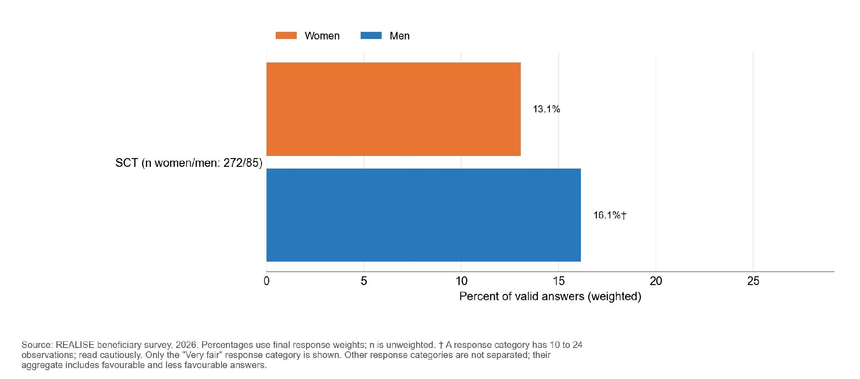
A small number of selected SCT respondents reported requests for an informal payment, gift, favour or political support. Estimates by sex are withheld because outcome cells are small.
The survey covers enrolled households only, and respondents may not report every request for a payment. Universal enrolment within selected communities is the stated intention, yet a focus group participant describes missed residents and some excluded people with disabilities: “Some of the people with disabilities whom we look after did not receive the money, although some others did.” (SCT-FGD-007, P0211). No eligibility error rate is available, and matching grievance records on enrolment is the next step.

9.3 Delivery pathway
Most SCT households reported receiving support and using the transfer; rare non-receipt and its complements are withheld. Among the 87.7 percent who expected a specific benefit at enrolment, 61.1 percent received every benefit they expected; the 12.3 percent who expected none are outside the full-receipt base. Payments were least often on time in SCT: 62.8 percent of those given a schedule said transfers always arrived on time, the lowest of the four components (Table 9.3.1).
Table 9.3.1. Six in ten SCT households received every benefit they expected, and about the same share were always paid on time
Indicator | Value % (n) | Women | Men | Note
Payments always on the communicated schedule | 62.8 (350) | 66.4 | 49.6 | Among households given a payment schedule
Received every benefit they expected | 61.1 (313) | 66.2 | 43.4 | Main gap: the number of transfers

Reading note: women reported better delivery than men on both measures (valid male bases are 74 for full receipt and 81 for timeliness, out of 85 men in the SCT sample). Full receipt excludes the 12.3 percent of households who expected no specific benefit; respondents without a communicated schedule are outside the on-time payment base. Percentages are weighted; n is the number of valid answers.

Figure 9.3.1. In SCT, 61.1 percent of beneficiaries received every expected benefit, while 62.8 percent reported transfers always on the communicated schedule.
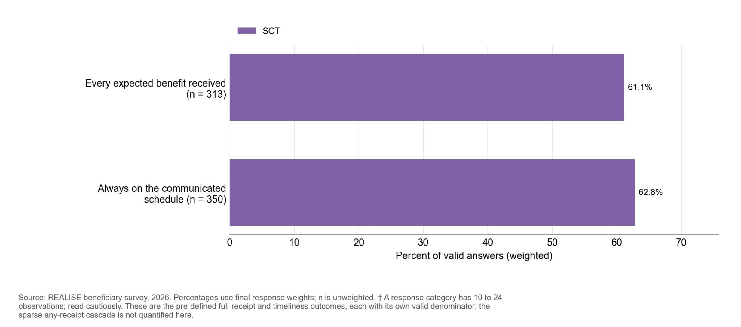
The main shortfall is the number of transfers: only 32.1 percent of those who expected up to six quarterly transfers reported receiving them (Annex F, Table 9.3.2), against 98.0 percent receipt among those who expected the quarterly cash transfer itself. Some households may have been interviewed before all six were due, so the gap may reflect timing. A verification team describes the cap: “There is a limit of six payments.” (SCT-KII-020, P0124). Recommendation R16 covers the registry data on transfers due and paid at the interview date, which would separate timing from non-payment.
Receipt was also lower for the covered cash-out fee (67.9 percent of 99) and for complaint or grievance information (42.2 percent of 22, a small base). Mobile-money registration was received by more households than expected it (90.8 against 57.7 percent), and 10.9 percent reported some other benefit, which the survey data do not describe. A visit sheet notes that cash-out points are hard to reach for older and disabled recipients (SV-SCT-02, P0060).
Staff describe universal enrolment, while beneficiaries and officials describe skipped settlements, and say household counts were checked at the home. An SCT key informant describes enrolment teams skipping small settlements: “they would jump over the town and go to the next bigger town” (SCT-KII-008, P0402). Participants in one SCT group say teams registered no more than five people per fire hut and left the others out, which “make some people to feel bad” (SCT-FGD-001, P0505 and P0506). Household size was checked at the home: “The zonal heads will go to your house, they can ask you how many persons in your house, how many fire hut you got, how many children all of that one.” (SCT-FGD-001, P0244). One grandparent says the team asked where the children were and “gave me support for only one child” of the seven they sent to school (SCT-FGD-003, P0212).
The detailed table is in the Annex F supplement (Table 9.3.2).

Figure 9.3.2. The largest gap between benefits expected and received in SCT is up to six quarterly transfers (46.3 percent expected, 27.1 percent received). Some displayed response categories contain 10 to 24 observations and are indicative.
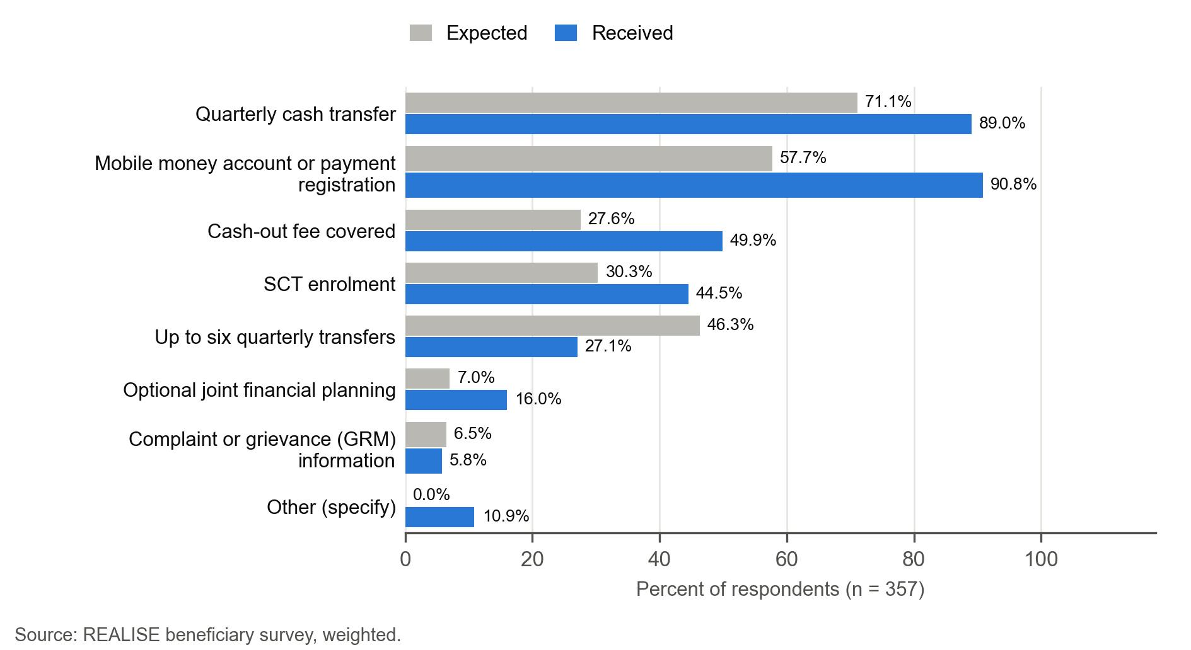
Among 350 respondents with a communicated schedule, 62.8 percent said transfers always arrived on time and 37.2 percent not always (Annex F, Table 9.3.3). The community-clustered interval overlaps that of SSB, so the ranking of payment timing is uncertain (Annex G, Table G.2). Finer timing categories are withheld. Late transfers are mostly occasional, although one participant says the programme “never use to send us the money on time” (SCT-FGD-003, P0315).
The detailed table is in the Annex F supplement (Table 9.3.3).

Figure 9.3.3. Payment timeliness is grouped into always on time and the combined remaining timing responses.
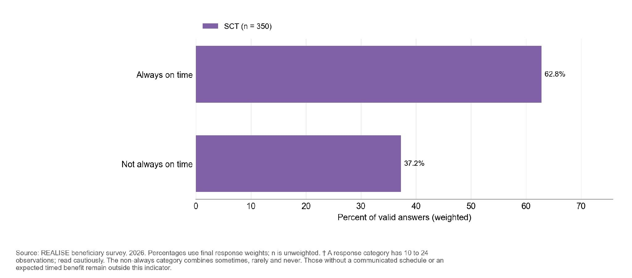
Mobile money was the channel reported by SCT transfer recipients. Among registered cash recipients answering for themselves, 99.4 percent hold a mobile-money account in their own name. The survey does not estimate the time or money spent to receive a transfer; Recommendation R6 covers cash-out fee data from the payment provider.

The use question asks whether the transfer was used as planned, not what it was spent on: 79.5 percent used it as planned. Sparse and complementary categories are not separated. The SCT form does not define the plan, and the joint financial planning questions were not asked, so the answer refers to the household’s own plan for the money.

Figure 9.3.4. Selected uses of SCT support by respondent sex; small and complementary categories are not displayed.
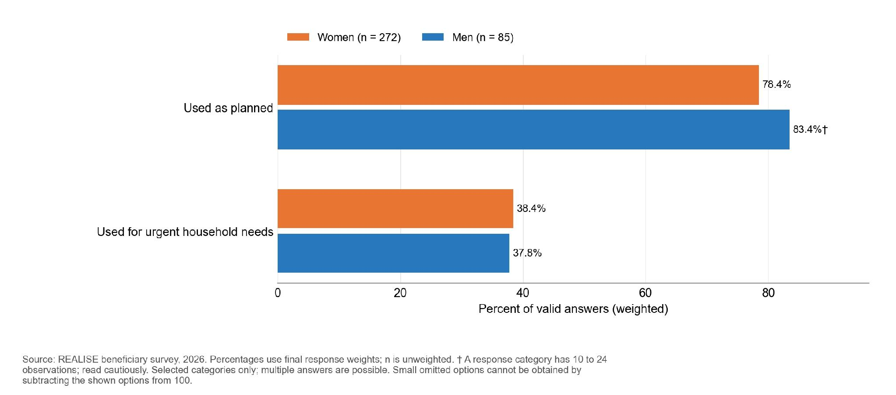
Weighted % of respondents selecting each option, by sex of the person answering. Multiple answers allowed.
The respondent-alone decision share was 45.0 percent among SCT women and 68.1 percent among men. Joint decisions and other deciders are not separated. The female- and male-labelled alone options are grouped consistently with Figure 9.3.5.

Figure 9.3.5. Share reporting that the respondent alone made the final decision on use; other decision categories are not displayed separately.
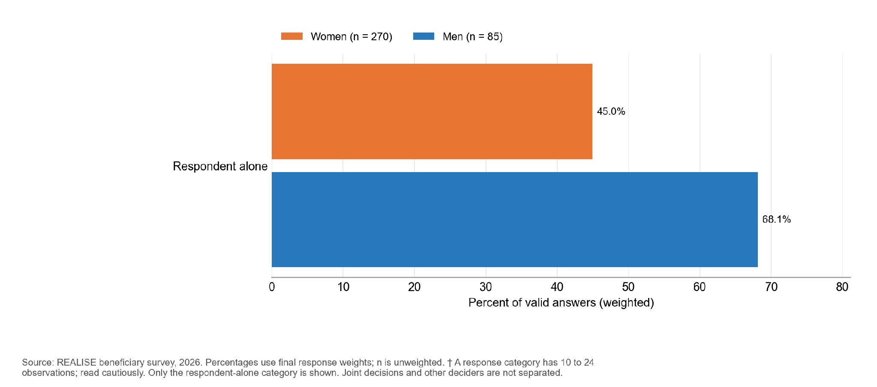
Men n = 85; women n = 270 (weighted % of valid answers; n unweighted). Don’t know and refused are excluded.

9.4 Outcomes
SCT households report the largest improvement of the four components in their ability to meet basic needs: the mean is +1.06 on a scale from -2 to +2 (Table 9.4.1). Nine in ten respondents (90.4 percent) are better or much better off since receiving the transfer (73.2 and 17.3 percent), and 9.6 percent report the same or worse (Annex F, Table 9.4.2). The change in basic needs is a retrospective self-report, so it describes the change households perceive and does not measure an effect.
Food insecurity nonetheless remains common. The mean coping-days score (higher means more coping with food shortage) is 6.5 on a scale from 0 to 84, the highest of the four components, close to LIPW (5.9). Improvement and hardship can coexist if households started from a very low position; the survey has no baseline to test this. Recipients describe the change in everyday terms: “Before the programme, I was eating once a day. When the money started coming, I began eating twice a day.” (SCT-FGD-004, P0292). Another finds the sum too small for food: “You can take all the money and use it to buy food, but it does not go very far.” (SCT-FGD-003, P0316). A case record notes a recipient who reports that the transfer helped meet household food needs, a self-report (CASE-SCT-01, P0088).
Almost every respondent has a mobile-money account in their own name (99.4 percent of beneficiaries answering for themselves; 99.2 percent of all respondents), and 96.2 percent of these accounts are active. The survey measures current ownership only (Section 9.5).
Table 9.4.1. Almost all SCT beneficiaries hold a mobile-money account and report better basic needs, while coping days remain the highest of the four components
Indicator | Value (n) | Women | Men | Note
Mobile-money account in own name, % | 99.4 (356) | Suppressed | Suppressed | Current ownership; beneficiaries answering for themselves
Coping-days score, 0 to 84 (lower is better) | 6.5 (357) | 6.7 | 5.8 | Highest of the four components
Change in ability to meet basic needs, -2 to +2 | +1.06 (356) | +1.06 | +1.08 | 90.4 percent better or much better off; 9.6 percent same or worse

Reading note: SCT households report the largest improvement in basic needs of the four components, yet their coping days are the highest. Percentages and means are weighted; proxy interviews are excluded from the change in basic needs and own-name accounts.

Figure 9.4.1. The coping-days distribution is shown in broad common score bands, preserving the original primary outcome and valid-answer universe.
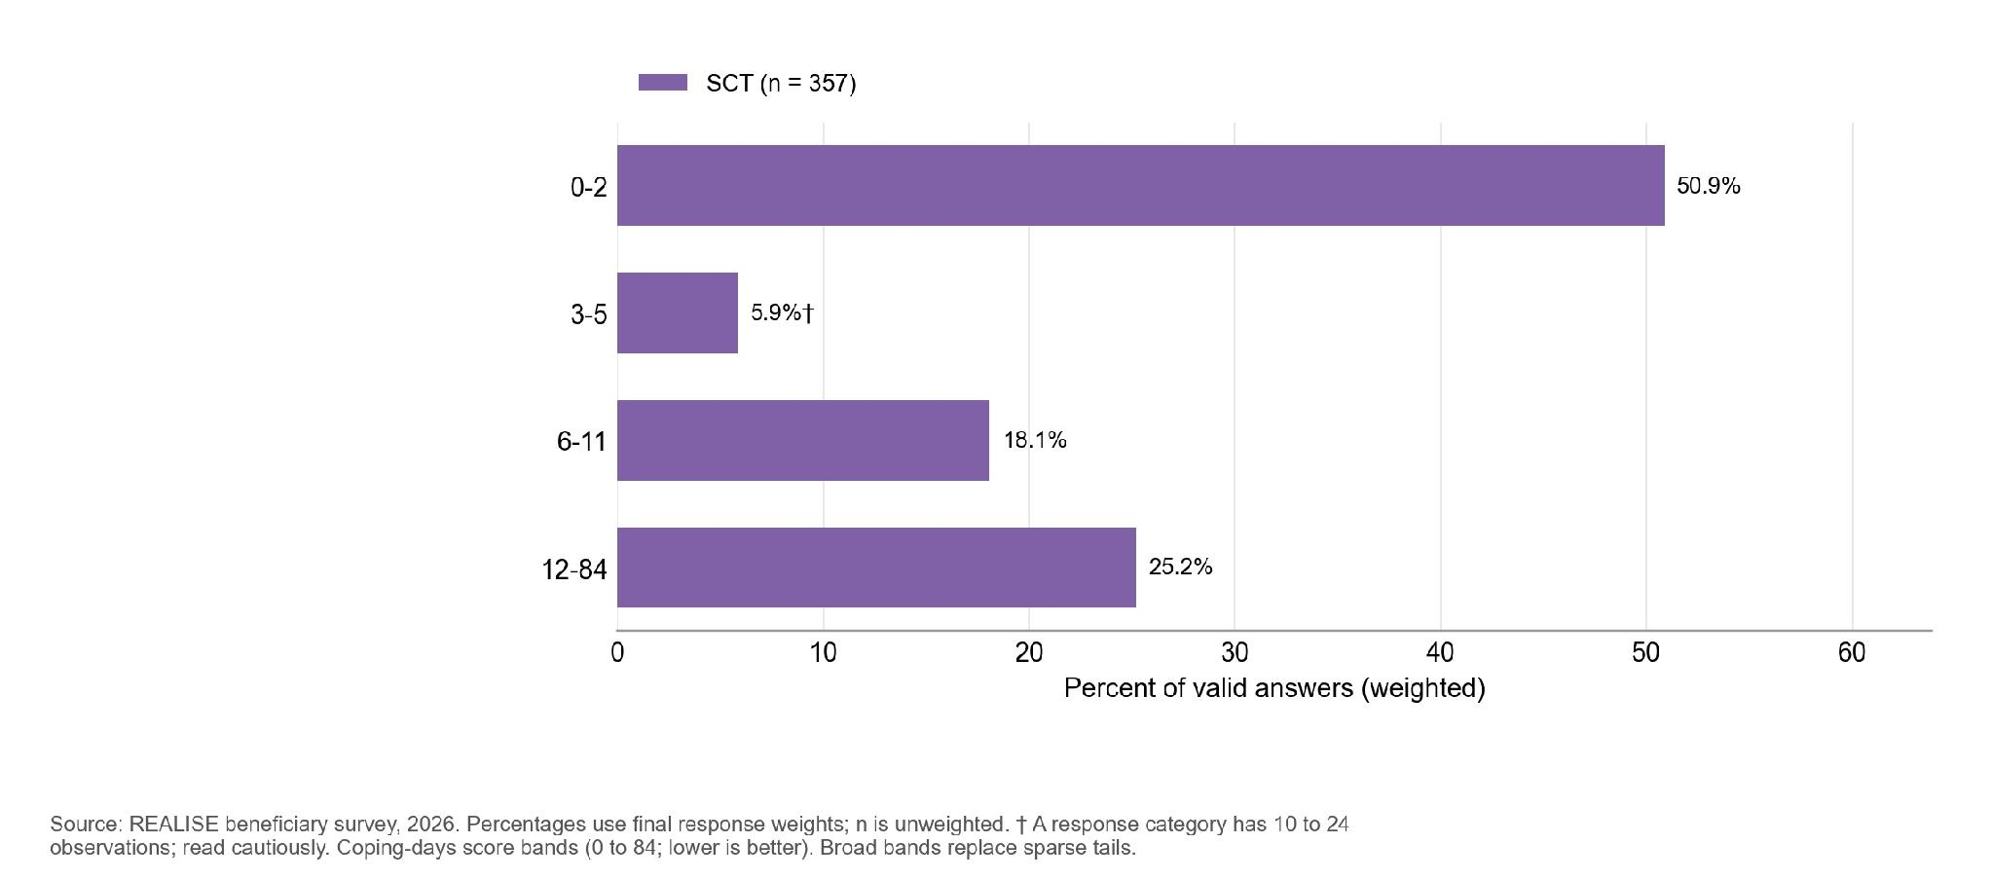
n by component: SCT 357. Bars and their labels show weighted percentages; n gives the unweighted number of valid respondents. Households with no food shortage score 0.
Figure 9.4.2. Retrospective basic-needs change is shown as better or much better versus the combined same-or-worse category.
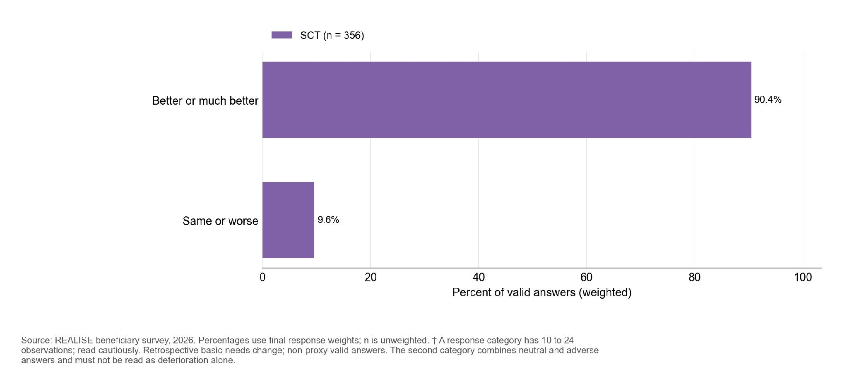
n by component: SCT 356. Bars and their labels show weighted percentages; n gives the unweighted number of valid respondents. Recoded so that positive values mean improvement. Retrospective self-report; proxy interviews excluded.
The detailed table is in the Annex F supplement (Table 9.4.2).

Women were more likely than men to receive every expected benefit (22.8 percentage points) and to report transfers always on time (16.8 points) (Table 9.4.3). Both hold after adjustment for multiple testing. Valid bases are 239 women and 74 men for full receipt and 269 women and 81 men for timeliness, within the total SCT sample of 272 women and 85 men. Sex is that of the person answering. Registry data by recipient (Recommendation R16) would show whether men are more often in households with irregular payments or registration problems. These respondents also report concerns about selection and reporting safety (Section 10.5); these descriptive views do not explain the delivery differences. No interview passage cited in this report explains this pattern. Gender-disaggregated grouped fair-or-very-fair rates and their complementary counts are withheld to protect small cells.
Counties differ on full receipt, on-time payment, coping and women’s self-efficacy, and the joint tests hold after adjustment (Table 9.4.3). Grand Kru has the highest full receipt (27.0 percentage points above Grand Bassa and 43.9 above River Gee) and on-time payment (22.0 above Grand Bassa); Grand Bassa has the fewest coping days (3.6 to 3.8 days fewer than the others) and the highest self-efficacy among women. The analysis did not resolve a difference in the change in basic needs by county. These differences are descriptive and depend on sample composition, not programme effects.
Table 9.4.3. SCT delivery outcomes differ by sex and county; basic needs and account ownership do not
Outcome | Women compared with men | County pattern
Every expected benefit received (n = 313) | +22.8 percentage points; clear difference | Highest in Grand Kru and lowest in River Gee; differences are clear.
Payments always on schedule (n = 350) | +16.8 percentage points; clear difference | More punctual in Grand Kru than in either other county.
Coping-days score, 0 to 84 (n = 357) | +1.0; uncertain difference | Fewer coping days in Grand Bassa; Grand Kru and River Gee are not clearly different.
Change in basic needs, -2 to +2 (n = 356) | -0.02; uncertain difference | County differences are uncertain.
Women’s self-efficacy, 8 to 40 (n = 271) | Women only | Higher in Grand Bassa than in the other counties; Grand Kru and River Gee are not clearly different.
Mobile money in own name (n = 356) | Comparison limited by sparse cells | Comparison limited by sparse cells.
Reading note: Results use the final survey weights; n is the number of valid answers. The Annex F supplement, Table 9.4.3, gives the full detail.

SCT households have the lowest mean Food Consumption Score (FCS) of the four components: 40.9, with 18.4 percent of the 321 scored households in the poor category, which means a score of 21 or below. They ate from an average of 5.9 of 12 food groups the previous day (Household Dietary Diversity Score, HDDS; n = 316). The 36 households without an FCS were interviewed before the food consumption module was added to the form; five later interviews also lack an HDDS.
Coping strategies are common: 48.6 percent relied on cheaper food, 42.1 percent reduced portions and 35.0 percent cut the number of meals; 22.9 percent borrowed food or relied on help and 10.1 percent spent whole days without eating.
Most households buy fish (82 percent), while own production is the main source for dark green leafy vegetables (64 percent), vitamin A-rich fruits (60 percent), other fruits (57 percent) and about half of white roots and tubers (47 percent); Annex F gives the source of each food group. One recipient describes treatment and other purchases: “the programme benefited me because I was able to provide for my child health when he was very sick. I also bought some materials that could help me.” (SCT-FGD-006, P0221). Another describes uneven relief: “Because the food is not available every day the money will be there and what I wanted to buy for the food to be there throughout the money will not be plenty like that (enough) just to buy food.” (SCT-FGD-008, P0458). Food purchases show use of the money, not reduced coping.
Figure 9.4.3. An acceptable food consumption score is recorded for 62.3 percent of SCT households, a borderline score for 19.3 percent and a poor score for 18.4 percent.
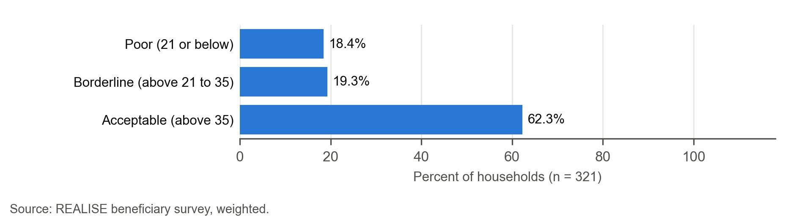

Figure 9.4.4. The most common coping strategy of SCT households in the past week was relying on less preferred, cheaper food (48.6 percent), followed by reducing portion size (42.1 percent). Some displayed response categories contain 10 to 24 observations and are indicative.
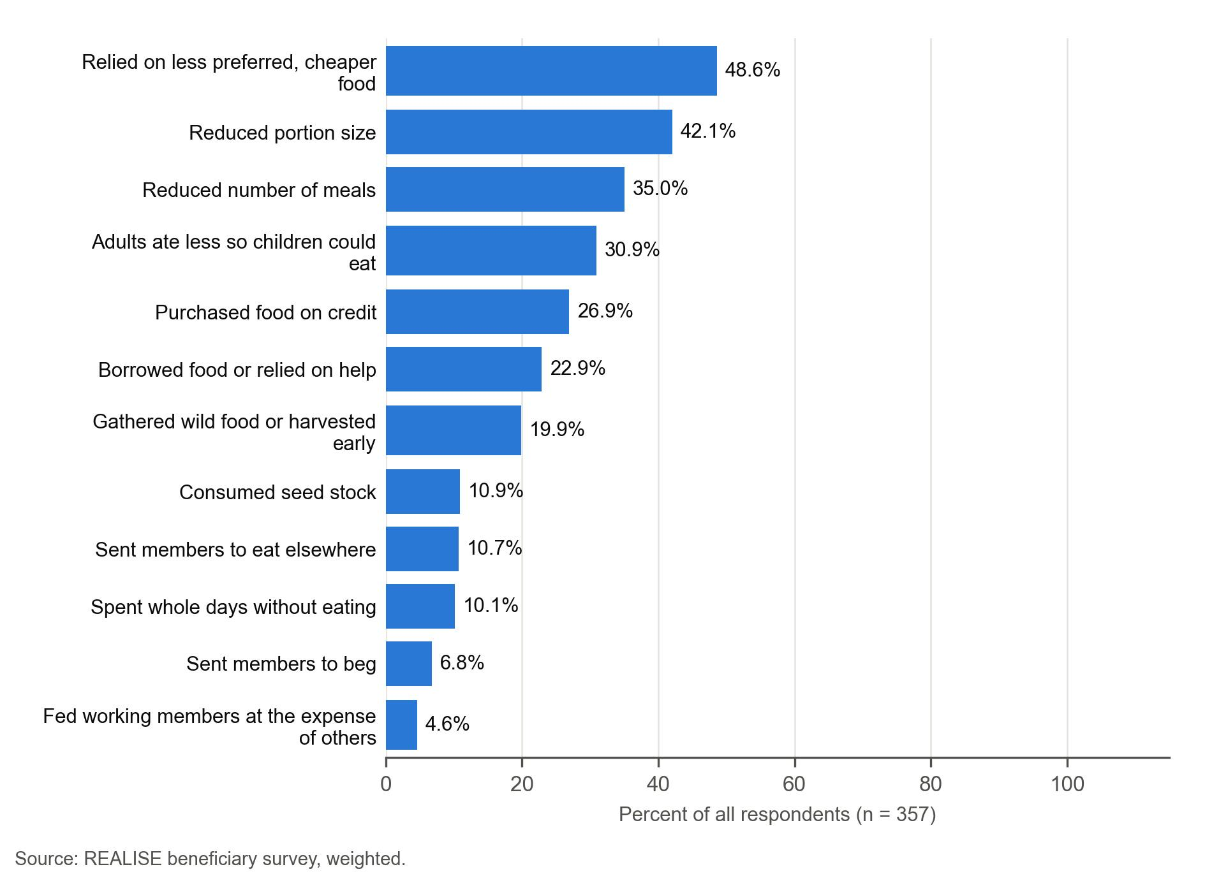

9.5 Mechanisms, records and rivals
Site observation draws on the SCT site visits. The survey adds shocks, remittances and other assistance as rival-explanation evidence, current own-name account ownership, and four comparisons between delivery and outcomes (the mechanism contrasts): the expectation is a lower coping score where receipt and timing held, a larger change in basic needs where support was received and used, higher own-name account ownership where payment was by mobile money, and higher self-efficacy among women who had their own or joint say over the use of the support (Table 3.2). They are supporting evidence only.
This assessment draws on the survey, the SCT interviews and focus groups, the four SCT site-visit sheets and the SCT case grid. Linking the payment registry and grievance records is part of Recommendations R13 and R16.
Most households (78.1 percent) had at least one shock in the past 12 months. Illness is by far the most common (65.2 percent), followed by food or input price rises (34.1 percent), crop failure (19.4 percent), a death in the household (16.9 percent) and flood or weather shocks (15.6 percent). In the SCT question on other assistance, 17.3 percent reported other aid, remittances, employment income or project support since their first SCT transfer. In the separately asked question on other assistance during transfers, 18.1 percent reported family assistance and 79.6 percent gave the code interpreted as no assistance. The items differ for 53 of 349 respondents with valid answers to both; their results are presented separately. The no-assistance choice in that question has a blank label in the v16 and v19 form files, while its constraint message identifies it as “None”; the display on each device is not established.
The two questions on other assistance and remittances produce different results and cannot be combined as a single series. Other programmes, family support, price rises and earlier mobile-money ownership remain possible explanations; the survey measures these factors only in part.
The detailed table is in the Annex F supplement (Table 9.5.1).

Figure 9.5.1. Selected shocks reported over the past 12 months; small categories are withheld.
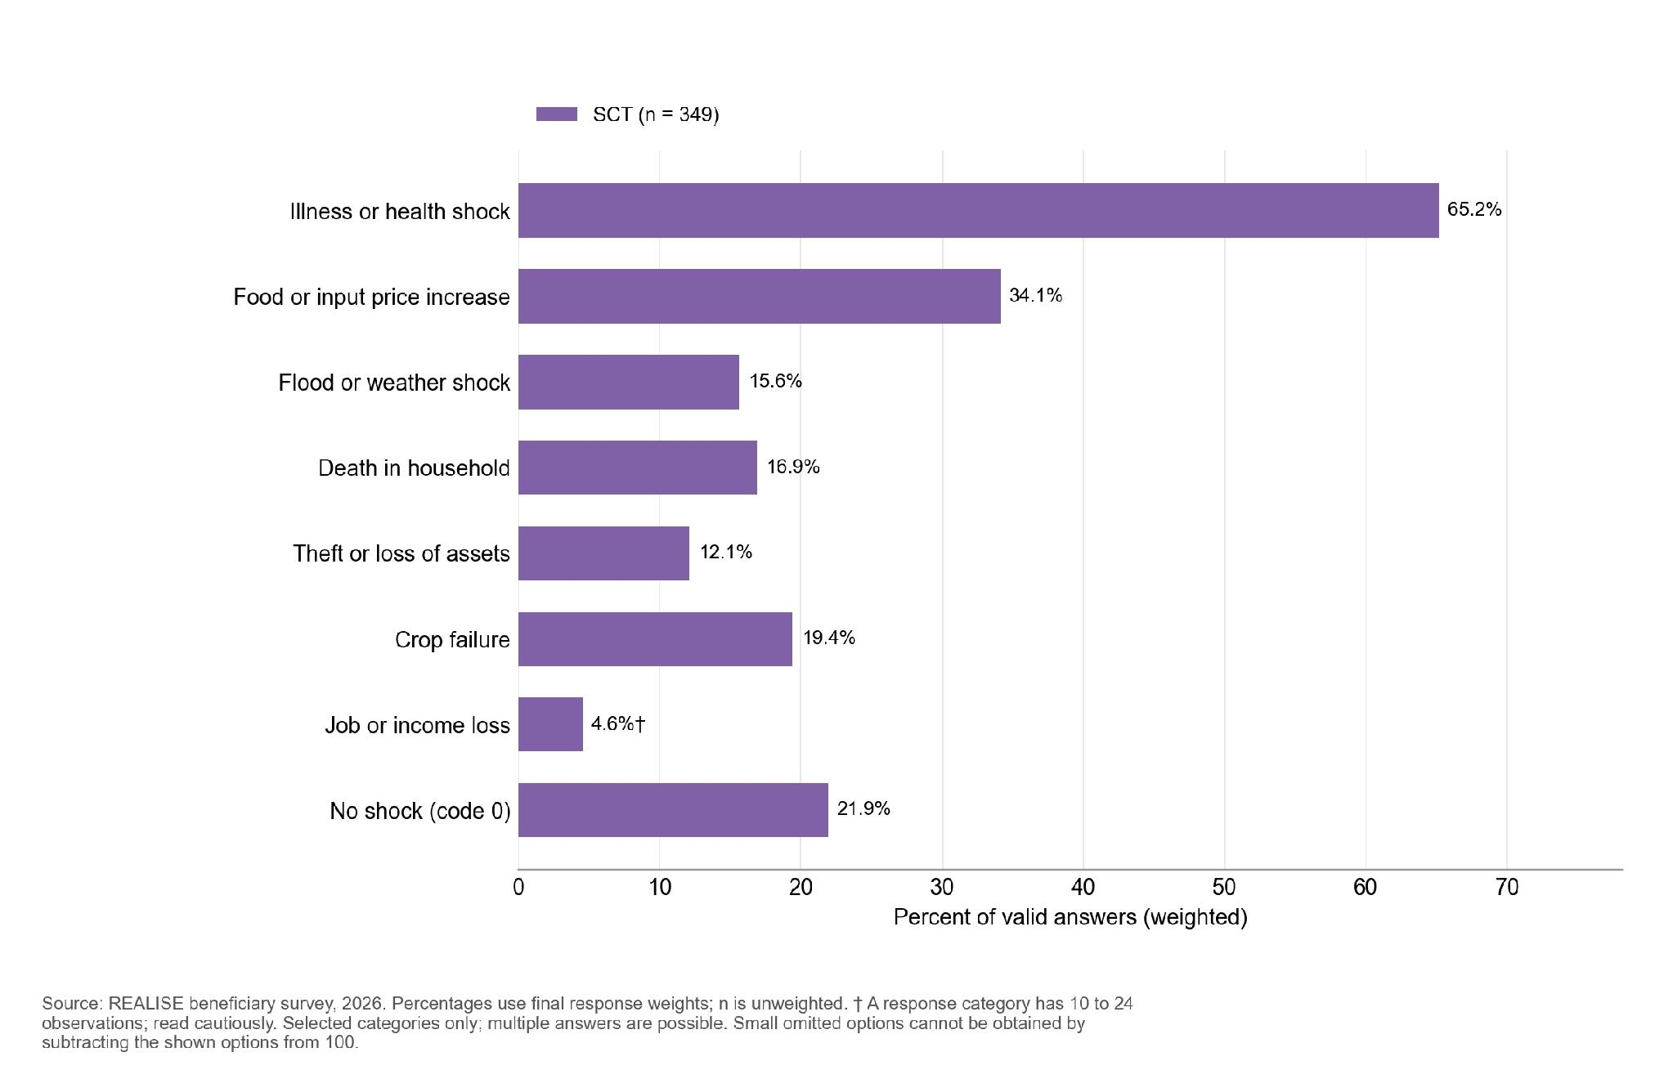
Figure 9.5.2. In the separately asked question on other assistance during transfers, 79.6 percent gave the code interpreted as no other assistance during transfers; the most common other source was remittances or help from family or friends (18.1 percent). Some displayed response categories contain 10 to 24 observations and are indicative.
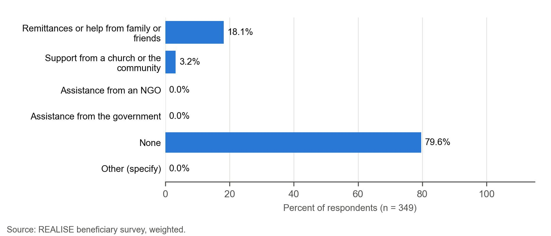
The comparisons between delivery and outcomes do not show the expected links for SCT (Table 9.5.2). Households with complete, always-timely delivery have slightly higher coping scores than others (6.7 against 6.1; adjusted difference +0.40 days), which is against the expected direction and not distinguishable from zero. Households that received and used every expected benefit report almost the same improvement in basic needs as others (1.0 against 1.1; adjusted difference +0.02). The own-name account and self-efficacy contrasts cannot be assessed: one arm of each comparison is below 10, with sparse sizes and their complements withheld.
The coping and basic-needs comparisons differ across the components. Because almost all SCT households report improvement whatever their delivery experience, the basic-needs finding may reflect receipt of the transfer more than how complete or punctual it was. The Annex F supplement gives the full tests.
Table 9.5.2. In SCT, the estimated delivery contrasts are not statistically resolved
Expectation | Exposed: n (mean) | Not exposed: n (mean) | Adjusted difference (95% CI) | p | Direction
H3 Coping score (P3); lower expected in exposed group | 133 (6.7) | 176 (6.1) | +0.40 (-1.31 to 2.12) | 0.645 | Opposite to expected; not distinguishable from zero
H4 Basic-needs change (P4); higher expected | 190 (+1.03) | 122 (+1.06) | +0.02 (-0.13 to 0.16) | 0.826 | Not distinguishable from zero
H5a Own-name mobile money (P5a, %); higher expected | Withheld (sparse comparison) | Withheld (sparse comparison) | Not estimated | n/a | Cannot assess
H5b Women’s self-efficacy (P5b); higher expected | Withheld (sparse comparison) | <10 (suppressed) | Not estimated | n/a | Cannot assess: fewer than 25 in one group
Reading note: Coping compares complete, timely delivery with other delivery experiences; basic needs compares receipt and use with incomplete receipt or non-use. Account ownership compares payment by mobile money with no payment; self-efficacy compares women with their own or joint say over support use with women without it. These are adjusted associations, not causal effects. Full estimates and the overall comparison across components are in the Annex F supplement.

9.6 Strengthening the national social protection system (Component 6b)
The Liberia Household Social Registry is the starting point for SCT enrolment. A programme informant explains that the registry shows which households are eligible and that they are then moved into the management information system (MIS), through which payment is made: “The registry indicates which beneficiaries are eligible to be moved into the Management Information System.” (CROSS-KII-002, P0274). The same informant notes a staffing gap: “Recently, our MIS officer left, and we did not have an officer in that role.” (CROSS-KII-002, P0274). A programme informant describes how CLAS beneficiary lists were corrected after beneficiaries or service providers reported errors (CLAS-KII-007, P0290). Community representatives cannot verify technical systems (CROSS-KII-032, P0207). Reconciling the records is the next step, and there is no survey measure.

9.7 Contribution assessment
Claim. SCT contributed to households’ ability to meet basic needs and to consumption smoothing through regular quarterly transfers paid by mobile money. Financial inclusion is graded as a separate claim.
Outcome materialisation. Partly observed (survey). Nine in ten households report being better able to meet basic needs (+1.06), the strongest result of the four components, but SCT households also have the lowest mean FCS (40.9; 18.4 percent poor) and the highest point estimate for the coping score.
Causal-chain evidence. Access is supported by reports of receipt and use; rare non-receipt and its complements are withheld. Completeness is partly met (61.1 percent; main shortfall in the number of transfers) and timeliness is partly met (62.8 percent). The coping and basic-needs contrasts do not show the expected differences. Interviews describe a plausible pathway from use to needs (Section 9.4) but mostly question delivery at the payment link. Registry data on transfers due and paid would settle this link.
Rivals and contradictions. Shocks affected 78.1 percent of households, illness most often. Other assistance is limited, mainly remittances. A key informant names other assistance as a rival explanation (CROSS-KII-002, P0178). SCT recipients and staff describe both prior and newly opened accounts: some already had phones registered in their own names, while others obtained a SIM card when the programme arrived (SCT-FGD-003, P0237; SCT-FGD-004, P0212; SCT-KII-019, P0122).
Evidence bundle. Survey (this chapter); SCT key informant interviews and focus groups (eleven interview files and eight focus group files); one SCT batch in the partial round-level PMT Mobile Money statements (no complete dated individual payment register that could be matched to respondents), with the payment registry, grievance and implementation records under Recommendation R16; SCT field sheets and one case grid (self-reported receipt with observed household conditions).
Reviewed contribution assessment. The assessment is Moderate for basic needs. The survey records the largest gain of the four components (+1.06), and recipients describe eating better and paying school fees from the transfers. The SCT question on other assistance reports it for 17.3 percent of households after their first transfer, but disagreement with the separately asked question and the lack of a counterfactual prevent separating its contribution. Price rises and shocks were reported, but their effects over time cannot be isolated. Coping is Limited: the adjusted contrast does not resolve the expected difference (+0.40, not distinguishable from zero), and qualitative accounts describe food improvements alongside remaining needs. Receipt, timeliness and continuation are also Limited, as recipients describe cash-out fees and long intervals between payments (Table 11.2).
Reporting statement. The evidence supports, with moderate confidence, the claim that SCT contributed to meeting basic needs. Its contribution to household coping, receipt of every expected transfer, payment on schedule and the sustainability of gains is supported with limited confidence. These are contribution claims for the households covered by the survey and the interviews, not impact estimates against a comparison group.
Financial inclusion. Almost all beneficiaries answering for themselves (99.4 percent) have an own-name mobile-money account. Without evidence on ownership before SCT, the survey cannot attribute ownership to the component.
Weakest link. Regularity of payment: 62.8 percent of those given a schedule report transfers always on time, and fewer than a third of those expecting up to six transfers report receiving them. The gap between the strong basic-needs result and the poor food measures is the main open question on outcomes. Registry data on transfers due and paid would most change the grade.
Findings by OECD-DAC criterion. Table 9.7.1 reads the SCT findings against the six criteria. Grades are in Table 11.2.
Table 9.7.1. SCT reached almost every household and gave the largest gain in basic needs; payment regularity and food consumption were weakest
OECD-DAC criterion and evaluation question | Finding | Grade | Where in this chapter
Relevance (KEQ1). Did support and selection match intended beneficiaries’ needs and profiles? | The very-fair response was chosen by 13.1 percent of women and 16.1 percent of men. The survey covers selected beneficiaries and cannot estimate exclusion. | Descriptive | 9.2, 10.1
Effectiveness (KEQ2). Were intended benefits delivered and were expected changes reported? | The quarterly transfer reached 98.0 percent of those who expected it, but 32.1 percent of those expecting up to six transfers received them; full receipt is 61.1 percent. | Limited (receipt) | 9.3
Efficiency (KEQ3). How efficiently were resources used, how timely were delivery and internal operations, and what transaction costs fell on beneficiaries? | Among those given a schedule, payments came always on time for 62.8 percent, the lowest of the four; the cash-out fee was covered for 67.9 percent of those who expected it. | Limited (timeliness) | 9.3
Impact and contribution (KEQ4). What changes in income, employment, food security, consumption, resilience and agency are observed, and how plausible is REALISE’s contribution? | Reported change in basic needs is +1.06, the largest, with 90.4 percent better off; yet 18.4 percent have poor food consumption. No statistically resolved difference in coping or basic needs was found by delivery experience. | Moderate (basic needs); Limited (coping) | 9.4, 9.5
Coherence (KEQ5). How do the four components complement one another and align with other government and partner programmes, and where are synergies, duplication or coordination gaps? | Other assistance since the first transfer reached 17.3 percent of households; none reported government or NGO assistance. The Liberia Household Social Registry and the management information system link enrolment to payment. | Descriptive | 9.5, 9.6
Sustainability (KEQ6). Which businesses, assets, groups, practices and household changes are likely to continue? | Persistence after the last transfer cannot be seen in a one-time survey; Recommendation R12 asks for one end date for all recipients. | Limited | 9.7, 14.1
Source: Sections 9.2 to 9.7, 10.1 and 14.1. Table 11.2 gives the contribution grades.
Finding. SCT transfers reached almost every household, and 90.4 percent report being better able to meet basic needs, the largest improvement of the four components. Payments were always on time for 62.8 percent of those given a schedule, the lowest of the four, and 18.4 percent of households still have poor food consumption; the evidence supports a Moderate grade for basic needs and a Limited grade for coping, receipt, timeliness and continuation.

Chapter 10. Cross-Cutting Findings

Key findings
- Selection views are described using the very-fair response consistently across components. Fine sensitive response categories and complementary combined rates are withheld (Section 10.1).
- Women reported fuller or more punctual delivery than men in SSB, LIPW and SCT: they more often received every expected benefit in SSB (60.4 against 47.2 percent, a borderline gap, Section 6.4) and SCT (22.8 percentage points more), and more often said payments always arrived on time in LIPW (13.9 points more) and SCT (16.8 points more) (Sections 6.4, 7.4 and 9.4). In CLAS, women more often said payments always arrived on time (71.1 against 66.5 percent) while receipt of every expected benefit was lower (30.5 against 35.2 percent) and the change in basic needs smaller (+0.02 against +0.11); the CLAS gaps in receipt, punctuality and basic needs remain statistically clear after allowing for the number of comparisons (Table 8.4.3 in Section 8.4).
- Own-name mobile-money ownership is near universal in every component among beneficiaries answering for themselves: 99.4 percent in SCT, 98.9 percent in LIPW, 98.4 percent in SSB and 97.2 percent in CLAS (Section 10.2).
- Women’s self-efficacy is high in all four components on the 8 to 40 scale: 35.8 in LIPW and 35.0 in SSB, against 32.6 in CLAS and 32.1 in SCT. Accounts from SSB and SCT describe both personal control over money and continuing constraints on household decisions (Section 10.2).
- SCT households report the largest net improvement in ability to meet basic needs (+1.06 on a scale from -2 to +2), followed by SSB (+0.65), LIPW (+0.47) and CLAS (+0.06) (Section 10.3).
- Food consumption separates the components: 90.3 percent of LIPW and 88.6 percent of CLAS households have acceptable consumption, against 69.9 percent in SSB and 62.3 percent in SCT, where 14.3 and 18.4 percent have poor consumption (Section 10.3).
- Awareness of how to complain is highest in CLAS (79.3 percent) and LIPW (78.6 percent) and can be strengthened in SCT (58.0 percent) and SSB (36.1 percent). Between 81.7 and 95.1 percent of respondents would feel safe reporting misconduct, with the highest shares in CLAS (95.1 percent) and LIPW (94.1 percent) (Section 10.5). Channel use and complaint outcomes have different eligible groups. Small complaint domains and response categories are withheld (Section 10.4).
- The very-satisfied response was chosen by 45.2 percent in SSB, 43.4 percent in LIPW, 43.3 percent in CLAS and 26.4 percent in SCT. This records views on REALISE and does not by itself measure effectiveness (Section 10.6).
Each component is estimated separately and shown side by side, using the final 1,477 interviews (SSB 268, LIPW 254, CLAS 598, SCT 357). Components are compared only where wording, scale, universe and coding match; weighting and design follow Section 4.7.

10.1 Targeting, inclusion and equity
The proportion of respondents rating beneficiary selection as fair or very fair is high across all four components: 98.2 percent in SSB (n=267), 99.0 percent in LIPW (n=254), 99.5 percent in CLAS (n=598), and 95.4 percent in SCT (n=357). Within this grouped measure, the share choosing specifically "very fair" varies across components and sexes (Table 10.1.1 and Figure 10.1.1), ranging from 13.7 percent in SCT to 53.7 percent in LIPW (40.0 percent in SSB and 41.2 percent in CLAS). The remaining categories and gender-disaggregated grouped fair-or-very-fair estimates are withheld where they would allow sensitive small response cells to be reconstructed. The survey measures the views of selected beneficiaries and cannot estimate exclusion. A participant in a LIPW focus group described not being selected and the difficulty of being left without work (LIPW-FGD-005, P0214). This individual account does not measure how common exclusion was.

Figure 10.1.1. Share choosing "Very fair", by respondent sex. The other response categories are not displayed separately.
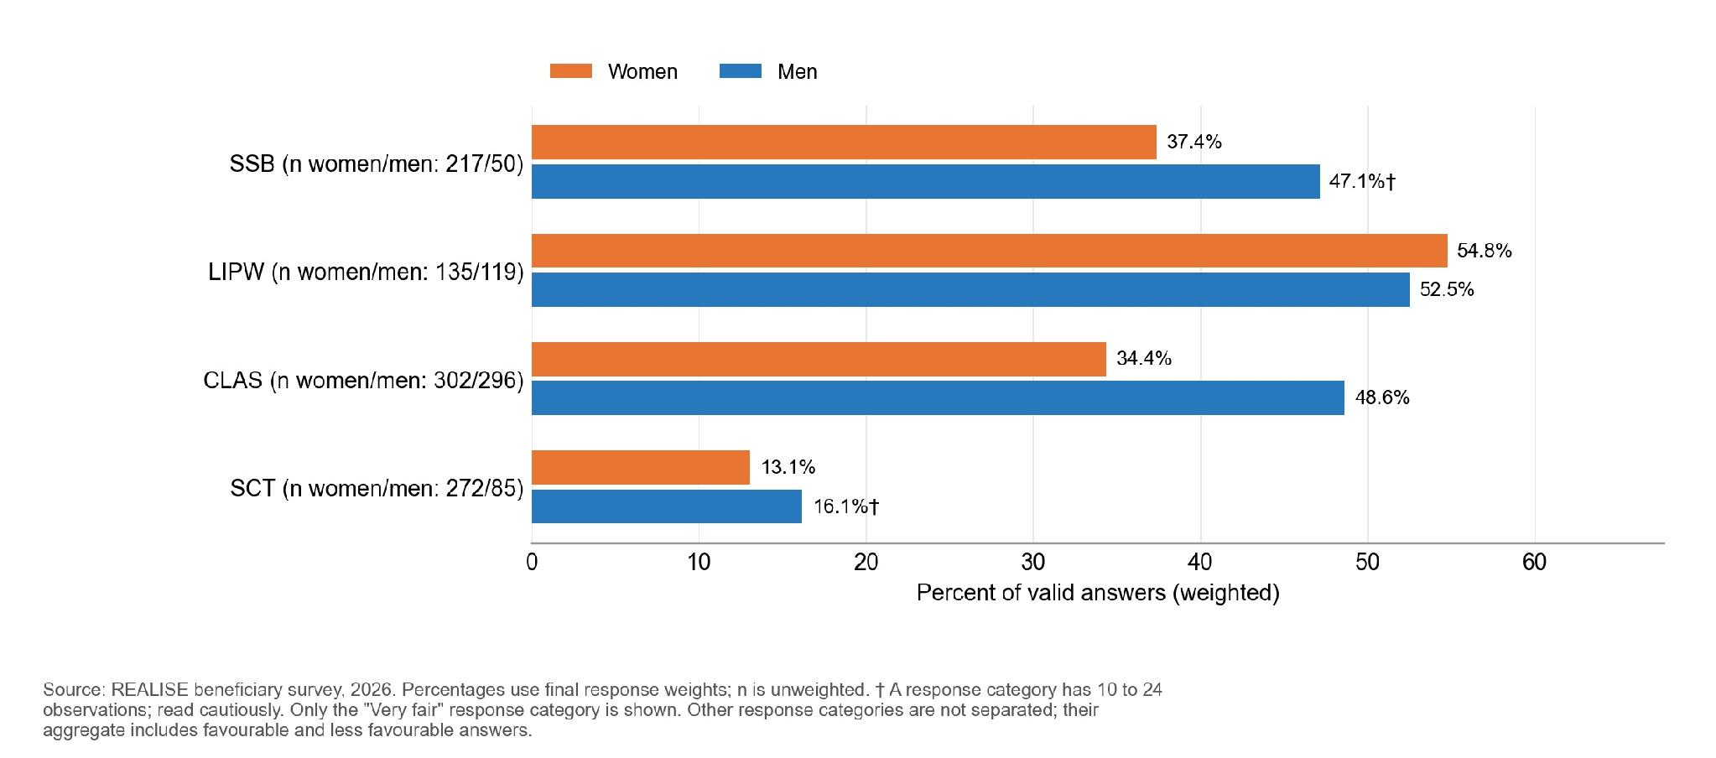
The figures and table show only very-fair responses, using item-specific valid denominators and final response weights. Other response categories include favourable and less favourable answers; they are not an unfairness rate.
Selected beneficiaries were asked whether an informal payment, gift, favour or political support had been requested. SSB valid respondents reported no such request; estimates for the other components and by sex are withheld because some outcome cells are small. The survey does not cover people who were not selected; their accounts provide context rather than a comparison group.
Table 10.1.1. Very-fair responses and disclosure-protected informal-payment results among selected beneficiaries
Component | Fair or very fair [Very fair], % (n) | Women, % | Men, % | Asked for informal payment, % | Note
CLAS | 99.5% [41.2%] (598) | 34.4 | 48.6 | Suppressed | Overall, 99.5 percent rated selection fair or very fair (41.2 percent very fair); gender-disaggregated grouped rates are withheld to protect small cells.
LIPW | 99.0% [53.7%] (254) | 54.8 | 52.5 | Suppressed | Overall, 99.0 percent rated selection fair or very fair (53.7 percent very fair); gender-disaggregated grouped rates are withheld to protect small cells.
SSB | 98.2% [40.0%] (267) | 37.4 | 47.1 | 0.0 | Overall, 98.2 percent rated selection fair or very fair (40.0 percent very fair); no payment requests reported; detailed categories withheld to protect small cells.
SCT | 95.4% [13.7%] (357) | 13.1 | 16.1 | Suppressed | Overall, 95.4 percent rated selection fair or very fair (13.7 percent very fair). Gender-disaggregated grouped rates and complementary counts are withheld to protect small cells.
Reading note: Results use the final survey weights; n is the number of valid answers. The Annex F supplement, Table 10.1.1, gives the full detail.
The components reached different groups. Women are 78.9 percent of SCT and 52.8 percent of CLAS beneficiaries on the beneficiary lists (77.9 and 52.3 percent of weighted survey respondents) and, weighted to the lists, 73.5 percent of SSB and 53.6 percent of LIPW respondents (Sections 6.2, 7.2, 8.2 and 9.2). LIPW reached the youngest group: respondents average 36.4 years, against 41.4 to 44.4 years in the other components. Functional difficulty is reported by 37.2 percent of SSB, 21.6 percent of CLAS and 11.4 percent of LIPW respondents; the SCT item (33.9 percent) covers anyone in the household. None of these items is a disability prevalence.

10.2 Women’s empowerment and financial inclusion
Own-name mobile-money ownership is near universal in every component among beneficiaries answering for themselves: 99.4 percent in SCT, 98.9 percent in LIPW, 98.4 percent in SSB and 97.2 percent in CLAS (Table 10.2.1). Among account holders, 98.2 percent in LIPW, 98.1 percent in CLAS and 96.2 percent in SCT have an active account, against 89.1 percent in SSB. The survey measures current ownership, so it cannot show how many accounts REALISE created.
Women’s self-efficacy is high in every component, highest in LIPW (35.8) and SSB (35.0) and lower in CLAS (32.6) and SCT (32.1) on the 8 to 40 scale (Table 10.2.1). The LIPW high-score percentage is withheld because its complementary category is below 10 observations (Figure 10.2.1). On each of the eight statements, at least 88 percent of women in every component agreed or strongly agreed; the lowest agreement is in SCT (88.1 and 88.7 percent) and CLAS (90.6 and 90.7 percent). Scores sit near the top of the scale, so the measure separates women less well at the upper end. The differences follow each component’s profile and are not programme effects (formal contrasts: Annex F, Table F.2; reliability and item distributions: Annex G.9).
Every eligible woman in every component could answer the personal questions in private (134 women in LIPW, 218 in SSB, 291 in CLAS and 271 in SCT), and the self-efficacy results rest on 134, 217, 290 and 271 of them.
Table 10.2.1. Mobile-money ownership was near universal, and women’s self-efficacy was highest in LIPW and SSB
Component | Own-name mobile-money account, % (n) | Account active, % | Women’s self-efficacy, 8 to 40 (n) | Score of 32 or more, %
LIPW | 98.9 (252) | 98.2 | 35.8 (134) | Suppressed
SSB | 98.4 (268) | 89.1 | 35.0 (217) | 93.7
CLAS | 97.2 (553) | 98.1 | 32.6 (290) | 75.3
SCT | 99.4 (356) | 96.2 | 32.1 (271) | 72.5
Reading note: the account measure covers beneficiaries answering for themselves, and the active-account share is among account holders; self-efficacy covers women answering for themselves in private. Annex F gives item-level results, the privacy check and confidence intervals.

Figure 10.2.1. Women’s mean self-efficacy scores and their survey-design 95% confidence intervals.
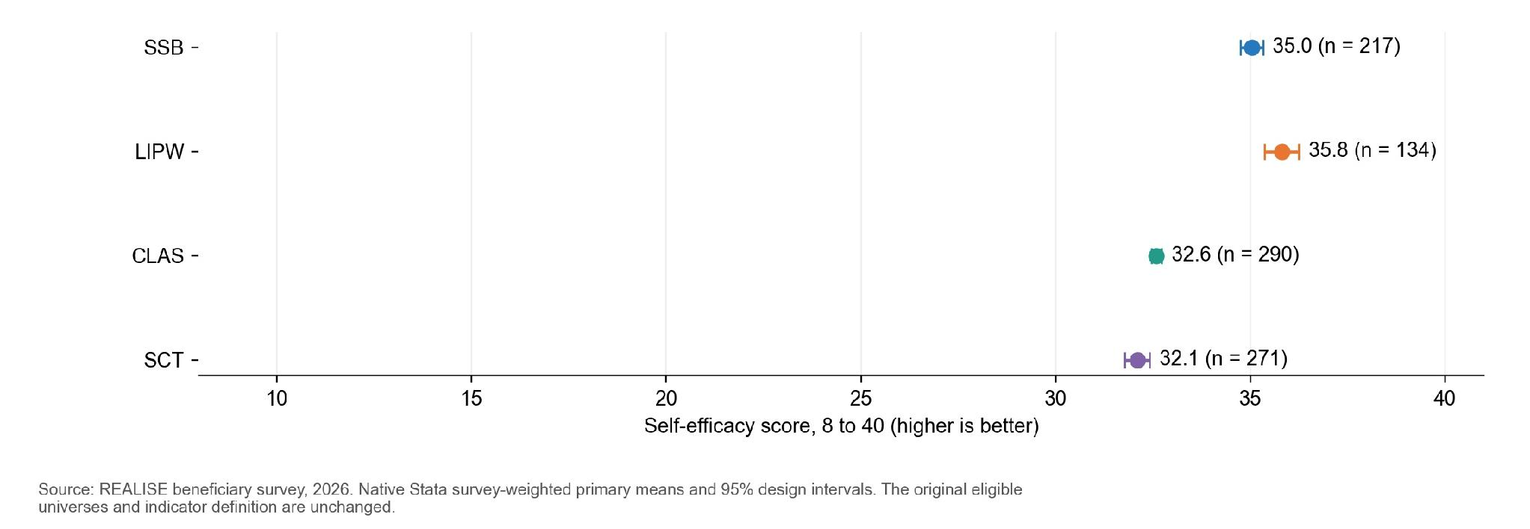
n by component: LIPW 134; SSB 217; CLAS 290; SCT 271. Bars and their labels show weighted percentages; n gives the unweighted number of valid respondents. Female non-proxy respondents who could answer in private, with all 8 items. Bars are 2 score points wide.
Women’s accounts show personal agency alongside continuing household constraints. An SSB participant describes control over her own money and business: “where I can control my own money, my own business what I want to do, I do it” (SSB-FGD-002, P0198). Another says that after her husband left, “REALISE came in that how I became to stand on my own” (SSB-FGD-006, P0231). In SCT, where scores are lower, a key informant, who had not yet spoken with recipients on the point, believes men still control the money: “even if you sent the woman to receive the money, she will still bring it to her husband” (SCT-KII-050, P0147), while a focus group participant reports that decisions are now shared: “If she says something about what should be done, it has to be considered.” (SCT-FGD-007, P0431). In CLAS, a participant says “Men and women now work together.” (CLAS-FGD-007, P0279).
Who decided how to use the support differs by component (Table 10.2.2). In LIPW, 80.7 percent of women and 48.8 percent of men reported deciding alone; corresponding shares are 45.0 and 68.1 percent in SCT and 45.6 and 38.9 percent in CLAS. SSB sex-specific shares, joint decisions and other deciders are withheld to protect small complementary categories. SCT respondent-alone combines its female- and male-labelled alone codes, matching the figure. Answer options differ by form, so the components are not directly comparable. In SSB, 85.6 percent of valid respondents in Rounds 1 and 2 combined (n = 124) and 80.9 percent in Round 3 (n = 140) said they decided alone how to use the grant. The first two rounds are combined because individual outcome categories are small. This descriptive comparison covers different cohorts and does not establish stability or causation.
Table 10.2.2. Respondent-alone decisions, with sparse sex comparisons and other categories withheld
Component (women / men, n) | Women decided alone, % | Other categories | Men decided alone, % | Other categories
SSB (215 / 49) | Suppressed | Not separated | Suppressed | Not separated
LIPW (134 / 119) | 80.7 | Not separated | 48.8 | Not separated
SCT (270 / 85) | 45.0 | Not separated | 68.1 | Not separated
CLAS (300 / 293) | 45.6 | Not separated | 38.9 | Not separated
Reading note: the remaining answers are another household member, a spouse or partner alone, or someone outside the household; Annex F gives all answer options.
The rotating empowerment module was answered in private by 302 women (46 in LIPW, 67 in SSB, 99 in CLAS and 90 in SCT), against a planning expectation of about 330; LIPW and SSB are below their planning figures (50 and 80) (Table 10.2.3).
Selected household-module results are reported for women answering privately under the random module assignment. Asset ownership averages 1.9 to 2.7 types. Binary asset ownership, decision-input and housework-sharing results are withheld where a small event or complementary group could be reconstructed. The LIPW housework domain has 12 women and remains indicative. Module weights target eligible women answering for themselves in the covered sites; estimates remain sensitive to small samples and non-response.
Table 10.2.3. Most women who answered the module own an asset and had input into household decisions
Component | Women answering the module (n) | Own at least one asset type, % | Asset types owned, 0 to 6 (mean) | Input into all applicable decisions, % | Housework shared equally, % (n)
LIPW | 46 | 100.0 | 2.7 | 100.0 (n=45) | Suppressed (n=12, indicative domain)
SSB | 67 | 80.2 (indicative category) | 2.2 | Suppressed | 63.7 (31)
CLAS | 99 | Suppressed | 2.2 | 88.0 (n=95; indicative category) | 44.6 (53)
SCT | 90 | Suppressed | 1.9 | Suppressed | 70.0 (46)
Reading note: Results use the final survey weights; n is the number of valid answers. The Annex F supplement, Table 10.2.3, gives the full detail. For input into all applicable decisions, valid n is 45 in LIPW, 67 in SSB, 95 in CLAS and 87 in SCT.

10.3 Household coping, shocks and food consumption
Coping scores (higher means more coping with food shortage) are low everywhere, with means from 4.0 in SSB and 5.4 in CLAS to 5.9 in LIPW and 6.5 in SCT on a scale up to 84 (Table 10.3.1).
Households report varied changes in their ability to meet basic needs; the CLAS community-clustered interval includes zero. SCT households report the largest net improvement in ability to meet basic needs (+1.06 on a scale from -2 to +2), followed by SSB (+0.65), LIPW (+0.47) and CLAS (+0.06) (Table 10.3.1). Nine in ten SCT households (90.4 percent) say they are better off, against 71.6 percent in SSB, 59.1 percent in LIPW and 49.4 percent in CLAS, where 44.7 percent say they are worse off. The CLAS split is read with caution because answers differ widely by enumerator (Section 8.9). The reference point differs by component (before the support, or before the first LIPW workday), so each component is compared with its own starting point (formal contrasts: Annex F, Table F.2).
Table 10.3.1. SCT households report the largest improvement in meeting basic needs; coping scores are low everywhere
Component | n (P3 / P4) | Coping-days score, 0 to 84 (P3) | Change in basic needs, -2 to +2 (P4) | Better off, % | Worse off, %
SCT | 357 / 356 | 6.5 | +1.06 | 90.4 | Suppressed
SSB | 268 / 267 | 4.0 | +0.65 | 71.6 | 24.3
LIPW | 254 / 252 | 5.9 | +0.47 | 59.1 | 31.9
CLAS | 598 / 553 | 5.4 | +0.06 | 49.4 | 44.7
Reading note: Results use the final survey weights; n is the number of valid answers. The Annex F supplement, Table 10.3.1, gives the full detail.

Figure 10.3.1. The coping-days distribution is shown in broad common score bands, preserving the original primary outcome and valid-answer universe.
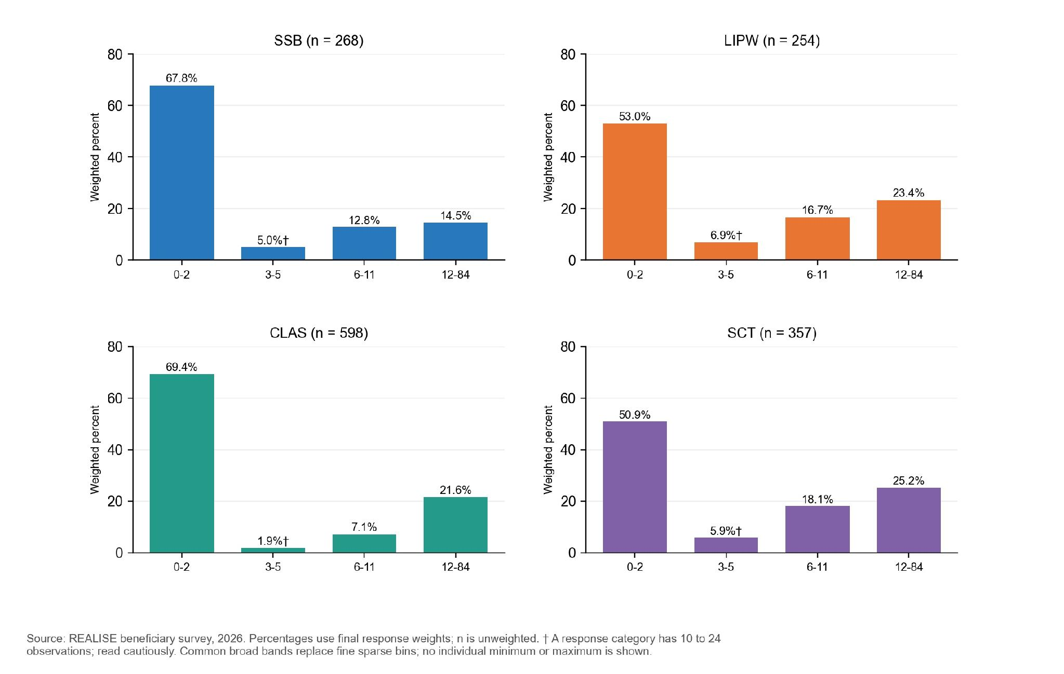
n by component: LIPW 254; SSB 268; CLAS 598; SCT 357. Bars and their labels show weighted percentages; n gives the unweighted number of valid respondents. Households with no food shortage score 0. Bars are 3 score points wide.
Figure 10.3.2. Retrospective basic-needs change, using the same two categories across components.
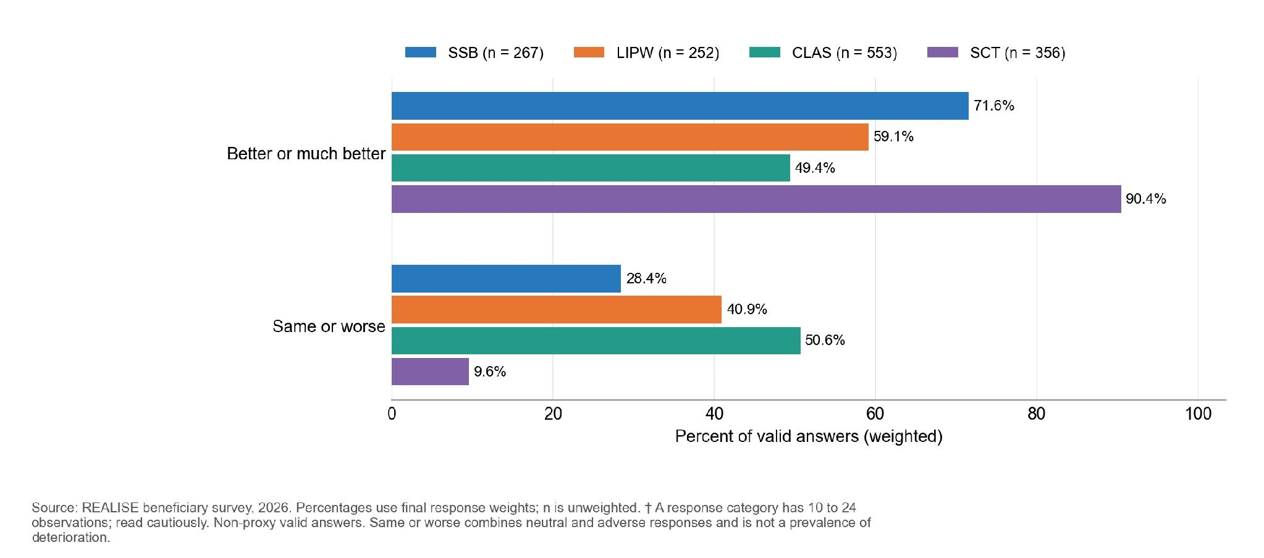
n by component: LIPW 252; SSB 267; CLAS 553; SCT 356. Bars and their labels show weighted percentages; n gives the unweighted number of valid respondents. Recoded so that positive values mean improvement. Retrospective self-report.
Table 10.3.2. Cheaper food, smaller portions and fewer meals were the most common coping strategies; farm-related strategies were more common in CLAS and SCT
Strategy used in the past 7 days | LIPW, % | SSB, % | CLAS, % | SCT, %
Relied on less preferred, cheaper food | 45.4 | 32.2 | 30.3 | 48.6
Reduced portion size | 44.5 | 29.0 | 28.4 | 42.1
Reduced number of meals | 41.6 | 26.8 | 28.3 | 35.0
Gathered wild food or harvested early | Suppressed | 6.3 | 21.9 | 19.9
Consumed seed stock | Suppressed | Suppressed | 17.5 | 10.9
Reading note: a household counts as using a strategy if it used it on at least one of the past 7 days, and households with no food shortage count as not using any strategy (n = 254 in LIPW, 268 in SSB, 598 in CLAS and 357 in SCT). Annex F lists all twelve strategies.
Food consumption separates the components into two groups (Table 10.3.3). On the Food Consumption Score (FCS), LIPW and CLAS households mostly have acceptable consumption (90.3 and 88.6 percent) and ate from about 8 of 12 food groups the previous day (Household Dietary Diversity Score, HDDS). In SSB and SCT, 14.3 and 18.4 percent have poor consumption and households ate from 6.6 and 5.9 food groups. SCT has the lowest mean FCS (40.9).
SCT households ate less of most food groups, including oils and fats (64.7 percent, against 87.1 to 97.8 percent elsewhere) and sweets (26.3 percent). CLAS households most often ate dark green leafy vegetables (66.2 percent), legumes (44.1 percent) and organ meat (27.3 percent), and LIPW households fish (86.9 percent), flesh meat (56.7 percent), milk (37.5 percent) and eggs (32.5 percent). Annex F gives all food groups.
Table 10.3.3. Nine in ten LIPW and CLAS households had acceptable food consumption, against about two in three in SSB and SCT
Component | n (FCS) | Food Consumption Score, mean | Poor consumption, % | Acceptable consumption, % | Food groups eaten, 0 to 12 (HDDS n)
LIPW | 242 | 56.3 | Suppressed | 90.3 | 7.9 (n=239)
CLAS | 556 | 54.9 | 2.5 | 88.6 | 7.7 (n=556)
SSB | 223 | 48.9 | 14.3 | 69.9 | 6.6 (n=223)
SCT | 321 | 40.9 | 18.4 | 62.3 | 5.9 (n=316)
Reading note: Results use the final survey weights; n is the number of valid answers. The Annex F supplement, Table 10.3.3, gives the full detail.
Figure 10.3.3. Cereals, oils and fats, and spices and condiments were the food groups eaten by most households (at least 64 percent in every component); organ meat, eggs and vitamin A-rich fruits were eaten least.
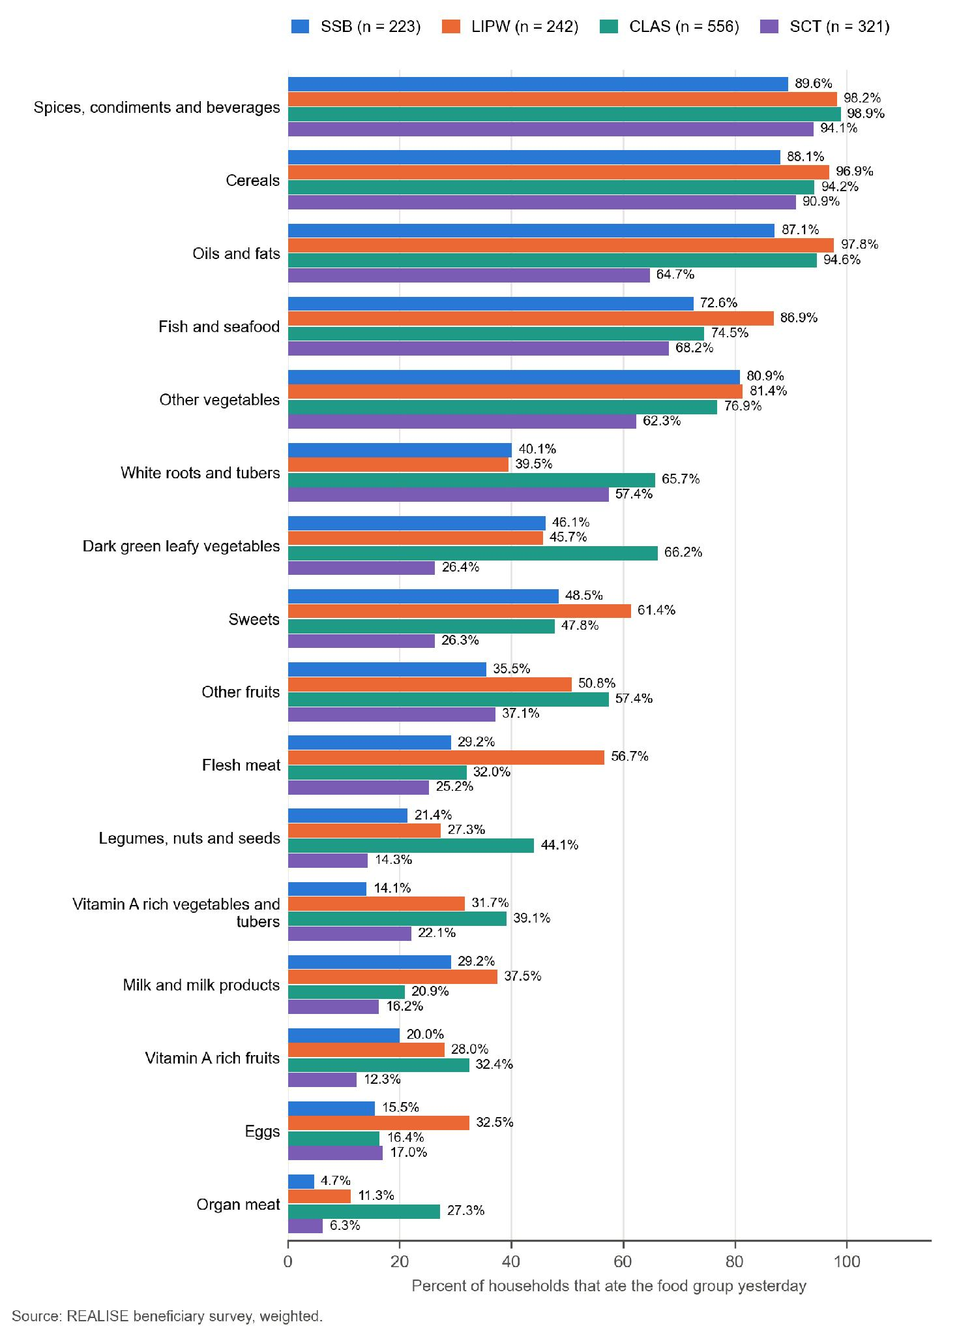
The type of coping follows the setting (Table 10.3.2 and Figure 10.3.4). About half of SCT and LIPW households relied on cheaper food (48.6 and 45.4 percent), and 44.5 percent of LIPW and 42.1 percent of SCT households reduced portion sizes. Strategies tied to farming are more common in CLAS and SCT: gathering wild food or harvesting early (21.9 and 19.9 percent) and eating seed stock (17.5 and 10.9 percent), against 6.3 percent or less in SSB and LIPW.
Figure 10.3.4. Selected coping strategies among all eligible households; small strategies are withheld.
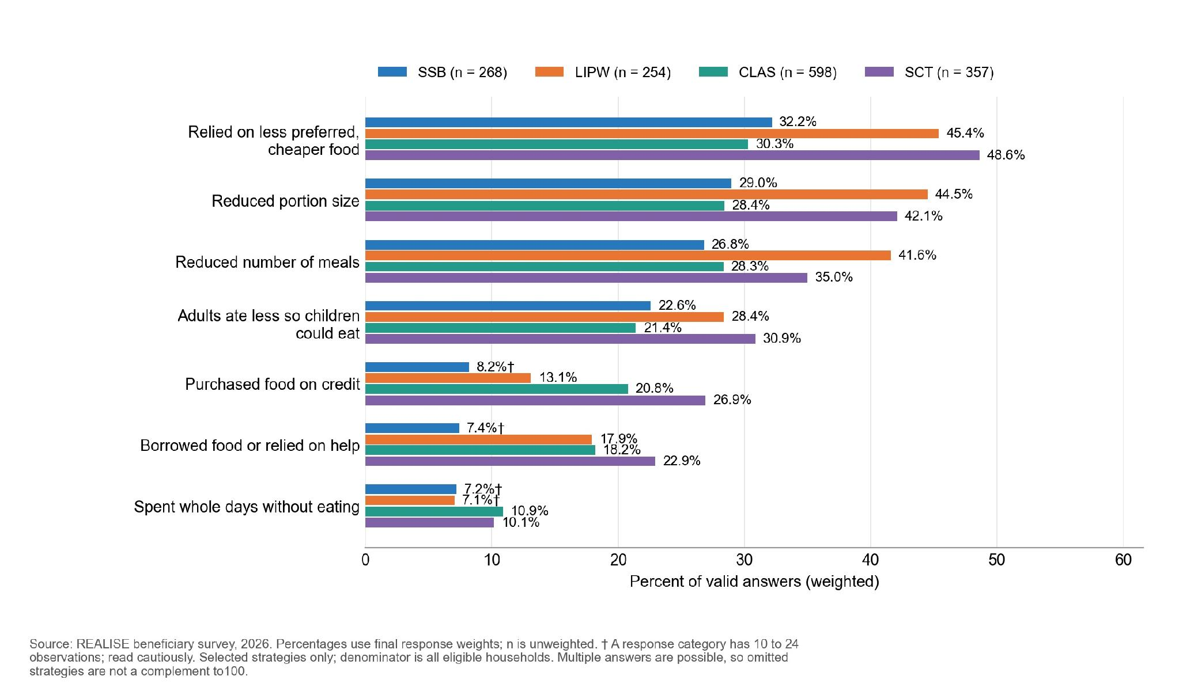

Figure 10.3.5. Food consumption categories grouped consistently into acceptable versus borderline or poor.
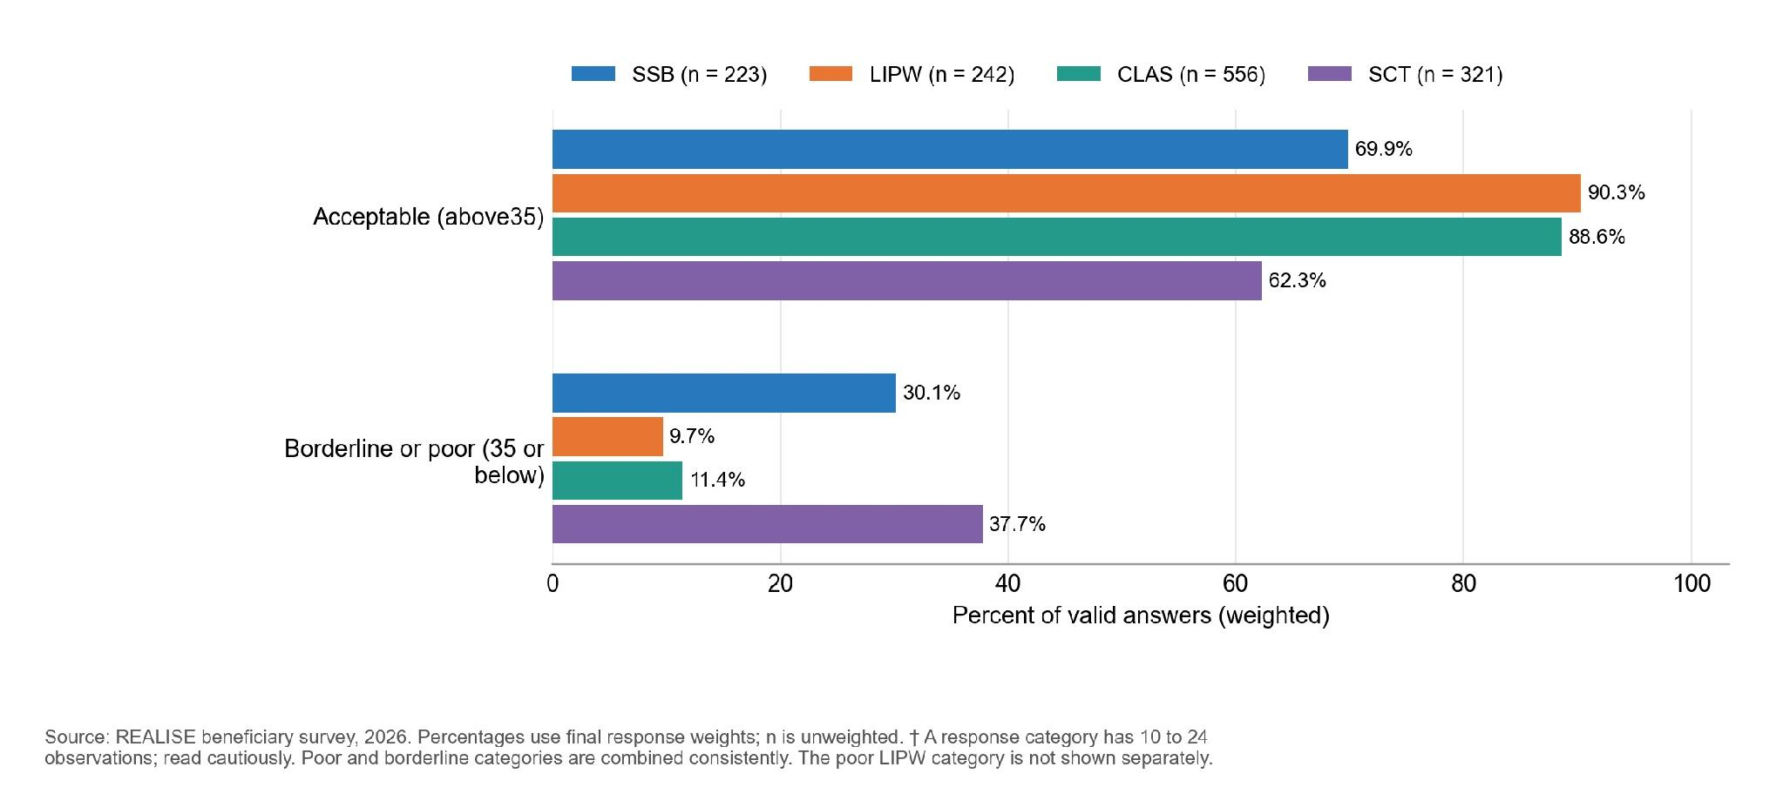
Illness is the most common shock in every component (46.4 to 65.2 percent) (Figure 10.3.6). SSB and LIPW households, in Montserrado and Margibi, more often report food or input price rises (44.5 and 42.4 percent), theft or loss of assets (29.1 percent in LIPW and 28.3 percent in SSB) and job or income loss (18.4 percent in SSB and 15.3 percent in LIPW). CLAS and SCT households more often report crop failure (27.4 and 19.4 percent), and CLAS households a death in the household (30.6 percent). About a fifth of CLAS and SCT households (21.9 percent each) report no shock.

Figure 10.3.6. Selected shocks over the past 12 months, using categories with sufficient counts in every component.
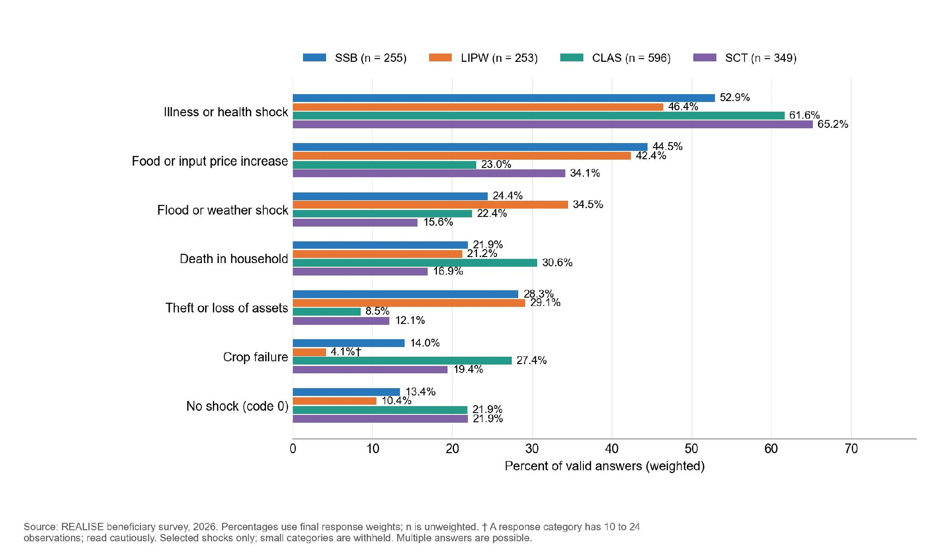

10.4 Information, grievance redress and accountability
Awareness of how to complain varies widely (Table 10.4.1): 79.3 percent in CLAS and 78.6 percent in LIPW knew how to complain or ask a question, against 58.0 percent in SCT and 36.1 percent in SSB. Channel use is shown only where categories have sufficient counts. Question wording differs across components (the CLAS question asks about REALISE; the CLAS and SCT use questions include other household members), so they are not directly comparable.
Complaint outcomes use small conditional samples. The SSB complaint domain is below 10 and is withheld; the other components have 17 to 27 complaints, but sparse response categories also require protection. In CLAS, 15 of 27 complainants reported full or partial resolution, a weighted 54.5 percent, with indicative response-category counts. These are respondent reports with different eligible denominators, not independent verification of closure. Dated case records are required to establish resolution.
Table 10.4.1. Awareness and channel use, with sparse complaint outcomes withheld or grouped
Component | Knew how to complain, % (n) | Used a channel, % | Complaints made (n) | Substantive response, % | Fully or partly resolved, %
CLAS | 79.3 (598) | 4.5 | 27 | Suppressed | 54.5 (indicative categories)
LIPW | 78.6 (254) | 6.3 (indicative category) | 17 | Suppressed | Suppressed
SCT | 58.0 (357) | 6.8 | 25 | Suppressed | Suppressed
SSB | 36.1 (264) | Suppressed | <10 | Not shown | Not shown
Reading note: Awareness, use and resolution have different eligible groups. Resolution percentages cover complainants with valid answers, rather than every beneficiary. The small complaint sample calls for caution; the Annex F supplement gives the response-stage detail.
The 14-day resolution standard comes from the POM; the Results Matrix indicator (complaints addressed within four weeks) is measured differently, so the two are not interchangeable. Awareness of a channel shows that the mechanism is known, not that it works.
Among respondents who had needed a channel, about 82 percent in LIPW, 95 percent in CLAS and 93 percent in SCT found it easy to access; as shares of all respondents these are 72.4, 79.8 and 54.0 percent, because 11.8, 16.1 and 42.1 percent never needed one. In LIPW, 12.1 percent of all respondents could not access a channel when they needed one, the highest share among the four components; the SSB no-need share is withheld because it would recover a small access-barrier category from the other displayed shares. Complaint logs held by the PMT, with response and resolution times by component, would allow these self-reports to be set against recorded handling.

10.5 Safeguards, safety and SEA/SH
Most respondents would feel safe reporting fraud, misconduct, harassment or abuse through project channels: 95.1 percent in CLAS, 94.1 percent in LIPW, 82.8 percent in SCT and 81.7 percent in SSB (Table 10.5.1). Sex comparisons are withheld where small categories or complementary cells could be reconstructed; 14.1 percent of SCT and 15.3 percent of SSB respondents would feel unsafe or very unsafe. SSB women and SCT men are the groups where reporting safety most needs attention. The accounts below do not explain the gap for these two groups; a key informant points to a community norm against taking matters outside the community.
LIPW participants described different experiences with protective equipment. One focus group reported a gap: “we use to go to those garbage’s with our bear hands, because no gloves.” (LIPW-FGD-002, P0206). In another group, a participant said “We received all our materials, and they were good.” (LIPW-FGD-004, P0222). On referral and disclosure, a key informant describes a community norm: “There is a traditional or community norm that anything that happens here should stay here. It should not go beyond the community.” (CROSS-KII-003, P0278). Accounts of no cases do not by themselves show that no harm occurred, and incident records held by the PMT were not part of the evidence. The survey safeguards finding is in Section 8.4: 32.8 percent of CLAS respondents said they or another group member had an injury or illness linked to CLAS farm work, tools or chemicals.

Figure 10.5.1. Share feeling safe or very safe reporting misconduct, by component; fine response-by-sex cells are not shown.
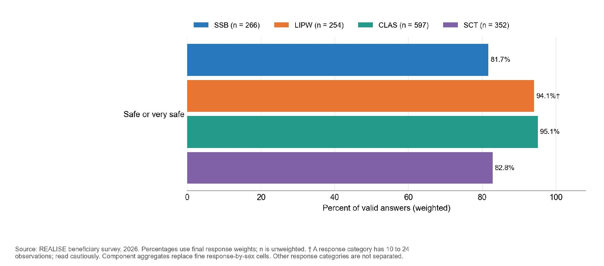
Component safety aggregates use 597 valid CLAS answers, 254 LIPW, 266 SSB and 352 SCT. Percentages are weighted and n is unweighted; don’t know and refused answers are excluded. Fine response categories and protected sex comparisons are not separated.
CLAS work-related injury or illness and children in farm-work tasks are in Section 8.4.
Table 10.5.1. Between 81.7 and 95.1 percent of respondents would feel safe reporting misconduct; SSB women and SCT men were the least likely
Component | Safe or very safe, % (n) | Women, % | Men, % | Unsafe or very unsafe, %
CLAS | 95.1 (597) | 95.2 | 95.0 | 2.2
LIPW | 94.1 (254) | Suppressed | Suppressed | 3.7
SSB | 81.7 (266) | Suppressed | Suppressed | 15.3
SCT | 82.8 (352) | 84.8 | 75.9 | 14.1
Reading note: percentages are weighted and exclude don’t know and refused answers; men and women n are CLAS 295 and 302, LIPW 119 and 135, SSB 49 and 217, and SCT 84 and 268. Annex F gives the full answer distribution and confidence intervals.

10.6 Satisfaction
The very-satisfied response was chosen by 45.2 percent in SSB, 43.4 percent in LIPW, 43.3 percent in CLAS and 26.4 percent in SCT (Table 10.6.1 and Figure 10.6.1). Other responses include satisfied as well as less favourable answers and are not separated. The sex differences in this highest response category are descriptive. Satisfaction does not, on its own, measure effectiveness. The CLAS form carried the question from a revision during fieldwork, so 390 of 598 respondents (206 men and 184 women) were asked it.

Figure 10.6.1. Share choosing "Very satisfied", by respondent sex. The other response categories are not displayed separately.
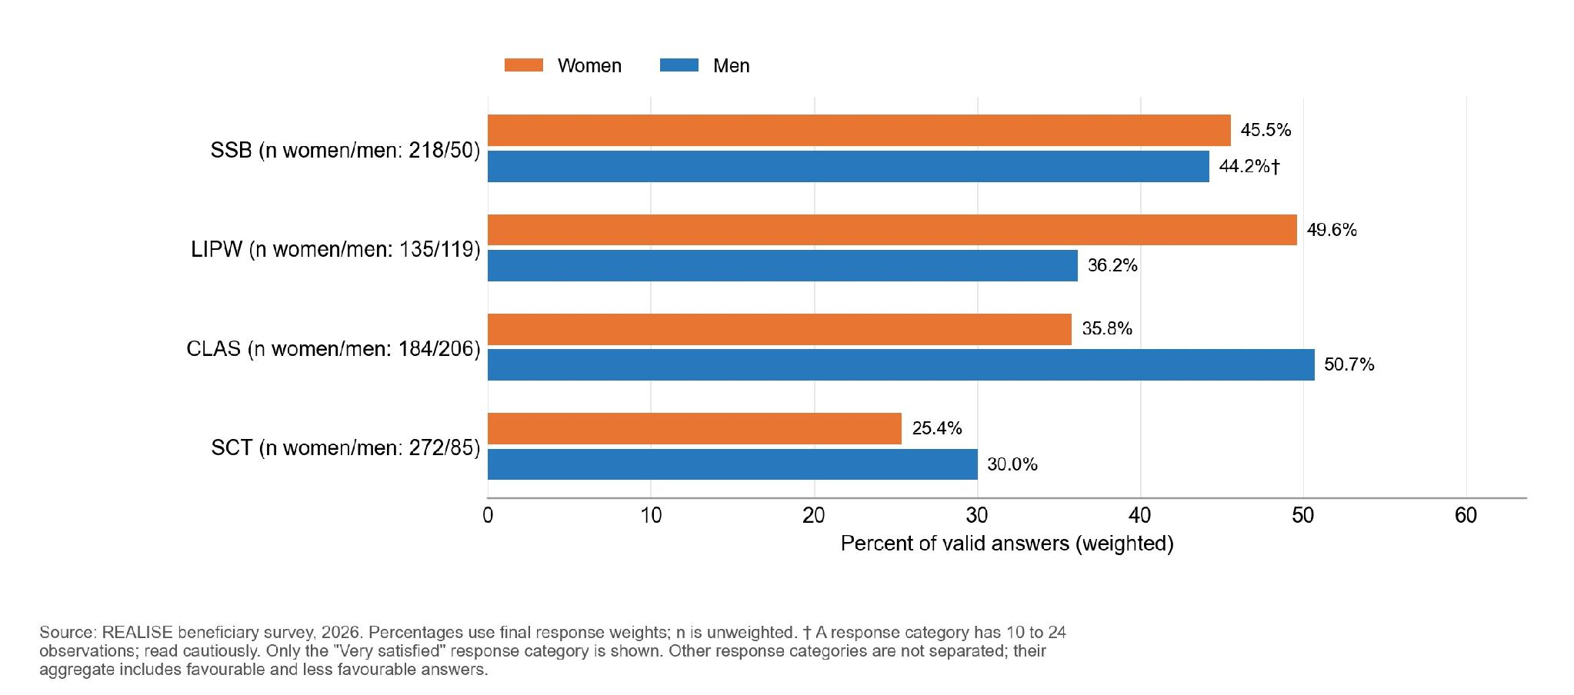
Only very-satisfied responses are shown. Valid answers, men/women: LIPW 119/135; SSB 50/218; CLAS 206/184; SCT 85/272. Percentages are weighted and n is unweighted. The remaining response categories are not separated.
Table 10.6.1. Very-satisfied responses by component and respondent sex
Component | Very satisfied, % (n) | Women, % | Men, % | Women minus men (points)
SCT | 26.4 (357) | 25.4 | 30.0 | -4.6
LIPW | 43.4 (254) | 49.6 | 36.2 | +13.4
CLAS | 43.3 (390) | 35.8 | 50.7 | -14.9
SSB | 45.2 (268) | 45.5 | 44.2 | +1.3
Reading note: percentages are weighted and exclude don’t know and refused answers; the CLAS question was asked of 390 respondents. Very satisfied is a single category, not the combined satisfied-or-very-satisfied measure. Other response categories are withheld consistently across the report and quantitative supplement.

10.7 Coherence, other assistance and synergies
The project design links the components through a common PMT and the social registry. Interviews describe the intended connections, while evidence of coordination in practice is more limited. Household receipt of other assistance, reported below, measures overlap and possible competing explanations; it does not establish institutional complementarity.
Reported overlap with other programmes was uncommon: estimates for government or NGO cash or food assistance and support from another REALISE component are withheld where outcome cells are small; in SCT, 17.3 percent reported other assistance since their first transfer. Informal sources matter more: remittances or family help reached 36.3 percent of SSB, 23.0 percent of LIPW and 18.5 percent of CLAS households. About a third of SSB (36.3 percent) and LIPW (31.7 percent) households reported no other support, against two-thirds of CLAS households (67.6 percent).
Donor and institutional accounts describe a strategic rationale and coordination, although a proposed synergy did not materialise: “in Liberia we are not actively funding food security programs but we are working with a lot on the agriculture components.” (CROSS-KII-046, P0087). Overlapping support limits attribution: “I cannot confidently attribute every change observed in a community exclusively to REALISE.” (CROSS-KII-002, P0178). For this reason the results in this report are read as associations with the support received.
REALISE is also consistent with national climate commitments. Liberia has no stand-alone climate-smart agriculture policy, and its national climate plan (NDC 3.0, 2025) carries the most specific farm targets. The CLAS training count and the NDC farmer-field-school target are defined differently, so attainment of the national target cannot be inferred (Section 8.5).

Figure 10.7.1. Receiving no other support since joining was most common in CLAS (67.6 percent), against 31.7 percent in LIPW and 36.3 percent in SSB.
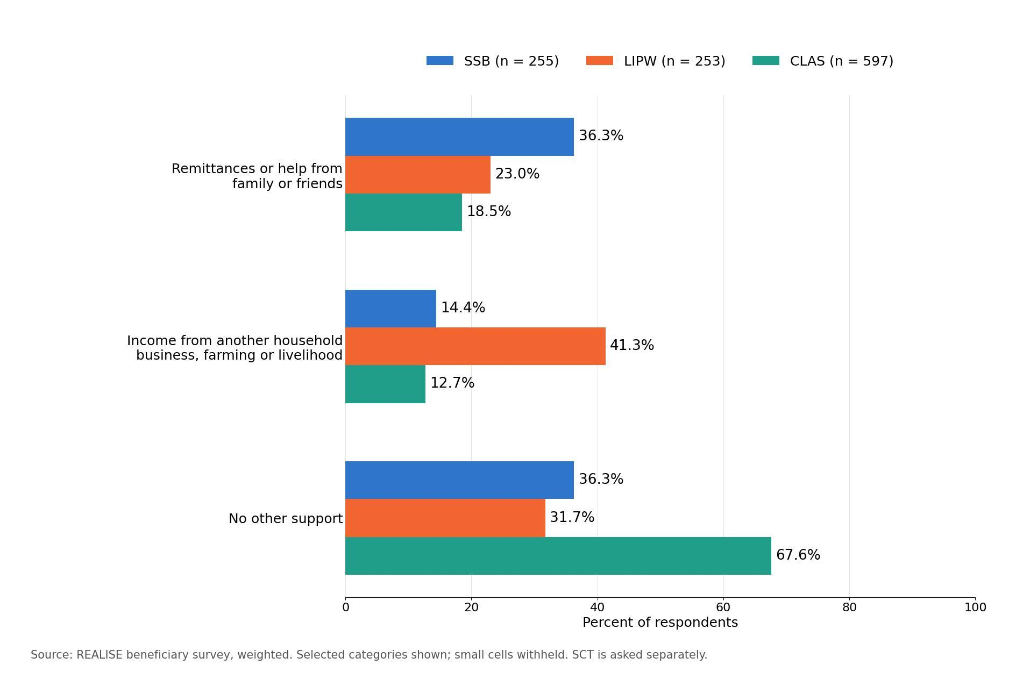

10.8 Unintended effects
Interview accounts record selection-related jealousy and friction with non-beneficiaries (CLAS-FGD-001, P0295), disputes over phones and withheld money (SCT-FGD-007, P0431) and access barriers at cash-out points (SCT-KII-042, P0319). These accounts concern selection and payment and describe cases rather than frequencies. The survey points to three areas to follow up: work-related injury or illness in CLAS (32.8 percent; Section 8.4), seed-stock consumption in CLAS households (17.5 percent; Section 8.4) and, separately, the share of LIPW respondents who say they are worse off than before their first workday (31.9 percent; Section 7.4), whose causes the evaluation could not establish.

Part C. Synthesis and recommendations

Chapter 11. Answers to the Evaluation Questions
This chapter answers the six evaluation questions, one for each OECD-DAC criterion, and gives the contribution grade of each of the 31 claims. It brings together the claim evidence, the review of the Results Matrix and the status of prior external evidence. Survey results describe eligible beneficiaries in the sites covered, and quotations cite their transcript and paragraph. The qualitative and quantitative strands cover different populations, questions and stages. A survey result can add a beneficiary perspective where a planned interview module is thin, but it does not resolve a missing qualitative response.
Contribution grades. The claim-level review assesses 31 claims under the pre-analysis plan, including a separate claim on women’s asset ownership. Three are Moderate, 27 Limited and one Insufficient. Each assessment considers the causal chain, rival explanations, triangulation and evidence quality; the overall grade cannot exceed the weakest dimension. A grade assesses contribution evidence, not programme performance or net impact.

11.1 Answers by evaluation question
This section answers each question in turn, in the order of the six OECD-DAC criteria, with the question worded as in the pre-analysis plan. Table 11.1a then sets out the evidence, the status and the contribution grades, and Table 11.1b in the Annex F supplement what each answer does not show. Each question takes one status (answered, partly answered or not resolved), which records whether every part of the question could be answered; it is not a contribution grade (Section 3.2 and the Glossary).
KEQ1 Relevance. Did support and selection match intended beneficiaries’ needs and profiles? (Answered)
Beneficiary views on selection are described using the very-fair response, with fine response categories withheld. The sites were chosen on purpose and the survey covers beneficiaries only, so it cannot show who was left out, and household headship was not asked. Interviews describe where enrolment missed people. An SCT key informant says enrolment teams skipped small settlements (SCT-KII-008, P0402), and participants in one SCT group say teams registered no more than five people per fire hut and left the others out (SCT-FGD-001, P0505 and P0506), with household size checked at the home (SCT-FGD-001, P0244). Section 12.2 gives the accounts. How common these cases were cannot be estimated, and they are not reported as targeting errors.
KEQ2 Effectiveness. Were intended benefits delivered and were expected changes reported? (Partly answered)
Almost everyone received some support, but the full expected package often did not arrive. The share who received every benefit they expected was 61.1 percent in SCT, 56.9 percent in SSB, 50.6 percent in LIPW and 32.7 percent in CLAS. The largest gaps were national ID and registration support in SSB and LIPW, buyer and market-linkage support in CLAS (received by 28.1 percent of those who expected it) and the number of SCT transfers (32.1 percent of those expecting up to six received them). Accounts of identification support differ: a participant in one LIPW group says the programme provided a citizen ID card, while a participant in another group says the card was not received (LIPW-FGD-001, P0240; LIPW-FGD-003, P0217). The question is partly answered because delivery is answered from beneficiary reports: the amounts paid are not confirmed. Only partial round-level payment records and two undated initial payrolls (LIPW Round 1 and SSB Round 2) were available; there was no complete dated individual payment register that could be matched to respondents.
KEQ3 Efficiency. How efficiently were resources used, how timely were delivery and internal operations, and what transaction costs fell on beneficiaries? (Partly answered)
The point estimates of on-time payments are highest in SSB and lowest in SCT; community-clustered intervals overlap, so the ranking is uncertain (Annex G, Table G.2). The share always paid on the communicated schedule was 91.5 percent in SSB, 72.8 percent in LIPW, 68.9 percent in CLAS and 62.8 percent in SCT; 12.0 percent of CLAS respondents were never paid on time, and the SCT cash-out fee was covered for 67.9 percent of those who expected it. Paying by mobile money simplified delivery for the programme. The finance respondent describes paying beneficiaries from the office instead of transporting cash: “We can just sit right here and pay the beneficiaries.” (CROSS-KII-004, P0242). Timeliness is described and recipients’ access barriers are documented. Resource use and cost-effectiveness are not resolved: they need component cost and budget data and a separate financial analysis, which the pre-analysis plan places outside this evaluation. The survey did not quantify recipients’ monetary transaction costs.
KEQ4 Impact and outcome contribution. What changes in income, employment, food security, consumption, resilience and agency are observed, and how plausible is REALISE’s contribution? (Partly answered)
Households report varied changes in their ability to meet basic needs, and many still struggle. The CLAS mean is close to zero and its community-clustered interval includes zero. On a scale from −2 (much worse) to +2 (much better), where −1 is worse, 0 about the same and +1 better, the recalled change in ability to meet basic needs was +1.06 in SCT, +0.65 in SSB, +0.47 in LIPW and +0.06 in CLAS. Nine in ten SCT households (90.4 percent) say they are better off, while in CLAS 49.4 percent are better off and 44.7 percent worse off. The CLAS split is read with caution because answers differ widely by enumerator (Section 8.9). In SSB and LIPW, households that received and used the full package reported more improvement (+0.44 and +0.38), an association and not an effect. SCT households report the largest improvement and also the poorest food consumption: 18.4 percent have a poor food consumption score. One recipient says the household now eats twice a day (SCT-FGD-004, P0269), while another says the transfer does not stretch to food for every day (SCT-FGD-008, P0458). Participants describe income pathways, such as a uniform maker whose sales grew after the grant (SSB-FGD-001, P0188) and a public works participant who could rent a place to live (LIPW-FGD-004, P0184). That participant and another in the same group describe conditions slipping back after the work ended (LIPW-FGD-004, P0179 and P0184), while a third reports continued improvement (LIPW-FGD-004, P0177; Section 7.4). The question is partly answered: income and employment are described from qualitative evidence only, without survey estimates, and the CLAS change is not conclusive. Food security, consumption, resilience and agency are described from the survey, focus groups, interviews and the available case material, and the plausibility of REALISE’s contribution is assessed through the contribution grades. No net impact is estimated.
KEQ5 Coherence. How do the four components complement one another and align with other government and partner programmes, and where are synergies, duplication or coordination gaps? (Partly answered)
The shared PMT and social registry provide intended links between components. Interviews describe their strategic rationale and a manual from another project that did not work out as planned, rather than a verified set of complementary services. The household survey separately shows that reported assistance from another REALISE component or government and NGOs was uncommon; selected estimates are withheld because outcome cells are small. In SCT, 17.3 percent reported other assistance after their first transfer; family help was also reported in a separate item. On climate commitments, programme records report 14,151 people trained in life skills and climate-smart agriculture, about 141 percent of the project target of 10,063; the NDC 3.0 target of farmers trained through farmer field schools is defined differently, so attainment of the national target cannot be inferred (Section 8.5). A donor representative describes rural economic-opportunity and vulnerability objectives (CROSS-KII-046, P0087), but a proposed synergy around an agricultural manual did not materialise: “we wanted to show this manual to the PMT … but it really didn’t work out at the end.” (CROSS-KII-046, P0152). Training is relevant to the national climate commitment, but the project and national targets use different definitions. The household figures do not establish how well components complement one another, and alignment with other government and partner programmes could not be verified without their documents.
KEQ6 Sustainability. Which businesses, assets, groups, practices and household changes are likely to continue? (Partly answered)
Beneficiaries describe plans to continue, while support and maintenance arrangements remain important. In CLAS, 86.8 percent expect their group to keep farming. A participant describes storing rice and saving (CLAS-FGD-001, P0237), and a key informant says communities have started reinvesting part of their income (CLAS-KII-014, P0192). Another participant says members could farm in smaller groups if the original group breaks up (CLAS-FGD-007, P0304), and a district authority reports that some groups have already regrouped and continued with less project support (CLAS-KII-024, P0173). CLAS site records describe farm activity and upkeep on the visit day; the Mawayasu narrative adds an account of training and mixed cropping, with its underlying case documents not linked in the corpus. In LIPW, observations describe clean sites and road signs, alongside deteriorated or uninspected tools, while one focus group is divided on whether gains lasted after the work ended (LIPW-FGD-004, P0177, P0179 and P0184; Section 7.4). A donor representative doubts that new practices will persist without follow-up (CROSS-KII-046, P0161). The question is partly answered because the site records do not cover the condition and upkeep of every supported asset and activity. As the pre-analysis plan provides, continuation is reported as a prospect.
Table 11.1a. One question is answered and five are partly answered, with contribution grades for four
Evaluation question | Answer in brief | Status and remaining question | Contribution assessment
KEQ1 Relevance | Beneficiary views on selection are described using the very-fair response; the survey cannot estimate exclusion among non-beneficiaries. | Answered | None: a descriptive finding, as the plan provides
KEQ2 Effectiveness | Support reached almost everyone; the full package reached 32.7 percent (CLAS) to 61.1 percent (SCT). | Partly answered: delivery is answered from beneficiary reports; the amounts paid are not confirmed | Limited for receipt in all four components. Grievance redress and safeguards: Limited.
KEQ3 Efficiency | Payment was always on the communicated schedule for 62.8 percent (SCT) to 91.5 percent (SSB). | Partly answered: timeliness and access barriers are described; monetary transaction costs were not measured; resource use and cost-effectiveness are not resolved | Timeliness: Moderate in SSB; Limited in LIPW, CLAS and SCT. None for cost-effectiveness
KEQ4 Impact and outcome contribution | Recalled change in ability to meet basic needs runs from +0.06 (CLAS) to +1.06 (SCT). | Partly answered: income and employment change is described from qualitative evidence only, without survey estimates, and the CLAS change is not conclusive; no net impact is estimated | Coping: Limited in all four components. Basic needs: Moderate in SCT; Limited in SSB, LIPW and CLAS. Climate-smart practices: Moderate. SSB business activity, women’s decision-making, self-efficacy, ownership of assets and accounts, safeguards and completed community assets: Limited. Housework-sharing change: Insufficient.
KEQ5 Coherence | Overlap with other assistance is small; CLAS trained 14,151 people against a project target of 10,063; the NDC farmer-field-school target is defined differently and is not directly comparable (Section 8.5). | Partly answered: documents of other government and partner programmes were not accessible | None: a descriptive finding, as the plan provides
KEQ6 Sustainability | 86.8 percent of CLAS respondents expect their group to keep farming. | Partly answered: prospects for continuation of businesses, assets, groups, practices and household changes are described from interviews, focus groups and the available case material. Site records do not cover the condition and upkeep of every supported asset and activity; complete observation records from the site visits would have settled this. As the pre-analysis plan sets out for a one-time evaluation, continuation is reported as a prospect. | Limited in each component; expectations and arrangements are not a substitute for later observation.
Reading note: Answer status records what can be answered with the available evidence. Contribution grades assess how strongly the evidence supports REALISE’s part in the reported change. Detailed sources and the scope of each answer are in the Annex F supplement, Tables 11.1a and 11.1b.
KEQ1 and KEQ5 produce descriptive findings, as the pre-analysis plan provides. KEQ3 cannot be answered for cost-effectiveness without a separate cost study (R19), and KEQ6 is partly answered because the site records do not cover every supported asset and activity.
The financial documents support an indicative assessment of resource use and payment delivery, but not a cost-effectiveness estimate. Table 11.1c places planned component allocations beside successful mobile-money transfer lines within the available statement periods. These measures have different coverage and should not be divided to infer a final disbursement rate, a cost per beneficiary or a cost per outcome. The component expenditure records by year and activity for 2022 to 2024, needed for a cost-effectiveness analysis, were not received from the PMT. The report therefore gives an indicative efficiency assessment (Table 11.1c) and recommends a separate cost study (R19).
Table 11.1c. Transfers paid to beneficiaries by mobile money up to June 2025, beside the planned component costs
Indicator | SSB | LIPW | CLAS | SCT
Planned component cost, US$ million (POM) | 4.60 | 6.00 | 4.77 | 15.00
Transfers paid by mobile money to June 2025, US$ million | 2.65 | 2.82 | 3.49 | No statement
First payment in the statements | December 2022 | September 2022 | April 2024 | Not applicable
Reading note: Planned costs are the component allocations in the Project Operations Manual. Transfers are the sum of successful transfer lines in US dollars. CLAS expenditure of US$4.67 million is recorded for the first quarter of 2026 alone, after the statements end, so the two rows do not measure cost per output. No account statement was received for SCT; the records include one SCT batch of 904 transfers in Grand Kru.
Source: Project Operations Manual, project cost table; project mobile-money account files for 2022 to 2024 and January to June 2025; evaluation team calculation.
Recorded expenditure was US$14.2 million in 2025, about 93 percent of the revised budget of US$15.2 million, and US$8.2 million in the first quarter of 2026, 51.5 percent of the approved budget of US$15.9 million. Programme implementation, capacity building and coordination took 15.6 percent of recorded expenditure in the second quarter of 2025, 20.6 percent in the fourth quarter and 3.8 percent in the first quarter of 2026. The quarterly reports disagree for the second quarter of 2025, which totals US$1.76 million in its own report and US$1.29 million in the fourth-quarter report. In SSB, the transfer lines of the 2024 file show an average of US$867 for each of 3,049 paid numbers, against two instalments of US$450 in the entitlement. These indicators do not show cost per outcome. A cost-effectiveness analysis needs component cost records for 2022 to 2024 and by activity (Recommendation R19).
The conflicting second-quarter 2025 expenditure totals are shown as reported and have not been reconciled. Budget execution and the use of mobile money describe resource use and delivery arrangements; they do not establish whether outcomes justify the full investment. A cost-effectiveness conclusion would require a reconciled cost series, consistent component and activity coverage, an agreed outcome measure and an appropriate analytical method. Recommendation R19 identifies that remaining work.

The detailed coverage and scope behind Table 11.1a are in the Annex F supplement (Table 11.1b).

11.2 Contribution grade summary
The joint display covers 31 contribution claims: six for SSB, six for LIPW, six for CLAS, five for SCT and eight cross-cutting. The grades are three Moderate, 27 Limited and one Insufficient, including a separate women’s asset-ownership claim. They combine survey and qualitative evidence with the available records and the final coding.
Table 11.2. Contribution assessments for 31 claims
Claim | Survey result | What the interviews show | Source locators | What would add to the evidence | Grade and files
SSB-P1 (SSB: expected benefits received) | 56.9% (n=267) | Training, records training and two US$450 grant instalments are directly described. The second instalment was delayed in the second group. These passages do not cover the whole identification and registration package. | SSB-FGD-001 P0218-P0222; SSB-FGD-004 P0220-P0222 | A package-by-round crosswalk and linked delivery evidence for ID, registration and grants. | Limited. Chain: Limited; rivals: Limited; triangulation: Limited; quality: Limited.
SSB-P2 (SSB: payment timing) | 91.5% (n=264) | Recipients identify the first tranche as timely and the second as delayed, with both eventually received. | SSB-FGD-003 P0278-P0281; SSB-FGD-004 P0220-P0222 | Communicated and actual dates matched by recipient, tranche and round. | Moderate. Chain: Moderate; rivals: Moderate; triangulation: Moderate; quality: Moderate.
SSB-P3 (SSB: household coping) | Coping score 4.05 (n=268) | One participant describes less reliance on relatives for food; others describe affording food or no longer borrowing for business, while school fees remain unaffordable for another. The periods and food-coping construct are not directly aligned with the survey. | SSB-FGD-001 P0202, P0235-P0237, P0270; SSB-FGD-002 P0259-P0263; SSB-FGD-002 P0310 | Aligned receipt-food-coping timelines, with seasonal and alternative-resource evidence. | Limited. Chain: Limited; rivals: Limited; triangulation: Limited; quality: Limited.
SSB-P4 (SSB: basic needs) | Change score +0.65 (n=267) | Accounts connect business activity to food, schooling, housing and medical spending. School fees can erode working capital or remain unaffordable. Positive trajectories and unmet needs coexist. | SSB-FGD-001 P0235-P0237, P0270-P0271; SSB-FGD-003 P0367-P0369; SSB-FGD-002 P0259-P0263 | Household-linked timing and financial evidence to separate programme proceeds from other resources. | Limited. Chain: Moderate; rivals: Limited; triangulation: Moderate; quality: Moderate.
SSB-BUSINESS (SSB: business activity) | No survey measure | One recipient describes moving from small retail to production and supplying sellers; another describes uniform orders. A KII describes closure. Visited stock, customers and female management confirm current operation; grant-funded restocking is declared and no financial records were present. | SSB-FGD-001 P0186-P0188; SSB-KII-052 P0182; SV-SSB-01, Functionality and Utilization cells; CASE-SSB-01, Effectiveness/Impact/Sustainability cells | Linked business trajectories, sales/profit records and negative-case observations. | Limited. Chain: Limited; rivals: Limited; triangulation: Limited; quality: Limited.
SSB-SUST (SSB: continuation prospects) | No survey measure | Recipients describe saving and adding reserves to stock after theft; a vendor describes losing invested selling space. The case reports reinvestment without financial records and the visit did not observe restocking. | SSB-FGD-006 P0203-P0207; SSB-FGD-004 P0363-P0367; CASE-SSB-01, Sustainability cell; SV-SSB-01, maintenance cell | Repeated activity and reinvestment observation linked to the final grant. | Limited. Chain: Limited; rivals: Limited; triangulation: Limited; quality: Limited.
LIPW-P1 (LIPW: expected benefits received) | 50.6% (n=250) | Staff distinguish US$4 regular-worker and US$7 supervisor daily rates. A participant reports a US$720 promise and US$230 received after six months; another passage describes working without footwear. | LIPW-KII-006 P0215-P0217; LIPW-FGD-001 P0244-P0246, P0248-P0249 | Matched timesheets, rate/role, communicated package and payroll. | Limited. Chain: Limited; rivals: Limited; triangulation: Limited; quality: Limited.
LIPW-P2 (LIPW: payment timing) | 72.8% (n=253) | Staff describe 15 credited days plus ten processing days and assert timely payment. Participants describe chasing payments and waiting a month rather than the expected short cycle. | LIPW-KII-006 P0130; LIPW-FGD-001 P0220-P0222, P0244-P0246 | Dated communicated schedules and payments linked to credited cycles. | Limited. Chain: Limited; rivals: Limited; triangulation: Limited; quality: Limited.
LIPW-P3 (LIPW: household coping) | Coping score 5.91 (n=254) | First wages finance a food business; another account connects a wife’s baking activity to no longer being short of food. Illness absorbed another household’s savings, and post-work hardship returned for some. | LIPW-FGD-001 P0123-P0133; LIPW-FGD-004 P0177-P0179, P0258-P0264 | Food-access timelines and follow-up after work, separating earnings and seasonal shocks. | Limited. Chain: Moderate; rivals: Limited; triangulation: Moderate; quality: Moderate.
LIPW-P4 (LIPW: basic needs) | Change score +0.47 (n=252) | Wages and management training are linked to trade, schooling, rent and health. A participant reports no material improvement, and post-programme decline coexists with sustained gain in the same group. | LIPW-FGD-001 P0117-P0125, P0131-P0140; LIPW-FGD-004 P0177-P0184, P0258-P0264 | Linked welfare histories and records separating wage-financed uses from other income. | Limited. Chain: Moderate; rivals: Limited; triangulation: Moderate; quality: Limited.
LIPW-ASSET (LIPW: asset condition) | No survey estimate of asset condition | Staff and participants describe cleaning and drains. One participant reports renewed dirt and flooding. The site observation record notes usable road signs and a clean community, alongside spoiled tools. | LIPW-KII-022 P0134; LIPW-FGD-003 P0243-P0245; LIPW site observation record (CASE_LIPW_01) P0031-P0042 | Asset-specific site/period register and repeated functionality observation. | Limited. Chain: Limited; rivals: Limited; triangulation: Limited; quality: Limited.
LIPW-SUST (LIPW: continuation prospects) | No survey measure | Tools are reportedly held by leaders and future retrieval/cleaning is planned. Another group describes dirt returning after paid work ended. The site observation record notes tools deteriorating despite clean surroundings. | LIPW-FGD-006 P0209, P0276, P0359; LIPW-FGD-005 P0179-P0183; LIPW-FGD-004 P0177-P0184; LIPW site observation record (CASE_LIPW_01) P0031-P0042 | Dated handover, maintenance actions/budget and repeat output condition. | Limited. Chain: Limited; rivals: Limited; triangulation: Limited; quality: Limited.
CLAS-P1 (CLAS: expected benefits received) | 32.7% (n=593) | Staff describe group-designated recipients and local procurement. Participants describe training and cooperation alongside months without expected pay; staff mention delayed materials and failed market linkage. | CLAS-KII-007 P0144-P0152; CLAS-FGD-007 P0208-P0211; CLAS-KII-025 P0136 | Role/group/round-specific entitlement and matched delivery records. | Limited. Chain: Limited; rivals: Limited; triangulation: Limited; quality: Limited.
CLAS-P2 (CLAS: payment timing) | 68.9% (n=488) | A staff account says direct transfers were timely; the same KII describes revised tranche sizes after earlier delays. Participants describe waiting two to five months and another KII describes delayed Round 3 materials. | CLAS-KII-007 P0152, P0309-P0311; CLAS-FGD-007 P0209; CLAS-KII-025 P0136 | Communicated due dates, actual transfers and crop calendar by round/group. | Limited. Chain: Limited; rivals: Limited; triangulation: Limited; quality: Limited.
CLAS-P3 (CLAS: household coping) | Coping score 5.35 (n=598) | Respondents describe drought and crop-specific performance; one sees no change in production, storage or sales. Another says only corn had been harvested in the first year. | CLAS-KII-024 P0143; CLAS-KII-025 P0151-P0153; CLAS-KII-054 P0186 | Aligned harvest, payment, weather, food-access and coping histories. | Limited. Chain: Limited; rivals: Limited; triangulation: Limited; quality: Limited.
CLAS-P4 (CLAS: basic needs) | Change score +0.06 (n=553) | Implementer monitoring relays higher yields and knowledge; first-year accounts cover corn but not yet rice/peanut harvest, while another KII sees no production or sales change. | CLAS-KII-007 P0168-P0170; CLAS-KII-054 P0185-P0188; CLAS-KII-025 P0153 | Post-harvest household evidence linked to actual sales/use and alternative resources. | Limited. Chain: Limited; rivals: Limited; triangulation: Limited; quality: Limited.
CLAS-CSA (CLAS: climate-smart practices) | 91.3% adopted at least one practice | Participants describe recently applying crop separation and measured spacing after training, sometimes received after planting. Non-selected farmers say they have not copied or seen new methods spreading. Site CSA notes only describe a calm, clean environment. | CLAS-FGD-007 P0257-P0261; CLAS-FGD-005 P0259-P0276; SV_CLAS_01/03 P0052-P0056 and SV_CLAS_02/04 corresponding CSA cells | Independent observation of named practices by crop/site and later season. | Moderate. Chain: Moderate; rivals: Moderate; triangulation: Moderate; quality: Moderate.
CLAS-SUST (CLAS: continuation prospects) | 86.8% expect their group to keep farming | Participants describe savings and smaller-group reorganisation. One authority reports some regrouped communities, while another says few want to repeat and relies on proposed government farming support. Visits show activity and upkeep on the day. | CLAS-FGD-007 P0301-P0306; CLAS-KII-024 P0173, P0208; CLAS-KII-025 P0187; SV_CLAS_01/03 P0033-P0043 and SV_CLAS_02/04 corresponding upkeep cells | Post-support group/practice follow-up and dated activity/savings records. | Limited. Chain: Limited; rivals: Limited; triangulation: Limited; quality: Limited.
SCT-P1 (SCT: expected benefits received) | 61.1% (n=313) | Recipients describe promised amounts arriving, while others describe substantial cash-out deductions. Nominal transfer issued and usable funds received are different. | SCT-FGD-004 P0233-P0235; SCT-FGD-002 P0245-P0249 | Linked household entitlement, transfer count and cash-out reconciliation. | Limited. Chain: Limited; rivals: Limited; triangulation: Limited; quality: Limited.
SCT-P2 (SCT: payment timing) | 62.8% (n=350) | Staff describe six quarterly instalments on time. One participant also calls payments on time but wants shorter intervals; another wants a more regular/monthly arrangement. | SCT-KII-020 P0120-P0121; SCT-FGD-007 P0483-P0486 | Communicated and actual dates by transfer and recipient. | Limited. Chain: Limited; rivals: Limited; triangulation: Limited; quality: Limited.
SCT-P3 (SCT: household coping) | Coping score 6.53 (n=357) | A recipient describes moving from one to two meals daily; another says money is insufficient to maintain food every day. SCT-FGD-005 P0201 is explicitly non-beneficiary hardship, not failure among recipients. | SCT-FGD-001 P0198-P0201; SCT-FGD-004 P0269; SCT-FGD-008 P0458; SCT-FGD-005 P0199-P0203 | Payment-to-food timelines, seasonal prices and resolved alternative-resource evidence. | Limited. Chain: Limited; rivals: Limited; triangulation: Limited; quality: Limited.
SCT-P4 (SCT: basic needs) | Change score +1.06 (n=356) | Recipients connect transfers to previously unaffordable schooling and housing work. Others were already feeding their families from farming, or could pay fees but had no funds left for further activity. | SCT-FGD-001 P0201, P0258-P0260; SCT-FGD-002 P0203-P0207; SCT-FGD-006 P0262-P0264 | Linked needs/transfer histories and independent confirmation of education/housing uses and alternative resources. | Moderate. Chain: Moderate; rivals: Moderate; triangulation: Moderate; quality: Moderate.
SCT-SUST (SCT: continuation prospects) | No survey measure | Some recipients cycle savings and susu into trade to continue after transfers; another uses all available transfer funds for fees and has no surplus for other activity. | SCT-FGD-001 P0358-P0362; SCT-FGD-002 P0203-P0207 | Post-final-payment follow-up and activity/savings records. | Limited. Chain: Limited; rivals: Limited; triangulation: Limited; quality: Limited.
CC-P5a (Across components: own-name accounts) | 97.2 to 99.4% hold an own-name account | A participant explicitly had no account before registration; another had a pre-existing account. Staff describe name checks and new SIMs when accounts were not in the recipient’s name. | CLAS-FGD-002 P0218; SSB-FGD-001 P0220-P0222; CROSS-KII-004 P0137 | Provider opening dates linked to programme registration and verified account holder. | Limited. Chain: Limited; rivals: Limited; triangulation: Moderate; quality: Limited.
CC-P5b (Across components: women’s self-efficacy) | Self-efficacy score (8 to 40): 35.8 LIPW, 35.0 SSB, 32.6 CLAS, 32.1 SCT | Women describe managing money and business, shared planning and greater respect. Committee representation varies; one oversight committee has five men, while women lead elsewhere. | CLAS-FGD-001 P0259-P0260; CROSS-KII-032 P0301-P0303; CLAS-KII-014 P0233; SSB-FGD-001 P0325-P0329 | Explicit efficacy timelines and prior norms/agency evidence, preserving the supplied eight-item scale. | Limited. Chain: Limited; rivals: Limited; triangulation: Limited; quality: Limited.
CC-DECISION (Across components: women’s say over decisions) | Rotating empowerment module (Section 10.2) | Some women describe increased respect and control over transfer spending. Joint discussion can coexist with male final authority, and business decisions can differ from home decisions. | SCT-FGD-001 P0361, P0390-P0394; SCT-FGD-002 P0287-P0291; SSB-FGD-001 P0325-P0329; CROSS-KII-032 P0303 | Before/after domain-specific decision histories and evidence on prior authority. | Limited. Chain: Limited; rivals: Limited; triangulation: Limited; quality: Moderate.
CC-GRM (Across components: complaint handling) | 36.1 to 79.3% knew how to complain | A hotline provided assistance for SIM/payment problems; local farm issues were discussed internally. One respondent does not know what happens after a complaint. Norms and network barriers restrict escalation. | CROSS-KII-032 P0235; CLAS-FGD-007 P0294-P0296; CLAS-KII-054 P0304-P0306; CROSS-KII-003 P0278 | Dated case-level response/closure log, complaint age and reporting-barrier evidence. | Limited. Chain: Limited; rivals: Limited; triangulation: Limited; quality: Limited.
CC-SAFE (Across components: safeguards) | 81.7 to 95.1% would feel safe reporting misconduct | Workers describe rules against intoxication, insults and inappropriate touch; staff describe a referral protocol. Network and local confidentiality norms impede complaints. LIPW workers describe missing footwear; inclusion comments in visits are partly respondent reports. | CLAS-FGD-007 P0273-P0274; CROSS-KII-003 P0278-P0285; LIPW-FGD-001 P0248-P0249; LIPW site observation record (CASE_LIPW_01) P0049-P0050 and SV_CLAS_01/03 P0050-P0051 | Non-identifying incident/referral records and aligned worksite safety observation. | Limited. Chain: Limited; rivals: Limited; triangulation: Limited; quality: Limited.
CC-ASSET (Across components: completed community assets) | No survey measure of completed assets | Accounts describe completed community projects, including a handpump and solar lighting, alongside unfinished works. Use, maintenance and attribution remain reported rather than independently verified. | CROSS-KII-047 P0112-P0114; CLAS-KII-025 P0136; CLAS-FGD-003 P0345 | Identify funded assets and confirm construction, use and maintenance independently. | Limited. Chain: Limited; rivals: Limited; triangulation: Limited; quality: Limited.
CC-HOUSEWORK (Across components: sharing housework) | Rotating empowerment module (Section 10.2) | Accounts mention cooking and engagement following training, and a granddaughter cooking, but do not trace a programme-linked change in the distribution of unpaid household tasks between partners. | CROSS-KII-032 P0303; CLAS-KII-014 P0233; SSB-FGD-001 P0204, P0321; LIPW-FGD-001 P0129; LIPW-FGD-004 P0258-P0264; targeted text screen of the 60 anonymised files; SSB-FGD-003 P0451; SSB-FGD-002 P0310 | Partner-specific task/time-use histories with a programme-linked mechanism. | Insufficient. Chain: Insufficient; rivals: Insufficient; triangulation: Insufficient; quality: Limited.
CC-WASSET (Across components: women’s asset ownership) | Women owning at least one of six asset categories: SSB 80.2% [70.6, 87.2] (n=67); LIPW 100% (n=46; no confidence interval reported); CLAS 95.9% [90.9, 98.2] (n=99); SCT 94.3% [87.0, 97.6] (n=90). Mean categories: 2.16, 2.70, 2.23, 1.94. | Women describe acquiring land, a freezer and housing improvements after support. A participant explicitly describes her own land but also anticipated help from a husband. The case observes a woman managing business stock, which does not itself establish ownership in each survey category. | SSB-FGD-001 P0198, P0200, P0271; SSB-FGD-006 P0203-P0204; CASE-SSB-01, Impact/Gender cells | Category-specific sole/joint ownership histories and contribution evidence, retaining privacy safeguards. | Limited. Chain: Limited; rivals: Limited; triangulation: Limited; quality: Limited.
Reading note: Grades are Moderate for three claims, Limited for 27 and Insufficient for one. A grade cannot exceed its weakest dimension, and an unresolved material divergence caps it at Limited. The Annex F supplement presents source references, dimension assessments and evidence gaps.

Moving a claim to a higher grade needs verification and attribution evidence. Payment, delivery and grievance standards need dated administrative records linked to beneficiaries, and functionality and continuation need direct observation and later contact. Other livelihoods, prior ownership, prices, seasons and shocks remain possible explanations of the reported outcomes. Conflicting accounts are kept in the quotation register and the claim display.
Continuation claims. Members in CLAS describe saving and reorganising, and 86.8 percent expect their group to keep farming. A district authority reports that some groups continued with less support (CLAS-KII-024, P0173); another informant describes limited willingness to repeat projects (CLAS-KII-025, P0187). The survey measures expectations, not later continuation. Across components, the continuation grade is Limited because post-support outcomes were not observed.
Cross-cutting claims. The assessment is Limited for own-name accounts, women’s self-efficacy, women’s say over decisions, grievance redress, safeguards, completed community assets and women’s asset ownership. Evidence for a change in housework sharing is Insufficient. Each claim is assessed against its own pathway; current levels are not treated as proof of change.
Women’s say over decisions (Limited). Some women describe more respect and a say over spending; accounts distinguish business decisions, consultation and final authority in the home. CLAS-FGD-003 P0326 explicitly describes a shift from the husband deciding alone to deciding with his wife after training, while P0324 describes a wife’s pre-existing input. SSB-FGD-001 P0327 retains a distinction between her business decisions and her husband’s home decisions. The rotating module measures current participation and cannot separate change from prior norms. These positive and limiting cases support a bounded Limited contribution assessment.
Grievance redress (Limited). Hotline and local channels helped resolve some reported problems, while some respondents did not know where to complain or described barriers to escalation (CROSS-KII-032, P0235; CLAS-FGD-007, P0296). Awareness is not the same as effective case closure. Few respondents used a channel, and dated case records were unavailable, so the grade is Limited for the functioning of the system as a whole.
Women’s self-efficacy (Limited). Scores on the 8 to 40 scale run from 32.1 in SCT to 35.8 in LIPW. Women with their own or joint say over the use of the support do not report higher self-efficacy, the coded accounts describe participation and joint planning, and one implementer describes an oversight committee of five men. The grade is Limited because the survey contrast does not point in the expected direction and the accounts show participation without showing a change in agency.
Own-name accounts (Limited). Between 97.2 and 99.4 percent of beneficiaries answering for themselves hold an own-name account, and beneficiaries and staff describe accounts opened at registration and name checks on payments. The survey records ownership at the time of the interview, and only two files support the claim; provider records of account-opening dates would show whether REALISE created the accounts. The grade is Limited because prior ownership cannot be ruled out.
Safeguards (Limited). Between 81.7 and 95.1 percent of respondents would feel safe reporting misconduct, the lowest shares being in SSB and SCT (Table 10.5.1); workers describe conduct rules taught at sites, and staff describe a referral protocol with MGCSP. A local norm of keeping matters inside the community limits reporting, and accounts of no cases do not show that no harm occurred. Two of three files support the claim, and incident registers would show how cases were handled, so the grade is Limited.
Sharing of housework (Insufficient). Among components with reportable categories, 44.6 to 70.0 percent of partnered women report equal sharing at interview; the small LIPW split is withheld (Section 10.2). These current arrangements do not establish programme-linked change. SSB-FGD-003 P0451 mentions changed cooking and more engagement with a fiancée, without identifying who performs the tasks or how the split changed. SSB-FGD-002 P0310 describes a granddaughter cooking under the respondent’s portion control, without a before/after redistribution. The contribution evidence remains Insufficient, while the module and these accounts inform further enquiry.
Completed community assets (Limited). Respondents describe projects including a handpump linked to CDS (CLAS-FGD-003, P0345) and solar lighting reported as illuminating a community at a visit (CROSS-KII-047, P0112). These accounts support construction or use for specific assets. The evidence is Limited because the same equipment is not independently linked across funding, construction, use and maintenance, and long-term upkeep is not established.
Women’s ownership of assets (Limited). The pre-analysis plan includes this claim. The rotating module describes ownership at one point in time (80.2 to 100 percent of women own at least one asset type). Some women describe assets acquired after programme support; ownership, management and the role of other resources must be distinguished. The Limited grade distinguishes asset acquisition accounts from a verified change in ownership across all categories.
Outcome and contribution are judged separately. A household can report better ability to meet basic needs and still be food insecure today, while the pathway from REALISE remains uncertain. The survey describes the outcome; process accounts and rival explanations inform the contribution judgement.

11.3 Results Matrix achievement
Table K.11.3 compares 74 indicators of the Results Matrix for SSB, LIPW, CLAS and SCT with their baseline and target. It lists the baseline, target, the project’s reported values, the verification source named in the matrix, the survey check where one exists and the evaluation reading. The matrix is the file of the February 2026 mission, and its tracking sheets carry a reported value in the column headed Q1 ISR (April 2026). The first quarter 2026 report prints most of the same indicators in its Annex 2. The table shows both values, states any difference and prefers neither. Indicators of Component 3 appear only where they measure SSB or LIPW beneficiaries.
The reading rule converts the project’s own value into achieved, partly achieved or not achieved. Achieved means the reported value is at or above the target (restructured where one exists), Partly achieved means 50 to 99 percent of it, and Not achieved means below 50 percent. The reading is not an independent finding: the evaluation had no management information system extract, training attendance record, grievance register or service-provider record, and no complete dated individual payment register. Partial round-level payment records and two undated initial payrolls (LIPW Round 1 and SSB Round 2) were available, but they cannot be matched to respondents, so the reported values could not be verified against records. A survey estimate sits beside an indicator only when it concerns the same subject, and it never replaces the project value because its definition, universe or period differs.
Reading of the table. Of 74 indicators, 32 are read as achieved, 33 as partly achieved, 5 as not achieved and 4 as not verifiable, on the project’s own values. The not verifiable readings arise where the two project sources give a different status. The matrix and the report give different values for 10 indicators, and 4 of these differences change the status. The four that change the status are the CLAS community development plans funded, the village development plans funded for youth, the farmers reached by marketing services and the cooperative staff trained. The six other differences concern the female share of LIPW beneficiaries, LIPW workdays, the LIPW final-wage share, female CLAS satisfaction, SCT programme beneficiaries and SCT safety-net beneficiaries. The evaluation cannot tell which value is current. Table 11.3.1 lists the ten, and Recommendation R15 asks the PMT and the World Bank to reconcile and confirm the current values.
Figure 11.3.1. Results Matrix indicators by achievement status, on project-reported values
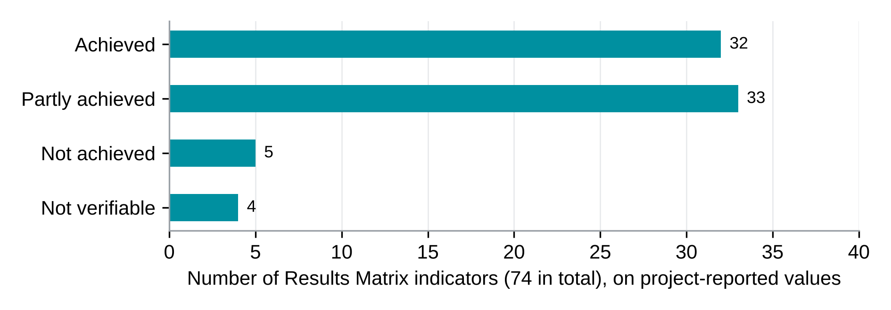
Source: Results Matrix, February 2026 mission; first quarter 2026 report; evaluation team reading.
These achievement categories are a conditional reading of project-reported values against the stated targets, not independently verified evaluation findings. The two project sources differ on 10 of 74 indicators; four differences change the achievement category. For those four, the current status remains unresolved. Survey comparisons use different definitions, periods or populations and therefore do not select the authoritative project value. Confirmation requires a dated PMT reconciliation of the indicator definition, target, reporting period and underlying record, with financing-partner agreement where the supervision record or a restructured target is affected (R15).
What the survey adds. A survey estimate stands beside 22 indicators. The survey profile is consistent with the female shares reported for LIPW, CLAS and SCT. The SCT survey estimate of payment always on the communicated schedule is close to the project’s on-time share of 63 percent and below the 75 percent target, which agrees with the project that SCT timeliness falls short. LIPW final-wage timeliness cannot be computed because the payrolls available carry no payment dates (Section 7.1). Satisfaction in SSB, LIPW and CLAS is high in the survey as in the project values. These checks use different definitions and cover the evaluation sites only, so they are consistent readings and not verifications.
Targets that were revised. End targets differ between the Results Framework sheet and the tracking sheets, and between the matrix, the first quarter 2026 report and the terms of reference (Annex F, Table 2.2). The Results Framework sheet gives 2,424 small businesses invested in and 6,200 CLAS beneficiaries, against 4,450 and 16,200 in the tracking sheets; the restructured CLAS target is 20,325 (first quarter 2026 report) or 24,255 (Results Matrix), depending on the indicator. The evaluation reports the tracking-sheet targets and does not reconcile the others.
Main readings. On the project’s own values, beneficiary counts stand at 93 percent of target for SSB businesses invested in, 88 percent for LIPW beneficiaries and 99 percent for SCT beneficiaries. These percentages are calculated against the tracking-sheet targets for SSB (4,450), LIPW (17,900) and SCT (16,711), and the restructured CLAS targets of 20,325 (first quarter 2026 report) or 24,255 (Results Matrix). The CLAS beneficiary count stands at 70 percent of the restructured target of the report and at 59 percent of the larger restructured target in the matrix. The count of public works projects initiated exceeds its target, while the shares of projects aimed at women and girls and at climate mitigation or adaptation fall short. Among the CLAS indicators, climate resilience and the two technical products (value chain analyses and technical guidelines) are not achieved, and the CLAS safety-net beneficiary count stands below half of its target. The Liberia Household Social Registry count is far above its target and is unverified. No extract of the management information system, complete payment registry or grievance register was available to verify these values.
Table 11.3.1 lists the ten indicators on which the two project sources give different values, with the status each value produces.
Table 11.3.1. The Results Matrix and the first quarter 2026 report differ on ten indicators, and four of the differences change the status
Indicator | Target | Results Matrix, April 2026 | First quarter 2026 report | Status with each value
CLAS community development plans funded | 500 | 735 | 432 | Achieved against partly achieved
Village development plans funded for youth | 705 | 735 | 432 | Achieved against partly achieved
Farmers reached by marketing services | 1,420 | 3,226 | 600 | Achieved against not achieved
Cooperative staff trained | 75 | 38 | 36 | Partly achieved against not achieved
Female share of LIPW beneficiaries | 50% | 51.7% | 54.7% | Achieved on both
LIPW workdays created | 1,074,000 | 843,420 | 547,020 | Partly achieved on both
LIPW final wage paid within two weeks | 90% | 88.8% | 84.2% | Partly achieved on both
Female CLAS beneficiaries satisfied | 80% | 98% | 91% | Achieved on both
SCT programme beneficiaries | 16,711 | 16,586 | 16,525 | Partly achieved on both
SCT safety-net beneficiaries | 83,555 | 82,930 | 64,625 | Partly achieved on both
Reading note: Achievement status follows the stated reading rule applied to the restructured target. The first quarter 2026 report prints 432 for each of the two plan indicators, while the Results Matrix prints 735 for each. These values are reproduced as printed. The ten differences remain unreconciled. The evaluation does not select an authoritative value where the sources disagree. Before final acceptance of the evaluation report, the PMT should provide an indicator-by-indicator reconciliation identifying the reporting period, definition, target, source record and value to be retained, together with the reason for each correction and the responsible reviewer’s confirmation. Until that record is available, both reported values and their resulting achievement statuses are retained, and the affected performance findings remain qualified.
Source: Results Matrix of the February 2026 mission, tracking sheets (column Q1 ISR, April 2026); first quarter 2026 report, Annex 2.

11.4 Triangulation with prior evidence
The terms of reference ask that impact be triangulated with existing experimental and quasi-experimental evidence. The PAP specifies evaluations of earlier iterations of the REALISE programmes, supplied by the PMT or the financiers, and evaluations of comparable programmes named in the technical proposal. External evidence informs how a mechanism is read. It never stands in for REALISE evidence, adds no project fact and does not count as a source in the triangulation dimension of the grading rubric.
The evaluations of earlier REALISE iterations and of comparable programmes named in the pre-analysis plan were not among the project files, so the evaluation did not triangulate against them (Annex F, Table 11.3). Annex K records the inventory of sources and the document register. This section therefore draws no conclusion from external studies.
The KEQ4 readings in Chapters 6 to 9 rest on the survey, the qualitative strand and the project’s own reports, and no grade relies on external studies. A reader who knows the cited programmes may find the direction of some results plausible, for example the near-universal reported improvement in basic needs among SCT recipients, but that impression is not part of this evaluation’s evidence. External studies would add context on the SCT and LIPW mechanisms; they would not change a grade, because the rubric does not count external evidence as a triangulating source.
The detailed table is in the Annex F supplement (Table 11.3).

11.5 Evidence basis and data quality limits
The findings rest on three kinds of evidence: what beneficiaries and informants report, what the project reports about itself, and what was observed or recorded in documents. Table 11.5.1 shows which kind carries each area of finding and which records were missing. No finding rests on a complete dated record matched to respondents.
Table 11.5.1. Most findings rest on beneficiary reports, and the records that would verify them were missing or partial
Finding area | Main evidence | Records or observation available | Basis of the finding | Effect on confidence
Receipt of expected benefits | Survey and interviews | No delivery or distribution record matched to respondents | Beneficiary-reported | Cannot be checked against records; grades in Table 11.2
Payment timing and amounts | Survey and interviews | Partial round-level mobile-money statements (SSB, LIPW, CLAS and one SCT batch) and two undated initial payrolls; no dated individual register | Beneficiary-reported, with partial documentary support in aggregate | Aggregate payment amounts have documentary support within the periods covered. Full entitlement receipt and individual payment timeliness are not verified; the available payrolls do not supply the payment dates needed for that check.
Coverage and reach against targets | Project reports and the Results Matrix | No management information system extract | Project-reported | Values not verified; ten indicators differ between sources (Table 11.3.1)
Basic needs, coping and food | Survey recall and interviews | No baseline | Beneficiary-reported and recalled | Direction and size are not causal estimates
Own-name accounts | Survey | No provider record of account-opening dates | Ownership at interview | Prior ownership cannot be ruled out
Grievance redress | Survey on awareness and use; interviews | No dated case register | Beneficiary-reported | Functioning of the system graded Limited
Safeguards | Survey and interviews | No incident register | Beneficiary-reported | Graded Limited
Community assets and public works | Interviews and site records | Site records for 15 of 16 assigned locations; no timesheets | Observed on the visit day in part | Upkeep and use not independently linked; graded Limited
Continuation after support | Survey expectations and interviews | No later contact with respondents | Expectation, not observation | Graded Limited in all four components
Efficiency | Project Operations Manual, quarterly reports and two mobile-money files | No expenditure for 2022 to 2024 and none by activity | Documentary and indicative | Cost-effectiveness not estimated (Table 11.1c)
Reading note: Basis describes how each finding is supported. Findings supported by records are named as such; the others are reports by respondents or by the project. Grades are in Table 11.2.
Source: Sections 4.5, 4.8 and 11.1 to 11.3; Table 4.6; Table 11.2.
Missing records have three consequences. Findings on receipt, timeliness, grievance handling and safeguards show how respondents experienced the programme and cannot confirm what the records would show. Payment amounts have partial documentary support: the CLAS Round 1 labour subsidy reached 9,280 accounts with a median of US$204, and the SSB transfer lines of the 2024 file average US$867 for each of 3,049 paid numbers, against two instalments of US$450 in the entitlement. These aggregate amounts document payments within the coverage of the available statements. They do not establish full receipt of each beneficiary’s entitlement or resolve the timing of any unpaid balance, and they have not been matched to survey respondents. Project-reported counts could not be verified, and ten indicator values differ between the Results Matrix and the quarterly report. The grading rule carries these limits into the grades: a grade cannot exceed its weakest dimension (Section 4.8), so missing records hold down the grade of every claim that depends on them.
The main consequences differ by finding. Missing linked delivery and payment records limit verification of coverage, amounts and timing. Missing grievance and incident registers limit verification of response, closure and safeguards. Incomplete site and case documentation limits independent checks of functionality and maintenance. The one-time survey records recalled change and expectations of continuation, rather than measured before-and-after change or later persistence. The contribution grades reflect these limits; a revised grade is an analytical judgement, not additional independent evidence or confirmation that the missing records have been obtained.

Chapter 12. Conclusions
Support reached almost every beneficiary, and payment by mobile money worked across components. Reported changes in basic needs are largest in SCT and vary across components, with an uncertain direction in CLAS under community clustering; the contribution is graded Moderate in SCT and Limited in SSB, LIPW and CLAS. The priorities are to complete the expected support, make payments usable and on time, and sustain livelihoods. The conclusions below bring the survey, interviews, site material and contribution assessments together; Section 12.3 summarises strengths, weaknesses, opportunities and threats by component, and Section 12.4 consolidates them for the project.

12.1 Overall conclusions

What REALISE delivered
Conclusion 1. Almost every beneficiary received support, and completing the expected package is the next step. The share who received every benefit they expected ranged from about one in three in CLAS (32.7 percent) to about six in ten in the Social Cash Transfer, SCT (61.1 percent), with SSB at 56.9 percent and LIPW at 50.6 percent. Women reported fuller receipt than men in SSB (a borderline gap, Section 6.4) and SCT, and more punctual payment in LIPW, CLAS and SCT. In CLAS, women reported less complete receipt (30.5 against 35.2 percent) and a smaller improvement in basic needs (+0.02 against +0.11). Section 8.4 gives the tests for these CLAS differences, which are small; the PMT should examine the delivery experience behind them. The programme design calls for enrolment in the Liberia Household Social Registry and, where needed, national identification and mobile-money registration for grant and subsidy payments. National ID and registration support is among the main gaps to close in SSB and LIPW. People in the Support to Small Businesses (SSB) component said they received two grant payments, and some said the second came late (SSB-FGD-004, P0222). They also asked for training on how to use the money well: “let us be trained on how to use the money so it can benefit us and how we will get profit from it, how it will be paid back.” (SSB-FGD-005, P0333). The evaluation did not count rumours, promises, or money sent to the organisation delivering the programme as proof that a beneficiary received a benefit. Payment and delivery records by round, delivery organisation and date would show which benefit each beneficiary received.
Conclusion 2. SCT payments reach almost every recipient, and timing and cash-out are the next areas to strengthen so that the money is fully usable. Recipients raise four separate points: the amount, its timing, the cash available at agents and what is left after fees. Interviewees attribute some delays to administrative approvals and the mobilisation of currency. Local agent coverage and liquidity, fees and travel affect withdrawal, and some recipients report prompt payment: “We don’t have problem with you guys, because whenever SCT promise money, Give Direct usually pay us right away. Whenever we have money issue, we take the complaint to the office.” (SCT-FGD-006, P0301). One informant judged the amount too small and the timing poor, while adding that payment came on the day recipients were told: “The timing didn’t work well, and the amount was not an amount that could take someone from poverty, it was just meant to give them a start” (SCT-KII-019, P0134). The share always paid on the communicated schedule is highest in SSB (91.5 percent), then LIPW (72.8 percent) and CLAS (68.9 percent), and lowest in SCT (62.8 percent). No dated individual payment register, tariff list, fee allowance record or entitlement record was available, so these accounts are not checked against records.
Conclusion 3. Core inputs reached almost everyone, and supporting services, buyer access above all, can be strengthened. In CLAS, core inputs reached 94.9 to 98.4 percent of those who expected them, while buyer and market-linkage support reached 28.1 percent of those who expected it. Implementers describe support to farmer-based organisations and access to price information (CLAS-KII-007, P0197). Groups describe uneven buyer access: accounts describe introductions not made and rice left unsold, and a donor saw little market linkage: “there was not from my perspective there was not much linkage there were not many communities that I can pin point to that were able to look for potential buyers with good price” (CROSS-KII-047, P0123). Road access, group capacity and competition in the rice market are possible explanations that the evidence does not separate.

What changed for beneficiaries
Conclusion 4. Households report relief, most strongly in SCT, and food consumption is the next area to strengthen. The recalled mean change in ability to meet basic needs ranges from +0.06 in CLAS to +1.06 in SCT on a scale from −2 to +2. In CLAS, the community-clustered 95% interval includes zero (−0.18 to +0.30). A mean of +0.06 whose interval includes zero does not show relief, and an exploratory analysis finds that CLAS answers differ widely by enumerator (Section 8.9). One recipient describes eating more often: “The situation in my household has changed. The way we work and eat has improved. Before, we used to eat once a day, but now we eat twice a day.” (SCT-FGD-004, P0269). Another says the transfer is too small to keep food in the house: “Because the food is not available every day the money will be there and what I wanted to buy for the food to be there throughout the money will not be plenty like that (enough) just to buy food.” (SCT-FGD-008, P0458). SCT households report the largest improvement in basic needs, and their mean food consumption score is the lowest of the four components (40.9, with 18.4 percent of households in the poor category). These figures describe food consumption at the time of the survey; they do not measure changes in household diet. Buying food shows how the money was used, not less food deprivation, and recalled change is not a causal estimate. In SSB and LIPW, households that reported receiving and using every expected benefit also reported more improvement. In CLAS and SCT, the survey did not establish an additional improvement for that group. Differences by sex and county within LIPW are descriptive only: they rest on few interviews and are sensitive to a small number of cases (Section 5.1).
Conclusion 5. Own-name accounts are common; whether REALISE created them is not recorded. Between 97.2 and 99.4 percent of beneficiaries answering for themselves hold a mobile-money account in their own name; ownership before the programme was not recorded, so the survey does not show that REALISE created them. Staff describe existing accounts, name checks, new SIM cards and authorised SCT trustees: “we always have the beneficiaries name, and we have the trustee, and the person is fit and authorized by the beneficiary to collect the money.” (CROSS-KII-004, P0137). Shared PINs affected the receipt of money in some cases (SCT-KII-020, P0159). Whether the beneficiary owns the account, whether it was opened before or after the first payment, proxy use and account activity each need their own evidence before the programme can be credited.

How credible is the contribution
Conclusion 6. Beneficiaries report important benefits from REALISE, and the assessment finds Moderate evidence for three contribution claims: SSB payment timing, recently reported use of climate-smart practices in CLAS, and SCT basic needs. Evidence is Limited for 27 claims and Insufficient for housework-sharing change. Accounts of completed assets and assets acquired by some women are included and assessed separately. Alternative explanations, timing and source quality affect these grades without negating the positive experiences documented. The assessments do not estimate net impact.
Conclusion 7. Beneficiaries describe ways to continue, while the durability of results needs later observation. One participant describes plans to regroup if the original group does not continue: “Even if the original group does not continue in exactly the same way, we can form smaller groups or work with one or two other people to continue farming.” (CLAS-FGD-007, P0304). A district authority reports that some groups have already regrouped and continued with less project support (CLAS-KII-024, P0173). In CLAS, 86.8 percent expect their group to keep farming. A donor representative doubts that new practices will persist without follow-up: “if the community knows no one is coming afterwards to spot them and check to get it right, I will not be 100% sure that these practices will be or will remain in the community.” (CROSS-KII-046, P0161). Continuation after the support ends cannot be observed in a one-time evaluation, so intentions, early practice, regrouped teams and verified persistence are kept apart, and earlier or renewed programme support may overlap with REALISE.

12.2 Conclusions on design and delivery
Targeting and inclusion. Almost all beneficiaries rate selection as fair or very fair (95.4 to 99.5 percent across components). Staff describe universal enrolment in the visited communities, while beneficiaries and officials describe absent residents, skipped settlements, incomplete SIM registration and disputed household counts. Participants in one SCT group say teams registered no more than five people per fire hut and left the others out, which “make some people to feel bad” (SCT-FGD-001, P0505 and P0506). A participant describes the household check: “The zonal heads will go to your house, they can ask you how many persons in your house, how many fire hut you got, how many children all of that one.” (SCT-FGD-001, P0244). An SCT key informant adds: “For example, during enrolment, when they came into a town and there were three, four or five structures, they would jump over the town and go to the next bigger town.” (SCT-KII-008, P0402). Disputed cases cannot be called targeting errors until they are checked against the entitlement, household, fire-hut, residence and five-person payment-cap rules.
Payments and channel. Mobile-money access is nearly universal: between 97.2 and 99.4 percent of beneficiaries answering for themselves hold an own-name account, and name and number checks and mobile transfers work. IDs and SIM cards, network reliability, approval times, risks of appropriation and funded travel are the areas to strengthen: “those processes were not as easy as possible to register some of the beneficiaries and time and some of these things delayed the payment at times” (CROSS-KII-047, P0107). A completed transaction does not prove that the beneficiary received or used the money, and savings on programme travel do not show lower costs for beneficiaries.
Grievance handling. Grievance channels resolved some reported problems, and awareness and closure can be strengthened further. Between 79.3 percent (CLAS) and 36.1 percent (SSB) of beneficiaries knew how to complain or ask a question, so 63.9 percent of SSB and 42.0 percent of SCT beneficiaries did not know; channel use was uncommon, with sparse results withheld. Some complaints about missing payments or PINs were traced through leaders, offices or provider staff to a later correction: “For me, on the second phase my money wasn’t correct, so they never paid me until the 4th phase, they put it together and give it to me.” (SCT-FGD-001, P0411). A key informant adds: “I think it was on a Tuesday the beneficiaries gave his grievance to me, and it was during that same week they solve the problem, so his problem was solved in two weeks’ time.” (SCT-KII-027, P0172). Others describe no known channel, no callback or unresolved loss of SIM access. A toll-free line or a local committee does not show that everyone could use it or that cases were closed, and a dated grievance register with first-response and closure dates would show both.
Safeguards. Sources describe conduct training and referral arrangements. Between 81.7 and 95.1 percent of respondents would feel safe reporting misconduct, with the highest shares in CLAS (95.1 percent) and LIPW (94.1 percent) and most room to improve in SSB (81.7 percent) and SCT (82.8 percent; Table 10.5.1). Community norms against disclosure, network barriers and incomplete recording may limit how far reporting mechanisms are used, and some safeguard challenges may not be visible to the PMT: “I think the team didn’t have any type of disclosure happening during the survey. That happened but that is very discreet.” (CROSS-KII-001, P0304). Another key informant adds: “There is a traditional or community norm that anything that happens here should stay here. It should not go beyond the community.” (CROSS-KII-003, P0278). Statements that no case occurred cannot establish that there was no harm, and incident registers and observation of pesticide handling would show more. Advice against chemical use is an instruction from the institutions, not observed practice.
Systems and records. A programme informant says registries and a management information system are in place, though payments are not made through them (CROSS-KII-004, P0228), and another describes correcting errors found when beneficiary lists were checked (CLAS-KII-007, P0290). Community representatives rely on the project for technical information: “I cannot provide details about the project’s internal databases or the technical systems used to manage the registration and payment information.” (CROSS-KII-032, P0207). The Results Matrix and the first quarter 2026 report give different values for ten indicators: four that change the achievement status (CLAS community development plans funded, village development plans funded for youth, farmers reached by marketing services and cooperative staff trained) and six that do not (the female share of LIPW beneficiaries, LIPW workdays, the LIPW final-wage share, female CLAS satisfaction, SCT programme beneficiaries and SCT safety-net beneficiaries; Section 11.3). The first-payment payrolls available carry no payment dates (Section 7.1). One register of indicator values with dated payment fields would let every reader work from the same figures.

12.3 Strengths, weaknesses, opportunities and threats by component
Each table sets the strengths and weaknesses of one component beside the opportunities and threats the evidence points to. Strengths and weaknesses concern what the component delivered and what households report. Opportunities and threats concern what could build on those results or undo them. Every entry rests on findings in Chapters 6 to 10. The survey results describe eligible beneficiaries in the sites covered.
Table 12.1. SSB: fair selection and punctual grants, with the full package and complaint awareness to strengthen
Strengths | Weaknesses
Selection views are reported using the very-fair response. Grants arrived always on the communicated schedule for 91.5 percent, all by mobile money. Most respondents reported receiving and using support, and 87.3 percent used it in the business. Reported ability to meet basic needs improved on average (+0.65 on a scale from −2 to +2), and beneficiary satisfaction is described in Section 10.6. | The package can be completed: 56.9 percent received every benefit they expected, and national ID and business registration support are the main gaps. Explaining the later stages at enrolment would help, as many respondents seem not to have known about them when they joined. Complaint awareness (36.1 percent) and safe reporting (81.7 percent would feel safe reporting misconduct, the lowest of the four components) can be strengthened. About one in four report being worse off.
Opportunities | Threats
Participants ask for training on using the money well (SSB-FGD-005, P0333) and describe putting savings back into their stock (SSB-FGD-006, P0205). Explaining the full package at enrolment, supporting ID and business registration, and tracking business status would build on a payment channel that works. | Theft, market demolitions, insecure selling space, inflation and illness threaten continuity (SSB-FGD-004, P0365). Shocks affected 86.6 percent of households, and family help (36.3 percent) is the main other source of support, so the part of REALISE in any gain is hard to separate.
Source: Chapter 6 and Sections 10.1 to 10.7; Table 11.2.
Table 12.2. LIPW: fair selection and full participation, with payment timing and lasting gains to strengthen
Strengths | Weaknesses
Selection views are reported using the very-fair response. Every respondent received some support; rare non-use is withheld. Almost all hold an own-name mobile-money account (98.9 percent), and beneficiary satisfaction is described in Section 10.6. Reported ability to meet basic needs improved (+0.47), and households that received and used the full package reported more improvement (+0.38), an association. 78.6 percent knew how to complain and 94.1 percent would feel safe reporting misconduct. | Half received every expected benefit (50.6 percent), and national ID support is the main gap to close. 72.8 percent were always paid on the communicated schedule, and interviews describe late or reduced payments in some groups. Estimates by sex and county are less stable than the overall results: they rest on few interviews and are sensitive to a small number of cases (Section 5.1).
Opportunities | Threats
Tools remain with community leaders and communities describe the works (LIPW-FGD-006, P0209; LIPW-KII-022, P0134). Naming who maintains each asset, recording the handover and keeping dated payroll and timesheet records would clarify upkeep, allow later assessment of lasting benefit and make timeliness measurable. | Upkeep depends on local arrangements and continued support. In one focus group, two participants describe life slipping back after the work ended and a third says things have stayed good (LIPW-FGD-004, P0177, P0179 and P0184; Section 7.4). Shocks were almost universal, and other income and wage work compete as explanations for household gains.
Source: Chapter 7 and Sections 10.1 to 10.7; Table 11.2.
Table 12.3. CLAS: strong inputs and reported practice adoption, with market linkage and the labour subsidy to strengthen
Strengths | Weaknesses
Selection views are reported using the very-fair response. Core inputs reached 94.9 to 98.4 percent of those who expected them. 91.3 percent adopted at least one climate-smart practice, 3.0 on average, and 66.5 percent reported no barrier to applying them. 86.8 percent expect their group to keep farming. | Completing the package is the priority: 32.7 percent received every expected benefit, the lowest of the four components. Buyer and market-linkage support reached 28.1 percent of those who expected it. The median labour subsidy received was 17,000 Liberian dollars against 59,500 expected. 68.9 percent were always paid on schedule and 12.0 percent never. The average reported change in basic needs is close to zero (+0.06), with 49.4 percent better off and 44.7 percent worse off. The community-clustered interval includes zero, and answers differ widely by enumerator (Section 8.9).
Opportunities | Threats
REALISE has trained 14,151 people in life skills and climate-smart agriculture, above its project target; the farmer-field-school target in Liberia’s NDC 3.0 is defined differently, so attainment of that target cannot be inferred (Section 8.5). Groups that save together describe a reason to stay organised (CLAS-FGD-007, P0306). | Bad weather (15.8 percent) and too little labour (15.7 percent) are the most frequent barriers, and interviews name rainfall, drought and market conditions as the main influences on harvests (CLAS-KII-024, P0143). Work-related injury or illness was reported by 32.8 percent. A donor representative doubts that new practices will persist without follow-up after the support ends (CROSS-KII-046, P0161).
Source: Chapter 8 and Sections 10.1 to 10.7; Table 11.2.
Table 12.4. SCT: the largest reported gains and near-universal receipt, with payment timing to improve
Strengths | Weaknesses
Most respondents reported receiving and using the transfer, and 98.0 percent of those expecting the quarterly transfer received it. The recalled improvement in ability to meet basic needs is the largest of the four (+1.06), with 90.4 percent better off. 99.4 percent hold an own-name mobile-money account, and beneficiary satisfaction is described in Section 10.6. | Payment timing is the area to strengthen: 62.8 percent were always paid on the communicated schedule, the lowest of the four, and 32.1 percent of those expecting up to six transfers received them. The cash-out fee was covered for 67.9 percent of those who expected it. 18.4 percent of households have a poor food consumption score. Selection feedback warrants follow-up, and 58.0 percent knew how to complain.
Opportunities | Threats
The registry and mobile-money systems are in place, so recipients can be linked to savings groups and other programmes that use the registry; some recipients already save through susu (SCT-FGD-001, P0360). One end date for all recipients, with an explanation of what follows, would help households plan. | Delayed approvals, the mobilisation of currency, missing local agents, agent liquidity, fees and travel make withdrawal harder, and shared PINs and lost SIM cards can block access to the money (SCT-KII-020, P0159). One recipient says the transfer does not stretch to food for every day (SCT-FGD-008, P0458), and continuation after the last transfer cannot be observed.
Source: Chapter 9 and Sections 10.1 to 10.7; Table 11.2.

12.4 Consolidated strengths, weaknesses, opportunities and threats
Table 12.5 brings the four component tables together for decision-makers. It adds no finding: each entry comes from Tables 12.1 to 12.4, Table 11.2 and the chapters cited in the entry, and it describes the four surveyed components in the sites covered. Components 3, 4 and 6b are treated through documents and interviews only (Section 4.5).
Table 12.5. REALISE at programme level: strengths, weaknesses, opportunities and threats
Reading note. This matrix consolidates the component findings and adds no new estimate. Unless identified as a project record or a site observation, entries describe respondent reports. A reported delivery gap is measured at interview and does not by itself distinguish permanent non-delivery from a payment or service not yet due. Threats are external or contextual risks, not automatic findings of programme responsibility. Contribution grades retain the evidence limits in Table 11.2.
Strengths | Weaknesses
Reach. Almost everyone received some support (KEQ2); core CLAS inputs reached 94.9 to 98.4 percent of those who expected them (Section 8.3). Payment channel. Mobile-money payment works across components, and 97.2 to 99.4 percent of beneficiaries answering for themselves hold an own-name account (Conclusion 5; origin of accounts not established). Punctual SSB grants. 91.5 percent always paid on the communicated schedule (Section 6.3; Moderate grade). SCT reported gains. Largest change in basic needs (+1.06), with 90.4 percent better off (Section 9.4; Moderate grade). Climate-smart practice. 91.3 percent of CLAS respondents adopted at least one practice (Moderate grade); 14,151 people trained, about 141 percent of the project target (Section 8.5). Accountability in CLAS and LIPW. 79.3 and 78.6 percent knew how to complain; 95.1 and 94.1 percent would feel safe reporting misconduct (Sections 10.4, 10.5). Shared systems. A common PMT and the Liberia Household Social Registry link the components by design (Sections 2.6, 10.7). | Package completion. Full receipt ranged from 32.7 percent (CLAS) to 61.1 percent (SCT) (Conclusion 1). National ID support. Reported receipt was among the largest package gaps in SSB and LIPW; 28.6 percent of CLAS respondents who expected this support reported receiving it. The survey does not distinguish a card not delivered by the interview from one delivered late (Sections 6.3, 7.3 and 8.3). Payment timing. Among respondents given a schedule, 62.8 percent in SCT and 68.9 percent in CLAS reported always being paid on time. In CLAS, 13.5 percent of those expecting a time-bound payment said that no schedule had been communicated; the reason is not established by this percentage (Sections 8.3, 8.8 and 9.3). CLAS livelihood results. Market linkage reached 28.1 percent of those expecting it. The reported median labour subsidy received was 17,000 Liberian dollars, against a median expectation of 59,500 Liberian dollars; this comparison does not establish arrears, since workdays, payment timing and recall may differ. Recalled basic-needs change was +0.06 (community-clustered 95% interval −0.18 to +0.30), with 44.7 percent reporting deterioration. Strong interviewer-associated variation and field assignment limit interpretation; the pattern does not identify a programme, place or interviewer effect (Sections 8.3, 8.4 and 8.9). SCT food consumption and payment sequence. 18.4 percent of SCT households have a poor food consumption score. Among 166 respondents expecting the item covering up to six transfers, 32.1 percent reported receiving it. The number of transfers actually due at interview has not been reconciled, so this is not an estimate of the share denied six payments (Sections 9.3 and 9.4). Complaint information and safe access. Awareness of how to complain was 36.1 percent in SSB and 58.0 percent in SCT; 81.7 and 82.8 percent, respectively, said they would feel safe reporting misconduct. These findings identify information and access issues to examine. They do not measure compliance with the programme’s grievance-resolution standard or establish the effectiveness of case closure without a dated register (Sections 10.4 and 10.5). Records and reporting. No complete dated individual payment register matched to respondents was available to the evaluation. Partial round-level payment records and two undated initial payrolls were available, while LIPW timesheets, CLAS delivery records and grievance records remained unavailable or incomplete. This describes the evidence available to the evaluation, not proof that the records do not exist. The Results Matrix and the first quarter 2026 report differ on ten indicators, four of which change the achievement category; reconciliation remains outstanding (Sections 4.5 and 11.3). Safeguards. 32.8 percent of CLAS respondents report a work-related injury or illness in their group (Section 8.4).
Opportunities | Threats
Registry and payment systems in place to link SCT recipients to savings groups and other programmes using the registry; some already save through susu (Table 12.4; R12, R17). Group savings and regrouping in CLAS. Members describe saving together to stay organised, and a district authority reports groups continuing with less support (CLAS-FGD-007, P0306; CLAS-KII-024, P0173). National climate alignment. CLAS training is relevant to Liberia’s Nationally Determined Contribution (NDC 3.0). Reporting against its farmer-field-school definition would permit a valid comparison with the national target; the current training count uses a different definition (Section 8.5; R10). Demand for complementary support. SSB participants ask for training on using the money and describe reinvesting in stock (SSB-FGD-005, P0333; SSB-FGD-006, P0205). Closing-period evidence. Obtaining and reconciling the payment, delivery and grievance records (R16), resolving the Results Matrix differences (R15), appropriately timed follow-up (R18) and a component cost analysis (R19) could strengthen the evidence supporting the completion report. These are opportunities for verification, not findings that the missing records have already been obtained or the grades increased (Section 14.3). Follow-on design. A baseline or phased roll-out and agreed record access (R20; Lesson 10). | Household and economic shocks. Reported shocks were common, including illness, food or input price increases, loss of assets or income, and crop failure. Price increases were reported by 44.5 percent of SSB and 42.4 percent of LIPW households; crop failure by 27.4 percent of CLAS households. These are contextual risks and possible rival explanations, not evidence that REALISE caused them or was expected to prevent every shock (Section 10.3). Weather and markets for CLAS. Bad weather and labour shortages are the most frequent barriers to practices; interviews name rainfall, drought and market conditions (Sections 8.5, 8.6). Seed-stock consumption (17.5 percent) may affect the next season (Section 8.4). Persistence without follow-up. A donor representative doubts practices will persist; some LIPW participants describe slipping back after the work ended (CROSS-KII-046, P0161; LIPW-FGD-004, P0179 and P0184; Conclusion 7). Cash-out constraints. Approvals, currency mobilisation, agent liquidity, fees, travel, PIN sharing and lost SIM cards (Conclusion 2; Section 12.2). Business and asset risks. Theft, market demolitions, inflation and illness for SSB; LIPW upkeep depends on local arrangements and continued support (Tables 12.1, 12.2). Short closing window and system capacity. The project ends December 2026 (Section 14.3); an informant reports the MIS officer post vacant (CROSS-KII-002, P0274); reporting norms keep harm inside communities (CROSS-KII-003, P0278).
Source: Chapters 6 to 14; Tables 12.1 to 12.4; Table 11.2.
Strategic priorities the matrix points to (each already a recommendation): complete the package and track each benefit (R2, R7, R10); make payment timing predictable and dated (R5, R8); close the record gaps before project closure (R15, R16); protect gains after support ends (R12, R18).

Chapter 13. Lessons Learned
This chapter sets out lessons that apply to follow-on programmes and to the national social protection system. Each lesson rests on findings reported in Chapters 4 to 11.

13.1 Design lessons
Lesson 1. Track each expected benefit separately. In CLAS, about one in three respondents (32.7 percent) received every benefit they expected. Looking at each item, such as a buyer introduction, shows which service needs attention. Households reporting complete receipt and use also reported more improvement in basic needs in SSB and LIPW. In CLAS, the estimated additional improvement was +0.05, too small to tell apart from no difference. The survey therefore does not establish an additional benefit for that group, and the PMT should examine the delivery and timing of the services alongside the farming cycle.
Lesson 2. Fair selection and reaching everyone eligible are different things. Nearly everyone rated selection as fair, and interviews also describe households that were away on enrolment day, settlements that were skipped and members who were not counted. Clear rules on registration, residence, household size and land, and a record of exceptions, would let programmes see who is left out.
Lesson 3. Plan identity documents, accounts and cash-out together. Sending a payment and its receipt are separate steps. Almost all beneficiaries hold a mobile-money account in their own name, and interviews also describe missing identity cards, lost SIM cards, shared PINs and long trips to agents. Planning these steps as one chain, and counting each step, would show where payments stall.
Lesson 4. Compare components fairly. Each component serves different people, with different schooling, livelihoods and food consumption. A common indicator allows a descriptive comparison; it does not mean that every component should produce the same result, or that a difference is an effect. Samples should also be large enough for the groups of interest: LIPW results by sex and county rest on small groups and are sensitive to a small number of cases (Section 5.1).
Lesson 5. Judge farming results after a full season. CLAS Round 3 enrolment ran from December 2025 to February 2026, and a key informant at a Round 3 site said only the first crop had been harvested (CLAS-KII-054, P0186). The average reported change in basic needs is close to zero (+0.06). That figure is read with caution: its community-clustered interval includes zero and answers differ widely by enumerator (Section 8.9), so an unfinished harvest is one possible reading among several. A later contact with consenting respondents after harvest would show whether results hold.

13.2 Delivery and learning lessons
Lesson 6. Publish a dated payment calendar and keep the actual dates. The share always paid on the communicated schedule was 91.5 percent in SSB, 72.8 percent in LIPW, 68.9 percent in CLAS and 62.8 percent in SCT. Because a rescheduled payment can still count as on time, dated records of approval, release and usable cash would allow a check against the original schedule.
Lesson 7. Treat communication as a delivery step, and explain the whole package at enrolment. In CLAS, 13.5 percent of those expecting a time-bound payment say no schedule was ever communicated, and in SSB many respondents seem not to have known about the later stages when they joined. Package information, planning sessions and complaint instructions need their own measures, because delivering a message does not show that it was understood or that the service could be used safely.
Lesson 8. Keep one register of indicator values and dated payment records. The Results Matrix and the first quarter 2026 report give different values for ten indicators, the first-payment payrolls available carry no payment dates, and the beneficiary workbook has no field for completion, dropout or replacement. A single register with a named source for each indicator, dated payment fields and status fields in the beneficiary list would remove most of these problems. Agreeing access to payment and payroll records with the evaluator before the first round would let findings be checked early (Section 7.1 and Section 11.3).
Lesson 9. Measure complaint handling in steps. People need to know the channel, feel safe using it, receive a first response and see the case resolved. Channel use was uncommon, with sparse results withheld, so complaint counts alone say little about problems, and the survey items and the group accounts cover different parts of the process (SCT-FGD-001, P0411; SCT-KII-027, P0172). A dated grievance register that defines each stage would allow the resolution standard to be checked for all complaints, and accounts of barriers or threats call for protected follow-up.
Lesson 10. Build a baseline and access to records into the evaluation design. The change in ability to meet basic needs is recalled by respondents, not observed over time, and coping and food consumption describe the present. A baseline, dated implementation records and a suitable comparison design would make future outcomes easier to interpret. This evaluation estimates no net impact.

Chapter 14. Recommendations
This chapter sets out actions that follow from the findings, before project closure in December 2026, during 2027, and in a follow-on programme. It has two parts: actions for the Government of Liberia through the PMT and its partner ministries (Section 14.1), and actions for the financing agencies (Section 14.2). Section 14.3 gives the sequence of the actions and the evidence that would strengthen future assessments. None depends on a higher contribution grade. Section 14.4 shows which conclusion or evidence gap each recommendation answers.

14.1 Recommendations for the Government of Liberia through the PMT
Each recommendation follows from Chapters 6 to 13, names an owner from the institutional arrangements of the Project Operations Manual (POM), and carries a timeframe and a priority. The theme of each recommendation is given in bold at its start. Short term: before project closure in December 2026 and during the completion report. Medium term: 2027, during follow-up and the design of a follow-on programme. Long term: a follow-on programme (REALISE 2.0) and the national social protection system.
Table 14.1. Recommendations for the Government of Liberia through the PMT: eleven of fifteen are short term
No. | Recommendation | Supporting findings | Responsible actor, timeframe and priority
R1 | Targeting and inclusion. Add a late-registration route for households that were absent on registration day, and publish the rule that caps the household members enrolled. Apply both in any follow-on cash transfer. During enrolment and validation, allow households to show that absent members belong to the household, for example through school enrolment records, so that members away from home at the time of the visit are counted. | Enrolment teams counted household members at the home visit and skipped some small settlements, so universal intent met practical limits on who was enrolled (SCT-FGD-001, P0244; SCT-KII-008, P0402). | MGCSP with the PMT and the County Steering Committees. Short term; design of follow-on in the medium term. High priority.
R2 | Targeting and inclusion. Agree with the government agency responsible for national identity a way to enrol beneficiaries without a national identity card, and report national identity support as a delivery output. | National ID and registration support is among the largest gaps in SSB and LIPW. Own-name rules do not establish new account ownership (CROSS-KII-004, P0137). | PMT with MYS, MGCSP and LACE; the financiers for any needed agreement. Short term. High priority.
R3 | Targeting and inclusion. Track the participation of persons with disabilities with one definition for all components, and test whether reserved places were filled. | The design reaches persons with disabilities through quotas, and accounts differ on whether they were included in practice (CROSS-KII-003, P0293; CROSS-KII-001, P0217). | PMT M&E Officer with MYS, LACE and MGCSP. Medium term. Medium priority.
R4 | Targeting and inclusion. Review beneficiary feedback separately for women and men, starting with the lower fairness rating among SCT men. Discuss the reasons with participants and check whether programme information, payment delivery or access to complaint channels need to change before choosing a targeted response. | Gender-disaggregated grouped selection-fairness rates and complementary counts are withheld to prevent reconstruction of small response cells. Participation and joint planning do not prove agency change (CROSS-KII-003, P0302). | PMT M&E Officer with the implementing entities. Medium term. Medium priority.
R5 | Delivery, payments and information. Publish a dated payment calendar and give every household the schedule, shorten the approval chain for payment requests, keep funds in Liberian dollars available for cash-out, and reconcile the timing of transfer release and usable cash. | Sending funds and obtaining usable cash are separate delivery steps (SCT-FGD-006, P0301; SCT-KII-019, P0134). Payment always on the communicated schedule: 62.8 percent in SCT. | MGCSP, MYS and LACE with the Project Financial Management Unit of the Ministry of Finance and Development Planning, and the payment service provider. Short term. High priority.
R6 | Delivery, payments and information. Collect cash-out fee data from the payment provider, settle whether recipients bear a charge, place agents closer to recipients and act on PIN sharing and withdrawals by third parties. | Transfer access can expose household and agent-control risks: sharing PINs caused problems in receiving money (SCT-KII-020, P0159; SCT-KII-036, P0209). | MGCSP with the PMT and the payment service provider. Short term. High priority.
R7 | Delivery, payments and information. Tell every beneficiary the package, the payment schedule and the complaint channel at enrolment and at each stage, and report the share informed as an output. | Information delivery did not guarantee comprehension (CROSS-KII-004, P0130; CROSS-KII-001, P0212). In CLAS, 13.5 percent of those expecting a time-bound payment say no schedule was ever communicated. | PMT communications officer with the service providers. Short term. Medium priority.
R8 | Delivery, payments and information. Keep dated payroll and timesheet records for every LIPW round, pay on the announced date, and compute the share of workers paid within 14 days of the 60th credited workday. | Participants describe late or reduced wages in some groups, and no dated payroll or timesheet record was available to check them (LIPW-FGD-001, P0222; LIPW-KII-022, P0162). | MYS with the PMT. Short term. High priority.
R9 | Livelihood support and sustainability. SSB: review the second-tranche receipt condition, document how participants can address missing evidence, and track business status while distinguishing pre-existing businesses from new activity. | Institutional accounts raise concern about the survival of new businesses and describe pre-existing businesses among recipients (CROSS-KII-001, P0148; CROSS-KII-003, P0170). | LACE with the PMT and the service providers. Medium term. Medium priority.
R10 | Livelihood support and sustainability. CLAS: review market-linkage and training delivery, starting in Bomi and Grand Cape Mount where delivery gaps and worse-off reports are concentrated, judge outcomes after a full farming cycle, and report the training count against the national climate target on the same definition (farmer field schools). Record specialist or additional work opportunities and agricultural decision authority separately. | Market information does not establish effective buyer access (CLAS-KII-007, P0197; CROSS-KII-047, P0123). Buyer and market-linkage support reached 28.1 percent of those who expected it. The CLAS county gap cannot be separated from the enumerators (Section 8.9). | LACE with the PMT and the farmer-based organisations. Short term for the review; medium term for follow-up. High priority.
R11 | Livelihood support and sustainability. LIPW: name who maintains each community asset and who holds the tools, and record the handover. | Tools remained with community leaders, but upkeep depended on local arrangements (LIPW-KII-022, P0128; LIPW-FGD-005, P0181). | MYS with the Community Oversight Committees and the County Steering Committees. Medium term. Medium priority.
R12 | Livelihood support and sustainability. SCT: give recipients one end date for the transfers, explain what follows, and link recipients to savings groups and other programmes that use the registry. | Some recipients save through susu and trade with what remains, while others spend it all on school costs, so continuation depends on savings, viable activities and timing (SCT-KII-018, P0277; SCT-FGD-002, P0268). | MGCSP with the PMT and the financiers. Short term; linkages in the medium term. High priority.
R13 | Grievance redress and safeguards. Improve complaint information and safe access, starting with SSB and SCT where fewer beneficiaries know the channel, protect complainants and check reporting safety with SSB women and SCT men. Keep dated response and resolution fields, and report the POM resolution-within-fourteen-days standard separately from first substantive response, the twenty-eight-day resolution threshold of the pre-analysis plan and the Results Matrix definition. | Complaint awareness and resolution are uneven (SCT-FGD-001, P0411; SCT-KII-027, P0172). Knowing how to complain: 36.1 percent in SSB and 58.0 percent in SCT. | PMT GRM Assistant with the County Steering Committees and the Community Oversight Committees. Short term. High priority.
R14 | Grievance redress and safeguards. Record safeguards data systematically, starting with work-related injury and illness in CLAS group farming: worksite incidents, injuries with severity and type, referrals for sexual exploitation, harassment and gender-based violence, and visits to worksites and farms. | Conduct training and referral arrangements exist, but statements that no case occurred do not show that no harm occurred (CROSS-KII-001, P0304; CROSS-KII-003, P0278). | PMT safeguards officer with the service providers, MYS and LACE. Short term. High priority.
R16 | Social registry, MIS and M&E. Bring payment, payroll, delivery, attendance and grievance records together using beneficiary identifiers, starting with the CLAS labour subsidy and SCT transfers. Record completion, dropout and replacement in the beneficiary list, and prepare verified extracts for authorised evaluation use under the project’s data-protection arrangements. | Community representatives cannot describe the project’s databases, beneficiary lists needed error correction, and no available record could be matched to respondents (CROSS-KII-032, P0207; CLAS-KII-007, P0290). | PMT with MGCSP, MYS and LACE. Short term for access; medium term for the fields. High priority.
Note: Recommendation numbers continue in Table 14.2, which opens with R15; R16 is listed here with the other recommendations to the Government of Liberia. The Annex F supplement retains the detailed source references.

14.2 Recommendations for the financing agencies
The World Bank, Sida and AFD can use the findings to decide what evidence is needed at closure, what follow-up to finance and how to strengthen future programmes. The Government and PMT retain responsibility for delivery; the financing agencies support agreed verification, coordination and learning.
Table 14.2. Priorities for closing verification and future financing
No. | Recommendation | Supporting findings | Responsible actor, timeframe and priority
R15 | Social registry, MIS and M&E. Before final acceptance of the evaluation report, reconcile the Results Matrix with the quarterly reports and record the agreed reporting period, definition, target and source for each discrepant indicator. Retain both original values and the reason for the value adopted. Have the third-party monitor verify a sample against the underlying records. Update the achievement table and all linked conclusions only after the reconciliation is documented. | Shared PMT figures are one underlying evidence stream (CROSS-KII-046, P0131). The Results Matrix and the first quarter 2026 report give different values for ten indicators (Section 11.3). | The World Bank for the supervision record and the third-party monitor, with the PMT M&E Officer. Reconciliation before final acceptance of the evaluation report; record-based verification within the agreed closing review. High priority.
R17 | Social registry, MIS and M&E. Document how other programmes use the registry, the interoperability of the management information system, and the role of county authorities in follow-up. | The strategic rationale for linking the components is clearer than any verified synergy; one informant says a manual from another project, which the team wanted to show to the PMT, did not work out (CROSS-KII-046, P0087; CROSS-KII-046, P0152). | The World Bank with MGCSP and the PMT. Medium term. Medium priority.
R18 | Learning and evaluation design. Fund a later contact with consenting respondents after harvest and after support ends, and give the evaluators access to the payment, delivery and site-observation records, so that the Moderate claims can be reviewed for a Strong grade. Use the contact to assess whether household gains and supported activities continue, identify remaining needs and guide decisions on future support. | Continuation is reported as a prospect, and a Strong grade needs corroboration by records or repeated observation (SCT-KII-019, P0200; SCT-FGD-001, P0511). | The financing agencies with the PMT and the evaluation team. Short term to agree and fund the work; medium term for follow-up after the relevant harvest and end of support. High priority.
R19 | Learning and evaluation design. Commission a separate analysis of component costs: name the analyst and give access to component budgets and costs. | The finance respondent describes paying beneficiaries by mobile money from the office, which shows convenience but is not a measured efficiency result (CROSS-KII-004, P0242). | The World Bank with the PMT, the Project Financial Management Unit and the evaluation lead. Medium term. Medium priority.
R20 | Learning and evaluation design. In follow-on programmes, fix a baseline or a phased roll-out at design, agree record access with the evaluator before the first round, and test the instrument length before fieldwork. | Informants speak from their own role and may not see the whole programme, which limits what the evidence can show (CLAS-KII-024, P0255). | PSC with the World Bank, Sida and AFD for any follow-on. Long term. Medium priority.
Source: Chapters 6 to 13. The Annex F supplement, Table 14.2, retains the detailed supporting evidence.

14.3 Sequence of the actions and evidence that would strengthen future assessments
The project period ends in December 2026. Short-term actions fall before project closure in December 2026 and during the completion report; medium-term actions fall in 2027, during follow-up and the design of a follow-on programme; and long-term actions belong to a follow-on programme (REALISE 2.0) and the national social protection system. Table L.14.2 sets out the order and the dependencies. Before closure in December 2026 the actions are R5, R6, R7, R8 and R13, the indicator reconciliation under R15 and record access under R16. The reconciliation under R15 is required before final acceptance of the evaluation report, as requested by the PMT, and its completion depends on confirmation of the source values and supporting records by the responsible project and financing counterparts. In the completion-report period and in 2027 the actions are R1, R2, R12, R14, R18 and R19 and the review under R10. R2 depends on an agreement with the identity agency, R18 on access to the records under R16, with follow-up timed after harvest and the end of support, and the judgement of CLAS outcomes under R10 follows the first full farming cycle. The design of a follow-on programme takes up R3, R4, R9, R11, R17 and R20 and the design points of R1, R2 and R12.
The closing evidence review should reconcile payment and grievance dates and investigate adverse cases. Follow-on programme decisions remain with the responsible project institutions and financiers.
The most useful additions are dated payment and delivery records, LIPW attendance and payroll linkage, provider cash-out fee records, a dated grievance register, direct asset observation and post-support follow-up. CLAS also needs evidence on specialist or additional jobs and direct accounts of agricultural decision authority. These address the gaps the analysis exposed. More transcript files alone would not resolve record linkage or source independence.

14.4 How the recommendations respond to the conclusions and evidence gaps
Table 14.3 links each conclusion in Chapter 12 and each evidence gap in Section 11.5 to the recommendations that answer it. Every recommendation from R1 to R20 appears at least once.
This table distinguishes actions to improve programme delivery from actions needed to verify the evaluation evidence. A recommendation to obtain records or conduct later follow-up does not mean that the corresponding gap has been resolved in this report. The PMT review actions and their remaining evidence or approval requirements are recorded separately in Annex L, Table L.12.
Table 14.3. Each recommendation answers a stated conclusion or evidence gap
Conclusion or evidence gap | Evidence behind it | Recommendations
Conclusion 1. Almost every beneficiary received support, and completing the expected package is the next step | The full package reached 32.7 to 61.1 percent; national ID and registration support was among the largest gaps | R2, R7, R9, R10
Conclusion 2. SCT payments reach almost every recipient, and timing and cash-out are the next areas to strengthen so that the money is fully usable | Always paid on schedule: 62.8 percent in SCT; approvals, agent liquidity and fees limit withdrawal | R5, R6, R12
Conclusion 3. Core inputs reached almost everyone, and supporting services, buyer access above all, can be strengthened | Market linkage reached 28.1 percent of those who expected it | R10
Conclusion 4. Households report relief, most strongly in SCT, and food consumption is the next area to strengthen | Recalled change in basic needs from +0.06 in CLAS to +1.06 in SCT; the CLAS community-clustered interval includes zero (Section 8.9) | R10, R12
Conclusion 5. Own-name accounts are common; whether REALISE created them is not recorded | Ownership before the programme was not recorded | R2, R16
Conclusion 6. Beneficiaries report important benefits from REALISE, and the assessment finds Moderate evidence for three contribution claims: SSB payment timing, recently reported use of climate-smart practices in CLAS, and SCT basic needs | Grades are held down by records that could not be verified | R16, R18
Conclusion 7. Beneficiaries describe ways to continue, while the durability of results needs later observation | Expectations were measured, not continuation | R11, R12, R18
Targeting and inclusion (Section 12.2) | Absent residents, skipped settlements and untracked disability participation | R1, R3, R4
Grievance handling and safeguards (Section 12.2) | Awareness of the channel from 36.1 to 79.3 percent; no dated case or incident record | R13, R14
Systems and records (Section 12.2) | Ten indicator values differ between sources; no dated payroll, timesheet or delivery record could be matched to respondents | R8, R15, R16, R17
Evidence gap: cost data (Section 11.5) | No expenditure for 2022 to 2024 or by activity; cost-effectiveness not estimated | R19
Evidence gap: evaluation design (Section 11.5) | No baseline, so change is recalled; record access was not agreed before fieldwork | R20
Source: Chapters 11, 12 and 14; Tables 14.1 and 14.2.

Annexes
The Annex F supplement accompanying this volume contains the detailed tables and statistical procedures behind the summaries in the main text. It retains the report table numbers, and wider source tables appear as single tables. Annex G contains the sensitivity results and diagnostics.
Annexes A to P are in Volume 2 of this report. Updated standalone Annexes G and L accompany this volume; other annex references point to Volume 2. Table A.1 lists the contents of each annex.
Table A.1. Contents of Volume 2
Annex | Title | Content
A | Terms of reference and evaluation inception documents | The documents that frame the evaluation and how this report meets the terms of reference.
B | Operational evaluation matrix | The matrix delivered with the pre-analysis plan: for each evaluation question, the evidence and the way it is closed.
C | Data collection instruments | Inventory of the questionnaires, survey forms, back-check forms, interview guides and consent scripts, with versions and status.
D | Sampling detail | The frame, the main draw and the field reserve by component, round and county.
E | Fieldwork record | Planned site-visit register, interview coverage by component, form versions in use, planned rollout against delivery status and back-check results.
F | Statistical tables | Estimates by component and subgroup with confidence intervals, unweighted n, missing share and design effect.
G | Sensitivity and diagnostic appendix | Sensitivity of each primary outcome by component and the diagnostics, including reliability and item distributions.
H | Qualitative evidence | Reading of the transcript corpus, with themes and selected excerpts.
I | Contribution analysis workbook extracts | For each of the 31 claims, the survey result, interview passages, disagreements, evidence gaps and contribution grade.
J | Outcome construction and coding rules | The coding rule of every measure by raw field, universe, transformation and treatment of missing values.
K | Document and records register | The documents and records used, with reliability ratings, the documents not available and the contradictions between project documents.
L | Departure log and decision register | Dated departures from the pre-analysis plan and the analysis decisions, with the approver and the outcome material already seen when each decision was made.
M | Stakeholders consulted | Qualitative transcript files by role and completed survey interviews by county.
N | Ethics and data protection | Approvals, consent procedures, data handling, retention and safeguarding arrangements.
O | Evaluation team and independence | Roles of the evaluation team and the field team, and the arrangements for independence.
P | Bibliography | Project documents and methodological references, listed separately.
Source: Volume 2 of this report.

The Organisation for Economic Co-operation and Development, Development Assistance Committee (OECD-DAC) criteria (relevance, coherence, effectiveness, efficiency, impact and sustainability) are the international standard for evaluating development programmes. The Terms of Reference require the evaluation to apply them.
The POM (version updated November 2024, Chapter 1) describes the situation that motivated the project as it stood when it was written. Conditions at the time of the evaluation can differ, and the evaluation took the poverty and employment figures from the POM, which cites national surveys, and did not check them against those surveys.
The sources differ on two points. The CLAS handbook gives US$1,680 per sub-project of 28 participants in its benefits section and US$1,800 in its introduction, and prints US$1,800 as the cap on its local procurement form; in the POM, US$1,800 is the ceiling for community development support (para 208). The conditions for the second SSB instalment are worded in three ways: proof of business registration and that 80% of the first instalment was spent on the business (POM para 61), proof that the funds were used for the approved proposal once all milestones are reached (POM para 115), and receipts showing that funds were used for the approved business plan, with business registration before the second instalment (SSB handbook).

