Machine Learning and Intelligent Systems - Fall 2017

3rd Lab Session's Report

by Berkay KÖKSAL

Part 1: Implementing the computation of entropy
- Trainingdata result screenshot:
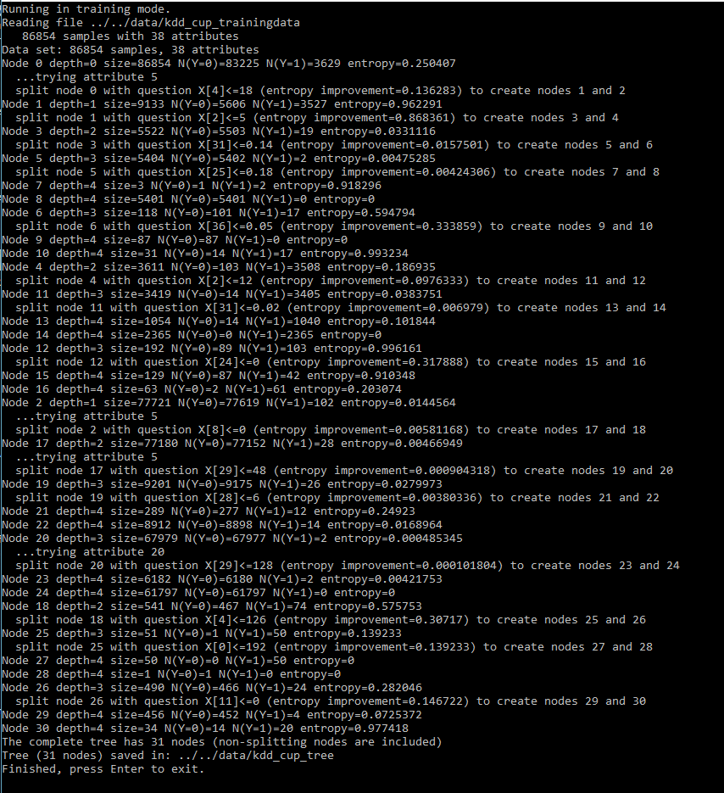
- on level 0 we have node 0 : question is if X[4] is less than the 18 threshold
- on level 1 we have node 1 and node 2 :
- node 1 : the chosen question is X[2] < 5 (threshold)
- node 2 : holds 77721 of the input data, needs to be split once more. So splits with question x[8] < 0 (threshold is zero)

- Comments on the tree created for the complete training set. (which attributes are the most
significant in determining a normal network connection, etc...)

For the trainingdata file (traning completed in 5 minutes)
The final tree has 31 nodes. The attributes used for the splitting are X[4], X[2], X[31], X[25], X[36], X[31], X[24], X[8], X[28], X[29], X[0] and X[11]. As can be seen we can choose many different attributes to split the dataset on different levels of the decision tree. The threshold we use to compare the attributes are also different on each level, sometimes zero sometimes even reachs up to 192.

Tree file generated:
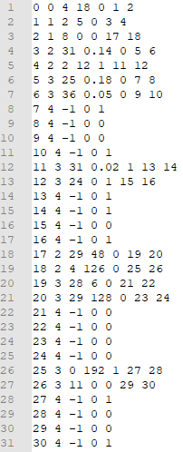

Part 2: Evaluation of the classification
Tree file is created using the trainingdata file. So for this part I will try to predict another dataset.

- Predicting the kdd_cup_testdata

9602 / 10000 Success, 392 instruction missed.

Node | Entropy | error
0 | 0,00508331 | 0,0398
1 | 0,0418891 | 0,37069
2 | 0,000792863 | 0,00122823
3 | 0,0167006 | 0,00155521
4 | 0,0822787 | 0,37069
5 | 0,0170452 | 0,0015873
6 | 0 | 0
7 | 0 | 1
8 | 0,0170723 | 0,00158983
9 | 0 | 0
10 | 0 | 1
11 | 0,0391977 | 0,00533333
12 | 0,703639 | 0,5
13 | 0,12148 | 0,0165289
14 | 0 | 0
15 | 0,749595 | 0,214286
16 | 0,650022 | 0,166667
17 | 0 | 0
18 | 0,116408 | 0,180328
19 | 0 | 0
20 | 0 | 0
21 | 0 | 0
22 | 0 | 0
23 | 0 | 0
24 | 0 | 0
25 | 0 | 0
26 | 0,131498 | 0,0740741
27 | 0 | 0
28 | 0 | 0
29 | 0,139233 | 0,0196078
30 | 0 | 0

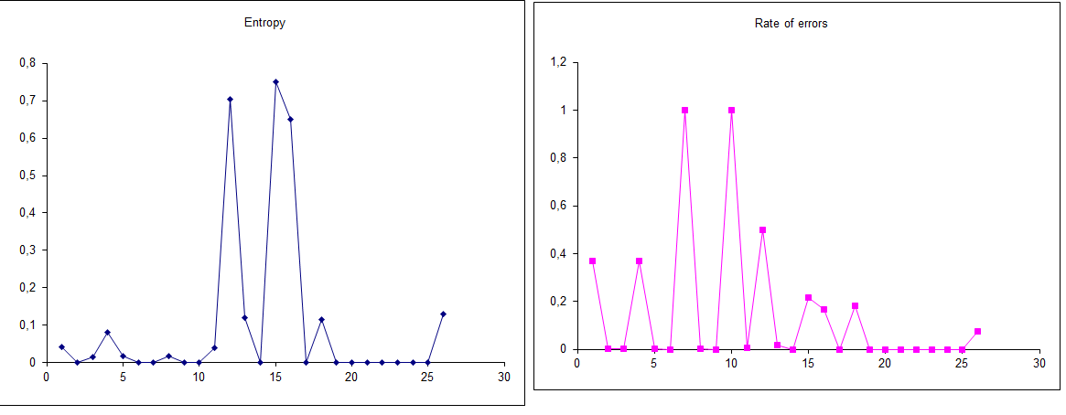

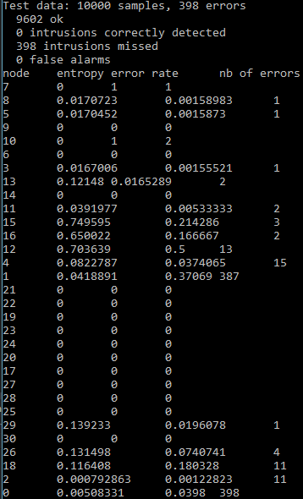
- Predicting the trainingdata
Let us try to predict the dataset that we used to generate our tree just to see what will happen.

83225 / 86854 Success, 3629 instruction missed.

Node | Entropy | Error
0 | 0,00674819 | 0,0417828
1 | 0,0296854 | 0,386182
2 | 0,00405283 | 0,00131239
3 | 0,00607482 | 0,00344078
4 | 0,0657911 | 0,028524
5 | 0,000509787 | 0,000370096
6 | 0,260934 | 0,144068
7 | 0,918296 | 0,333333
8 | 0 | 0
9 | 0 | 0
10 | 0,993234 | 0,451613
11 | 0,0313961 | 0,00409476
12 | 0,678274 | 0,463542
13 | 0,101844 | 0,0132827
14 | 0 | 0
15 | 0,910348 | 0,325581
16 | 0,203074 | 0,031746
17 | 0,00322209 | 0,000362788
18 | 0,122568 | 0,136784
19 | 0,0241939 | 0,00282578
20 | 0,000383541 | 0
21 | 0,24923 | 0,0415225
22 | 0,0168964 | 0,00157092
23 | 0,00421753 | 0,00032352
24 | 0 | 0
25 | 0 | 0,0196078
26 | 0,135325 | 0,0489796
27 | 0 | 0
28 | 0 | 0
29 | 0,0725372 | 0,00877193
30 | 0,977418 | 0,411765

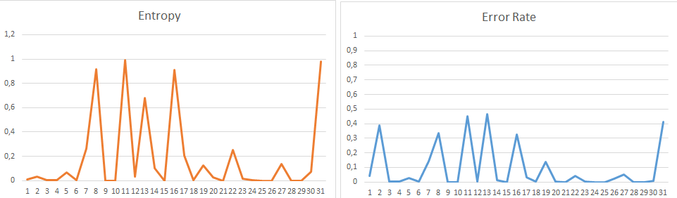

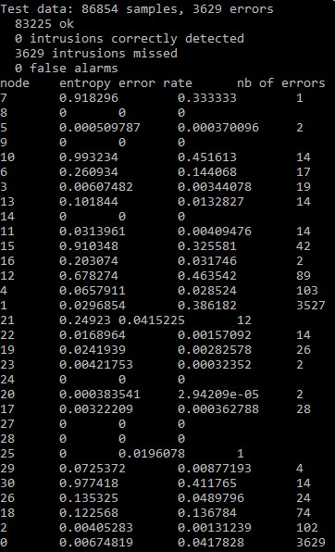

When we are using our decision tree to predict a dataset, our success relies on our threshold. If we use a very high threshold our decisions will not be correct and it will result in a terrible predictions with very wrong classification. Similarly, if we use a very low threshold then we will over fit the dataset and we will never give correct decisions because even a small error will result in a rejection on our decision algorithm. There is no such thing as the best threshold unless we 100% know what the dataset is, which is impossible since as it is named this is a ‘’prediction’’. Therefore, we need to try our best to define a threshold that will give us the best solution in overall.

Please notice that even the tree file we generated on the trainingset gave better result on another dataset (%96) but now on its own data that generated it (%95) and the reason is because we over fit the values on the trainingset, resulting in rejection of most on the attributes to be decided as success.

