MALIS Course

1st Lab Session's Report

by Berkay KÖKSAL

Exercise 1: Chromosome genetic operators
Please notice that the crossover and mutation start and ending points are taken randomly.
Refer to Exercise1.txt.
Mutation test 0:
Chromosome: fitness= 0.00, cities: 69 37 25 50 16 82 75 56 89 79 52 99 1 95 47 67 2 58 34 62 46 4 14 21 96 61 5 91 84 29 87 55 94 15 23 54 78 3 68 63 43 98 17 13 49 40 64 12 39 33 41 92 8 10 97 88 90 0 30 26 71 70 11 28 6 93 22 7 59 32 20 35 31 38 81 65 18 76 57 42 83 66 86 60 51 44 80 53 72 27 19 77 48 85 45 74 36 73 9 24
Chromosome: fitness= 0.00, cities: 69 37 25 50 16 82 75 56 89 79 52 99 1 95 47 67 2 58 34 62 46 4 14 21 96 61 5 91 84 29 87 55 94 15 23 54 78 3 68 63 43 98 17 13 49 40 64 12 39 33 41 92 8 10 97 88 90 0 30 26 71 70 11 28 6 93 22 7 59 32 20 35 31 38 81 65 74 45 85 48 77 19 27 72 53 44 80 51 60 86 66 83 42 57 76 18 36 73 9 24
Mutation test 1:
Chromosome: fitness= 0.00, cities: 5 62 57 56 29 18 70 39 32 97 63 2 72 44 27 50 55 77 34 66 31 43 36 47 91 12 52 45 41 16 58 60 79 49 84 67 22 20 93 53 46 94 82 38 37 7 9 80 81 98 21 88 33 6 8 28 48 75 65 78 30 51 54 83 95 68 87 64 71 24 99 73 74 59 35 19 0 96 23 90 69 14 1 10 42 11 61 40 86 89 85 25 17 4 13 92 76 26 15 3
Chromosome: fitness= 0.00, cities: 5 62 57 56 29 18 70 39 32 97 63 2 72 44 27 50 55 77 34 66 31 43 36 47 91 12 52 45 41 16 58 60 79 49 84 67 22 20 93 53 46 94 82 38 37 7 9 80 81 98 21 88 33 6 8 28 48 75 65 78 30 51 92 13 4 17 25 85 89 86 40 61 11 42 10 1 14 69 23 90 96 0 19 35 59 74 73 99 24 71 64 87 68 95 83 54 76 26 15 3
Mutation test 2:
Chromosome: fitness= 0.00, cities: 1 93 56 71 76 24 60 38 63 4 78 91 0 5 14 57 84 88 53 51 92 19 54 44 39 18 96 37 43 99 26 81 86 61 11 70 73 64 98 69 6 59 35 62 74 45 72 41 25 7 65 46 66 40 95 22 79 90 48 27 50 16 23 17 30 58 8 9 87 33 89 29 97 77 28 3 82 52 34 47 94 21 10 31 15 55 32 2 13 36 49 83 42 67 20 75 12 80 68 85
Chromosome: fitness= 0.00, cities: 1 93 56 71 76 24 60 38 63 4 78 91 0 5 14 57 84 88 53 51 92 19 54 44 39 18 40 66 46 65 7 25 41 72 45 74 62 35 59 69 6 98 64 73 70 11 61 86 81 26 99 43 37 96 95 22 79 90 48 27 50 16 23 17 30 58 8 9 87 33 89 29 97 77 28 3 82 52 34 47 94 21 10 31 15 55 32 2 13 36 49 83 42 67 20 75 12 80 68 85
Mutation test 3:
Chromosome: fitness= 0.00, cities: 90 54 56 75 6 43 40 1 21 70 17 68 78 23 38 59 29 45 76 96 13 60 85 24 57 28 48 97 49 32 65 15 86 61 27 39 67 80 20 63 66 64 94 95 11 9 10 83 99 26 5 46 53 35 0 47 41 93 8 51 73 58 84 3 14 44 77 12 98 91 42 52 33 19 25 79 34 2 22 72 18 55 89 16 71 92 62 31 74 30 87 4 50 82 37 69 36 88 7 81
Chromosome: fitness= 0.00, cities: 90 54 56 75 6 43 40 1 21 70 17 68 78 81 7 88 36 69 37 82 50 4 87 30 74 31 62 92 71 16 89 55 18 72 22 2 34 79 25 19 33 52 42 91 98 12 77 44 14 3 84 58 73 51 8 93 41 47 0 35 53 46 5 26 99 83 10 9 11 95 94 64 66 63 20 80 67 39 27 61 86 15 65 32 49 97 48 28 57 24 85 60 13 96 76 45 29 59 38 23
Crossover test 1:
Chromosome: fitness= 0.00, cities: 78 55 67 11 61 19 95 22 31 40 28 33 84 49 46 44 2 79 98 13 36 92 60 68 34 0 16 80 1 30 59 53 58 97 51 54 93 35 24 26 4 45 42 86 91 56 63 88 69 57 47 90 50 15 32 18 77 27 23 76 48 5 83 38 43 85 81 94 14 10 71 37 20 72 21 82 65 89 8 70 29 12 25 96 99 39 62 52 17 66 41 64 73 74 7 3 9 75 87 6
Chromosome: fitness= 0.00, cities: 15 40 19 81 69 47 50 5 27 43 82 95 61 87 36 94 57 80 59 2 31 4 48 41 76 33 0 25 3 53 74 18 1 49 7 10 96 90 83 32 72 68 46 54 89 17 14 93 62 16 75 39 6 86 26 23 22 9 8 77 56 60 99 73 91 55 30 92 98 45 13 63 12 44 35 84 65 88 70 38 66 78 20 64 79 21 85 71 34 67 52 37 29 11 97 42 51 28 58 24
Chromosome: fitness= 0.00, cities: 15 40 19 81 69 47 50 5 27 43 82 95 61 87 36 94 57 80 59 2 31 4 48 41 76 33 0 3 53 74 18 1 49 7 10 90 83 32 72 68 46 54 89 17 14 93 16 75 6 86 26 23 22 9 8 77 56 60 73 91 55 30 92 98 45 13 63 44 35 84 65 88 38 66 78 20 64 79 21 70 29 12 25 96 99 39 62 85 71 34 67 52 37 11 97 42 51 28 58 24
Crossover test 2:
Chromosome: fitness= 0.00, cities: 81 88 93 17 55 28 43 42 69 95 56 87 74 36 32 79 37 82 2 41 51 22 60 9 75 92 94 53 70 24 7 1 0 20 97 62 26 8 59 91 44 46 61 4 99 35 57 34 72 96 45 50 11 66 78 84 89 77 25 23 30 5 49 16 71 58 98 47 52 80 65 27 18 67 13 29 14 86 73 33 19 48 83 38 3 90 15 21 31 63 10 64 85 6 54 68 12 40 39 76
Chromosome: fitness= 0.00, cities: 42 84 65 31 58 51 61 37 92 52 32 94 62 73 53 71 21 75 12 18 3 36 10 93 9 28 55 44 40 34 74 49 97 20 82 95 77 81 1 30 17 86 78 15 11 80 41 46 57 43 6 98 67 33 54 4 16 2 19 39 0 27 5 96 87 85 25 90 88 23 8 76 68 83 7 69 72 29 48 89 45 63 64 70 50 59 79 14 99 24 38 35 13 26 66 91 56 22 47 60
Chromosome: fitness= 0.00, cities: 42 31 51 37 92 32 94 21 75 12 3 36 10 93 9 28 55 40 74 82 95 81 17 15 41 43 6 53 70 24 7 1 54 20 97 62 26 8 59 91 44 46 61 4 99 35 57 34 72 96 45 50 11 66 78 84 89 77 25 23 30 5 49 16 71 58 98 47 52 80 65 27 18 67 13 29 14 86 73 33 19 48 83 2 39 0 87 85 90 88 76 68 69 63 64 79 38 56 22 60
Crossover test 3:
Chromosome: fitness= 0.00, cities: 24 96 64 4 56 82 99 31 70 78 19 35 90 91 51 22 88 95 44 61 7 69 65 76 12 6 2 37 26 54 20 89 0 86 58 15 38 39 85 13 36 18 34 83 47 23 68 17 3 67 25 21 98 10 74 77 5 32 84 72 48 28 60 55 53 16 52 29 59 63 97 1 93 43 94 92 33 49 40 87 80 81 73 8 50 46 62 79 27 71 45 75 41 57 30 11 9 66 42 14
Chromosome: fitness= 0.00, cities: 85 86 46 43 83 89 69 59 58 53 10 28 42 55 48 12 9 72 23 25 32 67 65 5 37 13 82 11 76 14 34 41 87 0 66 44 8 31 47 68 62 97 4 22 27 95 16 2 74 39 18 7 30 52 33 56 60 73 49 57 99 1 92 94 26 6 29 54 35 19 24 91 45 21 93 70 96 81 77 64 17 51 38 88 63 79 15 71 61 3 20 36 84 50 80 90 98 40 78 75
Chromosome: fitness= 0.00, cities: 85 86 83 89 69 58 10 28 42 48 12 72 23 25 32 67 65 5 37 13 82 76 14 34 0 66 44 31 47 68 4 22 95 2 74 39 18 7 56 99 26 6 54 35 19 24 91 21 70 96 77 64 17 51 38 88 15 61 3 20 36 84 60 55 53 16 52 29 59 63 97 1 93 43 94 92 33 49 40 87 80 81 73 8 50 46 62 79 27 71 45 75 41 57 30 11 9 90 98 78

Exercise 2: Population evolution on a circle

Mutation rate: 0.100, Population size: 500

Generation: 0, population size: 500, Round-trip length: 4150.056, best 4150.056

Generation: 2, population size: 500, Round-trip length: 3956.987, best 3956.987

Generation: 8, population size: 500, Round-trip length: 3719.450, best 3719.450

Generation: 33, population size: 500, Round-trip length: 3413.822, best 3413.822

Generation: 150, population size: 500, Round-trip length: 3293.180, best 3293.180

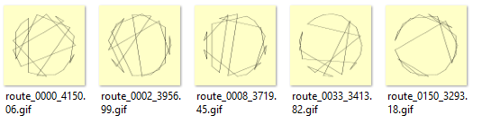
Trying for only 500 generations did not satisfy me. I ran the same exercise for millions of generations, so that I confirm my solutions are getting better and my code has no memory leak.

Here are some other solutions from 10 million generations with over 8 hours of running time:
(Low Mutation)
Mutation rate: 0.010, Population size: 500
Generation: 0, population size: 500, Round-trip length: 4155.778, best 4155.778
Generation: 2, population size: 500, Round-trip length: 4068.617, best 4068.617
Generation: 3, population size: 500, Round-trip length: 4057.294, best 4057.294
Generation: 8, population size: 500, Round-trip length: 4047.540, best 4047.540
Generation: 9, population size: 500, Round-trip length: 3702.992, best 3702.992
Generation: 18, population size: 500, Round-trip length: 3699.827, best 3699.827
Generation: 21, population size: 500, Round-trip length: 3681.108, best 3681.108
Generation: 27, population size: 500, Round-trip length: 3540.602, best 3540.602
Generation: 64, population size: 500, Round-trip length: 3391.158, best 3391.158
Generation: 226, population size: 500, Round-trip length: 3367.616, best 3367.616
Generation: 357, population size: 500, Round-trip length: 3254.417, best 3254.417
Generation: 872, population size: 500, Round-trip length: 3217.742, best 3217.742
Generation: 968, population size: 500, Round-trip length: 3201.777, best 3201.777
Generation: 3326, population size: 500, Round-trip length: 3063.816, best 3063.816
Generation: 7908, population size: 500, Round-trip length: 2921.241, best 2921.241
Generation: 13721, population size: 500, Round-trip length: 2911.616, best 2911.616
Generation: 39148, population size: 500, Round-trip length: 2887.648, best 2887.648
Generation: 45565, population size: 500, Round-trip length: 2870.391, best 2870.391
Generation: 81345, population size: 500, Round-trip length: 2852.284, best 2852.284
Generation: 83761, population size: 500, Round-trip length: 2472.613, best 2472.613
Generation: 1805169, population size: 500, Round-trip length: 2366.641, best 2366.641

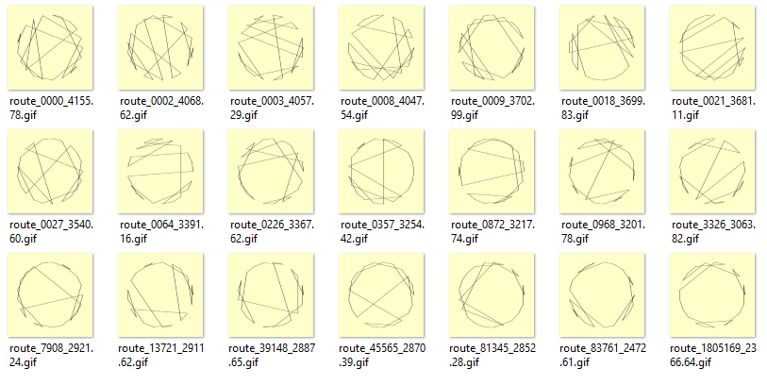

(High Mutation)

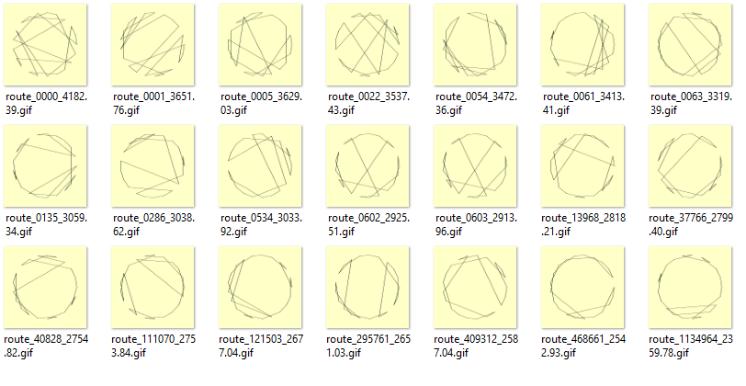
Lowest distance ever calculated randomly is 2359.78 after 1 million generations.

Exercise 3: Population evolution on cities in France
In this exercise, run the experiments 3 times (with different random starting points) for each set of parameter values and provide all 3 results.
When exercise3.cpp is ran, the program will run each test 3 times. Then ask for user to press a button to start the next test until it is over. Results in the end are listed below.

Mutation rate
- Mutation rate 0.01, Population Size 100
- Mutation rate: 0.010, Population size: 100
Generation: 0, population size: 100, Round-trip length: 3824.447, best 3824.447
Generation: 12, population size: 100, Round-trip length: 3676.095, best 3676.095
Generation: 14, population size: 100, Round-trip length: 3611.360, best 3611.360
Generation: 29, population size: 100, Round-trip length: 3494.644, best 3494.644
Generation: 56, population size: 100, Round-trip length: 3353.295, best 3353.295
Generation: 127, population size: 100, Round-trip length: 3340.187, best 3340.187
Generation: 128, population size: 100, Round-trip length: 3026.228, best 3026.228
- Mutation rate: 0.010, Population size: 100
Generation: 0, population size: 100, Round-trip length: 3917.614, best 3917.614
Generation: 1, population size: 100, Round-trip length: 3679.913, best 3679.913
Generation: 31, population size: 100, Round-trip length: 3564.594, best 3564.594
Generation: 43, population size: 100, Round-trip length: 3495.626, best 3495.626
Generation: 58, population size: 100, Round-trip length: 3492.025, best 3492.025
Generation: 74, population size: 100, Round-trip length: 3363.313, best 3363.313
- Mutation rate: 0.010, Population size: 100
Generation: 0, population size: 100, Round-trip length: 3312.831, best 3312.831
Generation: 48, population size: 100, Round-trip length: 3255.181, best 3255.181

- Mutation Rate 0.1, Population Size 100
- Mutation rate: 0.100, Population size: 100
Generation: 0, population size: 100, Round-trip length: 3838.720, best 3838.720
Generation: 2, population size: 100, Round-trip length: 3757.135, best 3757.135
Generation: 13, population size: 100, Round-trip length: 3596.824, best 3596.824
Generation: 23, population size: 100, Round-trip length: 3297.351, best 3297.351
Generation: 146, population size: 100, Round-trip length: 3243.007, best 3243.007
Generation: 329, population size: 100, Round-trip length: 3002.941, best 3002.941
- Mutation rate: 0.100, Population size: 100
Generation: 0, population size: 100, Round-trip length: 4209.410, best 4209.410
Generation: 1, population size: 100, Round-trip length: 4103.241, best 4103.241
Generation: 2, population size: 100, Round-trip length: 3760.161, best 3760.161
Generation: 16, population size: 100, Round-trip length: 3504.625, best 3504.625
Generation: 46, population size: 100, Round-trip length: 3498.065, best 3498.065
Generation: 124, population size: 100, Round-trip length: 3347.527, best 3347.527
- Mutation rate: 0.100, Population size: 100
Generation: 0, population size: 100, Round-trip length: 4141.580, best 4141.580
Generation: 1, population size: 100, Round-trip length: 4127.036, best 4127.036
Generation: 2, population size: 100, Round-trip length: 3825.003, best 3825.003
Generation: 4, population size: 100, Round-trip length: 3809.046, best 3809.046
Generation: 5, population size: 100, Round-trip length: 3598.742, best 3598.742
Generation: 24, population size: 100, Round-trip length: 3558.459, best 3558.459
Generation: 67, population size: 100, Round-trip length: 3549.530, best 3549.530
Generation: 90, population size: 100, Round-trip length: 3497.596, best 3497.596
Generation: 195, population size: 100, Round-trip length: 3435.110, best 3435.110
Generation: 261, population size: 100, Round-trip length: 3354.628, best 3354.628

- Mutation Rate 0.5, Population size 100
- Mutation rate: 0.500, Population size: 100
Generation: 0, population size: 100, Round-trip length: 3573.328, best 3573.328
Generation: 1, population size: 100, Round-trip length: 3353.388, best 3353.388
- Mutation rate: 0.500, Population size: 100
Generation: 0, population size: 100, Round-trip length: 4136.339, best 4136.339
Generation: 1, population size: 100, Round-trip length: 3920.241, best 3920.241
Generation: 3, population size: 100, Round-trip length: 3699.462, best 3699.462
Generation: 15, population size: 100, Round-trip length: 3504.663, best 3504.663
Generation: 24, population size: 100, Round-trip length: 3420.412, best 3420.412
Generation: 73, population size: 100, Round-trip length: 3136.760, best 3136.760
- Mutation rate: 0.500, Population size: 100
Generation: 0, population size: 100, Round-trip length: 4232.483, best 4232.483
Generation: 1, population size: 100, Round-trip length: 3863.837, best 3863.837
Generation: 2, population size: 100, Round-trip length: 3606.655, best 3606.655
Generation: 33, population size: 100, Round-trip length: 3540.311, best 3540.311
Generation: 64, population size: 100, Round-trip length: 3531.827, best 3531.827
Generation: 65, population size: 100, Round-trip length: 3332.326, best 3332.326
Generation: 299, population size: 100, Round-trip length: 3330.029, best 3330.029
Generation: 352, population size: 100, Round-trip length: 3223.159, best 3223.159

Population size
- Mutation Rate 0.1, Population Size 10
- Mutation rate: 0.100, Population size: 10
Generation: 0, population size: 10, Round-trip length: 4370.539, best 4370.539
Generation: 11, population size: 10, Round-trip length: 4185.287, best 4185.287
Generation: 49, population size: 10, Round-trip length: 3942.199, best 3942.199
Generation: 91, population size: 10, Round-trip length: 3757.831, best 3757.831
Generation: 96, population size: 10, Round-trip length: 3442.273, best 3442.273
- Mutation rate: 0.100, Population size: 10
Generation: 0, population size: 10, Round-trip length: 4610.345, best 4610.345
Generation: 2, population size: 10, Round-trip length: 4583.774, best 4583.774
Generation: 3, population size: 10, Round-trip length: 4500.458, best 4500.458
Generation: 7, population size: 10, Round-trip length: 4494.708, best 4494.708
Generation: 15, population size: 10, Round-trip length: 4299.504, best 4299.504
Generation: 28, population size: 10, Round-trip length: 4198.314, best 4198.314
Generation: 72, population size: 10, Round-trip length: 4073.077, best 4073.077
Generation: 73, population size: 10, Round-trip length: 3999.342, best 3999.342
Generation: 75, population size: 10, Round-trip length: 3726.895, best 3726.895
- Mutation rate: 0.100, Population size: 10
Generation: 0, population size: 10, Round-trip length: 4216.372, best 4216.372
Generation: 5, population size: 10, Round-trip length: 3852.658, best 3852.658
Generation: 260, population size: 10, Round-trip length: 3673.550, best 3673.550
Generation: 261, population size: 10, Round-trip length: 3596.708, best 3596.708
Generation: 342, population size: 10, Round-trip length: 3429.687, best 3429.687

- Mutation Rate 0.1, Population Size 50
- Mutation rate: 0.100, Population size: 50
Generation: 0, population size: 50, Round-trip length: 3977.523, best 3977.523
Generation: 1, population size: 50, Round-trip length: 3930.636, best 3930.636
Generation: 2, population size: 50, Round-trip length: 3804.345, best 3804.345
Generation: 8, population size: 50, Round-trip length: 3780.088, best 3780.088
Generation: 11, population size: 50, Round-trip length: 3648.863, best 3648.863
Generation: 67, population size: 50, Round-trip length: 3531.775, best 3531.775
Generation: 104, population size: 50, Round-trip length: 3524.486, best 3524.486
Generation: 144, population size: 50, Round-trip length: 3201.737, best 3201.737
- Mutation rate: 0.100, Population size: 50
Generation: 0, population size: 50, Round-trip length: 4278.855, best 4278.855
Generation: 1, population size: 50, Round-trip length: 3900.033, best 3900.033
Generation: 17, population size: 50, Round-trip length: 3874.219, best 3874.219
Generation: 19, population size: 50, Round-trip length: 3840.264, best 3840.264
Generation: 20, population size: 50, Round-trip length: 3704.030, best 3704.030
Generation: 60, population size: 50, Round-trip length: 3313.537, best 3313.537
- Mutation rate: 0.100, Population size: 50
Generation: 0, population size: 50, Round-trip length: 4196.970, best 4196.970
Generation: 1, population size: 50, Round-trip length: 4015.602, best 4015.602
Generation: 9, population size: 50, Round-trip length: 3994.775, best 3994.775
Generation: 11, population size: 50, Round-trip length: 3688.073, best 3688.073
Generation: 12, population size: 50, Round-trip length: 3502.827, best 3502.827
Generation: 13, population size: 50, Round-trip length: 3466.805, best 3466.805
Generation: 37, population size: 50, Round-trip length: 3418.312, best 3418.312
Generation: 378, population size: 50, Round-trip length: 3411.458, best 3411.458
Generation: 379, population size: 50, Round-trip length: 3236.156, best 3236.156
Generation: 446, population size: 50, Round-trip length: 3107.844, best 3107.844
Generation: 447, population size: 50, Round-trip length: 3040.318, best 3040.318
- Mutation Rate 0.1, Population Size 100
- Mutation rate: 0.100, Population size: 100
Generation: 0, population size: 100, Round-trip length: 3711.531, best 3711.531
Generation: 10, population size: 100, Round-trip length: 3689.419, best 3689.419
Generation: 20, population size: 100, Round-trip length: 3626.800, best 3626.800
Generation: 35, population size: 100, Round-trip length: 3606.938, best 3606.938
Generation: 51, population size: 100, Round-trip length: 3349.400, best 3349.400
Generation: 144, population size: 100, Round-trip length: 3325.442, best 3325.442
- Mutation rate: 0.100, Population size: 100
Generation: 0, population size: 100, Round-trip length: 4179.768, best 4179.768
Generation: 1, population size: 100, Round-trip length: 4107.611, best 4107.611
Generation: 4, population size: 100, Round-trip length: 3970.176, best 3970.176
Generation: 6, population size: 100, Round-trip length: 3859.625, best 3859.625
Generation: 8, population size: 100, Round-trip length: 3764.572, best 3764.572
Generation: 27, population size: 100, Round-trip length: 3622.085, best 3622.085
Generation: 38, population size: 100, Round-trip length: 3612.584, best 3612.584
Generation: 60, population size: 100, Round-trip length: 3594.091, best 3594.091
Generation: 77, population size: 100, Round-trip length: 3027.271, best 3027.271
- Mutation rate: 0.100, Population size: 100
Generation: 0, population size: 100, Round-trip length: 3833.221, best 3833.221
Generation: 8, population size: 100, Round-trip length: 3779.688, best 3779.688
Generation: 14, population size: 100, Round-trip length: 3572.314, best 3572.314
Generation: 25, population size: 100, Round-trip length: 3189.725, best 3189.725
Generation: 280, population size: 100, Round-trip length: 3143.457, best 3143.457
Generation: 281, population size: 100, Round-trip length: 3141.755, best 3141.755
- Mutation Rate 0.1, Population Size 500
- Mutation rate: 0.100, Population size: 500
Generation: 0, population size: 500, Round-trip length: 3739.768, best 3739.768
Generation: 5, population size: 500, Round-trip length: 3678.340, best 3678.340
Generation: 11, population size: 500, Round-trip length: 3598.372, best 3598.372
Generation: 19, population size: 500, Round-trip length: 3562.101, best 3562.101
Generation: 21, population size: 500, Round-trip length: 3519.375, best 3519.375
Generation: 22, population size: 500, Round-trip length: 3515.576, best 3515.576
Generation: 44, population size: 500, Round-trip length: 3499.493, best 3499.493
Generation: 54, population size: 500, Round-trip length: 3490.706, best 3490.706
Generation: 56, population size: 500, Round-trip length: 3427.179, best 3427.179
Generation: 69, population size: 500, Round-trip length: 3360.302, best 3360.302
Generation: 70, population size: 500, Round-trip length: 3194.799, best 3194.799
Generation: 78, population size: 500, Round-trip length: 3147.620, best 3147.620
- Mutation rate: 0.100, Population size: 500
Generation: 0, population size: 500, Round-trip length: 3704.186, best 3704.186
Generation: 1, population size: 500, Round-trip length: 3668.261, best 3668.261
Generation: 3, population size: 500, Round-trip length: 3634.418, best 3634.418
Generation: 4, population size: 500, Round-trip length: 3594.118, best 3594.118
Generation: 6, population size: 500, Round-trip length: 3191.056, best 3191.056
Generation: 81, population size: 500, Round-trip length: 3131.314, best 3131.314
Generation: 418, population size: 500, Round-trip length: 2922.524, best 2922.524
- Mutation rate: 0.100, Population size: 500
Generation: 0, population size: 500, Round-trip length: 3709.467, best 3709.467
Generation: 1, population size: 500, Round-trip length: 3657.338, best 3657.338
Generation: 3, population size: 500, Round-trip length: 3546.251, best 3546.251
Generation: 6, population size: 500, Round-trip length: 3520.477, best 3520.477
Generation: 15, population size: 500, Round-trip length: 3372.283, best 3372.283
Generation: 53, population size: 500, Round-trip length: 3239.863, best 3239.863
Generation: 217, population size: 500, Round-trip length: 3229.550, best 3229.550
Generation: 310, population size: 500, Round-trip length: 3188.354, best 3188.354

More population size brings more mutation to occur even on the same mutation ratio. And more mutation brings the possibility of better crossovers, which leads to more improvement steps (around almost one every 50 generations till 500).

Overview of all routes found during the experiment 3:
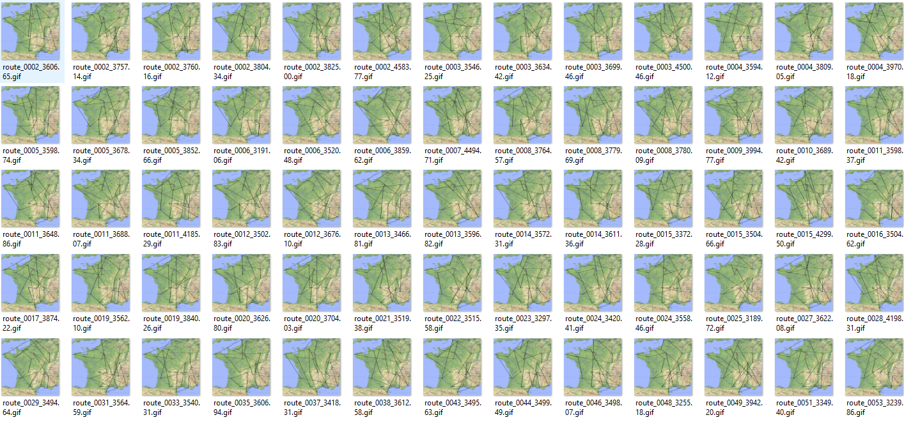

Best route
My best solution was found in the test of Mutation rate: 0.100, Population size: 500 on the 418th generation with the minimum distance of 2922.524.

Log:
Generation: 418, population size: 500, Round-trip length: 2922.524, best 2922.524

Image: route_0418_2922.52.GIF
