Paper Title* (use style: paper title)
*Note: Sub-titles are not captured in Xplore and should not be used

Authors Anonymized

Abstract—Health workforce planning plays a critical role in ensuring equitable and sustainable access to healthcare services. Despite comprehensive reforms such as the Health Transformation Program in Turkey, imbalances in the regional distribution of healthcare personnel persist. This study aims to predict future healthcare workforce needs at both city and regional levels using machine learning (ML) techniques. To this end, a multi-source dataset covering the years 2002–2023 and including all 81 provinces of Turkey was compiled, incorporating indicators such as population, hospital and bed capacities, and the number of healthcare professionals. A total of nine ML models — including tree-based ensemble methods, deep learning, and time series forecasting algorithms — were employed to generate forecasts for the year 2024. The models were evaluated using MAE, RMSE, R², and accuracy metrics. Among them, the XGBoost Regressor achieved the highest prediction accuracy (87.42%) across both city-based and region-based approaches. The results suggest that a region-based approach offers more robust predictions, especially in the presence of data imbalances in smaller provinces. This study proposes a practical framework for developing a data-driven, regionally focused decision support system for strategic health workforce planning in Turkey.
Keywords—healthcare workforce forecasting, machine learning, time series, XGBoost Regressor

Introduction (Heading 1)
Health has been one of the most fundamental needs for human survival throughout history. While its significance has remained constant over generations, the importance of health has evolved from an individual concern to a societal priority with the expansion of communities. In this context, community leaders historically played crucial roles in safeguarding public health. With the advent of modern times, these roles have largely been assumed by centralized governments, and healthcare has become a key area of public policy. The politicization of healthcare has, in turn, led to it becoming a major expenditure item in state budgets.
The healthcare sector holds significant importance for central government treasuries. While the effective management of healthcare expenditures can contribute to a nation’s economic growth, poorly designed policies may lead to substantial setbacks or even the collapse of state systems. In this regard, developed countries adopt a strategic approach to healthcare and implement various reforms to enhance the sustainability of their healthcare systems. Following global developments in the twenty-first century, the Republic of Turkey has also positioned itself among countries that prioritize healthcare. In this context, the Health Transformation Program, launched in 2003, initiated a comprehensive reform process aimed at improving access to healthcare services, increasing patient satisfaction, and strengthening healthcare infrastructure [1]. Although the program has yielded numerous positive outcomes for Turkey, certain unresolved challenges remain. One of the persistent issues is the unequal regional distribution of healthcare personnel. Problems stemming from staff shortages, particularly in rural or underdeveloped areas, continue to pose significant obstacles in the healthcare domain.
One of the critical problems in Turkey’s healthcare system is the unbalanced distribution of healthcare personnel across cities and regions. Current staffing decisions are primarily based on historical vacancy patterns, requests from provincial health directorates grounded in declarations, and rotation policies for personnel whose service terms have ended. However, these allocation methods often overlook crucial factors such as population growth, the need for equitable access to healthcare services, and regional geographical disparities, thereby contributing to the uneven distribution of personnel [2]. Staff shortages, particularly in rural and eastern regions, threaten the sustainability of the healthcare system and undermine individuals’ right to healthcare access [3]. It remains unclear to what extent key factors—such as population density and hospital infrastructure—are considered in the decision-making processes [4]. In this context, the analysis of historical data and the forecasting of future staffing needs have become essential. Such an approach is expected to enable a more effective identification of personnel requirements and contribute to a more balanced and equitable allocation of healthcare workers.
efforts have been undertaken to address inequalities in the healthcare sector. In particular, the advancement of artificial intelligence (AI)-based systems has led to their increasing application across a wide range of domains, from decision support systems to resource planning, in the fight against disparities in healthcare. Studies exploring the potential of AI technologies in healthcare have identified their significant contributions to enhancing overall efficiency [5]. Another study investigating the positive impacts of AI in the healthcare sector demonstrated its strategic value in public institutions, particularly in workforce optimization and employee engagement within human resource management [6].
AI-based systems are frequently utilized in the healthcare sector in Türkiye. Especially in studies conducted after 2020, there has been a strong focus on the distribution of healthcare personnel, with analyses conducted on various health professions. In one study, time series methods—specifically Box-Jenkins and Brown Exponential Smoothing, which are branches of AI—were employed to determine the ratio of doctors, nurses, and midwives to the population between 1928 and 2018 [7]. This study enabled predictions of healthcare personnel needs up to the year 2030, thereby offering a strategic vision for necessary actions. Another study focusing on healthcare workforce planning examined dentist employment [8]. In this work, six different machine learning (ML) algorithms were applied, with the Random Forest algorithm yielding the most accurate results.
The primary objective of this study is to analyze the disparities in the city-level distribution of healthcare personnel in Türkiye using data-driven methods and to develop predictive models to forecast future personnel needs. To this end, multi-source datasets—comprising historical data on healthcare personnel numbers, population statistics, hospital capacities, and healthcare service indicators—were integrated. Based on this data, key variables affecting personnel requirements at the provincial level were identified, and ML-based models were employed to project future demands. The ultimate goal is to propose a data-driven decision support model as an alternative to the existing planning system, which can be utilized by policymakers, particularly to reduce regional inequalities and ensure a more equitable allocation of human resources. Furthermore, this study stands as a pioneering example in Türkiye by integrating open data and predictive modeling techniques in the field of healthcare workforce planning.

Macıhe Learnıngs Method
This section outlines the ML algorithms employed in the study. Six distinct groups of algorithms were utilized within the scope of ML, each serving to address the prediction task from different methodological perspectives. The algorithm categories used in the analysis are as follows:
- Classical Regression Models
- Tree-Based Ensemble Models
- Deep Learning Models
- Time Series Forecasting Models
- Support Vector Regression
- K-Nearest Neighbors Regression
Each of the employed ML algorithms is discussed in detail under the corresponding subheadings.

Classical Regression Models
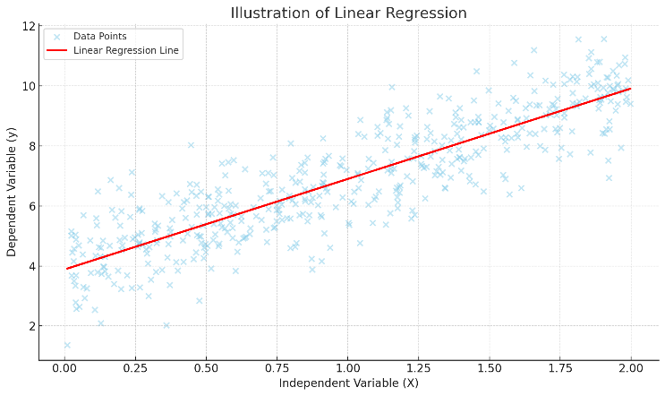
Classical regression models are methods that parametrically model the relationship between a dependent variable and one or more independent variables, mostly within the framework of linear assumptions. The most fundamental and widely used form among these is linear regression. Linear regression expresses the relationship between variables through fixed coefficients, assuming normally distributed residuals, constant variance (homoscedasticity), and linearity between variables [9]. Classical regression models offer high interpretability, especially in small and well-structured datasets. However, their performance may be inadequate when applied to high-dimensional, interactive, or non-linear data structures [10].
- Illustration of Linear Regression.

Tree-Based Ensemble Models
Tree-based ensemble models are ML techniques that achieve high performance in regression or classification tasks by combining multiple decision trees. The primary objective behind these models is to reduce the high variance or bias associated with individual decision trees by leveraging the ensemble structure. In this study, four different tree-based models were utilized. Random Forest (RF) constructs multiple trees by training each on different subsets of the data and features, then aggregates their outputs through majority voting. In contrast, Extra Trees enhances diversity by randomly selecting both data samples and splitting points. Additionally, Gradient Boosting and XGBoost are sequential algorithms that aim to minimize residual errors iteratively, thereby improving model accuracy step by step. Overall, these algorithms have been observed to outperform classical regression methods, especially in complex systems with non-linear relationships [11, 12, 13].
Tree-based ensemble methods are widely and frequently employed across various domains within the field of ML. Their popularity stems from their high accuracy and interpretability. In particular, models like XGBoost offer fine-tuned optimization capabilities and can be integrated with explainability techniques such as SHAP, enhancing transparency in decision-making processes. Overall, tree-based models provide distinct advantages—such as flexibility and strong performance—especially when dealing with high-dimensional, heterogeneous, and incomplete datasets [14, 15].

Deep Learning Models
Deep learning models are multilayered artificial neural networks that demonstrate strong performance in extracting patterns from complex datasets. These models have shown effectiveness across various domains and are also widely used for time series analysis. One of the most commonly employed architectures for time-dependent data is the Long Short-Term Memory (LSTM) network. Designed to capture temporal dependencies, LSTMs address the vanishing gradient problem inherent in classical recurrent neural networks (RNNs) through gating mechanisms that enable the learning of both short- and long-term dependencies. Furthermore, LSTMs possess the ability to learn directly from raw data without requiring explicit feature engineering, thereby offering an advantage over traditional ML algorithms. In addition to their accuracy, LSTMs can significantly influence model performance through hyperparameter settings and data preprocessing configurations [16].

Time Series Forecasting Models
Time series forecasting models are algorithms that rely on historical data to predict future values. These models are particularly useful for capturing patterns such as trends, seasonality, and irregular fluctuations. A variety of algorithms have been developed to handle time series data. One notable model among them is Facebook Prophet, which is designed to automatically decompose time series into trend and seasonal components, while also handling missing values effectively. Prophet employs a non-parametric approach, making it well-suited for modeling time series data with variable frequency. This flexibility enables its application across various technological domains. Additionally, Prophet can capture both piecewise and smoothly changing trends. Its intuitive parameter settings offer a user-friendly interface, and when combined with traditional models like SARIMA, it can deliver highly robust forecasting results [17].

Support Vector Regression
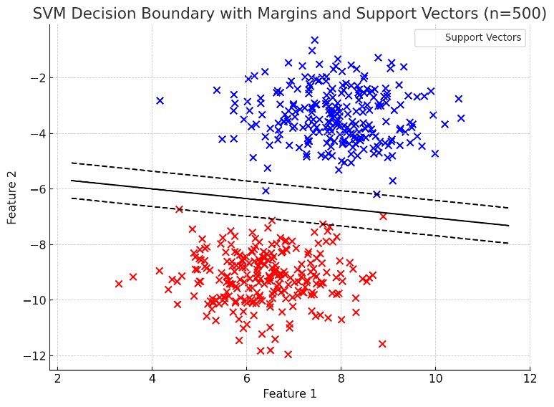
Support Vector Regression (SVR) is a ML algorithm capable of modeling both linear and nonlinear relationships, particularly effective for small to medium-sized datasets due to its strong generalization capabilities. The distinctive feature of SVR lies in its use of a tolerance margin, penalizing predictions that fall outside this predefined threshold. Through the use of kernel functions, SVR can flexibly model both linear and nonlinear patterns. However, the performance of SVR is highly sensitive to hyperparameter tuning, and it may struggle with highly complex data structures. Despite these limitations, SVR offers strong interpretability and statistical consistency, positioning it as a balanced approach between classical regression models and deep learning techniques [18], [19].
- SVM Sample.

K-Nearest Neighbors Regression
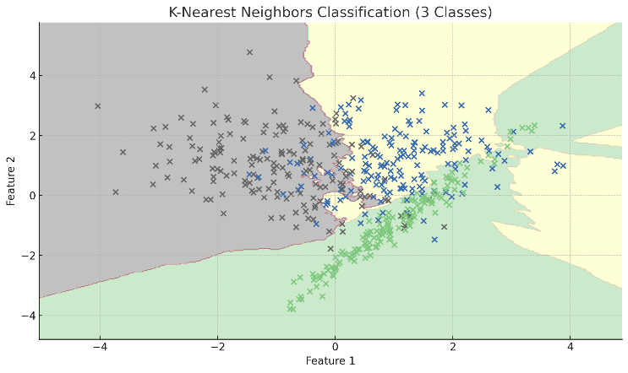
K-Nearest Neighbors (KNN) regression is a simple yet effective ML algorithm that makes predictions based on the similarity between data instances. In KNN, the predicted value for a new observation is calculated as the average of the target values of its k nearest neighbors in the training set. One of the key advantages of KNN is that it requires no explicit training phase. However, its performance can deteriorate in high-dimensional datasets, where distance metrics become less meaningful and computational costs increase significantly. To mitigate these issues, careful tuning of parameters is often necessary. Due to its simplicity and intuitive approach, KNN regression is widely used across various application domains [20], [21].
- KNN Classification Sample.

Evaulatıon Metrıcs
Various error and fit metrics are employed to evaluate the performance of ML-based regression models, thereby assessing the accuracy of predictions. The most commonly used metrics include MAE (Mean Absolute Error), RMSE (Root Mean Squared Error), and R² (Coefficient of Determination). MAE measures the average absolute difference between predicted and actual values, while RMSE penalizes larger errors more heavily by squaring the differences before taking the square root. In contrast, R² indicates the proportion of variance in the dependent variable that is explained by the model, serving as a key indicator of model fit [22].
The choice of evaluation metrics varies depending on the purpose of the dataset. For instance, when scale-independent assessment is needed, R² is generally preferred, whereas RMSE is considered a more consistent metric when sensitivity to the magnitude of error is required. A comparative table summarizing the characteristics of these threew different metrics is presented below [23].
- Evaluatıon Metrıcs Comparısons
Model Metrics | Comparison of Evaluation Metrics
Model Metrics | Sensivity of Outliers | Unit Free | Use Case
MAE | Low | No | Situations requiring balanced error evaluation
RMSE | High | No | Situations where emphasizing large error is important
R² | Medium | Yes | Assessing overall model performance

Dataset and Experimental Setup
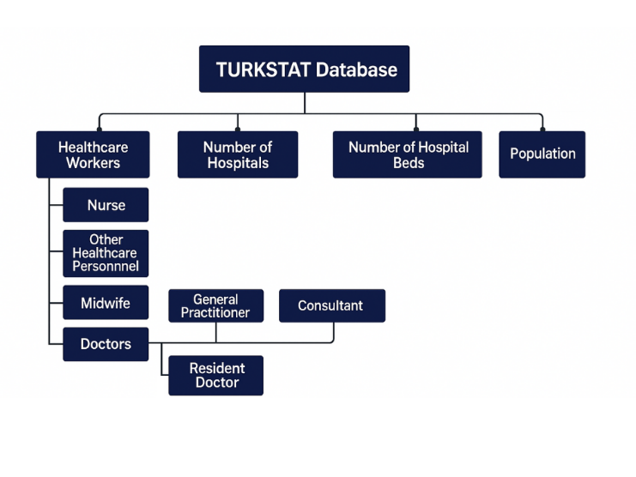
In this study, the dataset was obtained from the Turkish Statistical Institute (TURKSTAT). The data were retrieved from the central distribution system database within TURKSTAT, in accordance with the objectives of the project. The project encompasses four main data groups, each containing several subgroups. The structure of the data retrieved from TURKSTAT is illustrated in Figure 4.
- Dataset Planning.
In line with the study, the data presented in Figure 4 were obtained from TURKSTAT. The data were collected according to the specified categories provided by TURKSTAT.
- Data from the years 2002 to 2023 were collected (for population data, the year 2024 was also included).
- The data were retrieved separately for each of the 81 provinces.
As a result of data collection based on the specified criteria, for each occupational group (excluding population),
$$22×81=1782$$
data were obtained. The total amount of data collected is as follows:
$$\left(1782×8\right)+\left(81x23\right)=16119$$
It has been determined as such. The expression (81×23) in the formula refers to the population figures for each of the 81 provinces from 2002 to 2024. Following data acquisition, the preprocessing phase was initiated.
For the data preprocessing step, the datasets obtained from TURKSTAT in .xlsx format were first downloaded. These files were then converted into .csv format. The primary reason for this conversion lies in the structural differences between the two formats: while .xlsx files offer Excel-based structures with multiple sheets and complex formatting, .csv files store data as plain text in a single sheet, making them simpler but less flexible. This simplicity is one of the main reasons .csv files are preferred in ML applications [24].
After converting the datasets to CSV format, all files were standardized into a uniform structure to enable seamless data integration. The standardized format followed the schema: "province_name, year, value, data_type, category". Once all CSV files were transformed accordingly, they were merged into a single consolidated file named all_data.csv.
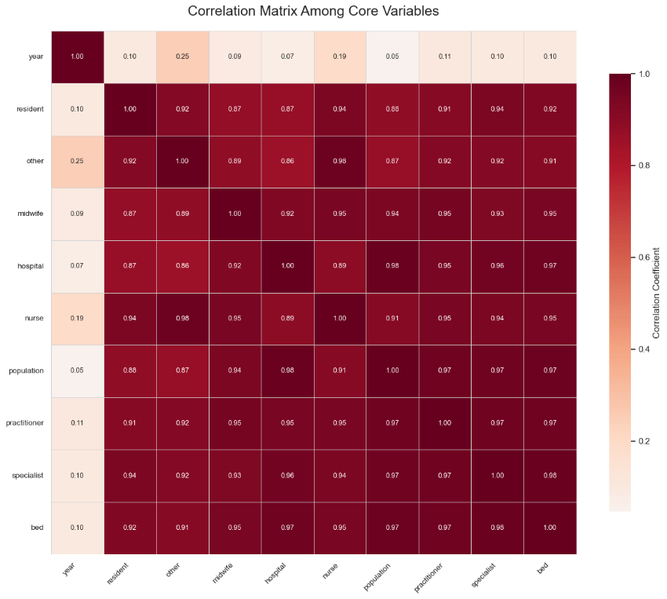
Within the all_data.csv file, which contains all collected data, a correlation analysis was conducted to examine the relationships between variables. The resulting correlation matrix is presented in Figure 5. Upon reviewing the matrix, it was observed that there are strong correlations among several variables, indicating significant interdependencies within the dataset.
- Correlation Matrix.

Results and Dıscussıons
In the results section of the study, the implementation of the applied machine learning algorithms and the outcomes obtained from their use are discussed. The results are presented through comparative tables, allowing for a detailed evaluation and discussion of the performance of each model.
In line with the aim of the study, machine learning algorithms were applied using two different approaches. In the first approach, a city-based perspective was adopted, and predictions for the year 2024 were made based on population data from 2002 to 2023. In the second approach, the same data groups were utilized; however, instead of a city-based framework, a region-based approach was preferred.

City Based Approach
In the first phase of the study, city-based forecasts for the year 2024 were conducted. Accordingly, nine different machine learning algorithms, as outlined under the "Machine Learning Method" section, were employed. During the implementation of these algorithms, hyperparameter optimization was performed to obtain optimal results specific to each algorithm. Hyperparameter optimization refers to the systematic search of predefined parameters in a model to maximize its performance [25]. In this process, techniques such as Grid Search and Random Search were utilized to identify the most suitable parameter combinations based on metrics such as accuracy and error rate.
In ML models, enhancing the diversity of features is of great importance for improving predictive performance. In this context, rather than relying solely on year-over-year population growth, additional features such as the number of various types of healthcare workers, hospitals, and hospital beds across the years were also incorporated for models where such usage was appropriate.
By effectively constructing feature maps for the models and applying hyperparameter optimization, the most accurate results for each model were achieved. Using these results, model performance was evaluated based on accuracy, MAE, RMSE, and R² metrics. The obtained metrics are presented in detail in Table 2.
- Cıty-Based Model Comparısons
Model | Evaluation Metric Comparison
Model | Accuracy (%) | MAE | RMSE | R²
Random Forest Regressor | 78.87 | 297.69 | 1052.59 | 0.915
Extra Tree Regresssor | 78.92 | 297.21 | 1095.41 | 0.908
Linear Regressor | 67.85 | 385.10 | 1676.15 | 0.784
Gradient Boosting Regressor | 78.41 | 301.13 | 1154.20 | 0.898
XGB Regressor | 79.89 | 252.83 | 893.36 | 0.939
SVR | 70.43 | 524.30 | 1938.14 | 0.711
KNeighborsRegressor | 79.18 | 296.30 | 982.87 | 0.926
LSTM | 77.84 | 264.34 | 669.62 | 0.939
Prophet | 78.65 | 281.40 | 794.67 | 0.921
Upon analyzing the model results, it was observed that the XGB Regressor yielded the most accurate predictions. However, these results alone do not provide sufficient predictive power for reliable healthcare personnel forecasting. Several factors contribute to this limitation, which are listed below:
- In some cities with low population, certain professional categories may be entirely absent (e.g., Assistant Doctors).
- In years marked by natural disasters or political events, population changes deviate significantly from historical trends.
- Legislative changes can lead to sharp fluctuations in the number of personnel in certain professions (e.g., the 2014 amendments to the Regulation on Specialty Training in Medicine and Dentistry – TUEY) [26].
In light of the challenges encountered, it was concluded that city-based forecasting does not provide sufficient accuracy. Instead, shifting to a region-based forecasting approach can help mitigate the deviations observed at the city level, offering a more robust and reliable estimation framework.

Region Based Approach
In the second phase of the study, region-based forecasts were conducted. Similar to the city-based approach, the forecasting algorithms listed under the “Machine Learning Method” section were also utilized in the region-based predictions. The results obtained from this phase are presented in Table 3.
- Regıon-Based Model Comparısons
Model | Evaluation Metric Comparison
Model | Accuracy (%) | MAE | RMSE | R²
Random Forest Regressor | 84.88 | 3266.14 | 5877.18 | 0.892
Extra Tree Regresssor | 85.82 | 3107.30 | 5695.60 | 0.892
Linear Regressor | 83.93 | 3352.48 | 6073.33 | 0.885
Gradient Boosting Regressor | 84.61 | 3175.84 | 5853.05 | 0.886
XGB Regressor | 87.42 | 2655.53 | 4704.70 | 0.931
SVR | 73.97 | 6136.08 | 11327.33 | 0599
KNeighborsRegressor | 84.98 | 3110.30 | 5395.57 | 0.909
LSTM | 85.41 | 5586.51 | 9529.15 | 0.924
Prophet | 84.94 | 5939.57 | 10349.63 | 0.911
When examining the model results, the XGB Regressor once again provided the best performance in the region-based forecasts, as it did in the city-based predictions. The primary reason behind XGB’s superior performance in both comparisons is its gradient boosting-based architecture, which exhibits strong compatibility with nonlinear and highly multivariate data structures. This architecture allows the model to effectively minimize error rates while also enhancing its generalization capability.
An analysis of the region-based approach table reveals that many of the issues encountered in the city-based predictions were largely mitigated. However, due to unpredictable events with widespread regional impact—such as the Hatay earthquake—none of the models were able to achieve an accuracy rate exceeding 90%. As a supplementary effort, the best-performing models in the table were ensembled to explore the potential for higher accuracy. Nevertheless, none of the ensemble results surpassed the 87.42% accuracy achieved by the XGB Regressor.

Conclusıon
The conducted study investigates the applicability of machine learning–based decision support systems to reduce regional disparities in the allocation of healthcare personnel in Turkey. Using data obtained from the Turkish Statistical Institute (TURKSTAT), a dataset comprising 16,119 samples was compiled, covering six healthcare professions, hospital and bed counts across 81 provinces from 2002 to 2023. Nine ML algorithms were employed within two spatial approaches—city-based and region-based—for predictive modeling. In the city-based predictions, the XGBoost algorithm achieved the highest performance with an accuracy rate of 79.89%. However, data imbalances in low-population provinces, regulatory changes, and unforeseeable socio-political events limited prediction accuracy. To address these challenges, the proposed region-based approach offered improved accuracy by mitigating inter-city variance. In region-based analyses, XGBoost again emerged as the top-performing model, achieving an accuracy of 87.42%. Ensemble attempts with other models did not surpass this performance. Ultimately, the study demonstrates that a data-driven and region-focused approach to health workforce planning can contribute to the development of more equitable and sustainable policies. Future studies are expected to focus on enhancing the effectiveness of time series forecasting algorithms.

References

- G. Y. Yaşar, “Health transformation programme in Turkey: an assessment,” Int. J. Health Plann. Manage., vol. 26, no. 2, pp. 110–133, 2011.
- B. B. Alkan, C. Atakan, and A. Şahin, “Measuring inequalities in the distribution of health workers by bi-plot approach: The case of Turkey,” unpublished.
- T. I. Agartan, “Health workforce policy and Turkey's health care reform,” Health Policy, vol. 119, no. 12, pp. 1621–1626, 2015. [Online]. Available: https://doi.org/10.1016/j.healthpol.2015.09.009
- Z. Ugur and A. Tirgil, “Regional health disparities in the aftermath of health system reforms in Turkey,” J. Health Syst. Policies, vol. 3, no. 3, pp. 137–169, 2021.
- M. Ak, “Artificial intelligence practices in healthcare management in Turkey,” Int. J. Health Syst. Rehabil. Res., vol. 3, no. 3, pp. 162–170, 2023. [Online]. Available: https://doi.org/10.5281/zenodo.10013237
- S. Devaraju, “AI-powered HRM and finance information systems for workforce optimization and employee engagement,” Turk. J. Comput. Math. Educ. (TURCOMAT), vol. 15, no. 1, pp. 269–281, 2024. [Online]. Available: https://doi.org/10.61841/turcomat.v15i1.14940
- A. B. Babaoglu and M. A. Tekindal, “Modelling the number of people per physician, nurse, and midwives in Turkey in terms of reproductive health indicators,” Inquiry: J. Med. Care Organ. Provis. Financ., vol. 58, pp. 469580211020873, 2021. [Online]. Available: https://doi.org/10.1177/00469580211020873
- A. Atalan and H. Şahin, “Forecasting of the dental workforce with machine learning models,” Müh. Bilim. Araşt. Derg. (MBAD), vol. 6, no. 1, pp. 125–132, 2024.
- G. Arbia, The classical linear regression model, in A Primer for Spatial Econometrics: With Applications in R, STATA and Python, Cham: Springer Int. Publ., 2024, pp. 1–29.
- S. A. Tiruneh, T. T. T. Vu, D. L. Rolnik, H. J. Teede, and J. Enticott, “Machine learning algorithms versus classical regression models in pre-eclampsia prediction: A systematic review,” Curr. Hypertens. Rep., vol. 26, no. 7, pp. 309–323, 2024.
- Z. Song, S. Cao, and H. Yang, “An interpretable framework for modeling global solar radiation using tree-based ensemble machine learning and Shapley additive explanations methods,” Appl. Energy, vol. 364, p. 123238, 2024.
- L. M. Soegianto, A. T. Hinandra, P. A. Suri, and M. Fajar, “Comparison of model performance on housing business using linear regression, random forest regressor, SVR, and neural network,” Procedia Comput. Sci., vol. 245, pp. 1139–1145, 2024.
- S. Jafari and Y. C. Byun, “Efficient state of charge estimation in electric vehicles batteries based on the extra tree regressor: A data-driven approach,” Heliyon, vol. 10, no. 4, 2024.
- K. Sharma, P. K. Tiwari, and S. K. Sinha, “Estimation of hematocrit volume using blood glucose concentration through extreme gradient boosting regressor machine learning model,” J. Chem. Inf. Model., 2025.
- Y. D. Prabowo and J. Gatc, “Optimizing CO2 emission predictions through an ensemble approach: Utilizing XGBRegressor, RandomForestRegressor, and DecisionTreeRegressor models,” in Proc. 2024 9th Int. Conf. Business and Industrial Research (ICBIR), 2024, pp. 1024–1029.
- J. Song, Q. Cheng, X. Bai, W. Jiang, and G. Su, “LSTM-based deep learning model for financial market stock price prediction,” J. Econ. Theory Bus. Manag., vol. 1, no. 2, pp. 43–50, 2024.
- J. Cheng, S. Tiwari, D. Khaled, M. Mahendru, and U. Shahzad, “Forecasting Bitcoin prices using artificial intelligence: Combination of ML, SARIMA, and Facebook Prophet models,” Technol. Forecast. Soc. Change, vol. 198, p. 122938, 2024.
- B. Sharma and N. K. Goel, “Streamflow prediction using support vector regression machine learning model for Tehri Dam,” Appl. Water Sci., vol. 14, no. 5, p. 99, 2024.
- Z. Liao, S. Dai, and T. Kuosmanen, “Convex support vector regression,” Eur. J. Oper. Res., vol. 313, no. 3, pp. 858–870, 2024.
- F. Zhao, M. Zhang, S. Zhou, and Q. Lou, “Detection of network security traffic anomalies based on machine learning KNN method,” J. Artif. Intell. Gen. Sci. (JAIGS), vol. 1, no. 1, pp. 209–218, 2024.
- A. Samad, S. Taze, and M. K. Uçar, “Enhancing milk quality detection with machine learning: A comparative analysis of KNN and distance-weighted KNN algorithms,” Int. J. Innov. Sci. Res. Technol., vol. 9, no. 3, pp. 2021–2029, 2024.
- D. Chicco, M. J. Warrens, and G. Jurman, “The coefficient of determination R-squared is more informative than SMAPE, MAE, MAPE, MSE and RMSE in regression analysis evaluation,” PeerJ Comput. Sci., vol. 7, p. e623, 2021.
- M. Shanmugavalli and K. M. J. Ignatia, “Comparative study among MAPE, RMSE and R square over the treatment techniques undergone for PCOS influenced women,” Recent Patents Eng., vol. 19, no. 1, p. E041223224190, 2025.
- Z. Zhu and X. Xu, “EasyMergeR: An interactive Shiny application to manipulate multiple XLSX files of multiple sheets,” arXiv Prepr., arXiv:2308.04478, 2023.
- B. Bischl, M. Binder, M. Lang, T. Pielok, J. Richter, S. Coors, and M. Lindauer, “Hyperparameter optimization: Foundations, algorithms, best practices, and open challenges,” Wiley Interdiscip. Rev. Data Min. Knowl. Discov., vol. 13, no. 2, p. e1484, 2023.
- Republic of Türkiye Ministry of Health and Council of Higher Education, Regulation on Specialty Training in Medicine and Dentistry, Official Gazette (Issue: 28983), Apr. 26, 2014. [Online]. Available: https://www.resmigazete.gov.tr/eskiler/2014/04/20140426-10.htm

