**Capstone Project - The Battle of Neighborhoods**

**Introduction**

To open a business in a new town we need to analyse the current market and competitors.

Therefore this case study is about a start a restaurant in Colombo city.

**Data**

All data were collected from Four Square.

Data were searched below keywords

1. Restaurants
2. Fast food centres
3. Bakeries

In 10 km radius in Colombo city.

**Layout diagram**

Below diagram plotted using **folium** library

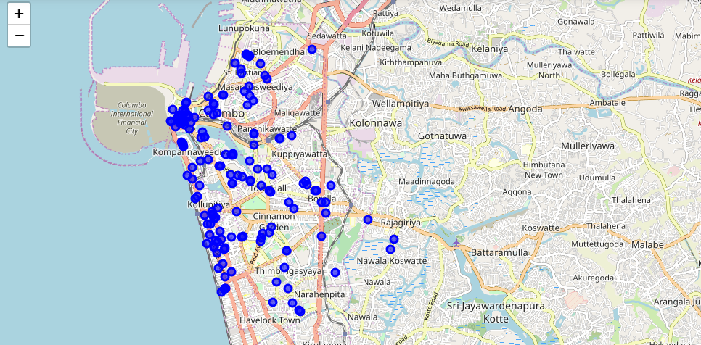

**Conclusion**

Compare to above diagram the best location is ‘Boralla’