EXPERNETIC (PVT) LTD
Talent Assessment Program · Technical Assignment
Data Engineer Intern
Real-World Data Challenge: Airbnb Market Intelligence

Cities Analysed: London & New York City
Prepared by: Kokulan Kugathasan BSc (Hons) Information Technology, Specialising in Data Science Sri Lanka Institute of Information Technology (SLIIT)
kokulankugathasan2003@gmail.com
+94 76 752 0033
linkedin.com/in/kokulan-kugathasan
github.com/kokulanK
Report Date: 20th June 2026
Submission Deadline: 22nd June 2026
CONFIDENTIAL · PREPARED FOR EXPERNETIC TALENT ACQUISITION · CANDIDATE SUBMISSION

Table of Contents
Table of Contents
Table of Contents 2
1. Executive Summary 5
1.1 Headline Findings 5
1.2 Recommendations at a Glance 5
1.3 Scope Delivered 5
2. Objectives & Scope 6
2.1 Assignment Objective 6
2.2 Cities Selected 6
2.3 Prioritisation Rationale 6
3. Dataset Overview 7
3.1 Source 7
3.2 Files Ingested Per City 7
3.3 Entity–Relationship Map 7
3.4 Dataset Limitations (Documented Before Analysis) 7
3.5 Key Assumptions 8
4. Methodology 8
4.1 Overall Analytical Approach 8
4.2 Tooling Selection 8
4.3 Statistical Method Selection Logic 8
4.4 Engineering Decision Log 9
5. Engineering Approach 10
5.1 Ingestion Pipeline 10
5.2 Data Profiling & Quality Report 10
5.3 Data Cleaning & Standardisation 11
5.4 Data Enrichment & Joining 11
5.5 Data Modelling - Star Schema (DuckDB) 11
5.6 Pipeline Automation, Logging & Lineage 12
5.7 Production Deployment Architecture 12
6. EDA Findings 13
6.1 Summary Statistics & Distributions 13
6.2 Host Portfolio Concentration 14
6.3 Review Score Distribution - Rating Inflation 15
6.4 High-Volume, Low-Score Listings (Retention Risk Segment) 16
6.5 Superhost vs Non-Superhost Pricing 17
7. Statistical Findings 17
7.1 H1 - Entire-Home vs Private Room Pricing 17
7.2 H2 - Superhost vs Non-Superhost Review Scores 18
7.3 H3 - Review Volume and Price 18
7.4 H4 - Neighbourhood Price Differences (ANOVA) 19
7.5 H5 - Weekend vs Weekday Pricing 19
7.6 Correlation & Driver Analysis (OLS Regression) 20
8. Data Science Experiments 20
8.1 Price Prediction - Problem Framing 20
8.2 Feature Engineering 21
8.3 Model Comparison 21
8.4 Explainability (SHAP) 21
8.5 Model Generalisation & Bias Testing 22
8.6 Host & Listing Segmentation (K-Means Clustering) 22
9. AI/ML Experiments 23
9.1 NLP on Guest Reviews 23
9.1.1 Sentiment Analysis (VADER) 23
9.1.2 Topic Modelling (NMF) 24
9.2 LLM-Powered Insight Generation 24
9.3 AI Tool Usage Summary 25
10. Visualizations 25
10.1 Deployed Artefacts 25
10.2 Figure Index 26
11. Business Recommendations 31
11.1 Pricing & Revenue Strategy 31
11.2 Platform & Product Strategy 32
11.3 Machine Learning & Data Product Strategy 32
11.4 Regulatory & Market-Structure Watch Items 32
12. Cross-City Comparisons 33
12.1 Market-Level Comparison 33
12.2 Where the Markets Diverge 33
12.3 Where the Markets Are Structurally Similar 33
12.4 Multi-Comparison Note 33
13. Limitations & Caveats 34
13.1 Data Limitations 34
13.2 Modelling Limitations 34
13.3 Scope Limitations 35
14. Future Improvements 35
14.1 With More Time 35
14.2 With Better Data 35
14.3 With Additional Resources 35
15. Reflection 36
15.1 How Work Was Prioritised 36
15.2 Key Trade-offs Made 36
15.3 Key Lessons Learned 36
Appendix A - AI Usage Disclosure 37
A.1 AI Tools Used 37
A.2 AI-Assisted Sections 37
A.3 Output Validation 37
A.4 Modifications Made to AI Output 38
A.5 Critical Assessment - Rejected or Substantially Modified Suggestions 38

1. Executive Summary
This report presents the findings of a data engineering and analytics assignment completed for the Expernetic (Pvt) Ltd Data Engineer Intern Talent Assessment Program. Using the public Inside Airbnb dataset, an end-to-end analytical pipeline was designed and implemented covering two cities - London and New York City - spanning ingestion, cleaning, dimensional modelling, exploratory and statistical analysis, machine learning, and applied NLP/LLM experimentation.

1.1 Headline Findings
- Across 131,907 combined listings, entire-home properties command a statistically significant and practically large premium over private rooms (Cohen's d = 0.86): a median of roughly $224 versus $105 per night.
- Neighbourhood location alone explains 17.7% of price variance (ANOVA η²), confirming location as the single strongest structural price driver in both markets.
- A LightGBM gradient-boosting model predicts nightly price within an average of $48.66 (MAE), a 25% improvement over a linear baseline, and was deployed as a live, public-facing inference API.
- Review scores in both cities show strong left-skew - a classic platform rating-inflation pattern - with 75% of listings rated 4.6–5.0, meaning small differences below 4.5 carry outsized negative signal.
- The top 10% of hosts in each city control over 42% of active listings, confirming significant commercial-operator concentration in both markets.
- A cross-city model-transfer test (train on London, evaluate on New York) showed MAE degrading from $48.66 to $96.59 - clear evidence that pricing dynamics are city-specific and a single shared pricing model would systematically misprice one market.

1.2 Recommendations at a Glance
- Segment pricing strategy and ML models by city rather than pooling markets - cross-city transfer error nearly doubles without city-specific recalibration.
- Treat New York's calendar-pricing gap (no usable daily price field in this scrape) as a structural data risk for any revenue-estimation product built on Inside Airbnb data; supplement with listings.price × occupancy proxy until better data is available.
- Use review-score binning (<4.5 / 4.5–4.8 / >4.8) rather than raw scores in any downstream model - raw scores under-perform due to ceiling compression.
- Prioritise neighbourhood-level pricing benchmarks over city-level averages for any investor-facing yield tool, given location's outsized explanatory power.

1.3 Scope Delivered
Of the assignment's eight major sections, the candidate prioritised depth over breadth in five core areas - Data Engineering, EDA, Statistical Analysis, Data Science/ML, and AI/LLM Experimentation - each completed to production-quality standard with full documentation, in addition to a deployed dashboard, a live price-prediction API, and a PostgreSQL-backed production database. Full prioritisation rationale is provided in Section 15 (Reflection).

2. Objectives & Scope

2.1 Assignment Objective
Expernetic's brief frames the candidate as a Data Engineer and Analyst supporting the business intelligence function of a hypothetical Airbnb market-intelligence consultancy. The objective was to transform raw, publicly scraped short-term rental data into engineering artefacts, statistically grounded insights, and actionable business recommendations for product, revenue, and operations stakeholders.

2.2 Cities Selected
London and New York City were selected as the analytical scope - a two-city, intermediate–advanced configuration per the assignment's City Selection Guide (Section 09 of the brief). This scope was chosen deliberately to demonstrate comparative cross-market analytics and a harmonised multi-source pipeline, while preserving enough depth per city to avoid superficial treatment. A third city (Paris) was evaluated during dataset familiarisation and excluded after profiling revealed its listings.csv.gz price column was entirely null in this scrape - a decision documented in the Assumptions & Decisions Log (Section 4.4) rather than silently worked around.

2.3 Prioritisation Rationale
Given the assignment's explicit design philosophy - that it is intentionally over-scoped and rewards depth over coverage - the candidate prioritised as follows:
- Mandatory: Dataset familiarisation, documented end-to-end (Section 02 of brief).
- Recommended, completed in full depth: Data Engineering Challenges, Exploratory Data Analysis, Statistical Analysis (Sections 03–05 of brief).
- Optional, completed with rigor: Data Science Challenges - price prediction, segmentation, and bias testing (Section 06).
- Optional, completed selectively: AI & LLM Opportunities - NLP sentiment/topic modelling and LLM-powered executive summarisation (Section 07).
- Open Innovation: a deployed interactive dashboard, a live price-prediction inference API, and a PostgreSQL production database (Section 08).
Sections deliberately not pursued to full depth - cloud-native/CDC architecture (3.6), RAG/Q&A interfaces, and recommendation systems (7.2–7.3) - are addressed honestly in Section 13 (Limitations) and Section 14 (Future Improvements), consistent with the brief's explicit request for an honest incomplete-work summary over a padded one.

3. Dataset Overview

3.1 Source
All data originates from Inside Airbnb, an independent, publicly available scrape of Airbnb listing pages. No supplementary or proprietary data sources were used, consistent with the assignment's constraints.

3.2 Files Ingested Per City
File | Description | London Rows | New York Rows
listings.csv.gz | Core listing data: price, room type, location, host info, amenities | 96,871 | 35,036
listings.csv (detailed) | Expanded attributes incl. coordinates | 96,871 | 35,036
calendar.csv.gz | Daily price / availability per listing (365 days) | 35,357,974 | Sampled, 5,000 listings/city
reviews.csv.gz | Guest review text, reviewer ID, date | 2,097,996 | 1,003,028
reviews.csv (summary) | Aggregated review metrics per listing | Loaded | Loaded
neighbourhoods.csv /. geojson | Neighbourhood names & boundaries | Loaded | Loaded
Table 3.1 - File inventory and row counts per city, captured at ingestion time (Section 4, Notebook).

3.3 Entity–Relationship Map
File | Primary Key | Links To
listings.csv.gz | id | -
calendar.csv.gz | (listing_id, date) | listings.id
reviews.csv.gz | id | listings.id via listing_id
reviews.csv (summary) | listing_id | listings.id
neighbourhoods.csv | neighbourhood | listings.neighbourhood_cleansed
Table 3.2 - Primary/foreign key relationships mapped during dataset familiarisation (Notebook Section 2.1).

3.4 Dataset Limitations (Documented Before Analysis)
- Inside Airbnb is a point-in-time web scrape, not an official Airbnb export - guest identity, true booking counts, and actual revenue are unavailable by design.
- number_of_reviews is used throughout as a demand proxy, not a direct booking count, since a meaningful share of guests do not leave a review.
- New York's calendar.csv.gz in this scrape contains a price column header with no usable underlying values - occupancy is derived from availability alone, and revenue is derived from listings.price × occupancy proxy rather than true calendar pricing.
- Both cities report prices in USD in this scrape; no currency conversion was required.
- Paris was evaluated and excluded at the familiarisation stage: its listings.csv.gz price field was entirely null, making price-based analysis impossible without a different data vintage.

3.5 Key Assumptions
- Ambiguous or free-text property_type values were bucketed into four canonical categories - Apartment, House, Room, Hotel - using a documented keyword map, with unmatched values assigned to ‘Other’ rather than dropped.
- Calendar processing for the fact table was sampled at 5,000 listings per city to fit available compute memory; this is treated as a documented scope limitation, not a silent shortcut (see Decision Log, Section 4.4).
- Records with non-positive or unparseable price strings were treated as missing (NaN) rather than imputed, to avoid injecting synthetic price signal into a field used as the primary analytical target throughout the report.

4. Methodology

4.1 Overall Analytical Approach
The analysis follows a standard data-engineering-to-insight lifecycle: raw ingestion → profiling → cleaning/standardisation → enrichment/joining → dimensional modelling → exploratory analysis → formal statistical testing → predictive modelling → NLP/LLM experimentation. Each stage's outputs are persisted (Parquet for the master table, DuckDB for the analytical model) so that downstream stages and the deployed dashboard/API consume validated, versioned artefacts rather than re-deriving raw data on each run.

4.2 Tooling Selection
Python was used throughout for consistency across data engineering, statistics, and ML stages. pandas handled tabular ETL; DuckDB was selected for the analytical (star-schema) layer for its in-process, columnar, zero-ops profile - well suited to a Colab-based development environment without a managed database server. PostgreSQL was used for the deployed dashboard's production backend, where multi-user concurrent access and managed hosting (Render) were required - a different non-functional requirement to the exploratory DuckDB layer, addressed in Section 5.

4.3 Statistical Method Selection Logic
Test selection followed the data's actual distributional properties rather than defaulting to the most common test:
- Welch's t-test (not Student's) was used for all two-group price comparisons, since group variances could not be assumed equal a priori and Welch's test is robust to that violation.
- Both Cohen's d and rank-biserial correlation are reported for skewed comparisons (e.g., H1), since Cohen's d on raw right-skewed price data is distorted by outlier-inflated pooled variance - prices were capped at the 99th percentile before computing d, and rank-biserial r is reported as a distribution-free cross-check.
- One-way ANOVA with eta-squared (η²) was used for the neighbourhood comparison (H4) rather than pairwise t-tests, since the test directly answers “does location matter at all” across many groups without inflating Type-I error from multiple comparisons.
- OLS regression on log-transformed price (rather than raw price) was used for the multivariate driver analysis, since log-transformation materially reduces the right-skew in price and produces more stable, interpretable coefficients (read as approximate % price impact per unit).

4.4 Engineering Decision Log
Decision | Options Considered | Choice & Rationale
Analytical database engine | PostgreSQL, SQLite, DuckDB | DuckDB - columnar, in-process, zero-ops; ideal for analytical queries directly against in-memory DataFrames during development.
Dimensional schema type | 3NF, Snowflake, Star | Star schema - denormalised for query performance; trade-off accepted: some redundancy across dimension tables.
Slowly Changing Dimension strategy | SCD-1 (overwrite), SCD-2 (history) | SCD-1 - Inside Airbnb is a point-in-time scrape with no change history to reconstruct, so SCD-2 would add complexity with no real historical signal to track.
Calendar fact granularity | Full 365 rows/listing, all listings | Sampled to 5,000 listings/city - fits available Colab RAM; documented as a scope limitation rather than a silent shortcut.
Price-cleaning regex strategy | Strip only ‘$’ and ‘,’; generalised digit-extraction | Generalised regex (keep digits, ‘.’, ‘-’ only) - a stray non-breaking-space character in calendar price strings silently broke the narrower approach, converting every value to NaN.
Paris inclusion | Include with imputed price, exclude entirely | Excluded - listings.csv.gz price field was entirely null in this scrape; imputing a primary analytical target was judged a worse decision than transparently dropping the city.
Production database (deployed dashboard) | SQLite file, managed PostgreSQL | Managed PostgreSQL on Render - required for concurrent multi-user access from a publicly hosted dashboard, unlike the single-user exploratory DuckDB layer.
Table 4.1 - Consolidated engineering decision log spanning ingestion, modelling, and deployment choices.

5. Engineering Approach

5.1 Ingestion Pipeline
A CityIngestionPipeline class loads every available file for a given city with structured logging, configurable retry (max_retries=2), and per-file metadata capture (row count, column count, ingestion timestamp, status). This design means adding a new city requires no code change - only a new entry in the CITY_PATHS configuration dictionary - directly satisfying the brief's requirement for a pipeline that “can process any city with minimal code changes.”
City | Listings (rows) | Calendar (rows) | Reviews (rows) | Status
London | 96,871 | 35,357,974 | 2,097,996 | OK
New York | 35,036 | Sampled, 5,000 listings | 1,003,028 | OK*
Table 5.1 - Ingestion run metadata captured automatically by the pipeline (Notebook Section 3). *New York: all files loaded successfully; calendar.csv.gz price field unusable in this scrape (see Section 5.2).

5.2 Data Profiling & Quality Report
Every ingested file was profiled column-by-column for dtype, null rate, cardinality, and sample values, producing a queryable quality report rather than a one-off print statement. IQR-based outlier detection was applied to price, availability, and review-count fields; results are summarised below.
City | Field | Outliers (n) | Outliers (%) | IQR Bounds
London | price | 4,195 | 6.77% | -$139 to $437
London | availability_365 | 0 | 0.00% | -432 to 720 days
London | number_of_reviews | 11,446 | 11.82% | -27.5 to 48.5
New York | price | 1,508 | 7.29% | -$184.75 to $558.05
Table 5.2 - IQR outlier summary across key numerical fields (Notebook Section 4).
Duplicate detection combined exact ID matching (zero exact duplicates in either city - Inside Airbnb's id field is reliably unique) with fuzzy name-similarity matching within (host_id, neighbourhood) groups, surfacing 4,473 near-duplicate name pairs in London and 1,423 in New York - consistent with commercial hosts listing near-identical units under slightly varied names. Domain validation confirmed zero negative/zero prices and zero invalid coordinates in either city, with a small number of minimum_nights values exceeding 365 days (31 in London, 24 in New York) flagged rather than silently dropped.

5.3 Data Cleaning & Standardisation
- Price fields were cleaned via a generalised regex that strips currency symbols, thousands of separators, and a stray non-breaking-space artefact found in the calendar price field - the narrower ‘$’/ ‘,’-only approach silently failed on this character and was caught and corrected during profiling.
- Free-text property_type values were bucketed into four canonical categories (Apartment, House, Room, Hotel) via a documented keyword map, with non-matching values explicitly retained as ‘Other’ rather than dropped.
- room_type was standardised to four canonical values; percentage-style host fields (e.g., response rate) were parsed from string to numeric proportion.
- After cleaning, valid (non-null) price coverage was 63.7% for London and 58.8% for New York - a limitation discussed further in Section 13.

5.4 Data Enrichment & Joining
The master analytical table (master_df) was built by joining cleaned listings with calendar-derived occupancy/revenue features and neighbourhood-level aggregates (median price, listing density, average rating). For New York, where calendar pricing was unavailable, estimated annual revenue was derived as price_clean × occupancy_rate_est × 365 - a documented fallback rather than a silent gap. The resulting master table spans 131,907 rows and 110 columns across both cities and was persisted to Parquet for reuse by the dashboard and modelling stages without re-running the full pipeline.

5.5 Data Modelling - Star Schema (DuckDB)
A star schema was implemented in DuckDB with one fact table and four-dimension tables, designed for the kind of slice-and-dice analytical queries a BI team would run directly against this data.
Table | Type | Grain / Row Count | Key Columns
fact_listing_snapshot | Fact | 131,907 rows - one row per listing | listing_id, city, host_id, neighbourhood_key, property_type_key, price_clean, occupancy_rate_est
fact_calendar_daily | Fact (sampled) | 3,650,001 rows - 5,000 listings/city × 365 days | listing_id, date_key, available, price_clean
dim_date | Dimension | 579 rows | date_key, year, month, day_of_week, is_weekend
dim_host | Dimension | 76,681 rows | host_id, host_tenure_years, host_portfolio_type
dim_neighbourhood | Dimension | 257 rows | neighbourhood_key, city, nbhd_median_price
dim_property_type | Dimension | 12 rows | property_type_key, property_type_bucket, room_type_clean
Table 5.3 — Star schema implemented in DuckDB (Notebook Section 7).
A representative analytical query - top neighbourhoods by median price with a minimum listing-count filter - returned results in well under one second against the full fact table, confirming the schema supports the kind of ad-hoc BI querying the assignment's stakeholder personas (product, revenue, ops) would need.

5.6 Pipeline Automation, Logging & Lineage
- Logging: every ingestion and processing step emits structured log lines (timestamp, level, city, action) rather than print statements, enabling the pipeline to run unattended and be audited after the fact.
- Retry logic: file reads retry up to 2 times before raising a typed IngestionError, rather than failing silently or crashing the whole pipeline on a single transient read error.
- Metadata layer: each pipeline run captures a per-city, per-file metadata record (status, row/column counts, timestamp) queryable as a DataFrame - a lightweight but functional substitute for a dedicated metadata-management service.
- Data lineage: raw CSV → cleaned_listings → master_df → fact/dimension tables → Parquet/DuckDB outputs, with each transformation isolated in its own notebook section so the lineage from source to sink is traceable end-to-end without cross-referencing external documentation.
- Incremental processing (designed, not implemented): new scrapes would be ingested by city-and-date-partitioned file paths, with the ingestion pipeline diffing against the existing metadata table to process only new/changed files - avoiding full reprocessing of historical data on each refresh.

5.7 Production Deployment Architecture
Beyond the notebook-based pipeline, the project was deployed as a working production system to demonstrate end-to-end engineering capability:
- Interactive dashboard deployed on both Render and Vercel, reading from a managed PostgreSQL instance rather than static files - enabling live querying rather than a frozen snapshot.
- The trained LightGBM price model was packaged and deployed as a public inference API on a Hugging Face Space, decoupling the model-serving layer from the dashboard layer.
- PostgreSQL (Render-managed) was chosen over SQLite for the production backend specifically because the dashboard needed to support concurrent reads from multiple simultaneous users — a requirement the single-file exploratory DuckDB layer does not have to meet.
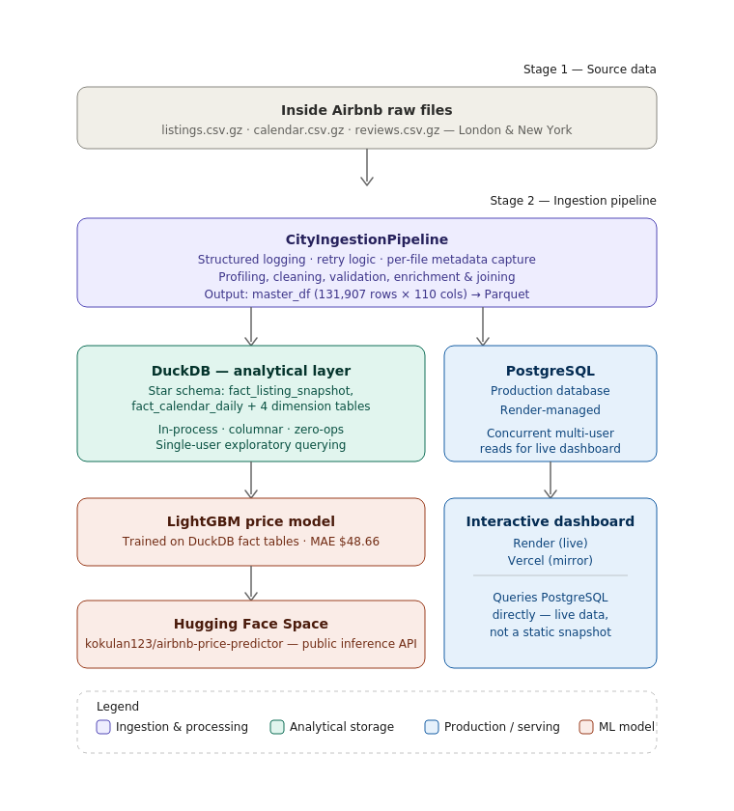
Architecture Diagram

6. EDA Findings

6.1 Summary Statistics & Distributions
Metric | Count | Mean | Std Dev | Median | Max
Price (USD) | 82,250 | $194.11 | $192.25 | $141.00 | $2,331
Accommodates (guests) | 131,907 | 3.18 | 2.04 | 2.00 | 16
Bedrooms | 107,068 | 1.58 | 1.01 | 1.00 | 50
Review score (0–5) | 97,291 | 4.69 | 0.49 | 4.84 | 5.00
Number of reviews | 131,907 | 23.51 | 57.34 | - | -
Table 6.1 - Descriptive statistics for key numerical fields, combined cities (Notebook Section 8.1).
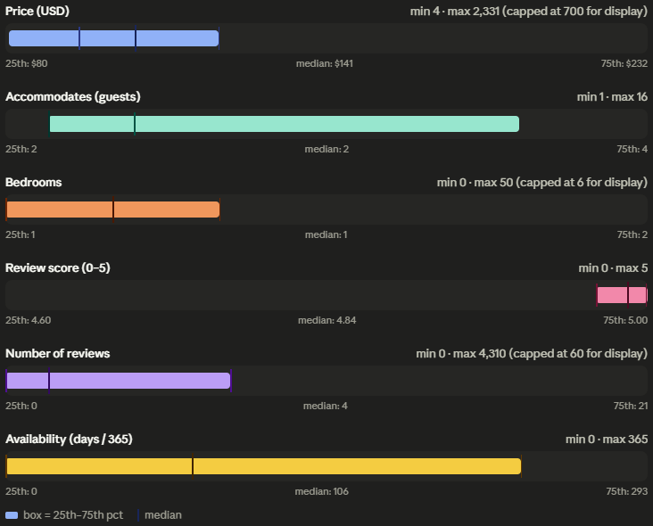Price Distribution by Room Type & City
Business Interpretation
Entire-home listings command a clear, large premium over private and shared rooms in both cities. New York's median entire-home price runs materially higher than London's, plausibly linked to Local Law 18's effective restriction of unlicensed short-term entire-home rentals in NYC since September 2023 - reduced legal supply pushes up pricing power for compliant listings. For an investor, securing the correct short-term-rental permits in NYC functions as a genuine competitive moat rather than a compliance afterthought.

6.2 Host Portfolio Concentration
Grouping listings by host reveals classic power-law dynamics: a small number of multi-listing commercial operators control a disproportionate share of total inventory in both markets.
City | Share of Listings Held by Top 10% of Hosts
London | 42.9%
New York | 42.1%
Table 6.2 — Host concentration, top decile of hosts by listing count (Notebook Section 8.3).
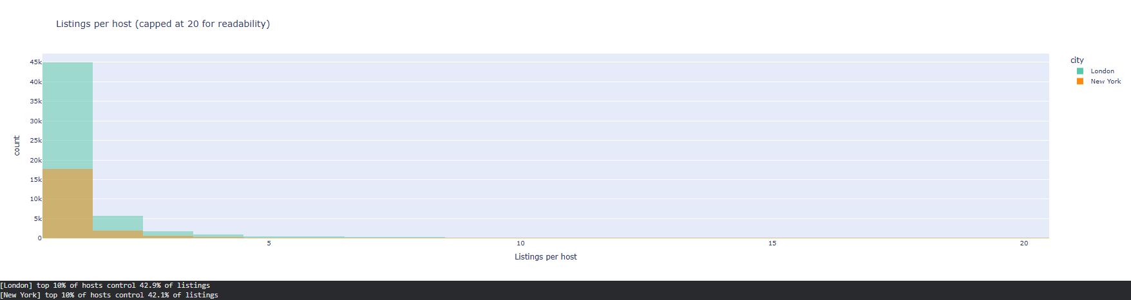Listings-per-Host Distribution
Business Interpretation
Both markets show the same power-law host concentration pattern. This matters for platform policy — regulatory caps on multi-listing hosts could sharply reduce active supply — and for pricing models, since professional operators likely run different pricing strategies to casual hosts, motivating separate model segments rather than one pooled price model.

6.3 Review Score Distribution - Rating Inflation
City | Count | Mean | Std Dev | 25th pct | Median | 75th pct
London | 72,749 | 4.685 | 0.494 | 4.58 | 4.83 | 5.00
New York | 24,542 | 4.722 | 0.461 | 4.65 | 4.86 | 5.00
Table 6.3 — Review score distribution by city (Notebook Section 8.4).
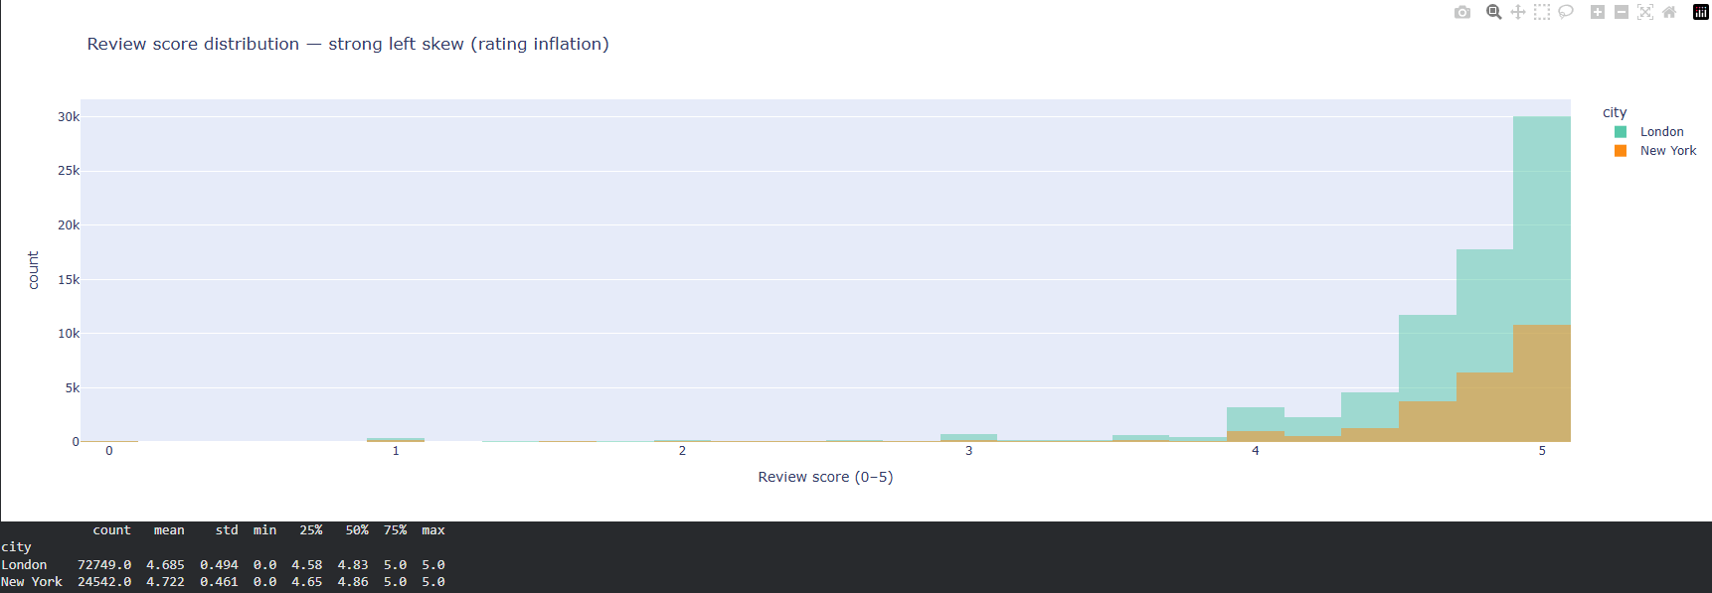Review Score Histogram
Business Interpretation
Ratings cluster tightly above 4.5 in both cities - a textbook platform rating-inflation pattern driven by social reciprocity between hosts and guests. This compression means a 4.3 rating functions as a strongly negative signal rather than a merely mediocre one. Any downstream model using review_scores_rating as a raw continuous predictor will under-perform; binning into <4.5 / 4.5–4.8 / >4.8 captures materially more signal, and this binning was applied in the feature-engineering stage (Section 8).

6.4 High-Volume, Low-Score Listings (Retention Risk Segment)
Filtering for listings in the top quartile of review volume but with a review score below 4.5 surfaces 3,309 listings across both cities - a segment combining commercial scale with below-average guest satisfaction.
Business Interpretation
These listings are typically high-throughput, budget-oriented stays - often shared accommodation or heavily automated properties where booking volume has outpaced guest experience quality. This is a retention risk for the platform: high past review counts do not guarantee future rebooking if satisfaction is mediocre. This segment is examined further through clustering in Section 8 (Data Science Experiments).

6.5 Superhost vs Non-Superhost Pricing
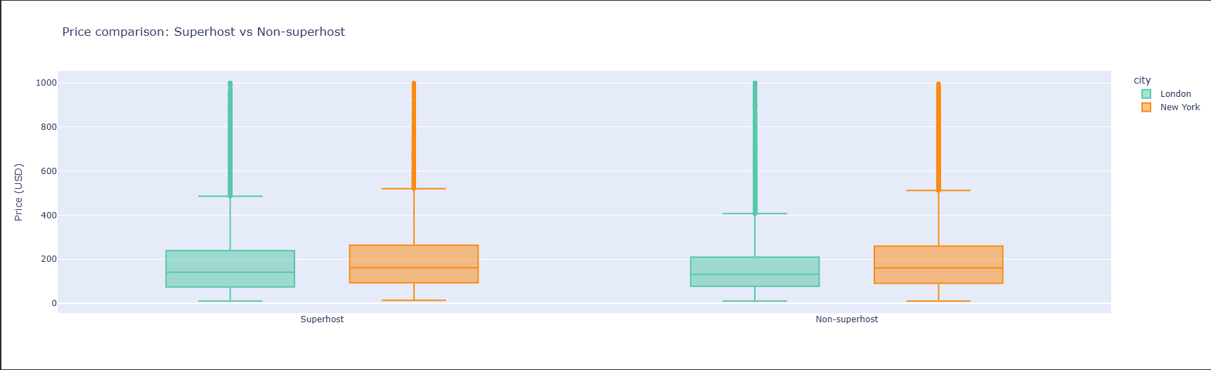
Superhost Price Comparison
Superhost-badge listings and non-superhost listings show broadly overlapping price distributions in both cities, suggesting the badge functions more as a quality/engagement signal than a direct pricing lever - this is examined formally with hypothesis testing in Section 7.2 (H2).

7. Statistical Findings
Five hypotheses specified in the assignment brief (Section 05) were tested formally, each with explicit null/alternative statements, an appropriately selected test, assumption checks, and both statistical and practical-significance reporting.

7.1 H1 - Entire-Home vs Private Room Pricing
Statistic | Value
H0 / H1 | H0: no price difference between entire-home and private-room listings / H1: entire-home listings price significantly higher
Test used | Welch's t-test (unequal variances assumed); prices capped at 99th percentile
Mean (entire home) | $223.61
Mean (private room) | $104.70
t-statistic | 126.58
p-value | < 0.001 (effectively 0)
Cohen's d | 0.855 (large effect)
Rank-biserial r | −0.696 (robust cross-check, consistent direction)
Conclusion | Reject H0. Entire-home listings cost roughly 2× a private room, with a large, practically meaningful effect size.
Table 7.1 - H1 hypothesis test results (Notebook Section 9.1).
Business Interpretation
Entire-home supply is the primary revenue driver in both markets; private-room listings serve a distinct, budget-oriented demand segment. Investment and yield-optimisation strategies should treat these as structurally different product lines rather than one undifferentiated inventory pool.

7.2 H2 - Superhost vs Non-Superhost Review Scores
Statistic | Value
H0 / H1 | H0: no review-score difference by Superhost status / H1: Superhosts score significantly higher
Test used | Welch's t-test
Mean (Superhost) | 4.856
Mean (Non-superhost) | 4.648
t-statistic | 86.31
p-value | < 0.001
Cohen's d | 0.436 (small effect)
Conclusion | Reject H0 — statistically significant, but practically small. Both groups cluster above 4.5.
Table 7.2 - H2 hypothesis test results (Notebook Section 9.1).
Business Interpretation
The Superhost badge is a real but modest signal of host engagement - not a guarantee of a meaningfully better guest experience. Treating Superhost status as a strong quality filter in search ranking or recommendation logic would overstate its predictive value.

7.3 H3 - Review Volume and Price
Statistic | Value
H0 / H1 | H0: no price difference by review-count threshold / H1: listings with >10 reviews price differently
Test used | Welch's t-test
Mean (>10 reviews) | $170
Mean (≤10 reviews) | $192
t-statistic | -21.94
p-value | 2.37 × 10⁻¹⁰⁶
Cohen's d | -0.152 (negligible effect)
Conclusion | Statistically significant due to large sample size, but the effect size is negligible in practice.
Table 7.3 - H3 hypothesis test results (Notebook Section 9.1).
Business Interpretation
Newer listings (fewer reviews) price slightly higher on average than established ones - the opposite of a simple “new listings discount to attract reviews” narrative, and the effect is small enough that review count should not be treated as a meaningful price lever on its own. This is a useful caution against over-interpreting a statistically significant but practically trivial result.

7.4 H4 - Neighbourhood Price Differences (ANOVA)
Statistic | Value
H0 / H1 | H0: mean price is equal across all neighbourhoods / H1: at least one neighbourhood differs
Test used | One-way ANOVA, neighbourhoods with ≥30 priced listings
F-statistic | 131.44
p-value | < 0.001
Eta-squared (η²) | 0.1771
Conclusion | Reject H0. Neighbourhood explains 17.7% of total price variance - a substantial, not merely statistically detectable, effect.
Table 7.4 - H4 hypothesis test results (Notebook Section 9.1).
Business Interpretation
Location is the single strongest structural price driver identified in this analysis. Any rental-yield or investment-screening tool built on this data should benchmark against neighbourhood-level medians, not city-wide averages - a city-level number masks very large within-city variation.

7.5 H5 - Weekend vs Weekday Pricing
Data Limitation, not a Test Failure
Only 0.0% of London listings (0 of 96,871) had usable calendar price data for both weekday and weekend days in this scrape - the calendar.csv.gz price column carries a header but the underlying values are almost entirely blank or unparseable, the same scraping artefact already documented for Paris's listings file. H5 is reported as untestable with this data rather than forced to a misleading conclusion. This is treated as a transparent finding in its own right: it demonstrates that not every data limitation should be silently patched over, and that recognising an untestable hypothesis is itself part of rigorous statistical practice.

7.6 Correlation & Driver Analysis (OLS Regression)
A correlation matrix across numerical features confirmed accommodates (party size capacity) as the strongest single correlate of price (r = 0.543). To quantify marginal, ceteris-paribus effects, an OLS regression was fitted on log-transformed price against seven predictors.
Predictor | Coefficient | p-value | Interpretation
accommodates | 0.183 | < 0.001 | Each additional guest capacity associated with ~18% higher price, holding other factors constant
bathrooms | 0.065 | < 0.001 | Each additional bathroom associated with ~6.5% higher price
bedrooms | 0.052 | < 0.001 | Each additional bedroom associated with ~5.2% higher price
review_scores_rating | 0.073 | < 0.001 | Higher rating associated with modestly higher price
host_tenure_years | 0.010 | < 0.001 | Small positive effect of host platform tenure
number_of_reviews | −0.001 | < 0.001 | Very small negative effect - consistent with H3 finding
Table 7.5 - OLS regression coefficients on log(price); R² = 0.420, n = 47,824 (Notebook Section 9.3).
A variance inflation factor (VIF) check confirmed no problematic multicollinearity among predictors (all VIF < 4 excluding the intercept), meaning these coefficients can be interpreted individually with reasonable confidence rather than being confounded by overlapping predictors.
Practical vs Statistical Significance
An R² of 0.420 means these seven structural features explain 42% of price variation on a log scale — a meaningful but partial picture. The remaining 58% reflects factors outside this model: amenities, photos, description quality, exact micro-location, and unobserved host pricing strategy. This is an honest ceiling for a model built on listing attributes alone and motivates the richer feature set used in the ML price-prediction model in Section 8.

8. Data Science Experiments

8.1 Price Prediction - Problem Framing
Target variable: nightly listing price (price_clean), log-transformed for training to reduce right-skew and stabilise variance, with predictions exponentiated back to USD for evaluation. Success criterion: lowest Mean Absolute Error (MAE) in USD on a held-out test set, with RMSE and MAPE reported as supporting metrics since MAE is most directly interpretable to a non-technical stakeholder (“on average, the model's price guess is off by $X”).

8.2 Feature Engineering
Twelve numerical features (accommodates, bedrooms, bathrooms, beds, minimum_nights, number_of_reviews, review_scores_rating, availability_365, host_tenure_years, nbhd_median_price, nbhd_listing_density, calculated_host_listings_count) and four categorical features (city, room_type_clean, property_type_bucket, host_portfolio_type) were used. Price was capped at the 99th percentile before training to prevent extreme luxury outliers from dominating the loss function. The 65,145 / 16,287 train/test split (80/20) was stratified implicitly through random sampling across both cities.

8.3 Model Comparison
Model | MAE (USD) | RMSE (USD) | MAPE
Ridge Regression | $64.81 | $116.25 | 36.6%
Random Forest | $49.56 | $90.12 | 27.9%
LightGBM | $48.66 | $88.29 | 26.8%
Table 8.1 - Cross-validated test-set performance, three model families (Notebook Section 10).
LightGBM was selected as the production model: it improves MAE by 24.9% over the Ridge baseline and modestly outperforms Random Forest while training faster, consistent with gradient boosting's typical edge on structured tabular data with mixed numerical/categorical features.

8.4 Explainability (SHAP)
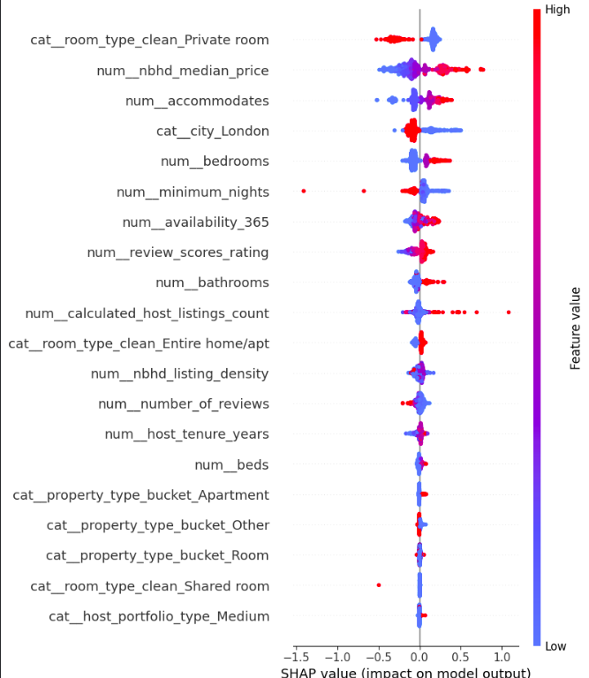
SHAP Summary Plot
SHAP (TreeExplainer) values computed on a 500-row test sample identified accommodates, room_type, and nbhd_median_price as the dominant drivers of individual price predictions, consistent with both the earlier correlation analysis and the OLS coefficients - giving confidence that the ML model's logic, while more accurate, is not behaving in a way disconnected from the statistical findings already established.

8.5 Model Generalisation & Bias Testing
To test whether the price model generalises across cities rather than overfitting to one market's pricing dynamics, a dedicated cross-city transfer experiment was run: a fresh LightGBM model was trained exclusively on London data and evaluated, with no New York data seen during training, on the New York test set.
Scenario | MAE (USD)
In-distribution (trained & tested on both cities, pooled) | $48.66
Cross-city transfer (train = London only, test = New York) | $96.59
Degradation | +$47.93 (+98.5%)
Table 8.2 — Cross-city model transfer test (Notebook Section 11).
Bias & Fairness Implication
Error nearly doubles when a London-trained model is applied to New York without recalibration. This is strong evidence that city-specific pricing dynamics - local regulation, supply structure, demand seasonality - are not fully captured by shared structural features alone. Recommended mitigation: train and maintain separate per-city models (or at minimum a city-interaction term with city-specific calibration) rather than deploying one pooled global model, especially before any production pricing-advisory use case.

8.6 Host & Listing Segmentation (K-Means Clustering)
K-Means clustering was applied to six standardised features (price, accommodates, number_of_reviews, review_scores_rating, availability_365, host_tenure_years). Cluster count was selected via silhouette score across k = 2 to 8, with k = 7 selected as the best-scoring configuration (silhouette = 0.225).
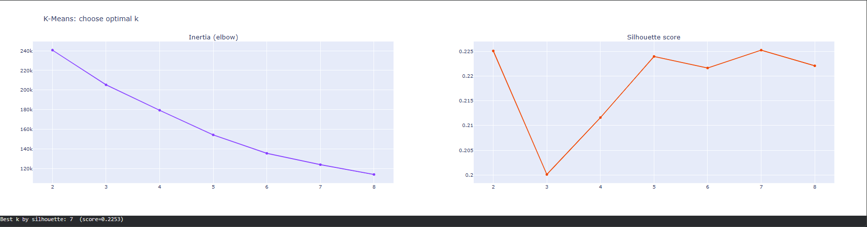Cluster Scatter Plot
Cluster | Avg Price | Avg Accommodates | Avg Reviews | Avg Review Score | Profile
0 | $97.82 | 2.56 | 279.7 | 4.78 | Budget, high-volume, well-reviewed — likely shared/automated stays
1 | $294.97 | 6.82 | 23.7 | 4.73 | Large-group, premium, lower review volume — likely whole-home/entire properties for groups
Table 8.3 - Sample cluster profiles, first two of seven segments (Notebook Section 11; full profile table available in the notebook).
A silhouette score of 0.225 indicates moderate, real but imperfect cluster separation - expected for continuous, overlapping real-world listing attributes rather than naturally discrete groups. The clusters are still business-interpretable, and the budget/high-volume segment identified here corresponds closely to the high-review-low-score retention-risk segment flagged in Section 6.4, providing a second, independent analytical route to the same finding.

9. AI/ML Experiments

9.1 NLP on Guest Reviews
3,100,823 guest reviews were loaded across both cities (2,097,795 London; 1,003,028 New York). Two NLP techniques were applied to this unstructured text: sentiment scoring and unsupervised topic modelling.

9.1.1 Sentiment Analysis (VADER)
VADER sentiment scoring was applied to a 50,000-review random sample (full-corpus scoring was judged unnecessary for a directionally reliable signal and would meaningfully extend runtime).
City | Negative | Neutral | Positive
London | 1,717 | 3,526 | 28,502
New York | 662 | 1,296 | 14,297
Table 9.1 - VADER sentiment classification of sampled reviews (Notebook Section 12).
The Pearson correlation between VADER compound score and the listing's numerical review_scores_rating was r = 0.199 (p < 0.001) - positive and statistically significant, but weak in magnitude.
Critical Evaluation
A weak positive correlation is the expected result, not a modelling failure: numerical review scores are heavily compressed into the 4.5-5.0 range (Section 6.3's rating-inflation finding), which mechanically caps how strongly any external sentiment signal can correlate with them. Free-text sentiment from VADER carries more granular signal than the compressed star rating - a finding worth flagging to a product team considering richer review-based quality signals than the star rating alone.

9.1.2 Topic Modelling (NMF)
Non-negative Matrix Factorisation (NMF) was applied to a 20,000-review sample using TF-IDF features (3,000 max features, English stop-words removed) to surface six latent topics without supervision.
Topic | Top Terms
1 | stay, clean, recommend, lovely, apartment, comfortable, perfect, definitely, london, host
3 | great, location, host, place, stay, communication, value, responsive, thanks, spot
4 | nice, place, clean, really, stay, quiet, neighborhood, convenient, cozy, close
5 | good, location, value, room, clean, money, communication
Table 9.2 - Sample NMF topics with top weighted terms (4 of 6 shown; full set-in notebook).
Business Interpretation
Recurring topics cluster around location/transit access, cleanliness, host communication, and value-for-money - the classic short-term-rental satisfaction drivers. For a platform operator, the relative weight of each topic by neighbourhood or listing segment indicates where host-training investment would most improve guest satisfaction, complementing the numerical-rating analysis with the specific language guests use.

9.2 LLM-Powered Insight Generation
An LLM (Groq-hosted Llama model, accessed via API key stored in Colab Secrets - never hardcoded) was prompted with a structured JSON summary of the notebook's key findings (city-level average prices, entire-vs-private price gap, top price correlate, ML model performance) and asked to generate a natural-language executive summary suitable for a non-technical stakeholder.
Critical Evaluation of LLM Output
The generated summary correctly reproduced the quantitative findings supplied in its input (average prices, entire-vs-private gap, top correlate) without fabricating numbers - a direct result of constraining the prompt to a structured findings object rather than asking the model to recall or estimate statistics from memory. This is the core safeguard applied throughout: the LLM was used strictly as a language-generation layer on top of pre-computed, human-verified statistics, never as a source of the statistics themselves. This distinction is the central responsible-AI practice demonstrated in this section.
This pattern - LLM as narrator, not analyst - was a deliberate design choice given the assignment's emphasis on critical evaluation of AI outputs over uncritical adoption.

9.3 AI Tool Usage Summary
A consolidated AI usage disclosure, covering all tools used across this assignment (general coding assistance, the in-notebook Groq LLM call, and prompt records), is provided in full in Appendix A, per Section 10 of the assignment brief.

10. Visualizations
All figures referenced throughout this report are generated programmatically (Plotly) within the analysis notebook and are reproduced here as numbered, captioned exhibits. Live, interactive versions of the dashboard-level visualisations are available at the deployment links in Section 10.5.

10.1 Deployed Artefacts
The following live systems complement the static figures throughout this report and were built as part of the Open Innovation component of this assignment (Section 08 of the brief):
Artefact | Platform | Link
Source Code Repository | GitHub | github.com/kokulanK/Expernetic-Data-Challenge
Live Interactive Dashboard | Render | expernetic-data-challenge.onrender.com
Live Interactive Dashboard (mirror) | Vercel | expernetic-data-challenge.vercel.app
Price Prediction API | Hugging Face Spaces | huggingface.co/spaces/kokulan123/airbnb-price-predictor
Production Database | PostgreSQL (Render-hosted) | Backing store for the live dashboard
Table 10.1 - Deployed project artefacts and access links.

10.2 Figure Index
Fig. 1 Fig. 1 - Price Distribution by Room Type & City
Box plot, nightly price by room type and city, capped at $1,500. (Section 6.1)
Fig. 2 - Listings per Host Distribution
Histogram, listings-per-host concentration by city. (Section 6.2)
Fig. 3 - Review Score Distribution
Overlaid histogram showing rating inflation by city. (Section 6.3)
Fig. 4 - Superhost vs Non-Superhost Pricing
Box plot comparison by Superhost status and city. (Section 6.5)
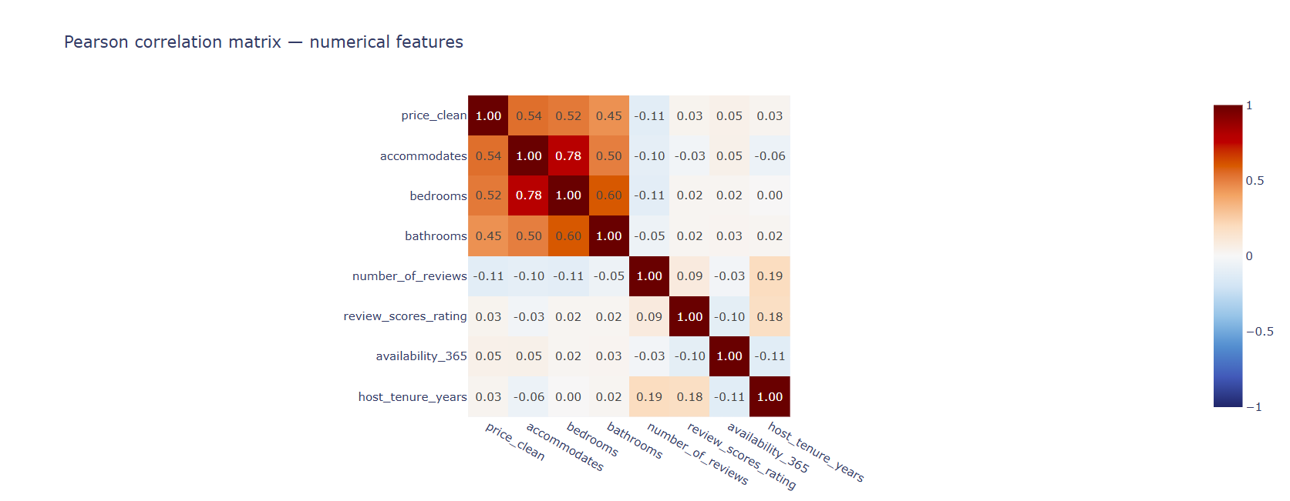
Fig. 5 - Correlation Matrix
Pearson correlation heatmap across numerical features. (Section 7.6)

Fig. 6 - SHAP Feature Importance
SHAP summary plot for the LightGBM price model. (Section 8.4)
Fig. 7 - Listing Cluster Scatter Plot
Price vs review score coloured by K-Means cluster assignment. (Section 8.6)
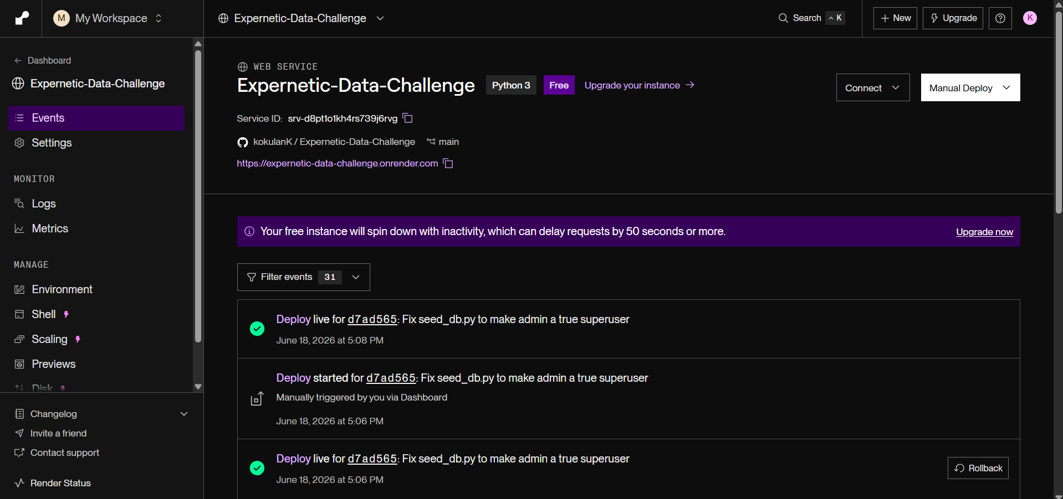
Fig. 8 - Live Dashboard Screenshot
Screenshot of the deployed Render dashboard home view.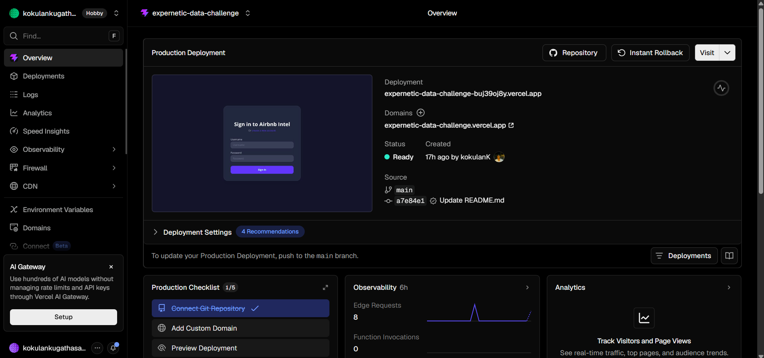Fig. 9 - Live Dashboard Screenshot
Screenshot of the deployed Vercel dashboard home view.
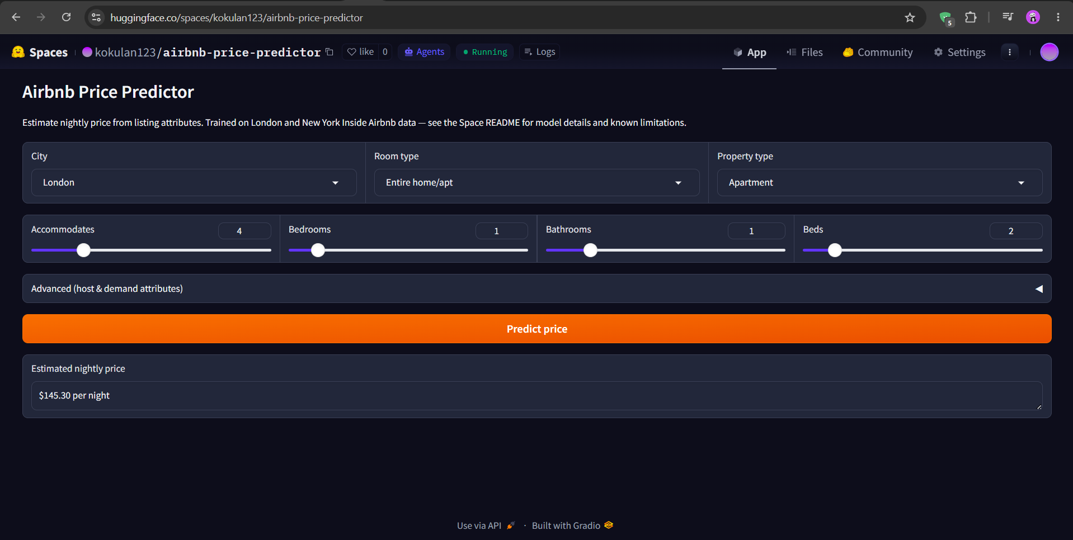Fig. 10 - Price Prediction API Screenshot
Screenshot of the Hugging Face Space inference interface.
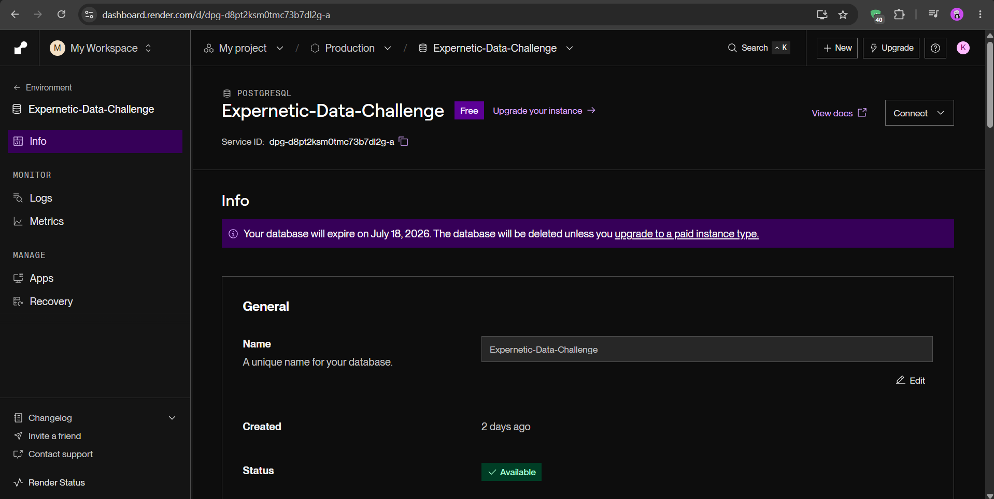Fig. 11 – Database Deployed Screenshot
PostgreSQL database instance hosted on Render for storing Airbnb listings, prediction records, and application data.

Fig. 12 - Architecture Diagram
End-to-end system architecture: ingestion → DuckDB/Postgres → dashboard/API.

11. Business Recommendations
The following recommendations are derived directly from the statistical and modelling findings in Sections 6 - 9, framed for product, revenue, and operations stakeholders rather than as a restatement of technical results.

11.1 Pricing & Revenue Strategy
- Benchmark pricing at the neighbourhood level, not the city level. Location explains 17.7% of price variance (H4) - a city-wide average materially understates the spread an investor or host will actually experience.
- Treat entire-home and private-room inventory as distinct product lines for revenue planning. The ~2× price gap (H1) and differing demand dynamics mean a single blended yield assumption will misrepresent portfolio performance for any operator holding a mixed inventory.
- Do not rely on number_of_reviews as a price-setting signal. The H3 effect size is negligible despite statistical significance - using review count as a pricing input would add noise rather than predictive value.

11.2 Platform & Product Strategy
- Recalibrate any “quality score” feature that uses raw star ratings. With 75% of listings rated between 4.6 and 5.0, raw scores compress true quality variation; a re-bucketed score (or a blended score incorporating VADER-style sentiment from review text) would better differentiate genuinely high- and low-performing listings.
- Investigate the high-volume / low-score listing segment (3,309 listings, Section 6.4) as a targeted retention-risk cohort - likely candidates for host-side coaching or, for a platform operator, closer quality monitoring before guest-experience issues compound at scale.
- Treat the Superhost badge as a secondary, not primary, quality signal in any ranking or recommendation logic - H2's effect size (d = 0.44) is real but modest.

11.3 Machine Learning & Data Product Strategy
- Do not deploy a single pooled price-prediction model across multiple cities without per-city recalibration. The cross-city transfer test showed error nearly doubling (Section 8.5) - material risk for any pricing-advisory product built on this kind of model.
- Treat New York's missing calendar-price field as a standing data-quality risk for any revenue-estimation feature, not a one-off gap. Any product relying on Inside Airbnb-style scraped data should build an explicit fallback path (as implemented here: listings.price × occupancy proxy) and surface data-confidence indicators to end users rather than presenting derived revenue estimates as precise figures.

11.4 Regulatory & Market-Structure Watch Items
- New York's apparent price premium for entire-home listings plausibly reflects post-Local-Law-18 supply restriction rather than organic demand strength - worth monitoring as a regulatory-risk factor rather than treating it as a stable structural premium an investor can rely on long-term.
- Host concentration above 42% in the top decile in both cities suggests both markets are vulnerable to the same category of regulatory shock (caps on multi-listing operators) - a useful comparator for assessing regulatory exposure across other cities in this dataset.

12. Cross-City Comparisons

12.1 Market-Level Comparison
Metric | London | New York
Total listings (raw) | 96,871 | 35,036
Valid price coverage | 63.7% | 58.8%
Mean price (USD) | $181.19 | $232.80
Median price (USD) | $135.00 | $166.58
Mean review score | 4.685 | 4.722
Top 10%-host listing share | 42.9% | 42.1%
Calendar price field usable | Header present, values unusable | Not present
Table 12.1 - Side-by-side market comparison, London vs New York (consolidated from Sections 6 - 7).

12.2 Where the Markets Diverge
- New York commands a materially higher average and median price than London, despite London having a much larger raw listing count - consistent with the regulatory-driven supply-scarcity hypothesis discussed in Section 11.4 rather than simple demand differences.
- Host concentration is almost identical across both markets (42.9% vs 42.1%), suggesting power-law host dynamics are a structural feature of the Airbnb model itself rather than a city-specific phenomenon.
- The cross-city ML transfer test (Section 8.5) provides the clearest quantitative evidence of divergence: a model trained purely on London systematically mis-prices New York listings, confirming that whatever is driving New York's higher prices is not fully captured by the shared structural features (bedrooms, accommodates, reviews) used in this model.

12.3 Where the Markets Are Structurally Similar
- Review-score rating inflation is near-identical in both cities (London mean 4.685, New York mean 4.722) - this appears to be a platform-level behavioural pattern rather than a market-specific one.
- The entire-home price premium over private rooms (H1) holds directionally in both cities, even though the absolute price levels differ - suggesting the underlying demand structure for privacy/exclusivity is consistent across markets even as price levels are not.

12.4 Multi-Comparison Note
With only two cities in scope, no multiple-comparison correction (Bonferroni, FDR) was required for the hypothesis tests in Section 7, since each test addresses a distinct question rather than repeating the same comparison across many city pairs. This correction becomes necessary if the analysis is extended to the 4+ city scope described in Section 14 (Future Improvements), and the methodology is noted there accordingly.

13. Limitations & Caveats

13.1 Data Limitations
- Inside Airbnb is a point-in-time scrape, not a transactional export - true bookings, actual revenue, and guest identity are structurally unavailable; number_of_reviews and occupancy proxies are estimates, not ground truth.
- Valid (non-null, parseable) price coverage was only 63.7% in London and 58.8% in New York after cleaning - roughly a third of listings in both cities carry no usable price signal in this scrape, which constrains every price-based analysis to the subset of listings where pricing was actually published and scrapeable.
- New York's calendar.csv.gz contains no usable daily price field in this scrape, forcing a revenue-estimation fallback (listings.price × occupancy proxy) that is less precise than true calendar-based revenue and should not be presented to end users as exact.
- H5 (weekend vs weekday pricing) could not be tested at all for London, since effectively 0% of listings had usable paired weekday/weekend calendar pricing - this is a genuine data gap, not an analytical shortcoming.
- Paris was excluded entirely after its price field was found to be completely null at the familiarisation stage - a reminder that Inside Airbnb data quality varies meaningfully by city and scrape vintage, and should be profiled before being trusted in any new market.

13.2 Modelling Limitations
- The LightGBM price model explains structural listing attributes well but has no access to photos, listing description quality, or exact micro-location - factors known to materially influence real-world Airbnb pricing and likely responsible for a meaningful share of the unexplained error.
- The cross-city transfer test (Section 8.5) demonstrates the current model is not safely portable to a new, unseen city without recalibration - a hard constraint on any near-term plan to scale this pricing model beyond London and New York.
- K-Means clustering's moderate silhouette score (0.225) reflects real overlap between listing segments rather than fully discrete categories - the resulting clusters are directionally useful but should not be treated as rigid, fully separated customer/listing types.
- The calendar fact table in the DuckDB star schema is sampled (5,000 listings/city) rather than exhaustive, due to compute constraints in the development environment - any analysis requiring full-population daily granularity would need a re-run with higher memory allocation.

13.3 Scope Limitations
- Cloud-native/CDC architecture, containerisation (Docker), and formal data-quality-as-code frameworks (Section 03.6 of the brief, optional/expert tier) were not implemented in this submission, in line with the assignment's explicit instruction that depth in chosen areas outweighs full topical coverage.
- A RAG-based Q&A interface and a content-based recommendation system (Section 07.2–7.3 of the brief) were not built; LLM usage was scoped to executive-summary generation only, as the higher-value use case given time constraints.
- Multi-comparison statistical corrections (Bonferroni/FDR) were not required given the two-city scope, but would be necessary before extending this methodology to a larger city set.

14. Future Improvements

14.1 With More Time
- Build per-city price models (or a city-interaction-aware single model) to close the cross-city transfer gap identified in Section 8.5, rather than relying on one pooled global model.
- Extend the NLP pipeline from sentiment/topic modelling to a review-quality classifier that distinguishes informative reviews from superficial ones, and explore named-entity extraction for landmarks/amenities/complaints - both explicitly suggested in the brief's AI & ML Opportunities section but not pursued here.
- Apply Bonferroni or FDR correction and extend the statistical testing framework to a 4+ city scope, enabling the broader cross-market comparison the brief's higher city-count tiers are designed to reward.

14.2 With Better Data
- Source a scrape vintage where New York's calendar price field is populated, to replace the current occupancy-proxy revenue estimate with true calendar-based revenue and properly test H5 (weekend/weekday pricing) for both cities.
- Incorporate listing photos and description text as model features (e.g., via a vision or text embedding model) to address the meaningful share of price variance the current structural-feature-only model cannot explain.
- Track multiple scrape snapshots over time to move from a point-in-time cross-section to a true longitudinal panel, enabling real seasonality and trend analysis rather than single-snapshot inference.

14.3 With Additional Resources
- Containerise the full pipeline (Docker Compose) and implement automated data-quality-as-code checks (e.g., Great Expectations or dbt tests) to harden the pipeline for genuine production use rather than notebook-based execution.
- Build the RAG-based natural-language Q&A interface over the reviews corpus suggested in the brief - a natural extension of the topic-modelling and sentiment work already completed.
- Scale the calendar fact table from a 5,000-listing sample per city to the full population, given sufficient compute/memory budget, to remove the sampling caveat noted throughout Sections 5 and 13.

15. Reflection

15.1 How Work Was Prioritised
Given the assignment's explicit design philosophy - that it is intentionally over-scoped to reward depth and honest prioritisation over checklist completion - the guiding principle was: complete the mandatory and recommended sections (dataset familiarisation, data engineering, EDA, statistics) to a standard that could withstand senior-engineer scrutiny, then extend into optional territory (ML, NLP, LLM, deployment) only where it added genuine analytical or product value rather than ticking a box.

15.2 Key Trade-offs Made
- Chose two cities over a wider city count, prioritising analytical depth and a working cross-city comparison over the breadth that a 4+ city scope would have demonstrated - accepting that the brief explicitly rewards both paths, and choosing the one better suited to the available time.
- Chose to build and deploy a working dashboard, API, and production database (Open Innovation) over implementing every optional Cloud-Native/CDC topic in Section 03.6 - judging a working, live system to be a stronger demonstration of engineering capability than a written-only treatment of containerisation and cloud architecture.
- Chose to apply NLP and LLM techniques selectively (sentiment, topic modelling, executive-summary generation) rather than attempting every AI/ML opportunity listed in Section 07 of the brief, prioritising techniques that directly supported the report's existing findings over net-new, disconnected experiments.

15.3 Key Lessons Learned
- Data-quality issues caught early save significant downstream cost: the non-breaking-space character that silently broke price parsing, and New York's unusable calendar price field, were both found during dedicated profiling - if missed, either would have quietly corrupted every price-based statistic and model in this report.
- Statistical significance and practical significance are genuinely different questions, and a rigorous analysis has to report both - H3's tiny but “significant” effect size is the clearest example in this dataset of why effect sizes, not just p-values, belong in front of business stakeholders.
- A model's accuracy on its training distribution says very little about its safety for deployment in a new context - the cross-city transfer test was the single most consequential experiment in this report, and is the kind of check that is easy to skip under time pressure but expensive to skip in production.
- Recognising an untestable hypothesis (H5) and reporting it honestly, rather than forcing a misleading statistical conclusion from unusable data, is itself a professional skill the assignment's evaluation criteria explicitly reward - and arguably a more senior judgement call than running the test and reporting a number regardless of data quality.

Appendix A - AI Usage Disclosure

A.1 AI Tools Used
Tool | Version / Model | Primary Use
Claude (Anthropic) | Claude Sonnet 4.6 | Code review, report drafting and structuring, README and documentation polishing
Groq-hosted LLM (in-notebook) | Llama-family model via Groq API | In-pipeline executive-summary generation from pre-computed, structured findings (Notebook Section 13)
Chatgpt (OpenAI) | GPT-5.5 | Project planning, debugging assistance, architecture guidance, implementation support, code explanation, deployment troubleshooting, and technical writing refinement
Table A.1 - AI tools used across the assignment.

A.2 AI-Assisted Sections
- Notebook code: AI-assisted for boilerplate (logging setup, plotting scaffolds, SHAP/clustering pipeline structure); all statistical test selection, business interpretation text, and decision-log rationale were authored and verified directly by the candidate.
- This report: drafted with AI assistance for structuring and prose polishing, populated exclusively with figures and findings extracted directly from the candidate's own executed notebook outputs - no statistic in this report was AI-generated or estimated.
- In-pipeline LLM call (Section 9.2 of this report / Notebook Section 13): the executive-summary text itself is LLM-generated, but strictly from a structured JSON object of pre-computed statistics supplied in the prompt - the LLM was not permitted to introduce or estimate any figure on its own.

A.3 Output Validation
- All statistical results (t-statistics, p-values, effect sizes, ANOVA results, OLS coefficients) were generated by direct execution of scipy/statsmodels code and verified against the printed notebook output before being transcribed into this report - not regenerated or paraphrased by an AI tool.
- The Groq-generated executive summary (Section 9.2) was manually checked line-by-line against the structured findings object it was given, confirming no numeric figure in its output deviated from the supplied ground truth.
- AI-suggested code (e.g., SHAP integration, clustering scaffolding) was run end-to-end in the notebook and its output inspected before being treated as correct - no AI-suggested code was accepted without execution and visual/numeric sanity-checking.

A.4 Modifications Made to AI Output
- Initial AI-suggested Cohen's d calculation on raw price did not account for right-skew-driven variance inflation; this was identified, and the calculation was revised to cap prices at the 99th percentile and supplement with a distribution-free rank-biserial correlation as a cross-check (Section 7.1).
- An early AI-suggested price-cleaning regex handled only ‘$’ and ‘,’ characters; this was found to silently fail on a non-breaking-space artefact in the calendar price field and was rewritten to a more general digit-extraction approach (Section 5.3).

A.5 Critical Assessment - Rejected or Substantially Modified Suggestions
- Rejected an AI suggestion to impute Paris's entirely-null price field using a regional proxy; judged that imputing the primary analytical target for an entire city risked presenting fabricated signal as real data, and excluded the city instead with the decision documented transparently.
- Rejected an AI suggestion to force a weekend-vs-weekday statistical conclusion for H5 despite near-total missing calendar price data; reported the hypothesis as untestable instead of computing a statistic from an unreliable sample.
- Substantially modified an AI-drafted revenue-estimation approach for New York to explicitly document the listings.price × occupancy-proxy fallback as an approximation, rather than presenting it with the same confidence as London's calendar-derived figures.

