**Types of shots**

Drive: - a flat fast shot which hits the front wall and bounces beyond front court

Drop: - A soft shot which hits the front wall and bounces at the front court

Lob: - a shot from the front court which hits the front wall and bounces in a high arching manner to the back court

Boast: - a shot that hits both the side walls (or is intent on hitting both sidewalls)

Smash/kill: - overhead shot (uncommon) which is played with the intent of killing off the rally.

Slice: - ***need to discuss with coach***

**Descriptors**

1a) Straight: - a shot from the left/right of the court which returns back to the left/right.

1b) Cross: - A shot from the left of the court to the right or vice versa.

2a) Volley: - A shot that is hit before the ball bounces on the floor

2b) Half volley: - A shot that is hit immediately following the ball bouncing on the floor (picked up off the floor)

2c) Bounce: - A shot that is hit after the ball has bounced and beyond the half volley stage.

3a) Forehand: - ***self-explanatory? I don’t know how to explain this***

3b) Back hand: - ***self-explanatory? I don’t know how to explain this***

**Positions**

|  |  |  |  |  |
| --- | --- | --- | --- | --- |
|  | Left | Center left | Center Right | Right |
| Front | FL | FCL | FCR | FR |
| Mid front | MFL | MFCL | MFCR | MFR |
| Mid Back | MBL | MBCL | MBCR | MBR |
| Back | BL | BCL | BCR | BR |

**Example of a shot is**

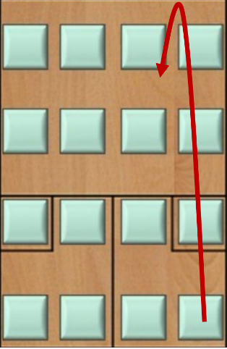Forehand Straight Volley Drop from the Back Right of the court