Information Sufficiency and Selective Prediction in a Structured Probabilistic Decision Model:
Nine Years of the Japanese Medical Licensing Examination
Ren Matsushita, MD
Independent Researcher
Preprint manuscript - September 2026

Abstract
Background. Medical licensing examinations no longer meaningfully discriminate the strongest generative language models by accuracy alone. More informative questions are whether a model recognizes when required information is missing, whether its probabilities identify likely errors, and whether confidence can support selective deferral.
Objective. To characterize Jev, a structured probabilistic decision interface, on nine years of Japanese Medical Licensing Examination (JMLE)-derived questions, with emphasis on information sufficiency, selective prediction, accuracy, latency, and recorded API cost.
Methods. We evaluated typesafe/jev-1.13 through the OpenRouter Decisions API on 3,556 option-choice JMedQA items from 2018-2026 after excluding 25 numeric-response items. JMedQA provides dataset-level image_dependency annotations: none, enough text, not enough text, image question, and image only. No images were supplied; the text-only question field was used. Probability analyses were restricted to 3,097 single-select items. Selective prediction was assessed descriptively and with a 5-fold held-out sensitivity analysis.
Results. Overall exact-set accuracy was 88.58% (3,150/3,556; 95% CI, 87.50%-89.59%). Accuracy was 91.75% for items annotated as having no image dependency and 92.09% for image-associated items annotated as answerable from text alone, but fell to 59.30% when text was annotated as insufficient and 49.19% for visual-finding questions. In single-select items, top-choice probability discriminated correct from incorrect answers (AUROC, 0.918). The 5-fold held-out sensitivity analysis accepted 67.6% of items at 99.00% accuracy. Median API wall-clock latency was 820.7 ms; recorded total API cost was US$0.120 for 3,556 calls.
Conclusions. The most informative finding was not examination "passing" but the alignment between performance and information sufficiency. In this closed-ended benchmark, a low-cost structured decision layer performed well when the text contained enough information and its native probabilities supported deferral of uncertain cases. These findings motivate routing architectures, not autonomous clinical use.
Keywords: Japanese Medical Licensing Examination; JMedQA; medical artificial intelligence; uncertainty; selective prediction; information sufficiency; calibration

1. Introduction
Medical licensing examinations have become standard benchmarks for medical artificial intelligence. GPT-4 and later multimodal systems have already reached passing or very high performance on the Japanese Medical Licensing Examination (JMLE) [1,2]. Consequently, the question "can an AI pass the licensing examination?" now provides limited discrimination among capable systems.
For deployment-oriented evaluation, different properties matter: whether a system can recognize when the input lacks information required for a decision, whether its uncertainty is informative, and whether easy high-confidence cases can be processed cheaply while difficult or incomplete cases are deferred. Broader frameworks such as MedHELM and HealthBench similarly emphasize that examination accuracy alone does not represent the diversity of clinical work [6,7].
Jev differs operationally from a conventional generative assistant. Its Choice interface receives predefined alternatives and returns a selected option together with a probability distribution over those alternatives [11,12]. We use the descriptive term structured probabilistic decision model to refer to this interface behavior; it is not a claim about undisclosed internal architecture.
JMedQA is especially useful for asking whether performance tracks information sufficiency. In addition to nine years of JMLE-derived questions, the dataset provides image_dependency annotations that distinguish questions with no image dependence from image-associated questions that remain answerable from text, questions for which text alone is insufficient, and questions that explicitly require visual interpretation [3]. This taxonomy makes it possible to ask a more precise question than whether an item merely contains an image.
We therefore evaluated four linked questions: (1) overall benchmark accuracy and operational efficiency across nine JMLE years; (2) whether performance follows JMedQA-defined information sufficiency under text-only evaluation; (3) whether native option probabilities identify likely errors and support selective deferral; and (4) how stable the results are across years and under conservative official-score reconstruction.

2. Methods

2.1 Study design and analysis set
We conducted a retrospective benchmark using JMedQA, a public dataset derived from JMLE materials released by the Ministry of Health, Labour and Welfare. The evaluated release contained 3,581 questions from the 112th through 120th examinations (2018-2026). Twenty-five numeric-response items were excluded because the Jev Choice interface requires predefined alternatives, leaving 3,556 option-choice items: 3,097 single-answer and 459 multiple-answer items [3].

2.2 JMedQA image-dependency taxonomy and text-only input
The central information-sufficiency analysis used JMedQA's dataset-provided image_dependency annotation; we did not infer these labels from Jev outputs. In the dataset documentation, none indicates no image dependency; enough text indicates that an image is referenced but the textual information is sufficient to answer; not enough text indicates that an image is referenced and text alone is insufficient; image question indicates that visual findings, image interpretation, or diagnosis from an image are explicitly required; and image only denotes questions whose text consists primarily of an image reference [3].
JMedQA provides both question_raw, which preserves explicit image-reference phrases, and question, which removes those phrases for text-only evaluation when image_dependency is not none. We used the question field and supplied no images. Thus, the comparison among image_dependency strata should be interpreted as a text-only benchmark conditioned on the dataset's information-sufficiency annotation, not as a paired causal experiment in which an image was removed from the same item [3].
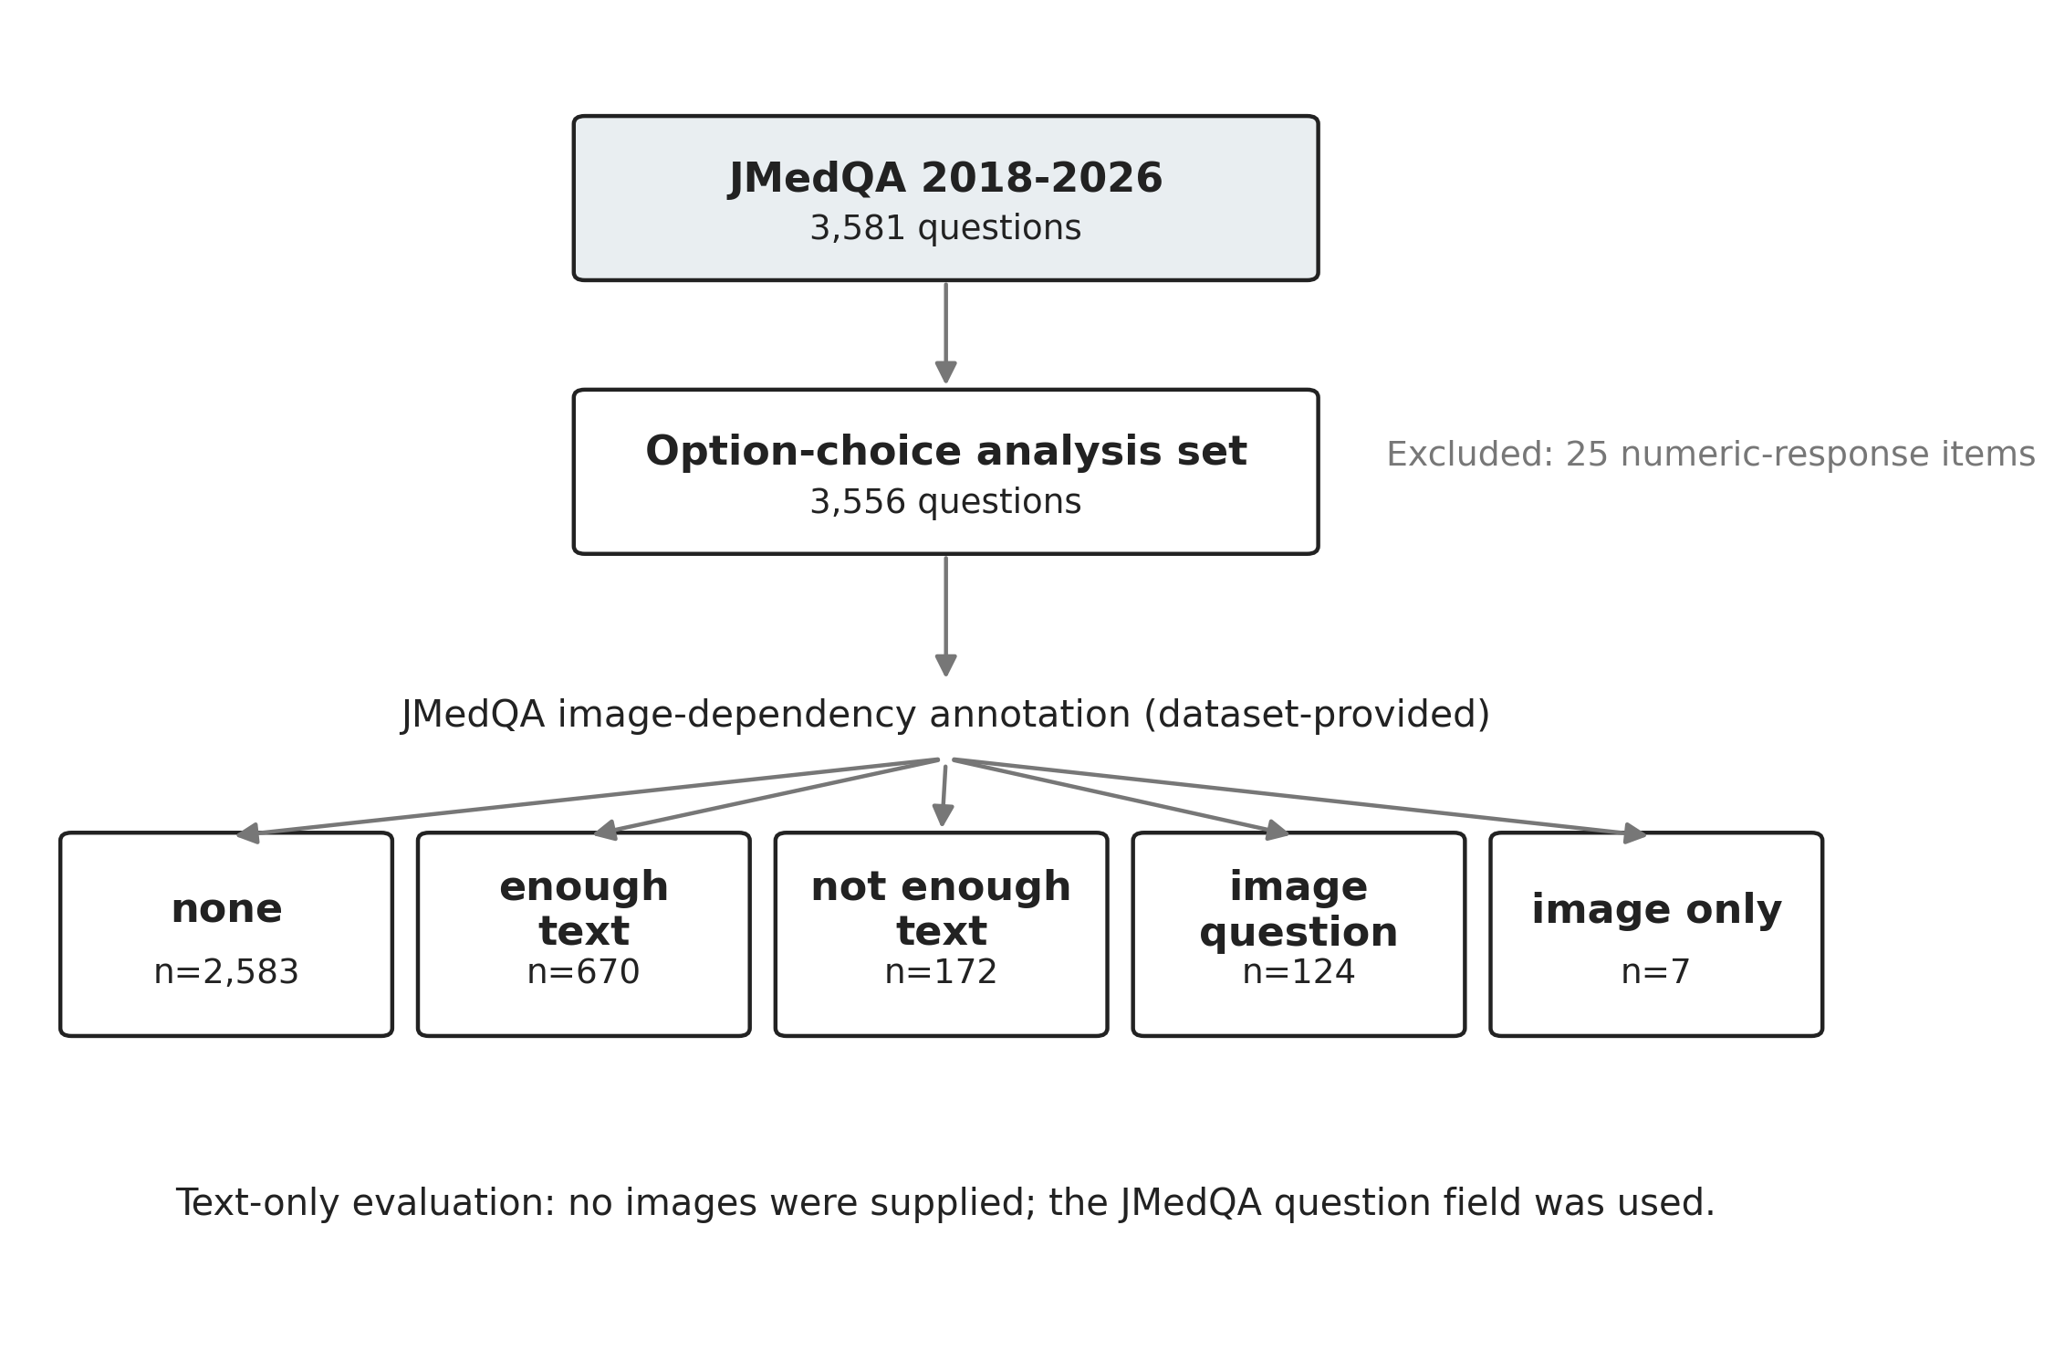
Figure 1. Study flow and JMedQA image-dependency strata. The labels are supplied by JMedQA and were not generated by the evaluated model. No images were provided during inference.

2.3 Model and inference
Inference used the fixed route typesafe/jev-1.13 through the OpenRouter Decisions API; the returned serving build was typesafe/jev-1.13-20260917. No role prompting, chain-of-thought request, few-shot example, retrieval, or external medical reference material was supplied. Each response record stored the selected option, per-option probabilities, model/build metadata, token usage, recorded cost, and wall-clock latency.

2.4 Scoring and probability analyses
Single-answer questions were scored by the highest-probability option. For multiple-answer questions, the prespecified number k of gold answers was selected by ranking Choice probabilities and taking the top k; exact set equality was required. Because the Choice distribution is mutually exclusive rather than a calibrated multilabel distribution, probability-quality analyses were restricted to single-select items.
For single-select items, we calculated negative log loss, multiclass Brier score, 10-bin expected calibration error (ECE), AUROC of top-choice probability for correctness, and risk-coverage curves. To reduce optimism from selecting a confidence threshold on the same observations used to report performance, we performed a 5-fold sensitivity analysis: in each fold, the lowest threshold yielding at least 99% accepted-item accuracy was selected on the remaining four folds and then applied to the held-out fold. This was an internal sensitivity analysis, not external validation.

2.5 Statistical analysis and examination reconstruction
Accuracy confidence intervals used the Wilson method. Differences between nonpaired item groups used Newcombe intervals and chi-square or Fisher exact tests as appropriate. Latency distributions were compared with the Mann-Whitney U test. Annual trend was explored with Spearman rank correlation across yearly aggregate accuracies. Published Ministry of Health, Labour and Welfare score thresholds were used for conservative exam-by-exam reconstruction. Formal pass/fail was not asserted because contraindicated-choice identities are not public and some numeric-response or officially adjusted items could not be reproduced identically.

2.6 Ethics, transparency, and reproducibility
The study used public examination-derived material and no patient or research-participant data; institutional review board review was therefore not sought. Code, derived result files, statistical scripts, environment information, and manuscript materials are available from the project repository. Examination question text and images are not redistributed.

3. Results

3.1 Overall performance and operational measurements
Jev answered 3,150 of 3,556 option-choice items correctly (88.58%; 95% CI, 87.50%-89.59%). Median API wall-clock latency was 820.7 ms and p95 latency was 1,061.0 ms. The run recorded 2,858,460 input tokens and a total API cost of US$0.120. These are gateway-level measurements and should not be interpreted as model-only inference latency or underlying compute cost.
Table 1. Primary benchmark outcomes
Condition | n | Correct | Accuracy (95% CI) | Median latency
All option-choice | 3,556 | 3,150 | 88.58% (87.50-89.59) | 820.7 ms
No image reference | 2,582 | 2,369 | 91.75% (90.63-92.75) | 820.3 ms
Image referenced; image withheld | 974 | 781 | 80.18% (77.57-82.57) | 822.6 ms
The binary image-presence grouping and the annotation-based image_dependency grouping are not identical. One item (2023C074) was classified as image-referenced by the metadata-based helper because auxiliary image metadata were present, although its JMedQA image_dependency label was none. Therefore, the binary no-image group contained 2,582 items, whereas the annotation-based none stratum contained 2,583 items. This does not alter the overall benchmark denominator or the annotation-stratified results.

3.2 Performance tracked information sufficiency
The binary image-referenced group was 11.57 percentage points lower than the no-image-reference group (95% CI, -14.28 to -8.85; P<.001), but these were different questions and this contrast is descriptive rather than causal. The JMedQA image_dependency strata provide the more interpretable result: none and enough text had nearly identical accuracy (91.75% vs 92.09%; difference, +0.34 percentage points; 95% CI, -2.16 to +2.47), whereas performance dropped to 59.30% for not enough text and 49.19% for image question. The seven image only items were all incorrect, but that stratum was too small for a stable estimate.
This pattern is important because "enough text" and "not enough text" are not labels created after observing Jev performance. They are JMedQA annotations describing whether the question text itself contains enough information for a text-only model. The observed gradient is therefore consistent with a simple interpretation: the model performed well when the necessary evidence was present in the input and degraded when the missing modality contained task-relevant evidence.
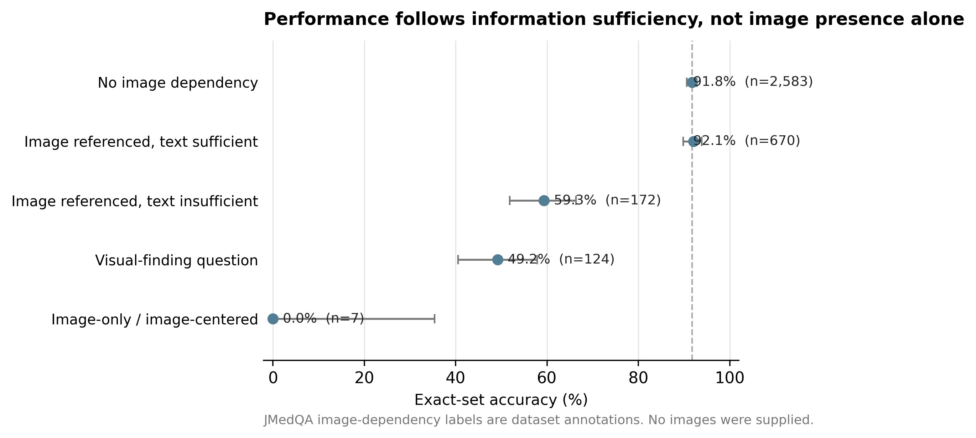
Figure 2. Exact-set accuracy by JMedQA image_dependency annotation. Error bars are Wilson 95% confidence intervals. The near-overlap of none and enough text is the key contrast; performance drops when the dataset annotation indicates that text alone is insufficient.
Table 2. JMedQA image-dependency taxonomy and observed performance
JMedQA label | Dataset definition | n | Accuracy
none | No image dependency | 2,583 | 91.75%
enough text | Image referenced; text is sufficient | 670 | 92.09%
not enough text | Image referenced; text alone is insufficient | 172 | 59.30%
image question | Visual finding / interpretation explicitly required | 124 | 49.19%
image only | Question is primarily an image reference | 7 | 0.00%

3.3 Native probabilities supported selective deferral
Among 3,097 single-select items, accuracy was 88.89%. Top-choice probability discriminated correct from incorrect answers with AUROC 0.918; 10-bin ECE was 0.014, negative log loss 0.366, and multiclass Brier score 0.157. We do not interpret ECE alone as proof of calibration.
Retrospectively, a top-choice probability threshold of 0.90 accepted 68.5% of single-select items with 99.01% accuracy. In the 5-fold held-out sensitivity analysis, thresholds of 0.90 or 0.92 selected on calibration folds accepted 2,093 of 3,097 held-out items in aggregate (67.6% coverage), of which 2,072 were correct (99.00%). This reduces, but does not eliminate, optimism from post hoc threshold selection and does not establish a clinical safety guarantee.
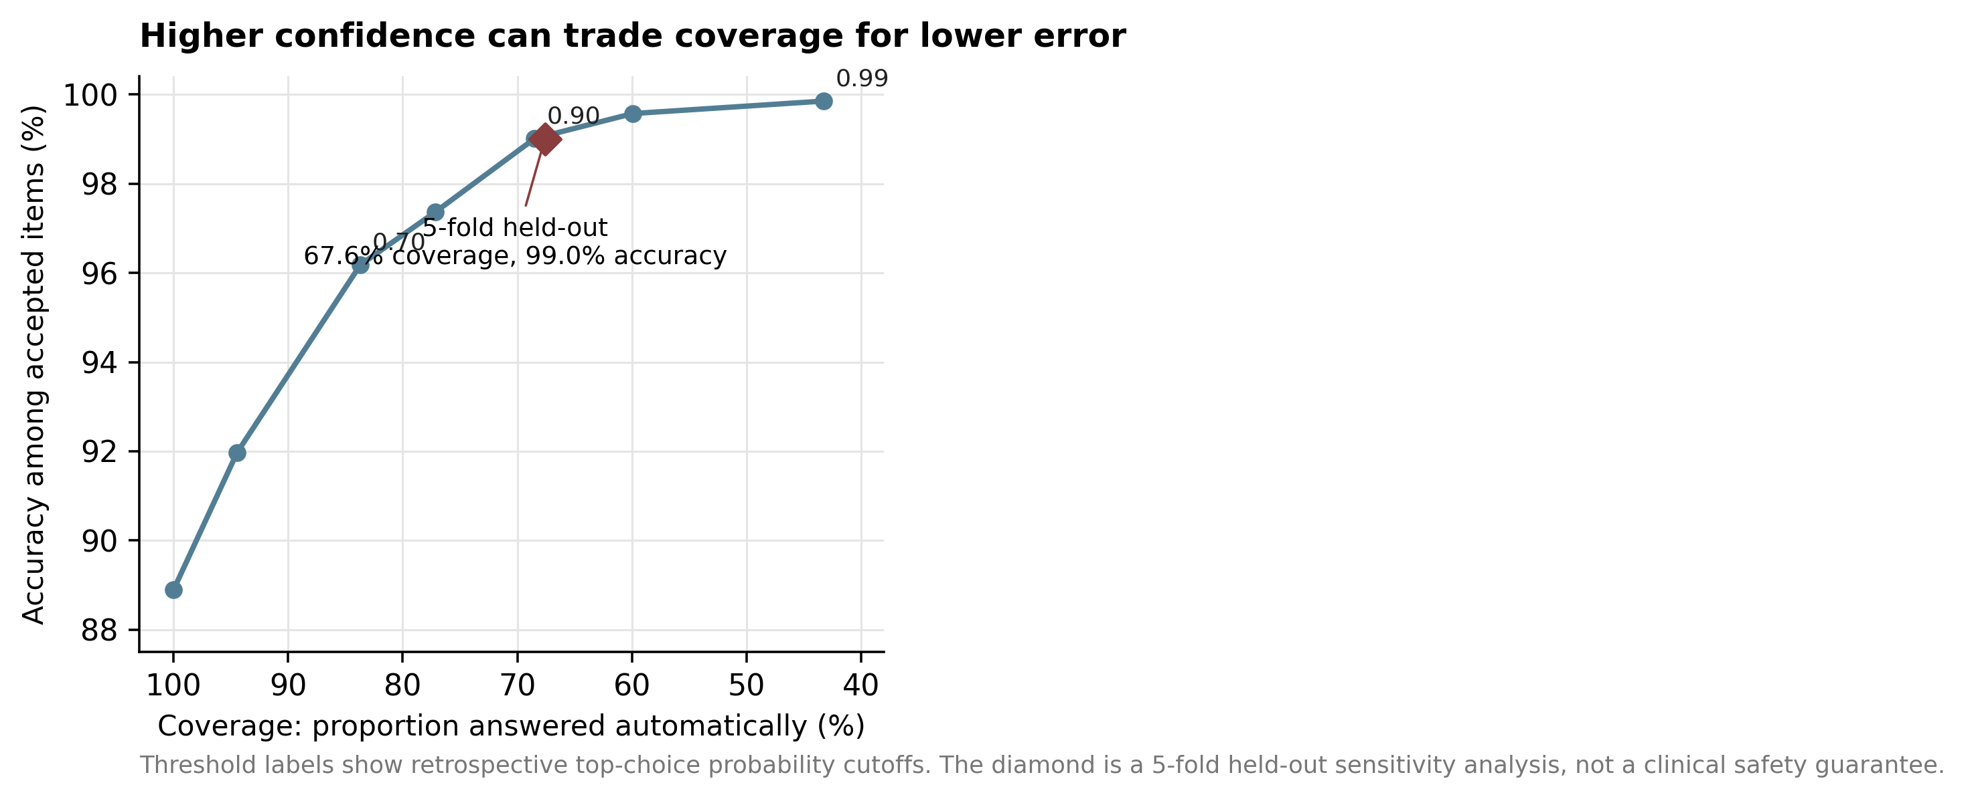
Figure 3. Risk-coverage trade-off for single-select questions. Raising the confidence threshold decreases the proportion of items answered automatically while increasing accuracy among accepted items. The diamond summarizes the 5-fold held-out sensitivity analysis.

3.4 Performance was broadly stable across examination years
Annual exact-set accuracy ranged from 85.68% on the 115th examination to 90.91% on the 118th examination. A monotonic trend across the nine annual aggregates was not statistically demonstrated (Spearman rho=0.533; P=.139). Because Jev is a closed model and historical JMLE items are public, this absence of a trend does not rule out training-data contamination.
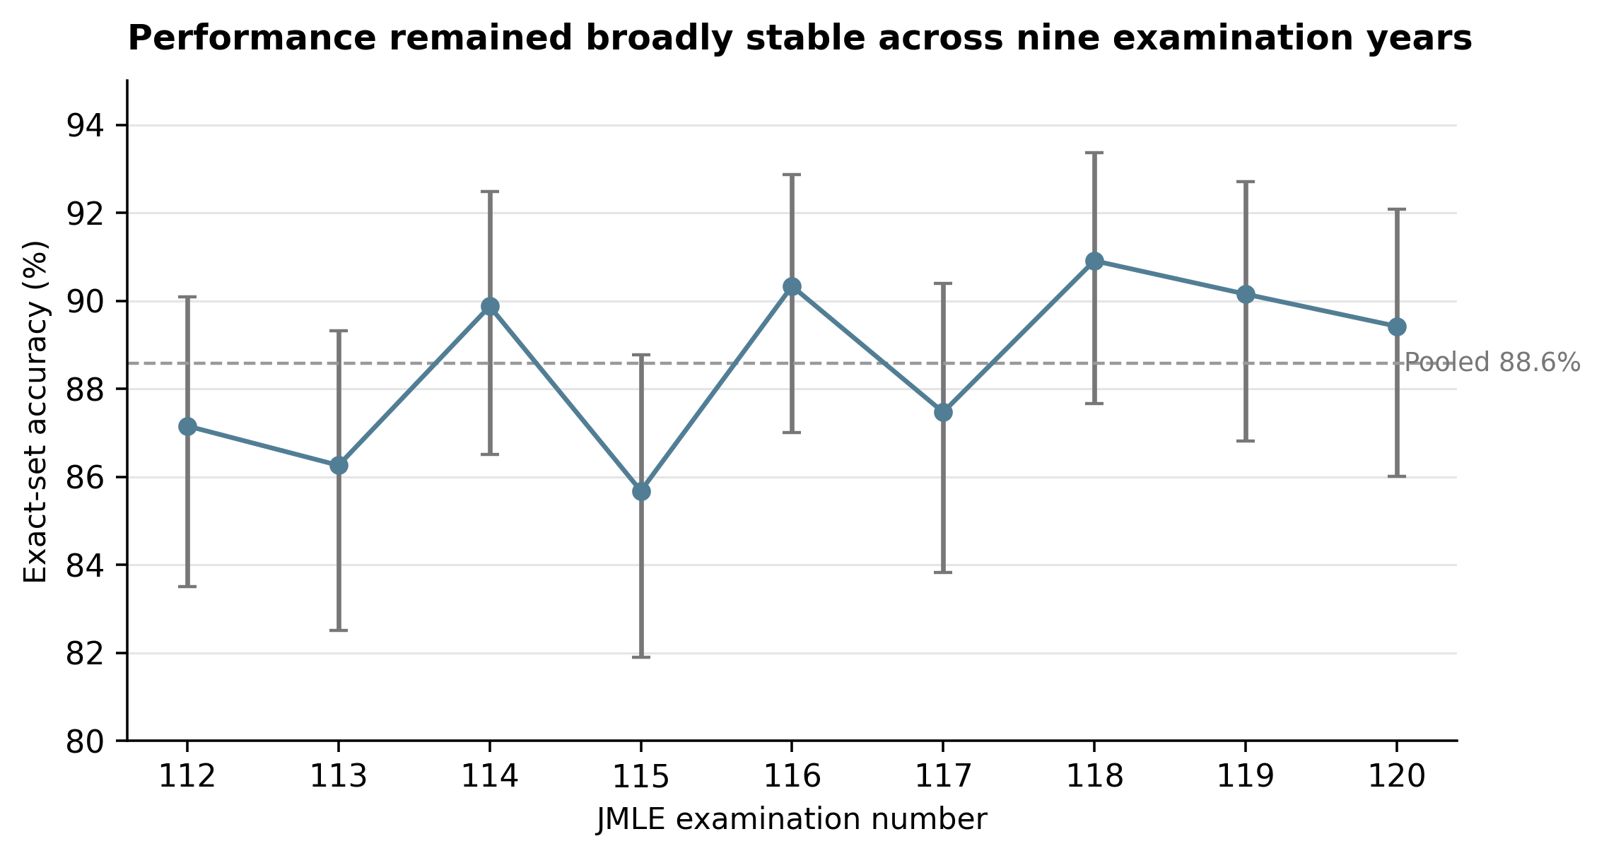
Figure 4. Year-by-year exact-set accuracy with Wilson 95% confidence intervals. The dashed line is the pooled nine-year accuracy.

3.5 Conservative official-score reconstruction
For each 112th-120th examination, the conservative lower bound of the reconstructed required-section and general/clinical scores exceeded that year's published score threshold. This supports the narrow statement that published score cutoffs were exceeded under the reconstruction. It does not support the statement that Jev formally passed the JMLE, because contraindicated-choice identities are undisclosed and non-option or officially adjusted items cannot be reproduced identically.

4. Discussion

4.1 The central result is information sufficiency, not examination passing
The clearest finding is that benchmark performance followed whether the input contained the information needed for the task. Image association by itself did not reduce performance: questions annotated by JMedQA as image-associated but answerable from text were solved at essentially the same rate as questions with no image dependency. In contrast, performance fell sharply when JMedQA annotated the text as insufficient or the task as requiring visual interpretation. This makes the result more informative than a simple "image versus no image" comparison.
This interpretation is deliberately narrower than a claim about model reasoning. Because the image-dependency labels were created by the dataset authors and the item groups were not paired counterfactual versions of the same question, the study cannot estimate the causal effect of removing an image. It can show, however, that performance stratified in the expected direction across an independently supplied taxonomy of text sufficiency. That pattern supports information availability as a practical boundary condition for this model interface.

4.2 Native probabilities are most useful as a routing signal
The second important finding is not that Jev knows when it is correct with certainty, but that its native Choice probabilities contain useful error-ranking information. Correct and incorrect single-select answers were strongly separable by top-choice probability, and confidence gating produced a favorable risk-coverage trade-off. The held-out sensitivity analysis suggests that this signal is not solely an artifact of choosing one threshold on the full dataset, although prospective validation remains necessary.
These properties suggest a possible role for structured decision models as a first-stage router in systems where the task already has a constrained option set: high-confidence, information-complete cases could be handled cheaply, while low-confidence or information-incomplete cases are escalated to a larger generative model, a multimodal model, or a human. The present study does not test such an end-to-end architecture, so this should be understood as a design hypothesis generated by the benchmark rather than a deployment recommendation.

4.3 Relation to prior medical-exam studies
Prior work has already shown passing or high JMLE performance for GPT-4 and GPT-4o [1,2]. The present study should not be interpreted as a rank-order comparison with those systems because the evaluated years, prompts, modalities, and model classes differ. Its contribution is instead the joint characterization of nine-year performance, dataset-defined information sufficiency, native option probabilities, selective prediction, and API-level latency and cost.

4.4 Why these results do not establish clinical competence
A licensing examination is a static, closed-ended task. Clinical work requires active information gathering, generation and revision of differential diagnoses, treatment planning, communication, documentation, and adaptation to evolving patient states [6,7]. An 88.6% examination accuracy therefore cannot be translated into an 88.6% rate of correct clinical decisions. The selective-prediction result likewise does not establish a safe clinical threshold.

4.5 Adversarial interpretation and strongest threats to validity
Training-data contamination. JMLE questions are public and Jev is closed; memorization cannot be excluded. The absence of a recent-year performance decline is not evidence that contamination is absent.
Multiple-answer semantics. Top-k ranking of a mutually exclusive Choice distribution is a heuristic for multilabel questions. Calibration claims were therefore restricted to single-select items, and an independent per-option binary sensitivity analysis remains desirable.
No matched generative baseline. The study measures absolute latency, cost, and accuracy, but cannot establish comparative superiority over GPT-4o, GPT-5, Claude, or another model without identical-condition evaluation.
Single serving build and limited repeatability. A closed API may change over time. Repeated runs are needed to quantify answer stability and probability variance.
Internal validation of deferral. The 5-fold analysis is stronger than a single in-sample threshold but remains internal. A prospective, prespecified threshold on unseen or embargoed items is required before operational claims.

4.6 Next decisive experiment
The most informative next study is not another larger retrospective JMLE run. It is a prospective routing experiment on newly authored or embargoed items: predefine a calibration set and confidence threshold, route low-confidence or modality-incomplete cases to a larger multimodal model or clinician, and compare end-to-end accuracy, residual error, latency, and cost against an "always use the large model" strategy. Such an experiment would directly test the practical hypothesis generated here.

5. Limitations
This study evaluated one closed model build at one time point; training data are unknown; contamination by public examination material cannot be excluded; image-dependency groups were not paired; no images were supplied; JMedQA annotations and extraction may contain residual errors; multi-answer top-k scoring has a semantic limitation; no identical-condition generative baseline was included; repeated inference was limited; selective prediction was internally rather than prospectively validated; and formal pass/fail could not be determined because contraindicated-choice identities are not public.

6. Conclusions
Across nine years of JMLE-derived option-choice questions, Jev achieved high benchmark accuracy with subsecond median API wall-clock latency and very low recorded API cost. The more informative result was the boundary condition: performance was preserved when text contained sufficient information, even for image-associated questions, and deteriorated when task-relevant visual information was absent. Native option probabilities also supported selective deferral of uncertain single-select items. Together, these findings motivate further study of low-cost structured decision layers as routers within larger decision systems, not as autonomous clinical agents.

Declarations
Funding: This research received no external funding.
Competing interests: The author declares no competing interests with TypeSafe, OpenRouter, JMedQA developers, or other relevant entities.
Data and code availability: Code, derived result files, statistical scripts, environment information, and manuscript materials are available at https://github.com/kokuren333/jev-jmle-benchmark. Examination question text and images are not redistributed; users should obtain JMedQA from its original source and follow the applicable terms of use.
Generative AI disclosure: Generative AI tools were used to assist code development, statistical workflow design, literature discovery, language editing, figure redesign, and manuscript drafting. The author reviewed the analyses, numerical results, references, interpretations, and final manuscript and assumes full responsibility for the work.
Author contributions: Ren Matsushita: Conceptualization, Methodology, Software, Formal Analysis, Investigation, Visualization, Writing - Original Draft, Writing - Review & Editing.

References
1. Tanaka Y, Nakata T, Aiga K, et al. Performance of Generative Pretrained Transformer on the National Medical Licensing Examination in Japan. PLOS Digital Health. 2024;3(1):e0000433. doi:10.1371/journal.pdig.0000433.
2. Miyazaki Y, Hata M, Omori H, et al. Performance of ChatGPT-4o on the Japanese Medical Licensing Examination: Evaluation of Accuracy in Text-Only and Image-Based Questions. JMIR Medical Education. 2024;10:e63129. doi:10.2196/63129.
3. Yamagishi Y, Kobayashi K, Shibaki R, Aizawa A, Kurohashi S. JMedQA: Benchmarking Large Language Models and Vision-Language Models on the Japanese Medical Licensing Examination. Hugging Face dataset. 2026. https://huggingface.co/datasets/SIP-med-LLM/JMedQA. Accessed June 25, 2026.
4. Singhal K, Azizi S, Tu T, et al. Large language models encode clinical knowledge. Nature. 2023;620:172-180. doi:10.1038/s41586-023-06291-2.
5. Bentegeac R, Le Guellec B, Kuchcinski G, Amouyel P, Hamroun A. Token Probabilities to Mitigate Large Language Models Overconfidence in Answering Medical Questions: Quantitative Study. J Med Internet Res. 2025;27:e64348. doi:10.2196/64348.
6. Bedi S, Cui H, Fuentes M, et al. Holistic evaluation of large language models for medical tasks with MedHELM. Nature Medicine. 2026;32:943-951. doi:10.1038/s41591-025-04151-2.
7. OpenAI. HealthBench: An evaluation for AI systems and human health. 2025.
8. McCoy LG, Swamy R, Sagar N, et al. Do Language Models Think Like Doctors? medRxiv. 2025. doi:10.1101/2025.02.11.25321822.
9. Large language model uncertainty proxies: discrimination and calibration for medical diagnosis and treatment. 2024. PMCID: PMC11648734.
10. Ministry of Health, Labour and Welfare, Japan. Official passing criteria and answer keys for the 112th-120th Japanese Medical Licensing Examinations, 2018-2026.
11. TypeSafe / Jev API documentation. Jev Choice API. Accessed September 2026.
12. OpenRouter. TypeSafe: Jev 1.13 model page. Accessed September 2026.

