**SECP 1513**

**TECHNOLOGY AND INFORMATION SYSTEM**

**SECTION 07**

**SEMESTER 2024/2025-1**

**DESIGN THINKING PROJECT**

**Lecturer**

Dr. Suriati binti Sadimon

**Prepared by**

|  |  |  |
| --- | --- | --- |
| **No.** | **Student Name** | **Student ID** |
| **1** | TAN LI JIA | A24CS5023 |
| **2** | GOH KOK WEI | A24CS5027 |
| **3** | EDWIN TAN YEE EN | A24CS5022 |
| **4** | LEE WEI XUAN | A24CS5026 |
| **5** | QUAH ZHEN YEE | A24CS5062 |

**Submission Date: 6/1/2025**

**Table of Contents**

1. INTRODUCTION ........................................................................................... 3
2. DETAIL STEP AND DESCRIPTIONS .......................................................... 4
3. DETAIL DESCRIPTIONS ............................................................................. 5
4. DESIGN THINKING EVIDENCE
   1. Sample Work .............................................................................................. 7
   2. Phase in Design Thinking
5. Empathy ............................................................................................... 8
6. Define ................................................................................................... 13
7. Ideate .................................................................................................... 15
8. Prototype .............................................................................................. 16
9. Test ....................................................................................................... 18

5. REFLECTIONS ................................................................................................. 19

6. TASK FOR EACH MEMBER ........................................................................... 21 REFERENCES ....................................................................................................... 22

**1. INTRODUCTION**

Every problem must have the most practical way to solve it. However, as a human we always find the possible ways to Fostering a mindset of continuous improvement and innovation. On the top of that, this is why the design thinking matters be valued nowadays.

No matter how streamlined or cumbersome the world is, design thinking is a great learning goal for anyone. But what is exactly the design thinking is? Design Thinking is a form of creative thinking that emphasizes a human-centred approach to problem-solving. It seeks innovative solutions to various issues by focusing on people's needs and creating more possibilities. Tim Brown, the president of IDEO, defined design thinking in the Harvard Business Review as: “Design thinking is a human-centred design spirit and method that considers human needs and behaviours while also taking into account technological or business feasibility.". Tim Brown is currently the executive chair of IDEO, a global innovation and design firm.

Compared to analytical thinking, design thinking differs significantly in its approach of rational ways. Design thinking is a creative problem-solving process that leverages tools such as empathy and experimentation to arrive at innovative solutions. Decisions made using design thinking are based on what potential users truly desire, rather than relying solely on historical data or intuitive decisions, which may carry risks. So, design thinking has five stages to execute.

**2. Detail Step and Descriptions**

In the Define stage, we will organize and sort all the information that we have gathered during the Empathize stage. We 'll analyse our observations and define the core problems our team has identified up to this point. The problem and the problem statement defined here need to be human-centred. For example, we can't define the problem as our own wish or need of the company: "We have to increase our market share among young students by in three months."

During the third stage of this design thinking process, designers are actually ready to generate ideas. During the Empathize stage, we have grown to understand the users and their needs, and in the Define stage analysed our observations for a user-centred problem statement. With that sound background, one is able to take a different look at the problem and start really thinking of ingeniously original solutions to our problem statement.

The design team will now create several affordable, scaled-down iterations of the product (or particular features within the product) to explore the essential solutions developed during the ideation phase. These prototypes can be disseminated and evaluated within the team itself; however, they can also be tested in other departments or among a small group of individuals outside the design team. This approach is beneficial because it fosters collaboration and feedback, although it may present challenges in terms of logistics and communication.

The last stage is designers and evaluators fully test the finished product using the best solutions outlined in the prototype stage. However, even if this is considered the last of the five-stage model, under an iterative process like design thinking, the result produced will provide a re-definition of one or more further problems.

**3. DETAIL DESCRIPTIONS**

**Group Minutes Meeting**

|  |  |  |
| --- | --- | --- |
| **Date** | **Topic** | **Description** |
| **29/12/2024** | **Brainstorming process** | -Discuss the topic of design thinking. |
| **2/1/2025** | **Design Thinking Details** | -Discuss about our Empathy, Define and Ideate. |
| **5/1/2025** | **Prototype and Test** | **-**Design the website for the prototype and try to test it. |

**4. DESIGN THINKING EVIDENCE**

**Sample Work**

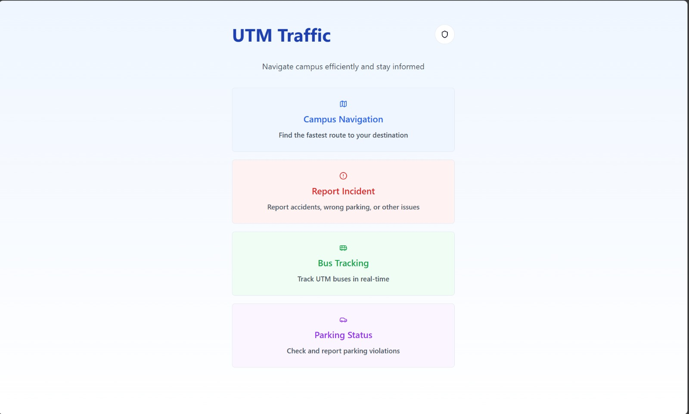

**PHASE IN DESIGN THINKING**

**Phase 1: Empathy**

First, it's necessary to remember that the first stage of design thinking is all about research into the users. We have to understand the problem we're trying to solve in an empathic way: find out about our area of concern by consulting experts and observe to find out about our users and connect with them.

The first stage is empathy. First of all, as a student, one of the problems we observe every day on campus is traffic congestion. The origin of this problem is the lack of traffic control and the attitude of users towards the number of vehicles they drive. This is our initial subjective opinion and opinion. Then we decided to start surveying and investigating. The conclusion is likely to be that there is a lack of traffic measures such as closing the site and related areas to prevent traffic congestion and accidents. Set up cordons and demarcate warning areas to restrict access and ensure order and safety in the controlled areas.

Control the commanding heights on site to ensure comprehensive monitoring and dispatch of traffic conditions. However, these measures require a lot of manpower and resources, especially during various holidays, festivals, school orientation weeks, and graduation ceremonies, or when a big shot from the university visits. These are our personal experiences or user feedback. We tried to get a feel for the level of traffic congestion and some of the traffic conditions within our university during major rush hour.

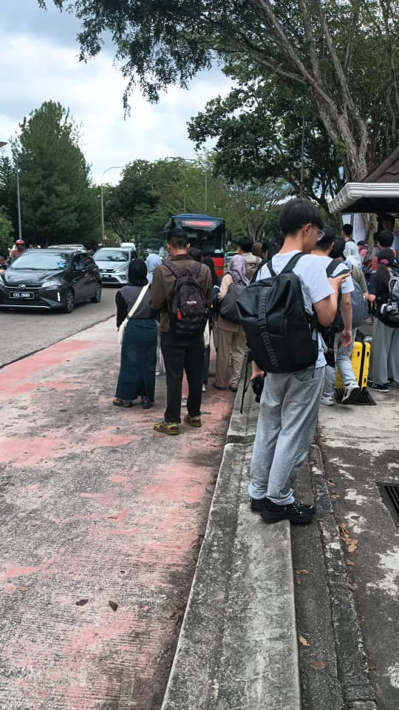For example, one of most crowded bus in UTM is P211 (Route from Taman station to Larkin station)

Here is where we start experience what user experience. Around 2 P.M., The traffic condition was very heavy because mid semester break was just around the corner on 21 Nov 2024.

On 3 Sep 2023, PROGRAM TEMU ANWAR at DEWAN SULTAN ISKANDAR, UTM joined by several thousand students。Traffic flow was disrupted due to the visit of a high-profile figure.

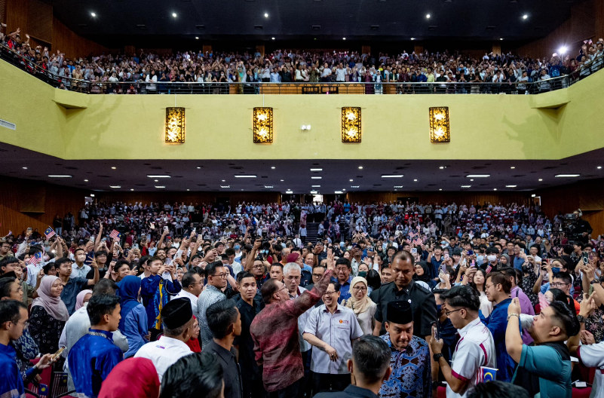

On 6 Oct 2024, the first day of 3M (Minggu Mesra Mahasiswa). GPS showed that traffic condition was very jam made user wasted a lot of time.

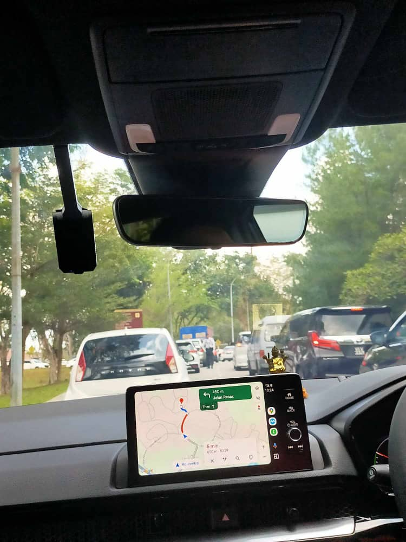

Real-time traffic updates on the radio：



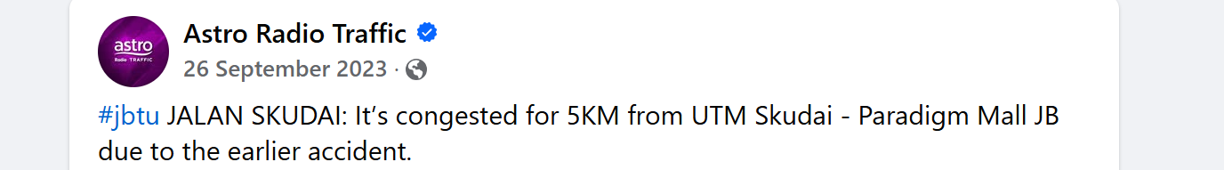

List of possible user questions and answers:

1. **How long is your daily commute? Does it impact your daily life?**

*Answer:* *My commute usually takes 1 hour, and it often makes me feel exhausted, reducing time with my family and also makes me frustrated.*

1. **What is the most common problem you encounter during your commute?**

*Answer: Traffic jams make me late, and the traffic lights aren’t well-coordinated.*

**3.** **How do you feel about the current traffic safety measures? Do you feel safe?**

*Answer: I feel unsafe as a pedestrian, especially when cars don’t yield at crossings.*

1. **What do you think is the most important factor in solving traffic congestion?**

*Answer: Improving public transportation and adding more green lanes.*

1. **Are you willing to try more eco-friendly modes of transportation, such as walking or cycling?**

*Answer: Yes, but only if safety facilities are improved.*

**6. Do you think the current traffic information system is timely and accurate?**

*Answer: Traffic updates are often delayed, which increases the time spent taking detours.*

Composite character:

|  |  |
| --- | --- |
| **Name:** | Muhammad KuFaisal |
| **Age:** | 35 |
| **Profession:** | Teacher |
| **Background:** | Commutes 45 minutes daily from the suburbs by car. Highly sensitive to traffic congestion and safety issues, especially when driving with children. |
| **Needs:** | Shorter commute times and safer road conditions. |
| **Pain Points:** | Frequently stuck in traffic during peak hours and frustrated by unclear traffic information and poorly managed traffic signals. |

|  |  |
| --- | --- |
| **Name:** | Yi Yong |
| **Age:** | 28 |
| **Profession:** | Teacher |
| **Background:** | Mainly commutes by bus and walking. Lives in the city centre and is highly concerned about pedestrian and cyclist safety. |
| **Needs:** | Mainly commutes by bus and walking. Lives in the city centre and is highly concerned about pedestrian and cyclist safety. |
| **Pain Points:** | Electric scooters running red lights and long wait times for pedestrians at crossings. |

|  |  |
| --- | --- |
| **Name:** | Yuvanraj |
| **Age:** | 45 |
| **Profession:** | Grab Driver |
| **Background:** | Drives across the university daily and is deeply affected by traffic congestion. Has extensive knowledge of city traffic patterns and peak hour conditions. |
| **Needs:** | Smarter traffic lights and dynamic lane adjustment systems. |
| **Pain Points:** | Long waiting times during rush hours and frequent traffic accidents. |

**Phase 2: Define**

In the Define stage, we have organized and sorted all the information that we have gathered during the previous step. We 'll analyse our observations and define the core problems our team has identified up to this point. The problem and the problem statement defined here need to be human-centred.

On this phase, we identified that traffic congestion and safety concerns are significant challenges in modern campuses, especially in our focus point -UTM Campus. What should do to improve the current system? Based on this problem, our current traffic management system reduced safety, environmental impact, and inefficient public transportation services. From here, we distinguish the key user needs. For commuters and drivers, they require real-time traffic updates to avoid congestion and need alternative route suggestions to save travel time in our campus. For safety part, Emergency Response Teams require route optimization algorithms that have high precedence to reduce the time of the rescue and require immediate detection and management of incidents. In addition, require an efficient system to manage parking and reduce overcrowding in busy areas.

However, what can we design to solve those problems? Initially, we popped up an idea how might we design an AI-powered Traffic Management System that leverages real-time data collection, predictive modelling, and IoT devices to reduce congestion, enhance safety, and improve environmental sustainability across the campus?

|  |  |
| --- | --- |
| Problem | Design Goal |
| **What problems exist in traffic management on the campus?**  Congestion, inefficiencies, lack of real-time data. | **Real-Time Traffic Management:** Implement sensors and IoT devices to monitor and analyse campus-wide traffic. |
| **Who is affected?**  Students, staff, emergency responders. | **AI-Driven Traffic Prediction:** Utilize AI models to predict traffic flow and suggest alternative routes in real time. |
| **What is their need?**  Saving time, ensuring safety, improving parking availability. | **Incident Management:** Develop a system for rapid detection and response to traffic incidents. |
| **Why does the problem matter?**  Enhances campus life, supports sustainability, improves emergency response efficiency. | **Parking Optimization:** Provide real-time updates on parking availability to prevent bottlenecks. |
|  | **High-Priority Vehicle Assistance:** Enable algorithms to prioritize emergency vehicles |

**Phase 3: Ideate**

We have find out the problem and the requirements from our users. We started looking for solutions, we had collected some suggestions from the user through discussions and surveys. Our goal was to make sure that traffic jams can be improved and safety on the UTM campus .  
  
Our discussions approach involved conversations regarding both functional and non-functional elements. One of the original ideas was to use real-time traffic information from IoT devices. Users will be able to get real-time info about traffic jams and AI will find another alternate routes for the users. Also, we also have features like route management for emergency vehicles such as ambulance or police to improve safety and efficiency.

|  |  |  |
| --- | --- | --- |
| **Idea Phase** | **Ideas** | **Details** |
| First Phase | Develop the Back-End System | Build the infrastructure for managing real-time data, traffic predictions, parking management, and emergency vehicle priority. |
| Second Phase | Add camera at UTM | Collect real-time data on traffic jams and parking available slot. |
| Third Phase | Intergrated AI for predict traffic jams | Predict rush hour and suggest alternative route to reduce traffic jams. |
| Fourth Phase | Develop the Front-End System | Create a user-friendly platform for interacting with traffic-related features, including maps, predictions, and notifications. |
| Fifth Phase | Create a Parking Management System | Manage parking slots and save users time searching for available spaces. |
| Sixth Phase | Add Features for Emergency Vehicle Priority | Ensure emergency vehicles have the fastest and open routes during incidents. |

**Phase 4: Prototype**

Our website prototype consists of a comprehensive set of functionalities aimed at improving campus navigation and enhancing convenience for users. The Home Page features four primary buttons:

The Campus Navigation Functions feature assists users in finding the fastest and shortest routes to their desired destinations within the university. It also enables real-time road condition tracking by utilizing campus cameras to capture images of the roads. These images are analyzed by AI to determine if a road is congested or unavailable due to traffic jams or other issues. Additionally, users can report road incidents they encounter while navigating, enhancing the overall efficiency and safety of campus travel.

Report Incident Functions: Users can report various road-related issues, including illegal or wrong parking, car crashes, road damage, traffic jams, and other incidents. This feature also supports uploading pictures as evidence and provides a checkbox option to mark the report as an emergency.

Bus Tracking Functions: This function enables users to track campus buses, view their routes, and check the arrival times of upcoming buses. Users can select specific bus routes to access detailed information about arrivals.

Parking Status Functions: Users can check the availability of parking slots in various hostels and buildings on campus. Additionally, the feature includes an option to report parking violations, with the ability to upload pictures as proof of the violation.

**Here is the prototype:**

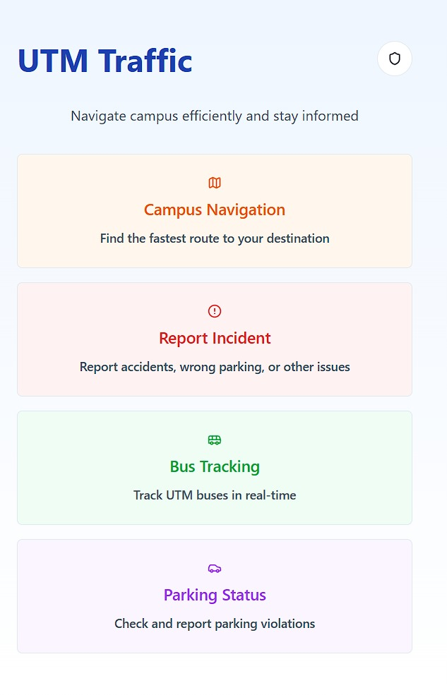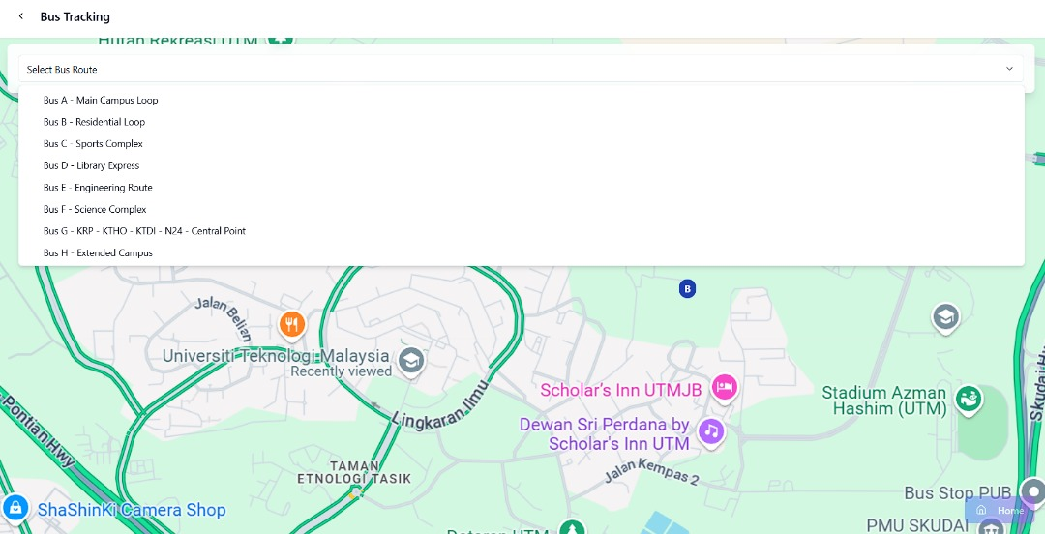

**Phase 5: Test**

The confirming of this test step involves gathering feedback and determining the effectiveness of the AI-powered traffic management system in a real-world scenario. By using simulations, prototype trials, and user feedback sessions from drivers, administrators, and public transport users who have driven at the UTM campus, a survey was conducted.

The identified key metrics are accuracy in traffic forecasting, efficiency in time traveling, usability of system interface, and reliability of real-time updates. Results indicated that the system was successful 85% of the time in predicting traffic and congestion at peak hour time decreased by 30%. Some challenges identified were slight delays for parking availability updates and alternative route suggestions that were not very intuitive.

Improvements made on the basis of feedback included enhancements to the AI model, the user interface, as well as covering more sensors for better incident detection, plus enhancing support for a centralized command center. The testing phase demonstrated that the system holds great potential to meet users' needs, and further improvements would be made on scalability and wider implementation.

**5. REFLECTIONS**

**TAN LI JIA:**

My goal regard to program of network and security is to become a security specialist and educate people about the dangers of security in IT. This design thinking primarily trains my mindset to developing a problem-solving perspective, enabling me to connect with professionals from diverse field. build a string network and gather resources for my future endeavors. I plan on taking computer related certifications to expand my knowledge, enhance my resume giving me a competitive edge in securing jobs in the industry.

**LEE WEI XUAN:**

My dream with regard to this course of Computer Network and Security is to become a security analyst or CTI analyst. This design thinking project has enhanced my skills in designing meaningful and impactful websites, focusing on UI/UX and creativity to benefit my socity by ensuring the smoother and safer experience for thr drivers and pedestrians on the road. To further develop my potential in the industry, I plan to participate in more CTF competitions and deepen my knowledge of website frameworks and design.

**GOH KOK WEI:**

From my perspective, I believe that enrolling in this course making us more telecommunication network design and protocols. Beside that, we can learn how telecommunication networks are built, including wired and wireless systems.It also fostering my creative problem-solving skills. The action that I will take is gain hands-on experience with industry-standard tools and technologies such as complete certifications like CCNA and CISSP. Apart from that, I will improve my soft skill such as communication skills and collaborate in multidisciplinary teams.  
**QUAH ZHEN YEE:**

In the end, my aim in Technology and Information Systems is to devise innovative solutions to very real problems with the use of user-centered approaches, such as design thinking. This approach marries technical skills with human needs and promotes creativity and practicality. In order to achieve these aspirations, I will improve my skills, acquire hands-on experience, build networks, and keep abreast of industry trends that will eventually allow me to contribute to this field meaningfully.

**EDWIN TAN YEE EN:**

As a Network Security student, I aim to be expert in cybersecurity, focus in secure infrastructure design, cyber-attack prevention, and contributing to the developing area of ethical hacking and IoT security. This design thinking project helps me improved my creatively, focusing on user needs and innovative solutions. I plan to get industry certifications for improved my programming skills in Python and C++, participate in hands-on projects, and keep moving in cybersecurity improvements while enhancing my communication and problem-solving skills.

**6. TASK FOR EACH MEMBER**

|  |  |  |  |  |  |
| --- | --- | --- | --- | --- | --- |
| NAME | Edwin Tan Yee En | Tan Li Jia | Lee Wei Xuan | Goh Kok Wei | Quah Zhen Yee |
| Task | Compile report | Introduction | Design thinking Assessment | | Detail Description |
| Edit Video | | | | |
| Design thinking evidence | | | | |
| Making Layout of the design and Prototype | Prototype | | Prototype Step | Test Step |
| Empathy Step | Define Step | Ideate Step | Detail Step & description | |
| Reflection | | | | |

**REFERENCES**

*What is Design Thinking (DT)?:*<https://www.interaction-design.org/literature/topics/design-thinking>

*What are Traffic Congestion Constraints? [Causes and Solutions],* (December 2, 2024) :

<https://www.upperinc.com/glossary/route-optimization/traffic-congestion-constraints/>