📡
IoT INTERNSHIP REPORT
Internet of Things — Device Communication, Simulation, Monitoring & Automation

Submitted by
Sohail Ahmed
✉ kolachisohailahmed55@gmail.com
Organization
DecideLab

Task 1 | Introduction to IoT & Device Communication
The Internet of Things (IoT) refers to a network of physical devices — sensors, actuators, and embedded systems — that connect, collect, and exchange data over the internet without requiring constant human involvement. This task focused on understanding the foundational concepts of IoT and how devices communicate with each other and with central systems.
Key Concepts Covered
● IoT Architecture: Perception layer (sensors/actuators), Network layer (connectivity), and Application layer (data processing & user interface).
● Device Communication Protocols: MQTT, HTTP, CoAP, and Bluetooth/Wi-Fi were studied as common methods for device-to-cloud and device-to-device communication.
● Sensors & Actuators: Devices such as temperature, humidity, and motion sensors gather real-world data, while actuators (fans, lights, relays) act on that data.
● Edge vs Cloud Processing: Understanding where data is processed — locally on the device (edge) or remotely on servers (cloud).
Why It Matters
A solid grasp of IoT fundamentals and communication protocols forms the base for every subsequent task in this internship — from simulating sensor data to building automation rules that react to real-world conditions.

Task 2 | Sensor Data Simulation
In this task, a Python script was used to simulate real-world IoT sensor readings — Temperature, Humidity, and Motion — since physical hardware was not directly connected. The simulation generated 10 sequential sensor readings and stored them for further analysis.
Simulation Output
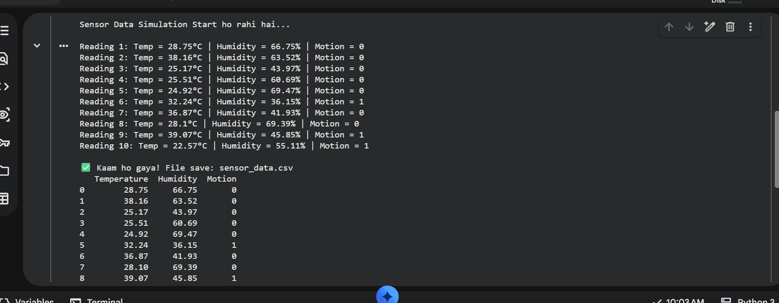
Fig 2.1 — Simulated sensor readings (Temperature, Humidity, Motion) and generated sensor_data.csv
Process Summary
● Random values were generated within realistic ranges: Temperature (22°C–39°C), Humidity (36%–70%), Motion (0 or 1).
● 10 readings were produced in sequence, each labeled 'Reading 1' through 'Reading 10'.
● The dataset was structured into a table with columns: Temperature, Humidity, and Motion.
● Results were exported and saved as sensor_data.csv for use in the dashboard and automation tasks.

Task 3 | IoT Data Monitoring Dashboard 📊
Using the simulated sensor data from Task 2, this task focused on visualizing the readings to make trends and anomalies easy to spot. Two line charts were created — one for Temperature and one for Humidity — plotted against the reading number.
Temperature Trend
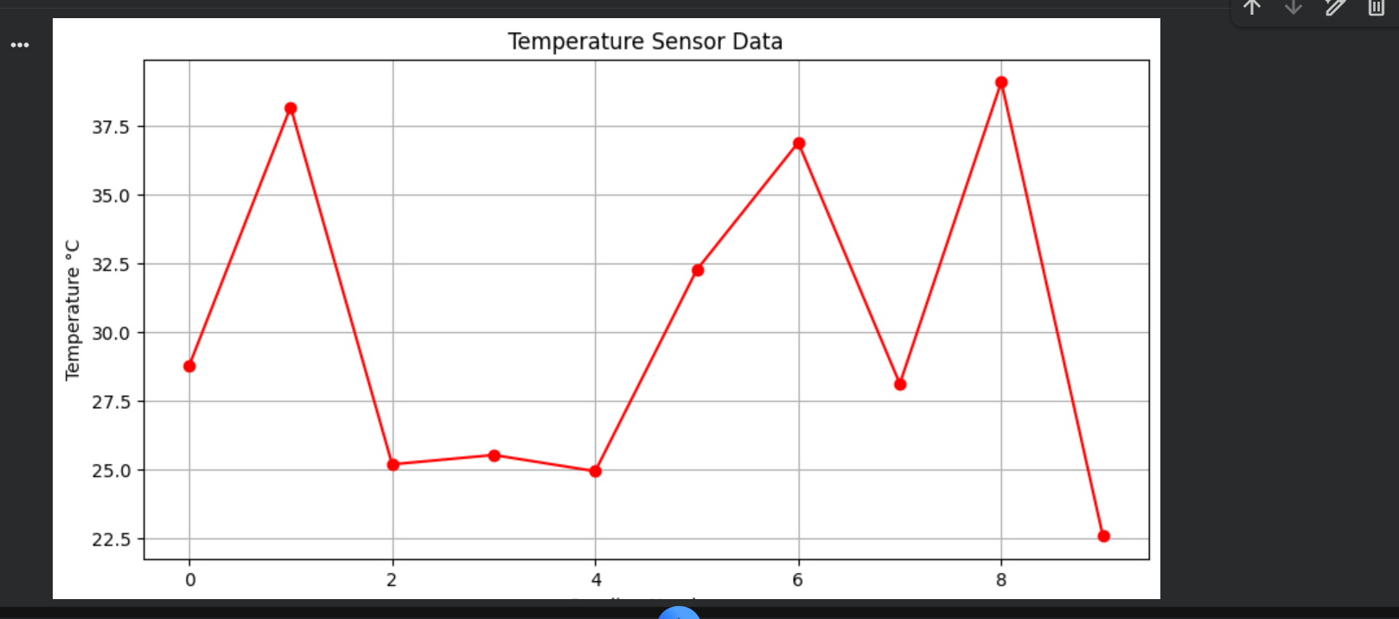
Fig 3.1 — Temperature sensor data across 10 readings, ranging from ~22.5°C to ~39°C
Humidity Trend
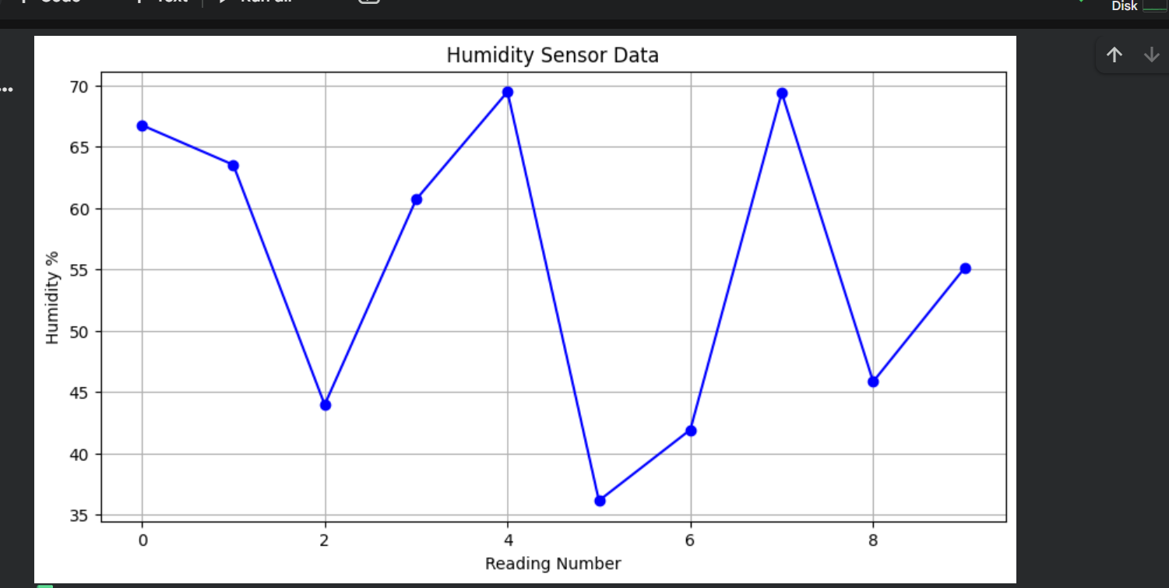
Fig 3.2 — Humidity sensor data across 10 readings, ranging from ~36% to ~70%
Observations
● Temperature spikes were observed at Reading 2, Reading 7, and Reading 9 — all above 36°C.
● Humidity dropped sharply at Reading 6 (36.15%), the lowest point in the dataset.
● Both charts confirm that sensor values fluctuate naturally, validating the need for automated alert logic.

Task 4 | IoT Automation Logic ⚙️
This final task applied rule-based automation logic to the sensor dataset. Each reading was evaluated against threshold conditions to trigger simulated device actions — mimicking how a real IoT system would respond automatically to environmental changes.
Automation Rules Applied
● If Temperature > 35°C → ALERT: Turn Fan ON.
● If Motion == 1 → Turn Light ON.
● Otherwise → Status remains Normal.
Execution Output
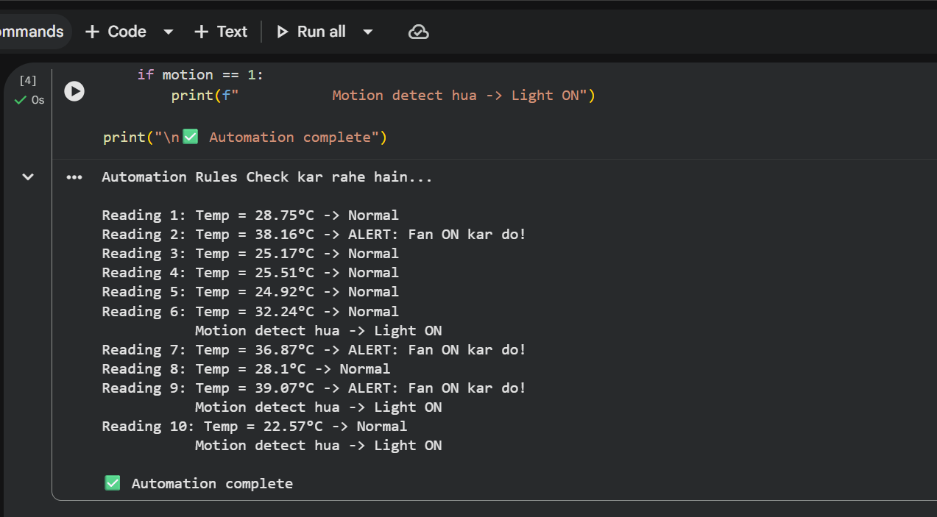
Fig 4.1 — Automation rules evaluated against all 10 readings with corresponding actions
Result Summary
Fan ON Alerts | Readings 2, 7, 9 (Temp > 35°C)
Light ON Triggers | Readings 6, 9, 10 (Motion = 1)
Normal Status | Readings 1, 3, 4, 5, 8
Outcome | Automation completed successfully for all 10 readings

Conclusion
Across these four tasks, the internship journey progressed from understanding core IoT concepts, to simulating realistic sensor data, visualizing that data on a monitoring dashboard, and finally applying automation logic that reacts to conditions in real time — mirroring the complete workflow of a functional IoT system.

