Department of Computer Science and Engineering
B.Tech III Semester Academic Year 2026-2027
Database Management Systems(2501IT05)
Capstone Project Documentation


ADITYA UNIVERSITY
Surampalem, Kakinada District Andhra Pradesh-533437


SCHOOL OF COMPUTING
Department of Computer Science and Engineering

CERTIFICATE

This is to certify that the Cornerstone project work entitled “University Academic Management Database Application” is submitted by
N.J.V.PRAVALLIKA | (25B11CS640)
R.NAVEENA | (25B21CS826)
K.HEMANTH | (26B21CS045)

in partial fulfillment of the requirements for the award of the B.Tech. degree in Computer Science and Engineering for the academic year 2026-2027.

Project Guide Head of the Department
Mrs. K Vydehi, M.Tech.,(Ph.D), Dr. Phani Sridhar Addepalli, Ph.D,
Assistant Professor, Assistant Professor,
Department of CSE Department of CSE

DECLARATION
We hereby declare that the Cornerstone project entitled “Pharmacy Management System” is original and is submitted to ADITYA UNIVERSITY, Surampalem, in partial fulfilment of the requirements for the award of the B.Tech. Degree in Computer Science and Engineering. We further declare that this project work has not been submitted, either in full or in part, for the award of any degree in this or any other institution. We also confirm that this work complies with the Institutional Academic Integrity and AI Usage Policy.
Place: Surampalem
Date: 30-09-2026
By
N.J.V.PRAVALLIKA | (25B11CS640)
R.NAVEENA | (25B11CS826)
K.HEMANTH | (26B21CS045)

ACKNOWLEDGEMENT
It is with immense pleasure that we express our sincere gratitude to our Cornerstone Project Guide, Mrs. K Vydehi, Assistant Professor, who has guided us throughout the project. Her valuable support, encouragement, and guidance have greatly contributed to the successful completion of this work.
We would like to thank our Deputy Heads of the Department, Dr. Chandra Sekhar Kolli, Associate Professor, Dr Hari Jyothula, Associate Professor and Dr Pennada Siva Satya Prasad, Assistant Professor, Department of Computer Science and Engineering, for their support and valuable suggestions.
Our deepest thanks to our Head of the Department Dr. Phani Sridhar Addepalli, Assistant Professor, for his inspiration and for providing all the necessary facilities and resources required for this project.
We also extend our sincere thanks to Dr. M.V. Rajesh, Associate Dean, School of Computing for their encouragement and support during the course of our project.
We would like to express our sincere gratitude to Dr. G. Suresh, Registrar, Dr. A Ramesh, Pro Vice-Chancellor (Engineering & Sciences), Dr. S. Rama Sree, Pro Vice-Chancellor (Academics), Dr. M.B. Srinivas, Vice-Chancellor, Dr. M. Sreenivasa Reddy, Deputy Pro Chancellor and Management, Aditya University for providing excellent infrastructure and state-of-the-art laboratories.
Finally, we would like to thank the faculty members, lab technicians, non-teaching staff, and our friends who have directly or indirectly supported us in completing this Cornerstone project successfully.

TABLE OF CONTENTS
1 | Cover Page | 1
2 | Certificate | 2
3 | Declaration | 3
4 | Acknowledgement | 4
5 | Table of Contents | 5
6 | Abstract | 6
7 | List of Figures | 7
7 | List of Tables | 7
8 | Abrevations | 8
9 | Introduction | 9
11 | System Analysis | 11
13 | Database Desgin | 13
18 | ER Diagram | 18
19 | Relational Schema | 19
20 | Table Desgin | 20
24 | Normalization | 24
28 | SQL Implemantation | 28
36 | SQL Queries & outputs | 36
43 | Conclusion | 43
43 | Future Enhancements | 43
44 | References | 5

ABSTRACT
The Pharmacy Management System is a database application designed to automate the day-to-day operations of a pharmacy through a centralized relational database. The system stores and manages information related to patients, doctors, hospitals, pharmacies, employees, medicines, suppliers, bills, and bill items. It tracks medicine stock, prices, manufacturers, and expiry dates, records the medicines supplied by suppliers, and generates itemized bills for every sale. The database minimizes redundancy, maintains data integrity through primary and foreign keys, and supports efficient retrieval of pharmacy information using SQL queries. The design is normalized up to Third Normal Form (3NF), which reduces update anomalies and improves consistency. The proposed system provides a structured foundation for inventory management, billing, supplier management, and pharmacy reporting.

LIST OF FIGURES

S.No | NAME
1 | ER Diagram of Pharmacy Management System
2 | Proposed Three-Layer Database Application Architecture
3 | Patient and Doctor Management Screen – Placeholder
4 | Medicine Inventory Screen – Placeholder
5 | Billing Screen – Placeholder
6 | Report Generation Screen – Placeholder

LIST OF TABLES
S.No | NAME
1 | Major Database Entities
2 | Relationships and Cardinalities
3 | Hospital Table Structure
4 | Doctor Table Structure
5 | Patient Table Structure
6 | Pharmacy Table Structure
7 | Employee Table Structure
8 | Medicine Table Structure
9 | Supplier Table Structure
10 | Bill Table Structure
11 | Bill_Item Table Structure
12 | Junction Tables (Consults, Sells, Supplies)
13 | Keys and Constraints
14 | Sample Data Records
33 | Sample Data – Patient Table
34 | Sample Data – Medicine Table
35 | Sample Data – Supplier Table
36 | Sample Data – Bill Table
37 | Sample Data – Bill_Item Table

ABREVATIONS
- DBMS – Database Management System
- ER – Entity Relationship
- SQL – Structured Query Language
- DDL – Data Definition Language
- DML – Data Manipulation Language
- DQL – Data Query Language
- DCL – Data Control Language
- TCL – Transaction Control Language
- PK – Primary Key
- FK – Foreign Key
- 1NF – First Normal Form
- 2NF – Second Normal Form
- 3NF – Third Normal Form

1. INTRODUCTION

1.1 Brief Information about the Project
A Pharmacy Management System is a database application that manages the medicines, sales, staff, and supplies of a pharmacy. The project provides a centralized relational database for patients, doctors, hospitals, pharmacies, employees, medicines, suppliers, bills, and bill items. It is intended to replace paper registers and scattered spreadsheet files with a structured database that supports accurate stock records, quick billing, and efficient retrieval of information.

1.2 Motivation and Contribution of Project
The project is motivated by common problems in pharmacy operations such as manual billing errors, poor tracking of stock levels, medicines expiring unnoticed, difficulty in tracing suppliers, and time-consuming searches through paper records. A centralized database provides a systematic approach to storing related pharmacy data and enforcing relationships through keys and constraints.
- Centralizing pharmacy, medicine, billing, and supplier records in one relational database.
- Tracking medicine quantity, price, and expiry date accurately.
- Maintaining referential integrity using primary and foreign keys.
- Generating itemized bills with discounts and payment modes.
- Providing a foundation for patient, doctor, employee, and supplier management.

1.3 Objectives of the Project
- Develop a centralized pharmacy database.
- Maintain patient and doctor information.
- Store hospital and pharmacy details.
- Record employee details and salaries.
- Manage the medicine inventory including price, quantity, and expiry date.
- Maintain supplier details and the medicines supplied to each pharmacy.
- Generate bills and bill items for every sale.

- Reduce duplicate data and update anomalies.
- Support efficient SQL queries and pharmacy reports.

1.4 Scope of the Project
The scope covers database-oriented management of pharmacy operations. The core scope includes patient, doctor, hospital, pharmacy, employee, medicine, supplier, bill, and bill item data. The database can be used as the backend for a pharmacy billing application and can be extended later with prescription management, stock reorder alerts, online ordering, insurance claims, and web/mobile interfaces.

2. SYSTEM ANALYSIS

2.1 Problem Statement and Existing System
Table 1: Problem Statement
Item | Description
Problem Statement | A pharmacy handles a large amount of information related to medicines, patients, doctors, suppliers, employees, purchases, sales, and billing. Therefore, there is a need for a computerized Pharmacy Management System to store, organize, and manage pharmacy data efficiently.

Table 2: Problems in the Existing System
S.No | Problems in the Existing System
1 | Manual maintenance of records takes more time.
2 | Difficult to track available medicine stock.
3 | Expired medicines may not be identified easily.
4 | Data may be duplicated or lost.

2.2 Proposed System
The proposed system uses a centralized relational database. It organizes pharmacy information into related tables and uses primary keys, foreign keys, uniqueness rules, NOT NULL conditions, and CHECK constraints where appropriate. The system supports patient, doctor, hospital, pharmacy, employee, medicine, supplier, and billing management.
- Centralized database
- Patient and doctor management
- Medicine inventory management
- Supplier management
- Employee management
- Billing and bill item processing
- SQL-based reporting
- Referential integrity

2.3 Functional Requirements
Module | Functional Requirement
Patient Management | Add, update, search, and display patient details.
Doctor and Hospital Management | Store doctor and hospital details and record the hospital where each doctor works.
Pharmacy Management | Maintain pharmacy (store) details and link each pharmacy to its associated hospital.
Employee Management | Store employee details and salary and associate employees with a pharmacy.
Medicine Management | Maintain medicine name, manufacturer, price, quantity, and expiry date.
Supplier Management | Store supplier details, quoted prices, and the pharmacies they supply.
Billing | Generate bills for each pharmacy and record the items, quantity, unit price, and discount.
Search and Reporting | Retrieve patient, medicine, stock, supplier, and sales information using SQL queries.

2.4 Non-Functional Requirements
- Performance – queries should return results efficiently for normal pharmacy workloads.
- Integrity – invalid references and duplicate key values should be prevented.
- Security – database privileges should be controlled for pharmacy staff and administrators.
- Usability – billing forms and reports should be easy to understand and use.
- Reliability – transactions should preserve a consistent database state, especially for stock and billing.
- Scalability – the design should support growth in medicines, bills, and pharmacy branches.

2.5 Requirements Specification
Category | Requirement
Hardware | Intel i3 or above; 4 GB RAM minimum; adequate storage; standard display and keyboard/mouse.
Operating System | Windows 10/11 or an equivalent supported platform.
Database | Oracle Database or another relational DBMS used by the implementation.

3. DATABASE DESIGN

3.1 Major Entities
Table 3: Major Database Entities
Entity | Description
Patient | Stores information about people who receive medicines or consult doctors.
Doctor | Stores information about doctors who consult patients.
Hospital | Stores information about hospitals associated with doctors and pharmacies.
Pharmacy | Represents the pharmacy (store) itself.
Employee | Stores information about the people working in the pharmacy.
Medicine | Stores medicine details such as manufacturer, quantity, price, and expiry date.
Supplier | Stores supplier details and the price quoted by each supplier.
Bill | Stores information about transactions made in the pharmacy.
Bill_Item | Stores the individual items contained in a bill.

3.2 Entity Descriptions
The attributes of each entity, as identified in the ER design, are described in the following tables.

3.2.1 Patient Entity
The Patient entity stores information about people who receive medicines or consult doctors.
Table 4: Patient Entity Attributes
Attribute | Description
PID | Patient ID; uniquely identifies a patient.
Name | Name of the patient.
Gender | Gender of the patient.
Contact | Contact number.
Address | Patient's address.
P details | Other patient-related details.

3.2.2 Medicine Entity
This is one of the most important entities because the pharmacy mainly deals with medicines.
Table 5: Medicine Entity Attributes
Attribute | Description
Drug_ID | Unique identification number of the medicine.
MfgDate | Manufacturing date.
ExpDate | Expiry date.
Quantity | Available quantity.
Price | Price of the medicine.
Manufacturer | Company that manufactures the medicine.

3.2.3 Doctor Entity
The Doctor entity stores information about doctors who consult patients.
Table 6: Doctor Entity Attributes
Attribute | Description
Doc_ID | Unique doctor identification number.
Doc_Name | Name of the doctor.
Hospital | Hospital where the doctor works/is associated.
Contact | Doctor's contact information.
Add1 | Address line 1.
Add2 | Address line 2.

3.2.4 Hospital Entity
The Hospital entity maintains information about hospitals associated with doctors and the pharmacy system.
Table 7: Hospital Entity Attributes
Attribute | Description
Hospital_ID | Unique hospital ID.
Hos_Name | Hospital name.
Location | Hospital location.
State | State where the hospital is located.
Pincode | Postal code.
City | City of the hospital.

3.2.5 Pharmacy Entity
The Pharmacy entity represents the pharmacy/store itself.
Table 8: Pharmacy Entity Attributes
Attribute | Description
Store_ID | Unique pharmacy/store ID.
StoreName | Name of the pharmacy.
City | City where the pharmacy is located.
State | State of the pharmacy.
Location | Location/address.
Pincode | Postal code.
Add1 | Address line 1.
Add2 | Address line 2.

3.2.6 Supplier Entity
Suppliers provide medicines to the pharmacy.
Table 9: Supplier Entity Attributes
Attribute | Description
SupplierID | Unique supplier ID.
SupplierName | Name of the supplier.
City | Supplier's city.
Location | Supplier's location.
State | Supplier's state.
Quoted_price | Price quoted by the supplier.

3.2.7 Employee Entity
The Employee entity stores information about people working in the pharmacy.
Table 10: Employee Entity Attributes
Attribute | Description
EID | Employee ID.
EmpName | Employee name.
Gender | Employee's gender.
E_address | Employee's email/address information as represented in the diagram.
Salary | Employee salary.

3.2.8 Bill Entity
The Bill entity stores information about transactions made in the pharmacy.
Table 11: Bill Entity Attributes
Attribute | Description
Bill_ID | Unique bill number.
Amt | Total amount.
Quantity | Quantity of medicine sold.
Drug_ID | Medicine associated with the bill.
Doc_ID | Doctor associated with the transaction.
PID | Patient associated with the bill.

3.2.9 Bill_Item Entity
The Bill_Item entity stores the individual items contained in a bill.
Table 12: Bill_Item Entity Attributes
Attribute | Description
Item_ID | Unique bill item number.
Quantity | Quantity of the item sold.
Unit_Price | Price of one unit of the item.
Discount | Discount given on the item.
Bill_ID | Bill to which the item belongs.

3.3 ER Model
The ER model represents the major entities of the pharmacy and their relationships. The model identifies nine entities: Patient, Doctor, Hospital, Pharmacy, Employee, Medicine, Supplier, Bill, and Bill_Item. The entities are connected through the relationships Consults, Works_At, Associated_With, Sells, Generates, Contains, and Supplies. Each entity has a key attribute, such as Patient_ID, Doc_ID, Hospital_ID, Store_ID, Emp_ID, Drug_ID, Supplier_ID, Bill_ID, and Item_ID, along with descriptive attributes such as name, phone, price, quantity, and expiry date.

3.4 Relationships
Table 13: Relationships and Cardinalities
Relationship | Cardinality | Description
Patient – Doctor (Consults) | M : N | A patient can consult many doctors and a doctor can be consulted by many patients.
Doctor – Hospital (Works_At) | N : 1 | Many doctors work at one hospital.
Hospital – Pharmacy (Associated_With) | 1 : N | One hospital can be associated with many pharmacies.
Employee – Pharmacy (Works_At) | N : 1 | Many employees work at one pharmacy.
Pharmacy – Medicine (Sells) | M : N | A pharmacy sells many medicines and a medicine can be sold by many pharmacies.
Pharmacy – Bill (Generates) | 1 : N | One pharmacy generates many bills.
Bill – Bill_Item (Contains) | 1 : N | One bill contains many bill items.
Pharmacy – Supplier (Supplies) | M : N | A pharmacy is supplied by many suppliers and a supplier can supply many pharmacies.

3.5 Application Architecture
The database is designed to sit at the bottom of a three-layer application. The presentation layer provides screens and reports, the application layer validates input and issues SQL requests, and the database layer stores and protects the data.
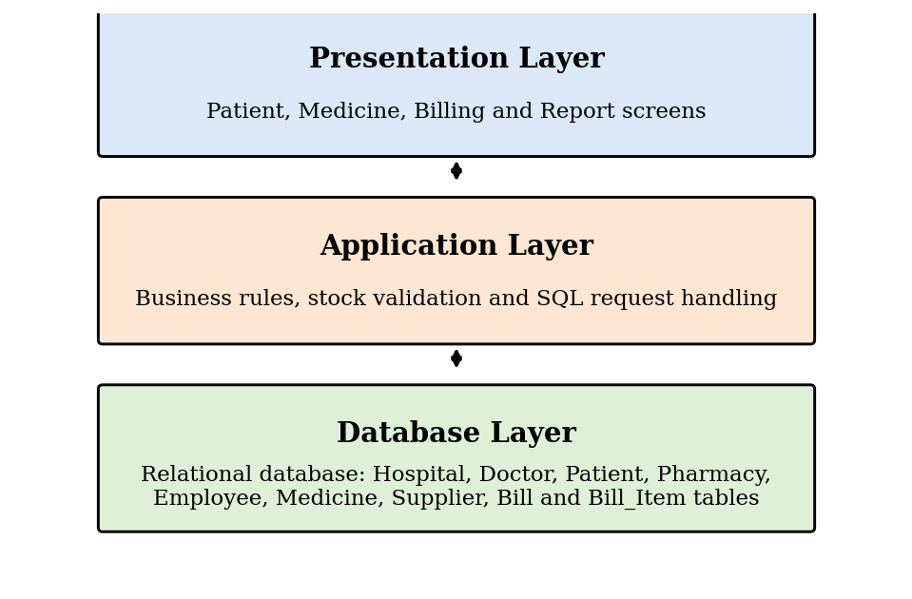
Figure 2: Proposed Three-Layer Database Application Architecture

4. ER DIAGRAM
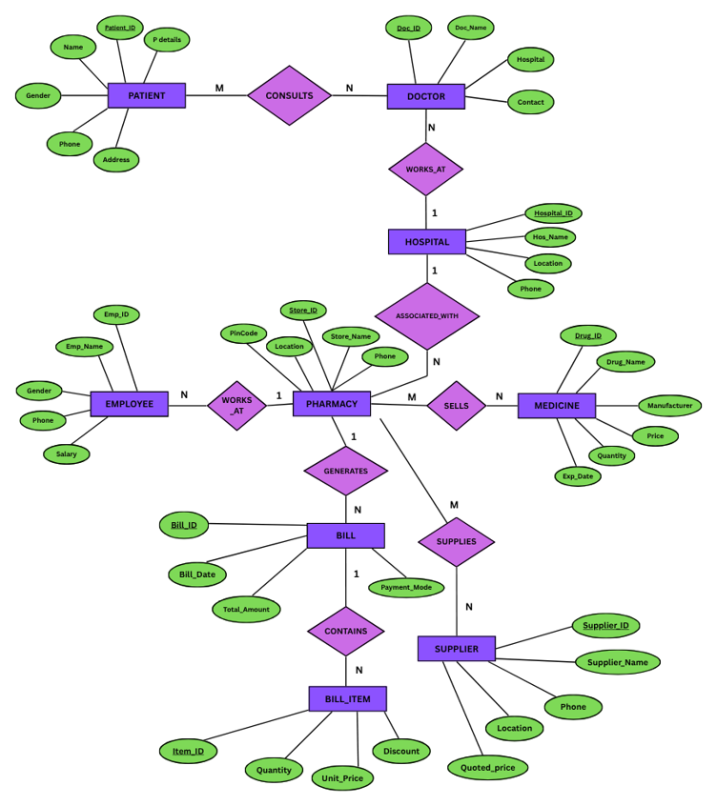
Figure 1: ER Diagram of Pharmacy Management System
The ER diagram summarizes the entities, attributes, and cardinalities of the Pharmacy Management System. Rectangles represent entities, diamonds represent relationships, ovals represent attributes, and underlined attributes are key attributes.

5. RELATIONAL SCHEMA
The ER diagram is mapped to nine relations. One-to-many relationships are represented by a foreign key on the “many” side of the relationship.
Relation | Relational Schema
HOSPITAL | Hospital_ID (PK), Hos_Name, Location, Phone
PHARMACY | Store_ID (PK), Store_Name, Location, Phone, Pincode, Hospital_ID (FK)
DOCTOR | Doc_ID (PK), Doc_Name, Contact, Hospital_ID (FK)
EMPLOYEE | Emp_ID (PK), Emp_Name, Gender, Phone, Salary, Store_ID (FK)
PATIENT | Patient_ID (PK), Name, P_Details, Gender, Phone, Address
MEDICINE | Drug_ID (PK), Drug_Name, Manufacturer, Quantity, Price, Exp_Date
SUPPLIER | Supplier_ID (PK), Supplier_Name, Phone, Location, Quoted_Price
BILL | Bill_ID (PK), Bill_Date, Total_Amount, Payment_Mode, Store_ID (FK)
BILL_ITEM | Item_ID (PK), Quantity, Unit_Price, Discount, Bill_ID (FK)
Doctor and Pharmacy reference Hospital; Employee and Bill reference Pharmacy; and Bill_Item references Bill. The many-to-many relationships shown in the ER diagram (Consults, Sells, and Supplies) can be implemented as separate junction tables when required (see Future Enhancements).

6. TABLE DESIGN

6.1 Hospital Table
Table 14: Hospital Table Structure
Attribute | Data Type | Constraint | Description
HOSPITAL_ID | NUMBER(5) | PRIMARY KEY | Unique hospital identifier
HOS_NAME | VARCHAR2(50) | NOT NULL | Hospital name
LOCATION | VARCHAR2(50) | — | Hospital location
PHONE | VARCHAR2(15) | UNIQUE | Hospital contact number

6.2 Pharmacy Table
Table 15: Pharmacy Table Structure
Attribute | Data Type | Constraint | Description
STORE_ID | NUMBER(5) | PRIMARY KEY | Unique pharmacy (store) identifier
STORE_NAME | VARCHAR2(50) | NOT NULL | Pharmacy name
LOCATION | VARCHAR2(50) | — | Pharmacy location
PHONE | VARCHAR2(15) | UNIQUE | Pharmacy contact number
PINCODE | VARCHAR2(10) | — | Postal pin code
HOSPITAL_ID | NUMBER(5) | FOREIGN KEY | References HOSPITAL (associated hospital)

6.3 Doctor Table
Table 16: Doctor Table Structure
Attribute | Data Type | Constraint | Description
DOC_ID | NUMBER(5) | PRIMARY KEY | Unique doctor identifier
DOC_NAME | VARCHAR2(50) | NOT NULL | Doctor name
CONTACT | VARCHAR2(15) | UNIQUE | Doctor contact number
HOSPITAL_ID | NUMBER(5) | FOREIGN KEY | References HOSPITAL (where the doctor works)

6.4 Employee Table
Table 17: Employee Table Structure
Attribute | Data Type | Constraint | Description
EMP_ID | NUMBER(5) | PRIMARY KEY | Unique employee identifier
EMP_NAME | VARCHAR2(50) | NOT NULL | Employee name
GENDER | VARCHAR2(10) | CHECK | Male or Female
PHONE | VARCHAR2(15) | UNIQUE | Contact number
SALARY | NUMBER(10,2) | CHECK | Employee salary (must be greater than 0)
STORE_ID | NUMBER(5) | FOREIGN KEY | References PHARMACY (where the employee works)

6.5 Patient Table
Table 18: Patient Table Structure
Attribute | Data Type | Constraint | Description
PATIENT_ID | NUMBER(5) | PRIMARY KEY | Unique patient identifier
NAME | VARCHAR2(50) | NOT NULL | Patient name
P_DETAILS | VARCHAR2(100) | — | Other patient-related details
GENDER | VARCHAR2(10) | CHECK | Male or Female
PHONE | VARCHAR2(15) | UNIQUE | Contact number
ADDRESS | VARCHAR2(50) | — | Patient address

6.6 Medicine Table
Table 19: Medicine Table Structure
Attribute | Data Type | Constraint | Description
DRUG_ID | NUMBER(5) | PRIMARY KEY | Unique medicine identifier
DRUG_NAME | VARCHAR2(50) | NOT NULL | Medicine name
MANUFACTURER | VARCHAR2(50) | — | Company that manufactures the medicine
QUANTITY | NUMBER(5) | CHECK | Quantity in stock (not negative)
PRICE | NUMBER(10,2) | CHECK | Price of the medicine (must be greater than 0)
EXP_DATE | DATE | — | Expiry date

6.7 Supplier Table
Table 20: Supplier Table Structure
Attribute | Data Type | Constraint | Description
SUPPLIER_ID | NUMBER(5) | PRIMARY KEY | Unique supplier identifier
SUPPLIER_NAME | VARCHAR2(50) | NOT NULL | Supplier name
PHONE | VARCHAR2(15) | UNIQUE | Supplier contact number
LOCATION | VARCHAR2(50) | — | Supplier location
QUOTED_PRICE | NUMBER(10,2) | CHECK | Price quoted by the supplier (must be greater than 0)

6.8 Bill Table
Table 21: Bill Table Structure
Attribute | Data Type | Constraint | Description
BILL_ID | NUMBER(5) | PRIMARY KEY | Unique bill identifier
BILL_DATE | DATE | NOT NULL | Date of billing
TOTAL_AMOUNT | NUMBER(10,2) | CHECK | Total amount of the bill (not negative)
PAYMENT_MODE | VARCHAR2(20) | — | Cash, Card, UPI, etc.
STORE_ID | NUMBER(5) | FOREIGN KEY | References PHARMACY (which generated the bill)

6.9 Bill_Item Table
Table 22: Bill_Item Table Structure
Attribute | Data Type | Constraint | Description
ITEM_ID | NUMBER(5) | PRIMARY KEY | Unique bill item identifier
QUANTITY | NUMBER(5) | CHECK | Quantity sold (must be greater than 0)
UNIT_PRICE | NUMBER(10,2) | CHECK | Price per unit (must be greater than 0)
DISCOUNT | NUMBER(10,2) | DEFAULT 0, CHECK | Discount given (not negative)
BILL_ID | NUMBER(5) | FOREIGN KEY | References BILL

6.10 Primary Keys and Foreign Keys
Table 23: Primary Keys
Primary Key | Table
Patient_ID | Patient
Drug_ID | Medicine
Doc_ID | Doctor
Hospital_ID | Hospital
Store_ID | Pharmacy
Supplier_ID | Supplier
Emp_ID | Employee
Bill_ID | Bill
Item_ID | Bill_Item

Table 24: Foreign Keys
Foreign Key | In Table | References Table
Hospital_ID | Doctor | Hospital
Store_ID | Employee | Pharmacy
Hospital_ID | Pharmacy | Hospital
Store_ID | Bill | Pharmacy
Bill_ID | Bill_Item | Bill

6.11 Constraints Used
Table 25: Constraints Used
Constraint Type | Applied To / Purpose
PRIMARY KEY | Identifier column of every table
FOREIGN KEY | Doctor.Hospital_ID, Pharmacy.Hospital_ID, Employee.Store_ID, Bill.Store_ID, Bill_Item.Bill_ID
NOT NULL | Names of hospitals, pharmacies, doctors, employees, patients, medicines, and suppliers; Bill_Date
UNIQUE | Phone number of hospital, pharmacy, patient, employee, and supplier; Doctor contact
CHECK | Gender IN ('Male','Female'); Salary > 0; Quantity >= 0; Price > 0; Quoted_Price > 0; Total_Amount >= 0; Unit_Price > 0; Discount >= 0
DEFAULT | Discount defaults to 0 in Bill_Item

7. NORMALIZATION

7.1 Introduction
Normalization is the process of organizing data into proper tables to reduce data redundancy and improve data consistency. The following example normalizes the Doctor table of the Pharmacy Management System up to Third Normal Form (3NF).

7.2 First Normal Form (1NF)
- Each column contains only atomic values.
- No multiple or repeating values are stored in a single cell.
- In the Doctor table, DOC_ID, DOC_NAME, CONTACT, HOSPITAL_ID, and HOSPITAL contain single values.

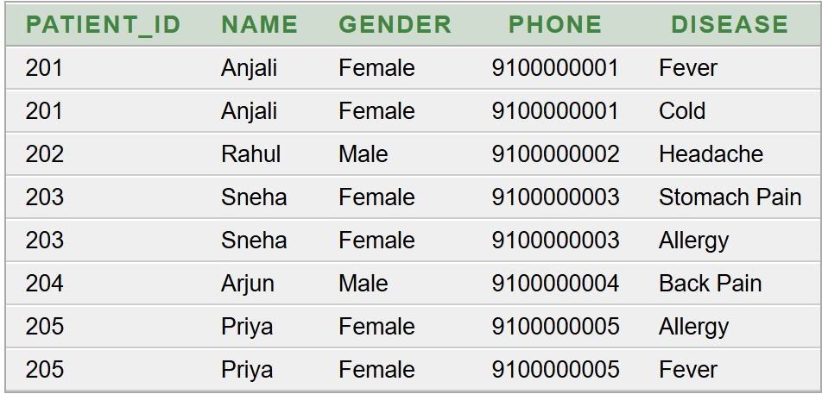

7.3 Second Normal Form (2NF)
- The table must first be in 1NF.
- Every non-key attribute must depend on the complete primary key.
- Since DOC_ID is a single-column primary key, there is no partial dependency.

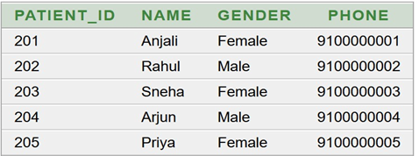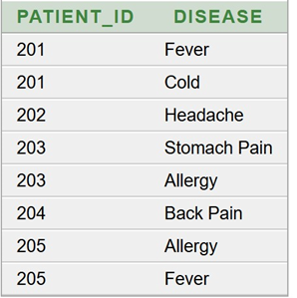

7.4 Third Normal Form (3NF)
- The table must first be in 2NF.
- There should be no transitive dependency.
- In the original Doctor table, DOC_ID → HOSPITAL_ID and HOSPITAL_ID → HOSPITAL.
- Therefore, hospital information is separated into a different table.
- This reduces repeated hospital names and improves data consistency.
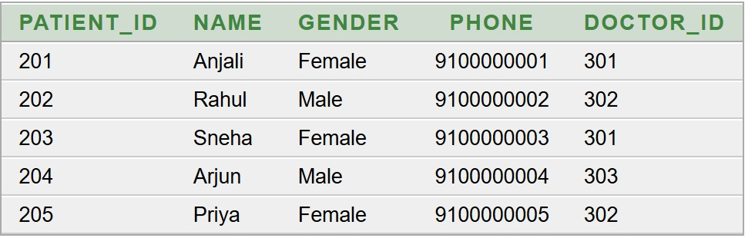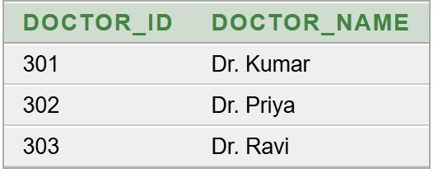

After 3NF the Doctor table is decomposed into two relations:
Table 26: Normal Forms Applied to the Doctor Table
Normal Form | Rule | Result for the Doctor Table
1NF | Atomic values; no repeating groups | DOCTOR (DOC_ID, DOC_NAME, CONTACT, HOSPITAL_ID, HOSPITAL) – all values atomic
2NF | No partial dependency on the primary key | DOC_ID is a single-column key, so there is no partial dependency
3NF | No transitive dependency | DOCTOR_DETAILS_3NF (DOC_ID, DOC_NAME, CONTACT, HOSPITAL_ID) and DOCTOR_HOSPITAL_3NF (HOSPITAL_ID, HOSPITAL)

7.5 Implementation After Normalization
The DOCTOR_HOSPITAL_3NF table stores each hospital once.
Table 27: DOCTOR_HOSPITAL_3NF Table (After Normalization)
HOSPITAL_​ID | HOSPITAL
101 | Apollo Hospital
102 | CARE Hospital
103 | KIMS Hospital
104 | Rainbow Hospital
105 | Manipal Hospital
106 | Yashoda Hospital
107 | AIG Hospital
108 | NRI Hospital
109 | Medicover Hospital
110 | Sunshine Hospital
111 | Lalitha Hospital
112 | Vijaya Hospital
113 | Omega Hospital
114 | Maxcare Hospital
115 | City Hospital

The DOCTOR_DETAILS_3NF table stores the doctor details with a foreign key to the hospital table.
CREATE TABLE DOCTOR_DETAILS_3NF
(
DOC_ID NUMBER(5)
CONSTRAINT PK_DD_3NF PRIMARY KEY,
DOC_NAME VARCHAR2(50)
CONSTRAINT NN_DD_NAME_3NF NOT NULL,
CONTACT VARCHAR2(15)
CONSTRAINT UQ_DD_CONTACT_3NF UNIQUE,
HOSPITAL_ID NUMBER(5)
CONSTRAINT NN_DD_HOSPITAL_3NF NOT NULL,
CONSTRAINT FK_DD_HOSPITAL_3NF
FOREIGN KEY (HOSPITAL_ID)
REFERENCES DOCTOR_HOSPITAL_3NF(HOSPITAL_ID)
);
INSERT INTO DOCTOR_DETAILS_3NF VALUES
(301, 'Dr. Suresh', '9200000001', 101);
INSERT INTO DOCTOR_DETAILS_3NF VALUES
(302, 'Dr. Anitha', '9200000002', 102);
Table 28: DOCTOR_DETAILS_3NF Table (After Normalization)
DOC_​ID | DOC_​NAME | CONTACT | HOSPITAL_​ID
301 | Dr. Suresh | 9200000001 | 101
302 | Dr. Anitha | 9200000002 | 102
303 | Dr. Ramesh | 9200000003 | 103
304 | Dr. Kavya | 9200000004 | 104
305 | Dr. Mahesh | 9200000005 | 105
306 | Dr. Swathi | 9200000006 | 106
307 | Dr. Prasad | 9200000007 | 107
308 | Dr. Divakar | 9200000008 | 108
309 | Dr. Meena | 9200000009 | 109
310 | Dr. Naveen | 9200000010 | 110
311 | Dr. Geetha | 9200000011 | 111
312 | Dr. Karthik | 9200000012 | 112
313 | Dr. Padma | 9200000013 | 113
314 | Dr. Venkat | 9200000014 | 114
315 | Dr. Rekha | 9200000015 | 115

8. SQL IMPLEMENTATION

8.1 DDL – Data Definition Language
The following DDL statements create the nine tables in Oracle Database. The tables are created in dependency order so that every foreign key refers to an existing table.
CREATE TABLE HOSPITAL
(
HOSPITAL_ID NUMBER(5) PRIMARY KEY,
HOS_NAME VARCHAR2(50) NOT NULL,
LOCATION VARCHAR2(50),
PHONE VARCHAR2(15) UNIQUE
);
CREATE TABLE PHARMACY
(
STORE_ID NUMBER(5) PRIMARY KEY,
STORE_NAME VARCHAR2(50) NOT NULL,
LOCATION VARCHAR2(50),
PHONE VARCHAR2(15) UNIQUE,
PINCODE VARCHAR2(10),
HOSPITAL_ID NUMBER(5),
CONSTRAINT FK_PHARMACY_HOSPITAL
FOREIGN KEY (HOSPITAL_ID)
REFERENCES HOSPITAL(HOSPITAL_ID)
);
CREATE TABLE DOCTOR
(
DOC_ID NUMBER(5) PRIMARY KEY,
DOC_NAME VARCHAR2(50) NOT NULL,
CONTACT VARCHAR2(15) UNIQUE,
HOSPITAL_ID NUMBER(5),
CONSTRAINT FK_DOCTOR_HOSPITAL
FOREIGN KEY (HOSPITAL_ID)
REFERENCES HOSPITAL(HOSPITAL_ID)
);
CREATE TABLE EMPLOYEE
(
EMP_ID NUMBER(5) PRIMARY KEY,
EMP_NAME VARCHAR2(50) NOT NULL,
GENDER VARCHAR2(10) CHECK (GENDER IN ('Male','Female')),
PHONE VARCHAR2(15) UNIQUE,
SALARY NUMBER(10,2) CHECK (SALARY > 0),
STORE_ID NUMBER(5),
CONSTRAINT FK_EMPLOYEE_PHARMACY
FOREIGN KEY (STORE_ID)
REFERENCES PHARMACY(STORE_ID)
);
CREATE TABLE PATIENT
(
PATIENT_ID NUMBER(5) PRIMARY KEY,
NAME VARCHAR2(50) NOT NULL,
P_DETAILS VARCHAR2(100),
GENDER VARCHAR2(10) CHECK (GENDER IN ('Male','Female')),
PHONE VARCHAR2(15) UNIQUE,
ADDRESS VARCHAR2(50)
);
CREATE TABLE MEDICINE
(
DRUG_ID NUMBER(5) PRIMARY KEY,
DRUG_NAME VARCHAR2(50) NOT NULL,
MANUFACTURER VARCHAR2(50),
QUANTITY NUMBER(5) CHECK (QUANTITY >= 0),
PRICE NUMBER(10,2) CHECK (PRICE > 0),
EXP_DATE DATE
);
CREATE TABLE SUPPLIER
(
SUPPLIER_ID NUMBER(5) PRIMARY KEY,
SUPPLIER_NAME VARCHAR2(50) NOT NULL,
PHONE VARCHAR2(15) UNIQUE,
LOCATION VARCHAR2(50),
QUOTED_PRICE NUMBER(10,2) CHECK (QUOTED_PRICE > 0)
);
CREATE TABLE BILL
(
BILL_ID NUMBER(5) PRIMARY KEY,
BILL_DATE DATE NOT NULL,
TOTAL_AMOUNT NUMBER(10,2) CHECK (TOTAL_AMOUNT >= 0),
PAYMENT_MODE VARCHAR2(20),
STORE_ID NUMBER(5),
CONSTRAINT FK_BILL_PHARMACY
FOREIGN KEY (STORE_ID)
REFERENCES PHARMACY(STORE_ID)
);
CREATE TABLE BILL_ITEM
(
ITEM_ID NUMBER(5) PRIMARY KEY,
QUANTITY NUMBER(5) CHECK (QUANTITY > 0),
UNIT_PRICE NUMBER(10,2) CHECK (UNIT_PRICE > 0),
DISCOUNT NUMBER(10,2) DEFAULT 0 CHECK (DISCOUNT >= 0),
BILL_ID NUMBER(5),
CONSTRAINT FK_BILLITEM_BILL
FOREIGN KEY (BILL_ID)
REFERENCES BILL(BILL_ID)
);

8.2 DML – Data Manipulation Language
Fifteen sample records were inserted into each table. An example INSERT statement and the resulting records (SELECT * output) are shown for every table.

8.2.1 Hospital Table
INSERT INTO HOSPITAL VALUES
(101, 'Apollo Hospital', 'Hyderabad', '9000000001');
SELECT * FROM HOSPITAL;
Table 29: Sample Data – Hospital Table
HOSPITAL_​ID | HOS_​NAME | LOCATION | PHONE
101 | Apollo Hospital | Hyderabad | 9000000001
102 | CARE Hospital | Vijayawada | 9000000002
103 | KIMS Hospital | Visakhapatnam | 9000000003
104 | Rainbow Hospital | Hyderabad | 9000000004
105 | Manipal Hospital | Bangalore | 9000000005
106 | Yashoda Hospital | Hyderabad | 9000000006
107 | AIG Hospital | Hyderabad | 9000000007
108 | NRI Hospital | Guntur | 9000000008
109 | Medicover Hospital | Visakhapatnam | 9000000009
110 | Sunshine Hospital | Hyderabad | 9000000010
111 | Lalitha Hospital | Rajahmundry | 9000000011
112 | Vijaya Hospital | Vijayawada | 9000000012
113 | Omega Hospital | Hyderabad | 9000000013
114 | Maxcare Hospital | Warangal | 9000000014
115 | City Hospital | Nellore | 9000000015

8.2.2 Pharmacy Table
INSERT INTO PHARMACY VALUES
(401, 'Apollo Pharmacy', 'Hyderabad', '9300000001', '500001', 101);
SELECT * FROM PHARMACY;
Table 30: Sample Data – Pharmacy Table
STORE_​ID | STORE_​NAME | LOCATION | PHONE | PINCODE | HOSPITAL_​ID
401 | Apollo Pharmacy | Hyderabad | 9300000001 | 500001 | 101
402 | CARE Pharmacy | Vijayawada | 9300000002 | 520001 | 102
403 | KIMS Pharmacy | Visakhapatnam | 9300000003 | 530001 | 103
404 | Rainbow Pharmacy | Hyderabad | 9300000004 | 500002 | 104
405 | Manipal Pharmacy | Bangalore | 9300000005 | 560001 | 105
406 | Yashoda Pharmacy | Hyderabad | 9300000006 | 500003 | 106
407 | AIG Pharmacy | Hyderabad | 9300000007 | 500004 | 107
408 | NRI Pharmacy | Guntur | 9300000008 | 522001 | 108
409 | Medicover Pharmacy | Visakhapatnam | 9300000009 | 530002 | 109
410 | Sunshine Pharmacy | Hyderabad | 9300000010 | 500005 | 110
411 | Lalitha Pharmacy | Rajahmundry | 9300000011 | 533001 | 111
412 | Vijaya Pharmacy | Vijayawada | 9300000012 | 520002 | 112
413 | Omega Pharmacy | Hyderabad | 9300000013 | 500006 | 113
414 | Maxcare Pharmacy | Warangal | 9300000014 | 506001 | 114
415 | City Pharmacy | Nellore | 9300000015 | 524001 | 115

8.2.3 Doctor Table
INSERT INTO DOCTOR VALUES
(301, 'Dr. Suresh', '9200000001', 101);
SELECT * FROM DOCTOR;
Table 31: Sample Data – Doctor Table
DOC_​ID | DOC_​NAME | CONTACT | HOSPITAL_​ID
301 | Dr. Suresh | 9200000001 | 101
302 | Dr. Anitha | 9200000002 | 102
303 | Dr. Ramesh | 9200000003 | 103
304 | Dr. Kavya | 9200000004 | 104
305 | Dr. Mahesh | 9200000005 | 105
306 | Dr. Swathi | 9200000006 | 106
307 | Dr. Prasad | 9200000007 | 107
308 | Dr. Divakar | 9200000008 | 108
309 | Dr. Meena | 9200000009 | 109
310 | Dr. Naveen | 9200000010 | 110
311 | Dr. Geetha | 9200000011 | 111
312 | Dr. Karthik | 9200000012 | 112
313 | Dr. Padma | 9200000013 | 113
314 | Dr. Venkat | 9200000014 | 114
315 | Dr. Rekha | 9200000015 | 115

8.2.4 Employee Table
INSERT INTO EMPLOYEE VALUES
(501, 'Ravi', 'Male', '9400000001', 25000, 401);
SELECT * FROM EMPLOYEE;
Table 32: Sample Data – Employee Table
EMP_​ID | EMP_​NAME | GENDER | PHONE | SALARY | STORE_​ID
501 | Ravi | Male | 9400000001 | 25000 | 401
502 | Sita | Female | 9400000002 | 27000 | 402
503 | Ajay | Male | 9400000003 | 26000 | 403
504 | Kavitha | Female | 9400000004 | 28000 | 404
505 | Mohan | Male | 9400000005 | 25500 | 405
506 | Deepa | Female | 9400000006 | 29000 | 406
507 | Surya | Male | 9400000007 | 26500 | 407
508 | Nandini | Female | 9400000008 | 27500 | 408
509 | Praveen | Male | 9400000009 | 30000 | 409
510 | Asha | Female | 9400000010 | 28500 | 410
511 | Rakesh | Male | 9400000011 | 31000 | 411
512 | Bhavya | Female | 9400000012 | 29500 | 412
513 | Chandra | Male | 9400000013 | 32000 | 413
514 | Swetha | Female | 9400000014 | 30500 | 414
515 | Ganesh | Male | 9400000015 | 33000 | 415

8.2.5 Patient Table
INSERT INTO PATIENT VALUES
(201, 'Anjali', 'Fever and cold', 'Female', '9100000001', 'Hyderabad');
SELECT * FROM PATIENT;
Table 33: Sample Data – Patient Table
PATIENT_​ID | NAME | P_​DETAILS | GENDER | PHONE | ADDRESS
201 | Anjali | Fever and cold | Female | 9100000001 | Hyderabad
202 | Rahul | Headache | Male | 9100000002 | Vijayawada
203 | Sneha | Stomach pain | Female | 9100000003 | Guntur
204 | Arjun | Back pain | Male | 9100000004 | Visakhapatnam
205 | Priya | Allergy | Female | 9100000005 | Hyderabad
206 | Kiran | Fever | Male | 9100000006 | Warangal
207 | Divya | Cough | Female | 9100000007 | Nellore
208 | Rohit | Skin infection | Male | 9100000008 | Hyderabad
209 | Keerthi | Migraine | Female | 9100000009 | Rajahmundry
210 | Vamsi | Cold | Male | 9100000010 | Guntur
211 | Pooja | Diabetes checkup | Female | 9100000011 | Vijayawada
212 | Sanjay | Joint pain | Male | 9100000012 | Visakhapatnam
213 | Lakshmi | Throat pain | Female | 9100000013 | Hyderabad
214 | Manoj | Eye irritation | Male | 9100000014 | Warangal
215 | Harini | Stomach infection | Female | 9100000015 | Nellore

8.2.6 Medicine Table
INSERT INTO MEDICINE VALUES
(601, 'Paracetamol', 'Cipla', 100, 20, TO_DATE('15-06-2027','DD-MM-YYYY'));
SELECT * FROM MEDICINE;
Table 34: Sample Data – Medicine Table
DRUG_​ID | DRUG_​NAME | MANUFACTURER | QUANTITY | PRICE | EXP_​DATE
601 | Paracetamol | Cipla | 100 | 20 | 15-JUN-27
602 | Amoxicillin | Sun Pharma | 80 | 50 | 20-AUG-27
603 | Cetirizine | Dr Reddys | 90 | 30 | 10-MAY-27
604 | Azithromycin | Cipla | 75 | 70 | 12-SEP-27
605 | Ibuprofen | Abbott | 120 | 40 | 18-NOV-27
606 | Metformin | Sun Pharma | 110 | 35 | 25-JUL-27
607 | Omeprazole | Dr Reddys | 95 | 45 | 14-OCT-27
608 | Pantoprazole | Lupin | 85 | 55 | 21-DEC-27
609 | Aspirin | Bayer | 100 | 25 | 16-MAR-27
610 | Diclofenac | Novartis | 70 | 60 | 19-APR-27
611 | Insulin | Novo Nordisk | 40 | 450 | 30-JAN-27
612 | Calcium | Cipla | 90 | 80 | 22-FEB-28
613 | Vitamin D | Abbott | 60 | 100 | 17-JUN-28
614 | ORS | Electral | 150 | 25 | 28-SEP-27
615 | Cough Syrup | Benadryl | 65 | 90 | 11-DEC-27

8.2.7 Supplier Table
INSERT INTO SUPPLIER VALUES
(901, 'MedSupply Ltd', '9500000001', 'Hyderabad', 18);
SELECT * FROM SUPPLIER;
Table 35: Sample Data – Supplier Table
SUPPLIER_​ID | SUPPLIER_​NAME | PHONE | LOCATION | QUOTED_​PRICE
901 | MedSupply Ltd | 9500000001 | Hyderabad | 18
902 | HealthCare Supplies | 9500000002 | Vijayawada | 45
903 | Pharma Distributors | 9500000003 | Visakhapatnam | 28
904 | Apollo Suppliers | 9500000004 | Hyderabad | 65
905 | LifeCare Ltd | 9500000005 | Bangalore | 38
906 | MediWorld | 9500000006 | Hyderabad | 32
907 | Global Pharma | 9500000007 | Guntur | 42
908 | SafeMeds | 9500000008 | Warangal | 50
909 | Care Suppliers | 9500000009 | Nellore | 22
910 | HealthFirst | 9500000010 | Hyderabad | 55
911 | MediPlus | 9500000011 | Rajahmundry | 75
912 | PharmaCare | 9500000012 | Vijayawada | 70
913 | Wellness Pharma | 9500000013 | Hyderabad | 90
914 | Prime Meds | 9500000014 | Visakhapatnam | 20
915 | Reliable Pharma | 9500000015 | Guntur | 85

8.2.8 Bill Table
INSERT INTO BILL VALUES
(701, TO_DATE('01-09-2026','DD-MM-YYYY'), 120, 'Cash', 401);
SELECT * FROM BILL;
Table 36: Sample Data – Bill Table
BILL_​ID | BILL_​DATE | TOTAL_​AMOUNT | PAYMENT_​MODE | STORE_​ID
701 | 01-SEP-26 | 120 | Cash | 401
702 | 02-SEP-26 | 250 | UPI | 402
703 | 03-SEP-26 | 180 | Card | 403
704 | 04-SEP-26 | 350 | UPI | 404
705 | 05-SEP-26 | 220 | Cash | 405
706 | 06-SEP-26 | 450 | Card | 406
707 | 07-SEP-26 | 175 | UPI | 407
708 | 08-SEP-26 | 300 | Cash | 408
709 | 09-SEP-26 | 500 | Card | 409
710 | 10-SEP-26 | 275 | UPI | 410
711 | 11-SEP-26 | 325 | Cash | 411
712 | 12-SEP-26 | 190 | Card | 412
713 | 13-SEP-26 | 600 | UPI | 413
714 | 14-SEP-26 | 275 | Cash | 414
715 | 15-SEP-26 | 400 | Card | 415

8.2.9 Bill_Item Table
INSERT INTO BILL_ITEM VALUES
(801, 2, 20, 0, 701);
SELECT * FROM BILL_ITEM;
Table 37: Sample Data – Bill_Item Table
ITEM_​ID | QUANTITY | UNIT_​PRICE | DISCOUNT | BILL_​ID
801 | 2 | 20 | 0 | 701
802 | 3 | 50 | 5 | 702
803 | 2 | 30 | 0 | 703
804 | 5 | 70 | 10 | 704
805 | 2 | 40 | 5 | 705
806 | 1 | 450 | 20 | 706
807 | 3 | 45 | 5 | 707
808 | 4 | 55 | 10 | 708
809 | 2 | 25 | 0 | 709
810 | 3 | 60 | 5 | 710
811 | 2 | 80 | 10 | 711
812 | 1 | 100 | 0 | 712
813 | 5 | 25 | 5 | 713
814 | 2 | 90 | 10 | 714
815 | 4 | 35 | 5 | 715

9. SQL QUERIES AND OUTPUTS
This section presents seven basic and eight advanced SQL queries executed on the MEDICINE table of the Pharmacy Management System. The output obtained for each query is shown below it.

9.1 Basic Queries
Query 1 – Complete Medicine Inventory
SELECT * FROM Medicine;
Output:
DRUG_​ID | DRUG_​NAME | MANUFACTURER | QUANTITY | PRICE | EXP_​DATE
601 | Paracetamol | Cipla | 100 | 20 | 15-JUN-27
602 | Amoxicillin | Sun Pharma | 80 | 50 | 20-AUG-27
603 | Cetirizine | Dr Reddys | 90 | 30 | 10-MAY-27
604 | Azithromycin | Cipla | 75 | 70 | 12-SEP-27
605 | Ibuprofen | Abbott | 120 | 40 | 18-NOV-27
606 | Metformin | Sun Pharma | 110 | 35 | 25-JUL-27
607 | Omeprazole | Dr Reddys | 95 | 45 | 14-OCT-27
608 | Pantoprazole | Lupin | 85 | 55 | 21-DEC-27
609 | Aspirin | Bayer | 100 | 25 | 16-MAR-27
610 | Diclofenac | Novartis | 70 | 60 | 19-APR-27
611 | Insulin | Novo Nordisk | 40 | 450 | 30-JAN-27
612 | Calcium | Cipla | 90 | 80 | 22-FEB-28
613 | Vitamin D | Abbott | 60 | 100 | 17-JUN-28
614 | ORS | Electral | 150 | 25 | 28-SEP-27
615 | Cough Syrup | Benadryl | 65 | 90 | 11-DEC-27

Query 2 – Medicine Names and Their Prices
SELECT Drug_Name, Price
FROM Medicine;

Output:
DRUG_​NAME | PRICE
Paracetamol | 20
Amoxicillin | 50
Cetirizine | 30
Azithromycin | 70
Ibuprofen | 40
Metformin | 35
Omeprazole | 45
Pantoprazole | 55
Aspirin | 25
Diclofenac | 60
Insulin | 450
Calcium | 80
Vitamin D | 100
ORS | 25
Cough Syrup | 90

Query 3 – Medicines Above ₹40
SELECT Drug_Name, Price
FROM Medicine
WHERE Price > 40;
Output:
DRUG_​NAME | PRICE
Amoxicillin | 50
Azithromycin | 70
Omeprazole | 45
Pantoprazole | 55
Diclofenac | 60
Insulin | 450
Calcium | 80
Vitamin D | 100
Cough Syrup | 90

Query 4 – Medicines from Selected Manufacturers
SELECT *
FROM Medicine
WHERE Manufacturer = 'Cipla'
OR Manufacturer = 'Sun Pharma';
DRUG_​ID | DRUG_​NAME | MANUFACTURER | QUANTITY | PRICE | EXP_​DATE
601 | Paracetamol | Cipla | 100 | 20 | 15-JUN-27
602 | Amoxicillin | Sun Pharma | 80 | 50 | 20-AUG-27
604 | Azithromycin | Cipla | 75 | 70 | 12-SEP-27
606 | Metformin | Sun Pharma | 110 | 35 | 25-JUL-27
612 | Calcium | Cipla | 90 | 80 | 22-FEB-28

Query 5 – Medicines Within a Price Range
SELECT Drug_Name, Price
FROM Medicine
WHERE Price BETWEEN 20 AND 60;
Output:
DRUG_​NAME | PRICE
Paracetamol | 20
Amoxicillin | 50
Cetirizine | 30
Ibuprofen | 40
Metformin | 35
Omeprazole | 45
Pantoprazole | 55
Aspirin | 25
Diclofenac | 60
ORS | 25

Query 6 – Medicines Starting with the Letter A
SELECT *
FROM Medicine
WHERE Drug_Name LIKE 'A%';
Output:
DRUG_​ID | DRUG_​NAME | MANUFACTURER | QUANTITY | PRICE | EXP_​DATE
602 | Amoxicillin | Sun Pharma | 80 | 50 | 20-AUG-27
604 | Azithromycin | Cipla | 75 | 70 | 12-SEP-27
609 | Aspirin | Bayer | 100 | 25 | 16-MAR-27

Query 7 – List of Unique Manufacturers
SELECT DISTINCT Manufacturer
FROM Medicine;
Output:
MANUFACTURER
Cipla
Bayer
Novartis
Novo Nordisk
Sun Pharma
Dr Reddys
Lupin
Electral
Abbott
Benadryl

9.2 Advanced Queries
Query 8 – Manufacturer-wise Total Quantity
SELECT Manufacturer, SUM(Quantity) AS Total_Quantity
FROM Medicine
GROUP BY Manufacturer;

Output:
MANUFACTURER | TOTAL_​QUANTITY
Cipla | 265
Bayer | 100
Novartis | 70
Novo Nordisk | 40
Sun Pharma | 190
Dr Reddys | 185
Lupin | 85
Electral | 150
Abbott | 180
Benadryl | 65

Query 9 – Manufacturers with More Than One Medicine
SELECT Manufacturer, COUNT(*) AS Medicine_Count
FROM Medicine
GROUP BY Manufacturer
HAVING COUNT(*) > 1;
Output:
MANUFACTURER | MEDICINE_​COUNT
Cipla | 3
Sun Pharma | 2
Dr Reddys | 2
Abbott | 2

Query 10 – Medicines Above Average Price and Quantity
SELECT Drug_Name, Price, Quantity
FROM Medicine
WHERE Price > (SELECT AVG(Price) FROM Medicine)
AND Quantity > (SELECT AVG(Quantity) FROM Medicine);
Output:
DRUG_​NAME | PRICE | QUANTITY
Calcium | 80 | 90

Query 11 – Manufacturers with Average Price Above ₹40
SELECT Manufacturer, AVG(Price) AS Average_Price
FROM Medicine
GROUP BY Manufacturer
HAVING AVG(Price) > 40;

Output:
MANUFACTURER | AVERAGE_​PRICE
Cipla | 56.666666666666666666666666666666666667
Novartis | 60
Novo Nordisk | 450
Sun Pharma | 42.5
Lupin | 55
Abbott | 70
Benadryl | 90

Query 12 – Medicines with Maximum Quantity
SELECT Drug_Name, Quantity
FROM Medicine
WHERE Quantity = (SELECT MAX(Quantity) FROM Medicine);
Output:
DRUG_​NAME | QUANTITY
ORS | 150

Query 13 – Medicines with Minimum Price
SELECT Drug_Name, Price
FROM Medicine
WHERE Price = (SELECT MIN(Price) FROM Medicine);

Output:
DRUG_​NAME | PRICE
Paracetamol | 20

Query 14 – Manufacturer-wise Medicine Count and Average Price
SELECT Manufacturer,
COUNT(*) AS Medicine_Count,
AVG(Price) AS Average_Price
FROM Medicine
GROUP BY Manufacturer
HAVING COUNT(*) >= 1
ORDER BY Average_Price DESC;

Output:
MANUFACTURER | MEDICINE_​COUNT | AVERAGE_​PRICE
Novo Nordisk | 1 | 450
Benadryl | 1 | 90
Abbott | 2 | 70
Novartis | 1 | 60
Cipla | 3 | 56.6667
Lupin | 1 | 55
Sun Pharma | 2 | 42.5
Dr Reddys | 2 | 37.5
Electral | 1 | 25
Bayer | 1 | 25

Query 15 – Manufacturers with Total Stock Above Average Stock
SELECT Manufacturer, SUM(Quantity) AS Total_Quantity
FROM Medicine
GROUP BY Manufacturer
HAVING SUM(Quantity) > (SELECT AVG(Quantity) FROM Medicine);
Output:
MANUFACTURER | TOTAL_​QUANTITY
Cipla | 265
Bayer | 100
Sun Pharma | 190
Dr Reddys | 185
Electral | 150
Abbott | 180

10. CONCLUSION
The Pharmacy Management System was successfully implemented in Oracle Database. Nine relational tables were created with appropriate primary keys, foreign keys, and constraints, and 15 sample records were inserted into each table. Seven basic and eight advanced SQL queries were executed and verified with outputs. The database was normalized up to Third Normal Form (3NF) to reduce redundancy and maintain data integrity. The project therefore provides a suitable DBMS cornerstone implementation that can be extended into a complete pharmacy management application.

Key Achievements
- 9 relational tables created
- 15 sample records inserted per table
- 7 basic + 8 advanced queries implemented
- Database normalized up to 3NF

11. FUTURE ENHANCEMENTS
- Junction tables for the many-to-many relationships Consults, Sells, and Supplies shown in the ER diagram.
- Prescription management linking patients, doctors, and dispensed medicines.
- Automatic low-stock and expiry alerts with reorder suggestions.
- Online ordering and home delivery of medicines.
- Insurance and claim processing.
- Automated sales analytics dashboards.
- Role-based access, backup and recovery, audit logging, and stronger database security.

REFERENCES
REFERENCES
Textbooks
- Elmasri, R. and Navathe, S. B., “Fundamentals of Database Systems”, Pearson.
- Silberschatz, A., Korth, H. F. and Sudarshan, S., “Database System Concepts”, McGraw-Hill.
Web Links
1. Oracle Database Documentation – https://docs.oracle.com/en/database/
2. W3Schools SQL Tutorial – https://www.w3schools.com/sql/
3. GeeksforGeeks DBMS – https://www.geeksforgeeks.org/dbms/

