Check List After Installation

Table of Contents

1.3 Select firewall & Run the tool 4

1.1. To use the setup (or) ntsysv command
1.2 To uncheck the unwanted serices
1.3 To disable the firewall

2 . Optimization.................................................................................................................5

2.1 To check the mysql connections
2.2 To check the httpd.conf
2.3 To modify the file of php.ini

3. Logmaintance...............................................................................................................7

3.1 To check the log of httpd server Limits
3.2 To check the webinterface of astguiclient

1. Linux OS settings.

Disable unwanted services. Like (Bluetooth, send mail, yum-updates, ip tables, ip6 tables, cups.,pcscd..etc.)

1.1 [root@localhost ~]# ntsysv –level 2345 ( shows different runlevel active services) (or) setup
To have check the need of services

Need to remove the check marks.
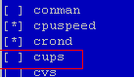
Cups is disabled.

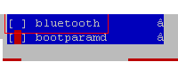
Bluetooth is disabled.

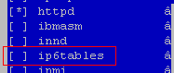
Ip6 tables is disabled.

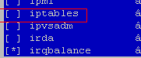
Ip tables is disabled.

1.2 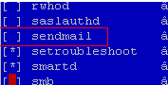
sendmail is disabled

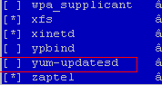
Yum Updates is disabled

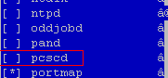

Enable;-httpd,mysqul

PCSCD is disabled.

Disable SElinux. (Procedure As follow.(In terminal use this command. Setup , Firewall configuration, Security Level and SELinux: should be disabled .

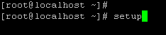(it shows system security,network manager,services..etc)

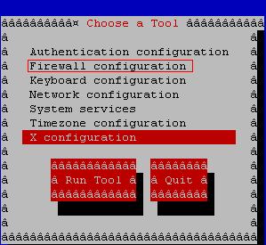

1.3 Select firewall & Run the tool

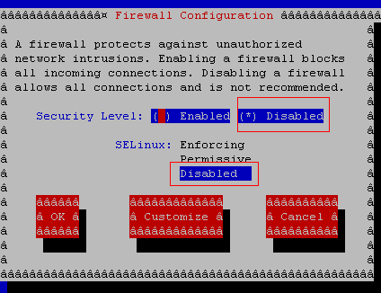

Security should be disable and se linux should be disabled then select ok. After disabling this system must restart once to take effect

2. Optimization .
2.1 vi /etc/my.cnf

Max_co9nnection=5000
Table_cache=5000
Skip-name-resolve
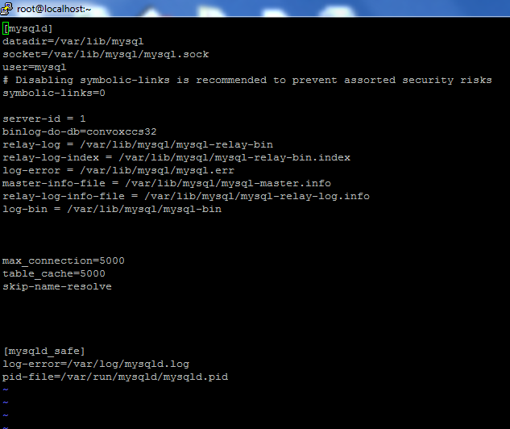

Note:-enter above contents in middle of page..

#vi /etc/rc.local/
Add the content as shown in screenshot safe_asterisk

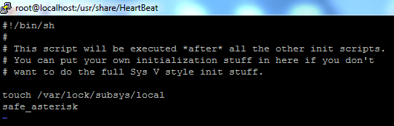

2.2 Changes in /etc/httpd/conf/httpd.conf.

KeepAlive OFF change to KeepAlive ON

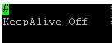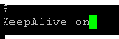

KeepAliveTimeout 15 change to KeepAliveTimeout 2

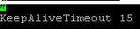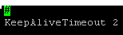
LogLevel warn change to LogLevel crit

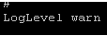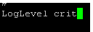

ServerLimit 256 Repalce with 1024

MaxClients 150 Repalce with 512.

2.3 Changes in php.ini

Changes need to be done in php.ini (changes in /etc/php.ini
memory_limit = 16M replace memory_limit = 200M

max_execution_time = 30 replace with max_execution_time = 600
max_input_time = 60 Replace with max_input_time = 600
post_max_size = 8M Repalce with post_max_size = 50M

upload_max_filesize = 2M replace with upload_max_filesize = 50M

default_socket_timeout = 60 replace with default_socket_timeout = 600.

3. Log Maintenance

3.1 Disabling Log of HTTPD

Comment these two lines also.
CustomLog logs/access_log combined
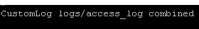

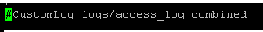
ErrorLog logs/error_log.

Changes need to be done in asterisk IF the server is using as an Application.
(/etc/asterisk/logger.conf)
messages => notice,warning,error (Remove notice,warning, and restart the asterisk).

Aster making this changes asterisk need to be restarted. To restart asterisk in terminal use this commands.
#asterisk -r
localhost*CLI> restart now

3.2 Disabling ConVox Log

Changes need to be done to Block the log of astguiclient.
http://ipaddress/astguiclient/admin.php and go list list all the servers in that you need modify the server.
Server Logs should be Inactive and AGI Output should be NONE.

