“Copy-on-Write Memory Demonstrator”
A Project Report Submitted in the partial fulfillment of the requirements for the award of the degree of
BACHELOR OF TECHNOLOGY
In
DEPARTMENT OF COMPUTER SCIENCE ENGINEERING
By
K RISHI VARMA | 2520030248
K CHARITH | 2520030356
K HITESH REDDY | 2520030420

Under the Esteemed Guidance of
Ms. Soumya Enukonda
Assistant Professor
Department of Computer Science and Engineering



K L (Deemed to be) University
DEPARTMENT OF COMPUTER SCIENCE ENGINEERING
&
DEPARTMENT OF COMPUTER SCIENCE AND INFORMATION TECHNOLOGY
Declaration
The Project Report entitled “Copy-on-Write Memory Demonstrator” is a record of Bonafide work of K RISHI VARMA - 2520030248, K CHARITH - 2520030356, K HITESH REDDY - 2520030420 submitted in partial fulfillment for the award of B. Tech in Computer Science and Engineering (or) Computer Science and Information Technology to the K L University. The results embodied in this report have not been copied from any other departments/University/Institute.

K RISHI VARMA | 2520030248
K CHARITH | 2520030356
K HITESH REDDY | 2520030420

K L (Deemed to be) University
DEPARTMENT OF COMPUTER SCIENCE ENGINEERING
CERTIFICATE
This is to certify that the project based report entitled “Copy-on-Write Memory Demonstrator” is a bonafide work done and submitted by K RISHI VARMA - 2520030248, K CHARITH - 2520030356, K HITESH REDDY - 2520030420 in partial fulfillment of the requirements for the award of the degree of BACHELOR OF TECHNOLOGY in Department of Computer Science Engineering, K L (Deemed to be University), during the academic year 2026-2027.
Signature of the Guide
Signature of the Course Coordinator Signature of the HOD

ACKNOWLEDGEMENT
The success of this project would not have been possible without the timely help and guidance rendered by many people. We wish to express our sincere thanks to all those who have assisted us in one way or the other in the completion of our project.
Our greatest appreciation goes to our Course Coordinator Dr. K. Anusha and our guide Dr. K. Anusha, Department of Computer Science and Engineering, whose tremendous support, encouragement and guidance cannot be expressed in words.
We express our gratitude to Dr. P. Venkateshwara Rao (CSE), Head of the Department of Computer Science and Engineering, for providing us with adequate facilities, ways and means by which we were able to complete this project-based lab.
We thank all the members of the teaching and non-teaching staff who have assisted us directly or indirectly in the successful completion of this project. Finally, we sincerely thank our parents, friends and classmates for their kind help and cooperation during our work.
K RISHI VARMA | 2520030248
K CHARITH | 2520030356
K HITESH REDDY | 2520030420

Abstract
Copy-on-Write (COW) is a fundamental Operating Systems technique that lets a process created with fork() share its parent’s memory instead of duplicating it. This project, “Copy-on-Write Memory Demonstrator,” builds a demonstration system that shows how memory is shared after fork() and copied only when a process modifies it. After fork(), parent and child map the same physical frames as read-only pages; the first write to a page raises a page fault, and the kernel gives the writer a private copy of that single page.
Three C modules were developed and tested on Ubuntu using GCC: a helper header, a demonstration program and a benchmark. They use the system calls mmap(), madvise(), fork(), getrusage(), pipe() and waitpid(), together with /proc/self/smaps and /proc/self/pagemap, to make the sharing and copying visible. The results show that reading shared pages causes no page faults, that writing 1024 pages causes exactly 1024 page faults and page copies, that the parent’s data stays unchanged, and that fork() of a 256 MB region is about 24 times faster than copying the same memory eagerly.
Index
S. No. | Chapter | Topics / Subtopics | Page No.
 | Acknowledgement |  | i
 | Abstract |  | ii
1 | Introduction |  | 1–3
 |  | 1.1 Background of the Project | 1
 |  | 1.2 Problem Statement | 1
 |  | 1.3 Scope of the Project | 1
 |  | 1.4 Objectives of the Project | 2
 |  | 1.5 Importance of the Application | 2
 |  | 1.6 Target Users / Audience | 3
2 | OS Concepts and Background Study |  | 4–6
 |  | 2.1 Operating System Concepts Related to the Project | 4
 |  | 2.2 Existing Methods / Algorithms | 5
 |  | 2.3 Proposed Approach | 6
 |  | 2.4 Advantages of the Proposed Approach | 6
3 | System Requirements |  | 7–8
 |  | 3.1 Hardware Requirements | 7
 |  | 3.2 Software Requirements | 7
 |  | 3.3 Operating System Environment – Ubuntu / WSL | 7
 |  | 3.4 Development Tools and Compilers | 8
4 | Technology and Tools Used |  | 9–11
 |  | 4.1 C / C++ Programming | 9
 |  | 4.2 GCC Compiler | 9
 |  | 4.3 Linux System Calls | 9
 |  | 4.4 POSIX Threads / Synchronization | 10
 |  | 4.5 Linux Commands and Utilities | 10
 |  | 4.6 Other Tools / Libraries Used | 10
5 | System Architecture and Design |  | 12–16
 |  | 5.1 Overall System Architecture | 12
 |  | 5.2 System Workflow | 12
 |  | 5.3 Flowchart / Data Flow | 13
 |  | 5.4 Module Description | 15
 |  | 5.5 Input and Output Design | 15
6 | Implementation |  | 17–25
 |  | 6.1 Module-wise Implementation | 17
 |  | 6.2 Algorithm / Pseudocode | 17
 |  | 6.3 Core C / C++ Implementation | 18
 |  | 6.4 Linux System Calls / APIs Used | 23
 |  | 6.5 Process / Thread Implementation | 24
 |  | 6.6 IPC / Synchronization Implementation | 25
 |  | 6.7 Memory Management Implementation | 25
 |  | 6.8 Optional User Interface Implementation | 25
7 | Execution and Demonstration |  | 26–30
 |  | 7.1 Compilation in Ubuntu | 26
 |  | 7.2 Execution Commands | 26
 |  | 7.3 Sample Inputs and Outputs | 26
 |  | 7.4 Screenshots of Execution | 28
 |  | 7.5 Demonstration of OS Concepts | 30
8 | Conclusion |  | 31–32
 |  | 8.1 Summary of the Project | 31
 |  | 8.2 Objectives Achieved | 31
 |  | 8.3 Results Achieved | 31
 |  | 8.4 Skills and Learning Outcomes | 32
9 | References |  | 33
 |  | 9.1 Books | 33
 |  | 9.2 Research Papers | 33
 |  | 9.3 Linux / GNU Documentation | 33
 |  | 9.4 Online Resources | 33

CHAPTER 1: INTRODUCTION

1.1 Background of the Project
A modern operating system gives every process its own private virtual address space, so that one process cannot read or modify the memory of another. A new process is created in Linux with fork(), which makes the child an almost exact duplicate of the parent: it has the same code, the same global data, the same heap and the same stack. If the kernel really copied all of this memory every time fork() is called, creating a process would be slow and would waste physical memory, because many children either only read the data or replace their memory at once by calling exec().
Operating systems solve this problem with Copy-on-Write (COW). Instead of copying the memory, the kernel lets the parent and the child share the same physical frames and marks the shared pages read-only in both page tables. A page is copied only at the moment one of the processes tries to write to it: the CPU raises a page fault, the kernel makes a private copy of that one page for the writer, and the write then continues normally. Pages that are never modified are never copied.
Copy-on-Write happens silently inside the kernel, so it is difficult to see. This project builds a Copy-on-Write Memory Demonstrator: C programs, run on Ubuntu, that make the behaviour visible by using page-fault counters (getrusage()), memory statistics (/proc/self/smaps) and page-frame information (/proc/self/pagemap).

1.2 Problem Statement
Textbooks explain Copy-on-Write with diagrams, but a student who simply calls fork() in a program sees nothing that proves the memory was shared or when it was copied. The parent and the child print the same virtual addresses before and after a write, and the data in each process looks completely independent.
The problem addressed by this project is: how can we show, with measurable evidence, that memory is shared after fork() and that a page is copied only when a process modifies it? The project answers this by building a demonstration system that allocates a known amount of memory, forks, and then observes the page-fault counts, the memory statistics and the physical page frames of both processes after each step.

1.3 Scope of the Project
Within the scope of the project:
- Allocation of a large anonymous memory region in a parent process and creation of a child with fork().
- Showing that the pages are shared after fork(), using Pss, Shared_Dirty and Private_Dirty from /proc/self/smaps and the “exclusively mapped” flag and frame number from /proc/self/pagemap.
- Showing that reading shared pages causes no page faults, and that writing causes one page fault and one page copy for every page written.
- Showing isolation: the child’s writes are not visible to the parent.
- Showing that a write by the parent to a still-shared page also triggers a copy, while a write to a page the parent now owns alone causes a fault but no copy.
- A benchmark that compares the time of fork() with the time of copying the same amount of memory eagerly.
- Compilation, execution and testing on Ubuntu Linux (native or WSL2) using GCC.
Outside the scope of the project:
- Changing the kernel or writing kernel modules; the demonstrator works only from user space.
- Other uses of Copy-on-Write (file systems, virtual-machine snapshots, the shared zero page) are mentioned only as background and are not implemented.
- Huge pages: transparent huge pages are switched off for the demonstration region so that one copy is exactly one 4 KiB page.
- Graphical user interfaces; the programs are command-line based.

1.4 Objectives of the Project
The objectives of the project are:
- To understand fork(), virtual memory, page tables and the Copy-on-Write technique in Linux.
- To demonstrate that the parent and the child share the same physical pages immediately after fork().
- To demonstrate that a page is copied only when a process writes to it, by counting page faults and observing the physical frame of the page.
- To measure the benefit of Copy-on-Write by comparing the time of fork() with the time needed to copy the same memory eagerly.

1.5 Importance of the Application
Copy-on-Write is one of the reasons why fork() is cheap in Linux. A process with hundreds of megabytes of memory can be duplicated in a few milliseconds, and the extra physical memory is used only for the pages that are really modified. Without it, every shell command, every pre-forked server worker and every background job would first have to copy the memory of its parent.
The same idea is used in many places: shells start programs with fork() and exec(), servers create worker processes with fork(), and databases such as Redis use fork() to take a consistent snapshot of a large data set while the parent keeps serving requests. Understanding Copy-on-Write also gives a solid foundation for learning virtual memory, paging and snapshot techniques in file systems and virtual machines.

1.6 Target Users / Audience
- Students of Operating Systems and Systems Programming who want to see virtual memory and page faults in a practical, working example.
- Instructors who need a small, clear program to demonstrate fork(), paging and Copy-on-Write in a lecture or lab.
- System programmers and developers who want to understand the real memory cost of fork() in multi-process applications.

CHAPTER 2: OS CONCEPTS AND BACKGROUND STUDY

2.1 Operating System Concepts Related to the Project
The project is built on the following core Operating System concepts.

Process and process creation
A process is a program in execution. In Linux a new process is created with fork(), which duplicates the calling process. The call returns twice: it returns the child’s process ID to the parent and 0 to the child. The child gets its own process ID and its own page tables, but at the moment of creation its memory has exactly the same contents as the memory of the parent.

Virtual memory and paging
Every process works with virtual addresses. The memory management unit (MMU) translates them to physical addresses using page tables. Memory is divided into pages of 4 KiB (4096 bytes) on x86-64 Linux, and physical memory is divided into frames of the same size. Each page-table entry (PTE) holds the number of the frame and permission bits such as present and writable. Two processes can use the same virtual address and still reach different frames, which is the basis of process isolation.

Page faults
A page fault is an exception raised by the CPU when a memory access cannot be completed, for example when a process writes to a page that is marked read-only. The kernel’s page-fault handler then decides what to do. A minor page fault is one that the kernel can resolve without reading from disk; Copy-on-Write faults are minor faults. Linux counts them for every process, and getrusage() returns the count in the field ru_minflt.

Copy-on-Write step by step
- During fork() the kernel copies the page-table entries of the parent (not the data) for the child, marks the writable private pages read-only in both page tables, and records that each frame is now used by two processes.
- Reading a shared page works normally in both processes; no fault occurs and nothing is copied.
- When one process writes to a shared page, the CPU raises a page fault. The kernel allocates a new frame, copies the 4096 bytes of the page into it, points the writer’s PTE to the new frame and makes it writable. The write is then repeated and succeeds.
- The other process still uses the original frame. When it later writes to that page and no other process uses the frame any more, the kernel simply makes the existing PTE writable again, without copying anything.

Observing memory with /proc
- /proc/PID/smaps lists the memory mappings of a process with their statistics. Rss is the resident memory of the mapping, Pss (proportional set size) divides every shared page by the number of processes that share it, Shared_Dirty is the modified memory that is shared with other processes and Private_Dirty is the modified memory used by this process alone.
- /proc/PID/pagemap contains one 64-bit entry per virtual page. Bit 63 tells whether the page is present, bit 56 tells whether the page is mapped exclusively by this process, and bits 0–54 hold the physical frame number (PFN). The PFN is visible only to privileged users.

Eager copying versus Copy-on-Write
Table 2.1: Eager copying versus Copy-on-Write
Feature | Eager copying (no COW) | Copy-on-Write
Work done by fork() | Copies every page of the address space | Copies page-table entries only; data is not copied
Memory used after fork() | Doubles immediately | Almost unchanged; frames are shared
Time to create a child | Grows with the amount of memory | Small; grows slowly with the number of pages
Pages never written | Copied anyway | Never copied
First write to a shared page | No extra cost | One page fault and a copy of one 4 KiB page
Isolation of the processes | Complete | Complete; the copy is made before the write completes

2.2 Existing Methods / Algorithms
Operating systems have used several methods to create a new process or to give it memory. Table 2.2 lists the common ones and shows why fork() with Copy-on-Write is the usual choice on Linux.
Table 2.2: Methods for creating a process and duplicating memory
Method | Description | Remarks
Full-copy fork() | The whole address space of the parent is duplicated when the child is created, as in early UNIX systems | Simple, but slow and wasteful for large processes
vfork() | The child borrows the parent’s address space until it calls exec() or _exit(); the parent is suspended | Very fast, but the child must not modify memory; error-prone
posix_spawn() / exec | Starts a new program directly without duplicating the caller | No copy, but the new process is not a copy of the parent
Threads (clone with CLONE_VM) | All threads share the same memory permanently | No isolation; needs locks to protect shared data
fork() with Copy-on-Write | Memory is shared after fork() and a page is copied only when it is written | Fast, memory-efficient and fully isolated; the method studied here

2.3 Proposed Approach
The proposed approach is to implement three small C modules and to study the behaviour of the kernel through them:
- Module 1 – cow_util.h: helper functions that allocate a memory region, count page faults, read the memory statistics of a mapping from /proc/self/smaps and read the exclusive flag and frame number of a page from /proc/self/pagemap.
- Module 2 – cow_demo.c: the parent fills a memory region, calls fork(), and then the child and the parent read and write pages in seven steps. After each step the program prints page-fault counts and memory statistics.
- Module 3 – cow_bench.c: measures the time of fork(), of an eager memcpy() of the same size, and of a child that writes to 10 % and to 100 % of the pages.
Each program checks the return value of every system call and prints tagged messages so that the order of events and the process that produced each line can be seen clearly.

2.4 Advantages of the Proposed Approach
- Visibility: an invisible kernel mechanism becomes visible through numbers that can be checked.
- Evidence from the kernel: page-fault counts and memory statistics are reported by the kernel itself, not assumed by the program.
- Proof of isolation: the program checks that the child’s writes never change the parent’s data.
- Quantified benefit: the benchmark gives the cost of fork() next to the cost of an eager copy.
- Simplicity and portability: the code is short, uses only standard Linux interfaces and, except for the frame number, needs no special privileges.

CHAPTER 3: SYSTEM REQUIREMENTS

3.1 Hardware Requirements
The programs are small and need very modest hardware. The benchmark uses up to about 800 MB of memory at its largest size. The minimum and recommended configurations are given in Table 3.1.
Table 3.1: Hardware requirements
Component | Minimum | Recommended
Processor | Dual-core x86-64, 1.6 GHz | Quad-core, 2.4 GHz or higher
RAM | 2 GB | 4 GB or more
Storage | 5 GB free space | 10 GB free space
Display | 1366 × 768 | 1920 × 1080
Network | Needed only for installing packages and using GitHub | Broadband connection

3.2 Software Requirements
Table 3.2: Software requirements
Software | Details
Operating system | Ubuntu 22.04 LTS or 24.04 LTS (native, virtual machine, or Ubuntu on WSL2). Program output in this report was produced on Ubuntu 24.04 with root privileges, so that frame numbers are visible.
Linux kernel | Version 4.2 or later (for the exclusive flag in /proc/self/pagemap); a 6.x kernel was used
Compiler | GCC 11 or later (GCC 13.3.0 used for the results in this report)
Editor / IDE | VS Code, Vim or Nano
Debugger / tracer | GDB and strace
Version control | Git and a GitHub account
Terminal | GNOME Terminal (Ubuntu) or Windows Terminal (WSL)

3.3 Operating System Environment – Ubuntu / WSL
The project targets Ubuntu Linux because fork(), /proc and the related interfaces are part of the Linux kernel. Students who use Windows can use Windows Subsystem for Linux 2 (WSL2), which runs a real Linux kernel inside Windows. WSL1 is not suitable because it does not use the Linux memory manager.
To install Ubuntu on WSL, open PowerShell as Administrator and run:
wsl --install -d Ubuntu

After restarting, create a Linux user name and password when prompted, then update the package list:
sudo apt update && sudo apt upgrade -y

Project files should be kept on the Linux file system (for example under /home) rather than on Windows-mounted drives such as /mnt/c.

3.4 Development Tools and Compilers
All required tools can be installed with a single command:
sudo apt install build-essential gdb strace git -y
gcc --version

The build-essential package installs GCC, the C library headers and make. GDB is used for debugging and strace is used to observe the system calls made by the programs.

CHAPTER 4: TECHNOLOGY AND TOOLS USED

4.1 C / C++ Programming
C is the natural language for systems programming on Linux because the Linux kernel and the C library expose the system-call interface directly in C. It gives direct control over memory addresses, which is essential here: the programs allocate a region with mmap(), step through it one page at a time with pointer arithmetic, and use the same virtual address in two processes. All programs in this project are written in C (C11, GNU extensions enabled through _GNU_SOURCE).

4.2 GCC Compiler
GCC (GNU Compiler Collection) is used to compile the programs. The following options were used:
- -Wall -Wextra – enable common and extra warnings so that mistakes are caught at compile time.
- -o name – set the name of the output executable.
Example: gcc -Wall -Wextra -o cow_demo cow_demo.c. Both programs compile without any warnings.

4.3 Linux System Calls
System calls are the interface between a user program and the kernel. Table 4.1 lists the calls used in this project.
Table 4.1: System calls used
System call | Header | Prototype | Role in the project
mmap | sys/mman.h | void *mmap(void *addr, size_t len, int prot, int flags, int fd, off_t off) | Allocates the anonymous memory region
munmap | sys/mman.h | int munmap(void *addr, size_t len) | Releases the region
madvise | sys/mman.h | int madvise(void *addr, size_t len, int advice) | Disables huge pages for the region
fork | unistd.h | pid_t fork(void) | Creates the child process
getrusage | sys/resource.h | int getrusage(int who, struct rusage *ru) | Returns the minor page-fault count
pipe | unistd.h | int pipe(int fd[2]) | Creates the synchronization pipes
read / write | unistd.h | ssize_t read(int fd, void *buf, size_t n) | Send and receive the synchronization signals
waitpid | sys/wait.h | pid_t waitpid(pid_t pid, int *status, int options) | Parent waits for the child
pread | unistd.h | ssize_t pread(int fd, void *buf, size_t n, off_t off) | Reads one entry of /proc/self/pagemap
clock_gettime | time.h | int clock_gettime(clockid_t id, struct timespec *ts) | Measures time in the benchmark
getpid | unistd.h | pid_t getpid(void) | Returns the process ID for display

4.4 POSIX Threads / Synchronization
The project is process-based and does not need POSIX threads. The two processes of cow_demo.c are kept in step in three ways:
- A pipe from the child to the parent: the child sends one byte when it has finished writing, and the parent waits for it with a blocking read().
- A pipe from the parent to the child: the child stays alive, blocked in read(), until the parent has finished its own steps. This is important, because the pages must still be shared with a living child while the parent writes.
- waitpid(): the parent terminates only after the child has terminated.
Threads of one process share the whole address space permanently, without any Copy-on-Write, so they are not suitable for demonstrating isolation. Threads are therefore not used in this project.

4.5 Linux Commands and Utilities
Table 4.2: Linux commands and utilities used
Command | Purpose
getconf PAGESIZE | Shows the page size of the system (4096 bytes)
cat /sys/kernel/mm/​transparent_hugepage/enabled | Shows the transparent huge page setting
cat /proc/PID/smaps | Shows Rss, Pss, Shared_Dirty and Private_Dirty of every mapping of a process
ps, top | Show running processes and their resident memory
strace | Traces the system calls (clone, mmap, …) made by a program
gcc, gdb | Compile and debug the programs

4.6 Other Tools / Libraries Used
- Standard C library: stdio.h, stdlib.h, string.h, stdint.h for printing, error handling, string and integer functions.
- Git and GitHub: version control and sharing of the source code.
- VS Code: source-code editing and debugging.
- Python (matplotlib and Pillow): used only to draw the diagrams in Chapter 5 and to render the captured terminal output in Chapter 7 as figures; they are not part of the project programs.

CHAPTER 5: SYSTEM ARCHITECTURE AND DESIGN

5.1 Overall System Architecture
Figure 5.1 shows the overall architecture. In part (A), the parent has just called fork(). Both page tables point to the same physical frames and every page is marked read-only, so no data has been copied. In part (B), the child has written to page 0. The kernel allocated a new frame F0’ for the child, copied the page into it and made it writable. The parent keeps the original frame F0, which is now used by the parent alone. Pages 1 to 3 are still shared.
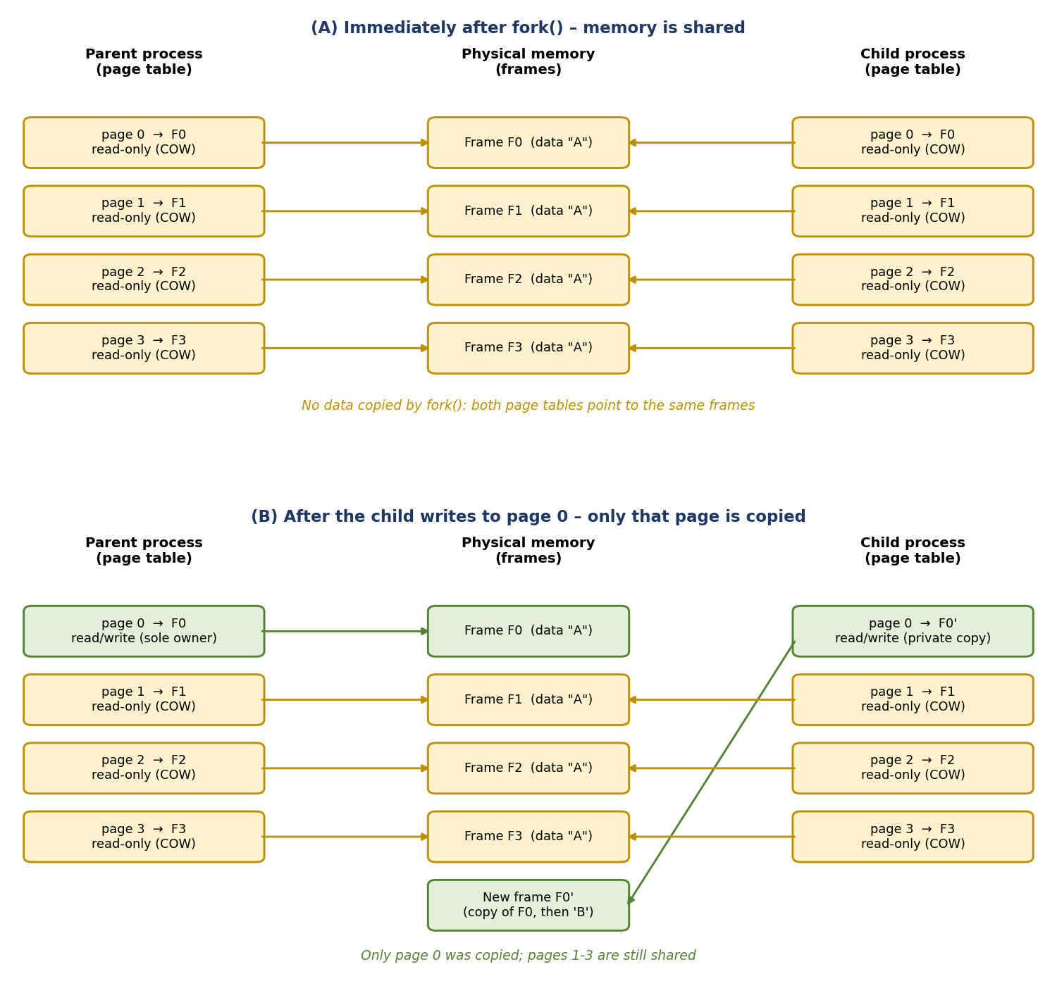
Figure 5.1: Overall system architecture

5.2 System Workflow
Workflow of the demonstration program (cow_demo)
- The parent allocates N pages with mmap(), fills them with the character ‘A’ and prints the memory statistics (Step 1).
- The parent creates two pipes and calls fork(); the child prints its statistics before accessing anything (Step 2).
- The child reads every page and prints the number of page faults, which is expected to be zero (Step 3).
- The child writes to W pages and prints the number of page faults and the changed frame of page 0 (Step 4).
- The child signals the parent through a pipe; the parent checks that its own data is unchanged (Step 5).
- The parent writes to W pages that are still shared with the child, which causes copies (Step 6).
- The parent writes to the W pages it now owns alone, which causes faults but no copies (Step 7).
- The parent signals the child, calls waitpid() and exits.
Workflow of the benchmark program (cow_bench)
- For each size (16, 64, 128 and 256 MB) the program allocates and fills a source buffer and allocates a target buffer.
- It measures the time of fork() itself while the child exits immediately.
- It measures the time of memcpy() from the source to the target buffer, which is the cost of an eager copy.
- It forks a child that writes one byte into 10 % of the pages and then another child that writes into 100 % of the pages, and records the time the child needs.
- Each measurement is repeated three times and the median is printed.

5.3 Flowchart / Data Flow
Figure 5.2 shows the flow of the demonstration program. The dashed arrows show the pipe signals that keep the two processes in step. Figure 5.3 shows what the kernel does when a process writes to a write-protected page, which explains the difference between Step 6 (copy) and Step 7 (reuse).
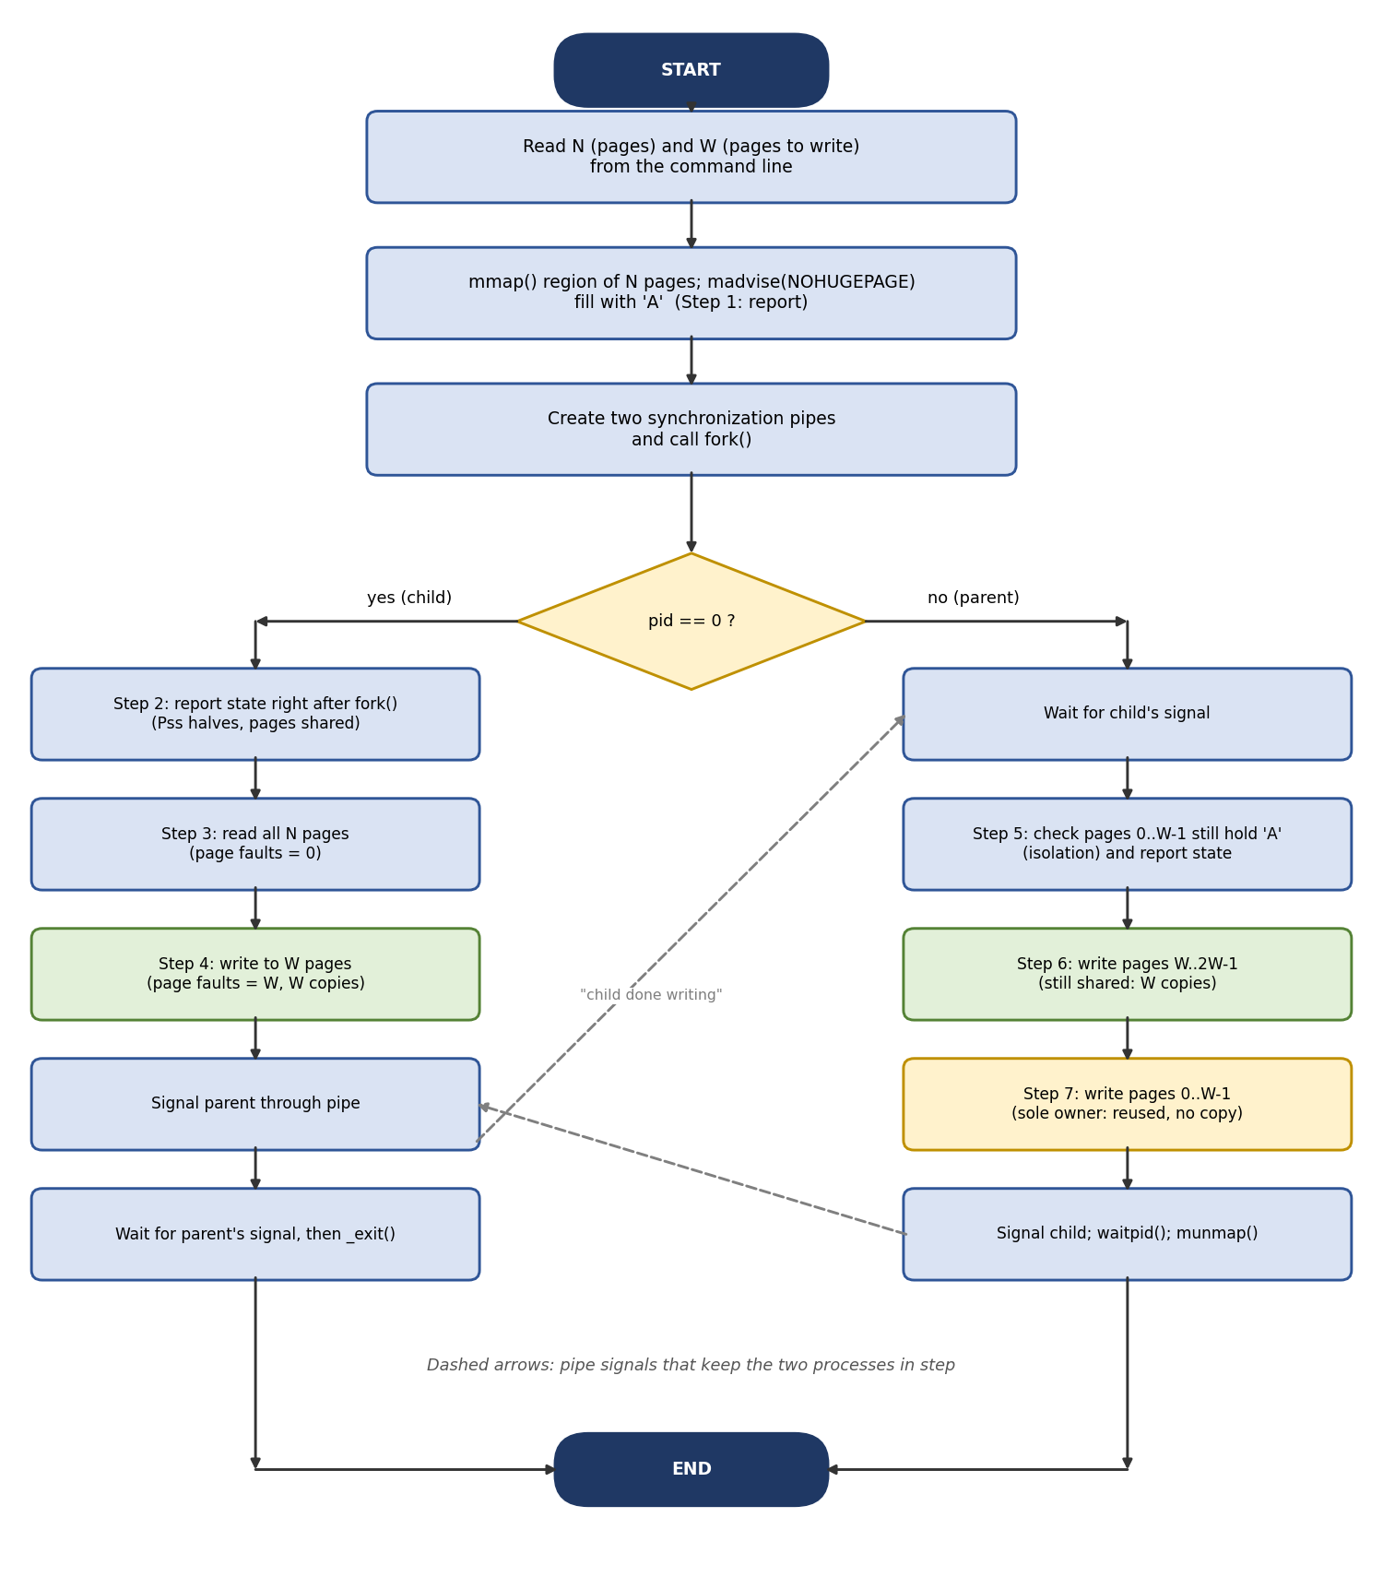
Figure 5.2: Flowchart of the Copy-on-Write demonstration program
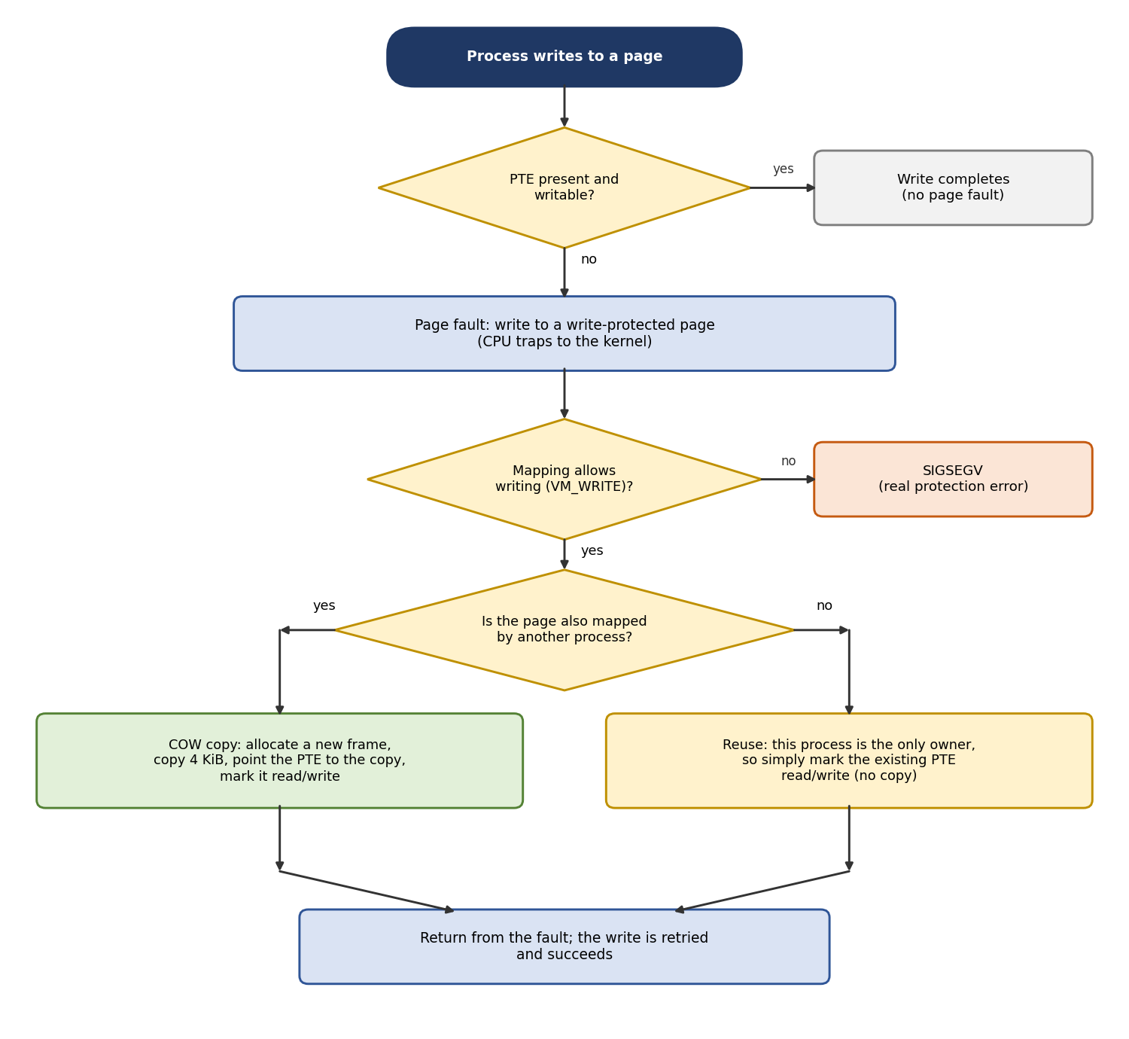
Figure 5.3: Handling of a write fault on a Copy-on-Write page

5.4 Module Description
Table 5.1: Modules of the project
Module | File | Description | Main calls
M1 – Helpers | cow_util.h | Allocates the region, counts page faults, reads memory statistics and page-frame information | mmap, madvise, getrusage, open, pread
M2 – Demonstrator | cow_demo.c | Forks and shows sharing, copying, isolation and reuse in seven steps | fork, pipe, read, write, waitpid
M3 – Benchmark | cow_bench.c | Compares the time of fork() with an eager copy and with writes by the child | fork, memcpy, clock_gettime
M4 – Error handling | all files | Every system call result is checked; errors are reported with perror() | perror, exit

5.5 Input and Output Design
Input design. cow_demo takes two optional command-line arguments: the number of pages N (default 4096, which is 16 MiB) and the number of pages W that are written (default 1024). The values must satisfy 2 × W ≤ N; otherwise the program prints an error message and stops. cow_bench needs no input.
Output design. Every line printed by cow_demo starts with a tag that shows which process produced it, for example [Parent PID 321] or [Child PID 322]. After each step the program prints Size, Rss, Pss, Shared_Dirty and Private_Dirty of the region and the exclusive flag and frame number (PFN) of page 0. cow_bench prints one table row per memory size. Error messages are written with perror().

CHAPTER 6: IMPLEMENTATION

6.1 Module-wise Implementation
Module M1 – Helpers (cow_util.h). alloc_region() maps anonymous memory with mmap() and calls madvise() with MADV_NOHUGEPAGE. minor_faults() returns ru_minflt from getrusage(). region_stats() reads /proc/self/smaps and returns the five values of the mapping that contains a given address. page_exclusive() and page_pfn() read the pagemap entry of a page and extract bit 56 and bits 0–54.
Module M2 – Demonstrator (cow_demo.c). The program implements the seven steps of Section 5.2. It reads a single byte of every page to cause page accesses, and writes a single byte to a page to modify it, because Copy-on-Write works on whole pages. Page faults are counted by reading minor_faults() before and after each loop, so that the output functions do not disturb the count.
Module M3 – Benchmark (cow_bench.c). For each size the program measures fork(), memcpy() and the child’s write loops with clock_gettime(). The child returns its measured time to the parent through a pipe. The median of three repetitions is printed.

6.2 Algorithm / Pseudocode
Algorithm 1 – Demonstration program
allocate region buf of N pages with mmap(); madvise(NOHUGEPAGE)
fill every page of buf with 'A' // all pages are private
print Step 1 report; create pipes p2c and c2p; pid = fork()
if pid == 0: // child
print Step 2 report // pages shared, Pss halves
faults0 = minor_faults(); read one byte of each of the N pages
print minor_faults() - faults0 // expected 0
faults0 = minor_faults(); write 'B' into pages 0..W-1
print minor_faults() - faults0, report // expected W
signal parent (c2p); wait for parent (p2c); exit
else: // parent
wait for child (c2p)
count pages 0..W-1 that no longer hold 'A' // expected 0
write 'C' into pages W..2W-1 // still shared: copy
write 'D' into pages 0..W-1 // sole owner: reuse
signal child (p2c); waitpid(child); munmap(buf)

Algorithm 2 – Reading the memory statistics of a mapping
open /proc/self/smaps
for each line:
if line starts with "lo-hi ...": // header of a mapping
inside = (lo <= addr < hi)
else if inside and line is "Key: value kB":
store Size, Rss, Pss, Shared_Dirty or Private_Dirty
close file; return the statistics

Algorithm 3 – Benchmark
for each size in {16, 64, 128, 256} MB:
map and fill the source buffer; map the target buffer
repeat 3 times:
t_fork = time of fork() (child exits at once)
t_memcpy = time of memcpy(target, source, size)
t_10 = time the child needs to write 1 byte in 10% of the pages
t_100 = time the child needs to write 1 byte in every page
print the median of each measurement

6.3 Core C / C++ Implementation

Program 1: cow_util.h
#ifndef COW_UTIL_H
#define COW_UTIL_H

#define _GNU_SOURCE
#include <stdio.h>
#include <stdlib.h>
#include <string.h>
#include <stdint.h>
#include <fcntl.h>
#include <unistd.h>
#include <sys/mman.h>
#include <sys/resource.h>

#define PAGE_SZ 4096UL

typedef struct {
unsigned long size_kb, rss_kb, pss_kb;
unsigned long shared_dirty_kb, private_dirty_kb;
} mem_stats_t;

/* Allocate 'pages' anonymous pages. Transparent huge pages are disabled
for the region so that every copy is exactly one 4 KiB page. */
static inline char *alloc_region(size_t pages)
{
char *p = mmap(NULL, pages * PAGE_SZ, PROT_READ | PROT_WRITE,
MAP_PRIVATE | MAP_ANONYMOUS, -1, 0);
if (p == MAP_FAILED) {
perror("mmap");
exit(EXIT_FAILURE);
}
madvise(p, pages * PAGE_SZ, MADV_NOHUGEPAGE);
return p;
}

/* Number of minor page faults of the calling process so far. */
static inline long minor_faults(void)
{
struct rusage ru;
if (getrusage(RUSAGE_SELF, &ru) == -1) {
perror("getrusage");
exit(EXIT_FAILURE);
}
return ru.ru_minflt;
}

/* Read Size, Rss, Pss, Shared_Dirty and Private_Dirty of the mapping
that contains 'addr' from /proc/self/smaps. */
static inline int region_stats(const void *addr, mem_stats_t *st)
{
FILE *fp = fopen("/proc/self/smaps", "r");
char line[256];
int inside = 0;
if (!fp) {
perror("fopen smaps");
return -1;
}
memset(st, 0, sizeof(*st));
while (fgets(line, sizeof(line), fp)) {
unsigned long lo, hi, val;
if (sscanf(line, "%lx-%lx", &lo, &hi) == 2) { /* new mapping */
inside = ((uintptr_t)addr >= lo && (uintptr_t)addr < hi);
} else if (inside) {
if (sscanf(line, "Size: %lu kB", &val) == 1)
st->size_kb = val;
else if (sscanf(line, "Rss: %lu kB", &val) == 1)
st->rss_kb = val;
else if (sscanf(line, "Pss: %lu kB", &val) == 1)
st->pss_kb = val;
else if (sscanf(line, "Shared_Dirty: %lu kB", &val) == 1)
st->shared_dirty_kb = val;
else if (sscanf(line, "Private_Dirty: %lu kB", &val) == 1)
st->private_dirty_kb = val;
}
}
fclose(fp);
return 0;
}

/* Read the /proc/self/pagemap entry of the page that contains 'addr'.
Bit 63 = present, bit 56 = exclusively mapped, bits 0-54 = PFN
(the PFN is shown only to privileged users). */
static inline uint64_t pagemap_entry(const void *addr)
{
uint64_t entry = 0;
off_t off = (off_t)((uintptr_t)addr / PAGE_SZ) * sizeof(entry);
int fd = open("/proc/self/pagemap", O_RDONLY);
if (fd == -1) {
perror("open pagemap");
return 0;
}
if (pread(fd, &entry, sizeof(entry), off) != sizeof(entry))
perror("pread pagemap");
close(fd);
return entry;
}

static inline int page_exclusive(const void *addr)
{
return (int)((pagemap_entry(addr) >> 56) & 1);
}

static inline uint64_t page_pfn(const void *addr)
{
return pagemap_entry(addr) & ((1ULL << 55) - 1);
}

#endif

Program 2: cow_demo.c
#include "cow_util.h"
#include <sys/wait.h>

static size_t N = 4096; /* pages allocated by the parent */
static size_t W = 1024; /* pages written by the child (and the parent) */
static int p2c[2], c2p[2]; /* synchronization pipes */

static void signal_peer(int fd)
{
char c = 'x';
if (write(fd, &c, 1) != 1)
perror("write");
}

static void wait_for_peer(int fd)
{
char c;
if (read(fd, &c, 1) != 1)
perror("read");
}

static void report(const char *who, const char *msg, const char *buf)
{
mem_stats_t st;
int pid = getpid();
region_stats(buf, &st);
printf("[%s PID %d] %s\n", who, pid, msg);
printf("[%s PID %d] Size=%lu kB Rss=%lu kB Pss=%lu kB\n", who, pid,
st.size_kb, st.rss_kb, st.pss_kb);
printf("[%s PID %d] Shared_Dirty=%lu kB Private_Dirty=%lu kB\n", who, pid,
st.shared_dirty_kb, st.private_dirty_kb);
printf("[%s PID %d] page 0: exclusive=%d PFN=0x%lx\n", who, pid,
page_exclusive(buf), (unsigned long)page_pfn(buf));
fflush(stdout);
}

int main(int argc, char *argv[])
{
if (argc > 1) N = strtoul(argv[1], NULL, 10);
if (argc > 2) W = strtoul(argv[2], NULL, 10);
if (2 * W > N) {
fprintf(stderr, "need 2*W <= N\n");
return EXIT_FAILURE;
}
setvbuf(stdout, NULL, _IOLBF, 0);

char *buf = alloc_region(N);
memset(buf, 'A', N * PAGE_SZ); /* touch every page */
printf("Region: %zu pages (%zu kB) at %p\n", N, N * PAGE_SZ / 1024, (void *)buf);
report("Parent", "Step 1: before fork(), memory filled with 'A'", buf);

if (pipe(p2c) == -1 || pipe(c2p) == -1) {
perror("pipe");
return EXIT_FAILURE;
}
pid_t pid = fork();
if (pid < 0) {
perror("fork");
return EXIT_FAILURE;
}

if (pid == 0) { /* ---- child ---- */
char *untouched = buf + W * PAGE_SZ; /* child never writes it */
report("Child ", "Step 2: right after fork(), nothing accessed yet", buf);

long f0 = minor_faults();
unsigned long sum = 0;
for (size_t i = 0; i < N; i++)
sum += (unsigned char)buf[i * PAGE_SZ];
printf("[Child PID %d] Step 3: read all %zu pages, checksum=%lu, "
"page faults=%ld\n", getpid(), N, sum, minor_faults() - f0);
report("Child ", " state after reading", buf);

f0 = minor_faults();
for (size_t i = 0; i < W; i++)
buf[i * PAGE_SZ] = 'B';
printf("[Child PID %d] Step 4: wrote 'B' into %zu pages, "
"page faults=%ld\n", getpid(), W, minor_faults() - f0);
report("Child ", " state after writing (page 0 was written)", buf);
printf("[Child PID %d] page %zu (never written): exclusive=%d "
"PFN=0x%lx\n", getpid(), W, page_exclusive(untouched),
(unsigned long)page_pfn(untouched));
fflush(stdout);

signal_peer(c2p[1]); /* tell parent: done writing */
wait_for_peer(p2c[0]); /* wait until parent is done */
_exit(EXIT_SUCCESS);
}

wait_for_peer(c2p[0]); /* ---- parent ---- */
size_t bad = 0;
for (size_t i = 0; i < W; i++)
if (buf[i * PAGE_SZ] != 'A')
bad++;
printf("[Parent PID %d] Step 5: isolation check, pages changed by "
"child's writes: %zu\n", getpid(), bad);
report("Parent", " state after child wrote", buf);

long f0 = minor_faults();
uint64_t pfn_before = page_pfn(buf + W * PAGE_SZ);
for (size_t i = W; i < 2 * W; i++)
buf[i * PAGE_SZ] = 'C';
printf("[Parent PID %d] Step 6: wrote 'C' into %zu still-shared pages, "
"page faults=%ld\n", getpid(), W, minor_faults() - f0);
printf("[Parent PID %d] page %zu: PFN 0x%lx -> 0x%lx (copied)\n",
getpid(), W, (unsigned long)pfn_before,
(unsigned long)page_pfn(buf + W * PAGE_SZ));

f0 = minor_faults();
pfn_before = page_pfn(buf);
for (size_t i = 0; i < W; i++)
buf[i * PAGE_SZ] = 'D';
printf("[Parent PID %d] Step 7: wrote 'D' into %zu pages it owns "
"alone, page faults=%ld\n", getpid(), W, minor_faults() - f0);
printf("[Parent PID %d] page 0: PFN 0x%lx -> 0x%lx (reused, not copied)\n",
getpid(), (unsigned long)pfn_before, (unsigned long)page_pfn(buf));
fflush(stdout);

signal_peer(p2c[1]);
waitpid(pid, NULL, 0);
printf("[Parent PID %d] Child finished. Exiting.\n", getpid());
munmap(buf, N * PAGE_SZ);
return EXIT_SUCCESS;
}

Program 3: cow_bench.c
#include "cow_util.h"
#include <time.h>
#include <sys/wait.h>

#define REPEAT 3

static double now_ms(void)
{
struct timespec ts;
clock_gettime(CLOCK_MONOTONIC, &ts);
return ts.tv_sec * 1000.0 + ts.tv_nsec / 1e6;
}

static double median(double *v, int n) /* simple insertion sort */
{
for (int i = 1; i < n; i++)
for (int j = i; j > 0 && v[j - 1] > v[j]; j--) {
double t = v[j]; v[j] = v[j - 1]; v[j - 1] = t;
}
return v[n / 2];
}

/* Fork a child that writes one byte into 'percent' % of the pages and
returns the time the child needed for those writes (in ms). */
static double child_write_time(char *buf, size_t pages, int percent)
{
int fd[2];
double ms = 0;
if (pipe(fd) == -1) { perror("pipe"); exit(EXIT_FAILURE); }
pid_t pid = fork();
if (pid < 0) { perror("fork"); exit(EXIT_FAILURE); }
if (pid == 0) {
size_t n = pages * percent / 100;
double t0 = now_ms();
for (size_t i = 0; i < n; i++) buf[i * PAGE_SZ] = 'B';
double dt = now_ms() - t0;
if (write(fd[1], &dt, sizeof(dt)) != sizeof(dt)) perror("write");
_exit(EXIT_SUCCESS);
}
if (read(fd[0], &ms, sizeof(ms)) != sizeof(ms)) perror("read");
waitpid(pid, NULL, 0);
close(fd[0]); close(fd[1]);
return ms;
}

int main(void)
{
size_t sizes_mb[] = {16, 64, 128, 256};
printf("%-9s %-12s %-14s %-16s %-16s\n", "Size(MB)", "fork() ms",
"memcpy ms", "child 10% ms", "child 100% ms");

for (int s = 0; s < 4; s++) {
size_t pages = sizes_mb[s] * 1024 * 1024 / PAGE_SZ;
char *buf = alloc_region(pages);
char *copy = alloc_region(pages);
memset(buf, 'A', pages * PAGE_SZ); /* touch the source */
memset(copy, 0, pages * PAGE_SZ); /* pre-touch target */

double tf[REPEAT], tm[REPEAT], t10[REPEAT], t100[REPEAT];
for (int r = 0; r < REPEAT; r++) {
double t0 = now_ms();
pid_t pid = fork();
if (pid == 0) _exit(EXIT_SUCCESS);
tf[r] = now_ms() - t0; /* cost of fork() */
waitpid(pid, NULL, 0);

t0 = now_ms();
memcpy(copy, buf, pages * PAGE_SZ); /* eager copy */
tm[r] = now_ms() - t0;

t10[r] = child_write_time(buf, pages, 10);
t100[r] = child_write_time(buf, pages, 100);
}
printf("%-9zu %-12.3f %-14.3f %-16.3f %-16.3f\n", sizes_mb[s],
median(tf, REPEAT), median(tm, REPEAT),
median(t10, REPEAT), median(t100, REPEAT));
munmap(buf, pages * PAGE_SZ);
munmap(copy, pages * PAGE_SZ);
}
return 0;
}

6.4 Linux System Calls / APIs Used
Table 6.1 explains how each system call is used in the programs and what it returns.
Table 6.1: System calls in the implementation
Call | Used in | Behaviour / return value
mmap(NULL, len, prot, flags, -1, 0) | cow_util.h | Returns the start address of a new anonymous region or MAP_FAILED; frames are allocated when a page is first touched
madvise(addr, len, MADV_NOHUGEPAGE) | cow_util.h | Asks the kernel not to use huge pages, so a copy is exactly one 4 KiB page
fork() | cow_demo.c, cow_bench.c | Returns the child's PID in the parent, 0 in the child, -1 on error; copies page tables, not data
getrusage(RUSAGE_SELF, &ru) | cow_util.h | Fills ru; the field ru_minflt is the number of minor page faults of the calling process
pipe(fd) | cow_demo.c, cow_bench.c | Creates a pipe; used for the handshake in cow_demo.c and to return a timing in cow_bench.c
write(fd, buf, n) / read(fd, buf, n) | cow_demo.c, cow_bench.c | Send and receive a one-byte signal or a timing; read() blocks until data is available
pread(fd, &entry, 8, off) | cow_util.h | Reads the 8-byte pagemap entry of one page without changing the file offset
waitpid(pid, NULL, 0) | cow_demo.c, cow_bench.c | Parent waits until the child has terminated
clock_gettime(CLOCK_MONOTONIC, &ts) | cow_bench.c | Returns a monotonic time stamp with nanosecond resolution
munmap(addr, len) | cow_demo.c, cow_bench.c | Releases the memory region

6.5 Process / Thread Implementation
cow_demo.c uses a single fork() to create one child process. After the call, two processes run the same code, and the return value of fork() decides which branch each one follows: the branch pid == 0 is executed by the child and the rest by the parent. The two processes have different process IDs, which the program prints with getpid().
The pointer buf holds the same virtual address in both processes, and it keeps this value after the child has written to the page. What changes is the physical frame behind the address: before the write, the parent and the child report the same PFN for page 0, and after the child’s write the child reports a new PFN while the parent keeps the original one. This is the central observation of the project.
cow_bench.c forks several short-lived children, one for each measurement. No threads are used in the project.

6.6 IPC / Synchronization Implementation
Handshake with two pipes. The output of the two processes must appear in a fixed order, and the child must stay alive while the parent writes. The program therefore uses two pipes, c2p (child to parent) and p2c (parent to child), as a simple handshake:
- After Step 4 the child writes one byte into c2p and then blocks in read() on p2c.
- The parent blocks in read() on c2p until that byte arrives; it then performs Steps 5 to 7.
- The parent writes one byte into p2c, which lets the child exit, and calls waitpid().
Why the child must stay alive. If the child exited before the parent’s writes, the pages would no longer be shared; the parent would be their only owner and Step 6 would not need any copy. Keeping the child alive keeps the pages shared, so the copy in Step 6 can be observed.
Output buffering. Standard output is set to line-buffered mode with setvbuf() and flushed before the processes wait for each other, so that no output is duplicated by fork() and the lines of both processes appear in the correct order.

6.7 Memory Management Implementation
The memory under study is one anonymous private mapping of N pages created with mmap(). Linux allocates the frames only when the pages are first touched, so the parent fills the region with memset() before forking to make all pages resident. The programs step through the region with a stride of PAGE_SZ (4096 bytes) and access one byte per page, because the kernel copies whole pages and one write per page is enough to trigger the copy.
Transparent huge pages could make the kernel copy 2 MiB at once, which would hide the behaviour of a single page. madvise(MADV_NOHUGEPAGE) is therefore called for the region. The size of the mapping reported by /proc/self/smaps (16384 kB in the sample run) is printed so that it can be checked that the statistics belong to exactly this region. The region is released with munmap() at the end of each program.

6.8 Optional User Interface Implementation
The project uses a simple command-line interface and no graphical interface. As described in Section 5.5, every line printed by the demonstration program is tagged with the role and the process ID. The output is short enough to be read directly in a terminal, so a graphical front end is not necessary to demonstrate the operating-system concepts.

CHAPTER 7: EXECUTION AND DEMONSTRATION

7.1 Compilation in Ubuntu
Open a terminal in the project folder and compile the two programs with GCC:
gcc -Wall -Wextra -o cow_demo cow_demo.c
gcc -Wall -Wextra -o cow_bench cow_bench.c

The programs compile without errors or warnings. The compiled executables appear in the same folder. The header cow_util.h must be in the same folder as the source files.

7.2 Execution Commands
Demonstration program:
./cow_demo # 4096 pages, child and parent write 1024 pages each
./cow_demo 8192 2048 # N = 8192 pages, W = 2048 pages
sudo ./cow_demo # additionally shows the physical frame numbers

Without root privileges the kernel hides the frame numbers and the program prints PFN=0x0. All other values, including the exclusive flag, are still correct.
Benchmark:
./cow_bench

Shell-level demonstration:
getconf PAGESIZE
cat /sys/kernel/mm/transparent_hugepage/enabled

7.3 Sample Inputs and Outputs
The programs need no input in their default configuration. The output obtained when they were run is shown below.

Output of cow_demo
Region: 4096 pages (16384 kB) at 0x7f501d600000
[Parent PID 321] Step 1: before fork(), memory filled with 'A'
[Parent PID 321] Size=16384 kB Rss=16384 kB Pss=16384 kB
[Parent PID 321] Shared_Dirty=0 kB Private_Dirty=16384 kB
[Parent PID 321] page 0: exclusive=1 PFN=0x13486c
[Child PID 322] Step 2: right after fork(), nothing accessed yet
[Child PID 322] Size=16384 kB Rss=16384 kB Pss=8192 kB
[Child PID 322] Shared_Dirty=16384 kB Private_Dirty=0 kB
[Child PID 322] page 0: exclusive=0 PFN=0x13486c
[Child PID 322] Step 3: read all 4096 pages, checksum=266240, page faults=0
[Child PID 322] state after reading
[Child PID 322] Size=16384 kB Rss=16384 kB Pss=8192 kB
[Child PID 322] Shared_Dirty=16384 kB Private_Dirty=0 kB
[Child PID 322] page 0: exclusive=0 PFN=0x13486c
[Child PID 322] Step 4: wrote 'B' into 1024 pages, page faults=1024
[Child PID 322] state after writing (page 0 was written)
[Child PID 322] Size=16384 kB Rss=16384 kB Pss=10240 kB
[Child PID 322] Shared_Dirty=12288 kB Private_Dirty=4096 kB
[Child PID 322] page 0: exclusive=1 PFN=0x13725e
[Child PID 322] page 1024 (never written): exclusive=0 PFN=0x106685
[Parent PID 321] Step 5: isolation check, pages changed by child's writes: 0
[Parent PID 321] state after child wrote
[Parent PID 321] Size=16384 kB Rss=16384 kB Pss=10240 kB
[Parent PID 321] Shared_Dirty=12288 kB Private_Dirty=4096 kB
[Parent PID 321] page 0: exclusive=1 PFN=0x13486c
[Parent PID 321] Step 6: wrote 'C' into 1024 still-shared pages, page faults=1024
[Parent PID 321] page 1024: PFN 0x106685 -> 0x10af5b (copied)
[Parent PID 321] Step 7: wrote 'D' into 1024 pages it owns alone, page faults=1024
[Parent PID 321] page 0: PFN 0x13486c -> 0x13486c (reused, not copied)
[Parent PID 321] Child finished. Exiting.

Figures 7.2 and 7.3 show the same output as screenshots. The main observations are:
- Immediately after fork() the child reports the same Rss (16384 kB) but only half of the Pss (8192 kB), and its Shared_Dirty value is 16384 kB. Page 0 has the same PFN in the parent and in the child, and the exclusive flag is 0.
- Reading all 4096 pages caused 0 page faults and changed nothing in the statistics.
- Writing 1024 pages caused exactly 1024 page faults. Private_Dirty rose to 4096 kB (1024 × 4 kB), page 0 received a new PFN and became exclusive, and the untouched page 1024 kept its PFN.
- The parent found 0 changed pages (isolation) and its page 0 still has the original PFN.
- The parent’s write to the 1024 still-shared pages caused 1024 faults and a new frame for page 1024 (a copy). Its write to the 1024 pages it owned alone also caused 1024 faults, but page 0 kept its PFN: the existing frame was reused.

Output of cow_bench
Size(MB) fork() ms memcpy ms child 10% ms child 100% ms
16 0.645 6.991 0.875 10.851
64 1.058 19.737 3.358 32.928
128 1.743 33.980 7.662 65.556
256 3.701 87.444 16.172 159.094

Table 7.1: Benchmark results (median of three runs)
Size (MB) | fork() (ms) | Eager memcpy (ms) | Child writes 10 % (ms) | Child writes 100 % (ms)
16 | 0.645 | 6.991 | 0.875 | 10.851
64 | 1.058 | 19.737 | 3.358 | 32.928
128 | 1.743 | 33.980 | 7.662 | 65.556
256 | 3.701 | 87.444 | 16.172 | 159.094

The cost of fork() grows slowly with the size, because only page-table entries are copied: 0.645 ms for 16 MB and 3.701 ms for 256 MB. Copying the 256 MB eagerly took 87.444 ms, about 24 times more. Writing to 10 % of the pages cost about 10 % of the cost of writing to all pages, so the cost of Copy-on-Write is proportional to the number of pages that are really modified. When the child wrote to every page, the total (159.1 ms) was larger than the eager copy (87.4 ms), because every page also pays for a page fault. Copy-on-Write therefore pays off most when children modify only a small part of their memory. The timings come from a single run on the test machine (1 CPU core, Ubuntu 24.04) and will differ on other machines.

Test cases
Table 7.2: Test cases and results
No. | Test case | Expected result | Result
1 | Memory filled before fork() | Rss = Pss = Private_Dirty = 16384 kB; page 0 exclusive | Pass
2 | Child state right after fork() | Pss = 8192 kB, Shared_Dirty = 16384 kB; same PFN as the parent; not exclusive | Pass
3 | Child reads all 4096 pages | 0 page faults; statistics unchanged | Pass
4 | Child writes 1024 pages | 1024 page faults; Private_Dirty = 4096 kB; page 0 gets a new PFN; untouched page keeps its PFN | Pass
5 | Isolation check in the parent | 0 pages changed; parent’s page 0 keeps its original PFN | Pass
6 | Parent writes 1024 pages still shared with the child | 1024 page faults; new PFN for page 1024 (copied) | Pass
7 | Parent writes 1024 pages it owns alone | 1024 page faults; PFN unchanged (reused, not copied) | Pass
8 | Invalid arguments (2 × W > N) | Error message and exit status 1 | Pass
9 | Benchmark: fork() versus eager memcpy() | fork() is faster than memcpy() for all four sizes | Pass

7.4 Screenshots of Execution
The figures below show the terminal output of the programs. Figure 7.1 shows the compilation, Figures 7.2 and 7.3 the demonstration program, Figure 7.4 the benchmark and Figure 7.5 the shell-level demonstration together with a run on a small region of 8 pages.
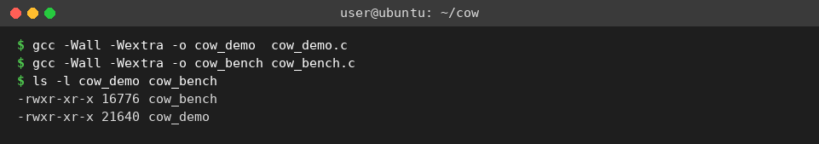
Figure 7.1: Compilation of the two programs
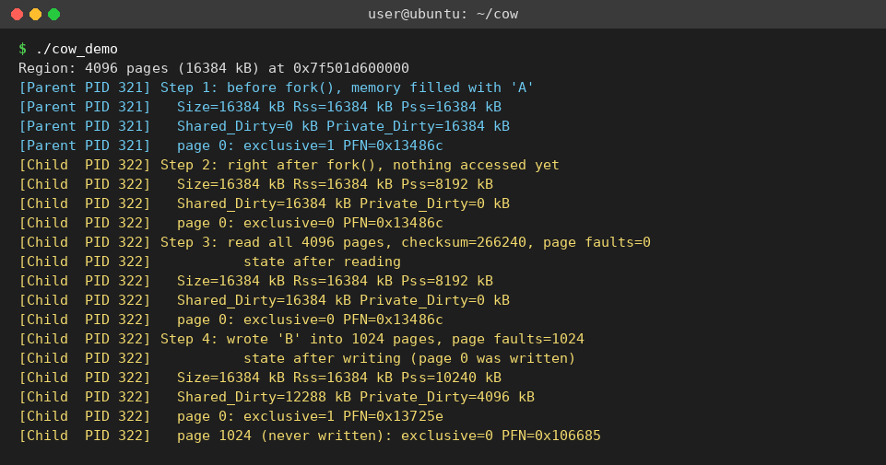
Figure 7.2: cow_demo – before fork() and the child’s steps
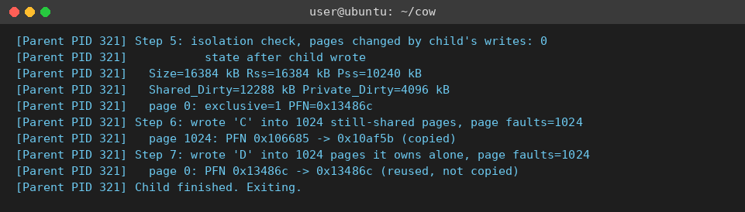
Figure 7.3: cow_demo – the parent’s steps
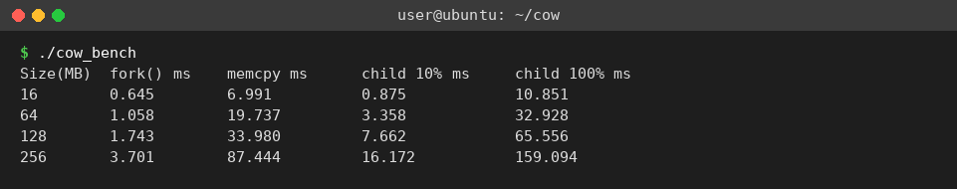
Figure 7.4: Output of the benchmark
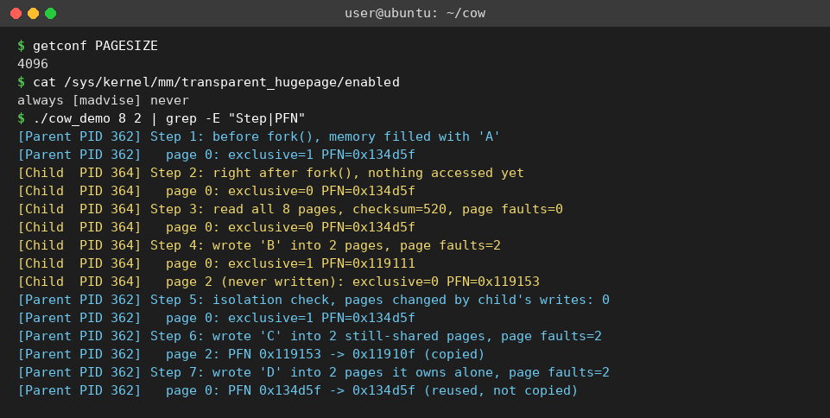
Figure 7.5: Page size, huge-page setting and a run with 8 pages

7.5 Demonstration of OS Concepts
Table 7.3 relates the operating-system concepts to what can be observed in the project.
Table 7.3: OS concepts demonstrated
OS concept | How it is demonstrated
Process creation | fork() creates a child with its own process ID; both processes print different PIDs.
Virtual and physical memory | The same virtual address maps to different frames after a write: the PFN of page 0 differs in the child and the parent.
Page sharing | Right after fork() the Pss halves, Shared_Dirty equals the whole region and both processes report the same PFN.
Page faults | getrusage() shows 0 faults for reads and one fault per page written.
Copy-on-Write | Only the written pages receive new frames; Private_Dirty grows by exactly 4 kB per written page.
Process isolation | The parent’s pages still hold ‘A’ after the child wrote ‘B’ into the same addresses.
Page ownership | A write to a page that no other process uses causes a fault but no copy; the PFN stays the same.
Efficiency of fork() | fork() of 256 MB is much faster than copying the same memory with memcpy().
Synchronization | Two pipes make the processes alternate in a fixed order; waitpid() ends the run.

CHAPTER 8: CONCLUSION

8.1 Summary of the Project
This project studied Copy-on-Write memory management in Linux and built a demonstration system for it. Two C programs and a helper header were designed, implemented and tested on Ubuntu: a demonstrator that shows memory being shared after fork() and copied only when it is modified, and a benchmark that measures the benefit. The programs use mmap(), madvise(), fork(), getrusage(), pipe() and waitpid() together with /proc/self/smaps and /proc/self/pagemap to show how the kernel handles page sharing, page faults and page copies.
Limitations and future scope. The demonstrator uses 4 KiB pages with transparent huge pages switched off, relies on Linux-specific /proc interfaces, and needs root privileges to show frame numbers. Only anonymous private memory is studied, and the benchmark timings depend on the machine. Possible extensions include Copy-on-Write with huge pages, file-backed private mappings, a graphical view of the page states, a comparison with vfork(), and measurements for a server with many pre-forked workers.

8.2 Objectives Achieved
Table 8.1: Objectives and their status
No. | Objective | Status | Evidence
1 | Understand fork(), virtual memory and Copy-on-Write | Achieved | Chapters 1 and 2; Figure 5.3
2 | Show that pages are shared after fork() | Achieved | Steps 1 and 2; Figure 7.2
3 | Show that a page is copied only when written | Achieved | Steps 3 to 7; Figures 7.2 and 7.3; Table 7.2
4 | Measure the benefit of Copy-on-Write | Achieved | Table 7.1; Figure 7.4

8.3 Results Achieved
- Right after fork() the Pss of the 16384 kB region dropped to 8192 kB and the same physical frame was reported in the parent and in the child.
- Reading the shared pages caused no page faults.
- Writing 1024 pages caused exactly 1024 page faults and 1024 page copies (Private_Dirty = 4096 kB); the pages that were not written kept their original frames.
- The parent’s data stayed unchanged after the child’s writes, which proves isolation.
- A write to a page owned by one process alone caused a page fault but no copy.
- fork() of a 256 MB region took 3.7 ms, while copying the same memory took 87.4 ms.
- All nine test cases in Table 7.2 passed, and both programs compiled with no warnings under -Wall -Wextra.

8.4 Skills and Learning Outcomes
- Using the process and memory system calls of Linux: fork(), mmap(), madvise(), pipe() and waitpid().
- Understanding virtual memory, page tables, page faults and Copy-on-Write.
- Reading kernel-provided information from /proc and interpreting Rss, Pss and page-frame data.
- Designing and measuring an experiment, and comparing eager copying with lazy copying.
- Compiling, running and testing C programs on Ubuntu with GCC, and preparing a technical report as a team with Git and GitHub.

CHAPTER 9: REFERENCES

9.1 Books
- Michael Kerrisk, The Linux Programming Interface, No Starch Press, 2010.
- Abraham Silberschatz, Peter B. Galvin and Greg Gagne, Operating System Concepts, 10th Edition, Wiley, 2018.
- Andrew S. Tanenbaum and Herbert Bos, Modern Operating Systems, 4th Edition, Pearson, 2014.
- Daniel P. Bovet and Marco Cesati, Understanding the Linux Kernel, 3rd Edition, O’Reilly, 2005.

9.2 Research Papers
- Dennis M. Ritchie and Ken Thompson, “The UNIX Time-Sharing System,” Communications of the ACM, vol. 17, no. 7, pp. 365–375, 1974.
- Richard Rashid et al., “Machine-Independent Virtual Memory Management for Paged Uniprocessor and Multiprocessor Architectures,” IEEE Transactions on Computers, vol. 37, no. 8, pp. 896–908, 1988.
- Andrew Baumann, Jonathan Appavoo, Orran Krieger and Timothy Roscoe, “A fork() in the road,” Proceedings of the Workshop on Hot Topics in Operating Systems (HotOS ’19), 2019.

9.3 Linux / GNU Documentation
- Linux manual page fork(2) – create a child process: https://man7.org/linux/man-pages/man2/fork.2.html
- Linux manual page proc(5) – the /proc filesystem, including smaps and pagemap: https://man7.org/linux/man-pages/man5/proc.5.html
- Linux manual pages mmap(2), madvise(2) and getrusage(2): https://man7.org/linux/man-pages/
- Linux kernel documentation, “Pagemap”: https://www.kernel.org/doc/html/latest/admin-guide/mm/pagemap.html

9.4 Online Resources
- The Open Group Base Specifications (POSIX.1-2017), fork(): https://pubs.opengroup.org/onlinepubs/9699919799/functions/fork.html
- Microsoft Learn, “Install WSL”: https://learn.microsoft.com/en-us/windows/wsl/install

