 | OAK INTERNATIONAL SCHOOL  MYP 5 MATHEMATICS — MID-TERM TEST 2  Bilingual Excellence in Education & Leadership
Duration: 30 minutes | Total: 20 marks | Calculator: not permitted
Name: _____________________________ Class: ________________ Date: ______________

Answer ALL questions. Show all working — marks are awarded for method, for general rules, for verification of rules, and for interpretation in context. Write final answers on the dotted lines. Non-exact decimals: 2 d.p. Amounts in francs are exact. Aim for about 90 seconds per mark.
TASK 1 — UNDERSTANDING NUMBER PATTERNS — Criterion A • 4 MARKS
For a class display, three students each recorded a number pattern:
Ali: 4, 10, 16, 22, … Bea: 1, 4, 9, 16, … Camille: 40, 36, 32, 28, …
(a) Two of the three patterns change by a constant amount. Identify these two patterns and state the constant change in each. [2 marks]

(b) A classmate says that Bea’s pattern is linear “because it always increases.” Explain the classmate’s error, using calculations. [2 marks]

TASK 2 — INVESTIGATION: STONE-EDGED GARDEN BEDS — Criterion B • 6 MARKS
For the school’s greening project, the mathematics club builds triangular garden beds edged with equal stones. Beds 1, 2 and 3 are shown, in order.
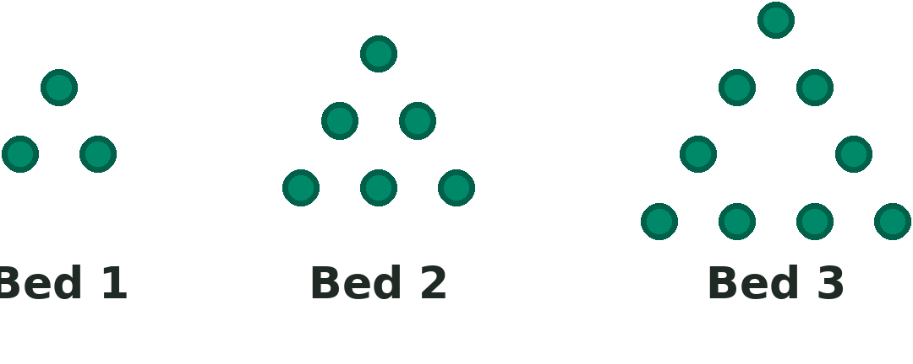
(a) Determine the number of stones needed for Bed 4 and Bed 5. [2 marks]

(b) The club describes the pattern with a general rule. Write a formula for the number of stones, S, in Bed n, where n is the bed number. [2 marks]

(c) The gardener has ordered 30 stones — according to the club, exactly enough for Bed 10. Use your rule to verify the order, and explain why your rule must work for every bed, referring to the structure of the pattern rather than only to the numbers. [2 marks]

TASK 3 — APPLICATION: AMINA’S SAVINGS CHALLENGE — Criterion D • 6 MARKS
Amina joins a one-year savings challenge in Cotonou. She deposits 10 000 francs in January (month 1), and from then on she increases each month’s deposit by exactly 2 500 francs.
(a) Show that Amina deposits (2 500n + 7 500) francs in month n. [2 marks]

(b) How much does Amina deposit in December (month 12)? [1 mark]

(c) Calculate the total amount Amina has saved by the end of December. [2 marks]

(d) In January, Amina sees a bicycle costing 300 000 francs, payable at the end of December. Determine whether her savings will be enough. Justify with a calculation. [1 mark]

TASK 4 — REASONING CHALLENGE: TWO CANDLES — Criterion A • 4 MARKS
Two candles are lit at the same moment. Candle A is 24 cm tall and burns 1.5 cm every hour; Candle B is 16 cm tall and burns 1 cm every hour. A student claims: “Candle B will still be burning after Candle A has gone out.”
(a) Write a formula for the height of each candle after t hours. [1 mark]

(b) Investigate the student’s claim. Find when the two candles have the same height, and state what your result means for the claim. Justify fully. [3 marks]

