Practice 5.3.22
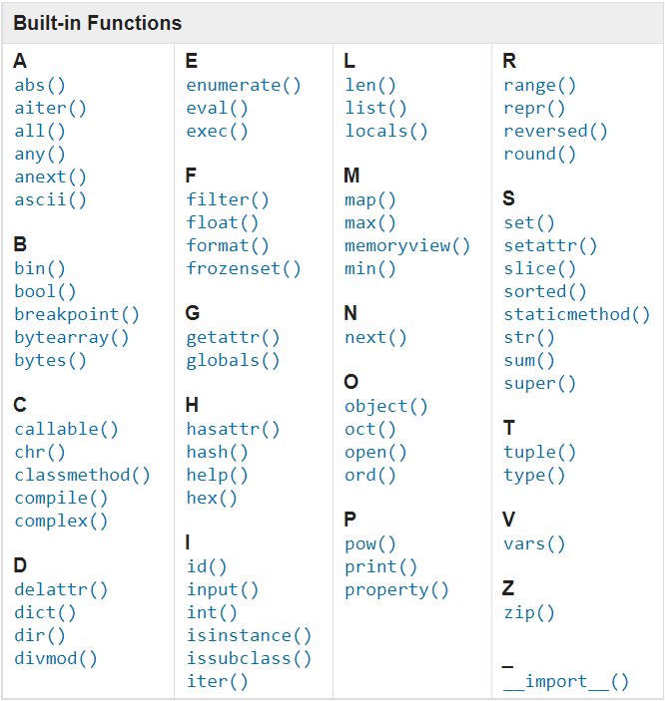install sublime text
Terminal python
Single =
Double ==
Assignment creates a memory in the computer and holds it
Avoid using space as part of a string, may become hard to recall later
When assigning data to variable, always delete old variable of the same name to avoid taking up memory on the computer
Use delete
Vectorisation vs For loops
FirstName or firstname or first_name but never first.name
Put it in mind that when you are writing a variable, that sm1 else will use it
e.g. amount_KFC, amoutn_McDonalds
Variables are case sensitive
Built-in Function
type()
len()
str()
int()
float()
print()
input()

Print only accepts strings and not integer
https://docs.python.org/3/
github.com

