PA2-43480-70019

Peer-Review

1. This program does compile with warnings, it has an issue with hold1 and hold2 in sequence.c for what ever reason. Below is what I entered and what was returned.
2. 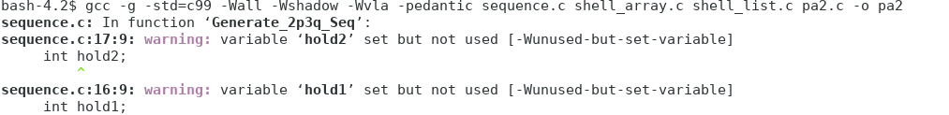I think due to this issue It is running into a non print issue, so I am not able to see it working I am going to skip to 5 and pretend it didn’t compile, and work on the questions that you asked
3. I
4. I
5. “Would like some help to see if the sequence is correct in order and correct in implementation. Used a helper function that calculates the held power and returns to be used to generate sequence back into the function.”
   1. Is sequence correct?
   2. Is it implemented correctly?
   3. Is helper function needed?
6. A screenshot of a cell phone

   Description automatically generated

Above is the function output of generate using size 10, so Im thinking that it is implemented wrong. I will address this more in an explanation later, however, it looks like the memory is dynamically allocated for each point to be returned. To computer the 2q3p values it does not look like it does compute these values but that’s okay because the user has stated they are unsure of it this is implemented correctly and it is worded kind of weird in the .pdf for what is being asked.

1. For the following functions because it would not compile fully or allow me to straight run everything, I am going to cover how the functions look. Load File function looks like it does everything correctly, they then also allocate memory for the long array given the amount of items int the file which it determines by reading through the file first and counting for each value in the file.
2. Save to File looks 100% good, everything is being written to the file that is output, argv[3], and it is taking the number of saves as well.
3. The shell sort looks good like it is cycling through everything as it is supposed to, one thing I don’t know that declaring the n_comp within the if statement is the best option. You can declare it outside and use it inside, the reason I say this is if you need to use it outside it doesn’t exsist.
4. Unfortunately I too am working through more issues on my code, be careful using github desktop it does not allow you to save locally, just an FYI and never delete your changes, always stash and look at what you have.
5. So to address part 5 with your questions, I was able to get a small output for part 6 it did not look like it was outputting correctly to what I believe generate needs to be producing. So in the pdf for requirements it was written kind of weird and non descript I think using examples for this would have been way more helpful for everyone. What it is asking is that you input the number of items in input file and the address of a seq_size, I am assuming that this is the array of 2q3p. These sequence is supposed to be a PRATT GAP SEQUENCE, only highlighting and cap so its easy to find again later, but there is a algorithim to find this. You are supposed to find every number equal to less than the total number of items in the original long array which is why its said if there are 16 items you will have in the array [1,2,3,4,6,9,12] these numbers are to give you the shell sorting k values. So looking at your code I would say that you are possibly making it more complex than it needs to be. This is were I am getting things a little mixed up I am not sure why I am returning a long, unless we should be calling shell sort with int size being the values of the array generated which would make sense. I do not think you need a helper function. As for the rest of your program I believe you are either right on the cusp of being done or if you do run into issues they will be small changes just to make the different codes agree with each other. You don’t look to have any glaring issues in this code.
6. I did not run Valgrind with your list function, but my words of wisdom would be to use as many objects from array as possible without creating the original array, so what would be a good idea would be to just have a create function extra. I would say that in the shell sort function I think that you can just use an insertion or bubble sort in each shell to move the objects around you will just need to account for moving the address’ of each which should only be 1-3 more lines of code.

Hopefully this has been helpful to you, I think many people are having an issue with the generate function and I think that us all asking more descript or probing questions on piazza will help that way we as students can help each other more and the professor is able to let us know who is working on the right path.