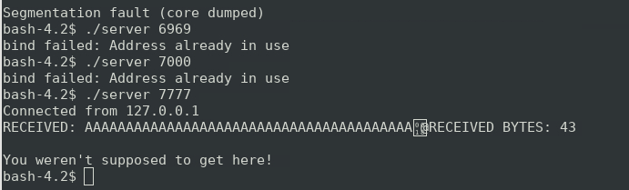

This picture is of sending the string of 40A’s and the address of secret function to server

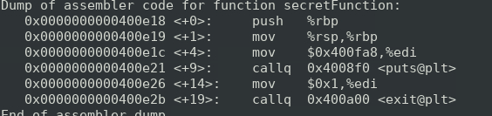

RBP gives us the address which we will have to use \x18\x0e\40\x00

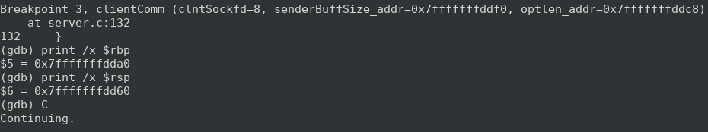

These are the print statements that give use the stack pointer and the base pointer when subtracted we get 40 which tells us the number of A’s

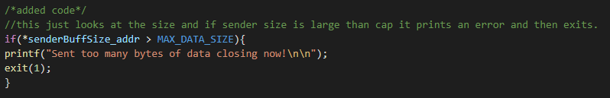

Added this code to check if the sent data size is larger than the buffer we have made if so it exits before it can copy so that there is no buffer overflow. This code is circled by comment blocks