ANOVA (Analysis of Variance) problems

1. Let’s consider a school dataset having data about student’s performance. By using One Way ANOVA let us determine is there any impact of the guardian on the final grade.

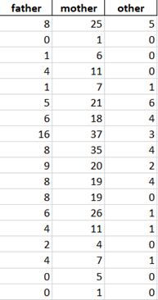

* Perform One Way ANOVA following the steps:
* Define Hypothesis
* Calculate the Sum of Squares
* Determine degrees of freedom, F-value
* Accept or Reject the Null Hypothesis
* Explain the conclusion.

2. Download the data named “bipolar disorder” from canvas.

This dataset was analized in this publication: Espinós U, Fernández-Abascal EG, Ovejero M (2019) Theory of mind in remitted bipolar disorder: Interpersonal accuracy in recognition of dynamic nonverbal signals.

This dataset may help people who are starting with data analysis and want to perform basic ANOVA.

Perform an ANOVA test to verify that different group has different mean number of right answers.

Provide the ANOVA table for more details analysis.

If null hypothesis is rejected, perform pairwise comparison using host hoc test Tukey’s test. Provide all the tables and explain your result.

3. Data “P03.xlsx” represents the mean income of people from different race and sex from 1947 to 2019.

Define and Perform your own hypothesis(more than one) to explain mean income level of people from different groups.