

**Table of Contents**

1. Description
2. Nav Bar
3. Colours
4. Typography
5. Snapshot of each page

1.

My website has a home page, about me page, projects page, services page, GitHub page and a contact me page. It has information on what I do, like to do and how you can contact me.

2.



The nav bar is highlighted blue when you are on that page, and when hovered over it will highlight red.



3.

<http://www.colorzilla.com/gradient-editor/#31beff+62,31beff+78,c1ecff+100,c1ecff+100,c1ecff+100,c1ecff+100,c1ecff+100,e5f7ff+100;Custom> is the background colour.



Header h1 #FC0



Nav active page #09F



Nav hover #C00

Nav border #FFF (white)

4.

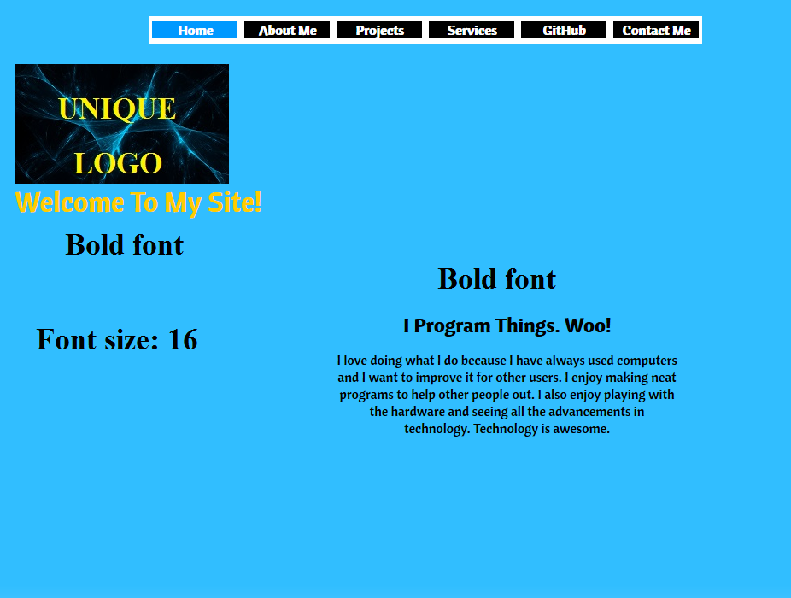

5.



