Background:

A websocket is a socket initiated over HTTP and are typically long-lived. Messages can be sent in either direction at any time. They are useful where low-latency or server-initiated messages are required.

Very cool, burp has its own tab in the proxy section dedicated to websockets. Simply do typical application mapping with burp and check this tab to see websocket requests/ responses.

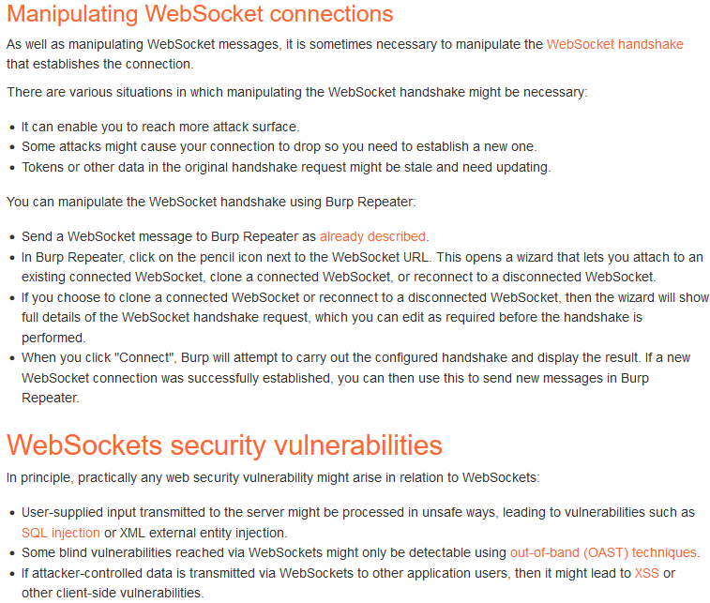

This section details how to edit the websocket handshake, which can be used to initiate vulnerabilities

Make sure to thoroughly look through all of the different websocket traffic and test all different parameters for a variety of vulnerabilities. If you see reflected input coming from a websocket message ofcourse make sure to test it for XSS! (test anything stored for SQLi, stored xss ………)

Cross-site WebSocket Hijacking

