Traveling salesperson problem

Homework 1.

EOA

CTU, FEL

David Koleckar, winter 21/22

Running the application
Program can be either run as script by running ‘model.py’ for console output or by running ‘main.py’ which starts the full graphical user interface of the program.
Modules
model.py: Represents algorithm and it’s parameters.

local_search.py: Implements exhaustive 2-opt, 3-opt and first-improving local search with variable perturbation (either swap2 or reverse_subsequence)

evolutionary_algorithm.py: Basic evolution pipeline: parent selection(truncate/tournament) → breed:(crossover→mutate) → population replacement with multiple changeable parameters and operators.

operators.py: Implements various crossover and mutation/perturbation operators.
crossovers:
- OX2 (Order Xover 2),
- PMX (Partially Mapped Xover),
- ERX (Edge recombination Xover)
mutations:
- reverse_sub = reverse sub-sequence of length k
- swap2 =swap two genes in permutation (yields random k-opts)

function_tools.py Contains all other and helper functions and tools.
Gathering statistics by running algorithm multiple times.
Population initialization:
- ‘random’ = initialize population of given size with random solutions.
- ‘nearest_neighbour = constructive heuristics, choosing the best (distance) available neighbour, deterministic.

controller.py: Represents controller in MVC (model-view-controller), one main GUI thread and two helper threads. Worker – running model, ViewUpdater – live plotting the best solution and fitness in time(fitness calls).
view.py: Implements the application UI. Using PyQt5. Live plots use pyqtgraph package.

plotting_matplotlib.py, plotting_pyqtgraph.py: Plotting the graphs running the application from console or GUI respectively.
Dependencies:
- PyQt5
- pyqtgraph
- matplotlib
- numpy

Graphical user interface

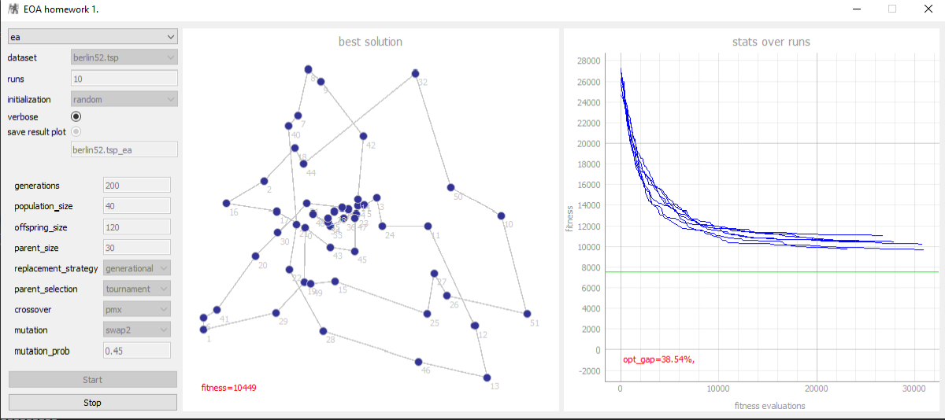
Image 1. Graphical user interface of the application.

The left panel allows to set parameters of the model. User can choose algorithm, dataset, etc. Setting verbose, prints run-time info/changes to the console.
Middle pannel shows at real-time the best found solution and it’s fitness.
Right pannel plots the real-time progress of actual run of the chosen model and the actual optimum gap.
Start the search by clicking Start button.
Model parameters

self.available_algorithms = {
"ea": evolutionary_algorithm,
"ls": local_search,
"opt-2": opt_2_best_improving,
"opt-3": opt_3_best_improving
}
Code snippet 1: Available algorithms.

self.optimums = {"gr17.tsp": 2085, "gr21.tsp": 2707, "gr24.tsp": 1272, "gr48.tsp": 5046,
"hk48.tsp": 11461,
"si175.tsp": 21407, "si535.tsp": 48450, "si1032.tsp": 92650,
"swiss42.tsp": 1273,
"berlin52.tsp": 7542,
"a280.tsp": 2579}

Code snippet 2: Prepared datasets (with their optimums).

self.params_general = {'algorithm': self.available_algorithms[self.algorithm_name],
'algorithm_name': self.algorithm_name,
'generations': 200,
'solution_size': self.graph.dimension,
'runs': 10,
'dataset_name': self.dataset_name,
'optimum': self.optimums[self.dataset_name],
'plot_solutions': False,
'verbose': True,
'save_result_plot': True,
'save_results_file_name': self.dataset_name + "_" + self.algorithm_name}
self.params_ea = {'population_size': 40,
'offspring_size': 120,
'parents_size': 30,
'initialize_solution_func': initialize_solution_permutation,
'replacement_strategy': "generational",
'parent_selection': "tournament",
'crossover': "pmx",
'mutation': "swap2",
'mutation_prob': 0.45,
}
self.params_ls = {'initialize_solution_func': initialize_solution_permutation,
'perturbation_operator': mutate,
'distances': get_distances(self.graph),
'ls_stype': opt_2_best_improving,
}
Code snippet 3: Model parameters – default setting.

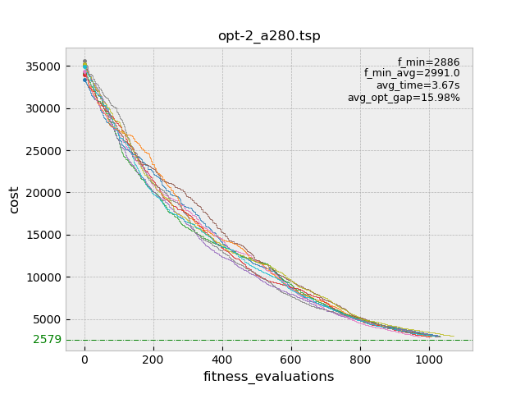
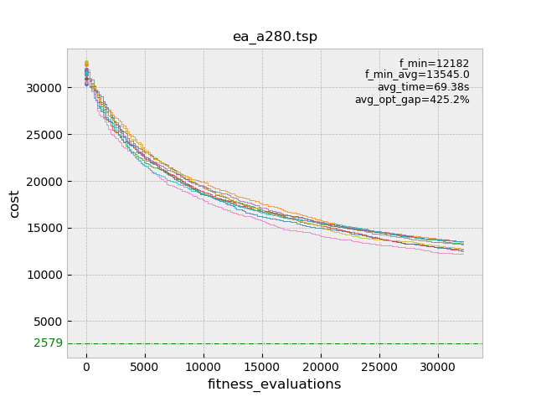
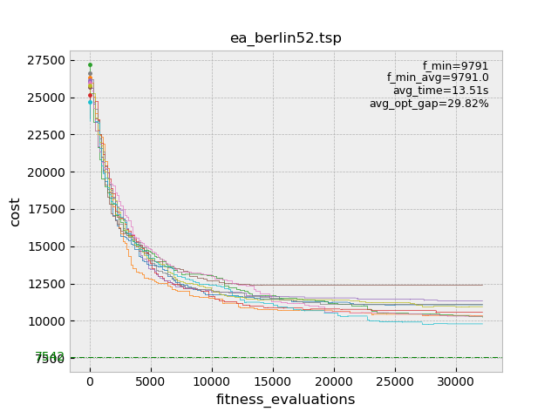
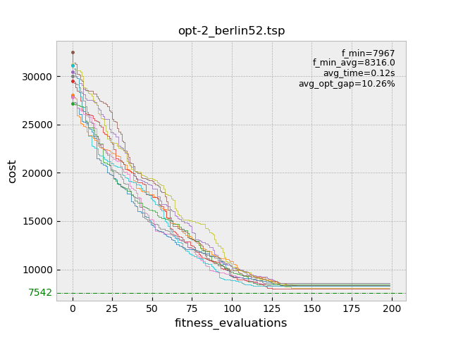
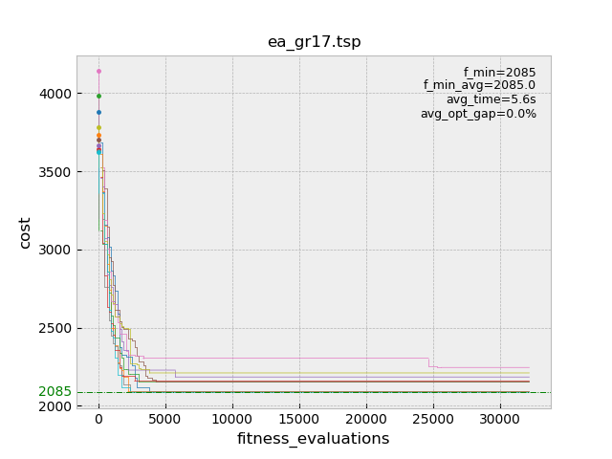
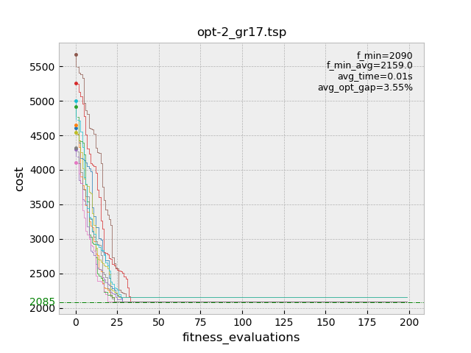
Graphs (10 runs)
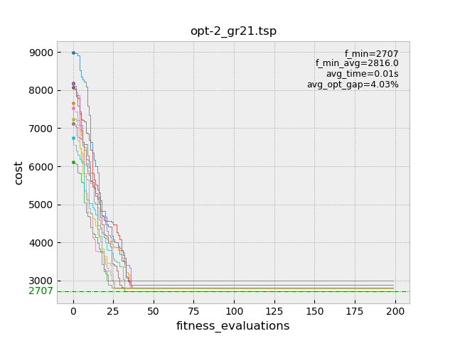
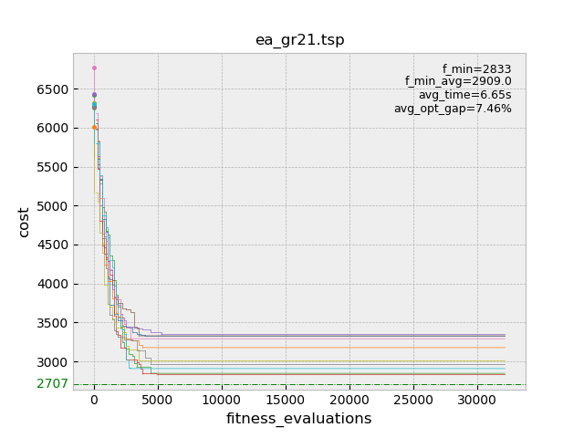
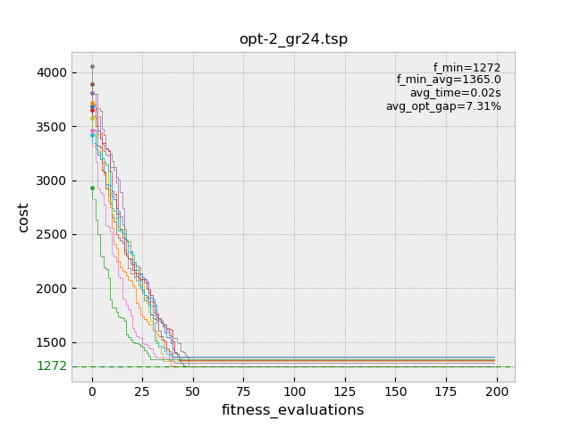
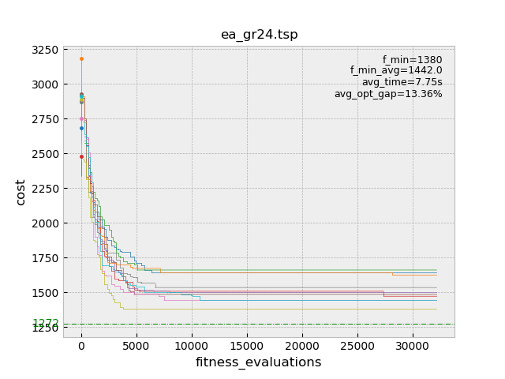
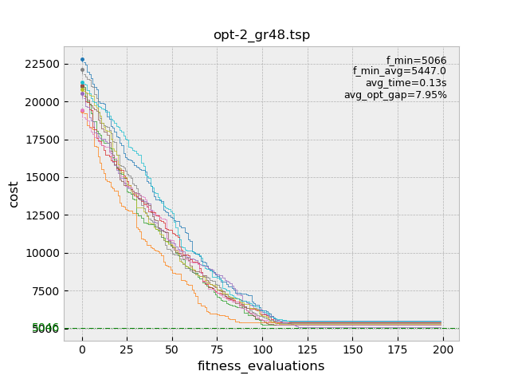
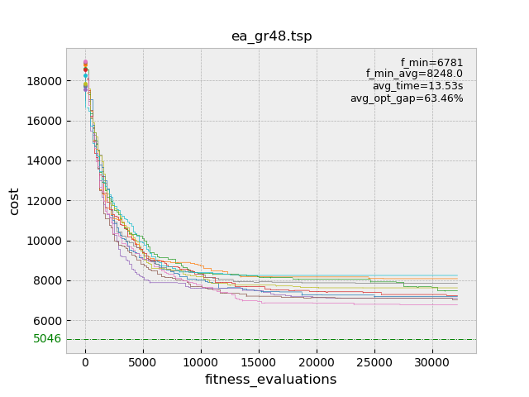
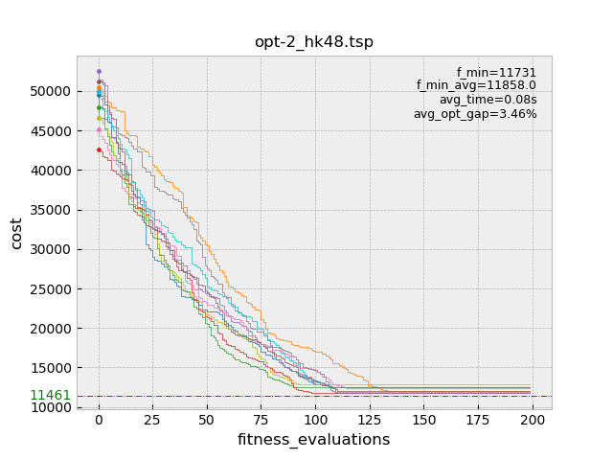
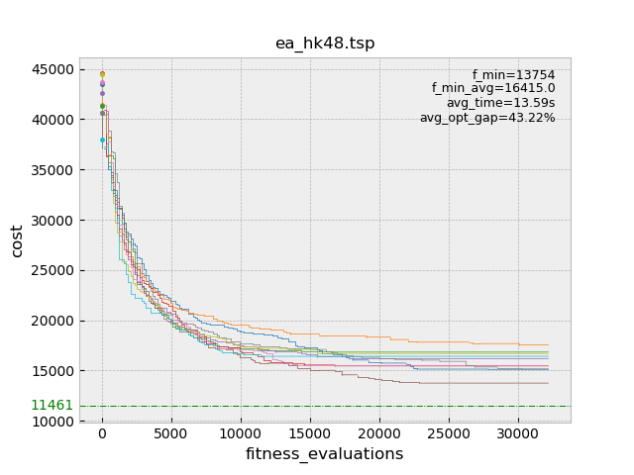
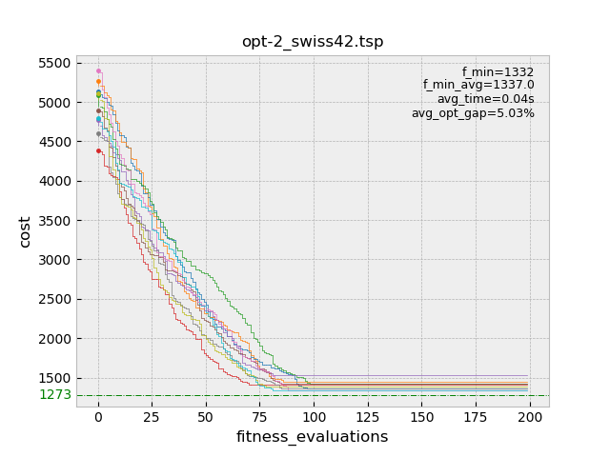
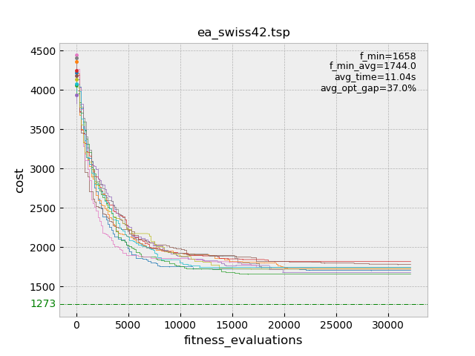
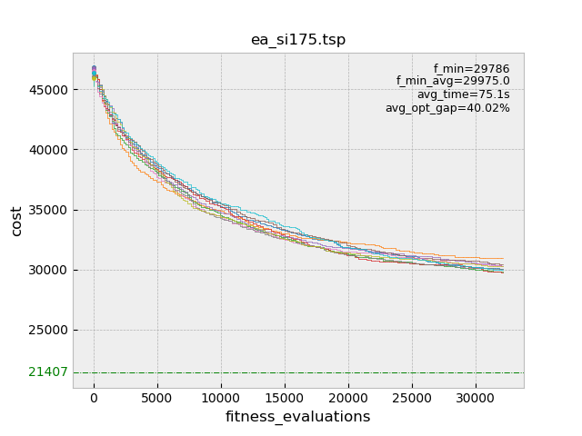
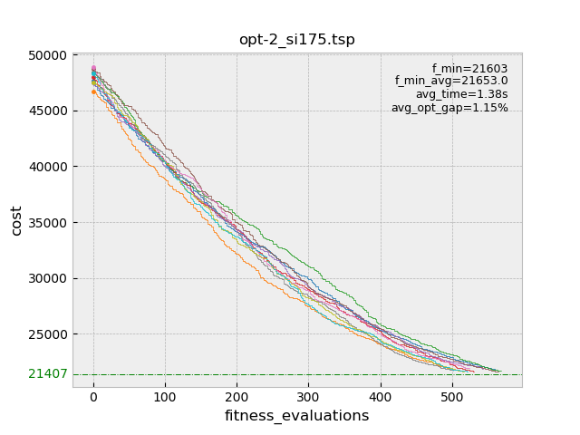
Results
The local search with 2-opt wins over evolutionary algorithm on all 10 tested datasets in terms of both speed of convergence and found optimum. The 3-opt in terms of optimality beats 2-opt but has cubic time complexity in number of nodes instead quadratic of the 2-opt, which is quite significant for the larger datasets.
Notes
Loading datasets: using tsplib95 package facilitating datasets input.
For the bigger datasets I was not able to plot the solutions. 10 runs on datasets with ~1000 nodes was to much for my laptop.

Improvements
GUI not fully debugged, possibility of crashes in some situations.
Implement more algorithms/operators.
EA pipeline and operators could be speed/memory optimized.

