EA for constrained optimization

EOA - Homework 2.

David Koleckar
CTU, FEL, winter 21/22

Modules
main.py
Runs all the algorithms for all the objective functions, collects statistics and visualizations.

objective_functions.py
Implemented objective functions from [3], namely g05, g06, g08, g11, g24.
Provides an interface for working with listed functions.

class ObjectiveFunction:
def __init__(self, id):
self.name = id
self.fitness_func = g<id>
self.feasibility_func = g<id>_feasibility
self.variables_size = g<id>_variables_size
self.objectives_size = g<id>_objectives_size
self.opt = g05_f_opt

Code snippet 1.: the objective_functions.py interface

for each of the objective functions there is in objective_functions.py a:
- function returning value for each of the objectives – fitness and constraints,
- function returning True, if the solution is feasible
- number of objectives and variables
- known optimum
Epsilon for numerical precision is set to eps = 0.00001.

function_tools.py
All helper functions and non-specific ea functions common to all the used ea pipelines (e.g. init_population(), breed(), …).

operators_real_encoding.py
Collection of various crossover, mutation functions.

ea_nsga2.py, ea_spea2.py, ea_stochastic_ranking.py
Implementing the specific ea algorithms. Can be run as a script, if params[“verbose”] - printing some basic population statistics [Image 1].
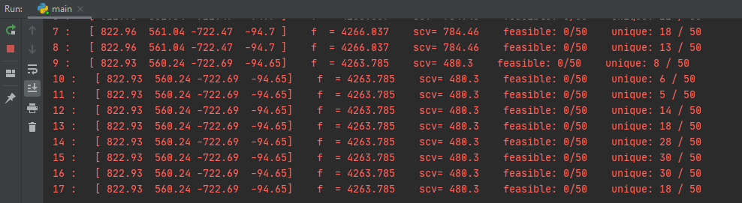

Image 1: Information(coordinates, fitness, scv, etc.) printed to console during chosen algorithm run.
Parameters

objective_function = ObjectiveFunction(objective_function_name)
params = {
'fitness_func': objective_function.fitness_func,
'feasibility_func': objective_function.feasibility_func,
'objectives_size': 2, # objective_function.objectives_size
'variables_size': objective_function.variables_size,
'evaluation_mode': "single_objective", # “multi_objective”
'solution_bounds': [-1000, 1000],
'population_size': 50,
'offspring_size': 150,
'parents_size': 40,
'generations': 200,
'initialize_solution_func': init_population,
'cmp_mode': "constraint_domination", # constraint_domination / "binary_tournament"
'replacement_strategy': "generational",
'tournament_size': 15,
'crossover': xover_arithmetic,
'mutation': mutation_cauchy,
'mutation_prob': 0.35,
'verbose': True,
}

Code snippet 2.: parameters for the ea.

These parameters were fixed and used for all of the test runs, except g05, where generations=2000.
objectives_size is set to =2, it is possible to set it to =objective_function.objectives_size, to consider other objectives and not only the sum of constraints violations.
If the objectives_size considers all the objectives, the evaluation_mode should be set to “multi_objective”.

Results
The following plots of the algorithms run were generated with [Code snippet 2] parameters. For information the full number of objectives is noted, but the algorithms were considering only 2 – fitness and sum of all constraints violations (the other “objectives”).
Note: the plots for Spea2 are not present, since the implementation of algorithm doesn’t converge (due to possible bug). Also the plots for multi-objective version of Nsga2 are not shown, because the algorithm didn’t converge neither, getting stuck in one solution (unique_specimen=1 from the whole population_size), while still not being feasible.
On the left: the plots for best fitness in current population (archive – for spea2) are given. Best means smallest fitness value, all functions are minimization problems. If non of the current solutions is feasible, the fitness value of solution with the smallest sum of constraint violation is given. Only values +- ¼ from the optimum are plotted.
On the right: unique and feasible solutions in current population.
Note: y-axis should be better called “specimen in population”.

The optimum gap is calculated as an average of the fitness of the best specimen from the last population across the multiple runs.
g06
# variables = 2, # objectives = 7, (function definition given in [3])
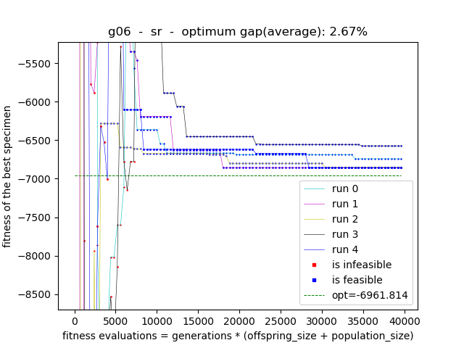
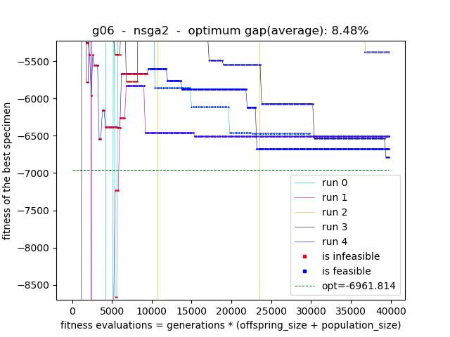
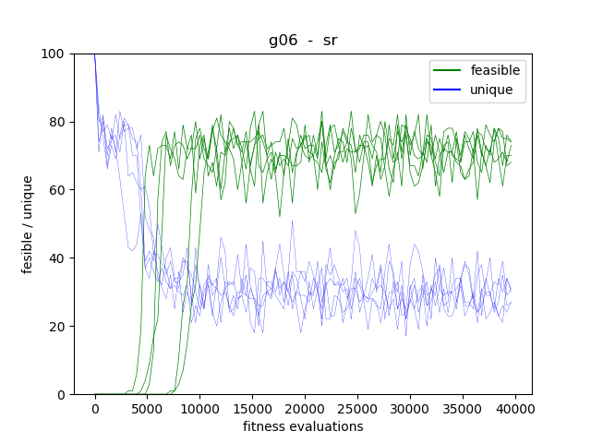
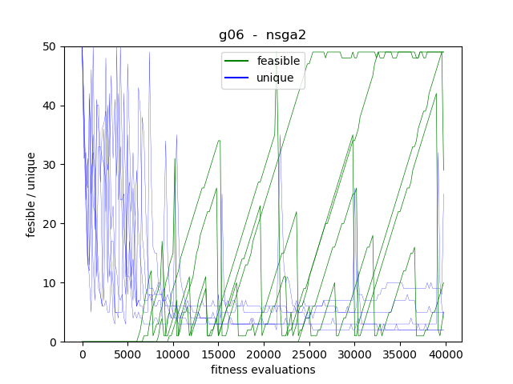
g06 (20 runs)
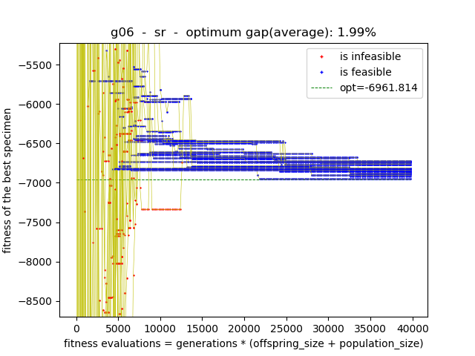
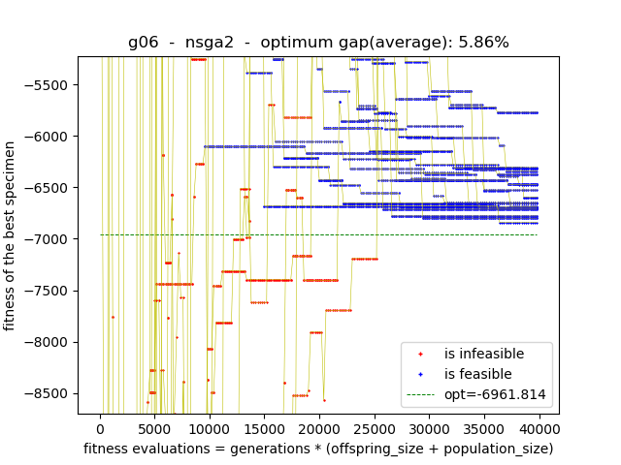
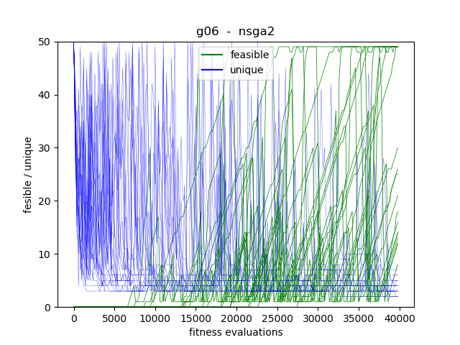
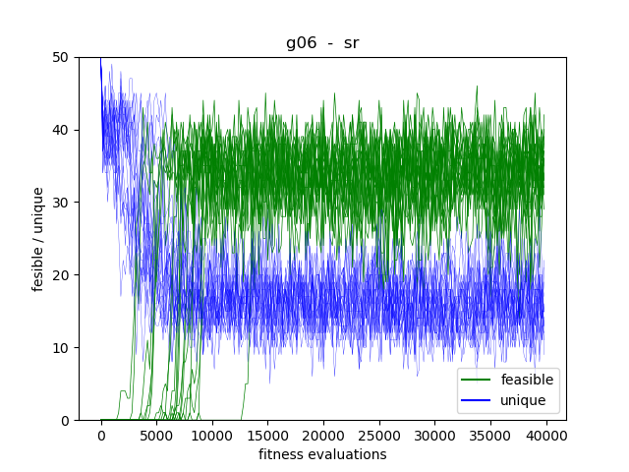
g08
# variables = 2 min # objectives = 7 f(x) = (x₁ − 10)³ + (x₂ − 20)³ st:
g₁(x) = −(x₁ − 5)² − (x₂ − 5)² + 100 ≤ 0
g₂(x) = (x₁ − 6)² + (x₂ − 5)² − 82.81 ≤ 0
13 ≤ x₁ ≤ 100 0 ≤ x₂ ≤ 100

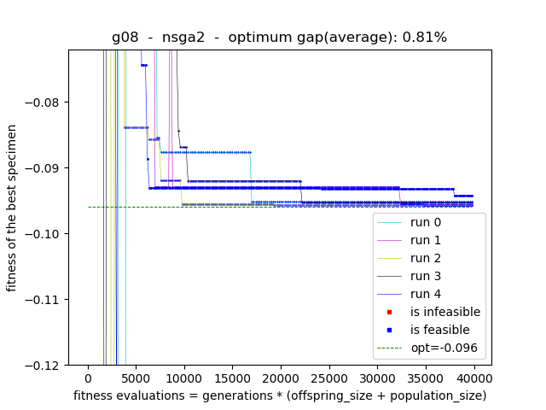
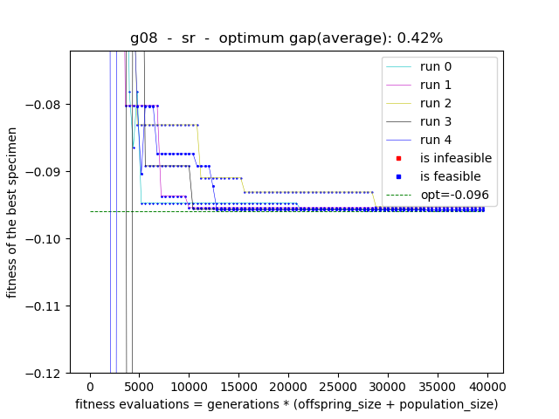
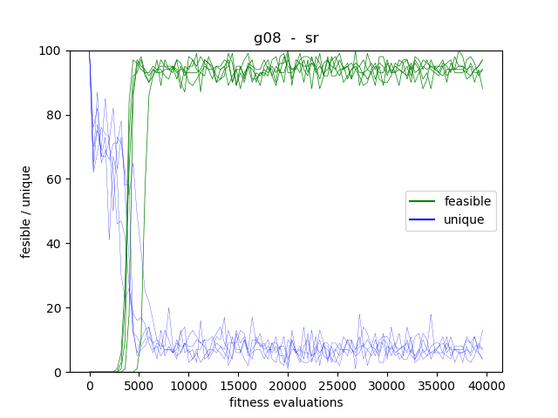
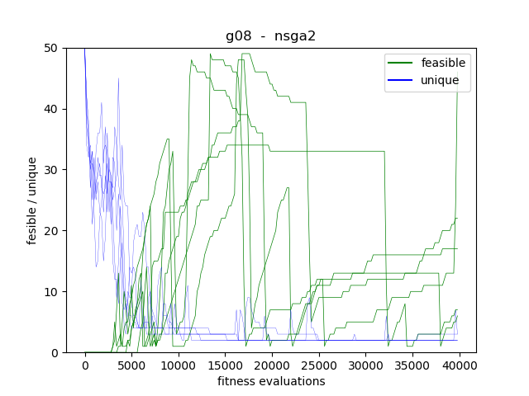
g11
# variables = 2 min
# objectives = 6 f(x) = x₁ ² + (x₂ - 1)²
st:
h(x) = x₂ - x₁² = 0
-1 ≤ x₁ ≤ 1
-1 ≤ x₂ ≤ 1
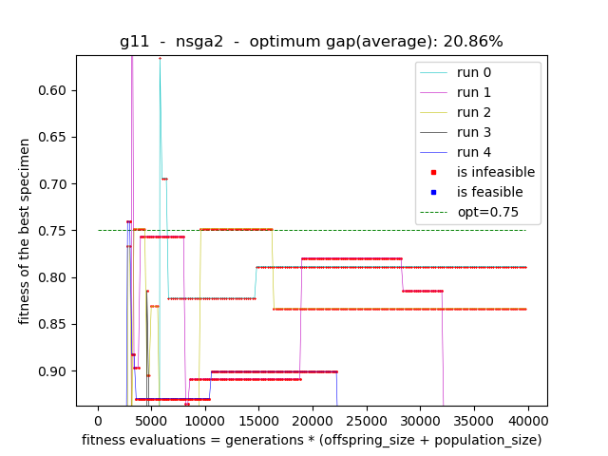
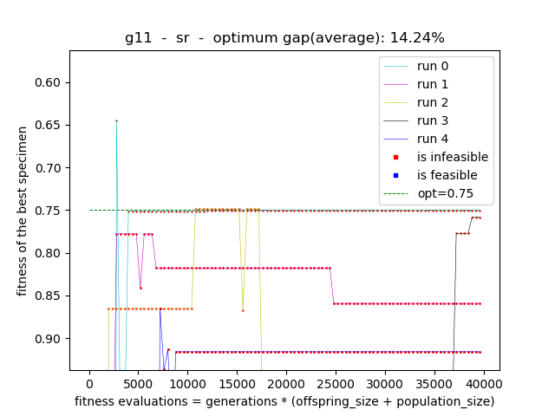
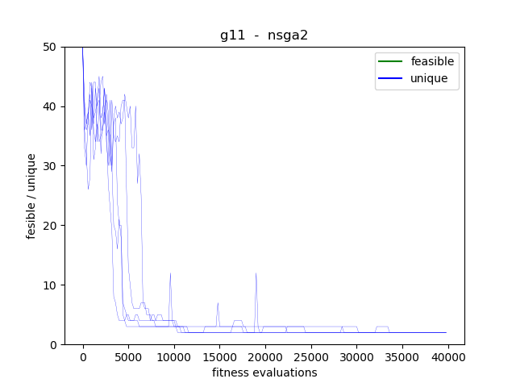
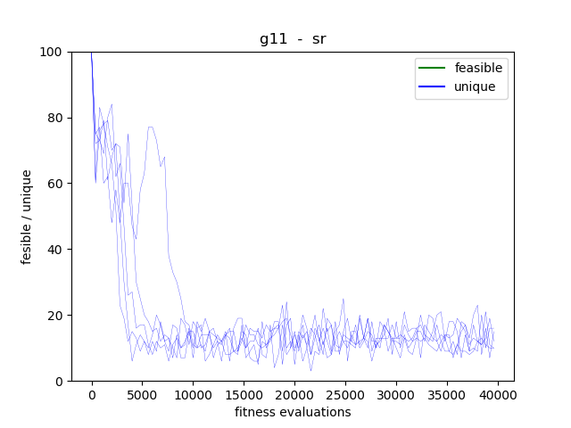
g24
# variables = 2, # objectives = 7, (function definition given in [3])
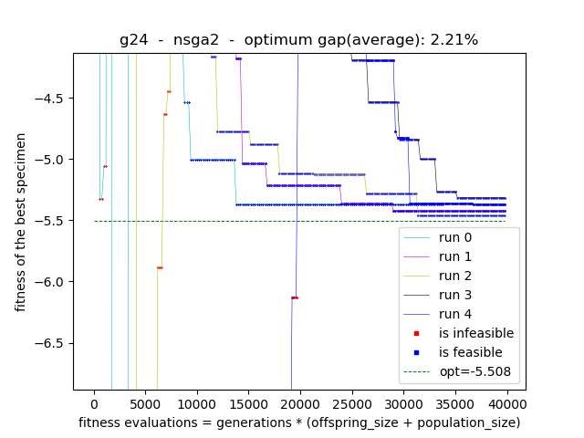
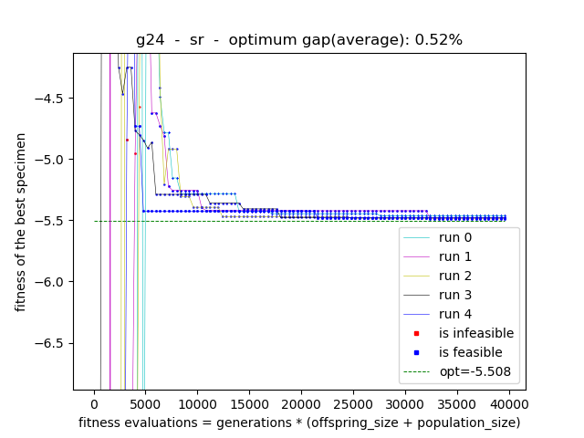
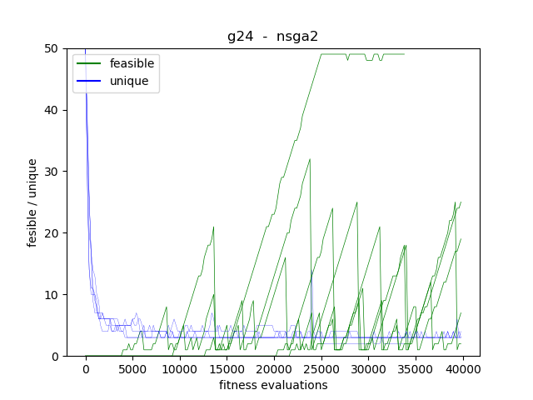
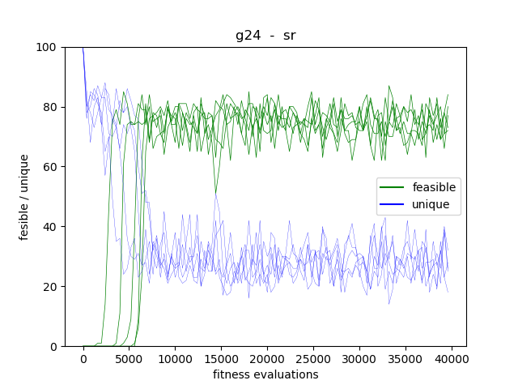
g05
# Variables = 4, # Objectives = 14, (function definition given in [3])

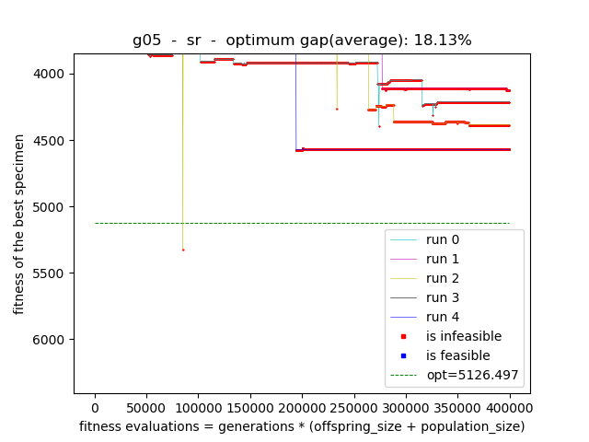
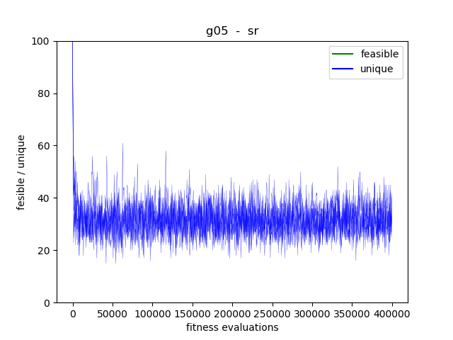

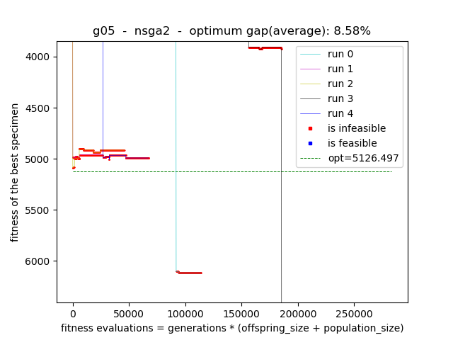

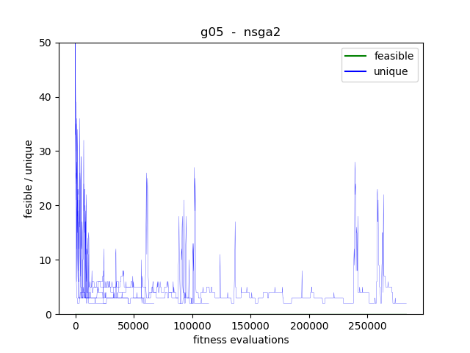

The Nsga2 was in every run killed – due to the policy of100 non-improving generations.
The stochastic ranking was still improving (even if it is not clear from the plot resolution).
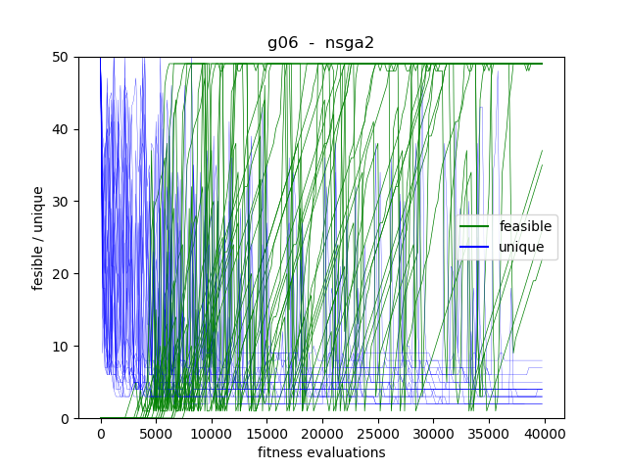
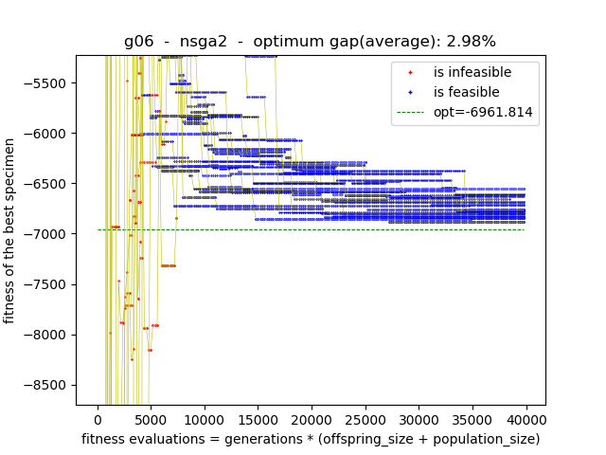
NSGA2: binary tournament vs. constraint domination - 20 runs
(constraint domination first, binary tournament as second plot)
Discussion
Stochastic ranking (sr), NSGA2 and SPEA2 algorithms were implemented. The results show for given implementation the stochastic ranking ea converges faster towards the global optimum. The NSGA2 search seems to be more fluctuating.

The fitness was decreasing monotonically for both sr and NSGA2 once the feasible solution was found.
The nsga2 tends to keep smaller portion of feasible solutions in population, contrary to the stochastic ranking. (Such phenomenon could be caused by given implementation?).

The optimality gap seems to decrease with increasing generations, but the ratio of optimality gaps for the sr and nsga2 seems to remain more the same.

For g11 both algorithms in given generations limit didn’t converged, but it is possible, they would given more generations, the population is “balancing” on the infeasible side of pareto-optimal front. It seems however, the same cannot be said about g05.

The operators for parent selection in NSGA2, namely the binary tournament for nsga2 seems to be more effective on some functions than using constraint domination tournament .

Notes:
1)
Computing of the crowding distance is given by [2] as follows:
for specimen j the partial crowding distance for objective i is given as:

partial_crowding_j[i] = (objective_j[i + 1] - objective_j[i – 1]) / (objective_i_max – objective_i_min)

The case for objective_i_max == objective_i_min however is not discussed in the [2]. This is for example the case when all every solution has violation equal to zero for the same objective.

2) the statistics could be re-run with 'cmp_mode': "binary_tournament", which could improve the optimality gap and convergence for some of the test functions.

References
[1] Zitzler, Eckart; Laumanns, Marco; Thiele, Lothar, (2001), SPEA2: Improving the strength pareto evolutionary algorithm

[2] Deb, K., Pratab, A., Agarwal, S., and Meyarivan, T. (2002a). A fast and elitist multi-objective genetic algorithm: NSGA-II. IEEE Transactions on Evolutionary Computation, 6:182–197.

[3] test functions defintions: https://cw.fel.cvut.cz/wiki/_media/courses/a0m33eoa/cviceni/2006_problem_definitions_and_evaluation_criteria_for_the_cec_2006_special_session_on_constraint_real-parameter_optimization.pdf

