Metaheuristic framework for permutation-based optimization problems
David Kolečkář CTU, FEL, winter 21/22

Work motivation
This work aims at creating metaheuristics optimization solver/framework (mof)[1] for optimization problems with solutions that can be meaningfully represented as permutations with repetition and variable length (pwravl). The permutations and permutations with repetition being subset of prwavl. Example: Given a set {0, 1, 2, 3, 4}, some of solutions using this representation could be: [0, 1, 2, 3, 4], [0, 1, 0, 2, 4] and [0, 0, 0, 1, 2, 3, 4, 1, 2, 3]. (Nothing about validity of such solutions for any problem is said, they stand here solely as example of the pwravl representation.)
Solving of large or hard instances of NP-hard problems (i.e. their optimization version) is often intractable even by the best commercial MILP solvers (eg. Gurobi). The MILP solvers (and ILP formulation) strength is the ease of implementation and also if the solver is able to solve the problem instance, it is solved to the global optimum.
Even though lots of optimization problems are subjected to intense research and advanced methods that solve hard instances of ‘standardized’ datasets -even to the optimum- can be found in literature, they are often non-trivial, very problem specific and hard to implement. Also the palette of metaheuristics usable for addressing hard problems is notably large. Single-solution (e.g. iterated local search, tabu-search) vs. population-based (genetic algorithms, ant-colony optimization), the combinations of population and single solution approaches in the form of memetic algorithms, etc. [2], [Image 1]. Even for someone proficient in this domain however, it can be intricate to choose and implement the most suitable one.
This work aims at being somewhere in the middle. Given any problem representable by pwravl, the only thing that user has to implement is the fitness (cost) function for the given problem instance, following a simple predefined interface. The solver should be able to tackle even the hard problems. The generality and ease of use comes however with a cost. Such approach cannot compete with the problem-tailored heuristics and some gap for the optimum relative to optimum found by problem-tailored heuristics is presumable.

Optimization problems representable as pwravl
The potential optimization problems sharing pwravl representation are quite a few. Some of them are the more simple versions of pwravl being either just permutations (e.g. TSP) or permutations with repetitions in case of Job-Shop for example. Most of these problems have in their basic form a single objective and are subjected to one or more constraints. The next short list is not a complete enumeration.
- traveling salesman problem - tsp and it’s generalized variants

- vehicle routing problems – vrp and its variants cvrp, vrptw

- scheduling - Job shop

The solver was tested at first on the ‘capacitated vehicle routing problem with time windows’ (cvrptw) or more likely to be referred to in the literature just as the ‘vehicle routing problem with time windows’ (vrptw). (c)vrtpw is a constrained optimization problem that can be described as follows. Given:
- set of customers C ={1, …, n} and the depot D={0}
- fleet of k homogeneous vehicles (usually k=inf or k=|C|)
- time(/distance) matrix of size <|C|+1, |C|+1>, (+1 accounting for the depot)
- vehicle capacities: q₁, …, q_{k}, where 0 < q_{i}, for i: {1, …, k}
- customer demands: d₁, …, d_{k}, where 0 ≤ d_{i}, for i: {1, …, n}
- customer time windows (earliest and latest time that customer can be served) [a_{i}, b_{i}], for i: {1,…,n}, where: 0 < a_{i} < b_{i}, [a₀, b₀] is the scheduling horizon, usually [0, inf]
- customer service times (duration of serving the customer) s_{i} for i:{1, …, n}, where 0 ≤ s_{i}
Minimize the total time (time traveled to serve all customers by the fleet and sum of the time waited by vehicles if arrived to any customer early) it takes to service all of the customers, subjected to satisfying all the customer demands in the according time windows, not exceeding the vehicle capacity on the route. Each customer has to be served exactly once. Each vehicle has to start and end at the depot. Formal ILP descriptions of such constrained optimization problem are numerous.
Example: Valid pwravl for C={1,2,3,4} and depot={0} would be [0, 1, 2, 0, 4, 5, 0] (feasibility constraints could be violated given some specific instance). Feasible example given in [Image 4].
There could be multiple version of this problem given the constraints. Deadlines (time windows) are usually hard, meaning arrival after the upper bound of the time window means either failure or constraint violation, the same goes for car capacities. If car arrives early it waits until time window starts and s_{i} is usually non-zero. The datasets the solver was tested on used all the listed constraints.

Population based metaheuristics and evolution algorithms
The so far implemented solver uses the quite common ‘standard’ evolution algorithm (ea) pipeline.
The population is initialized by random initialization. If the initialized specimen is not feasible the initialization is repeated for some number of tries. If even after k tries an infeasible solution is generated, such infeasible solution is kept. The mechanism of ea produces feasible ones later on.
The parent selection for breeding offspring is based upon algorithm for optimization problems with constraints called stochastic ranking[4]. For each specimen a fitness and constraints violation sum (scv) is calculated. For some constraint, let’s say time window of <10, 45>, one such violation would be visiting such customer with a time window constraint at time=55, giving the violation=10. No weights of violations are present, they are just summed up. When choosing the parents, the population is first ranked by the stochastic ranking. The lower the rank, the better. If the two compared solutions are feasible, they are only compared by fitness. Otherwise a weighted coin is flipped (random number is generated from <0, 1>). If the generated random number is lower than a chosen probability P (usually 0.4 < P < 0.5) the two solutions are compared only by fitness, even if (one or both) are infeasible. Otherwise they are compared only by scv. Such approach allows for keeping some infeasible solutions in population, increasing the probability of exploring more of the search space, moving close to the pareto-optimal front [5], if minimization of scv is viewed as second objective. Such ranking is used for tournament selection. Tournament indices from the population are generated at random with repetition, and sorted by the ranking. Then the winner is randomly chosen from a weighted distribution, where the probabilities geometrically decreases.
The chosen parents are then subjected to the breeding. Two randomly chosen parents are passed to crossover creating a child. The crossover being one of the most crucial parts of the ea is described in more detail in the next page.
Then with some chosen probability P_mutation (usually 0.3 < P_mutation < 0.6), the child is subjected to a mutation. One from the three mutation modes is chosen at random. 1. swap two randomly chosen genes (standard 2-opt perturbation), 2. a non-essential gene is removed or 3. non-essential gene is added. Non-essential gene is deemed as such, if after removal or addition to the chromosome, it’s lower or upper bound constraints for the presence in the chromosome will be still satisfied. E.g.: In vrtpw problem such constraints on gene presence in the chromosome could be expressed by lower and upper bounds (lb, ub). All customers have lb=1, ub=1 and the depot has lb=2, ub=inf (or ub=|C|+1, if the [0, 1, 0, 2, 0] and [0, 1, 0, 0, 2, 0] solutions are considered equal)
The population is replaced in generational mode, which is recommended when using the stochastic ranking. Thus all the old population is replaced with the offspring. First the offspring are sorted by stochastic ranking and then the fist |population_size| are added.
There is also left a possibility to use algorithm only with fitness, if some constrained violation penalty is added to it. The simplest case would be the death penalty (some large number). For such simple case of comparing the population only by fitness, which implicitly accounts for constraints violation a steady-state population replacement is used.
Population is kept evolving for given number of generations or stopped after some given time limit.
The main pipeline of ea solver could be described by the following pseudocode:

Solver::solve(Instance):
population ← initialize_population(Instance, “random-valid”)
while (generation++ < params[“generations”]):
population_fitness ← Instance::fitness(population)
offspring ← breed(population, population_fitness)
population ← replace_population(population, offspring)
end
end
Solver::breed(population, fitness):
ranked_population ← ranking(population, fitness) // e.g. stochastic_ranking
parent_indices ← parent_selection(ranked_population, mode=”tournament”)
offspring ← mutate(crossover(parent_indices))
return offspring
end
Crossover operators
The representation chosen determines what kind of crossover (xover) operators could be used. Important property of xover is generating only the feasible solutions.
For the permutation representation there are quite a few xover operators. Namely:
- order crossover (OX)
- partially mapped crossover (PMX)
- edge recombination crossover (ERX)
- cycle crossover (CX)
- alternating edges crossover (AEX)
- heuristic greedy or random or probabilistic crossover (HGreX or HRndX or HproX)
[3]. Where the best results usually shows the PMX and the ERX. These basic xovers for permutation representation forms a basis of many of more advanced/specialized xover operators.

For chromosomes representing permutations with repetition could be used also some variety of operators. The most notable are the:
- Generalized Order Crossover (GOX)
- Generalized Position Crossover (GPX)
- Generalized Uniform Crossover(GUX)
- Position Preservative Crossover (PPX)
GOX is usually described as the best performing crossover for permutations with repetition [6].

Also for the chromosomes with variable length exists plenty of xover operators. Of the most used ones we could named the:
- The Speciation Adaptation Genetic Algorithm (SAGA),
- Virtual Virus (VIV)
- Synapsing Variable Length Crossover Algorithm (SVLC) [5]
Special-GOX
For permutations with repetition with variable length however the special operators lack to exist or are very hard to find in the literature. Not being able to find such existing crossover, new one had to be constructed.
The basic idea was to utilize GOX operator. However it works only on chromosomes of same length and with same number of repetitions from each of the genes.
To satisfy such conditions, some adjustments have to be made.
The first violation for using the GOX is the chromosome length. The longer chromosome has to be shortened (or vice versa shorter one has to be prolonged) to match the size of the shorter chromosome. Such operation should be still random in choosing the genes to be removed/add, while still being constrained by the lower and upper bounds of the single genes.
Second violation would be the uneven gene repetitions. Because it’s not just the length that must match, but also the same number of repetitions for each gene inside the chromosomes. Violation n.1 also directly implies the violation n.2.
E.g.:
chr₁= [0 1 0 1 2 3 4 1 0 5] chr₂= [0 1 2 3 4 1 5] both length and number of repetitions violated
chr₁= [0 1 0 1 2] chr₂= [1 3 4 1 5] number of repetitions violated
To repair the violations the following steps are made. For every gene present in one of the chromosomes but missing in the second one, add this gene to the according chromosome. After satisfying the gene count violation, if the chromosomes still differ in length, remove from the longer chromosome the non-essential genes (after removal the lower bound on gene presence in chromosome would still hold). All the removals and additions are done by randomly picking the indices of the genes to remove or add.
After all the conditions are satisfied perform the GOX.
After the GOX, the coin is flipped for each removed gene to be - or not to be - inserted back to the GOX-child chromosome. The measure for the reinsertion is to try to restore the length of blocks as much as possible as before the non-essential gene was removed. Example shown in [Image 2].

Comparison with State of the Art methods and conlusion
The solver was tested with the problem-specific backend for the vrptw on standardized datasets namely the Solomon 1987 - C1, Gehring and Homberger 1991 – C1, C2 from www.VRP-REP.org [7]. For some of the problems the optimum is known.
However the conditions under the test for this proposed solver and the conditions stated in the literature describing results of the state of the art (SOT) solvers are very different, in favor of the SOT solvers.
Some notes on vrptw SOT:
“The state-of-the-art results are achieved by branchcut-and-price algorithms (Pecin et al, 2014, 2017a; Pessoa et al, 2020), which combine column and cut generation with several additional mechanisms”
”This type of algorithm is able to produce optimal solutions for almost all instances with up to 250 customers, and in some cases, it can solve even larger instances (the largest one already solved has 654 customers).”
“Important observation on the behavior of modern branch-cut-and-price algorithms for VRP problems, explored in this work, is the following: while instances with more than 200 customers usually take hours or even days to be solved, many instances with up to 150 customers can be solved in few minutes, and many instances with up to 100 customers can be solved in seconds” [8]
As stated in [8] not even the SOT algorithm is problem-tailored but also consumes quite a computing power and time, uses parallelism etc..
The experiments performed for this solver were run without parallelism, any further optimization on IdeaPad laptop with Intel i5 core, with time limit set for smaller instances on 5 minutes, on larger instances (more than 200 customers) for 1 hour. For the two tested dataset the following observations were made.
Found solutions were feasible, on average 8 times the known optimum [Table 1] (average taken from 10 runs for each tested dataset instance and then these averages were averaged).
The instance size was not a big factor in means of solver performance. Even for the biggest instances of 1000 nodes the algorithm was performing similar as on the small ones and the algorithm was still improving the solution when the time was up. The algorithm on smaller instances seems tend to get stuck in some local optima or the proposed Special-GOX operator can’t exchange the building blocks well enough. [10]
Also the MILP solver was tested - namely the Gurobi and ILP formulation as given in [8] - with same conditions as experiments with the solver. However this ILP the formulation is quite simple and given the experiment conditions the Gurobi solver was able to solve only smaller instances (up to 30 customers).
The results are far from optimal, but the algorithms has good properties on large datasets which could be interesting if further inspected.
Possible improvements
The potential for solver further improvement is quite large. The logical next step would be the parallelization, lot of tasks performed by the solver are independent, notably the crossover and mutation for each child, which are also the most computationally heavy operations.
Also next step would be to try other advanced ea techniques for constrained/multi-objective optimization such as NSGA-II. The variety of special crossovers and their combinations is quite vast. The last step could be to use the memetic algorithm, e.g. by changing the mutation operator to some advanced local search.
Images
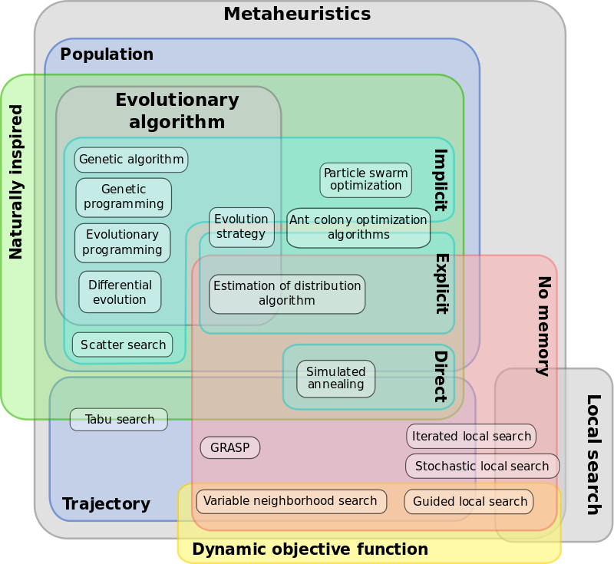

Image 1. Gant diagram of various metaheuristic classifications, courtesy of Johann Dréo, Caner Candan

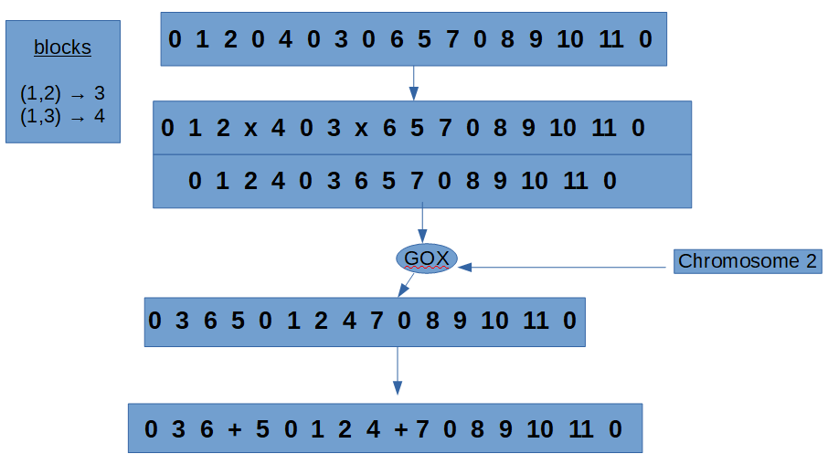

Image 2: Operations before and after GOX in the special-GOX operator – shortening and reinsertion

Problem_Specific_Instance : implements Instance
Generic Solver

class Solver

int get_fitness(pwravl)
abstract class Instance

class Solution

bool is_feasible(pwravl)
class Population

Dataset reader

eg. VRP-REP compliant dataset .xml reader
Etc…

Image 3: proposed framework basic structure diagram.

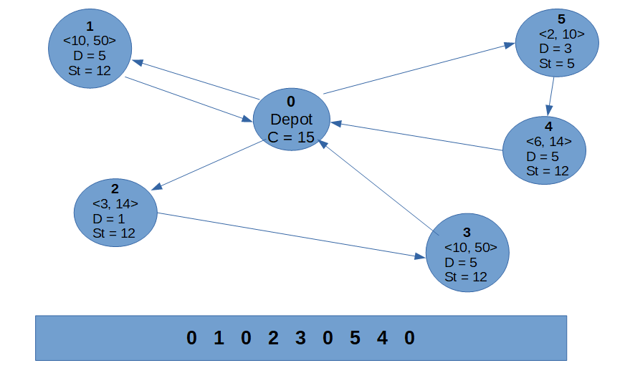

Image 4: VRPTW instance diagram and feasible solution represented as pwravl
Tables

Gehring and Homberger 1999-C1
Instance optimum average 10 runs feasible
small:
C1_02_01 2704.57 27045.12 1
C1_02_02 2917.89 19012.27 1
C1_02_03 2707.35 15002.02 1
C1_02_04 2643.31 32121.22 1
C1_02_05 2702.05 51000.43 1
C1_02_06 2701.04 18045.10 1
large:
C1_10_04 39501.23 210329.44 1
C1_10_05 42469.18 190612.35 1
C1_10_06 42469.18 270121.22 1
C1_10_07 42873.78 229121.98 1
C1_10_08 42220.24 310400.43 1
C1_10_09 40570.60 230445.11 1
C1_10_10 39933.06 131678.20 1

Table 1: results for some of the instances from Gehring and Homberger 1999 – C1 dataset.

-----------------------------------------------------------------------------------------------------------References -----------------------------------------------------------------------------------------------------------
[1] Aurora Ramirez, Rafael Barbudo and Jose Raul Romero: An experimental comparison of metaheuristic frameworks for multi-objective optimization (2020)
[2] Blum, C.; Roli, A. (2003). "Metaheuristics in combinatorial optimization: Overview and conceptual comparison"
[3] Krunoslav Puljic and Robert Manger: Comparison of eight evolutionary crossover operators for the vehicle routing problem (2011)
[4] Yao, X.: Stochastic ranking for constrained evolutionary optimization. IEEE Trans. Evol. Comput. 4, 284-294
[5] B. Hutt, K. Warwick: Synapsing Variable-Length Crossover: Meaningful Crossover for Variable-Length Genomes, 2007, IEEE transactions on neural networks / a publication of the IEEE Neural Networks
[6] P.Fenton, P.Walsh (2005), Improving the Performance of the Repeating Permutation Representation Using Morphogenic Computation and Generalised Modified Order Crossover

[7] VRPTW - VRP-REP: the vehicle routing problem repository

[8] E.Uchoa, R.Sadykov, E.Quieroga: A modern POPMUSIC matheuristic for the capacitated vehicle routing problem

[9] B.Kallehauge, J.Larsen, O.B.G Madsen, M.M.Solomon: Vehicle Routing Problem with Time Windows, Column Generation (2006)

[10] H.J. Yang, M.Q.Li: Schemata theorem and building blocks in evolutionary algorithms (2003)

