Create couple files into a folder named Git

Using the Linux terminal we go to the folder named Git and created index.html and app.css files:  
  
cd Git  
touch index.html app.css

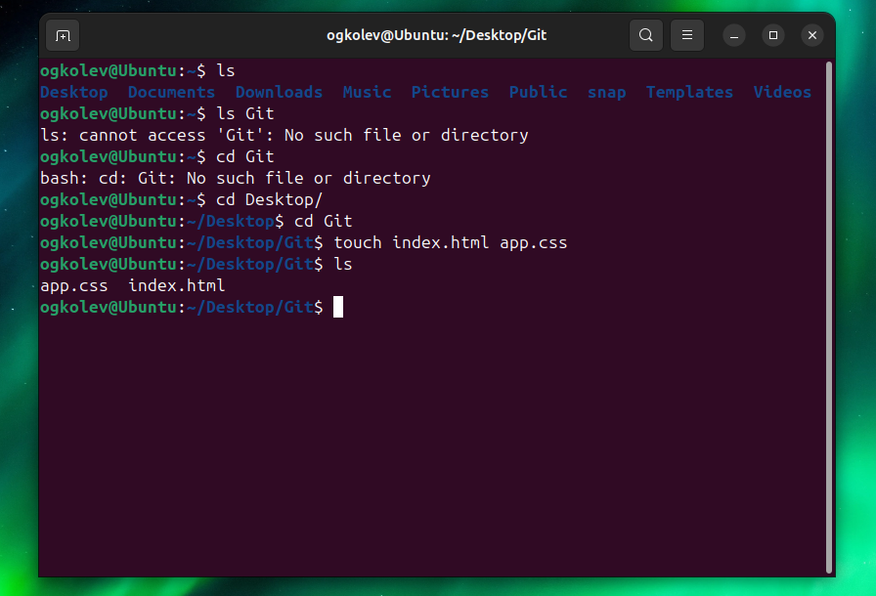

Add all files and commit using  
  
git add .  
git commit -m ‘add html and css’



Delete app.css and add java.app instead then commit the changes:  
  
rm app.css  
touch java.app  
git add .  
git commit -m ‘remove app.css and add java.app’  
  
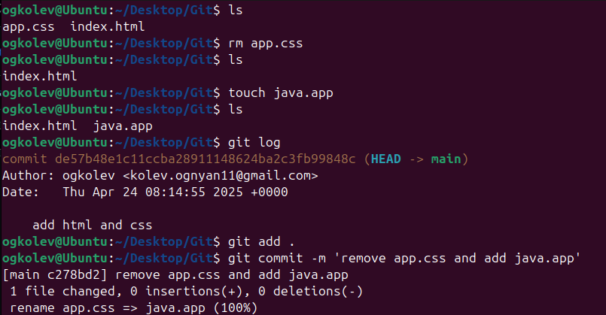  
  
Get logs and return back to the app.css and index.html  
  
git log  
git checkout  
ls  
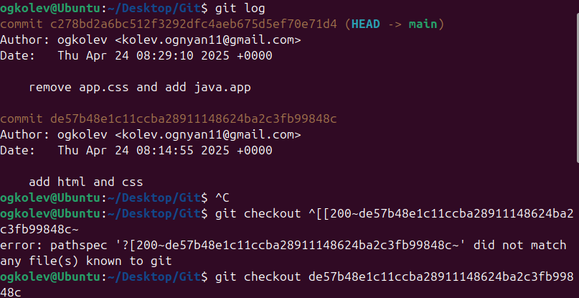  
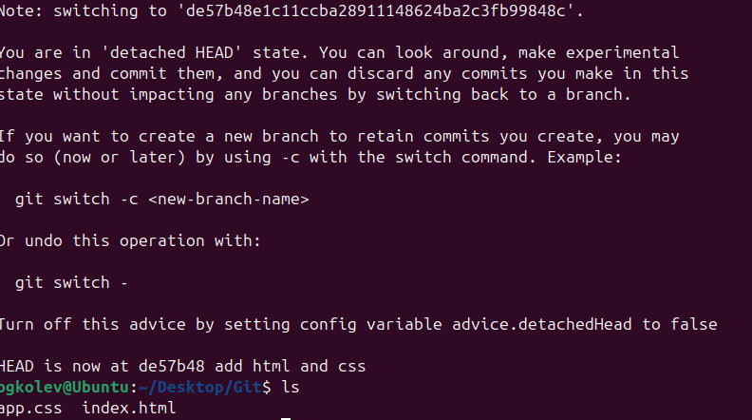  
  
Push the files into a repository called Task1 into GitHub  
  
git remote add origin https://github.com/koleff11/Task1.git

git push -u origin main

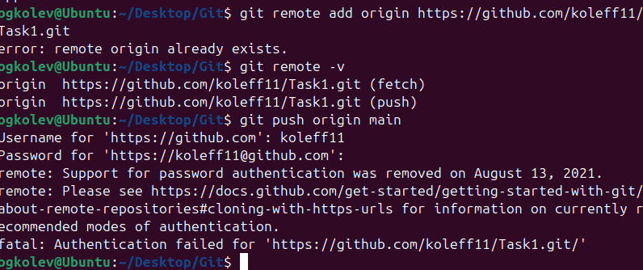  
  
Encountered an error that the authentication via username and password are not used anymore.  
  
Found that a possible way is to create an ssh key pair using:  
  
ssh-keygen -t ed25519 – C “example.email@com ”   
  
After that we can create a passphrase and continue:  
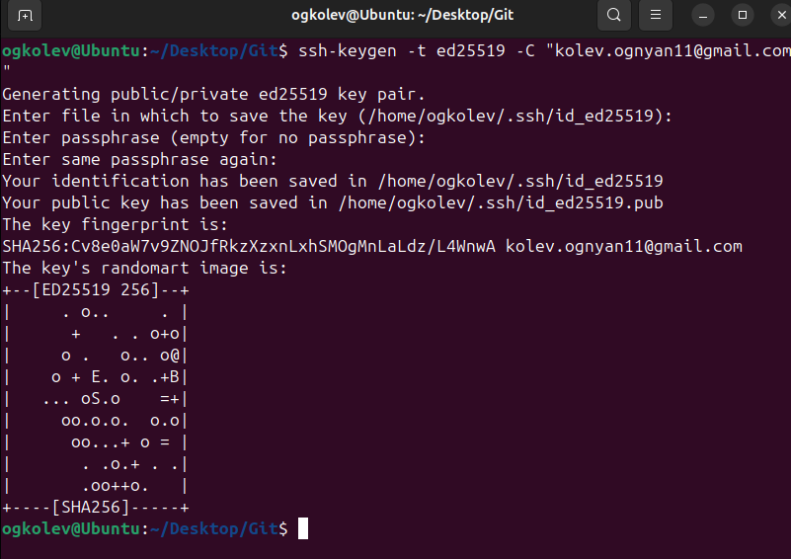  
  
We have to then copy the public ssh key and add it to GitHub

cat -/ . ssh/id_ed25519.pub  
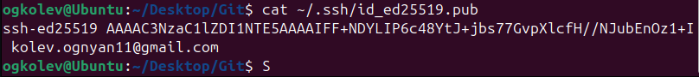  
  
Test the ssh connection and authenticate:  
  
ssh -T [git@github.com](mailto:git@github.com)  
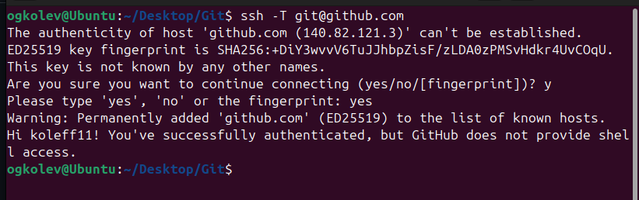  
  
Change the remote URL to use ssh

git remote set – url origin [git@github.com:USERNAME/REPO_NAME.git](mailto:git@github.com:USERNAME/REPO_NAME.git)  


Then push again the files

git push -u origin main  
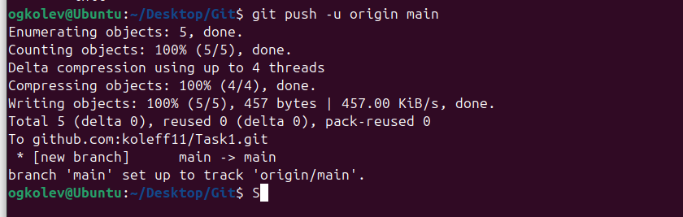  
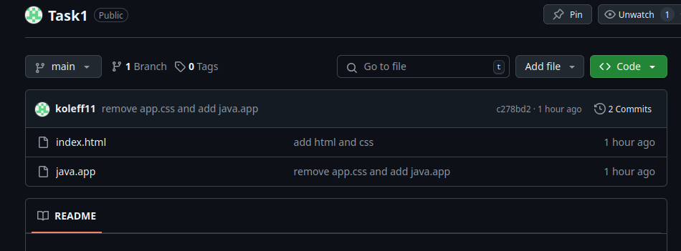  
  
Files are successfully pushed.