Training, Evaluation, and Deployment of a Convolutional Neural Network Using a Custom Framework

Introduction
CNN-CPP is a comprehensive deep learning framework developed entirely from scratch in C++ for designing, training, and evaluating Convolutional Neural Networks (CNNs). The framework is built with a strong emphasis on flexibility, modularity, and performance, enabling users to construct and customize deep learning architectures tailored primarily for image processing tasks.
CNN-CPP provides a complete pipeline for model creation, training, and evaluation, offering essential components required for end-to-end experimentation and analysis. In addition to training capabilities, the framework supports model export in compliance with the ONNX standard, allowing trained models to be deployed in external inference engines. Furthermore, CNN-CPP enables inference on existing pretrained ONNX models, ensuring interoperability with widely used deep learning ecosystems.
Model Training

Training

Model Training Pipeline
Model training in the CNN-CPP framework is implemented as a mini-batch supervised learning process that follows the standard deep learning workflow while remaining fully custom and transparent. The training logic is encapsulated in the NeuralNetwork::train(...) method, which manages data batching, forward and backward propagation, parameter updates, evaluation, and metric logging.
Before training begins, the network must be compiled and a loss function must be defined. Compilation prepares the model by propagating tensor dimensions, initializing trainable parameters, and attaching the selected optimizer to convolutional and fully connected layers, ensuring the network is structurally valid and ready for optimization. Training data is provided through a dedicated BatchManager, which supplies mini-batches of input tensors and corresponding labels, cleanly separating data handling from training logic.

Training proceeds in epochs, where each epoch iterates over all mini-batches. At the start of each epoch, Batch Normalization layers are switched to training mode, and an optional learning rate decay can be applied. For each batch, a forward pass is executed through all layers, while intermediate tensors are cached to enable correct gradient computation during backpropagation. The loss is computed by comparing predictions with ground-truth labels, and epoch-level loss is accumulated in a sample-weighted manner. Training accuracy is computed in parallel using thresholding for binary classification or argmax for multi-class classification.
Backpropagation is performed by propagating loss gradients backward through the network. Each trainable layer computes gradients for its parameters and updates them internally using the optimizer assigned during compilation. The framework supports several optimizers, including SGD, SGD with momentum, Adam, and RMSprop, with Adam using a global timestep for bias correction. Optional gradient clipping can be enabled to improve numerical stability, and an optional ELRALES mechanism can adaptively control training by identifying successful epochs, wasted epochs, or triggering early stopping.
At the end of each epoch, the model is evaluated on the test dataset in inference mode, producing validation accuracy and loss metrics that are reported alongside training results. Logging is an integral part of the training process: a CSV log file is initialized at the start of training and updated after each epoch with training and validation metrics, as well as the ELRALES state if enabled. Optional console-based logging provides real-time progress reporting, timing information, and tensor statistics for debugging purposes.
After training completes or early stopping is triggered, the network is marked as trained and is ready for inference, detailed evaluation, single-image prediction, or export to the ONNX format for deployment.

Implementation Challenges
Implementing and debugging a convolutional neural network framework in proved to be significantly more challenging than using existing deep learning libraries. One of the most difficult aspects was debugging numerical behavior during training, as neural networks can appear to function correctly while silently producing unstable or incorrect results. In practice, debugging neural networks often feels like debugging a system where everything compiles, runs, and still learns the wrong thing.
The most reliable—yet time-consuming—debugging approach was manually computing forward and backward passes with paper and pen and comparing them with the framework’s outputs, by using relatively small inputs. To support this process, the framework includes detailed tensor logging through the NNLogger component, enabling full tensor dumps and statistical summaries after each forward and backward pass.
Another challenge involved supporting multiple loss functions, classification modes and multiple optimizer support. Correctly handling binary and multi-class outputs, along with their corresponding label encodings and loss derivatives, required consistent conventions across training, evaluation, and logging. Ensuring this consistency was critical for achieving correct and reproducible results.
Runtime performance posed a major challenge, particularly in convolutional layers, which represent the dominant computational cost in convolutional neural networks. An initial single-threaded implementation resulted in prohibitively long execution times, making training impractical even for moderately sized models. To address this bottleneck, convolutional forward and backward passes were parallelized using a thread pool, distributing computation across multiple CPU cores at the batch level. This design allows different images within a batch to be processed concurrently while preserving correctness of gradient accumulation. All other layers in the framework, including pooling, activation, batch normalization, and fully connected layers, remain single-threaded, as their computational cost is comparatively low.

Training on CIFAR-10 Dataset

Cifar-10 Dataset
The CIFAR-10 dataset is a widely used benchmark for image classification tasks in machine learning and computer vision. It contains 60,000 color images of size 32×32 pixels across 10 object classes, with 50,000 images for training and 10,000 for testing. Due to its small resolution and diverse categories, CIFAR-10 is well suited for evaluating convolutional neural network architectures. Sample images from the dataset are shown in Figure 1.
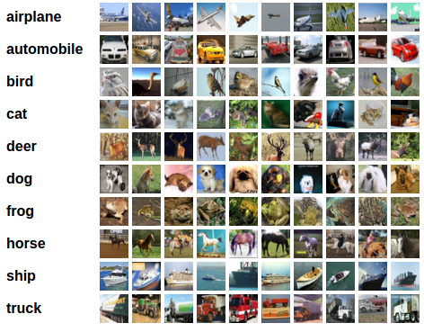
Figure 1 CIFAR-10

Model Selection & Training
The selected convolutional neural network architecture was designed as a baseline model for experimental evaluation rather than as a highly optimized solution. Its structure represents a balanced trade-off between simplicity and representational capacity, making it suitable for controlled comparisons. This design enables a fair evaluation of training behavior and performance between the proposed CNN-CPP framework and an established framework such as TensorFlow. The model architecture used for these experiments is shown in Figure 2.
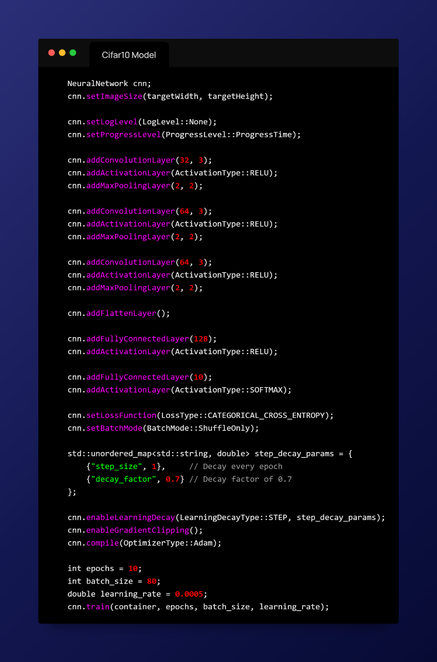
Figure 2 Model

Results & Comparison
The training results are presented in Figures 3–6, where Figures 3 and 4 show the training process using the CNN-CPP framework, and Figures 5 and 6 show the corresponding results obtained using TensorFlow on the same model architecture.
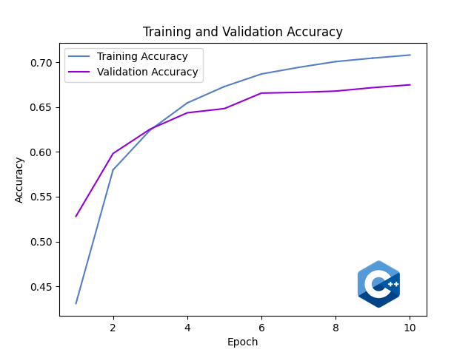  Figure 3 Cifar-10 CNN-CPP Accuracy | 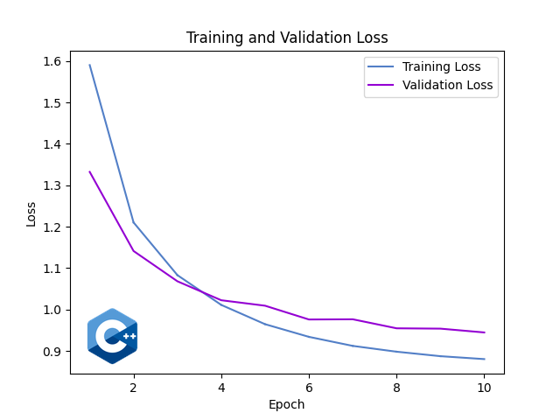  Figure 4 Cifar-10 CNN-CPP Loss
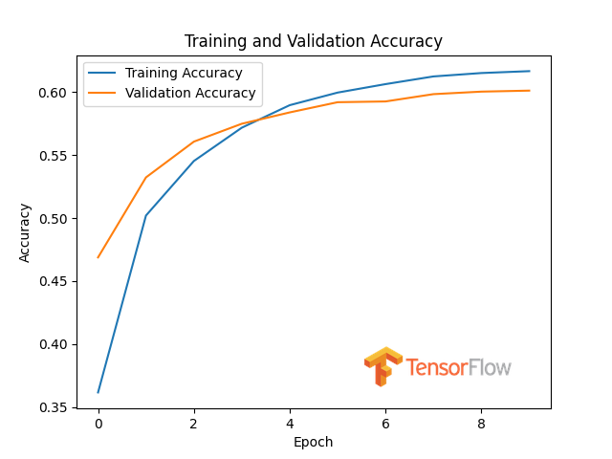  Figure 5 Cifar-10 TensorFlow Accuracy | 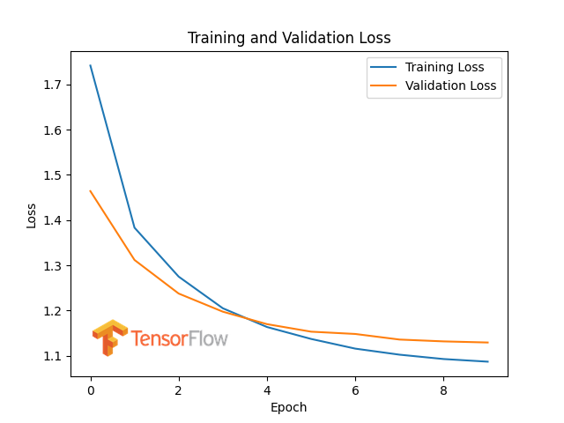  Figure 6 Cifar-10 TensorFlow Loss

Evaluation

Evaluation techniques

Notations
$$N – total number of samples$$
$$C – number of classes$$
$$TP_{k}, FP_{k}, FN_{k}– true positives, false positives, and false negatives for class k$$
$$L_{i}– loss value for sample i$$

Average Loss
The average loss represents the mean value of the selected loss function computed over all evaluation samples. It provides a continuous measure of how well the predicted outputs align with the ground-truth labels, taking into account not only correctness but also prediction confidence. Unlike accuracy, loss is sensitive to small probability changes and is therefore useful for analyzing optimization behavior.
$$L_{avg}= \left(\frac{1}{N}\right)sum_{i=1}^{N}L_{i}$$

Top-1 Accuracy
Top-1 accuracy measures the proportion of samples for which the predicted class label exactly matches the ground-truth class. It serves as a primary performance indicator for classification tasks and allows straightforward comparison between different models or frameworks. This metric is particularly intuitive and widely used in benchmark evaluations.
$$Accuracy =\frac{\left(sum_{k=1}^{C}TP_{k}\right)}{N}$$

Balanced Accuracy
Balanced accuracy is computed as the average recall across all classes, ensuring that each class contributes equally to the final score. This metric is especially important in scenarios where class distributions are imbalanced, as it prevents dominant classes from masking poor performance on underrepresented classes. In this framework, balanced accuracy corresponds to macro-averaged recall.
$$BalancedAccuracy = \left(\frac{1}{C}\right)sum_{k=1}^{C}Recall_{k}$$

Precision (per class)
Precision quantifies the proportion of correct predictions among all predictions assigned to a specific class. High precision indicates that when the model predicts a given class, it does so reliably with few false positives. This metric is particularly relevant in applications where incorrect positive predictions are costly.
$$Precision_{k}=\frac{TP_{k}}{\left(TP_{k}+ FP_{k}\right)}$$

Recall (per class)
Recall measures the proportion of true samples of a given class that are correctly identified by the model. A high recall value indicates that the model successfully captures most instances of that class, minimizing false negatives. Recall is especially important in tasks where missing relevant samples is undesirable.
$$Recall_{k}=\frac{TP_{k}}{\left(TP_{k}+ FN_{k}\right)}$$

F1-score (per class)
The F1-score is defined as the harmonic mean of precision and recall, providing a single metric that balances both error types. It is particularly useful when precision and recall exhibit a trade-off or when class distributions are uneven. By combining both aspects, the F1-score offers a more comprehensive view of class-level performance.
$$F1_{k}=\frac{\left(2 * Precision_{k}* Recall_{k}\right)}{\left(Precision_{k}+ Recall_{k}\right)}$$

Support (per class)
Support represents the total number of ground-truth samples belonging to a specific class in the evaluation dataset. While not a performance metric itself, support provides essential context for interpreting per-class results. Metrics computed on classes with very low support should be interpreted with caution.
$$Support_{k}= TP_{k}+ FN_{k}$$

Macro-Averaged Precision, Recall, and F1-score
Macro-averaged metrics are computed by averaging the corresponding per-class metrics across all classes. This approach treats each class equally, regardless of its frequency in the dataset. Macro metrics are therefore well suited for assessing overall class-wise performance, especially in imbalanced datasets.
$$Precision_{macro}= \left(\frac{1}{C}\right)sum_{k=1}^{C}Precision_{k}$$
$$Recall_{macro}= \left(\frac{1}{C}\right)sum_{k=1}^{C}Recall_{k}$$
$$F1_{macro}= \left(\frac{1}{C}\right)sum_{k=1}^{C}F1_{k}$$

Micro-Averaged Precision, Recall, and F1-score
Micro-averaged metrics are calculated by aggregating true positives, false positives, and false negatives across all classes before computing the final values. This method weights classes proportionally to their number of samples, effectively emphasizing performance on more frequent classes. Micro-averaged metrics closely reflect overall sample-level performance.
$$Precision_{micro}=\frac{\left(sum_{k}TP_{k}\right)}{\left(sum_{k}\left(TP_{k}+ FP_{k}\right)\right)}$$
$$Recall_{micro}=\frac{\left(sum_{k}TP_{k}\right)}{\left(sum_{k}\left(TP_{k}+ FN_{k}\right)\right)}$$
$$F1_{micro}=\frac{\left(2 * Precision_{micro}* Recall_{micro}\right)}{\left(Precision_{micro}+ Recall_{micro}\right)}$$

Confusion Matrix
The confusion matrix provides a detailed breakdown of prediction outcomes by recording the number of samples for each true–predicted class pair. It serves as the foundation for most classification metrics and enables detailed analysis of systematic misclassifications. By inspecting the confusion matrix, common error patterns between specific classes can be identified.
$$M_{t,p}= \left|\left\{ y = t , y_{hat}= p \right\}\right|$$

Evaluation implementation
The evaluation pipeline is implemented as a structured, multi-stage process that performs inference, metric computation, result serialization, and visualization in a reproducible manner. During evaluation, the network is switched to inference mode and the test dataset is processed in batches, where forward passes generate predictions used to compute the average loss, top-1 accuracy, balanced accuracy, and a full confusion matrix. From the confusion matrix, per-class precision, recall, F1-score, and support are derived, together with macro- and micro-averaged metrics, and all values are collected into a structured key–value representation that is exported to a JSON file. This JSON output is then processed by a separate Python script, which generates a row-normalized confusion matrix visualization (Figure 7), a per-class recall bar chart (Figure 8), and a plot of the most frequent off-diagonal misclassifications (Figure 9). These figures provide a consistent visual summary of the evaluation results produced by the framework.

Evaluation on CIFAR-10 Dataset
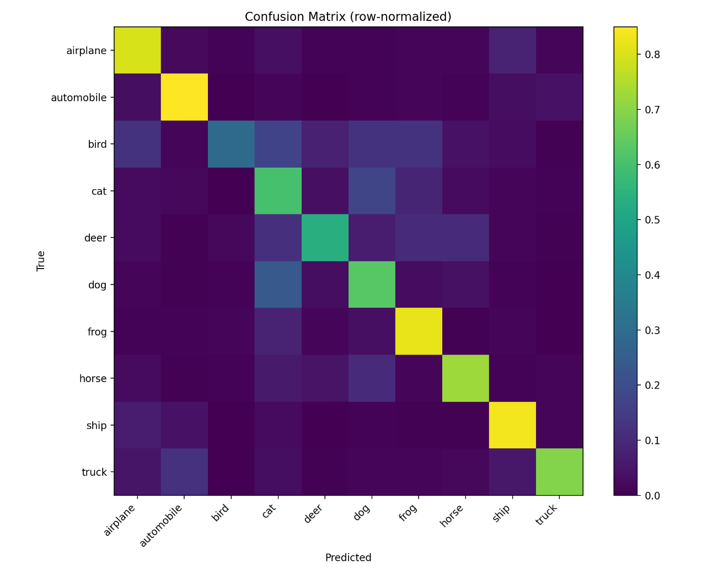
Figure 7 Cifar10 Confusion Matrix
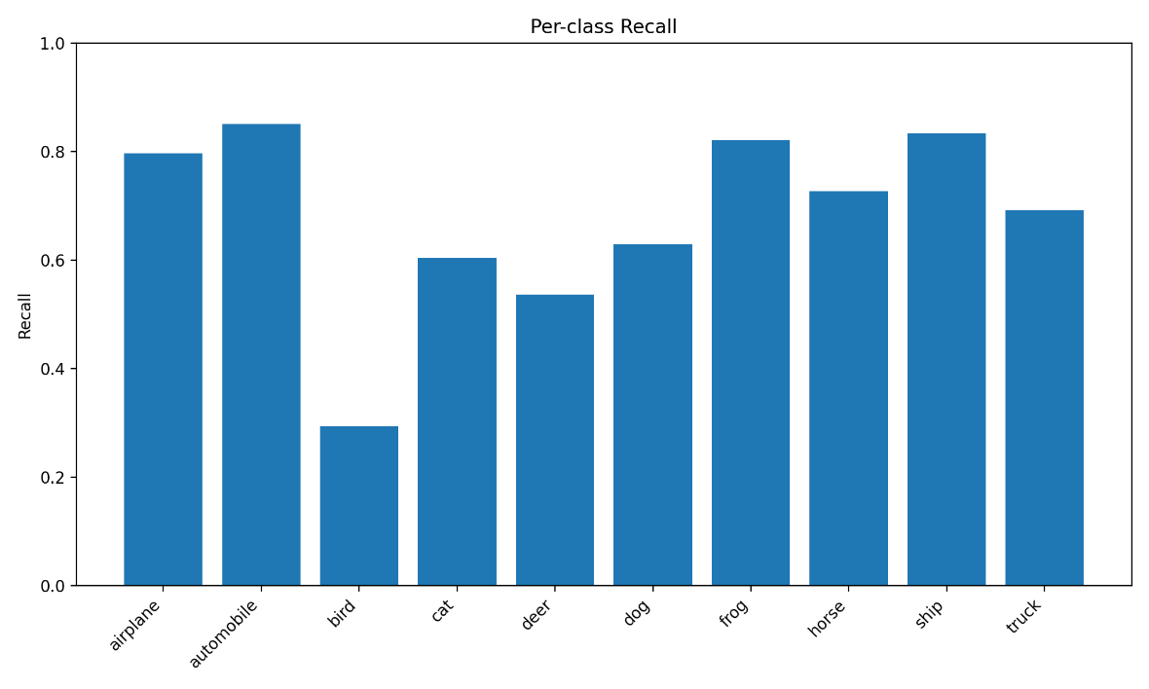
Figure 8 Cifar10 Per Class Recall
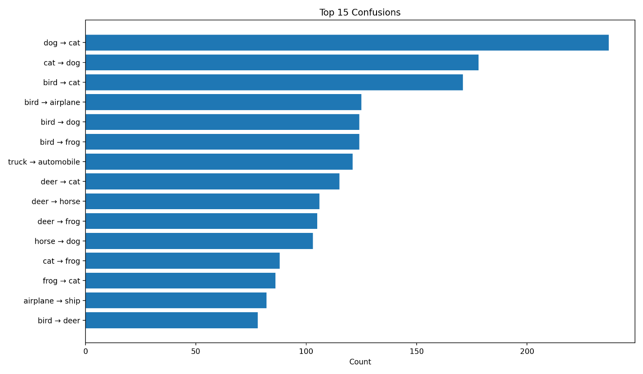
Figure 9 Cifar10 Top Confusions

Deployment (ONNX)

ONNX standard
The Open Neural Network Exchange (ONNX) is an open, framework-independent standard designed to represent deep learning models in a portable and interoperable format. It was introduced in 2017 as a collaborative initiative by Microsoft and Facebook (Meta), with the goal of enabling seamless model exchange between different machine learning frameworks and deployment environments. Since its introduction, ONNX has been widely adopted by the industry and is now supported by major frameworks such as PyTorch, TensorFlow, and many production-grade inference runtimes.
At its core, ONNX defines a standardized computation graph that describes a model’s structure, operators, and data flow, independent of the framework used during training. This allows models to be trained in one environment and deployed in another without modification, which is particularly important in production systems where training and inference often occur on different platforms or hardware. ONNX also provides a stable and extensible operator set, ensuring long-term compatibility and forward support for evolving model architectures.

In addition to defining the model graph, ONNX standardizes the representation of model parameters, including weights, biases, and other learned tensors. All parameters are stored together with the graph in a single serialized file, ensuring that a model can be saved, versioned, transferred, and restored in a self-contained manner. This unified representation simplifies model management, improves reproducibility, and reduces the risk of inconsistencies between model structure and parameter values. As a result, ONNX serves not only as an exchange format but also as a robust standard for long-term model storage and deployment in modern machine learning workflows.

ONNX Adoption in CNN-CPP
The CNN-CPP framework adopts the ONNX standard as a bridge between its internal tensor representations and external deployment environments, providing both export and import capabilities for trained models (Figure 10). This integration allows models created and trained in CNN-CPP to be serialized into a standardized graph format with embedded parameters, as well as enabling pretrained ONNX models to be reconstructed within the framework. As a result, CNN-CPP supports framework interoperability while maintaining a clear separation between training logic and deployment-ready model artifacts.
A key technical challenge in this adoption is the alignment of tensor memory layouts and dimensional conventions between CNN-CPP and ONNX. Internally, CNN-CPP relies on Eigen tensors, where convolutional parameters are stored as four-dimensional tensors following a fixed layout that reflects the framework’s execution order. ONNX, however, enforces explicit tensor shapes and operator-specific input formats. During export, convolution kernels must therefore be reshaped and serialized to match the ONNX convolution operator requirements, ensuring that filter count, channel depth, and spatial dimensions are preserved in the correct order. The serialization process explicitly iterates through all tensor dimensions in a deterministic nested-loop order, guaranteeing contiguous memory layout and reproducible parameter encoding.
Fully connected layers introduce an additional conversion step, as CNN-CPP internally represents dense weights in a four-dimensional form for consistency with other layers, while ONNX expects a two-dimensional matrix representation. To resolve this mismatch, weight tensors are reshaped by collapsing singleton spatial dimensions into a standard [output, input] layout before serialization. Bias vectors are exported as one-dimensional tensors, maintaining direct correspondence between internal and external representations. These transformations ensure that matrix multiplication semantics in ONNX remain equivalent to the original dense layer computations in CNN-CPP.
During model import, the reverse process is applied. ONNX tensor initializers are parsed, validated, and reconstructed into Eigen tensors with exact dimensional recovery. This includes expanding two-dimensional dense weight matrices back into the internal four-dimensional format and restoring convolution kernels with correct spatial and channel alignment. Throughout this process, strict checks on tensor sizes, ordering, and element counts are enforced to prevent silent errors caused by incompatible layouts or misaligned memory. By explicitly managing tensor reshaping and alignment at the serialization boundary, CNN-CPP ensures numerical correctness, consistent inference behavior, and reliable interoperability with ONNX-compatible runtimes.
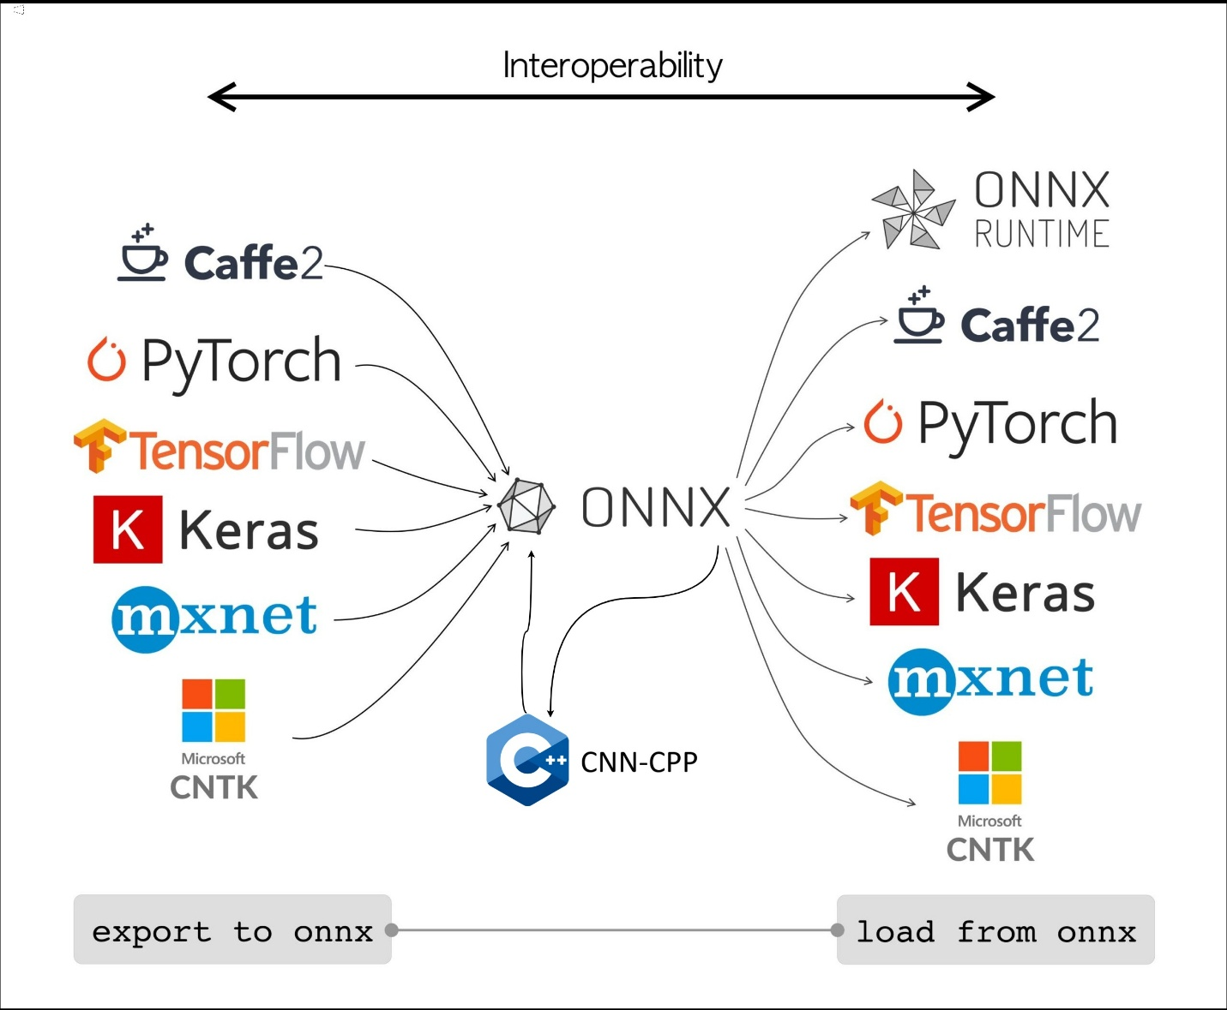
Figure 10 ONNX Adoption

