TA setup
Once per lab PC. Students do not do this. Do not assume the oven port or the board addresses from an old note. Read them on this machine.

Physical setup
The oven serial cable does not go through the switch. The switch only joins the PC and the PYNQ boards. All boards that are being compared sit in the same oven.
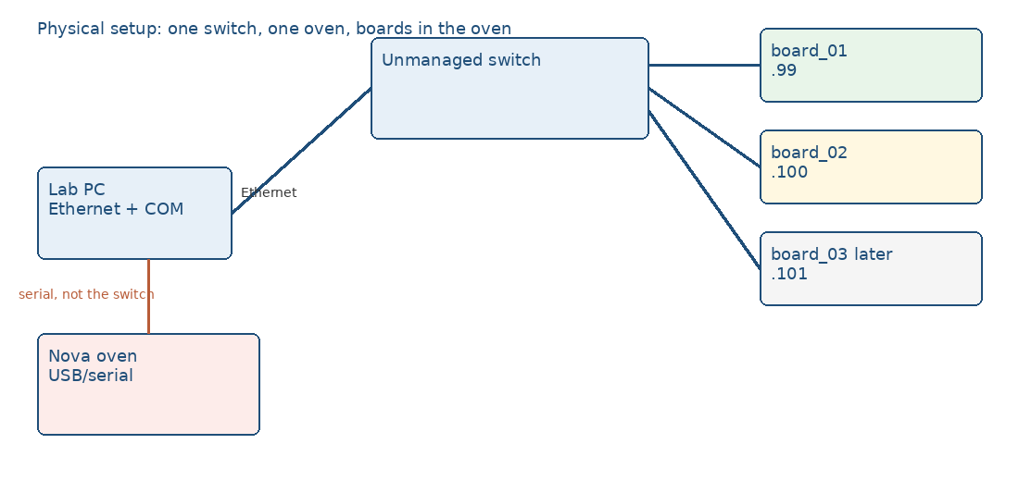
- Lab PC Ethernet port to the switch. Each PYNQ Ethernet port to the switch. No router on this switch.
- Nova controller to the PC on USB or serial. That is the oven port, not an Ethernet address.
- Board power is the board supply, not the switch. Label each board with its id.
- Leave the lab Windows session logged in for the whole week. Fast user switching is fine. Logoff and reboot stop the run.

Find the oven port
The default in run/config.py is COM4 only if oven_port is left unset. Confirm the port before a week starts.
- Plug in the Nova cable. Open Device Manager, Ports (COM & LPT), and note the new COM name.
- Unplug the cable and plug it back. The entry that appears and disappears is the oven.
- If several COM ports stay, start with the one that appeared. check_oven.bat will fail with the port name if it cannot be opened.
- Set oven_port in run/config.py to that name, for example oven_port = "COM5". Students change this only if you tell them the name.
lab_tools/oven_csv_single_read_list.py and oven_initial_read_array.py have their own port setting. Change those too if you use them, or they will still open the old port.

Check and change the PC address
The boards are on a link-local network with no router. Current lab values are PC 169.254.168.184, board_01 169.254.168.99, board_02 169.254.168.100. Treat these as the last known values, not as a guarantee.
- Windows: Settings, Network, the Ethernet adapter that goes to the switch, IP assignment Manual.
- Set IPv4 address 169.254.168.184, subnet mask 255.255.0.0. No gateway. Leave Wi-Fi for internet and mail.
- In an admin command prompt, route print 169.254.168.99. The Ethernet adapter must be the route, not Wi-Fi.
- ping 169.254.168.99 and ping 169.254.168.100 from the lab account.

Check and change a board address
- ssh xilinx@169.254.168.99. Password is xilinx unless it was changed on the card.
- ip addr show eth0 and cat /etc/network/interfaces.d. A DHCP or link-local line is not a fixed address.
- To fix it, set a static address on eth0, for example 169.254.168.99, netmask 255.255.0.0, then reboot the board.
- Put the same address in boards.py under that board id. oven_board_01.bat uses board_01. board_02_only.bat uses board_02.
- hostname can be set to pynq-99 or pynq-100 so a later SSH session is obvious. Label the case to match.
Each measured board must already have rofc_11.ipynb, rofc_21.ipynb, and rofc_51.ipynb in /home/xilinx/jupyter_notebooks/rofc/. The copies in run/notebooks/ are not used.

Software on the PC
Keep one checkout, for example C:\pynq_lab\pynq_reliability_biu. Do not also run an old copy under C:\pynq\pynq_codes.
py -3 -m venv .venv
.venv\Scripts\python.exe -m pip install -r requirements.txt
check_oven.bat and check_board_02.bat must say OK before the week. python run/oven_run.py --dry-run --boards board_01 only checks config. It does not open the oven.

