# Exercise: MiniORM Core

This document defines the **exercise assignments** for the [Databases Advanced - Entity Framework course @ SoftUni](https://softuni.bg/trainings/3966/entity-framework-core-february-2023)

This **tutorial** provides step-by-step guidelines to build an "**ORM Framework"** in C#, as well as a sample app, which utilizes the framework. The app is designed to resemble the functionality of [Entity Framework Core](https://docs.microsoft.com/en-us/ef/core/) to an extent. **You will be provided with a partially-implemented framework C# project**.

## I. Project Specification

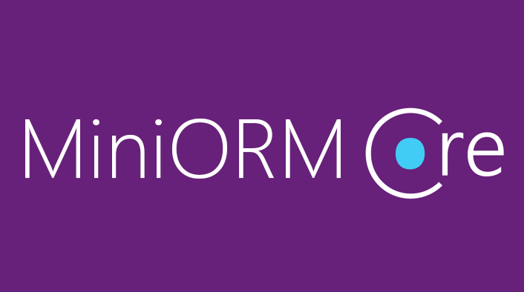

The framework should support the following **functionality**:

* Connecting to a database via a provided connection string
* **Discovering** entity classes at **runtime**
* **Retrieving entities** via **framework-generated SQL**
* **CRUD** operations (inserting, modifying, deleting entities) via **framework-generated SQL**

## Framework Overview

The framework consists of the following **classes**:

* DbSet<T> – **Custom generic collection**, which holds the actual **entities** inside it. The DbContext class has several DbSets, which correspond to all the tables in the database.
* DbContext – **Database context** class, responsible for **retrieving entities** **from the database** and **mapping the relations** between them (through so-called navigation properties).
* DatabaseConnection – Responsible for **establishing database connections** and **sending SQL queries**. Usually used by the DbContext.
* ConnectionManager – Simple DatabaseConnection wrapper, which allows it to be wrapped in a using block for **opening and closing connections** to the database.
* ChangeTracker – Responsible for tracking the **added**, **modified** and **deleted** entities from the DbSets. Every DbSet has one. Used by the DbContext to **persist changes** into the database.
* ReflectionHelper – Utility class, which contains some reflection-related methods.

Now that you have a very basic understanding of what each class should do, let's get to **implementing them**.

It's time to **open** the provided **skeleton** and **start writing code**.

## Implement Framework

### Implement the ChangeTracker class

In this class, we will need three **lists**. The first one will store all the entities. The second one will keep track of the **added** ones and the third – the removed ones. Add a generic constraint to **limit** the **generic type parameters** to only **reference types**, which have a **parameter-less constructor**.

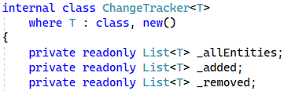

The ChangeTracker constructor will accept a **collection of entities** as a parameter. In its body, we have to initialize our **added** and **removed** lists. Then, the allEntities field will store **clones** of all the entities of the parent DbSet. We need to clone them, so we can find out which ones were **modified** whenthe time for **persisting them** into the database comes. To do that, we call CloneEntities() with the **collection of entities** as parameters.

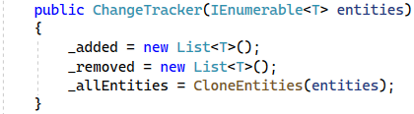

The next step is to implement the CloneEntities method. This method will return a List<T> with the **cloned** entities. We need another variable of type PropertyInfo[] to collect the properties, we need to clone. We only care about properties, which are part of the database, so we only get the properties with **valid SQL types**.

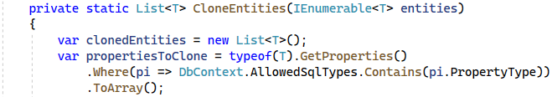

We iterate over each **real** entity, create a new blank entity of the same type and **set** all its cloneable properties to the real entity's property values. Lastly, we add the clonedEntity to our List<T>. After we're done cloning our entities, we return them to our caller.

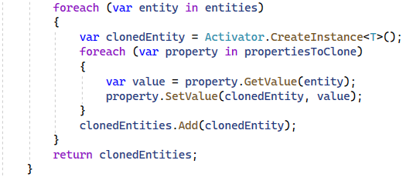

Next, we need to make all the fields of type IReadOnlyCollection<T> because we don't want someone to modify our lists.

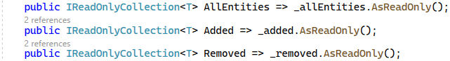

We need Add() and Remove() methods which will take as parameter T element. You can do this on your own.



The next method is GetModifiedEntities(), which takes a DbSet<T> variable as a parameter. The method returns a collection of modified entities. In this method we have to get the **primary keys** for the current T object, but you already know how to do that.

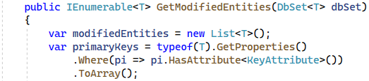

After that, we go through the IReadOnlyCollection of allEntities and use the GetPrimaryKeyValues() method (implement later), which takes our primaryKeys variable as a parameter and the **current** proxy entity from all the entities. Then, we get the entity from the dbSet which has the same primaryKeyValues as our our **proxy entity**.

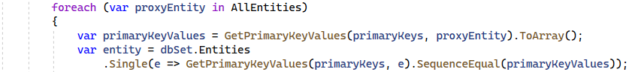

We can check if the original object has been modified, using the IsModified() (implement later) method. If there is any modification, we have to add the real entity to our modifiedEntities.

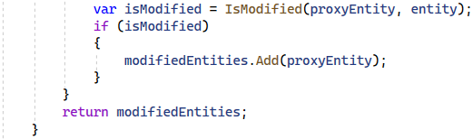

The next method to implement is IsModified(), which takes the **original** and **proxy** **entities** as **parameters**. They are guaranteed to be of the same type, because they are of the **same generic type**.

First, we'll extract all properties, which are valid SQL types and ignore the rest. We will use this variable to check for any modified entities. This can be done by making another variable of type PropertyInfo[] and calling method Equals to compare our originalEntity and proxyEntity's **property values**. Finally, we check if there are **any** **modified** properties and return the result.

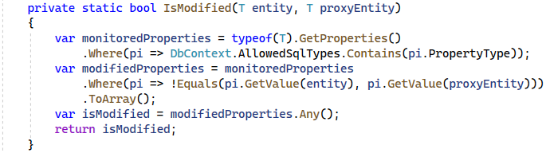

The last method for this class is static and will return an IEnumerable collection of objects. We used this method before to get our **primary key values**. The method will take an IEnumerable<PropertyInfo> as a parameter, which holds the primary key properties and the entity to which the primary keys belong to. This method only does one thing – gets each **primary key property's** **value**.

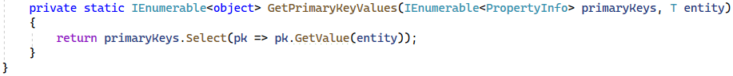

### Implement the **DbSet** class

Create a generic DbSet<TEntity> class, which inherits from ICollection<TEntity>. It should look like this:



Our DbSet<T> class represents the collection of all entities in the context, or that can be queried from the database, of a given type. The type argument must be a reference type, including any class, interface, delegate, or array type and must have a public parameter-less constructor.  In this class we have to define two internal properties with getters and setters. The first one is a which provides access to features of the context that deal with change tracking of entities. The second one is IList<TEntity>, where we are going to collect our entities.

The code should look like this:



Our DbSet constructor must be **internal** and should take parameters of type IEnumerable<TEntity> which will be our entities. The **constructor** sets the **entities property** and creates a ChangeTracker, so we can track changes in the entities.

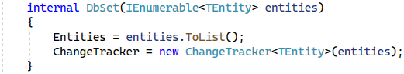

Our DbSet class acts like an ICollection<T>, so we need to implement all of its methods.

First, we need to implement a method for **adding entities** in the database. If the parameter value is **null,** we throw an ArgumentNullException with the message "Item cannot be null". After this check,we **add** our item both in the **Entities** property and the **ChangeTracker**.

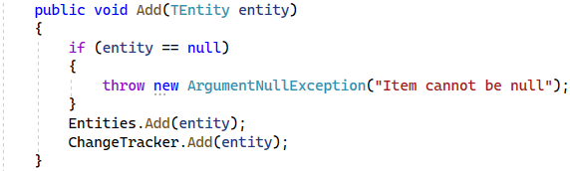

The Clear method removes all entities by using the Remove method. We use it like this, so we can also let the **ChangeTracker** know, that all the entities were removed.

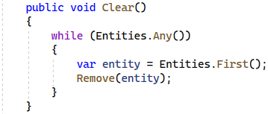

The Contains method checks if our entities contain a particular entity.



The CopyTo method copies our **entities** to an array of type **T**, starting at a particular **array index**. We aren't going to use this anywhere, but it's a part of the ICollection<T> interface, so we need to implement it.



The Count property gets the count of our **entities**.



The IsReadOnly property checks if our entities collection is of type **readonly**. Again, we need this because of the ICollection<T> interface.



The last method we have to implement from our ICollection<T> interface is the **Remove** method. We need to check for two problems. First, the **T** element must **not be** **null**. If it is, we throw an ArgumentNullException with a message "Item cannot be null". After that we need to create a **variable** where we check if we have **successfully** **removed** the item. If we have, we **remove it from our change tracker** as well.

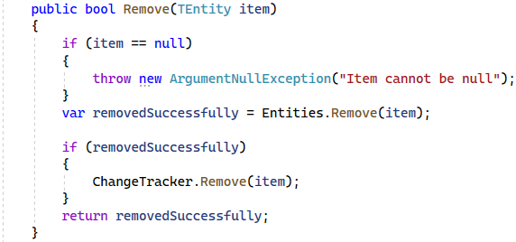

Our DbSet class has two more methods to implement. These methods are IEnumerator<T> GetEnumerator() and IEnumerable.GetEnumerator(). We need them to **iterate** through our entities collection.

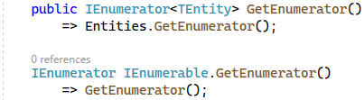

The last thing we need to do in this class is to create a method which will remove a range of entities. To do that, we need to iterate through our entities parameter and **remove each entity** inside of it.

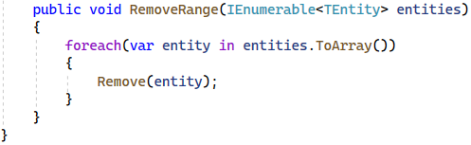

### Implement the **DbContext**

Create an **abstract** DbContext class. For starters, in this class, we need to have **two fields**. The first field is a DatabaseConnection. The second one is of type Dictionary<Type, PropertyInfo>, where we're going to store our DbSet<T> properties, once we discover them. Remember, since we're writing a **framework**, which other people are going to be using, we **don't know** what entities/DbSets they will define at **compile-time**, so we need to discover that **at runtime**.

When you're done, you should have something like this:

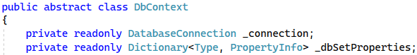

Now we need to create a **field**, where we store our **allowed SQL type**s. Think about what kinds of data you can store in **SQL Server** and then list them in your field. When you're done, your code should look something like this:

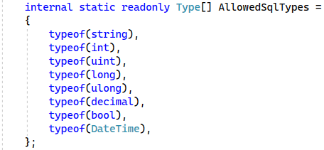

We're going to use these later when we determine what entity properties we're going to involve in our database manipulations.

Our DbContext constructor must be protected and should take as parameter connectionString. In the body of the constructor we have to create an instance of the DatabaseConnection class with the connectionString. We should initialize our dbSetProperties by using a method called DiscoverDbSets() which we will implement later. After that we need a **using** statement like before, where to open a connection to our database and in this **using** we should call a method InitializeDbSets(). Out of the using statement body we have to call MapAllRelations method (implement later). Your constructor should look like this:

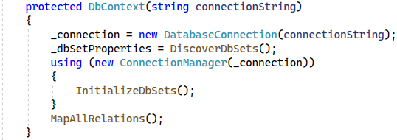

Now we're going to create the only **public** method – SaveChanges(). All this method does is **iterate** over each DbSet and **execute the** Persist<TEntity>() **method** for each of those DB sets. Since we don't know what the **generic types** of our DB sets are, we need to dynamically invoke the method, using reflection and provide it with a type parameter. After we make the persist method, we'll wrap its invocation in a **try-catch** block and provide a few different types of exceptions it's going to catch.

First, we need to declare an array of our **actual DB sets as collections**:

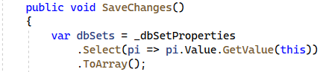

Before we do any persisting, we need to ensure each entity in the context is **valid**. If any **invalid entities** exist in our DB set, we **throw** an InvalidOperationException with message **"**{invalidEntities.Length} Invalid Entities found in {dbSet.Name}!**"**. The code should look like this:

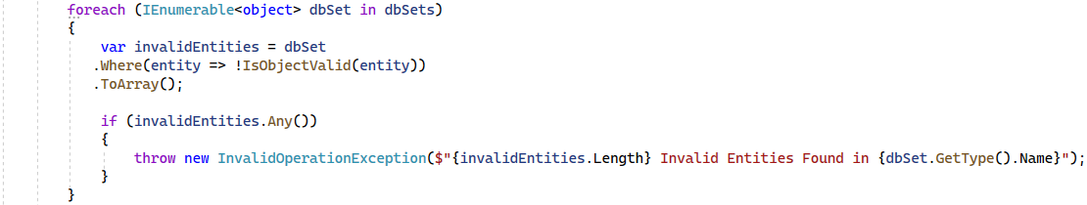

After that, we need a using **block**, which will **open a connection** to our **database.** We wrap each code block, which **accesses** the **database** in a **using** block, so we don't have to **close** our connection **manually**. Opening and closing stuff **manually**, whether it be a database connection, or a stream, or any unmanaged resource is a great recipe for **forgetting** to write **open**/**close** statements and encountering mysterious bugs, so **don't ever do it**.

Anyway, in this **using** block, we need to create **another** using **block** – this time for **starting a database transaction**. That way, if anything goes wrong, **no entities** will be inserted/modified/deleted. The code looks something like this:

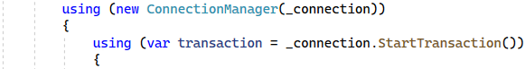

Now we need to find the entity type of each DbSet. We need another variable, which will hold the **Persist** method (which we are going to implement later) and make a generic version of that method, using the DB set type. The code looks like this:

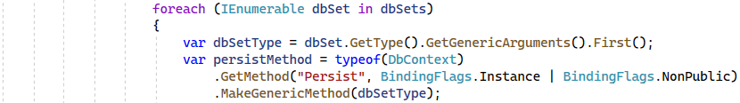

Last, but not least, we need to invoke this method inside a try block with a couple of catch blocks for the different types of exceptions. In the try block, we will invoke the **Persist** method for the dbSet. The code looks like this:

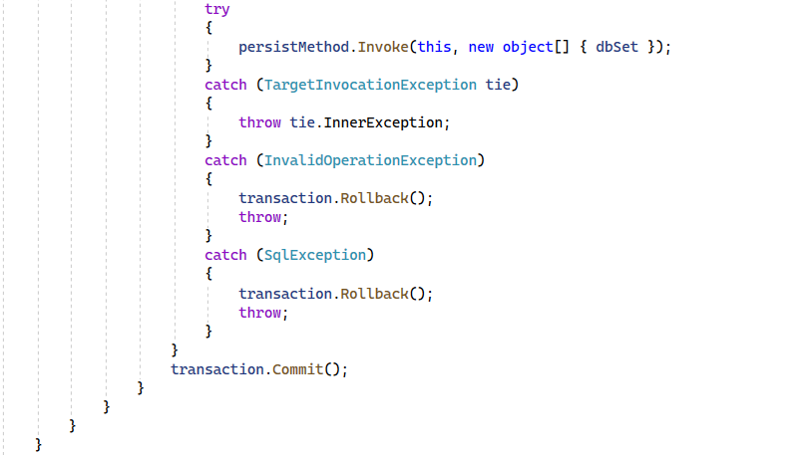

The first **catch** block will handle TargetInvocationException. If the invoked method **throws an exception**, this is the exception we need to **catch**. Consequently, this block **throws** the inner exception, because this is the actual exception, which occurred within the method invocation, which the **second and third** catch blocks will handle.

The second and third catch blocks will handle InvalidOperationException and SqlException respectively. In both cases we, need to rollback the transaction. If no exceptions are thrown, we're going to **commit** the transaction and **save our changes** to the database.

Now it's time to implement our Persist<TEntity> **method**. It accepts a DbSet as the **generic type** parameter and a **transaction**.

First, we need to create a variable where we can save our **current table name** (**string**) using the GetTableName() method (which we'll implement later). Then, we need an array, where we will collect our columns by calling the FetchColumnNames() method (also implemented later). Then, we check the **dbSet's** ChangeTracker for **any** added entities and if there are any, we use the InsertEntities() method, which we already have in our DbConnectionclass.

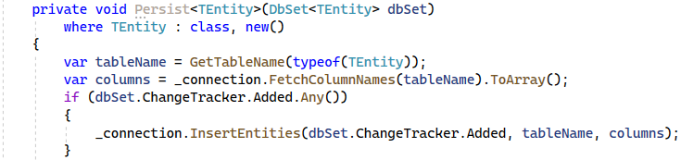

Now we need our **modified** entities. We can get them by using GetModifiedEntities(), which we will have in our ChangeTracker class. If there are any modified entities, we **update** our database using UpdateEntities(), which accepts our **entities**, the **table name** and **table** **columns** as parameters.

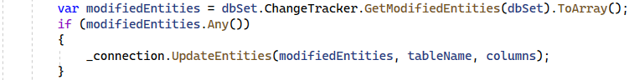

Lastly, we check if there are any removed entities using the ChangeTracker's Removed collection. If we have any, we **delete** them from our database too.

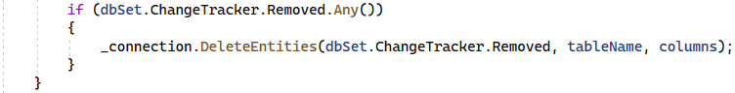

The next step is to create a method for initializing **dbSet**s called InitializeDbSets(). For each DB set, we will invoke the PopulateDbSet(dbSetProperty) method **dynamically**, because we are providing the **generic type parameter** at **runtime**, since we don't know what the framework user's **DB** sets are.

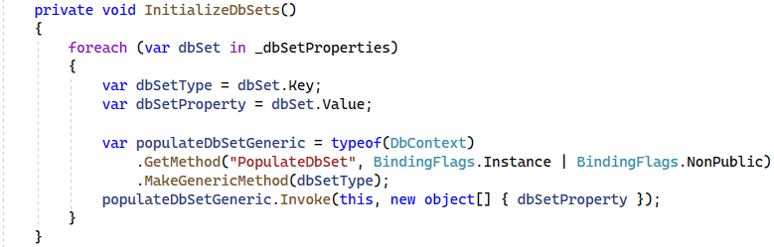

Our next method to implement is PopulateDbSet<TEntity>(). We retrieve the entities from the database, using the LoadTableEntities<TEntity>() method. Then, we create a new DbSet<TEntity> instance, passing the entities to its constructor.

Finally, we need to replace the actual DbSet property in the current DbContext **instance** with the one we just created. Since the **Db sets** don't have a setter, we need to replace its backing field, by using the ReflectionHelper.ReplaceBackingField() method. This works, because every auto-property has a **private**, **autogenerated** **backing field**.

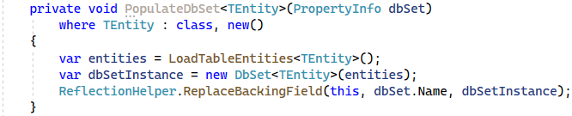

Now, we implement a new method, called MapAllRelations(). All this method will do is call MapRelations() dynamically for each **DB** set **property**. This method looks very similar to the InitializeDbSets() method.

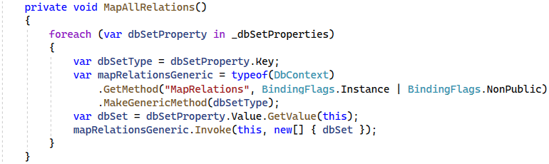

Now it's time to implement our MapRelations<TEntity>() method, we talked about before. This method accepts a DbSet<TEntity> variable as its only parameter.

This method maps all of the relations of the DB set. There are two types of relations: Foreign key properties, which map many-to-one relations, and collections, which map one-to-many and many-to-many relations. First, we map the navigation properties and then we map the collections. In order to discover what collections our TEntity has, we need to reflect the class and find every property, which is of type ICollection<>.

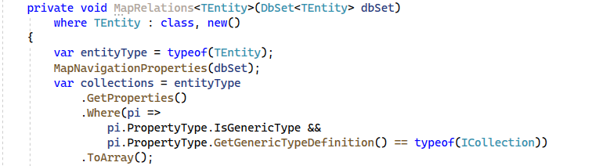

After we find our collections, we iterate through them and call the MapCollection method dynamically for each of them, much like the previo us 2 methods that did something similar.

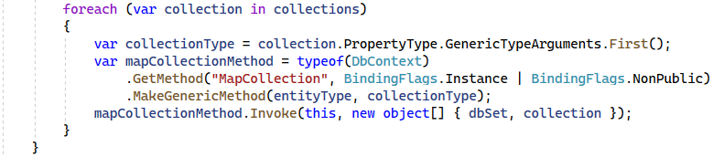

Now it's time for the MapCollection<TDbSet, TCollection>() method's implementation, which accepts a DbSet<TDbSet> and PropertyInfo variables as parameters. Now, we need to get the primary and the foreign keys. The primary ones we find by getting all the properties which have a [Key] attribute in the collectionType variable we declared before. We can get the foreign key in the same way, but using the entityType variable.

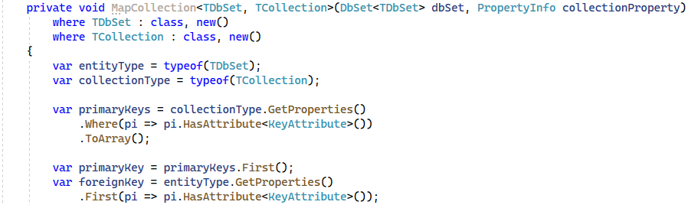

We check if we are dealing with a many-to-many relation, which is only true if we have 2 or more primary keys. If we have a many-to-many relation, we can get the foreign key by finding the first type property, whose name is equal to the foreign key attribute's name and has the **same property type** as the entity type.

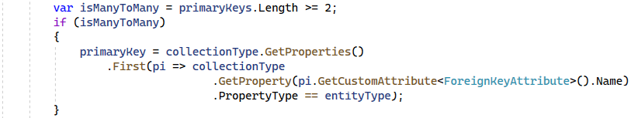

Now we get the collection's DB set, which we will filter with a where clause and extract all of the entities whose foreign keys are equal to the primary key of the current entity.

Finally, call the ReflectionHelper.ReplaceBackingField() method and we replace the null collection with a populated collection.

At the end your code should look like this:

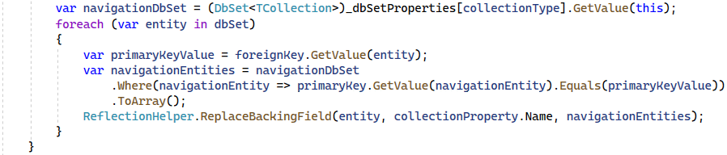

The next method to implement is MapNavigationProperties<TEntity>() which accepts a **DB set** as a parameter. This method finds the **entity's foreign keys** (there could be **multiple**) and iterates over them. For each of those foreign keys, we discover what **navigation property** they point to and **its type**. Then, we use this type to get the other side of the relation's **DB set**. Then, **for each entity** in that **DB set**, we find the **first entity**, whose **primary key** **value** **is equal** to the **foreign key value** in our TEntity. Finally, we replace the navigation property's value (which is currently null) with the entity we found.

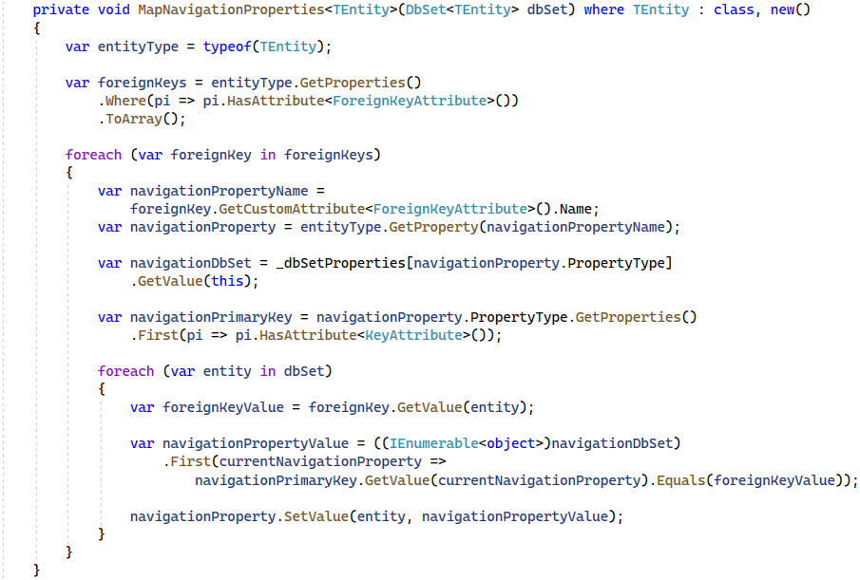

We mentioned a method, called IsObjectValid() which accepts an object as a parameter and returns a bool as result. Since the Validator class is very old, we need to write a bunch of [boilerplate](https://en.wikipedia.org/wiki/Boilerplate_code) code to use it. So instead of writing this everywhere we need to validate an object, we can just extract it into a method. The boilerplate looks like this:

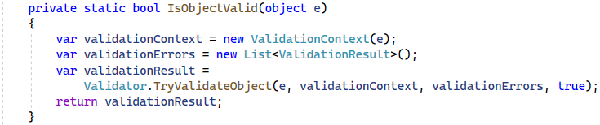

The next method to implement is LoadTableEntities<TEntity>() method. We have to declare a few variables in it. The first one will keep the type of the TEntity and it will be our **table**. The next one will be for the **columns** and it will be an **array of strings**. There, we will keep the **column names** for the current table by calling GetEntityColumnNames (implement this **last**). The third variable will be for the **table name** and we will get it by calling GetTableName() (implement **second**). The last one and the one our method will return is the fetchedRows variable. We can get the fetched rows by calling the DbConnection's FetchResultSet<TEntity>() method with the expected parameters.

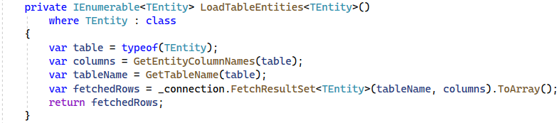

Let's implement GetTableName(), which returns a string and gets the tableType as a parameter. You can implement it yourself 😊

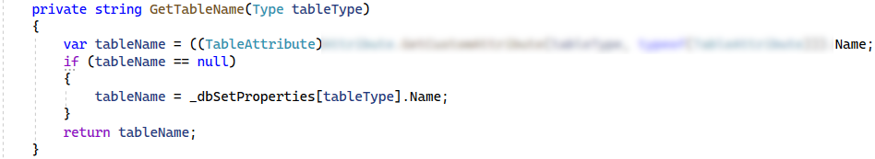

We are almost done with this class. But before that, we need to implement a simple DiscoverDbSets() method. We used that method in our constructor to populate our dbSetProperties field, which is a **Dictionary** with а **Type** as a key and a PropertyInfo as a value. Its code is only 3 lines long. Three annoyingly long lines…

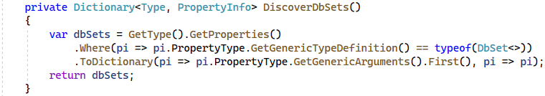

The last method is GetEntityColumnNames(), which returns an **array of strings** with the **column names** and accepts the **table type** as a parameter. Finally, we need to get the **table properties**, which are of **valid SQL types** and are contained in the **column names**. After that, we get the property names (using the Select **LINQ** extension method) and **return** them.

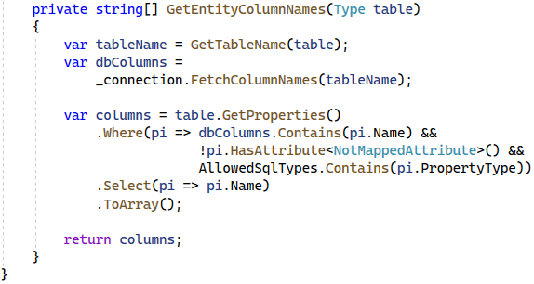

And with this final method, we are done with the framework! Let's go ahead and test it out by writing a simple application, which utilizes it and defines its own data model.

## Create a Simple Client App

Now that the framework is ready, let's see how it discovers our database types, tables, relationships and much more, all using the power of reflection.

### Create the Database

Import this SQL script into SSMS:

|  |
| --- |
| CREATE DATABASE MiniORM  GO  USE MiniORM  GO  CREATE TABLE Projects  (  Id INT IDENTITY PRIMARY KEY,  Name VARCHAR(50) NOT NULL  )  CREATE TABLE Departments  (  Id INT IDENTITY PRIMARY KEY,  Name VARCHAR(50) NOT NULL  )  CREATE TABLE Employees  (  Id INT IDENTITY PRIMARY KEY,  FirstName VARCHAR(50) NOT NULL,  MiddleName VARCHAR(50),  LastName VARCHAR(50) NOT NULL,  IsEmployed BIT NOT NULL,  DepartmentId INT  CONSTRAINT FK_Employees_Departments FOREIGN KEY  REFERENCES Departments(Id)  )  CREATE TABLE EmployeesProjects  (  ProjectId INT NOT NULL  CONSTRAINT FK_Employees_Projects REFERENCES Projects(Id),  EmployeeId INT NOT NULL  CONSTRAINT FK_Employees_Employee REFERENCES Employees(Id),  CONSTRAINT PK_Projects_Employees  PRIMARY KEY (ProjectId, EmployeeId)  )  GO  INSERT INTO MiniORM.dbo.Departments (Name) VALUES ('Research');  INSERT INTO MiniORM.dbo.Employees (FirstName, MiddleName, LastName, IsEmployed, DepartmentId) VALUES  ('Sophia', NULL, 'Ivy', 1, 1),  ('Peter', 'Isaacs', 'Porter', 0, 1),  ('Ian', 'Phillips', 'Taylor', 1, 1),  ('George', NULL, 'Wilson', 1, 1);  INSERT INTO MiniORM.dbo.Projects (Name)  VALUES ('C# Project'), ('Java Project');  INSERT INTO MiniORM.dbo.EmployeesProjects (ProjectId, EmployeeId) VALUES  (1, 1),  (1, 3),  (2, 2),  (2, 3) |

### Create the Project

Create a new C# **Console Application**, called "MiniORM.App" and **add a reference** to the MiniORM project:

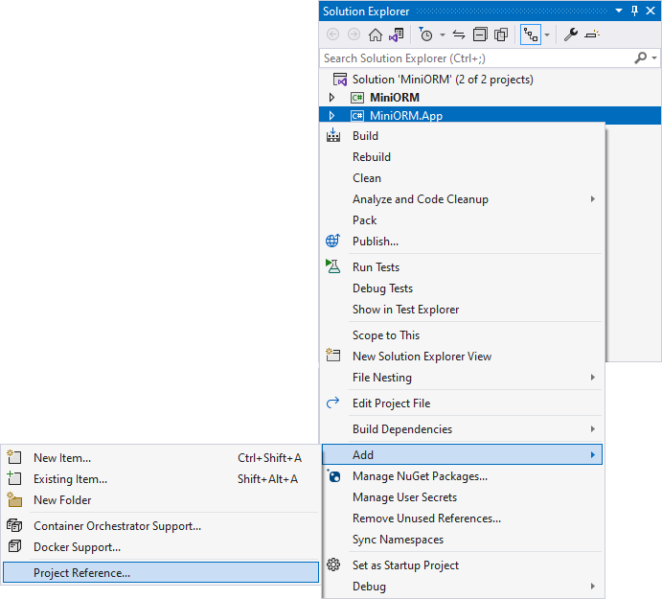

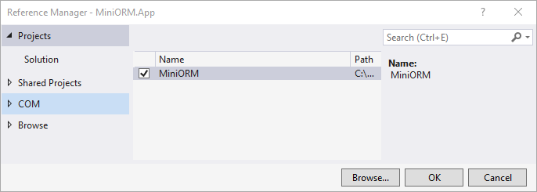

### Define the Data Model

Now it's time to create our data models using all the information we have in our database.

Create a **Data** directory, and inside it, create an **Entities** directory. When you're done, you should have the following folder structure:

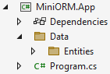

Now, let's get to creating the data model. First, create a Department class inside of the Entities folder. Entity classes have **one property** **for** **each column** of the table.

Create two properties – Id and Name. For the Id, use the [Key] annotation (using System.ComponentModel.DataAnnotations) to let our framework know that this is the **primary key** of the entity. We can forbid the Name **property** from having a **null value** upon calling SaveChanges() by adding the [Required] annotation to it. Our **framework** takes care of **validating every object** before persisting any changes. Finally, add an ICollection of employees as a **navigation property** for all of the **employees**, who belong to a particular **department**. When you're done, the class should look like this:

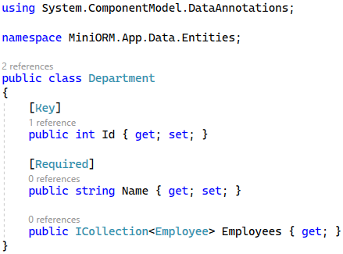

Next, create a **Project** class with an Id and a Name. The Id is our **primary key**, while the Name should be **required** (not null). Additionally, create a **navigation property**, called EmployeesProjects, which is a mapping entity between our Employee and Project entities. We'll create this class later.

It's generally a good idea to use a **get-only** property of type ICollection<T> for our navigation properties to prevent them **from being redeclared** outside of our framework. When you're done, your code should look like this:

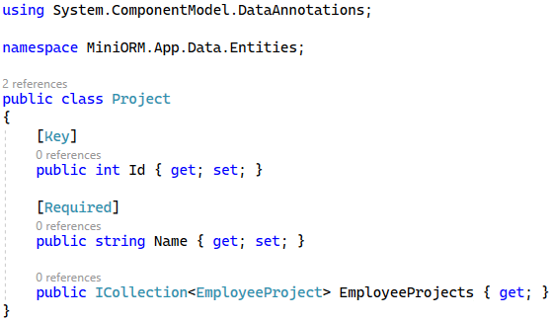

After that, create an **Employee** class and use the same logic. The only difference between the other two models we've created is that in the **Employee** class, we need a **foreign key** to our **Department** model. We can do that by using [ForeignKey(nameof(Department)] annotation above the DepartmentId property.

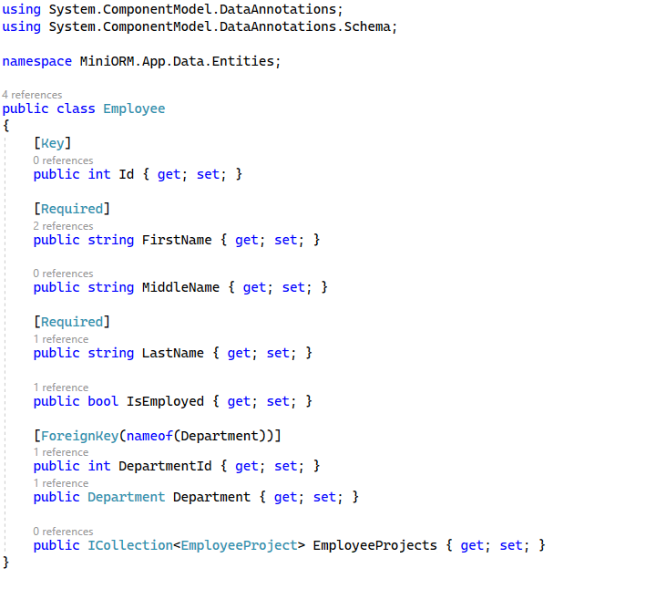

The last class to create is EmployeesProject, where we will have a **composite** key for the Projects and EmployeesId property. Then make the two composite keys **foreign** keys too.

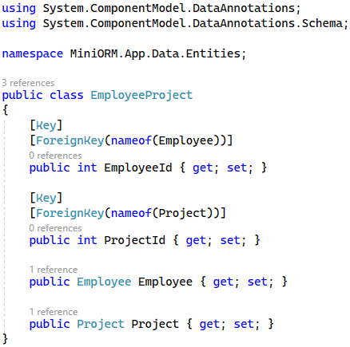

Now, let's create our DbContext class. Create a SoftUniDbContextClass in the Data folder, which **inherits** from our base DbContext class and has DbSets for all the **models** we've created. Make sure to inherit the constructor too.

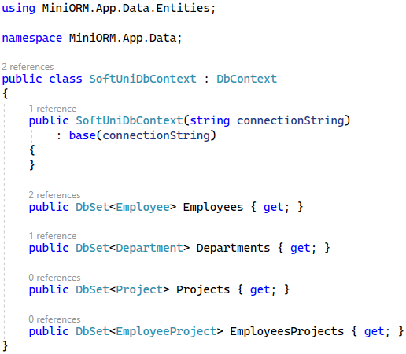

That's it! Our data model is done. Now it's time to test out the framework.

### Test the Framework

Let's test our MiniORM Framework by inserting some sample data in our database. Go to your **Program.cs** and declare your **connection** **string**. After that create an instance of the SoftUniDbContext class with your connection string and insert a new Employee. Then, find the **first employee** and modify their **name**. Finally, call the context's SaveChanges() method.

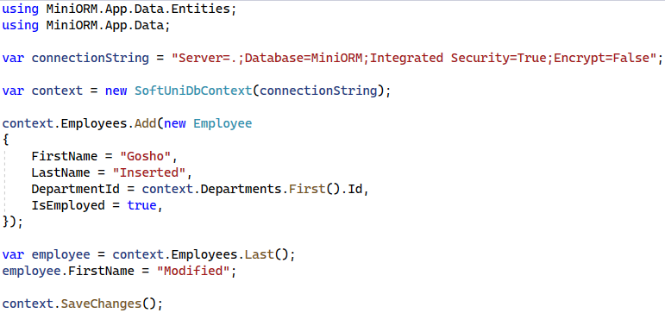

If everything works without any exceptions, we should be done! You've just gained some valuable insight into how an ORM Framework like **Entity Framework Core** is written. The MiniORM.App code can be transferred to a project, using **Entity Framework Core** and it will work **identically** without requiring any syntax changes!

You can try extending the framework by implementing extra stuff like **concurrency control** by yourself. Happy coding 😊