# Exercises: Introduction to Entity Framework

This document defines the **exercise assignments** for the [Databases Advanced - Entity Framework course @ SoftUni](https://softuni.bg/trainings/3966/entity-framework-core-february-2023)  
You can check your solutions in [Judge](https://judge.softuni.org/Contests/3917/Entity-Framework-Introduction)

## Import the SoftUni Database

Import the **SoftUni** database into SQL Management Studio by **executing** the provided script.

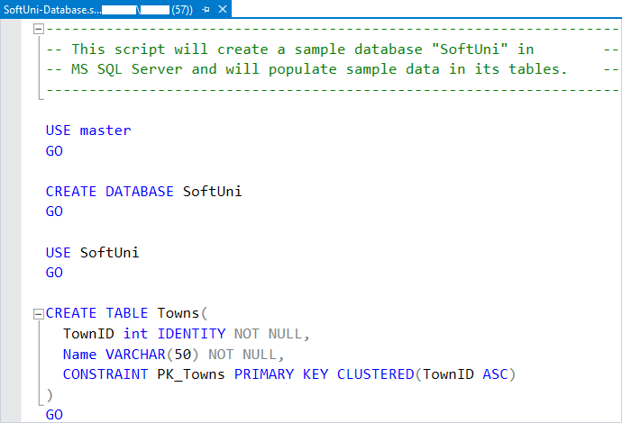

## Database First

Model the existing database by using the Database First approach.

First create a new empty **.NET Core** **Console Application** and after it is created open the **Package Manager Console**

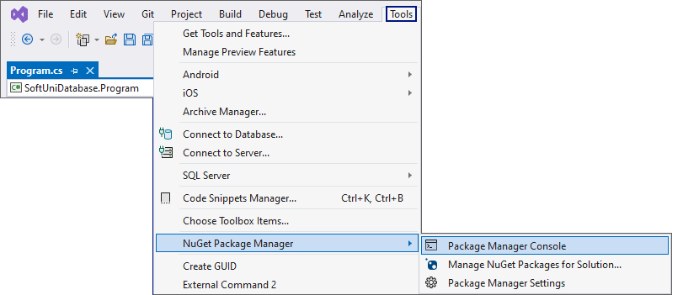

It will look something like this:

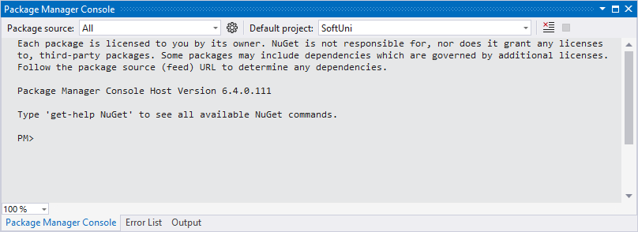

Use it to run the following commands **one by one**:

|  |
| --- |
| Install-Package Microsoft.EntityFrameworkCore.Tools –v 6.0.1  Install-Package Microsoft.EntityFrameworkCore.SqlServer –v 6.0.1  Install-Package Microsoft.EntityFrameworkCore.Design -v 6.0.1 |

These are the **packages** you will need, in order to **scaffold** our **SoftUniContext** from the **SoftUni** **database**.

**NOTE:** If **Package Manager Console** gives you any **errors** while trying to **execute the above commands**, try using the following ones:

|  |
| --- |
| Install-Package Microsoft.EntityFrameworkCore.Tools –Version 6.0.1  Install-Package Microsoft.EntityFrameworkCore.SqlServer –Version 6.0.1  Install-Package Microsoft.EntityFrameworkCore.Design -Version 6.0.1 |

**NOTE:** For the next steps you will need **public Program class** and a **static void Main()** method.

Next, we must **execute** the **command** to **scaffold** our **context** **class**. It will consist of 4 things:

1. First, the name of the command:

|  |
| --- |
| Scaffold-DbContext |

1. Second, the connection we will be using (our connection string):

|  |
| --- |
| -Connection "Server=<ServerName>;Database=<DatabaseName>;Integrated Security=True;" |

For **ServerName**, use the name of your local MS SQL Server instance or ".".

For **DatabaseName**, use the name of the database you want to use, in this case – **SoftUni**.

1. Third, we need to declare our service provider, we'll be using **Microsoft.EntityFrameworkCore.SqlServer**:

|  |
| --- |
| -Provider Microsoft.EntityFrameworkCore.SqlServer |

1. And the fourth thing we'll do, is to give it a directory where all of our models will go (e.g. **Models**):

|  |
| --- |
| -OutputDir Data/Models |

Our final command will look like this:

|  |
| --- |
| Scaffold-DbContext -Connection "Server=.;Database=SoftUni;Integrated Security=True;" -Provider Microsoft.EntityFrameworkCore.SqlServer -OutputDir Data/Models |

Execute the **whole command** on a **single line.**

**NOTE:** You should write only one '**\**' in the connection string. Otherwise, an **InvalidOperationException: Instance failure** will be thrown.

Entity Framework Core has successfully **mapped the database schema to C# classes**. Use the **Solution Explorer** in Visual Studio to move the **SoftUniContext** class out of **Models** intothe **Data** folder and move the **Models** folder out of the **Data** folder into the project's directory. Press OK on both of the pop-up windows that will be shown.

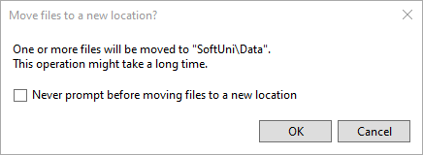

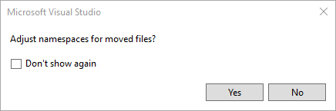

This way Visual Studio will also **rename** the **classes** **everywhere** they're used.

However, sometimes Entity Framework Core isn't good enough with names – all classes may have been pluralized. If this is your case, just rename all of our classes properly. Use **right-click → Rename** or the **F2** shortcut and press **OK** on this **pop**-**up** **window** after renaming each class:

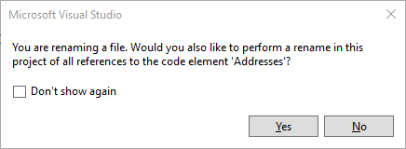

The final result should look like this:

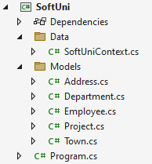

Don't forget to check the **SoftUniContext**'s namespace after moving it and to add a reference to the **Models** and **Data** namespaces:

**Make** **sure** that your namespaces are **exactly** the same as these:

|  |
| --- |
| SoftUni SoftUni.Data  SoftUni.Models |

Finally, we want to clean up the packages we won't be using anymore from the package manager GUI or by running these commands **one by one**:

|  |
| --- |
| Uninstall-Package Microsoft.EntityFrameworkCore.Tools -r  Uninstall-Package Microsoft.EntityFrameworkCore.Design -RemoveDependencies |

## Employees Full Information

**NOTE:** You will need method **public static string GetEmployeesFullInformation(SoftUniContext context)** and **public StartUp** class.

Now we can use **SoftUniContext** to extract data from our database. Your first task is to extract **all employees** andreturn their **first**, **last** and **middle** name, their **job** **title** and **salary**, rounded to **2** **symbols** after the decimal separator, all of those separated with a space. Order them by **employee** **id**.

### Example

|  |
| --- |
| Output |
| Guy Gilbert R Production Technician 12500.00 |
| Kevin Brown F Marketing Assistant 13500.00 |
| Roberto Tamburello Engineering Manager 43300.00 |
| … |

## Employees with Salary Over 50 000

**NOTE:** You will need method **public static string GetEmployeesWithSalaryOver50000(SoftUniContext context)** and **public StartUp** class.

Your task is to extract **all employees** with **salary** over **50000**. Return their **first names and salaries** in format **"{firstName} – {salary}". Salary** must be rounded to **2** **symbols,** after the decimal separator. Sort them **alphabetically** by **first** name.

### Example

|  |
| --- |
| Output |
| Brian - 72100.00 |
| Dylan - 50500.00 |
| James - 84100.00 |
| … |

Use **Express** **Profiler** and check if the query Entity Framework Core sent is correct (there is only one query, but there may be more that are performed by EF for checks).

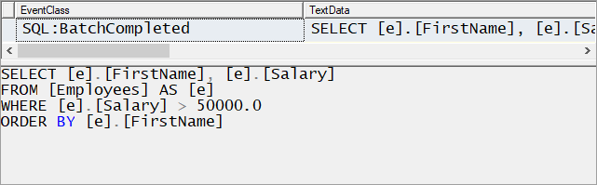

## Employees from Research and Development

**NOTE:** You will need method **public static string GetEmployeesFromResearchAndDevelopment(SoftUniContext context)** and **public StartUp** class.

Extract all employees from the **Research and Development** department. Order them by **salary** (in ascending order), then by **first name** (in descending order). Return only their **first name**, **last name**, **department name** and **salary** rounded to **2** **symbols,** after the decimal separator in the format shown below:

### Example

|  |
| --- |
| Output |
| Gigi Matthew from Research and Development - $40900.00 |
| Diane Margheim from Research and Development - $40900.00 |
| Michael Raheem from Research and Development - $42500.00 |
| … |

Use Express Profiler and check if the made query by Entity Framework is correct (there is only one query).

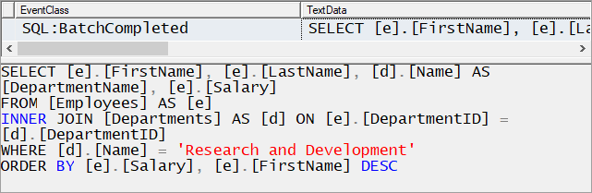

## Adding a New Address and Updating Employee

**NOTE:** You will need method **public static string AddNewAddressToEmployee(SoftUniContext context)** and **public StartUp** class.

Create a new address with the **text** "**Vitoshka 15**" and **TownId** = **4**. Set that address to the employee with last the name "**Nakov**".

Then order by **descending** all the employees by their **Address'** **Id**, take **10** rows and from them, take the **AddressText**. Return the results each on a new line:

### Example

|  |
| --- |
| Output |
| Vitoshka 15 |
| 163 Nishava Str, ent A, apt. 1 |
| … |

After this **restore** your **database** for the tasks ahead!

### Hints

Create the address and find the employee with last name equal to "Nakov" in order to assign the address to him.

## Employees and Projects

**NOTE:** You will need method **public static string GetEmployeesInPeriod(SoftUniContext context)** and **public StartUp** class.

Find the first **10** employees and print each employee's **first name**, **last name, manager's first name** and **last name. If they** have **projects** started in the period **2001 - 2003** (inclusive), print them with information about their name, start and end date. Then return **all** of their **projects** in the format "--<**ProjectName**> - <**StartDate**> - <**EndDate**>", each on a **new** **row**. If a project has no end date, print "**not finished**" instead.

### Constraints

Use date format: "M/d/yyyy h:mm:ss tt".

### Example

|  |
| --- |
| Output |
| Guy Gilbert - Manager: Jo Brown |
| --Half-Finger Gloves - 6/1/2002 12:00:00 AM - 6/1/2003 12:00:00 AM |
| --Women's Tights - 6/1/2002 12:00:00 AM - 6/1/2003 12:00:00 AM |
| Kevin Brown - Manager: David Bradley |
| Roberto Tamburello – Manager: Teeri Duffy |
| --Classic Vest – 6.1.2003 12:00:00 - not finished |
| … |

## Addresses by Town

**NOTE:** You will need method **public static string GetAddressesByTown(SoftUniContext context)** and **public StartUp** class.

Find all addresses, **ordered** by the **number of employees** who live there (**descending**), then by **town name** (**ascending**) and finally by **address** **text** (**ascending**). Take only the **first 10 addresses**. For each address return it in the format "<**AddressText**>, <**TownName**> - <**EmployeeCount**> employees"

### Example

|  |
| --- |
| Output |
| 7726 Driftwood Drive, Monroe - 2 employees |
| 163 Nishava Str, ent A, apt. 1, Sofia - 2 employees |
| … |

## Employee 147

**NOTE:** You will need method **public static string GetEmployee147(SoftUniContext context)** and **public StartUp** class.

Get the **employee with id 147.** Return only his/her **first name**, **last name**, **job title** and **projects** (print only their names). The projects should be **ordered** **by** **name** (**ascending**). Format of the output.

### Example

|  |
| --- |
| Output |
| Linda Randall - Production Technician |
| HL Touring Handlebars |
| … |

## Departments with More Than 5 Employees

**NOTE:** You will need method **public static string GetDepartmentsWithMoreThan5Employees(SoftUniContext context)** and **public StartUp** class.

Find **all departments** with more than **5 employees**. Order them by **employee count** (**ascending**), then by **department** **name** (**alphabetically**). For each department, print the **department name** and the **manager's first** and **last name** on the **first row**. Then print the **first** **name**, the **last** **name** and the **job** **title** of every **employee** on a new row. Order the employees by **first** **name** (**ascending**), then by **last** **name** (**ascending**).  
Format of the output: For each department print it in the format "<**DepartmentName**> - <**ManagerFirstName**> <**ManagerLastName**>" and for each employee print it in the format "<**EmployeeFirstName**> <**EmployeeLastName**> - <**JobTitle**>".

### Example

|  |
| --- |
| **Output** |
| Engineering – Terri Duffy |
| Gail Erickson - Design Engineer |
| Jossef Goldberg - Design Engineer |
| … |

## Find Latest 10 Projects

**NOTE:** You will need **method** **public static string GetLatestProjects(SoftUniContext context)** and **public StartUp** class.

Write a program that returns information about the **last 10 started projects**. **Sort** **them by name** lexicographically and return **their name, description and start date**, each on a new row.

### Constraints

Use date format: "M/d/yyyy h:mm:ss tt".

### Example

|  |
| --- |
| Output |
| All-Purpose Bike Stand Research, design and development of All-Purpose Bike Stand. Perfect all-purpose bike stand for working on your bike at home. Quick-adjusting clamps and steel construction. 9/1/2005 12:00:00 AM |
| … |

## Increase Salaries

**NOTE:** You will need method **public static string IncreaseSalaries(SoftUniContext context)** and **public StartUp** class.

Write a program that increases salaries of all employees that are in the **Engineering**, **Tool Design**, **Marketing,** or **Information Services** department by **12%**. Then **return first name, last name and salary** (2 symbols after the decimal separator)for those employees, whose salary was increased. Order them by **first** **name** (**ascending**), then by **last** **name** (**ascending**). Format of the output.

### Example

|  |
| --- |
| Output |
| Ashvini Sharma ($36400.00) |
| Dan Bacon ($30688.00) |
| … |

## Find Employees by First Name Starting with "Sa"

**NOTE:** You will need method **public static string** **GetEmployeesByFirstNameStartingWithSa(SoftUniContext context)** and **public StartUp** class.

Write a program that finds all employees whose first name starts with "**Sa**". Return their **first**, **last** **name**, their **job** **title** and **salary** rounded to **2** **symbols** after the decimal separator in the format given in the example below. Order them by the **first** **name**, then by **last** **name** (**ascending**).

### Constraints

### Find a way to make your query case-insensitive.

### Example

|  |
| --- |
| Output |
| Sairaj Uddin - Scheduling Assistant - ($16000.00) |
| Samantha Smith - Production Technician - ($14000.00) |
| … |

## Delete Project by Id

**NOTE:** You will need method **public static string DeleteProjectById(SoftUniContext context)** and **public StartUp** class.

Let's **delete** the project with id **2**. Then, take 10 projects and return their names, each on a new line. Remember to restore your database after this task.

### Example

|  |
| --- |
| Output |
| Classic Vest |
| Full-Finger Gloves |
| … |

### Hints

If we try to delete the project directly:

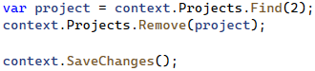

This happens:

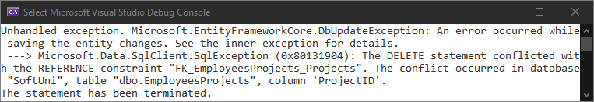

The project is **referenced** by the join (many-to-many) table **EmployeesProjects**. Therefore we cannot safely delete it. First, we need to remove any references to that row in the **Projects** table.

This is done by removing the project from all employees who reference it.

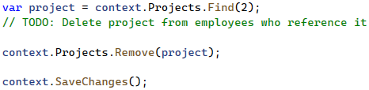

## Remove Town

**NOTE:** You will need method **public static string RemoveTown(SoftUniContext context)** and **public StartUp** class.

Write a program that **deletes a town** with name **"Seattle"**. Also, **delete all addresses** that are in those towns. Return the **number** of **addresses** that were **deleted** in format **"{count} addresses in Seattle were deleted".** There will be **employees** living at those addresses, which will be a problem when trying to delete the addresses. So, start by setting the AddressId of each employee for the given address to **null**. After all of them are set to **null**, you may safely remove all the addresses from the context and finally remove the **given** **town**.

### Example

|  |
| --- |
| Output |
| 46 addresses in Seattle were deleted |