**Smart Washing**

**By Tim Perkins, Kole Young, Spencer Ellis**

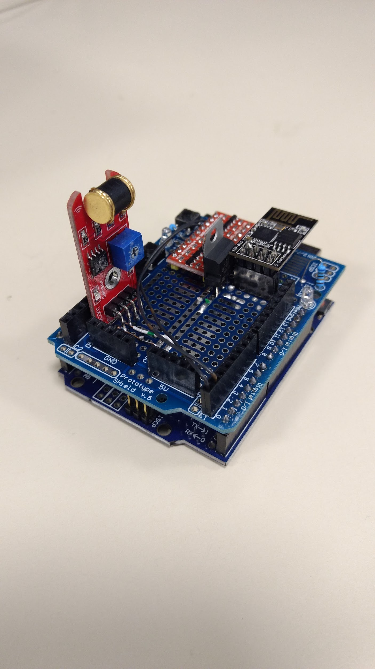

**Introduction**

The purpose of this project was to create a device that would alert the user when their washing machine would be done through text or email. This was achieved through attaching a vibration sensor to the Arduino and program it to detect vibrations. Once the vibrations have ceased for a certain amount of time, we would then use a WIFI emitter to connect to the internet and send an email to user’s phone. This project would be an effective tool for everyone so that the simple things, such as your laundry, wouldn’t be forgotten.

**Vibration Sensor**

In order to keep track of when the washer is done we used a 801s vibration sensor which sent out a analog signal that we could then interpret with the arduino. We originally thought that this would be the easy part of the project thinking that we could just tell the arduino that when there is no vibrations the washer is done. We then realized that sometimes the washer sends no vibrations in between different cycles of the wash sending a false washer done signals. In order to fix this we implemented a few hoops that the code had to jump through before it would know that the washer was done.

* Took data over a minute and then took the average.
* Has the spin cycle happened yet?
* Was the average 0 for more than four minutes.

With these three things all put together the arduino was able to filter out all of the 0 average vibrations that were not the end of the cycle. We also made sure that it would not start collecting data until the sensor reached a certain threshold so that it also could tell when the washer had started. This kept it from sending washer done over and over when the washer hasnt been started yet.

c  
312.66  
3.10  
3.54  
4.48  
6.29  
5.64  
5.00  
4.75  
9.40  
4.33  
3.83  
7.46  
4.95  
7.65  
3.50  
7.38  
3.05  
6.36  
3.18  
3.21  
3.17  
3.49  
11.07  
291.53  
7.20  
595.40  
529.57  
34.96  
3.84  
2.10  
4.12  
2.83  
5.22  
25.49  
166.09  
2.83  
14.70  
3.38  
3.04  
4.56  
218.04  
285.04  
160.77  
156.56  
116.75  
247.39  
310.28  
379.81  
450.55  
469.88  
695.89  
608.94  
667.32  
600.94  
582.29  
527.06  
581.46  
1  
Done yet?  
2  
Done yet?  
3  
Done yet?  
4  
Done yet?  
d

**Wifi Module**

In order for the device to notify the user that the washer has completed we needed to have some sort of communication module. Due to budget constraints we decided to implement the communications with an open source wifi module. The model number for the wifi module is ESP8266-01. This module allowed us to stay under budget but also gave us the ability to communicate over the internet using WIFI. To program the WIFI module, we used the Arduino IDE with the ESP8266 board package installed. To actually send the text message and email, we used the AlertMe library and we used serial communication to send messages from the Arduino to the ESP8266 module.

**Extra Parts**

To make the device work properly and be presentable we had to add few extra parts that simply allowed the device to function. We needed to have a logic level shifter because the Arduino has a 5 volt logic level while the ESP8266 has a 3.3 volt logic level. To power the WIFI module, we needed a 3.3 volt source. The Arduino has a 3.3 volt regulator but is not able to source enough current to adequately power the ESP8266. We added an external 3.3 volt regulator that is able to source the necessary current for the logic shifter and the WIFI module. Though these parts are not performing large functions they allow the Arduino and the WIFI module to communicate together and with the outside world.

**Code**

The code for this project can be found at the following link.

<https://github.com/koleyou/smartwashing>

**Future Objectives**

- A functional Fourier transform program

- A separate function for the washing machine and the dryer.

- Repeating Alert program.

- Enable the device to enter “sleep mode.”

**Conclusion**

In conclusion, we were able to achieve our main purpose of the project. We were able to have the device to average out the vibrations of the washing machine in order to know when it was done washing. We have the Arduino taking the average vibrations over a minute and if there were 4 minutes of no vibrations, then we would activate the WIFI Emitter. The WIFI emitter was successful in sending to our phones alerts that the machine was done. Due to the limited time factor, we were not able to go further. However, we were successful in making a working product.