# EmployeeManagement_Nitin

Employee Management System

Project Name : Employee Management

Author : Nitin kolhe

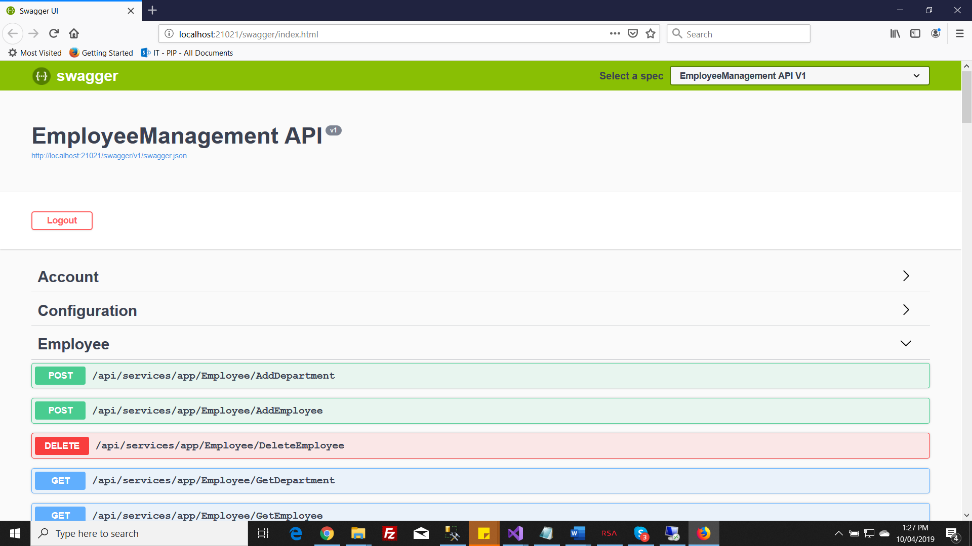

Swagger: Default username and password to test api click on Authorize button

Username : Admin

Password : 123qwe

**App service: EmployeeAppService (path : EmployeeManagement\4.8.0\aspnet-core\src\EmployeeManagement.Application\Employee)**

Technologies Used: asp core 2.0 , Code First Entity Framework , Sql 2016 , Visual Studi 2019 , Linq.

Framework : ABP (Choose ABP Framework its latest in market and it gives Various features like Tenant Management , User Management , Localization , Authorization , Token Based Security , Exception Loggin , audit trail , Signal R , Admin Panel , Swagger , Test Case writing for API, Coding stadard used by following Solid Principles , Dependency Injection is Used , Delegates are also used)

Steps to Run

Install asp core 2.0

1) Open solution file in VS 2019

2) Change Connection String in Host Project appsetting.json

3) Open nuget package console Set Enity Framework As default project and run “Update-Database” command. Database will be created.

4) Set Host as default project and Run, you can see swagger containing api details.

In current Solution to Develop Project Following things are done

1. Created Entity Employee/Department in Core Project

(employee.Management.CoreEmployee (Two classes added for table))

1. Added Entry in Database context.

( EmployeeManagement.EntityFrameworkCoreEntityFrameworkCore (.EntityFrameworkCore project includes a pre-defined DbContext. I should add a DbSet for the Employee/Department) entity into the DbContext:))

1. Created Table in Database by running query “Add-Migration” and update-database though nuget console on Entity framework Project
2. (EmployeeManagement.EntityFrameworkCore

Migrations

Script (20191004055752_TableAddeEmpDept) added to add table to database.)

1. Added Request and Response Classes for API in DTO Folder under application Project

(Added Interface and appservice for api (Add employee/Add Department/Get Employee/get Department)

Required request and response model and classed added under DTO folder)

6) Created Interface IEmployeeAPP service to define methods

7) Created Class EmployeeAPPService and implemented interface there.

8) Added validation project to validate Request Parameters

9) Exception handling taken care globally

10) ABPAUTHORIZE added for security

5) Test Project added in solution (EmployeeManagement.Tests)

Under Employee folder you will find EmployeeAppService_Tests test case for employee app service