WICKED WINES

Wine Buying Behaviour of US Consumers

23 Oct 2020 (updated on 2020-10-26)

Table of Contents

# 1 Data1: Consumer feelings toward wine

## 1.1 Missing values

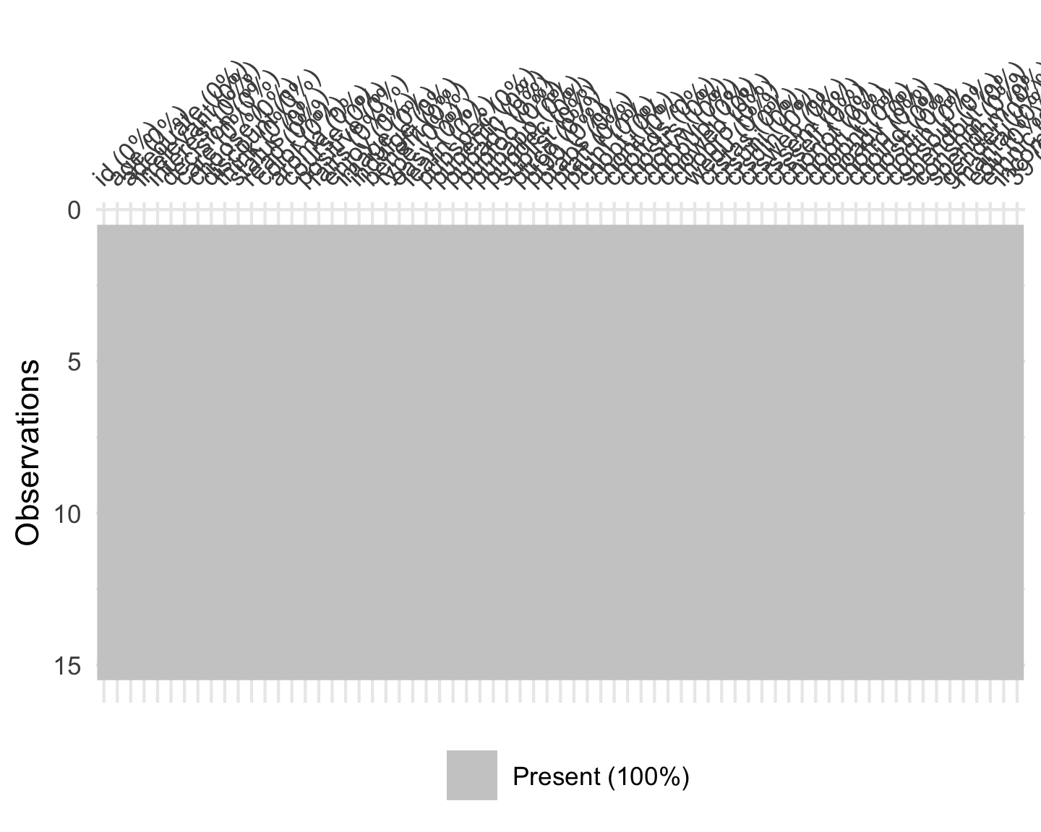

Figure 1.1: Pattern of missing values

## 1.2 Consumer feelings toward wine

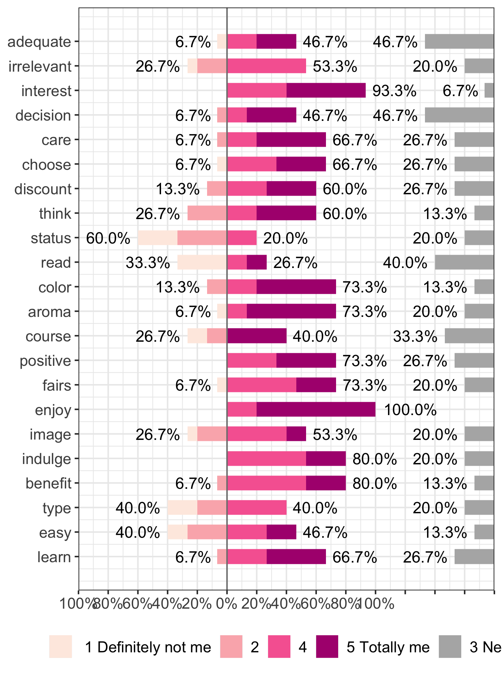

Figure 1.2: Consumer feelings toward wine and wine consumption

# 2 Influence of brand on wine enjoyment

## 2.1 Round 1

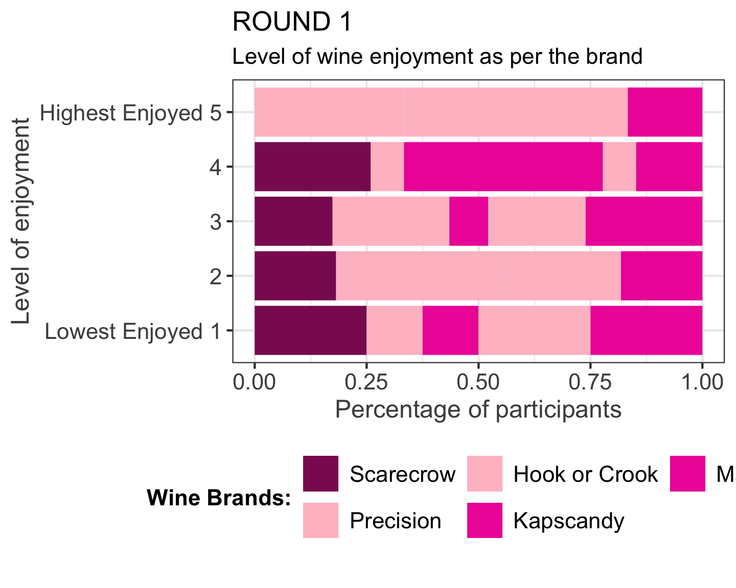

## 2.2 Round 2

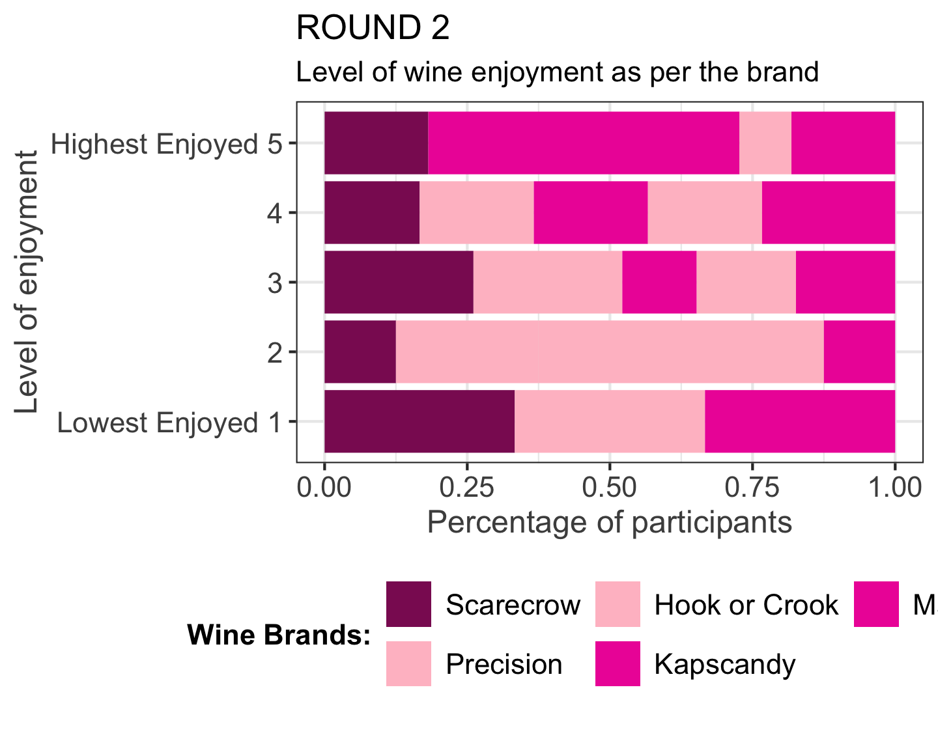

## 2.3 Round 3

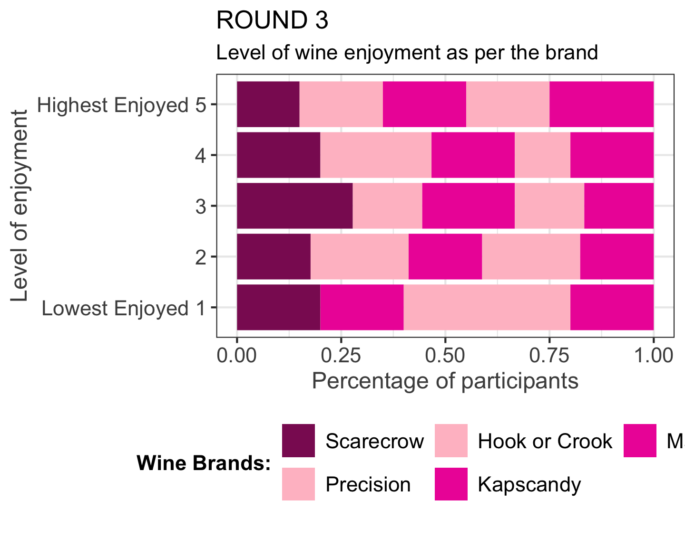

# 3 Desired wine feature

This will help us to understand for which brand which particular attribute is playing a major role in the higher or lower wine enjoyment score.

## 3.1 Round 1

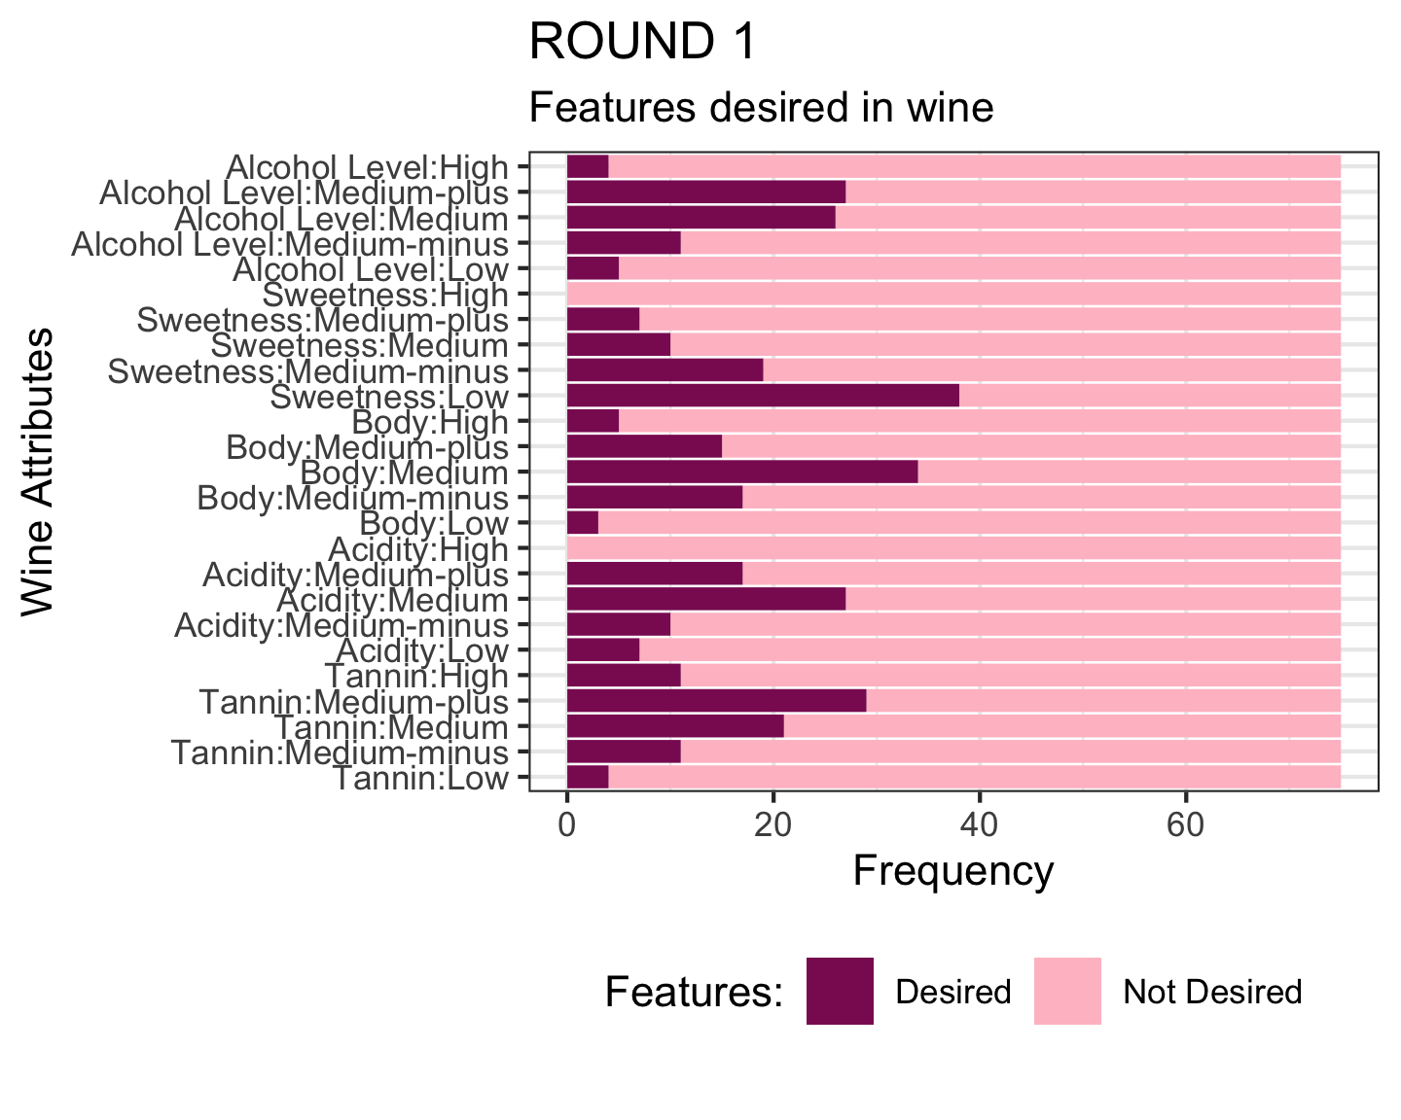

## 3.2 Round 2

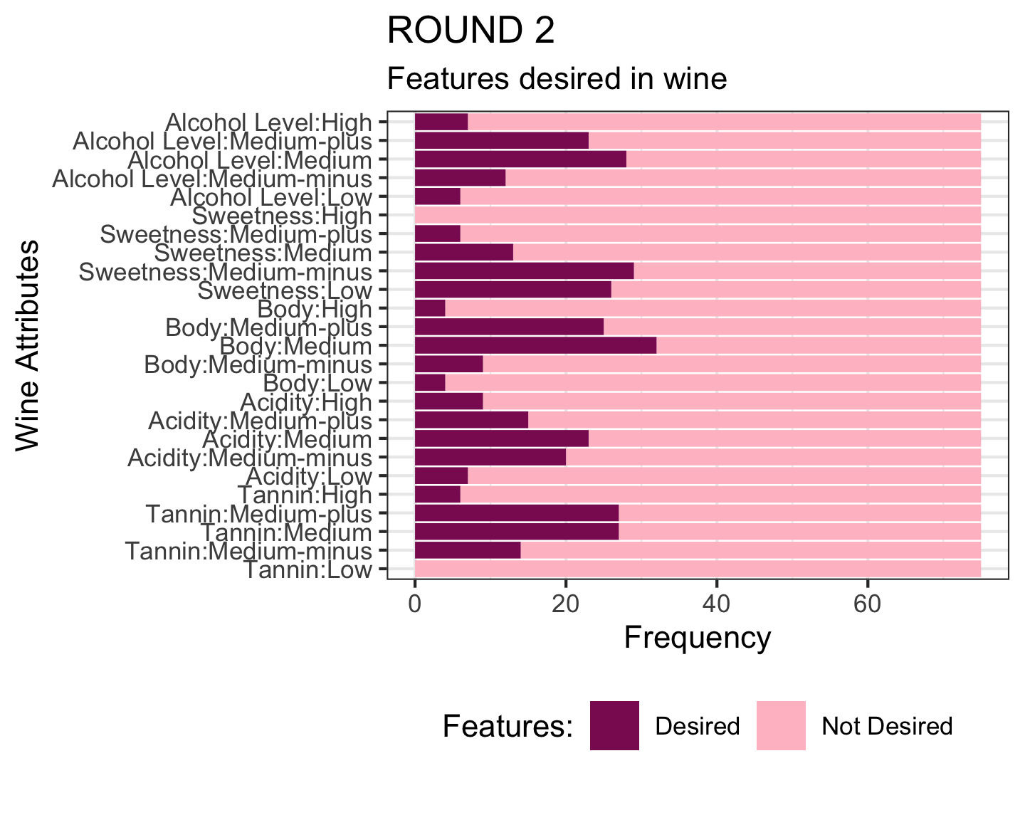

## 3.3 Round 3

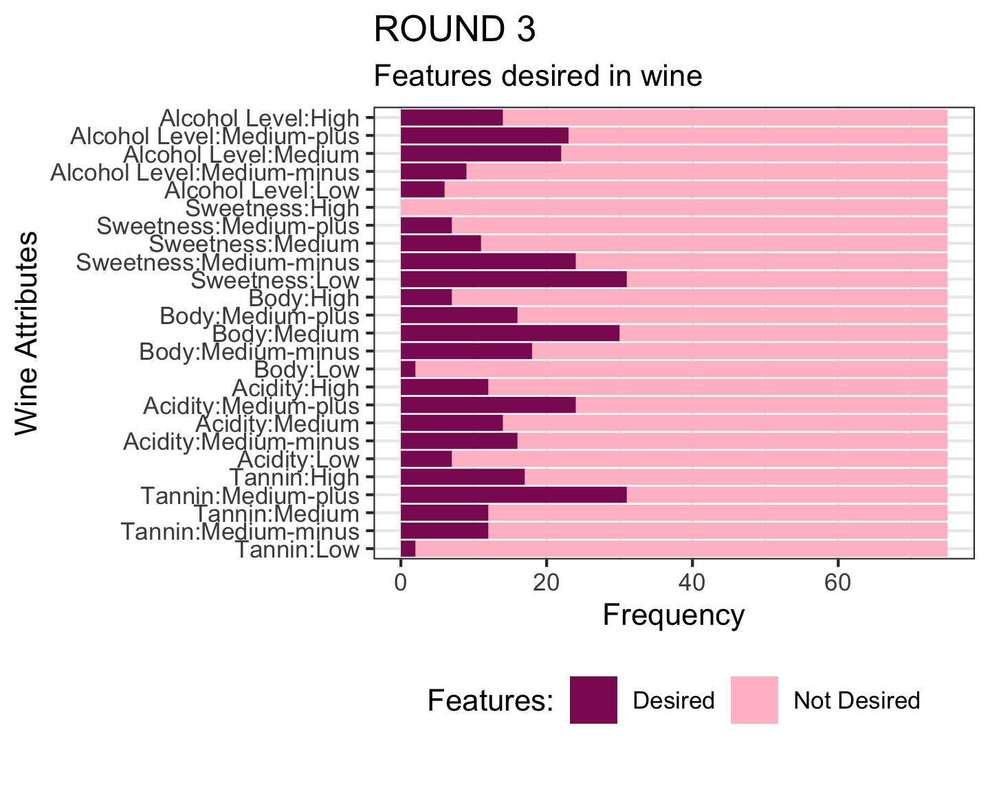

# 4 Chi square tests

## 4.1 Brand and Enjoyment

### 4.1.1 Round 1

##   
## Pearson's Chi-squared test  
##   
## data: table(round1a$brand1, round1a$enjoy1)  
## X-squared = 26.037, df = 16, p-value = 0.05351

### 4.1.2 Round 2

##   
## Pearson's Chi-squared test  
##   
## data: table(round2a$brand2, round2a$enjoy2)  
## X-squared = 19.103, df = 16, p-value = 0.2634

### 4.1.3 Round 3

##   
## Pearson's Chi-squared test  
##   
## data: table(round3a$brand3, round3a$enjoy3)  
## X-squared = 4.4085, df = 16, p-value = 0.998

## 4.2 Enjoy and Re-drink

### 4.2.1 Round 1

##   
## Pearson's Chi-squared test  
##   
## data: table(round1a$enjoy1, round1a$drink1)  
## X-squared = 35.057, df = 4, p-value = 4.523e-07

### 4.2.2 Round 2

##   
## Pearson's Chi-squared test  
##   
## data: table(round2a$enjoy2, round2a$drink2)  
## X-squared = 46.986, df = 4, p-value = 1.535e-09

### 4.2.3 Round 3

##   
## Pearson's Chi-squared test  
##   
## data: table(round3a$enjoy3, round3a$drink3)  
## X-squared = 49.129, df = 4, p-value = 5.489e-10

# 5 Regression Model

## Rows: 75  
## Columns: 12  
## $ participant <dbl> 1, 1, 1, 1, 1, 2, 2, 2, 2, 2, 3, 3, 3, 3, 3, 4, 4, 4, 4,…  
## $ brand <dbl> 1, 2, 3, 4, 5, 1, 2, 3, 4, 5, 1, 2, 3, 4, 5, 1, 2, 3, 4,…  
## $ study <chr> "round1", "round1", "round1", "round1", "round1", "round…  
## $ enjoyment <dbl> 3, 4, 3, 4, 5, 1, 1, 1, 1, 1, 4, 3, 4, 3, 3, 1, 2, 3, 2,…  
## $ redrink <dbl> 1, 1, 1, 1, 1, 0, 0, 0, 0, 0, 1, 1, 1, 1, 1, 0, 0, 1, 0,…  
## $ Brix <dbl> 9.2, 8.2, 9.4, 9.0, 7.9, 9.2, 8.2, 9.4, 9.0, 7.9, 9.2, 8…  
## $ ABV <dbl> 16.4, 14.4, 16.9, 14.6, 15.0, 16.4, 14.4, 16.9, 14.6, 15…  
## $ TA <dbl> 5.6, 5.6, 5.9, 5.9, 5.9, 5.6, 5.6, 5.9, 5.9, 5.9, 5.6, 5…  
## $ pH <dbl> 3.68, 3.69, 3.52, 3.70, 3.64, 3.68, 3.69, 3.52, 3.70, 3.…  
## $ RRSugars <dbl> 3.3, 2.3, 2.3, 7.9, 1.5, 3.3, 2.3, 2.3, 7.9, 1.5, 3.3, 2…  
## $ Anthocyanins <dbl> 144, 254, 27, 345, 153, 144, 254, 27, 345, 153, 144, 254…  
## $ Phenolics <dbl> 55, 50, 51, 52, 46, 55, 50, 51, 52, 46, 55, 50, 51, 52, …

enjoyment

Predictors

Estimates

CI

p

(Intercept)

19.41

-26.27 – 65.09

0.400

Brix

0.25

-0.45 – 0.95

0.481

ABV

-0.11

-0.74 – 0.51

0.720

TA

-0.23

-2.64 – 2.19

0.851

pH

-4.22

-12.35 – 3.92

0.305

Observations

75

R2 / R2 adjusted

0.053 / -0.001