BRAND ARCHITECTURE · VISUAL IDENTITY · COMMUNITY
ZERO-BASED IDENTITY EXPLORATION
Rocci branding and
community foundation
A reversible public-preview recommendation for an open-source Roc ecosystem project

17 August 2026 · Exploratory · Community review required
Not trademark clearance. Not authorization to use or modify the Roc logo.

This report prepares Rocci for a public preview and community discussion. It does not approve a permanent name, authorize use of the Roc logo, or replace a trademark search. Recommendations are deliberately reversible until Roc and Datastar community feedback has been collected.

Executive recommendation
Keep Rocci as the public masterbrand for the first preview. The acquired rocci.dev domain, existing command, file extension, repository history, and documentation already give the name meaningful equity. A rename before anyone outside the project has reacted would exchange known, manageable ambiguity for new migration work and equally uncertain alternatives.
Use one public family:
Rocci — web and desktop interface tools for Roc
├── Rocci templates .rocci components and pages
├── Rocdown Rocci's Markdown-first document format
├── Rocci Docs public product name for the Rocs generator
│ └── rocs engine, crate, and compatibility command
└── Rocci runtime run, preview, and bundle
Ecosystem relationships: Roc language · Datastar hypermedia
The important change is hierarchy, not mass renaming. Rocdown remains a useful endorsed subname. Rocs should recede from public brand status because it is generic, difficult to search, and already strongly associated with other software and scientific products. Documentation should say “Rocci Docs” in prose and show rocs build only when naming the current command.
Use “Rocci — web and desktop interface tools for Roc” as the consistent descriptor during the preview. A strong home-page headline is:
Build web and desktop interfaces in Roc.
This is clearer and more searchable than “without the framework tax,” which is vague to newcomers and frames the introduction as an argument against other tools.

What the implementation already says
The current repository supports a masterbrand architecture even though its names are sometimes presented as peers:
- Rocci is the workspace, CLI, configuration prefix, desktop host, template syntax, repository, and website name.
- .rocci is a source format that lowers templates to ordinary Roc Html.
- .rocdown is a Markdown-first sibling format with explicit executable regions.
- Rocs is the static documentation compiler. It uses a Rocci-authored theme and renders static article/catalog work in Rust.
- Datastar is an external client-side hypermedia dependency, pinned per app; Roc is the language and compiler ecosystem on which Rocci builds.
This is not a portfolio of independent products. It is one toolchain with two authoring formats and several delivery modes. The public vocabulary should reflect that reality.

Naming assessment

Rocci
Strengths
- Short, visually distinctive, and immediately contains “Roc.”
- Flexible enough to cover templates, documents, static sites, and desktop hosting without becoming false as the implementation evolves.
- rocci.dev, .rocci, rocci.toml, and the rocci command form a coherent owned namespace.
- Friendly rather than enterprise-coded, which fits Roc's stated “fast, friendly, functional” character.
Weaknesses and risks
- Pronunciation is not self-evident. “ROCK-ee,” “ROW-chee,” and “Roc C.I.” are plausible readings. The project should choose one and show it unobtrusively on the About page.
- The name does not explain the product without a descriptor. Every early mention should pair it with “web and desktop interface tools for Roc.”
- Search ownership is not clean. rocci is an active Python package for ROC confidence intervals; historical rOCCI cloud tooling and ROCI robotics work also appear for similar queries.
- A Roc-derived name and Roc-adjacent logo can look official. The site must say that Rocci is an independent open-source project unless and until the Roc project agrees to a different relationship.
Conclusion: retain for preview, with a descriptor and a two-week naming feedback window. Do not call the project “the Rocci Foundation” unless a legal entity actually exists; use Rocci Project or simply Rocci.

Rocdown
Rocdown is the best of the component names. Developers can infer the Markdown relationship, the .rocdown extension is memorable, and its scope is bounded. The name does collide with the statistical phrase “ROC down” and unrelated organizations, so it should not be expected to rank well alone.
Use these forms consistently:
- First mention: “Rocdown, Rocci's Markdown-first document format”
- Navigation: Rocdown
- Search titles: “Rocdown syntax | Rocci” or “Write Rocdown pages with Rocci”
Do not make Rocdown a separate website, logo, community, or top-level social account during the preview.

Rocs
Rocs is compact and playful, but a poor public product identity:
- “rocs” is the ordinary plural of ROC and an acronym in several fields.
- KDE has long shipped an application named Rocs.
- OpenEye ROCS is established chemistry software.
- Search results also contain recent academic ROCS acronyms.
- Spoken references such as “Rocs docs” are easy to mishear and hard to query.
Keep the implementation name where changing it has a cost, but present it as Rocci Docs. A later compatibility path can introduce rocci docs build as an alias while retaining rocs build. Rename crates only if publishing or registry ownership makes that necessary.

Alternative names and structures
No alternative is clearly better enough to justify an immediate rename. These are candidates for community testing, not availability or legal clearance:
Candidate | Useful signal | Main drawback | Preliminary finding
Rocci | Ownable masterbrand; existing domain and syntax | Ambiguous pronunciation; Python/rOCCI/ROCI collisions | Best low-regret preview choice
Rocweave | Composition of templates, content, and HTML | Longer; less obviously a toolchain; registry/domain checks still required | Cleanest fresh-name candidate from a basic web search
Rocwing | Connection to Roc's mythical bird and movement | An existing VTOL product uses ROCWING; risks appearing official | Do not advance without stronger differentiation
Roclet | Small Roc unit; friendly diminutive | “Roclet” is already roxygen2's plugin concept and older OCL tooling | Reject
Rocfold | Source folding into output; strong visual idea | Existing scientific software term; may sound like a formatter | Keep only as a design metaphor
Rocform | Forms/interfaces and “form” as structure | Long-standing construction product and related marks | Reject
Rocbound | Boundary-oriented architecture | Existing business use; “bound” can imply limitation | Weak reserve candidate

Three structuring alternatives remain valid:
- Masterbrand (recommended): Rocci Templates, Rocdown by Rocci, Rocci Docs, Rocci Runtime. Lowest explanation and maintenance cost.
- Endorsed family: Rocci, Rocdown, and Rocs each get identities followed by “by Rocci.” Useful only if they acquire independent users and release cycles.
- Descriptive umbrella: “Roc Web Tools” as the site, with Rocci and Rocdown underneath. Immediately clear, but generic, hard to own, and more likely to imply official Roc status.
Advance from the masterbrand model only when usage data demonstrates separate audiences, maintainers, or distribution channels.

Preliminary exact-name snapshot — 17 August 2026
A dated API and registry screen narrows the practical namespace question. It is not a reservation, trademark search, or proof that an account can be created:
- Rocci: crates.io and npm returned no exact package record, while PyPI is occupied. GitHub's case-insensitive repository-name search returned 126 results, led by the established rOCCI cloud-tooling family. The owned rocci.dev domain remains the strongest namespace advantage.
- Rocdown: crates.io, npm, and PyPI returned no exact package record, and GitHub returned no repository-name match. This improves package practicality but does not remove the ordinary “ROC down” search phrase collision.
- Rocweave: crates.io, npm, and PyPI returned no exact package record; GitHub returned no repository-name match; and RDAP returned no record for rocweave.dev, .org, or .com. Those results make it the cleanest reserve candidate in this limited screen, but none of the names or domains has been reserved and legal clearance remains outstanding.
Exact-name absence is volatile and weaker than ownership. If Rocweave is kept as a serious fallback, reserve the relevant namespace before publicly promoting it. If Rocci remains, expect search results to require the full descriptor and rocci.dev rather than the bare name alone.

Searchability and SEO

Current strengths
The generated site already emits descriptive per-page titles and descriptions, canonical URLs, Open Graph fields, a social image, sitemap.xml, robots.txt, and llms.txt. The content is static, semantic, and available without JavaScript. These are excellent foundations.

Current gaps
- The home title puts a long proposition before the name. Prefer “Rocci — Web and desktop interfaces for Roc.”
- The H1 should contain both the activity and language. “Build web and desktop interfaces in Roc” serves humans and queries better than an anti-framework slogan.
- There is no WebSite structured-data declaration or alternate name. Google recommends one consistent, unique site name and supports alternateName. Because the site intentionally uses a strict CSP, choose CSP-compatible JSON-LD or standards-compliant microdata and test the result.
- No favicon or multi-size application icon appears in the generated head.
- The current single social card uses a serif identity while the site uses a heavy sans-serif identity. This weakens recognition between shared links and the destination.
- The docs hierarchy lacks short brand-intent landing pages for Rocdown and Rocci Docs. Reference pages alone do not answer broad discovery queries.

Search plan
- Use one site name everywhere: Rocci; add the alternate name Rocci Project only if it is used visibly.
- Put the descriptor in the home title, description, repository About text, package metadata, social bios, and the first README paragraph.
- Create focused evergreen pages:
- /rocdown/: “Rocdown: Markdown-first documents for Roc”
- /docs/: “Rocci Docs: static documentation from Rocdown”
- /datastar/: “Server-driven Roc interfaces with Datastar”
- Use compact, unique page titles and headings; keep important pages in the top-level internal-link graph. Google explicitly cites compact headings, logical structure, and relevant anchors as inputs to useful sitelinks.
- Add SoftwareSourceCode or another appropriate schema only after the basic WebSite identity validates; do not add decorative structured data.
- Add GitHub topics such as roc-lang, datastar, template-language, static-site-generator, and desktop-app, provided each still accurately describes shipped behavior.
- Preserve the dated preliminary crates.io, npm, PyPI, GitHub, and domain snapshot above. Before publishing packages, complete the remaining VS Code Marketplace, Open VSX, Homebrew, organization/account, and intended package manager checks. The PyPI rocci name is already occupied. Registry results can change and do not reserve a name.
- Conduct a professional trademark search before investing in a final identity or merchandise. This report is not legal clearance.

Visual identity and site styling

Existing system
There are currently three accent stories:
- The Rocs site uses warm ivory, charcoal, and coral-orange.
- Rocdown's default paper theme uses neutral stone with blue links.
- Rocdown's rocci theme uses deep green.
All three are individually plausible, but together they do not teach users that the surfaces belong to one project. The current Rocs site is polished and content-first; it should evolve rather than be replaced.

Recommended palette
Use the warm Rocs foundation as the shared family and add a restrained violet only as an ecosystem bridge to Roc's purple identity:
Role | Light | Dark | Use
Canvas | #FAF9F6 | #191817 | Page background
Surface | #FFFFFF | #22201E | Cards, tables, navigation
Ink | #201E1C | #F3EEE8 | Body and headings
Muted | #6D6862 | #B8B0A8 | Secondary text
Signal coral | #B92F19 | #FF987F | Links, focus, selected state
Fold coral | #E64B2F | #FF765A | Large marks and non-text accents
Roc bridge violet | #6D4AFF | #A78BFA | Rare ecosystem/reference facet

Do not use violet as a second general-purpose accent. It belongs in the logo's fold geometry, ecosystem diagrams, or a small “built for Roc” marker. Coral remains Rocci's recognizable action color.
The existing contrast is mostly strong: #B92F19 on #FAF9F6 is about 5.73:1, and dark #FF987F on #191817 is about 8.49:1. Two current cases need attention:
- White text on #E64B2F is about 3.88:1 and fails WCAG AA for the current small CTA text. Use the darker #B92F19 fill, dark text, or a larger text treatment.
- Rocdown green #0D9A5C on #F3F7F5 is about 3.35:1 and fails normal-text contrast. Darken the light-scheme green if the branded Rocdown theme remains.
Run a complete automated and manual audit before launch; these spot checks do not validate every mixed or state color.

Site hierarchy
The current documentation shell treats the home page like a very large article. At desktop widths the 4.35rem headline dominates the explanation and pushes the code sample down. The left navigation also repeats the full SEO title.
Recommended changes for a launch-ready home page:
- Add a landing-page presentation mode rather than forcing the article template to carry marketing, orientation, and reference navigation simultaneously.
- Cap the hero at roughly 3.4rem on ordinary desktop widths and use a 10–14 word descriptive headline.
- Follow with three concrete paths: Build a component, Write a Rocdown page, and Add a Datastar action.
- Show a compact architecture strip: .rocci / .rocdown → Roc + HTML → web or desktop.
- Move status and compatibility beside the first CTA: experimental, supported Roc revision, Datastar pin, and platform limitations.
- Replace “Source ↗” with a familiar GitHub label/icon and add a visible “Community” destination when the feedback channel is ready.
- Use a short nav label such as Overview instead of repeating the home-page SEO title in the sidebar and breadcrumb.
Typography should be consistent across the site, social cards, report covers, and logo lockups. A system sans stack with a system monospace is the most reliable zero-network choice. A display serif can be used in editorial illustrations, but should not become a second wordmark without a deliberate type license and asset pipeline.

Default Rocdown sites
Keep Paper as the default. A generated document should feel useful before it feels branded. Evolve it into a neutral member of the Rocci family:
- warm-neutral canvas and ink shared with the main site;
- a darker accessible blue or coral for links;
- 42–46rem measure, generous line-height, strong code overflow, and restrained tables;
- visible focus, selection, task-list, print, forced-color, and reduced-motion behavior;
- no Rocci header, product badge, remote font, or decorative logo by default.
The named Rocci Rocdown theme can carry coral plus the rare violet fold. Replace its unrelated green palette or rename that green theme if compatibility requires preserving it. Keep the stable --rd-* compatibility variables; visual consolidation should not force an authoring-contract break.

Logo and icon exploration

Corrected brief: begin from zero
The existing single-letter r is a placeholder, not a brand asset, research input, or constraint. It should not influence proportions, geometry, typography, color, or the choice of whether Rocci needs a symbol at all. An r-based mark is not disqualified, but it must earn its place against non-letter symbols and a wordmark-only identity.
The first orange folded-R sheet remains in the exploration because the maintainer likes it, not because it resembles or improves the placeholder. As that generation saw the current social card, it is not independent evidence for the direction. Any production sketch must be redrawn from first principles without the placeholder or generated raster as geometry to trace.
Roc's official explanation says its mark is an origami bird, derived from a physical paper model and formed from triangles as both an Elm homage and a computer-graphics primitive. Folds, bounded shapes, and composition are available ideas, not requirements. The Roc relationship belongs in the later similarity and official-status review, not as the starting grid for Rocci's mark. It does not grant permission to copy, recolor, crop, or modify the Roc bird.
Seven generated explorations accompany this report. The first three are the original constrained probes; the next four deliberately reset the brief.

A. Folded R — maintainer-preferred candidate
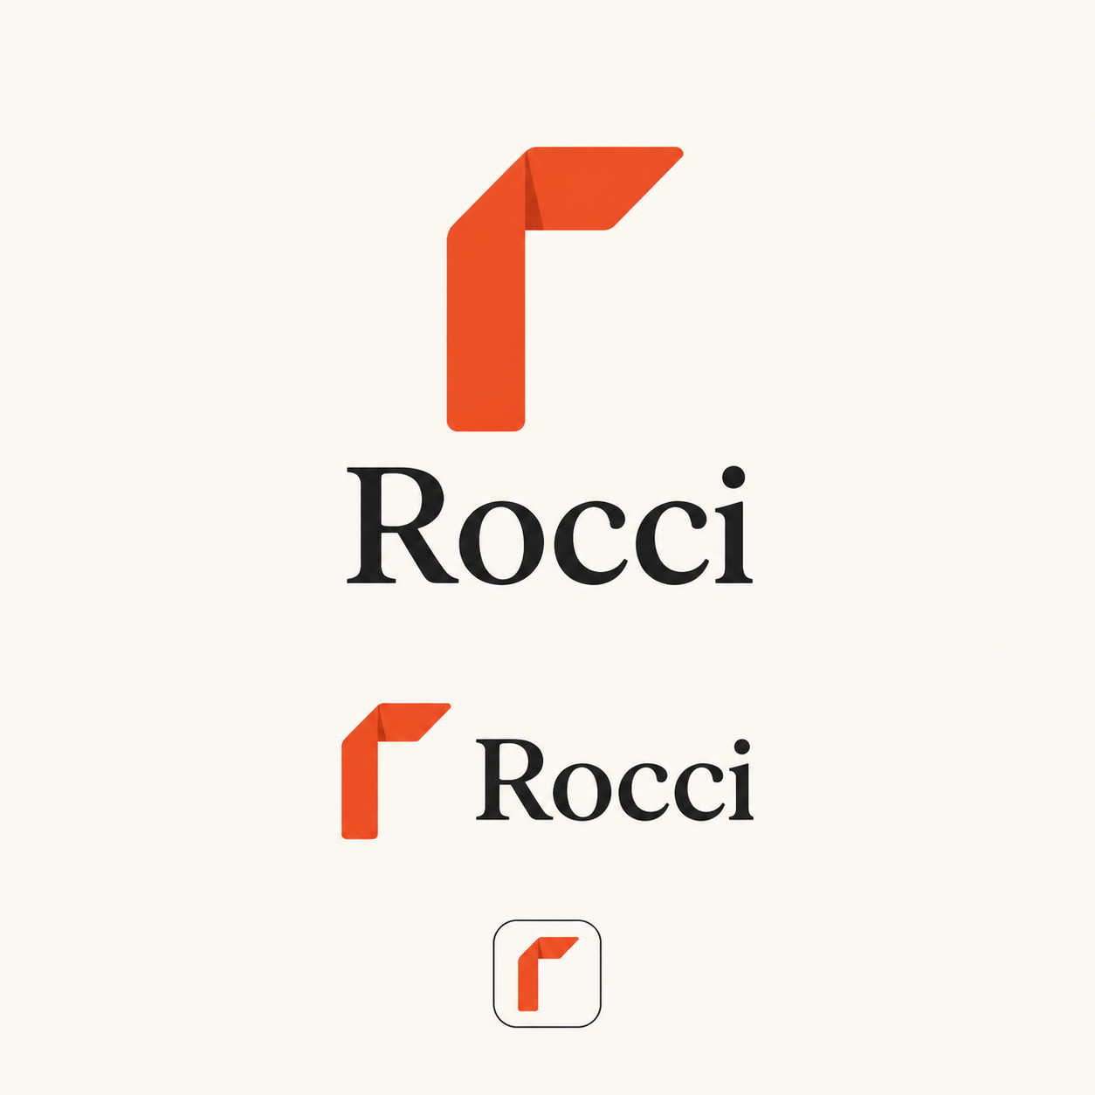
Folded R exploration — generated concept probe; not a production logo
The folded lowercase “r” is compact and memorable, and the maintainer likes the orange direction. Those are valid reasons to keep testing it. It must not be treated as the default merely because an r placeholder existed. Redraw it in one color from a blank canvas, then test whether it reads as an “r,” survives 16px use, and resembles any existing technology mark.

B. Page wing
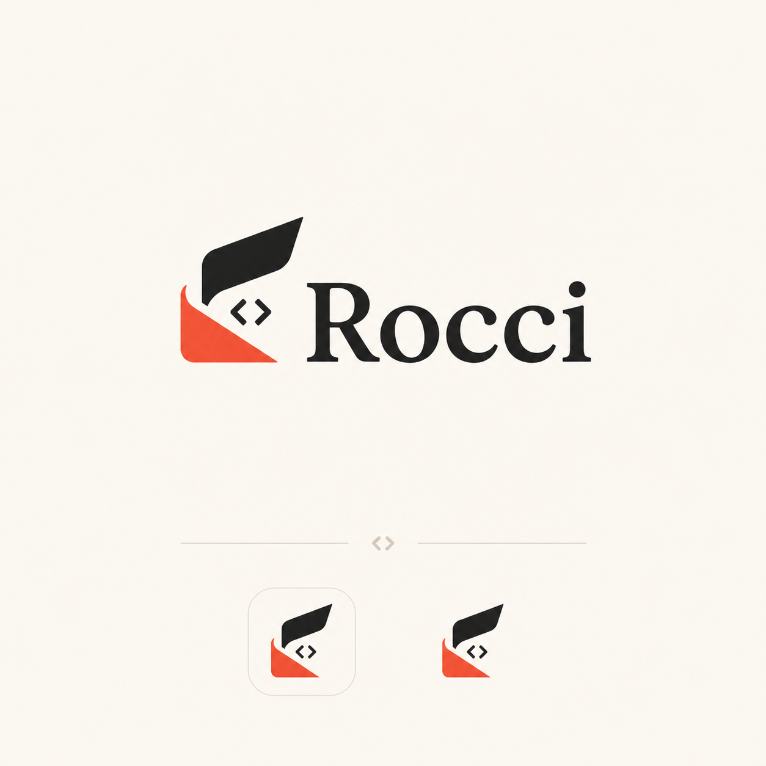
Page wing exploration — generated concept probe; not a production logo
The page/wing idea connects Rocdown and code, but the current concept has too many parts for 16px use and begins to look like an illustration. Keep it as a Rocdown or documentation motif, not the primary mark.

C. Connected tags
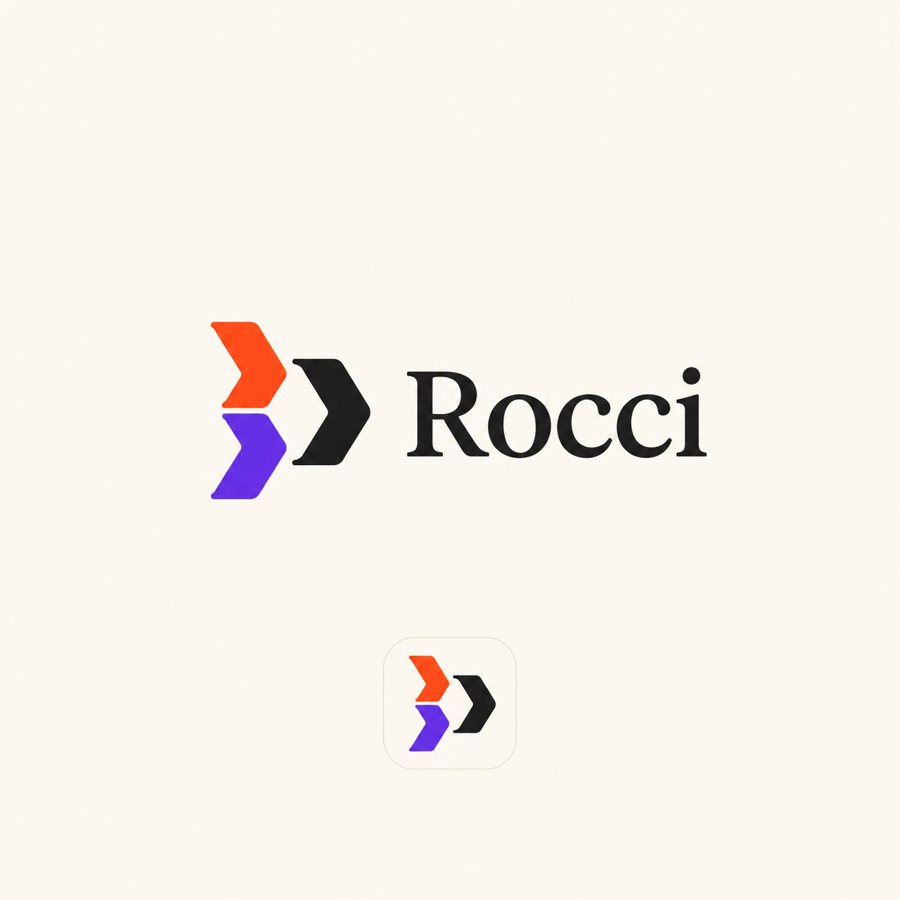
Connected tags exploration — generated concept probe; not a production logo
The three chevrons express multiple inputs converging on one boundary and use violet as a Roc reference. The silhouette is generic and risks resembling deployment, terminal, or cloud tooling. It is more useful as an architecture diagram motif than as a logo.

D. Open aperture — unconstrained probe
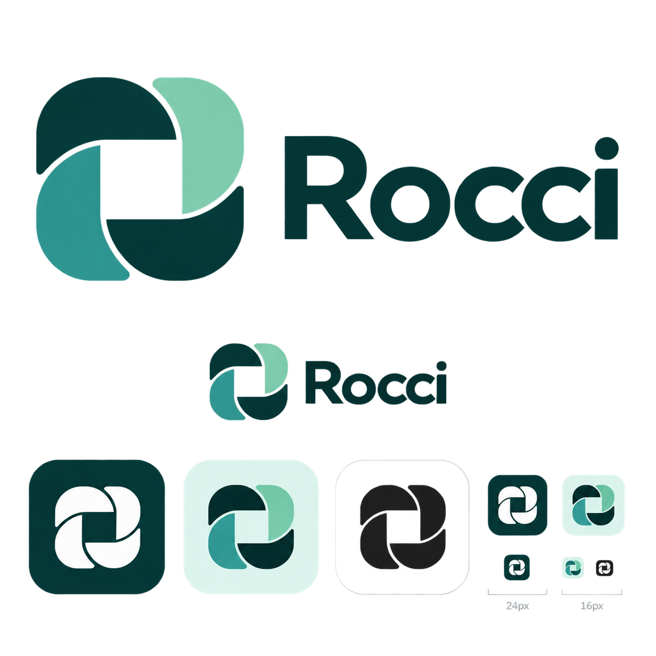
Open aperture exploration — generated concept probe; not a production logo
This fresh direction does not depend on a letter or the Roc logo. Its strong negative-space center suggests an interface or opening, but the rotating-blade construction is strongly associated with cameras and creative software. Do not advance this exact form.

E. Modular commons — strongest non-letter candidate
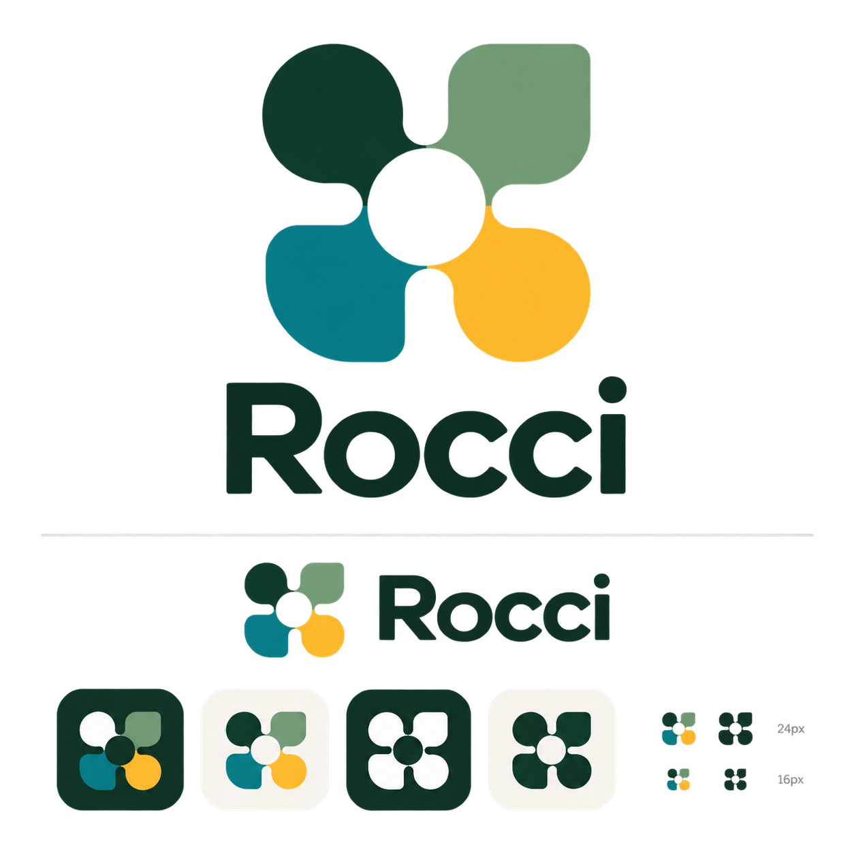
Modular commons exploration — generated concept probe; not a production logo
Four cooperating pieces around an open center express composition, contribution, and shared infrastructure without relying on an r. It is friendly and holds up reasonably well in one color, but flower, fan, and puzzle associations make the current silhouette generic. Advance only as a black-and-white sketch track with fewer, more ownable shapes.

F. Signal bridge — unconstrained probe
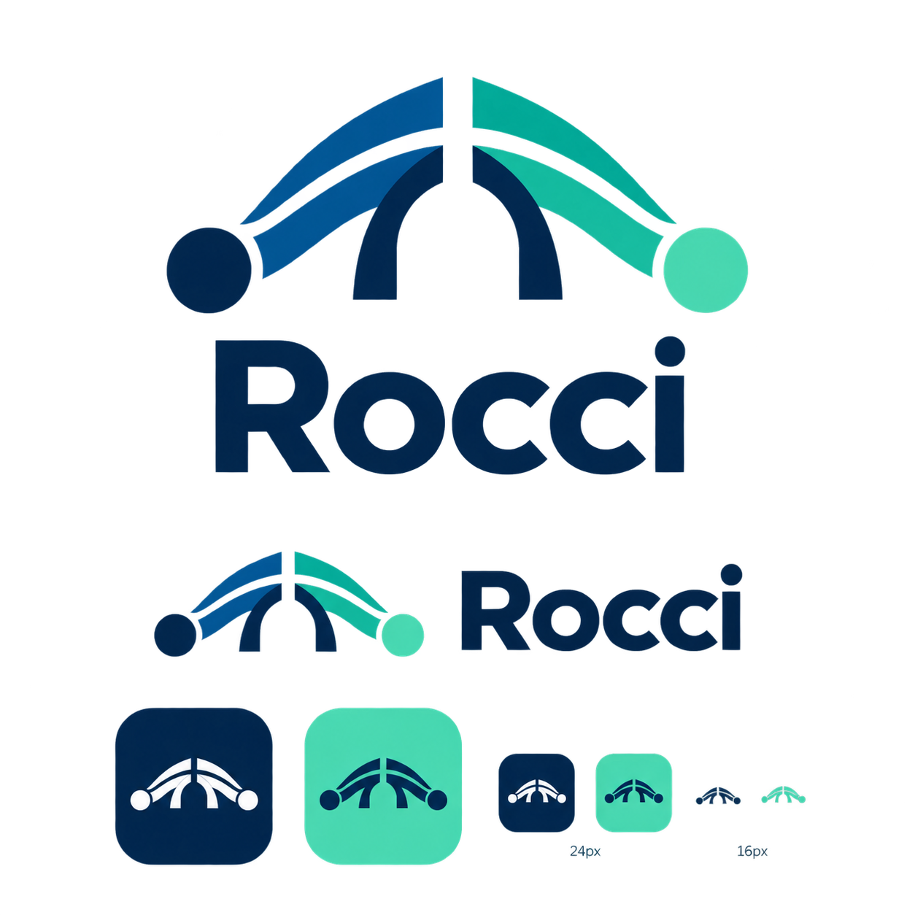
Signal bridge exploration — generated concept probe; not a production logo
The boundary-crossing story is relevant, but the generated form is too literal, too detailed at small sizes, and can read as networking or infrastructure software. Do not advance this exact form.

G. Wordmark only — no-symbol control
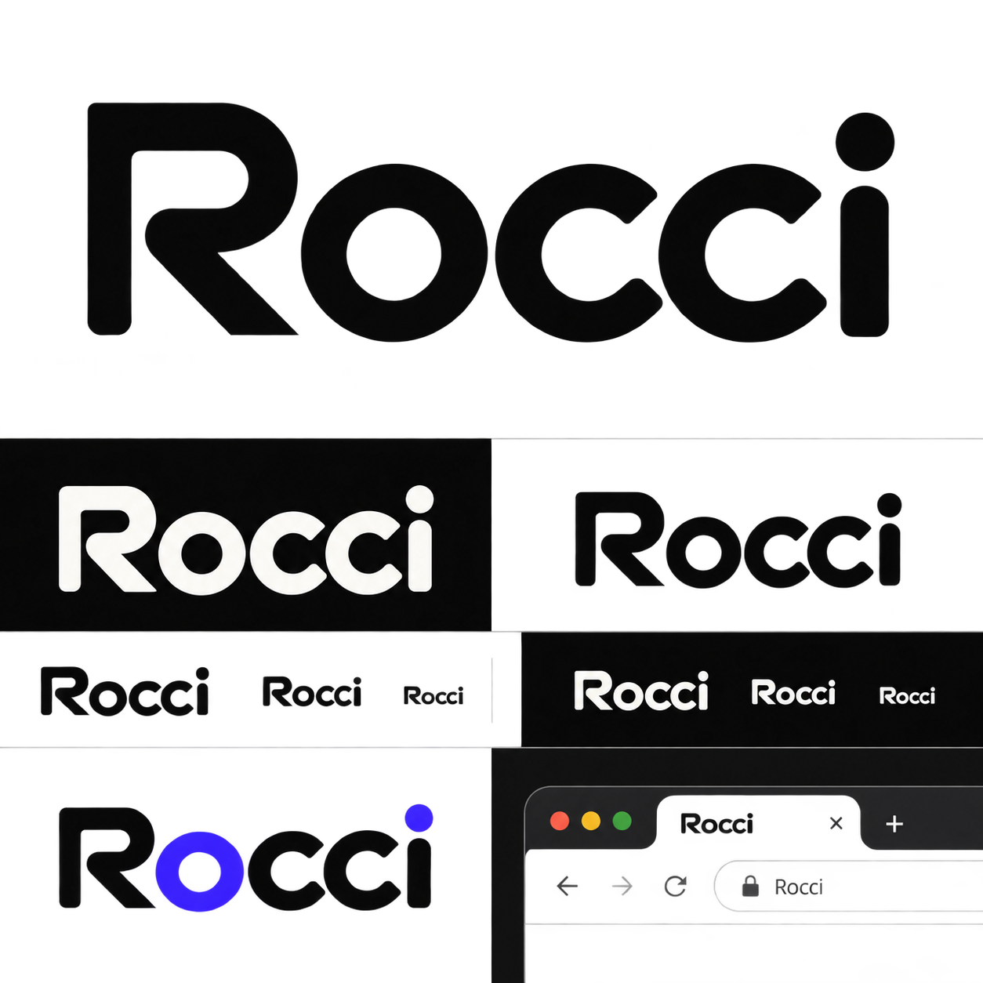
Wordmark-only exploration — generated concept probe; not a production logo
A custom wordmark is the necessary control case: Rocci may not need a separate emblem. The generated lettering is clear and developer-friendly, but its geometric initial and rounded construction are not yet distinctive enough. Advance the strategy, not this exact drawing, alongside the folded-R and modular-commons tracks.
The next comparison should therefore contain three genuinely different black-and-white vector routes: a fresh folded-letter mark, a non-letter modular mark, and a wordmark with no emblem. Use color only after silhouette, legibility, similarity, and community perception have been tested. The orange folded R is the current subjective favorite, not a settled recommendation.
The generated sheets are ideation artifacts, not source logos. Production work must be redrawn in SVG, simplified, optically corrected, checked in one color, tested at 16/24/32px, screened for confusing similarity, and licensed to the project. Ask the Roc project before using its actual mark in lockups or implying an official relationship.

Community foundation and public-preview plan

Launch posture
Call the first release a public preview or early design preview, not a general production release. The invitation is strongest when it asks the Roc community to shape a small, working system rather than approve a finished framework.
Suggested one-sentence pitch:
Rocci is an independent open-source toolchain for writing HTML components and Markdown-first documents in Roc, adding server-driven interaction with Datastar, and running the same interface on the web or in a desktop webview.

Non-negotiable repository blockers
The workspace declares MIT OR Apache-2.0, but the repository root currently contains neither license text. It also lacks the standard root community files. Resolve these before making the repository public:
- add LICENSE-MIT and LICENSE-APACHE (or change metadata to the license actually selected);
- add CODE_OF_CONDUCT.md with a real enforcement contact;
- add CONTRIBUTING.md, SECURITY.md, SUPPORT.md, and GOVERNANCE.md;
- add issue forms for bugs, design feedback, and documentation problems;
- state the supported Roc compiler revision, Datastar version, OS status, and compatibility policy in one visible page;
- provide one deterministic install path, one five-minute example, expected output, uninstall/cleanup instructions, and a known-limitations list;
- decide where the domain, GitHub organization, package registry accounts, signing keys, and social identities should live as maintainers are added.
GitHub treats these files as community health infrastructure, not decoration. Do not adopt a code of conduct unless the maintainer is prepared to enforce it.

Four-week feedback sequence

Week 0 — make evaluation safe
- Resolve licenses and community health files.
- Tag a reproducible preview revision; pin the tested Roc and Datastar versions.
- Record which paths work and which are demonstrations.
- Publish the five-minute component example and one small Datastar counter.
- Open one “Public preview feedback” discussion or issue with scoped questions.

Week 1 — Roc community first
Introduce the project in Roc Zulip, the community's primary gathering place. Choose the current projects/show-and-tell location with help from community regulars rather than assuming a channel. Lead with a 60–90 second demo, an architecture diagram, and the explicit independent-project disclaimer.
Ask five answerable questions:
- Does “Rocci” read naturally, and how did you pronounce it?
- Is the Rocci/Rocdown/Rocci Docs hierarchy understandable after one screen?
- Does “Roc-native” accurately describe the integration or sound official?
- Which one workflow would make the project worth trying next?
- Does the folded visual direction feel related, derivative, or unrelated to Roc?
Do not begin by asking the community to review the entire syntax. Separate brand, product need, syntax, compiler compatibility, and governance topics.

Week 2 — Datastar community
Share a focused integration demo in the Datastar Discord, which the Star Federation identifies as its community support venue. Frame Rocci as an independent backend integration and ask about event/patch semantics, documentation accuracy, and the value of a Roc example or SDK. Do not call the integration an official SDK without acceptance into the Datastar project.

Weeks 3–4 — synthesize in public
- Publish a short feedback summary with counts, quotations only with consent, and decisions/non-decisions.
- Keep a decision log: retained, changed, deferred, rejected, and why.
- Choose the pronunciation and confirm or reopen the name.
- Select one vector-logo direction only after the name decision.
- Announce the next narrow milestone and invite contributions with bounded “good first” issues.

Community operating model
Start with honest, lightweight governance: maintainer-led, open development. Document how decisions are made, how contributors become maintainers, where security issues go, and which assets are project-controlled. Avoid premature committees or the word “foundation.” Revisit a formal nonprofit or fiscal host only when there are multiple active maintainers, money to steward, or ecosystem assets that need durable neutral ownership.
Measure the preview by learning and retention, not stars:
- successful clean installs;
- time to first rendered component;
- number and quality of independent examples;
- repeat contributors after 30 and 90 days;
- unanswered support questions and median response time;
- feedback themes resolved or explicitly deferred;
- documentation search terms that produce no useful destination.

Ready-to-review execution material
Two companion documents turn the recommendation into reviewable work without publishing anything externally:
- COMMUNITY_LAUNCH_KIT.md contains a Roc-first announcement, a focused Datastar follow-up, a feedback issue template, a moderation protocol, and a two-week synthesis format.
- LANDING_PAGE_PROTOTYPE.md specifies the dedicated home-page information architecture, responsive rules, content constraints, and acceptance checks. A responsive visual direction was tested at mobile, laptop, and desktop widths. It deliberately uses a wordmark-only header so no logo candidate becomes the default by appearing in the prototype.
These are drafts. The announcement placeholders, community venue, support owner, demo claims, and compatibility facts must be verified immediately before use.

Decisions to take now, later, and not yet

Take now
- Rocci is the public preview masterbrand.
- Rocdown is an endorsed format: “Rocdown by Rocci.”
- Rocs becomes “Rocci Docs” in public prose; current command names remain.
- Use a clear Roc descriptor on every first mention.
- Keep the warm neutral/coral family and begin accessibility fixes.
- Compare three zero-based vector routes: folded letter, non-letter modular symbol, and wordmark only. Treat the orange folded R as the current maintainer preference, not the inherited default.
- Fix licensing and community health before publicity.

Take after community feedback
- Final pronunciation and whether the name survives the preview.
- Permission and rules for any actual Roc-logo co-branding.
- Final vector mark and wordmark typography.
- Whether rocci docs should become the primary CLI spelling.
- Whether the branded Rocdown theme replaces its green palette.
- Which community channel and governance host should be durable.

Do not take yet
- A legal “Rocci Foundation.”
- Separate Rocdown or Rocs communities and websites.
- Broad package/crate renames.
- A token-format migration or a large design-system implementation.
- Claims of official Roc or Datastar status.
- Merchandise or trademark filings before name and similarity review.

Remaining investigations
The following work is intentionally separated because it needs direct community, legal, or user evidence:
- Naming validation: 8–12 short interviews split between Roc developers, Datastar users, and developers unfamiliar with either; test unaided pronunciation, recall, expected function, and perceived official status.
- Registry and legal clearance: the preliminary crates.io, npm, PyPI, GitHub, and Rocweave-domain screen is complete. Reserve chosen namespaces, check editor and distribution marketplaces, and commission company and trademark searches in intended jurisdictions.
- Logo route and similarity audit: commission black-and-white folded-letter, non-letter modular, and wordmark-only sketches; run reverse image/similarity checks, small-size tests, and request Roc project feedback on ecosystem use.
- Accessibility audit: automated contrast/semantics plus keyboard, zoom, forced colors, reduced motion, print, and light/dark manual review.
- Landing-page implementation test: the exploratory dedicated layout now exists. Implement it only after a short first-impression test, then validate real content, links, performance, and accessibility in the Rocs shell.
- Message testing: announcement drafts now exist. Compare “web and desktop interface tools for Roc,” “Roc-native interface toolkit,” and “server-driven UI for Roc” against actual task comprehension rather than preference alone.
- Governance design: revisit maintainership, asset ownership, funding, and a fiscal host after the preview produces real contributors.

Sources
- Current repository contracts: root README.md, docs/rocs.toml, docs/index.rocdown, crates/rocci-rocdown/README.md, crates/rocci-theme, and crates/rocs/templates/RocsTheme.rocci.
- Roc FAQ: name and origami-bird logo
- Roc community
- Roc Programming Language Foundation
- Datastar / Star Federation community
- Google guidance for site names
- Google sitelink guidance
- GitHub community health files
- PyPI `rocci` package
- rOCCI cloud project
- KDE Rocs handbook
- crates.io exact-name registry
- npm package registry
- PyPI package registry
- GitHub repository search
- RDAP domain lookup
- Companion execution drafts: reports/branding/COMMUNITY_LAUNCH_KIT.md and reports/branding/LANDING_PAGE_PROTOTYPE.md.

