CINEWAVE ENTERTAINMENT
MOVIE TICKET BOOKING MANAGEMENT SYSTEM
Pega Blueprint Project Report
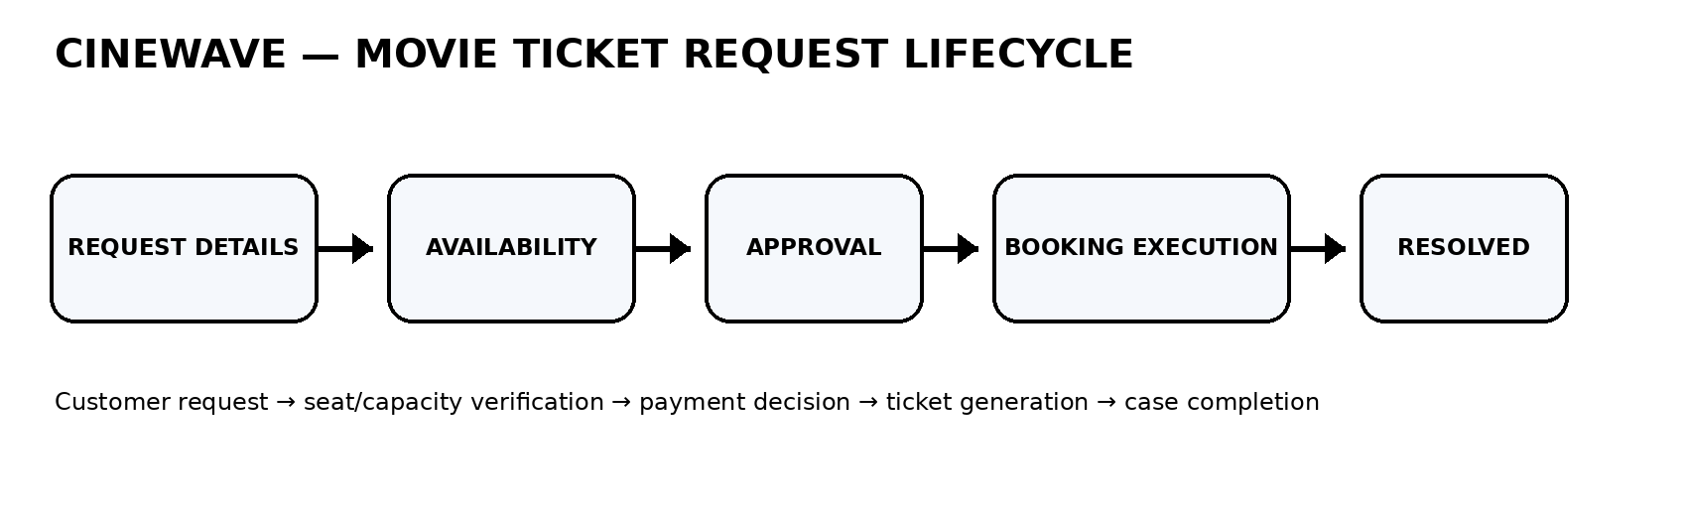
Application: Ticketing and Booking
Case Type: Movie Ticket Request
Business: CineWave Entertainment
Prepared by: Kolla Aditya

ACKNOWLEDGEMENT
I sincerely thank the faculty, trainers and mentors who provided guidance during the development of this Pega Blueprint project. I also acknowledge the Pega Blueprint environment and the project evaluation process that helped structure the movie ticket booking requirements into a case-management workflow.

TABLE OF CONTENTS
1. Project Overview
2. Business Problem
3. Objectives
4. Existing and Proposed Process
5. Technology and Platform
6. Solution Architecture
7. Case Lifecycle
8. Detailed Stage Design
9. Field Specification
10. Business Rules and Validations
11. Data Architecture
12. Personas and Access
13. Payment Management
14. Premium / Standard Routing
15. SLA Management
16. Booking Execution
17. Testing Strategy
18. Actual Pega Screenshots
19. Runtime Observation and Limitation
20. Future Enhancements
21. Conclusion

1. Project Overview
CineWave Entertainment requires a controlled process for handling movie ticket requests. The project converts the booking journey into a Pega case type named Movie Ticket Request. Each case moves through clearly defined stages and records the business information needed to complete the transaction.
Project Item | Configured Value
Business | CineWave Entertainment
Application | Ticketing and Booking
Case Type | Movie Ticket Request
Platform | Pega Blueprint / Pega Platform
Location | India
Language | English
Lifecycle | Request Details → Availability → Approval → Booking Execution → Resolved

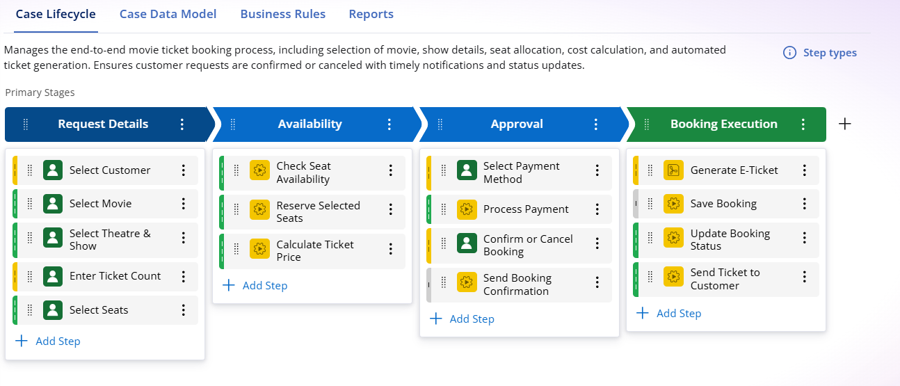
Figure 1. Actual Pega Blueprint workflow view captured during project development.

2. Business Problem
A movie ticket request is not only a payment transaction. The process must maintain a relationship between the selected show, available seats, ticket quantity, seat allocation, ticket price, payment method and final booking status.
- Requests can become inconsistent when ticket quantity and seats do not match.
- Booking should not continue when available capacity is lower than requested quantity.
- Payment options must follow the business requirement.
- Cancellation requires a reason so that the case remains complete.
- Booking execution should create ticket information and save the booking.
- Different show types need queue-based routing.
- Requests should be monitored against a defined service-level target.
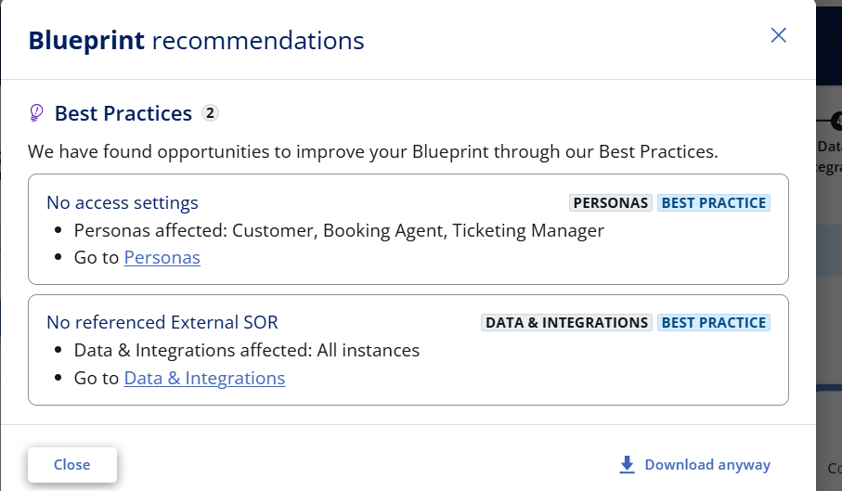
Figure 2. Actual Pega Blueprint recommendations screen captured during configuration.

3. Project Objectives
- Model a complete movie ticket request as a Pega case.
- Use five controlled lifecycle stages.
- Capture Movie Name, Show Date, Show Time, Number of Tickets and Show Type.
- Capture seat allocation and availability information.
- Apply the availability rule: Available Seats Count >= Number of Tickets.
- Keep selected/allocated seat count equal to Number of Tickets.
- Calculate Total Booking Cost as Ticket Price × Number of Tickets.
- Allow UPI and Credit/Debit Card as payment choices.
- Support Pending, Confirmed and Cancelled booking states.
- Require a cancellation reason for cancelled bookings.
- Route Premium and Standard shows to their configured queues.
- Apply a one-day goal and two-day deadline.
- Generate e-ticket and Ticket ID during booking execution.

4. Existing and Proposed Process
Area | Uncontrolled / Traditional Process | Proposed Pega Case Process
Request | Manual or scattered input | Single Movie Ticket Request case
Availability | Checked separately | Dedicated Availability stage
Seats | Possible mismatch | Seat quantity validation
Payment | Multiple possible choices | UPI / Credit-Debit Card
Cancellation | May be incomplete | Reason required when cancelled
Routing | Manual assignment | Premium/Standard queue routing
Tracking | Limited visibility | Case status + SLA
Completion | Separate confirmation | E-ticket + saved booking + Resolved

5. Technology and Platform
Technology / Component | Use in Project
Pega Blueprint | Visual application and workflow modelling
Pega Case Management | Movie Ticket Request lifecycle
Case Data | Movie, show, booking, payment and request fields
Business Rules | Availability, seat count, pricing, cancellation and routing
Personas | Customer, Booking Agent, Ticketing Manager, Application Control Agent
SLA | Goal 1 day; Deadline 2 days
Preview | Runtime-style validation of the designed case flow

6. Solution Architecture
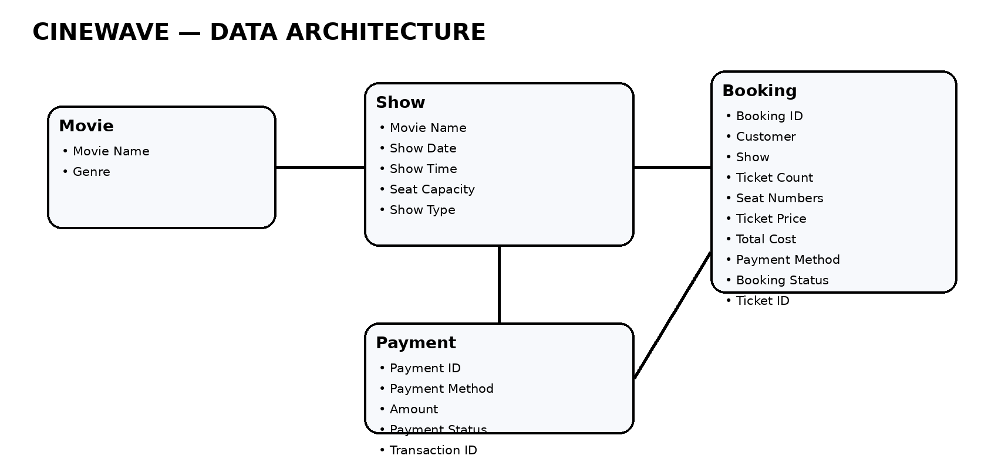
Figure 3. Logical data architecture for the CineWave booking solution.
The Pega case is the central process object. Reusable data objects represent Movie, Show, Booking and Payment information. Business rules use these values to control progression and produce the final booking outcome.

6.1 Architecture Layers
Layer | Responsibilities
User Layer | Customer and operational users provide or process booking information.
Case Layer | Movie Ticket Request controls stages, steps, status and lifecycle.
Business Logic Layer | Availability, seat quantity, price, payment, cancellation and routing rules.
Data Layer | Movie, Show, Booking and Payment reusable objects.
Outcome Layer | E-ticket, Ticket ID, booking record, execution status and Resolved case.

7. Case Lifecycle
Figure 4. Final five-stage Movie Ticket Request lifecycle.
Stage | Purpose
Request Details | Collect customer, movie, show, ticket quantity and seat request.
Availability | Verify capacity, reserve selected seats and calculate ticket price.
Approval | Select payment, process payment and confirm or cancel.
Booking Execution | Generate e-ticket, save booking, update status and send ticket.
Resolved | Complete the successful case.

8. Detailed Stage Design
Stage | Steps | Expected Business Result
Request Details | Select Customer; Select Movie; Select Theatre & Show; Enter Ticket Count; Select Seats | Complete request information.
Availability | Check Seat Availability; Reserve Selected Seats; Calculate Ticket Price | Verify capacity and establish price.
Approval | Select Payment Method; Process Payment; Confirm or Cancel Booking; Send Booking Confirmation | Complete payment decision.
Booking Execution | Generate E-Ticket; Save Booking; Update Booking Status; Send Ticket to Customer | Finalize booking.
Resolved | Successful completion | Case closed/resolved.

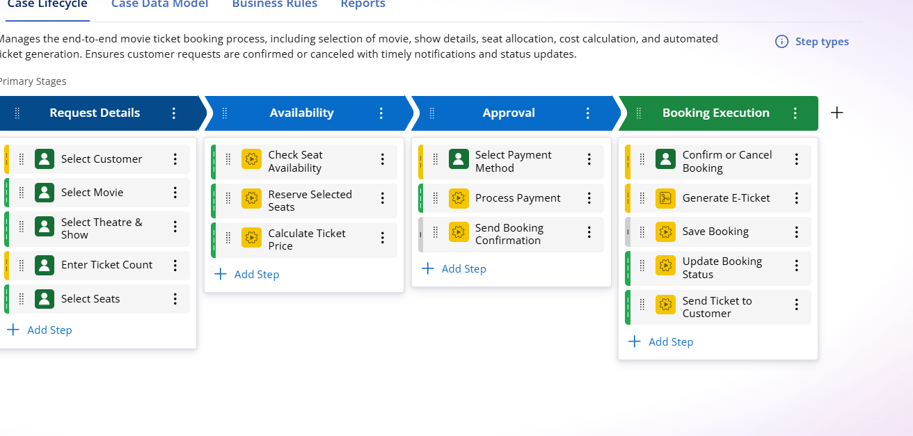
Figure 5. Actual Pega workflow configuration captured during development.

9. Field Specification
Field | Expected Type / Values | Purpose
Movie Name | Movie reference / text | Identifies selected movie.
Show Date | Date | Identifies show date.
Show Time | Time | Identifies show time.
Number of Tickets | Integer | Requested ticket quantity.
Show Type | Premium / Standard | Controls show classification.
Seat Allocation / Seat Numbers | Seat information | Stores selected/allocated seats.
Available Seats Count | Integer | Capacity used for availability validation.
Ticket Price | Currency | Price per ticket.
Total Booking Cost | Currency | Ticket Price × Number of Tickets.
Payment Method | UPI / Credit-Debit Card | Payment selection.
Booking Status | Pending / Confirmed / Cancelled | Booking state.
Cancellation Reason | Text | Required when Cancelled.
Ticket ID | Text | Ticket identification.
Execution Status | Status | Tracks execution.

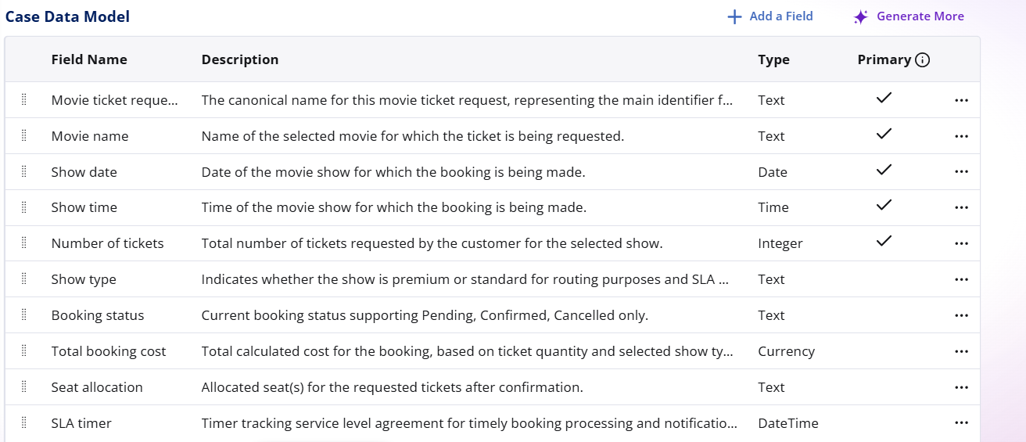
Figure 6. Actual Pega case data/model screen captured during the project.

10. Business Rules and Validations
Rule | Condition | Action / Result
Availability | Available Seats Count >= Number of Tickets | Allow progression.
Insufficient Availability | Available Seats Count < Number of Tickets | Block progression.
Seat Count | Selected/Allocated Seat Count = Number of Tickets | Prevent mismatch.
Pricing | Ticket Price × Number of Tickets | Set Total Booking Cost.
Payment | UPI or Credit/Debit Card | Allow only configured choices.
Cancellation | Booking Status = Cancelled | Require Cancellation Reason.
Routing | Show Type = Premium | PremiumShowQueue.
Routing | Show Type = Standard | StandardShowQueue.

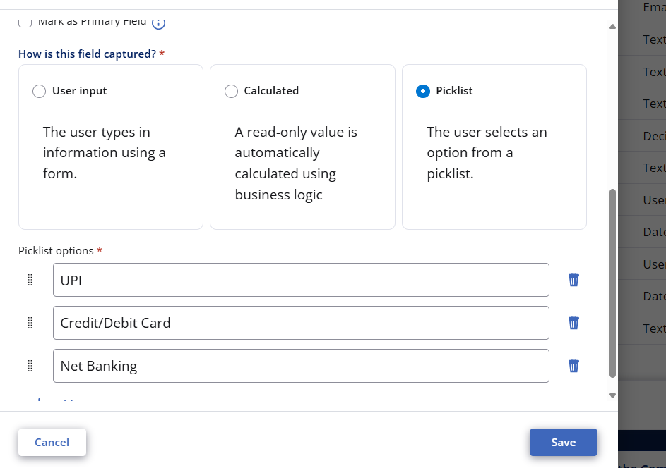
Figure 7. Actual field configuration evidence from the uploaded Pega screenshots.
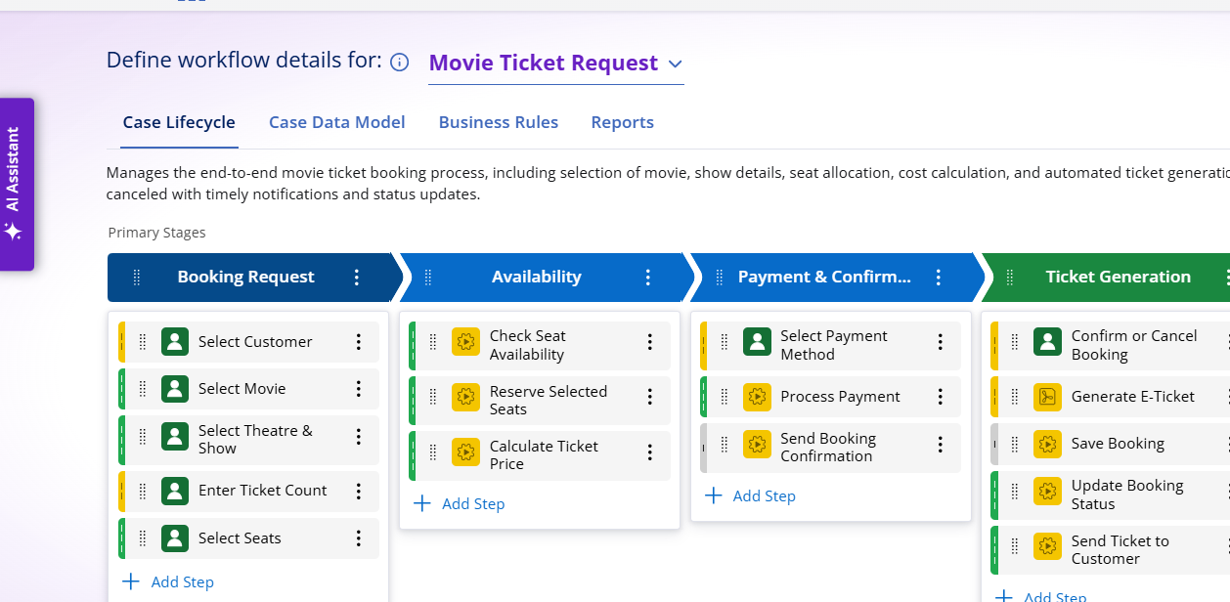
Figure 8. Actual Blueprint configuration evidence.

11. Data Architecture
Figure 9. Movie, Show, Booking and Payment data relationships.
Object | Key Attributes
Movie | Movie Name, Genre
Show | Movie Name, Show Date, Show Time, Seat Capacity, Show Type
Booking | Booking ID, Customer, Movie, Show, Show Date, Show Time, Number of Tickets, Seat Numbers, Ticket Price, Total Booking Cost, Payment Method, Booking Status, Ticket ID, Execution Status
Payment | Payment ID, Payment Method, Amount, Payment Status, Transaction ID

12. Personas and Access
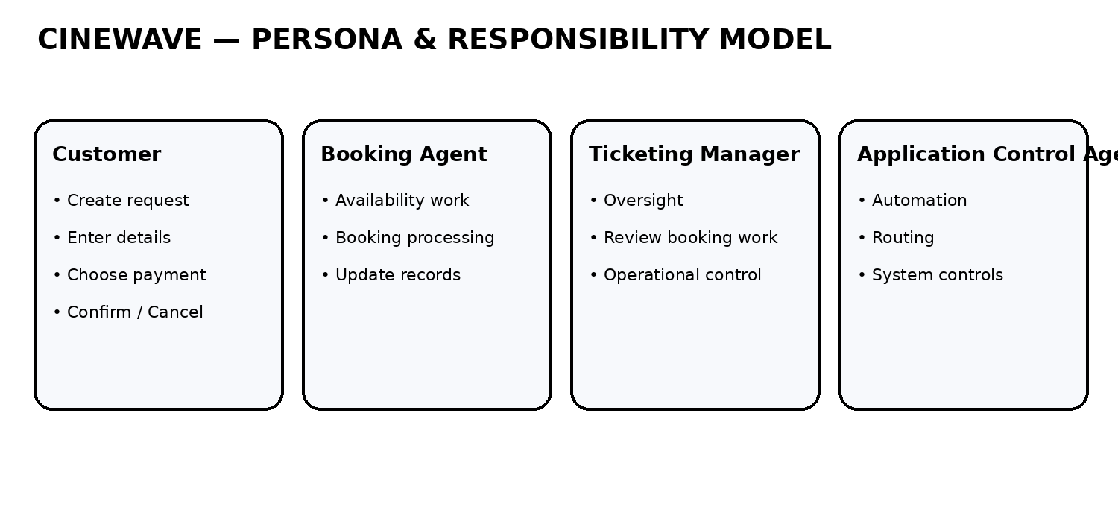
Figure 10. Persona responsibility architecture.
Persona | Main Responsibility
Customer | Creates request, enters details, selects payment and confirms/cancels.
Booking Agent | Processes availability and booking-related work.
Ticketing Manager | Provides management-level oversight.
Application Control Agent | Supports automation, routing and application control.

The project also configured access expectations for the major data and case operations. The exact access configuration was handled during the Blueprint configuration process.

13. Payment Management
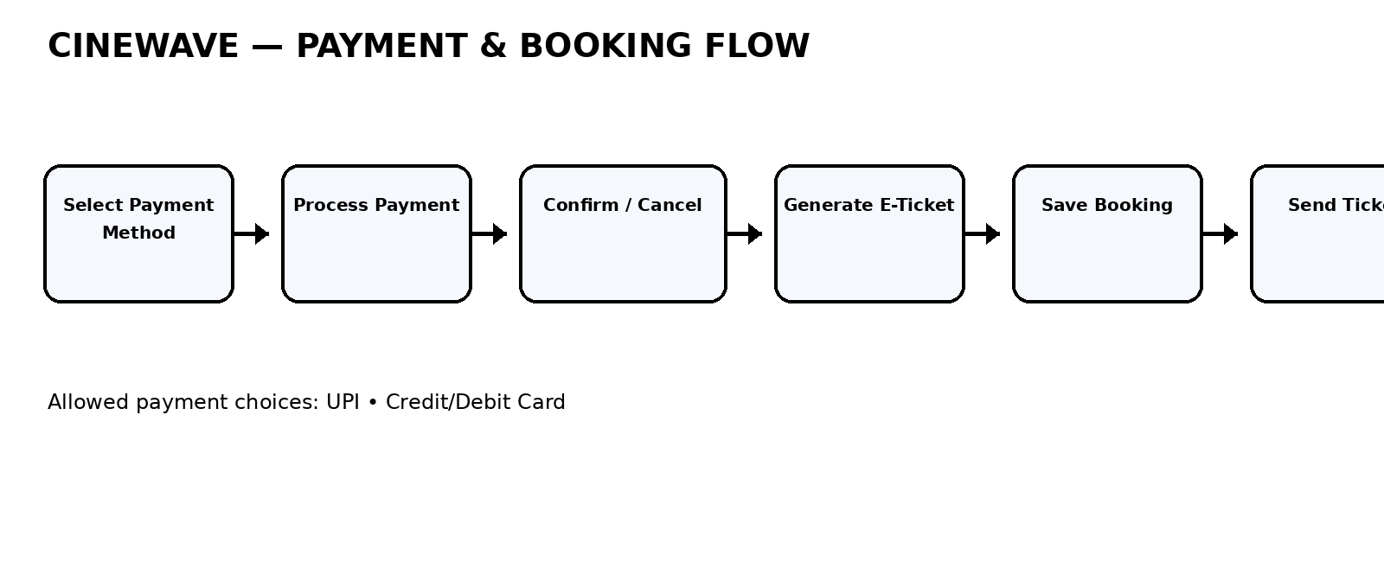
Figure 11. Payment and booking flow.
The payment method requirement is intentionally restricted to two choices: UPI and Credit/Debit Card. Wallet and Net Banking are not included in the configured requirement.
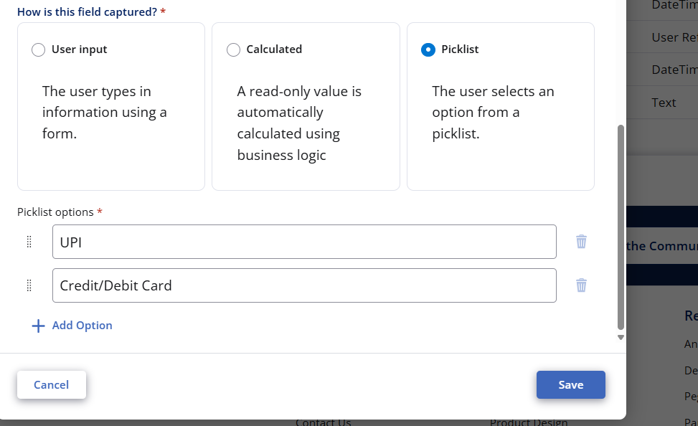
Figure 12. Actual Pega screenshot showing Payment Method configuration.
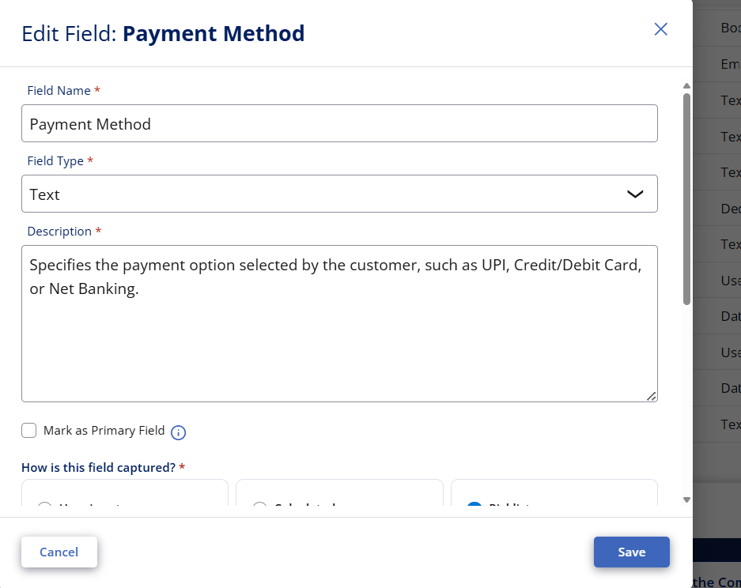
Figure 13. Actual Payment Method field editor screenshot.
Booking Status supports Pending, Confirmed and Cancelled. Cancellation Reason is conditional and required when the status is Cancelled.

14. Premium / Standard Routing
Show Type | Queue | Routing Purpose
Premium | PremiumShowQueue | Direct Premium show requests to the Premium queue.
Standard | StandardShowQueue | Direct Standard show requests to the Standard queue.

Routing is based on Show Type and does not create a separate lifecycle. The main case continues through the same five stages.

15. SLA Management
SLA Item | Configured Value
Goal | 1 day
Deadline | 2 days
Purpose | Monitor timely completion of Movie Ticket Request cases.
Approaching deadline | Flag / priority handling according to case configuration.

The SLA provides a measurable processing window. A case approaching its deadline can be highlighted or given increased priority so that operational users can act before the deadline.

16. Booking Execution
- Generate E-Ticket.
- Create or capture Ticket ID.
- Save Booking information.
- Update Booking Status.
- Update Execution Status.
- Send the ticket to the customer.
- Complete the successful case in Resolved status.
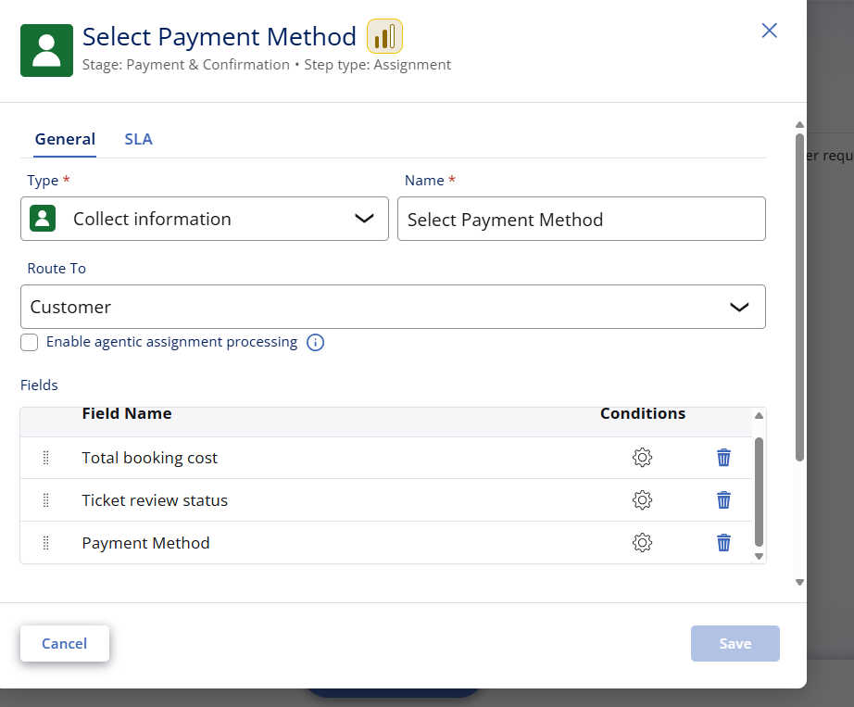
Figure 14. Actual preview/configuration screenshot from the project.
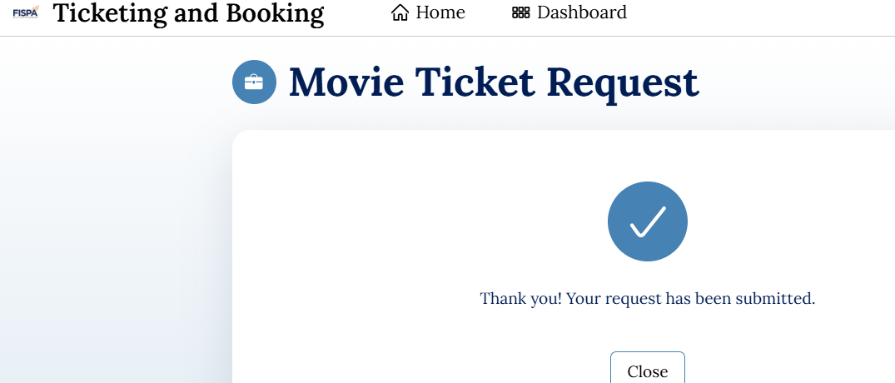
Figure 15. Actual successful preview submission evidence.

17. Testing Strategy
Test ID | Test Input / Scenario | Expected Result
TC-01 | 2 tickets, 2 selected seats | Progression allowed.
TC-02 | 5 tickets, 5 selected seats | Progression allowed.
TC-03 | 5 tickets, 2 selected seats | Progression blocked by seat-count validation.
TC-04 | Available seats less than requested tickets | Progression blocked.
TC-05 | Payment = UPI | Payment choice accepted.
TC-06 | Payment = Credit/Debit Card | Payment choice accepted.
TC-07 | Cancelled without reason | Cancellation blocked.
TC-08 | Cancelled with reason | Cancellation can continue.
TC-09 | Premium show | Route to PremiumShowQueue.
TC-10 | Standard show | Route to StandardShowQueue.

18. Actual Pega Screenshots
This section preserves the actual screenshots uploaded during the project. They are grouped by purpose rather than placed as an unstructured image dump.

18.1 Blueprint and Workflow Evidence
Actual uploaded Pega screenshot — 3378b60c-cd76-4d92-aa60-1469448c0308.png
Actual uploaded Pega screenshot — 2707e306-e1d3-45d0-bd0f-38d47ef4f461.png
Actual uploaded Pega screenshot — 25e4529a-564c-4611-8af2-6f3426dd62cd.png
Actual uploaded Pega screenshot — b570baa0-9613-4f1a-b80b-3fcc2327e5dc.png

18.2 Request and Preview Evidence
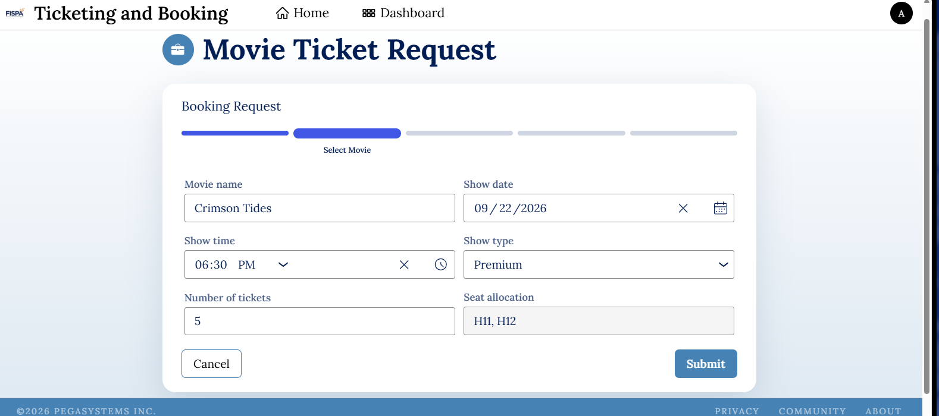
Actual uploaded Pega screenshot — 3b4e5f99-8a8e-4cd5-933d-cbd1e94e2853.png
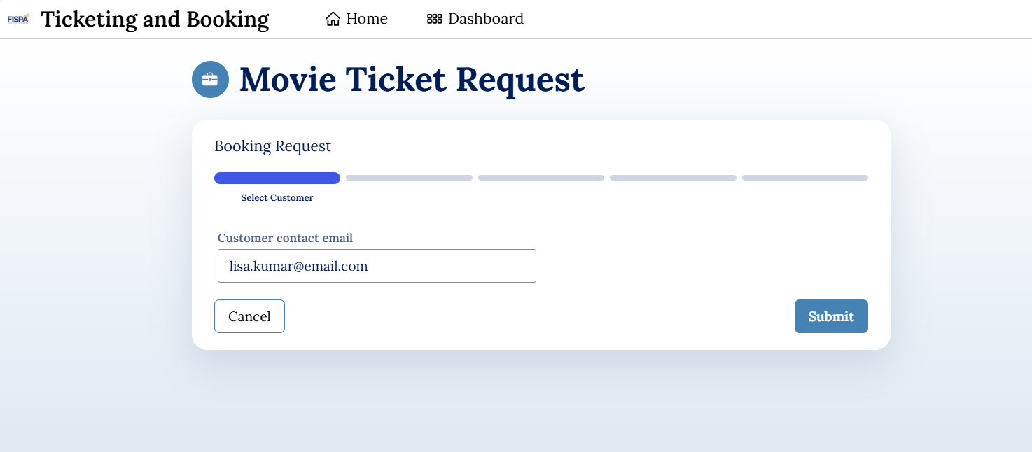
Actual uploaded Pega screenshot — e3291218-d09e-4d8c-810e-4e19eeb5fab1.png
Actual uploaded Pega screenshot — 60e636ed-05bb-4487-bb01-22fd9d6aaa4f.png

18.3 Field and Payment Configuration Evidence
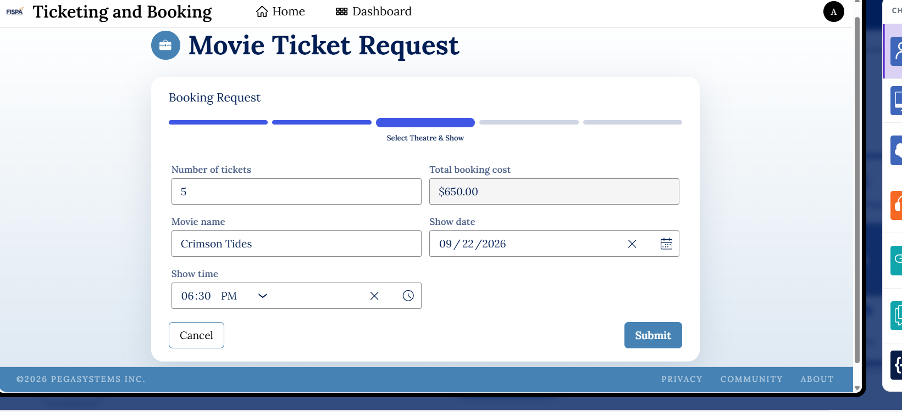
Actual uploaded Pega screenshot — 463abcb7-86ca-4a60-bbc5-cff649ece1d6.png
Actual uploaded Pega screenshot — 6ab4be99-185e-4cc6-b7c2-9504216203ed.png
Actual uploaded Pega screenshot — 1b6bfe0c-a42f-4c8c-a6a8-a7a521e23891.png
Actual uploaded Pega screenshot — 7d295354-37a1-4b59-8981-497df7cb1d58.png
Actual uploaded Pega screenshot — 3a228e24-6aed-41e0-bff9-e79d22f5e06f.png
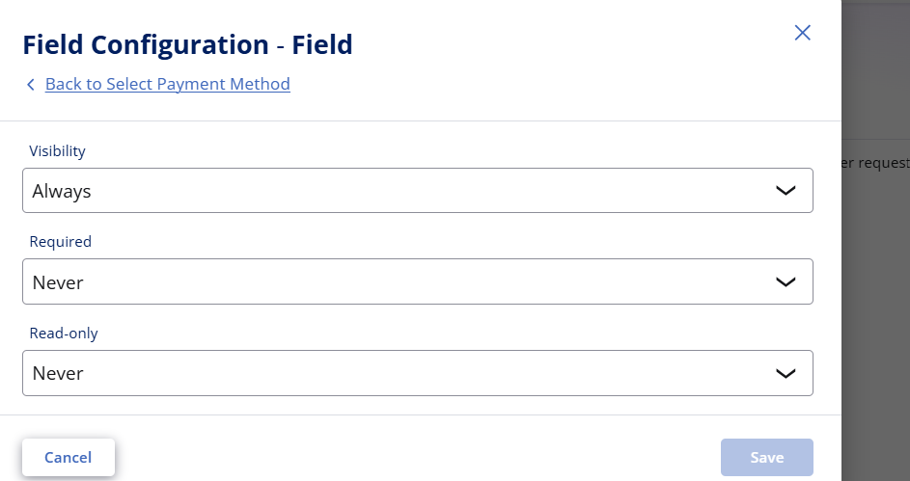
Actual uploaded Pega screenshot — 7e032ad9-59ab-4ccb-8121-5fa57bad8570.png
Actual uploaded Pega screenshot — 3970aa84-cad1-4416-a887-ea505db377bb.png

18.4 Booking, Status and Blueprint Evidence
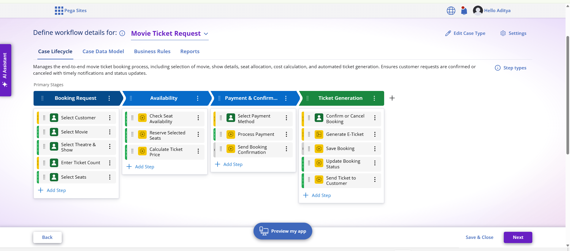
Actual uploaded Pega screenshot — 52e24e4f-d19f-4c4f-a9c4-f840ddd7acc0.png
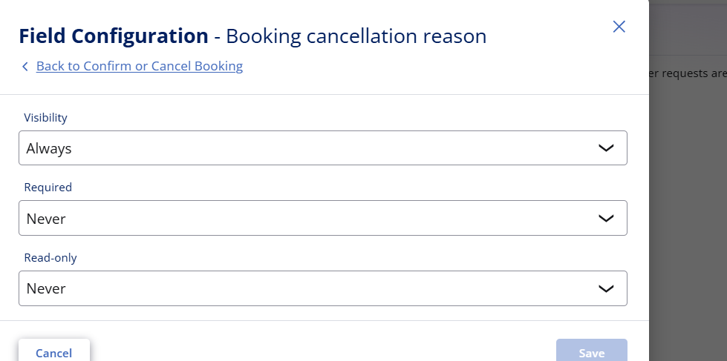
Actual uploaded Pega screenshot — 5cf01187-49c8-439c-8ca7-c22908a0dd33.png
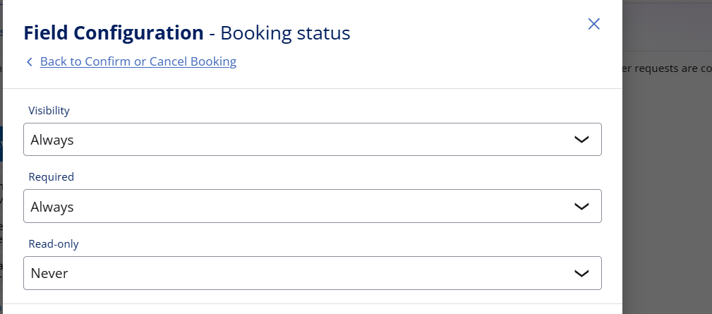
Actual uploaded Pega screenshot — 157b4334-42a2-4e26-96df-e397bd4219fa.png
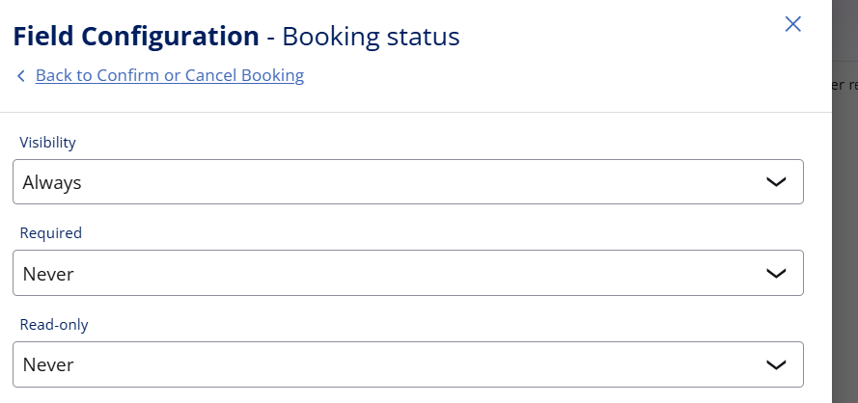
Actual uploaded Pega screenshot — 827a242d-ade4-4b19-9281-20ca7cc92d95.png
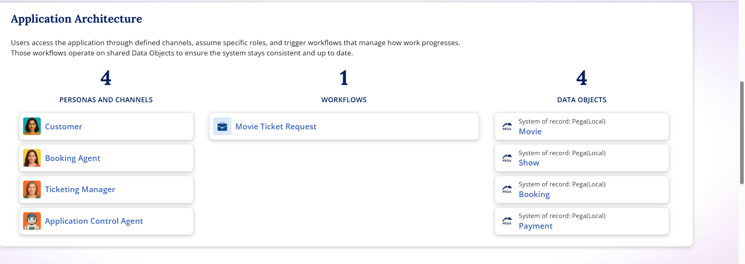
Actual uploaded Pega screenshot — d2682b0e-697a-4b40-9d1e-db63be97671d.png
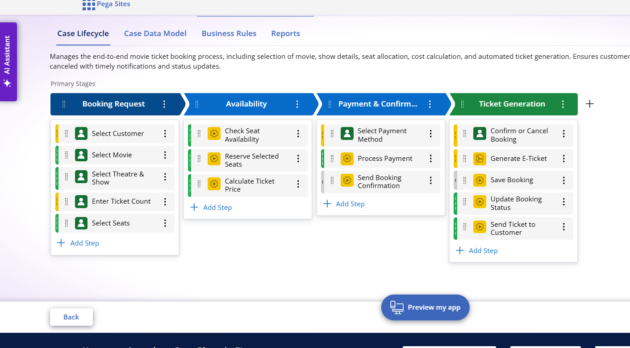
Actual uploaded Pega screenshot — 8271e3cc-1b1b-4188-96a4-2d1e6fcdf5d3.png
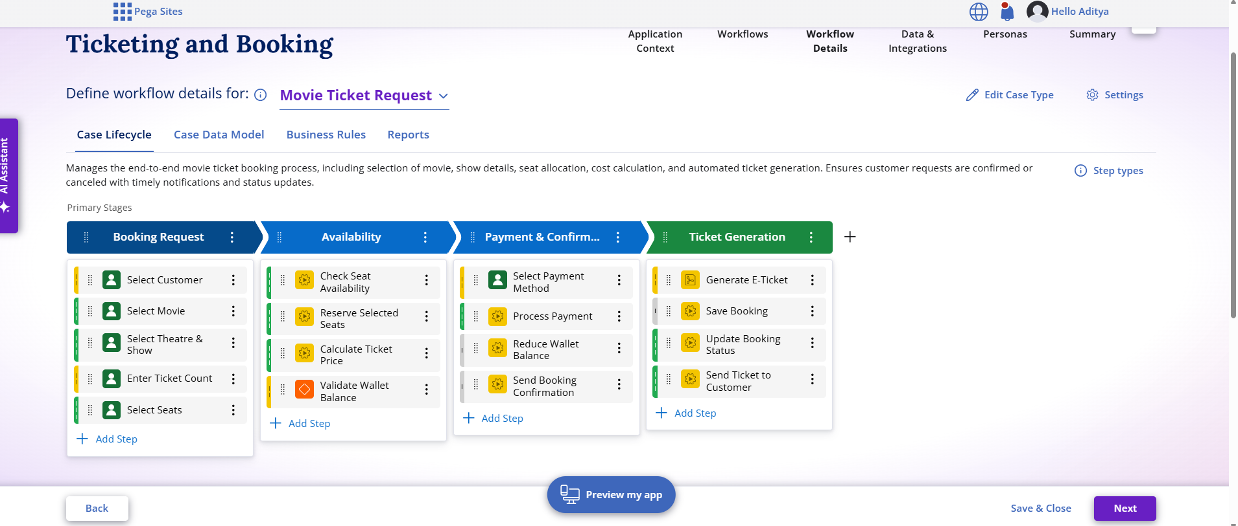
Actual uploaded Pega screenshot — 47cb608b-8e56-4d1f-8163-87313a0e72c1.png
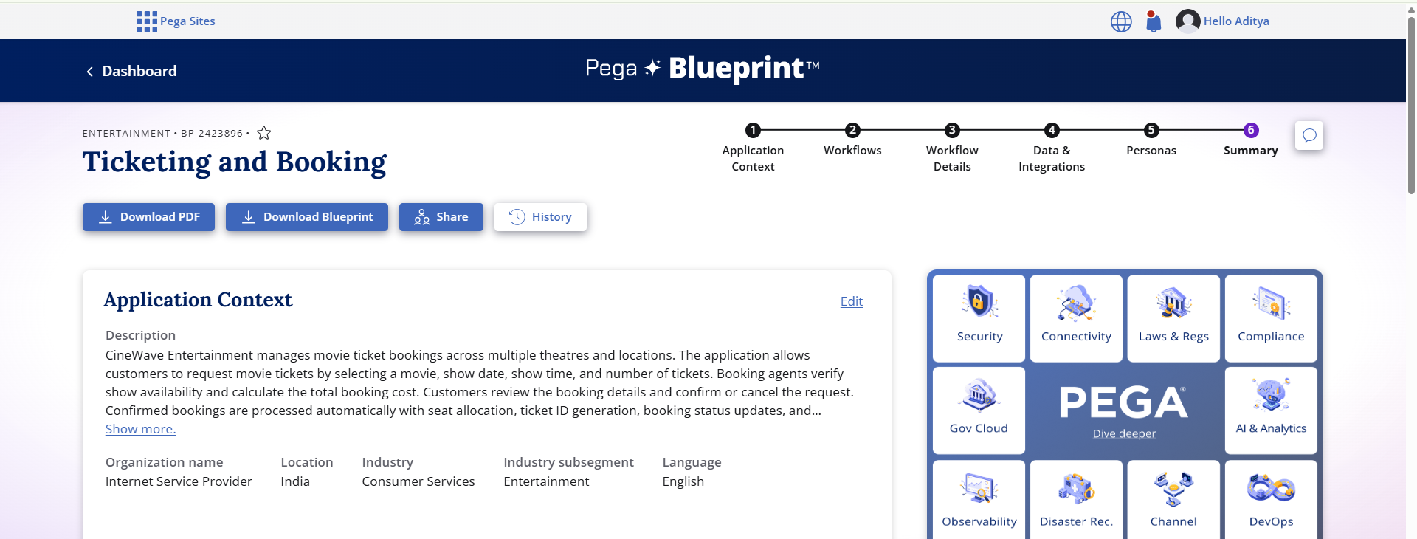
Actual uploaded Pega screenshot — 4d31e166-57c2-47df-b208-81be2fed660a.png
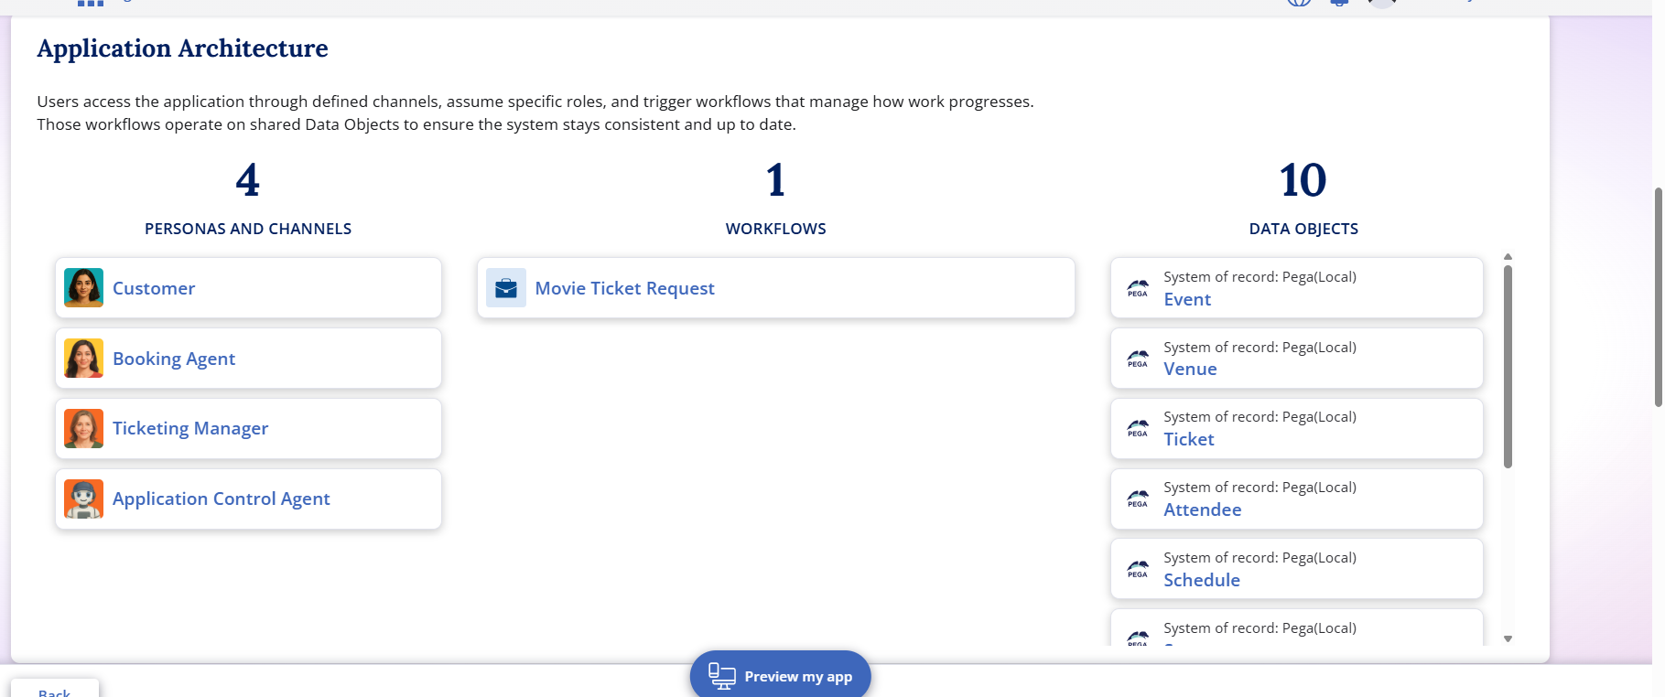
Actual uploaded Pega screenshot — ea0855a5-045b-43aa-bbe7-ffb8a633670f.png

19. Runtime Observation and Limitation
During preview testing, a specific runtime behavior was observed: when a larger Number of Tickets was entered, the seat picker could still show or allocate fewer seats. For example, the project testing identified the situation where 5 tickets were requested while only 2 seats were shown/allocated.
The Blueprint configuration can define the business validation that the number of selected/allocated seats must match the ticket quantity. However, the Blueprint Assistant does not directly provide low-level control over the runtime seat-picker mechanism needed to automatically select the next N available seats.
Accordingly, this report does not falsely claim dynamic automatic seat allocation as a completed runtime feature. The correct production enhancement is to implement a runtime seat-selection component or integration that reads Number of Tickets and automatically allocates exactly that number of available seats.
Figure 16. Actual preview evidence relevant to ticket quantity and seat allocation.
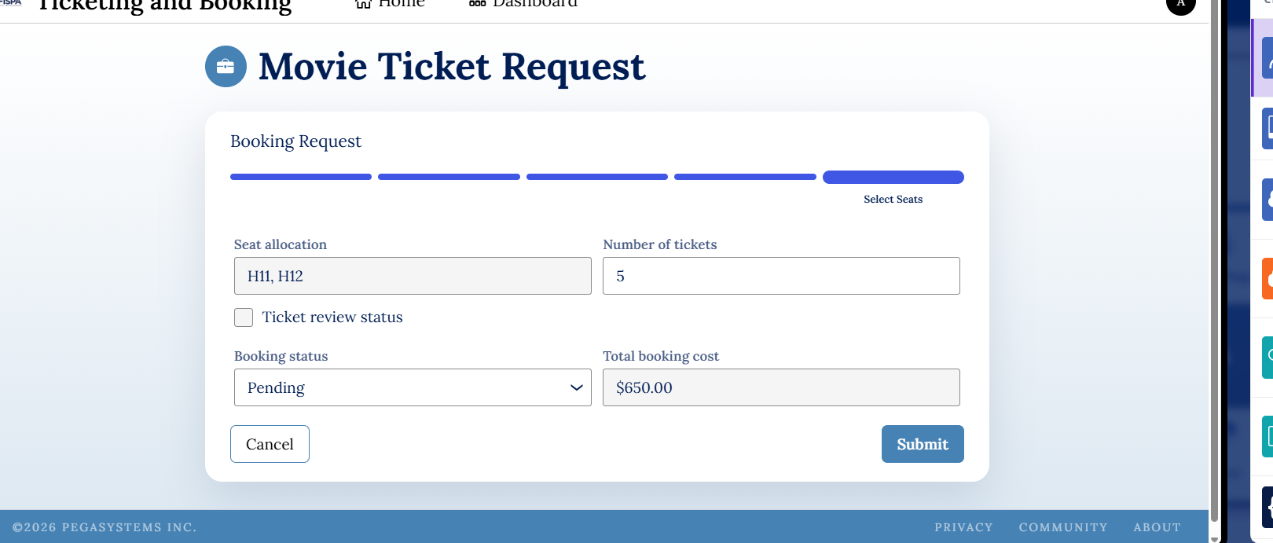
Figure 17. Actual uploaded screenshot showing booking/seat-related configuration.

20. Future Enhancements
Enhancement | Expected Improvement
Dynamic seat allocation | Automatically allocate exactly N available seats based on Number of Tickets.
Live inventory | Read real-time seat availability from theatre/show data.
Payment gateway | Connect real payment processing and transaction verification.
QR e-ticket | Generate a scannable ticket for customer entry.
Booking history | Provide customer history and cancellation records.
Analytics | Track bookings, revenue, occupancy and SLA performance.
Failure recovery | Handle payment or booking execution failures with retry/recovery.

21. Conclusion
The CineWave Movie Ticket Booking Management System demonstrates how a movie booking process can be structured as a Pega case-management application. The project defines a clear five-stage lifecycle, reusable data objects, field requirements, business validations, payment controls, queue routing, personas, SLA and booking execution.
The report includes actual screenshots from the project work and documents the runtime seat-allocation observation transparently. This makes the report suitable as a project submission document while clearly separating configured workflow rules from functionality that would require deeper runtime implementation.

