# Artificial Intelligence Based Smart Door with Face Mask Detection

1. **Introduction**

During this pandemic situation it is mandatory to wear mask for everyone mainly in public places where we have more chance to spread the diseases. People may visit home and could not be aware that they are wearing masks. It is difficult even difficult to person to verify whether the person have mask or not so, to avoid this we are designing a smart device. This device is introduced at the entrance of an building. The system typically uses a camera to capture images of individuals as they approach the door. The images are then analyzed using computer vision algorithms to detect faces and determine whether or not they are wearing masks. If a person is not wearing a mask, the system can trigger an alert to remind them to put one on before entering the building. An alert will be in the form of sound it means the buzzer will start to ring when the person trying to enter the building without mask.

# Literature Review

Baluprithvirah K, Bharathi K, Chendhrun S, Lokeshwaran.P introduced an AI based smart door with surgical mask detection. To distinguish between facial recognition and whether a person is identified, a deep learning method is proposed.is either wearing a face mask or not. The Raspberry Pi, Tensor Flow, OpenCV, and Python programming languages are used to implement it. A facemask recognition alarm system uses convolutional neural networks to detect whether a person is wearing or not wearing a facemask in real time. The trained CNN model performed admirably in achieving the validation accuracy. By merging classification networks (SRCNet), image super-resolution, and measures for a three category classification problem based on 2D facial pictures, a new facemask- wearing condition recognition approach was created. Facemask wearing condition identification, facial detection cropping, and image pre-processing are the major the suggested algorithm's phases.

Pavan Narayana A, Janardhan Guptha S, Deepak S, Pujith Sai **P** article provides information on convolutional neural networks. CNN now has a significant impact on machine learning for a variety of applications, including image and video recognition. In this essay, the topics of convolution, stride, padding, input representations, CNN features, convolutional formula, and pooling are discussed. They have used face mask detectors in this paper by deploying CNN. The deployed model was implemented using the Python programming language with tensor flow and keras datasets. They used the collected datasets to train their face mask model in Python. In this publication, they experimented and researched on several deep convolution neural networks to extract deep characteristics from input images. Several machine learning classifiers, such K-Nearest Neighbors (K-NN) and Support Vector Machines but these gave less accuracy it gives only 80% accuracy.

Gayatri Deore, Ramakrishna Bodhula, Dr. Vishwas Udpikar, Prof Vidya and more introduced Study of Masked Face Detection Approach in Video Analytics using Artificial Intelligence and Machine learning. Identifying the people who are not wearing mask through surveillance camera is a major task. By using machine learning we can reduce the complexity in identifying the people without mask. In this technique they proposed four different steps to detect a person without face mask they are Eye line detection, Distance from camera, Eye detection and Facial part detection. In certain cases, facial part detection might not detect the face of a person when a person wearing mask..The accuracy rate of eye line detection and facial part detection is less than 50% so it fails to detect the person accurately and with this less accuracy we cannot implement the simulation of door .

Venkateswarlu.B, Jagadeesh Kakarla and Shree Prakash has proposed the Face Mask Detection Using Mobilenet and Global Pooling Block. The observation of a face mask manually in a public places is a difficult task. So they implemented automatic face mask detection. CNN and transfer learning both are used for classification and segmentation. In transfer learning there is a pre-trained Mobilenet that take a color image and generates a multi dimensional feature map. Global Pooling Block takes a multi dimensional feature map and converts it to a one dimensional feature vector using global Pooling. The drawback of this model is face mask detection can’t be done over multi face images.

# Proposed System

According to a previous literature study, a proposed system for a Smart Door with Face Mask Detection using Deep Learning algorithms was presented. The system consisted of a camera installed at the entrance of the building, which captures the image or video of the person approaching the door. The captured image was then preprocessed to remove any noise, correct for brightness and contrast, and resize the image to a suitable size for the deep learning model. The preprocessed image was then fed into a deep learning model trained on a large dataset of images containing people with and without masks. The deep learning model was able to detect if a person was wearing a mask with high accuracy. The output of the deep learning model was then processed to determine if the person was wearing a mask. If the person was wearing a mask, the door would automatically open, allowing them to enter the building. If the person was not wearing a mask, the system would deny access and give an alert message with buzzer sound which indicates to wear mask and the gate or door will not be opened until the person wear mask. The proposed system was found to be efficient, accurate, and could provide a safe and secure environment for the individuals who enter the building by enforcing the wearing of face masks.

1. **Dataset**

For this device to train the model we collected the dataset of 3833 images. The dataset includes 1915 images with masks and 1918 images without masks. We split the dataset into 80% training and 20% testing sets for model development and evaluation. The dataset is as shown in below figures

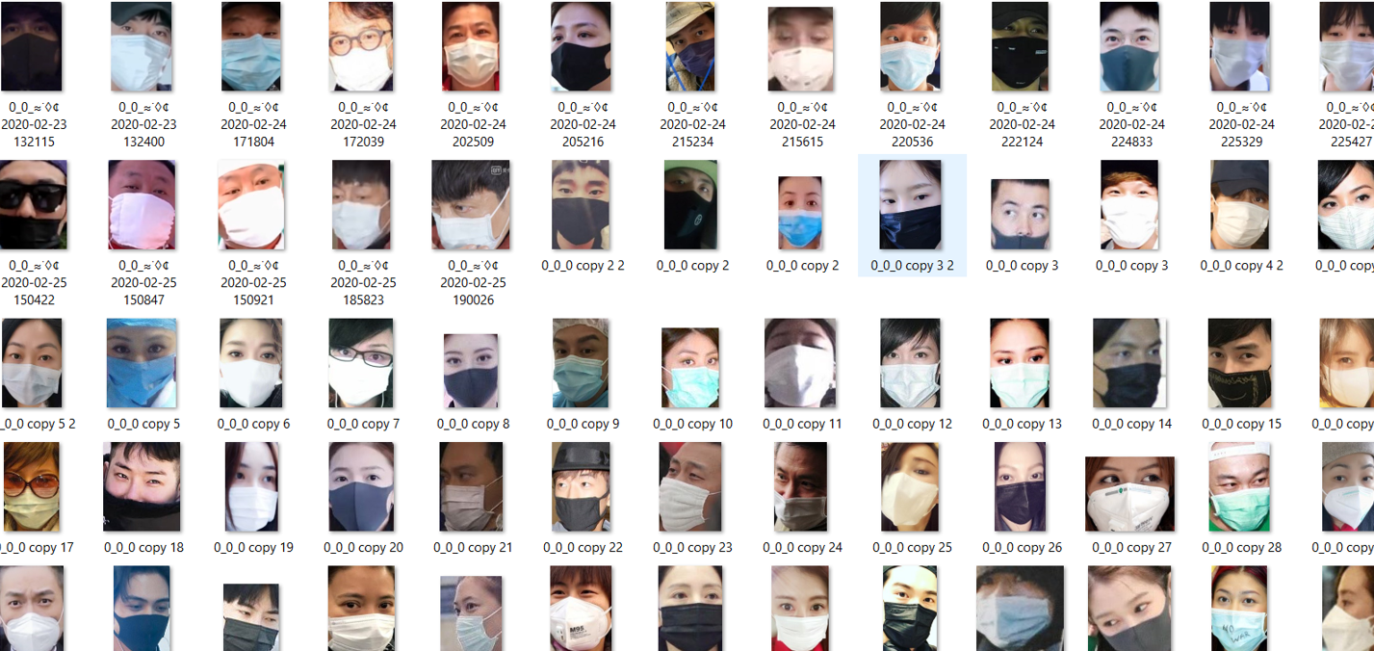 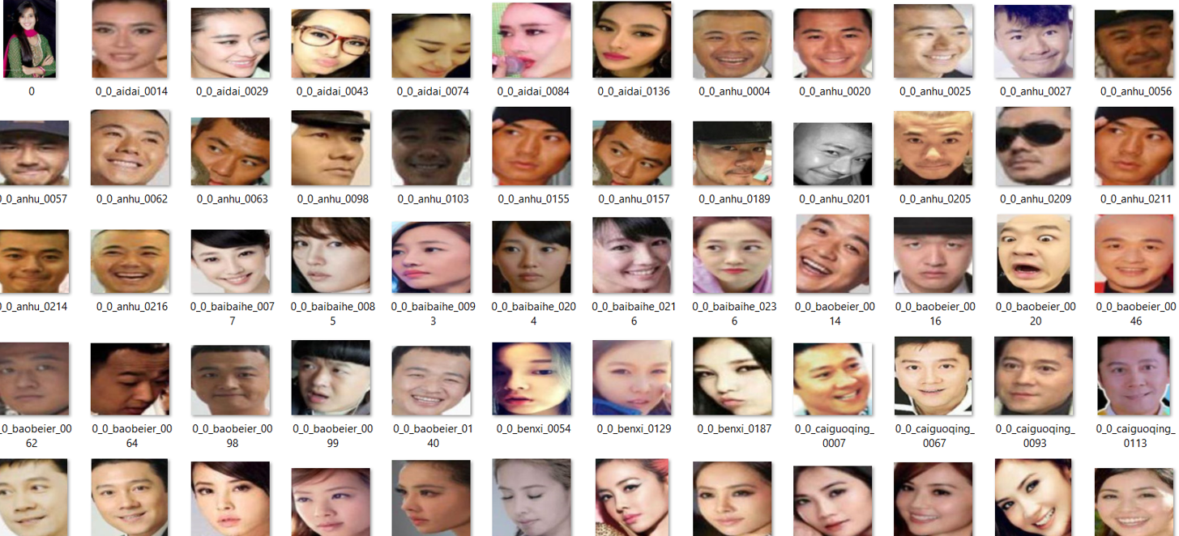

Fig1.1: dataset “With_Mask” and “Without_Mask”

1. **Methodology**

The architecture of smart device mainly consists of three stages at these are interlinked together. The model for face mask detection is done at the first layer, it will be implemented with real time images at second stage and at last stage we will link this mask detection code to the circuit which is used to stimulate or control the door. The architecture is as shown below

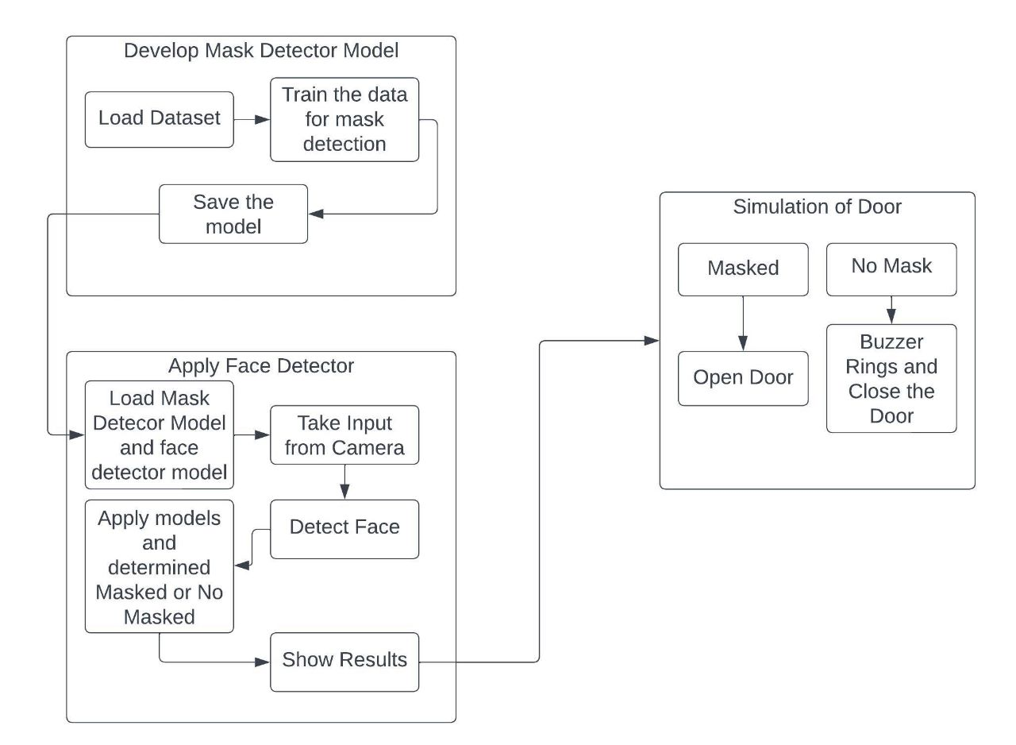

Fig.1: System Architecture

At the second stage the face mask of a person is detected and the door stimulates according to the output. If the person have mask the door will be opened if not an alert message is given in the form of buzzer sound. It indicates to wear the mask and the door will be closed after some time it is 1-2 minutes.

In this study we are considering two pre trained datasets with masks and without masks. The models that are used to detect face mask of a person are MobilenetV2 and FaceNet. MobileNetV2 is a type of Convolutional Neural Network(CNN) designed for mobile and embedded vision applications (which takes input from camera of videos).It was developed by Google and uses depthwise separable convolutions to reduce the number of computations required to perform for maintain high accuracy. In this we have 4 different layers to detect the mask of a person they are :

1. Depthwise Separable Layer
2. Pointwise Separable Layer
3. Global Average Pooling Layer
4. Fully connected Layer

The output of every layer is input to the next layer. Initially the input is taken from the camera or it can also be from videos. The input image is sent to the MobilenetV2 model or an network which consists of two convolutional layers they are depthwise separable and pointwise separable. This convolution differs from the normal convolutional layers it is the convolution is performed on multiple channels whereas depthwise performs on each channel separately. The depthwise separable layer output is input to the pointwise convolutional layer. This architecture we call it as base model. In this base model we get convoluted image or filtered image. This is to extract the required features to detect the face mask of a person.

The output of base model will be given as input to fully convoluted layer which we call it as head model. At this layer classification is done. By taking the features from base model it label the input image as 0 or 1 which indicates absence or presence of mask. In this we are using one more layer known as softmax layer. It is used to convert the output of neural network, which can be any real number, into probability distribution overall different classes.

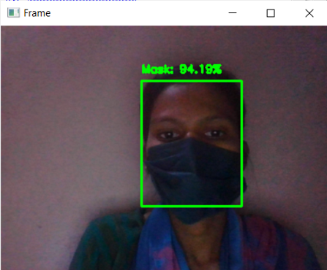

Fig.2: Mask Detected

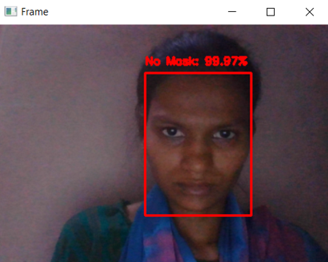

Fig.3:Mask Not Detected

The above shown figures are the output of the second stage this results will be sent to the proteus software which is third stage of our implementation.

At the final step the door simulation it will done after getting the output from second stage the circuit that designed will be executed and it will control the door. To communicate with the proteus software we require an interface it is Virtual Serial Port Emulator. It works as interface between two devices by using this we can communicate with proteus software and stimulate the door.

**Conculsion**

In this pandemic situation it is important to stop the spread of virus to do this wearing mask is one way to reduce the spread of dangerous diseases. It is mandatory to have mask mostly in public places where we have more chance to spread the virus but some people don’t have the awareness on this and enter without mask . It is highly impossible to lookafter all the people and intimate them to have mask so here we introduced a smart device this will automatically detects the face mask of a person . The door opens only when the person wear mask .If the person don’t have mask the buzzer will ring and intimate to wear mask by making sound.