Smart Door with AI-Enhanced Face Mask Detection

**Mr. Kondanna Kanamaneni1, Vineetha K2, Prasuna C3, Sreeja P4, Sai Sagar Reddy O5**

1Associate Professor, Dept. of CSE (Data Science), Srinivasa Ramanujan Institute of Technology,Anantapur, Andhra Pradesh, 515701.

2,3,4,5UG Student, Dept. of Computer Science of Engineering, Srinivasa Ramanujan Institute of Technology,Anantapur, Andhra Pradesh, India

# Abstract

Health plays a big part in everyone's lives, especially in current pandemic circumstance. The majority of individuals are unaware of how to protect themselves against this pandemic catastrophe. Regular mask wear is crucial for both our own protection and that of others. Due to their ignorance, visitors won't use masks, which may have an adverse effect on others. Individuals might not be aware if someone has visited their house while they are away. This study proposes an AI-based project that determines whether a mask is being worn and issues a warning message. If someone is wearing a mask, this smart gadget unlocks the door automatically. This is functional 24/7. When someone tries to enter without a mask, the buzzer will begin to sound. In public spaces like malls, shops, temples, etc., the smart gadget is highly helpful.

**Key Words:** Facial Mask, Automatic Door Opening and AI-based.

# Introduction

Everyone must wear a mask during this pandemic, especially in crowded areas where there is a higher risk of disease transmission. Visitors to a residence may not be aware that the residents are hiding their identities. To avoid this, we are developing a smart gadget because it is challenging to tell if someone is wearing a mask or not. This gadget is unveiled at a building's entryway. Usually, a camera is used by the system to take pictures of people as they approach the entrance. Computer vision techniques are then used to examine the photographs in order to find faces and decide whether or not people are hiding their identities. The system can send out an alert to remind someone to put on a mask before entering the building if they are not already doing so. When a person tries to enter the building without a mask, the buzzer will start to ring an alarm in the form

of sound. The device mostly used in crowded places where we have more chance to spread the virus not only to stop the virus it can also be used to identify the person if there is any database to store the data so it can also use for security.

# Literature Survey

Pavan Narayana A, Janardhan Guptha S, Deepak S, Pujith Sai P [1] has proposed Smart door face mask detection to determine if someone is wearing or not. We created this face mask detection utilising a variety of technologies, such as Open CV, MTCNN, CNN, IFTTT, and ThingSpeak. The Viola- Jones method is used by MTCNN to identify human faces on the screen. The Viola-Jones algorithm locates the position on the coloured image after first identifying the face on the grayscale image. The MTCNN method first finds the face in a grayscale image, pinpoints its location, and then locates this spot on a coloured image. Using test datasets and MobileNetV2, which serves as an object detector in our case, CNN is built to recognise masks in human faces. The information we receive from the smart door is displayed using ThingSpeak, an open-source Internet of Things application. The drawbacks are no alerting system like buzzer, limited dataset, mask variations, light conditions.

Baluprithviraj K.N, Bharathi K.R, Chendhuran S and Lokeshwaran.P [2] introduced an AI based smart door with face mask detection technique using Convolutional Neural Network. This device not only detects mask but also measures the temperature of a person. The smart door opens only when the person is healthy. This device is integrated with mobile app so when the person enters without mask automatically send notification to the owner and rings the alarm. To build this model a face mask dataset with 690 face mask images and 686 without face mask images are used in it. However, it requires different attributes to detect a face of a person such as face orientation, eye location, mask location, face location. After getting an output of an image the door will be opened. The demerits of this smart device is that during night time the image won’t be clearly visible.

Utkarsha Barde1, Dhanshree Kadam2, Manasi Patil3, Kirti Shirnath4 [3] has proposed Survey on Face Mask Detection with Door Locking and Alert System using Raspberry pi. A dataset for face mask recognition contains a variety of pictures of people

wearing and not wearing masks. Pi cameras will be used for real-time facial detection. Using Python, OpenCV, TensorFlow, and a Raspberry Pi, we'll develop a COVID-19 face mask detector utilising computer vision using the Kaggle dataset. This system's primary objective is to determine whether or not the individual in the video feed is hiding their face. Also, if the system discovered somebody without a mask, a buzzer alert would be given to them, and the entrance to that particular organisation would not open until they had on a mask.

B Varshini, HR Yogesh, Syed Danish Pasha, Maaz Suhail, V Madhumitha, Archana Sasi [4] has proposed IoT-Enabled smart doors for monitoring body temperature and face mask detection, a smart door with IoT capabilities that detects face masks and monitors body temperature using machine learning. The suggested model can be applied to any entry, including those to a mall, a hotel, an apartment complex, etc. Moreover, a non-contact temperature sensor is used to track the person's body temperature. By allowing the Internet, this proposed system may identify individuals.it gives result in slow or unreliable performance.

Anargha Roy Chowdhury, Sneha Ray, Manish Rai, Parna Das, Dr. Sangita Roy, Rimpi Dutta, Anushree Mondol [5] has proposed Advance door lock with face mask detection using Arduino motion detector by PIR sensor and YOLO-LITE, with the help of this we aim to determine whether or not people wear masks when they enter public areas like malls, theatres, hospitals, and other places. Simply put, if a person is wearing a mask, they are permitted to access the system (department), otherwise they are not. It functions the same way day and night. It can activate features like an alarm or even fire a water pistol that runs on batteries. Because of its extremely low level of complexity, its application is simple. The project has a big scope for the future but might potentially be put on hold. Arduino boards have limitations in terms of processing power, memory and connectivity.

Alimul Rajee and Saiful Islam [6] has proposed a Smart Door with Face Mask Detection. Artificial intelligence (AI) is the project's central subject. The research entails employing image processing and artificial intelligence (AI) techniques to identify those wearing face masks and those who are not in public spaces. If a person is not wearing a

mask, the entry door will not open for them, making it impossible for them to access the busiest venues like a mall or a hospital. The methods for object detection are utilised to distinguish between those wearing face masks and those who are not. The You Only Look Once (YOLO) technique is used in this research for real-time object identification, and a deep learning-based assistive system is used to categorise the COVID-19 Face Mask that is implemented in rasbperrypi-3. The YOLO technique has two major limitations that should be taken into consideration: a large localization error and lower recall when compared to two stage object detectors.

Daniyar Syrlybayeva, Nurlan Nauryza, Aidana Seisekulova, Kaiyrbek Yerzhanova, and Md. Hazrat Alia [7] has proposed an automated door opening system. This system uses the guest's phone display to detect the vaccination software's positive status, a camera to identify the guest's facemask, and Python and the OpenCV library to activate the motor that controls the door. The primary distinction between a human face that is disguised and one that is not is made only using OpenCV's built-in face recognizer. The turnstile or sliding door may be controlled by the system, potentially reducing the need for manpower and providing effective security. The model demonstrates an accuracy of 77% when properly identifying masked faces and 99.1% when correctly identifying non-masked faces. It repeatedly delivers the incorrect result to the face recognizer and misrecognizes the face, which is the biggest problem.

Panakaje. N, Rahiman, H.U Rabbani, M.R Kulal, A. Pandavarakallu, M.T, Irfana

[8] has proposed IoT-based face mask detection system in public transportation, particularly buses. This technology would use facial recognition to gather data in real- time. The major goal of the research is to use deep learning, machine learning, and image processing techniques to detect the existence of face masks in a real-time video stream. A hybrid deep and machine learning model was created and put into use to accomplish this goal. In addition to publicly available datasets, a novel dataset was used to evaluate the model. The findings shown that the Convolution Neural Network (CNN) classifier performs better than the Deep Neural Network (DNN) classifier. It has nearly full face- identification skills with regard to people's presence in the situation of their wearing

masks, with an error rate of only 1.1%. Overall, the suggested model performed better than the traditional models AlexNet, Mobilenet, and You Only Look Once (YOLO).

Gayatri Deore, Ramakrishna Bodhula, Dr. Vishwas Udpikar, Prof Vidya [9] introduced Study of Masked Face Detection Approach in Video Analytics using Artificial Intelligence and Machine learning. Identifying the people who are not wearing mask through surveillance camera is a major task. By using machine learning we can reduce the complexity in identifying the people without mask. In this technique they proposed four different steps to detect a person without face mask they are Eye line detection, Distance from camera, Eye detection and Facial part detection. In certain cases, facial part detection might not detect the face of a person when a person wearing mask. The accuracy rate of eye line detection and facial part detection is less than 50% so it fails to detect the person accurately.

Kallakuri Anirudh, Anirudh Ravi, Vecha Sri Charan and Vijayshri Chaurasiya [10] has proposed a face mask detection using deep learning. Using a variety of machine learning methods, patterns in an image may be used to identify face masks. In this case, three machine learning algorithms—CNN (Convolutional Neural Network), SVM (Support Vector Machine), and PCA—were taken into consideration (Principal Component Analysis). Images of people wearing masks and not wearing masks were taken from Kaggle and included in the dataset. After completing K-cross validation, the effectiveness of the face mask detection has been calculated in this literature.

# Methodology

## Proposed System

A suggested system for a Smart Door with Face Mask Detection utilising Deep Learning algorithms was given, per a recent literature review. The system consists of a camera placed at the building's entry that records a picture or a video of anyone approaching the door. After that, the acquired picture underwent preprocessing to be cleaned up, adjusted for brightness and contrast, and resized to be compatible with the deep learning model.

In previous papers to detect face mask of a person only one model is used so the accuracy is decreased. In this to detect face mask of a person we are using two models one for face detection and one for mask detection. The two models are Facenet and MobilenetV2. In this we also introduced a buzzer which will ring when person don’t wear mask this work as an alerting system.

## System Architecture

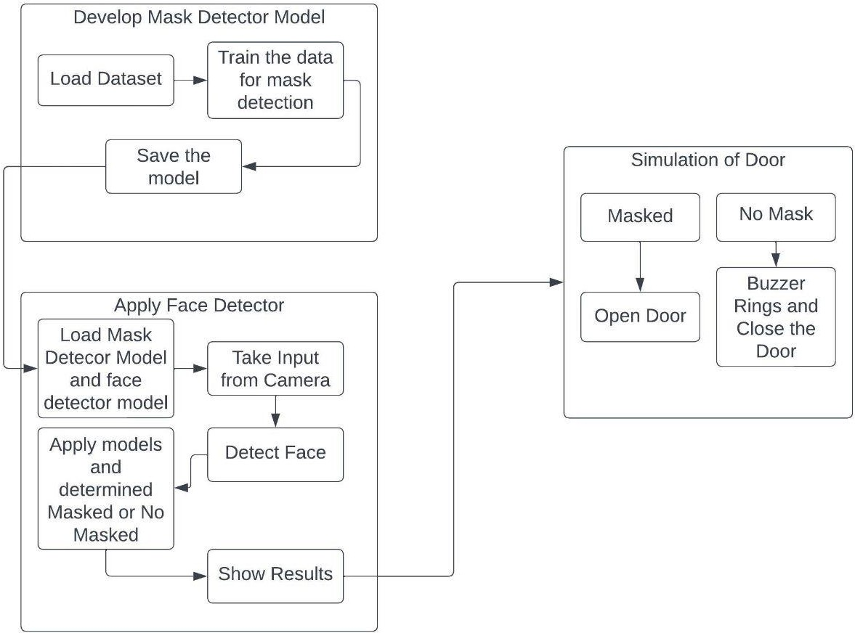

Fig.3.1 System Architecture

The architecture mainly consists of three stages. The first stage is training the dataset to detect the face mask of a person. As we are using pretrained model for face detection no need any training for face detection. The second stage is to test the model with real time images by capturing from the camera of PC or any external cameras. The third stage is to transfer the result to the device which consists of stimulation code for door.

## Virtual Serial Port Emulator (VSPE)

The VSPE work as an interface between two or more devices and it is used to send or receive the data. Its functionality is like a transmitter. The data sent and received to these virtual devices is handled by software that manipulates the

transmitted and received data to grant greater functionality. The port is connected as shown in figure

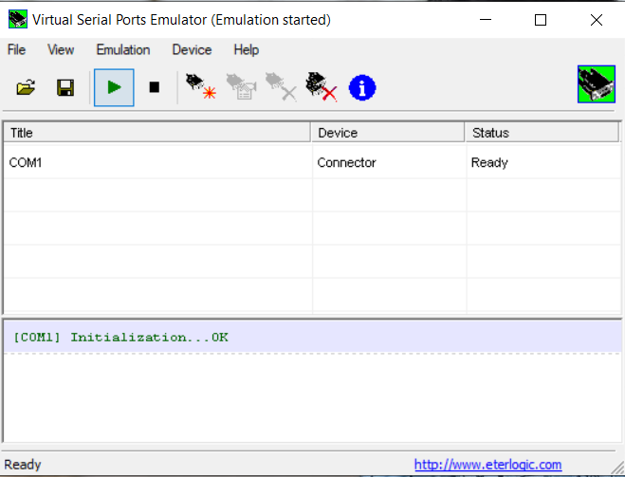

Fig.3.2 Virtual Serial Ports Emulator

## Circuit Design

The result of mask detection model will be transferred through virtual serial port emulator. It is an interface used to transfer data between two different devices. The data is transferred in the form of signals this will be collected by the circuit and stimulate the door according to the result.

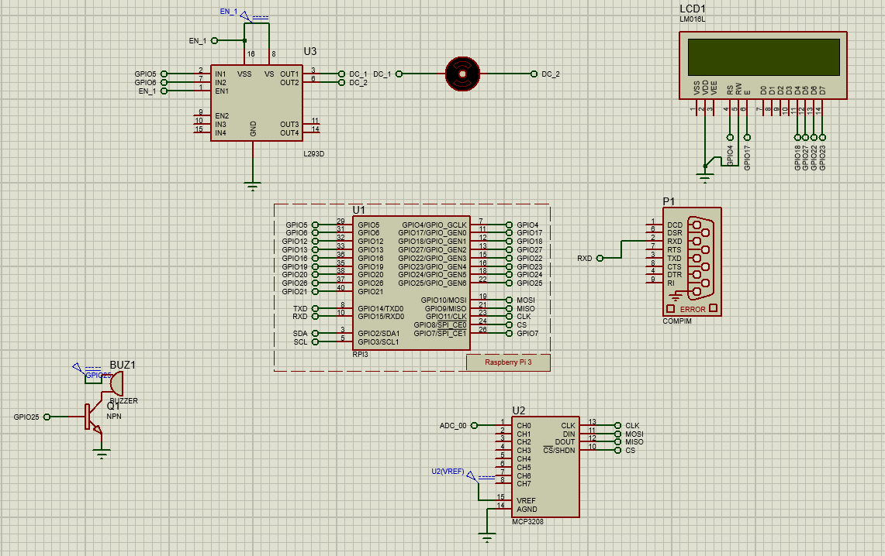

Fig.3.3 Circuit Design

# Implementation

In this we have two parts one is to train the model and testing the model the other one is stimulation of door.

* + The first part is training the dataset which consits of masked images and without mask images.It is the sample code to train the dataset and also to develop the model which detects the face mask of a person.

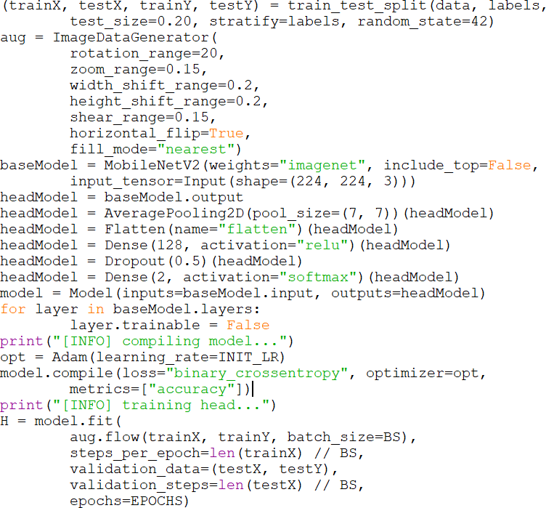

* + The second part is to stimulate the circuit and control the door. It display the statement open the door when face mask is detected and close the door when mask is not detected and also gives the buzzer sound. The circuit works according to the code which is embedded in it.The below is the sample code for stimulation of circuit.

while 1:

Data=pio.uart.recv() if(Data == "1"):

lcd_byte(0x01,LCD_CMD) # 000001 Clear display GPIO.output(22,False)

lcd_string(" Mask Detected",LCD_LINE_1) lcd_byte(0x01,LCD_CMD) # 000001 Clear display lcd_string("Gate Open",LCD_LINE_1) GPIO.output(Motor_1, True) GPIO.output(Motor_2, False) GPIO.output(Motor_1, False) GPIO.output(Motor_2, True) GPIO.output(Motor_1, False) GPIO.output(Motor_2, False)

else:

lcd_byte(0x01,LCD_CMD) # 000001 Clear display lcd_string(" Mask not ",LCD_LINE_1)

lcd_string(" Detected ",LCD_LINE_2) GPIO.output(buzzer_pin,True) time.sleep(1)

# Results

The result of this smart device is two categories one is mask not detected when person is not wearing mask and gate open when mask is detected. The two results will be displayed on the lcd screen. The first image shows that mask of a person is detected and display the statement Gate Open. The door simulation is controlled by the dc motor. The rotation of this motor shows that the opening of the door. The idle state of the motor tells that mask is not detected.

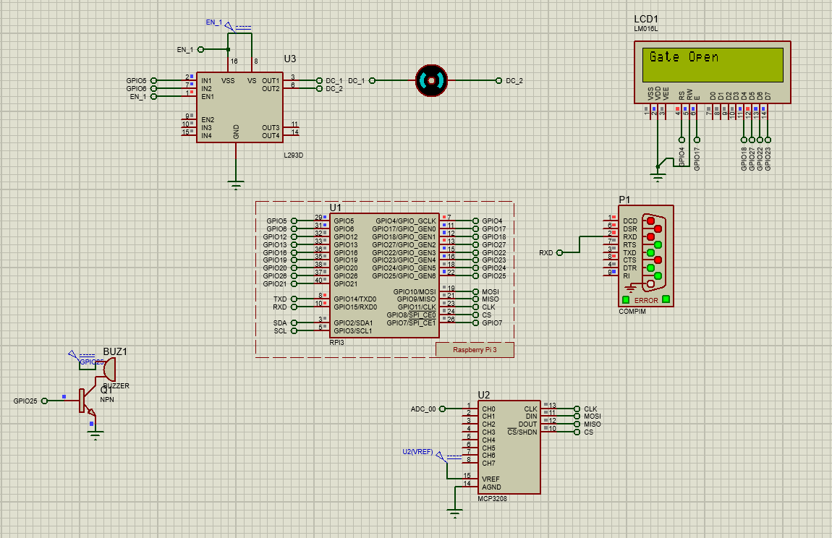

Fig.5.1 Mask Detected

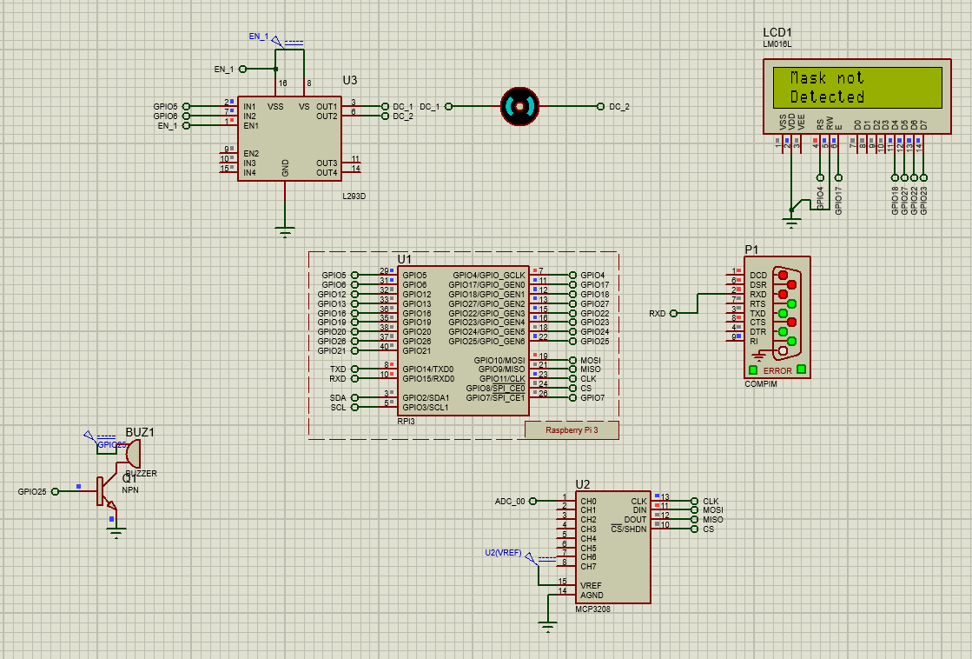

Fig.5.2 Mask Not Detected

# Conclusion

Wearing a mask is one technique to inhibit the transmission of viruses in this pandemic condition, which is vital to prevent the development of hazardous diseases. Most public areas where there is a higher risk of virus transmission require mask use, yet some people enter without them because they are unaware of the requirement. It is very hard to watch after all the individuals and intimate them to wear mask therefore here we created a smart device this will automatically identifies the face mask of a person. Only when a person is wearing a mask does the door open. The buzzer will ring and announce that the individual has to wear a mask if they don't already.

# References

[1]. Pavan Narayana A, Janardhan Guptha S, Deepak S, Pujith Sai P “Smart Door / COVID-19 Face Mask Detection”, IJITEE,2021.

[2]. K.N Baluprithviraj, K.R Bharathi, S Chendhuran, P Lokeshwaran, “Smart Door with Face Mask Detection” published in 2021 International Conference on Artificial Intelligence and Smart Systems (ICAIS).

[3]. Utkarsha Barde1, Dhanshree Kadam2, Manasi Patil3, Kirti Shirnath4 “Survey on Face Mask Detection with Door Locking and Alert System using Raspberry pi”, IRJET,2022.

[4]. B Varshini, HR Yogesh, Syed Danish Pasha, Maaz Suhail, V Madhumitha, Archana Sasi “IoT-Enabled smart doors for monitoring body temperature and face mask detection”, Global Transitions Proceedings 2 ,2021.

[5]. Anargha Roy Chowdhury, Sneha Ray, Manish Rai, Parna Das, Dr. Sangita Roy, Rimpi Dutta, Anushree Mondol” Advance door lock with face mask detection using Arduino motion detector by PIR sensor and YOLO-LITE”, IJARIIT,2022.

[6]. Alimul Rajee and Saiful Islam **“**Smart Door with Face Mask Detection”, published on May 2022.

[7]. Daniyar Syrlybayeva, Nurlan Nauryza, Aidana Seisekulova, Kaiyrbek Yerzhanova, and Md. Hazrat Alia “Smart Door for COVID Restricted Areas”, published in 5th International Conference on Emerging Data and Industry 4.0 (EDI40) March 22-25, 2022, Porto, Portugal.

[8]. Tamilarasan Ananth Kumar, Rajendrane Rajmohan, Muthu Pavithra, Sunday Adeola Ajagbe, Rania Hodhod and Tarek Gaber **“**Automatic Face Mask Detection System in Public Transportation in Smart Cities Using IoT and Deep Learning”, published:15March2022,https://doi.org/10.3390/electronics11060904.

[9]. Gayatri Deore, Ramakrishna Bodhula, Dr. Vishwas Udpikar, Prof Vidya and more introduced “Study of Masked Face Detection Approach in Video Analytics” published in 2016 Conferences on Advances in Single Processing.

[10]. Kallakuri Anirudh, Anirudh Ravi, Vecha Sri Charan and Vijayshri Chaurasiya “Face Mask Detection Using Deep learning”, Published in: 2022 IEEE International Students Conference on Electrical, Electronics and Computer Science (SCEECS)