Farming and water management in india

1.INTRODUCTION
Agriculture plays a crucial role in the Indian economy and supports the livelihood of millions of farmers. One of the most important factors affecting agricultural productivity is the availability and efficient use of water. In many regions of India, farmers face challenges such as irregular rainfall, water scarcity, and inefficient irrigation practices. These challenges can significantly affect crop yields and farm income.
Effective water management has therefore become an essential component of sustainable agriculture. Farmers are increasingly adopting innovative practices such as drip irrigation, rainwater harvesting, farm ponds, and other water conservation techniques to improve irrigation efficiency and ensure better crop productivity.
This project analyzes a dataset of farm success stories related to water management practices. The objective of the analysis is to identify key patterns and insights that explain how innovative water management strategies contribute to successful farming outcomes. The findings from these case studies also provide valuable lessons that can be applied to regions such as Chhattisgarh, where agriculture depends heavily on monsoon rainfall and efficient water use is critical for long-term sustainability.

2. Executive Summary
Water management is one of the most important factors influencing agricultural success. The dataset analyzed in this project contains 21 documented farm success stories where farmers implemented different water management innovations to improve their farming outcomes.
The analysis reveals that farmers who adopt efficient irrigation techniques and water conservation methods experience significant improvements in productivity, sustainability, and income. Practices such as drip irrigation, farm ponds, rainwater harvesting, and improved irrigation systems appear frequently in successful cases.
Several important insights emerge from the dataset. First, micro-irrigation techniques such as drip irrigation help farmers reduce water wastage while improving crop yield. Second, water storage structures such as ponds and recharge systems increase farm resilience during periods of low rainfall. Third, many farmers combine water management techniques with other sustainable farming practices, such as crop diversification and soil conservation.
These insights are particularly relevant for stakeholders such as farmers, policymakers, agricultural researchers, and development organizations. For farmers, these practices provide practical strategies to improve productivity and reduce risk. For policymakers, the findings highlight the importance of promoting water-efficient agricultural technologies.
In regions like Chhattisgarh, where agriculture heavily depends on rainfall, adopting similar water management strategies can significantly improve farm sustainability and productivity.

3. Problem Framing
Water scarcity and inefficient water usage are major challenges affecting agriculture across India. Many farmers rely on traditional irrigation methods that often lead to excessive water consumption and uneven distribution of water across fields. This not only wastes valuable water resources but also affects crop growth and yield.
In many agricultural regions, farmers face multiple water-related challenges, including:
- Irregular rainfall patterns
- Increasing drought frequency
- Depletion of groundwater resources
- Limited access to irrigation infrastructure
- Inefficient traditional irrigation techniques
These problems increase the vulnerability of farmers, especially small and marginal farmers who have limited resources to cope with climate variability.
The situation is particularly significant in Chhattisgarh, where agriculture is highly dependent on monsoon rainfall. While the state receives substantial rainfall during the monsoon season, water availability during the rest of the year can be limited. Many farmers lack adequate water storage systems, which leads to water shortages during critical crop growth stages.
Water management innovations provide practical solutions to these problems. Techniques such as drip irrigation, rainwater harvesting, and water storage systems allow farmers to use water more efficiently and maintain crop productivity even under challenging environmental conditions.
The objective of this project is therefore to analyze farm success stories related to water management and identify which strategies contribute most to successful farming outcomes.

4. Methodology
This project uses a data storytelling approach, where the dataset is analyzed using visualizations and the insights are explained through a simple narrative.
Data Source
The dataset contains 21 farm success stories related to water management practices. Each record represents a farmer who adopted a particular water management method and achieved successful farming outcomes.
Data Preparation
Before analysis, the dataset was cleaned to improve consistency. The following steps were performed:
- Removed extra spaces and formatting issues in column names
- Standardized similar irrigation practice terms
- Grouped water management methods into categories such as micro-irrigation, water storage, rainwater harvesting, and traditional practices
Analysis and Visualization
After cleaning the data, charts and graphs were created to visualize the information. Visualizations such as bar charts and pie charts were used to identify patterns and comparisons between different water management practices.
Storytelling Approach
The results from the visualizations were then interpreted and presented as a data story, explaining the challenges farmers face, the solutions they adopted, and the impact of these water management practices.

Insights and patterns obtained from visualizations:

1.Distribution of Climatic Conditions:
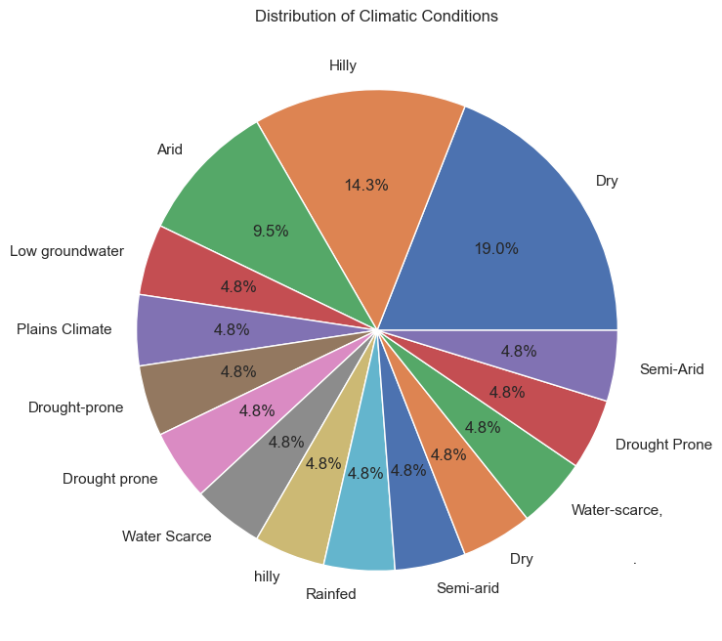
This pie chart shows the distribution of climatic conditions represented in the dataset of farming success stories related to water management. The visualization helps identify the types of environments where water management practices are commonly implemented. A large proportion of cases appear in dry and water-scarce regions, indicating that farmers in these areas are more motivated to adopt efficient irrigation and water conservation techniques. Other climatic regions such as hilly, drought-prone, semi-arid, and rainfed areas also appear in the dataset. These regions often face irregular rainfall and limited water availability. The presence of success stories across multiple climatic zones suggests that water management innovations are useful in diverse agricultural environments. Overall, the chart highlights that water management becomes especially important in regions facing environmental stress and limited water resources.

2.Climate Conditions vs Land Size (Heatmap): 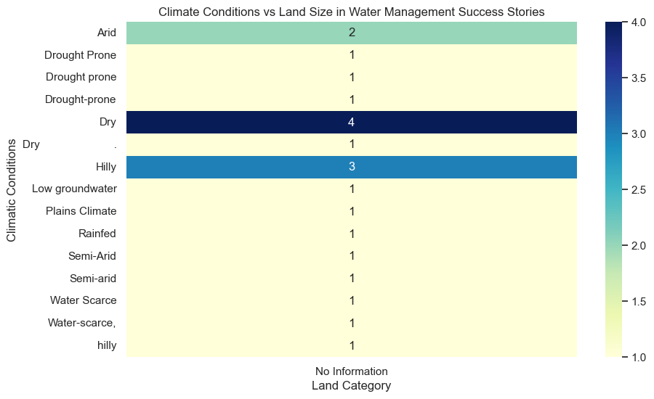

This heatmap illustrates the relationship between climatic conditions and farm land size categories in the dataset. Each cell in the heatmap shows the number of farms belonging to a particular land category within a specific climatic condition. The visualization helps identify patterns in how farmers of different land sizes adopt water management practices across environmental conditions. The results indicate that small and medium farmers appear frequently across multiple climates, suggesting that water conservation techniques are widely adopted by farmers with limited resources. The presence of cases across different climatic zones also indicates that water management innovations are not limited to a particular environment. Instead, they are implemented wherever water availability is uncertain. Overall, the heatmap demonstrates that successful water management practices are adopted across various farm sizes and environmental contexts.

3.Top Crops Used:
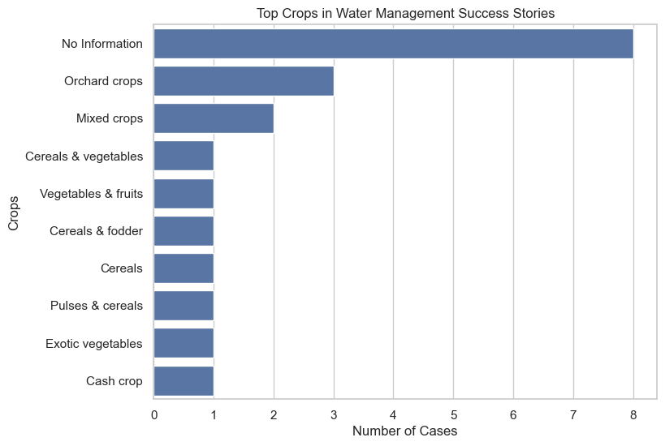

This bar chart highlights the most common crops grown by farmers who adopted water management practices. The visualization displays the top crops based on the number of occurrences in the dataset. The results suggest that farmers often cultivate diverse crops or mixed cropping systems, which help optimize water usage and reduce agricultural risk. Certain crops appear more frequently because they benefit from improved irrigation systems. Efficient water management allows farmers to grow crops that require reliable water supply throughout the growing season. Crop diversity also helps farmers maintain stable production under uncertain climatic conditions. Overall, the chart indicates that improved irrigation and water conservation methods support both crop productivity and agricultural diversification.

4.Impact of Climate on Income Results:

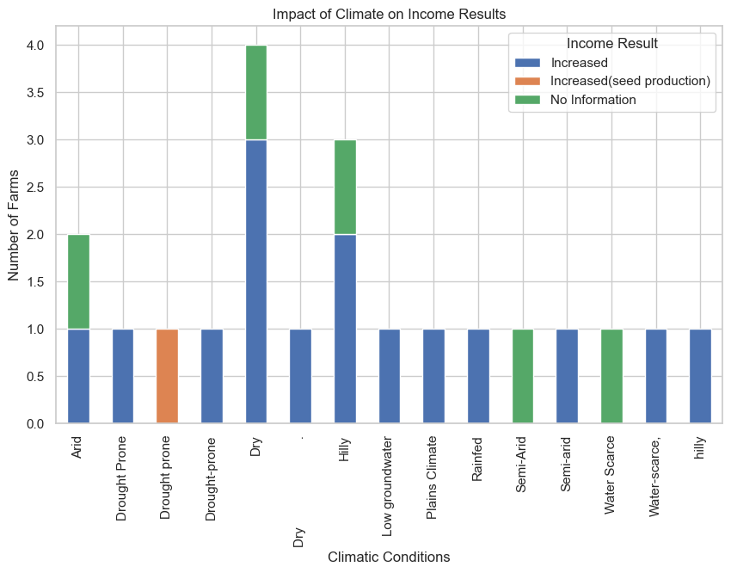

This stacked bar chart shows the relationship between climatic conditions and income outcomes after farmers adopted water management techniques. The visualization compares cases where farmers experienced increased income, stabilized income, or cases where income data was not available. The results suggest that many farmers in dry and water-scarce regions reported increased income after implementing water management practices. Efficient irrigation methods enable better water utilization, leading to improved crop productivity. In some challenging climatic regions, water management practices help stabilize income by protecting farms from water shortages. Rainfed and semi-arid areas also show positive income outcomes, indicating that conservation techniques can improve resilience against climate variability. Overall, the chart highlights the economic benefits of adopting improved water management strategies in agriculture.

5.Applicability in Chhattisgarh:

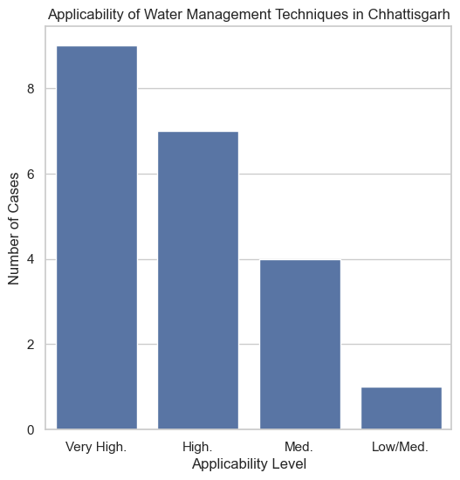
This bar chart evaluates how suitable different water management techniques are for farming conditions in Chhattisgarh. The visualization categorizes the techniques based on their level of applicability, such as low, medium, high, and very high. The results show that most techniques fall under high or very high applicability, indicating that these practices can be effectively implemented in the region. Chhattisgarh’s agriculture relies heavily on seasonal rainfall, making water conservation strategies particularly important. Techniques such as drip irrigation, rainwater harvesting, and farm ponds can help farmers manage water more efficiently. Some practices show medium applicability, meaning their success may depend on specific local conditions. Overall, the chart highlights the strong potential for adopting water management innovations to improve agricultural sustainability in Chhattisgarh.

Story Arc: Water Management Success in Farming
Context:
Agriculture plays a vital role in rural economies, particularly in states such as Chhattisgarh where a large portion of the population depends on farming for their livelihood. However, agriculture in these regions is highly dependent on seasonal rainfall and natural water availability. Irregular rainfall patterns, changing climate conditions, and limited irrigation infrastructure make farming uncertain and risky. In such situations, effective water management becomes crucial for maintaining crop productivity and ensuring stable farm income. The dataset used in this project contains documented success stories of farmers who adopted innovative water management practices to overcome these challenges. By analyzing these cases through data visualizations, it becomes possible to understand how different environmental conditions, farm characteristics, and water management strategies contribute to successful farming outcomes.

Conflict:
Many farmers operate in dry, semi-arid, rainfed, or drought-prone regions, where water scarcity directly affects crop growth and productivity. Limited rainfall and poor water storage systems often lead to crop failures and unstable income for farmers. Small and medium farmers are particularly vulnerable because they usually have limited resources, smaller land holdings, and restricted access to advanced irrigation technologies. In such conditions, even minor variations in rainfall can significantly impact agricultural output. The dataset also shows that farming occurs across different climatic conditions, each presenting unique challenges related to water availability and soil conditions. These factors create a major barrier to sustainable agriculture and make it difficult for farmers to maintain consistent productivity and income.

Resolution:
Despite these challenges, many farmers have successfully addressed water scarcity by adopting efficient water management techniques. Practices such as drip irrigation, rainwater harvesting, farm ponds, micro-irrigation systems, and improved crop planning allow farmers to use water more efficiently. These strategies help store water during rainy periods and use it effectively during dry seasons. The dataset highlights several examples where farmers improved irrigation efficiency, diversified their crops, and increased farm resilience through better water management. By optimizing the use of available water resources, farmers can maintain crop production even in areas with unpredictable rainfall. These practices not only improve agricultural productivity but also encourage sustainable farming methods that conserve water and protect the environment.

Impact:
The analysis and visualizations developed in this project demonstrate that water management innovations can have a significant positive impact on farming outcomes. Many cases in the dataset show increased or stabilized farm income after the adoption of improved water management practices. The visualizations also reveal that these techniques are applicable across various climatic conditions and farm sizes, including small and medium farms. Furthermore, the analysis of applicability indicates that several of these practices are highly suitable for regions such as Chhattisgarh. This suggests that wider adoption of water management strategies could improve agricultural sustainability, increase farm productivity, and strengthen farmers’ resilience to climate variability. Overall, promoting efficient water management can play an important role in improving rural livelihoods and supporting long-term agricultural development.

Limitations of the Study
This study is based on a relatively small dataset of documented farming success stories related to water management. Because the number of records is limited, the findings may not represent all farming conditions or practices across different regions. Some variables in the dataset also contained missing or incomplete information, such as land holdings or crop details, which required data cleaning and categorization. In addition, the dataset mainly focuses on successful cases, which means unsuccessful or unsuccessful implementations of water management practices are not included. Therefore, the results should be interpreted as indicative patterns rather than definitive conclusions about all farming situations.

Recommendations
Based on the analysis of the dataset and visualizations, several recommendations can be made to support improved water management in agriculture. Farmers should be encouraged to adopt efficient irrigation methods such as drip irrigation and rainwater harvesting to optimize water use. Government agencies and agricultural organizations can support farmers by providing training programs and financial assistance for implementing water conservation technologies. Increasing awareness about sustainable farming practices can also help farmers improve crop productivity while conserving water resources. In regions like Chhattisgarh, promoting locally suitable water management techniques could significantly improve agricultural resilience and farm income.

Conclusion
This project analyzed farming success stories related to water management to understand how different techniques influence agricultural outcomes. The analysis showed that many farmers operating in challenging climatic conditions were able to improve or stabilize their income by adopting efficient water management practices. The visualizations highlighted patterns related to climate conditions, farm sizes, crop types, and income outcomes. The results suggest that water management innovations play an important role in improving agricultural sustainability and productivity. Overall, the study demonstrates that effective water conservation and irrigation practices can help farmers adapt to environmental challenges and improve long-term farming success.

AI Usage Declaration
Artificial intelligence tools were used in this project to assist with coding guidance, explanation of data analysis concepts, and drafting of report sections. However, the dataset analysis, interpretation of visualizations, and final report structure were completed and reviewed by the student. All insights and conclusions presented in this report are based on the analysis of the provided dataset.

