Ecommerce Microservices Functionality Testing
Creation of Product details: POST /products
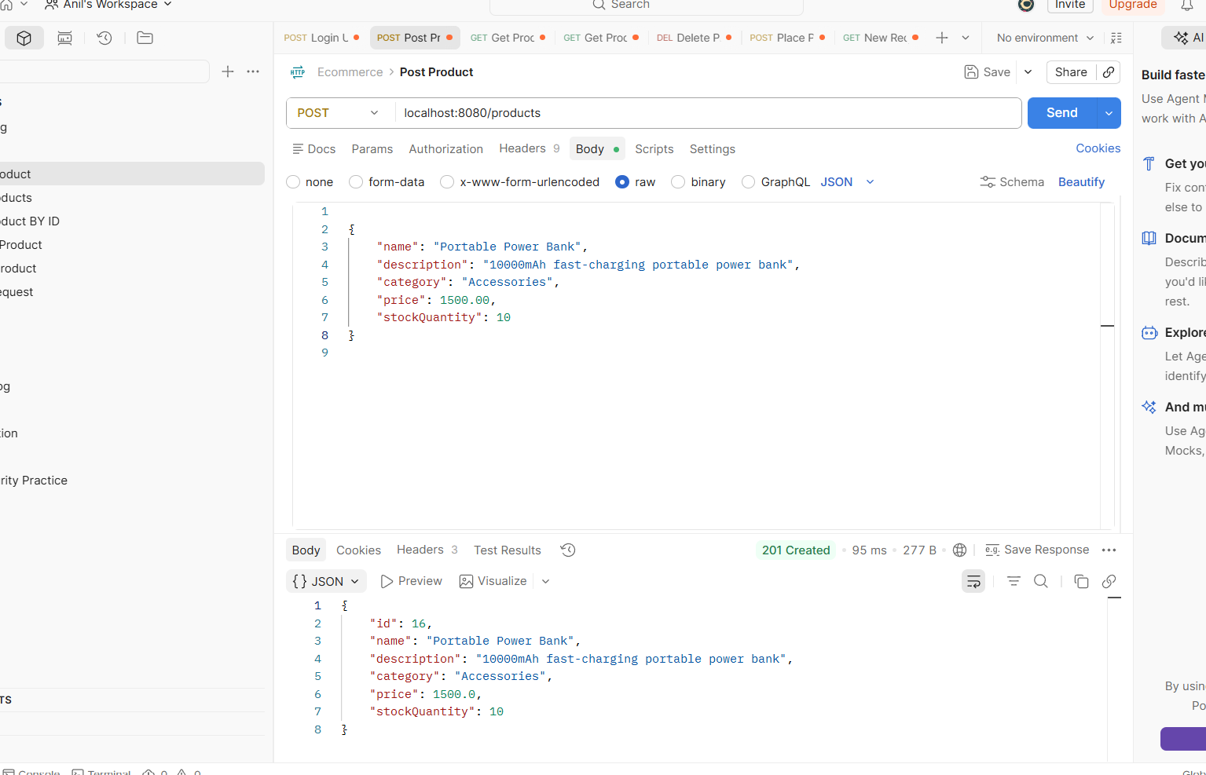
Get Product details: GET product/{id}
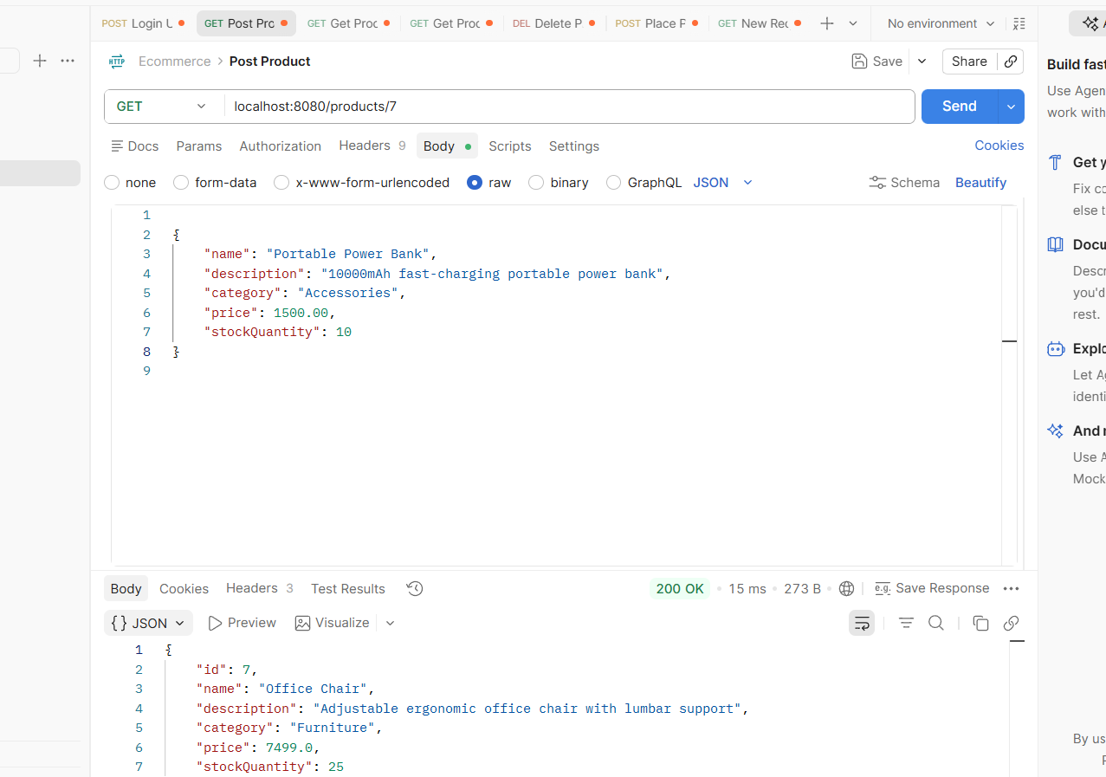
Get All Products Details: GET /products
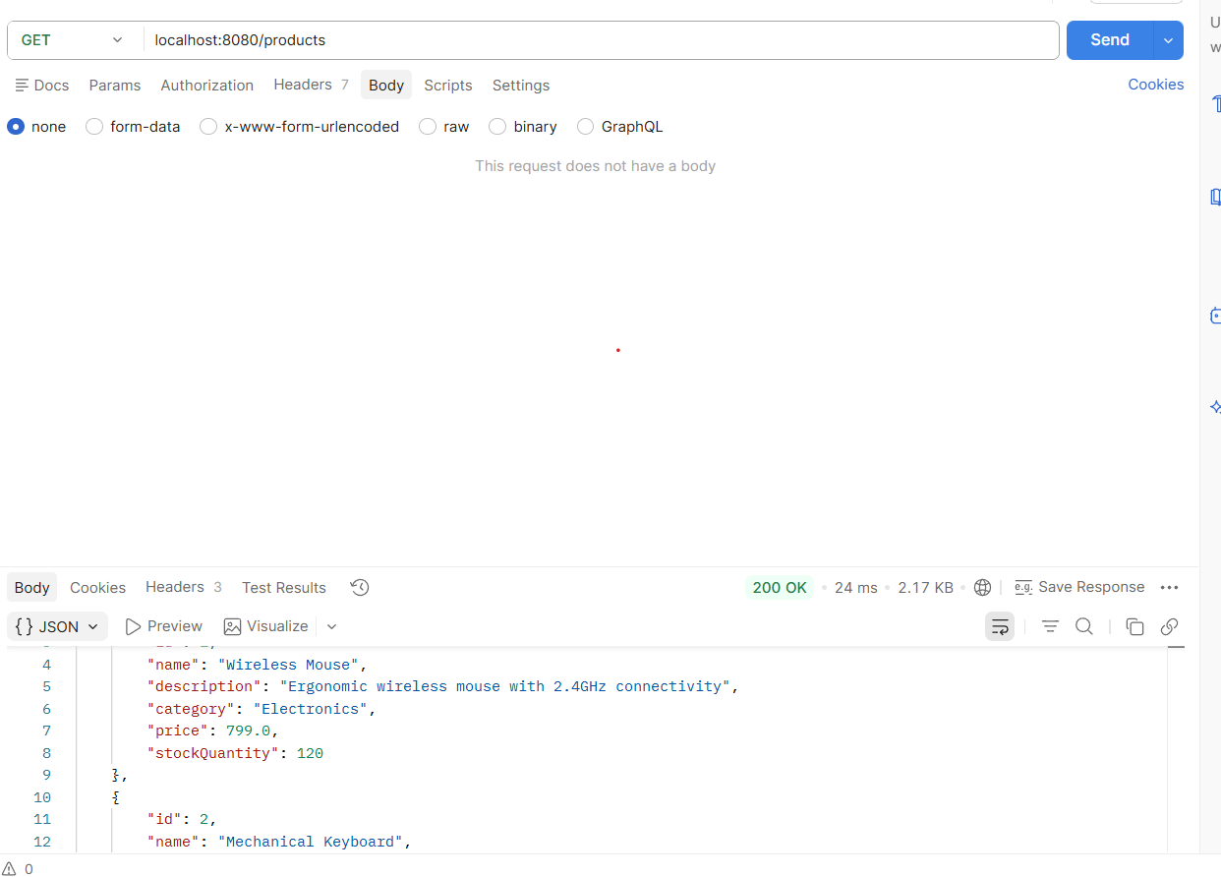
Placing Order with quantity : Post /orders
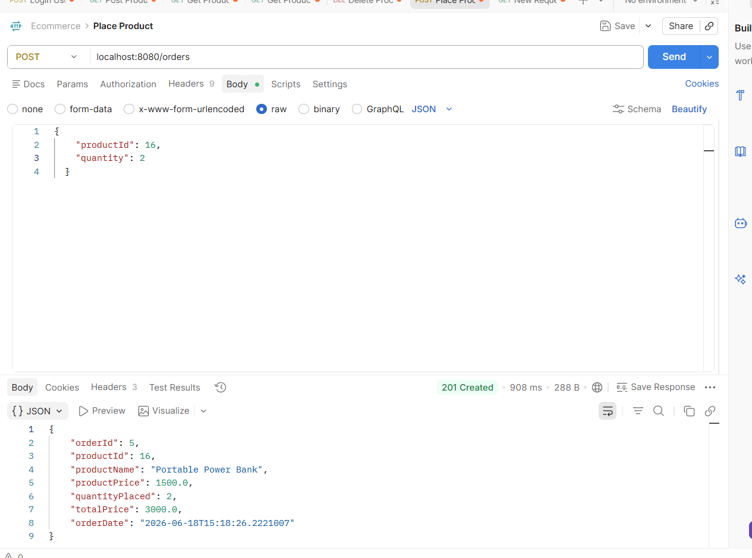
Get orders details by Id : GET / orders/{id}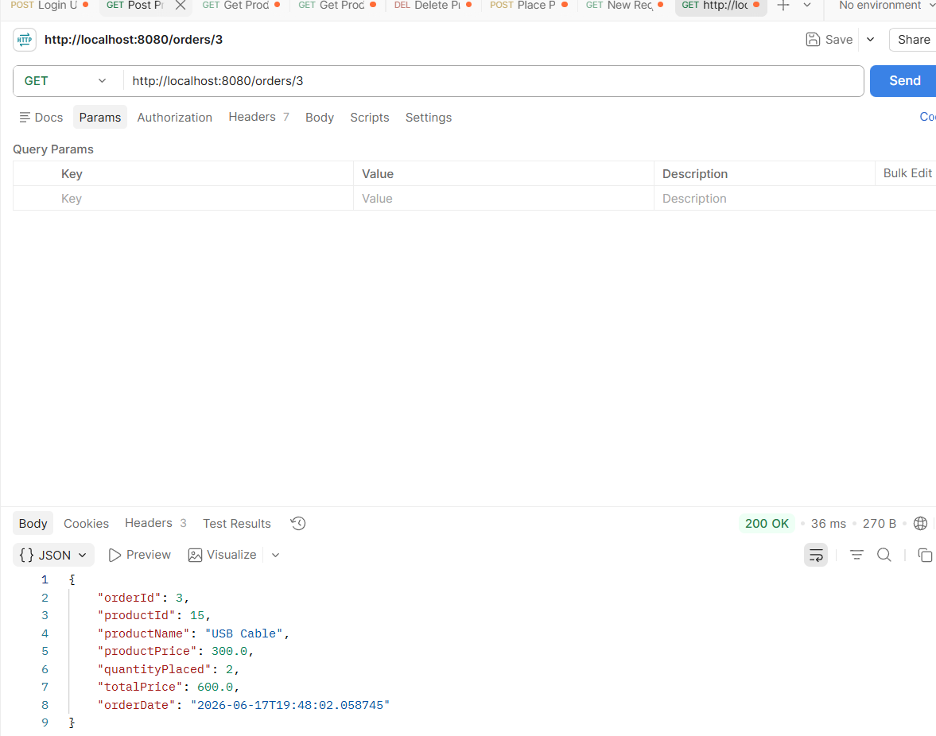

Get All Order Details: GET /orders
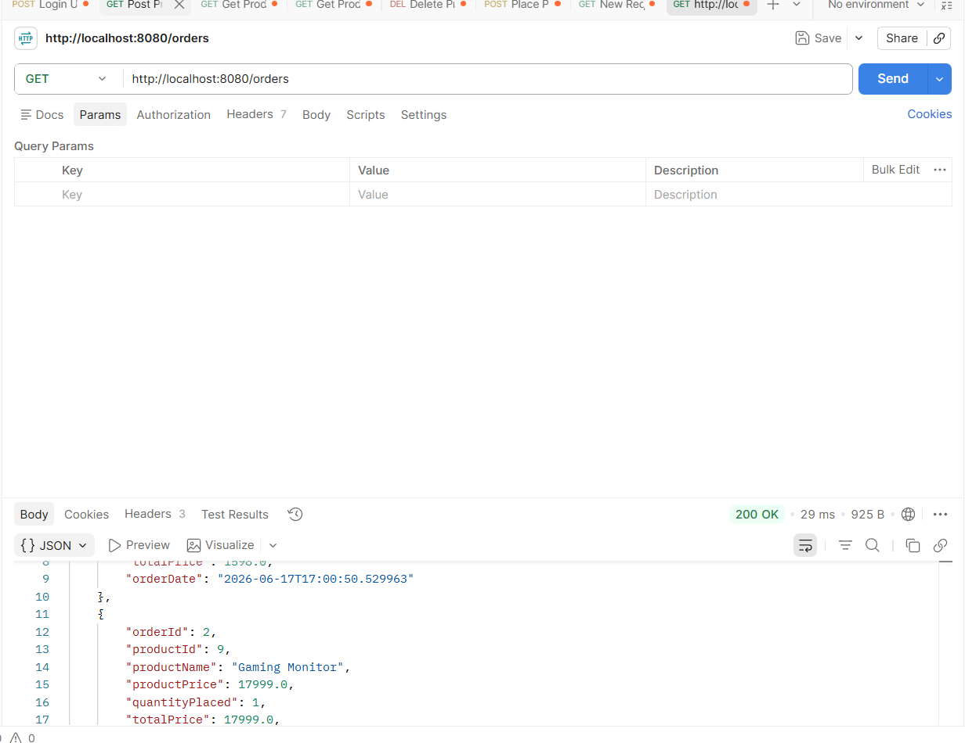
Product Database data:
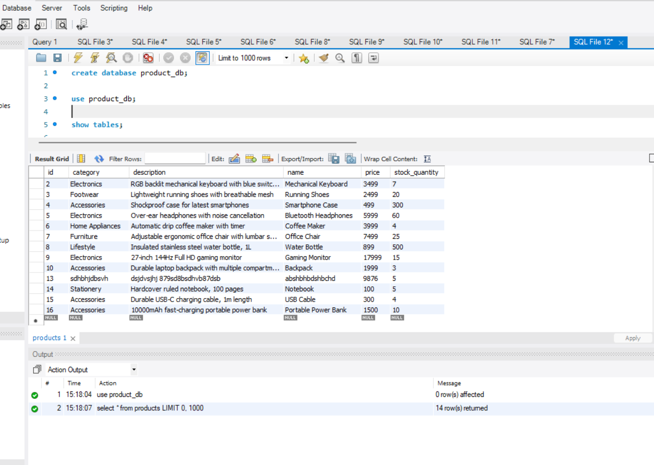
Placed Orders details database data :
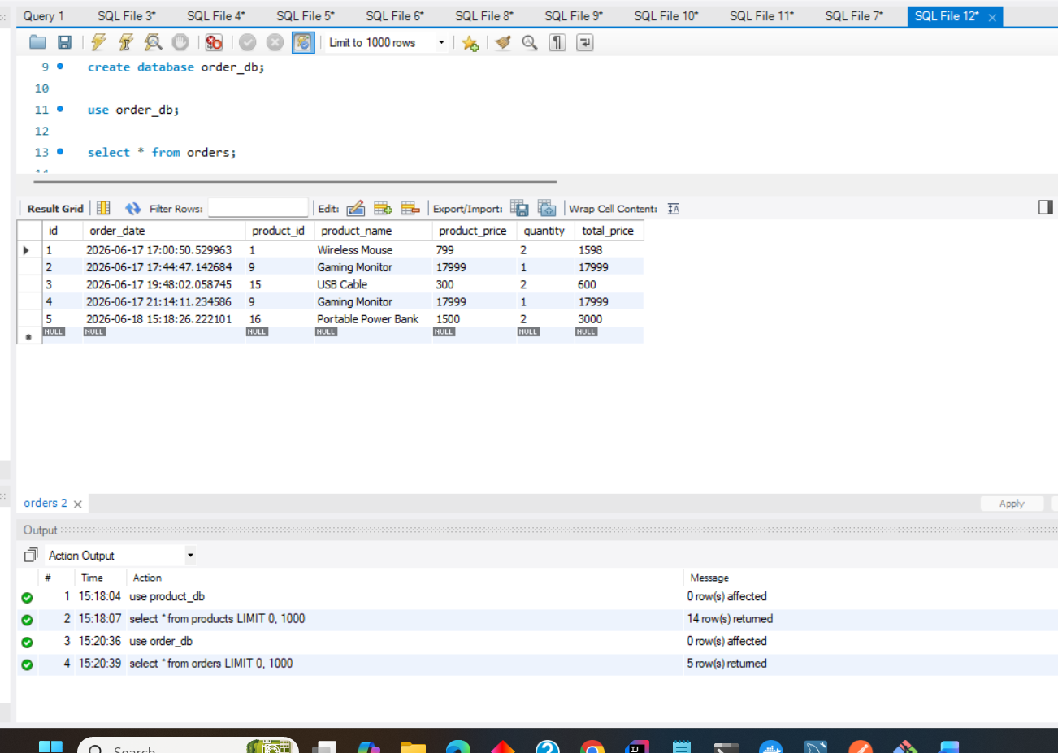
Notification details database data:
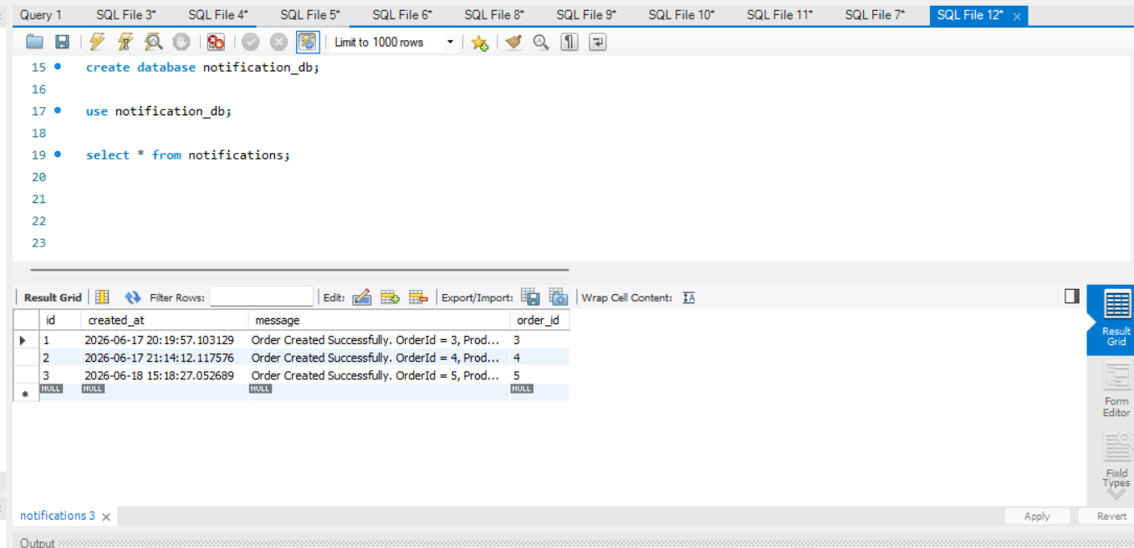
Docker set up to run Kafka locally,
