19CSE463

MOBILE APPLICATION DEVELOPMENT

PROJECT

INDEX

|  |  |
| --- | --- |
| CONTENT | PAGE NO |
| INTRODUCTION | 2 |
| DATASET AND BASE PAPER | 3 |
| LITERATURE SURVEY | 4 |
| ARCHITECTURE | 5 |
| METHODOLOGY | 6 |
| MODELS USED | 7 |
| USER INTERFACE | 12 |
| SIMILAR APPS | 13 |
| CONCLUSION | 14 |

Roll numbers:

CB.EN.U4CSE21052 – SAJITH RAJAN

CB.EN.U4CSE21232 – KOLLEPALLI RISHITH PRANAV KUMAR

PiSave: Smart Expense Tracker

PROBLEM STATEMENT:

Because manual money management is frequently laborious and imprecise, consumers find it difficult to efficiently track their spending. Expense tracking has to be streamlined with a method that combines automatic detection and manual entry.

ABSTRACT:

The spending Tracker Application is a cutting-edge Android solution that combines automated and manual spending monitoring features to improve personal budget management. Accurate and effective tracking is ensured by the Naive Bayes machine learning model, which allows users to easily enter their spending or automatically extract transaction details from SMS texts. With the help of the app's user-friendly pie charts, users can rapidly comprehend their spending patterns and financial tendencies. In order to help users stay on track with their financial goals, it also provides goal-setting tools and promptly notifies them when they go over their spending caps. The Expense Tracker Application seeks to give consumers a complete and intuitive solution for efficient financial decision-making by integrating these features.

INTRODUCTION :

Effective personal finance management is essential in the fast-paced world of today, yet handling money by hand can be ineffective and inconvenient. This issue is resolved by the Expense Tracker Application, which offers a feature-rich solution for monitoring everyday spending. With the help of a Naive Bayes-based machine learning model, this Android app gives customers the option to either manually enter their spending or have their bank automatically identify and interpret their expense messages. The app hopes to simplify the spending monitoring process by including these features, giving users easier and more accurate access to their financial activity.

Users can manually enter expense details including amount, category, date, and description using the program. Pie charts are then used to illustrate the data, providing a quick and easy way to see how much they spend. The software also helps users keep on track with their financial goals by allowing them to create goals and sending out alerts when they go over their spending limitations. By combining automated and manual expense tracking, along with user-friendly visual and alert capabilities, the Expense Tracker Application enables users to better manage their money and make wise spending choices.

DATASET:

[url: https://www.kaggle.com/datasets/uciml/sms-spam-collection-dataset]

BASE PAPER:

Title: SMART EXPENSE TRACKER APPLICATION USING NAIVE BAYES(2023)

**Contributions:**

* By examining several machine learning approaches and how well they recognize spam messages, the study advances the field of SMS spam detection. For various datasets, it demonstrates how Convolutional Neural Networks (CNN) can achieve high accuracy rates of 99.19% and 98.25
* It offers a thorough analysis of the body of research on SMS spam detection, including summary methods, algorithms, and assessment metrics.
* The study highlights how crucial it is to have efficient filtering methods in order to shield users from online threats and data breaches brought on by spam SMS.

**Challenges:**

* The scarcity of datasets for machine learning model training is one of the primary issues noted, which may reduce the efficacy of spam detection systems.
* The identification procedure is made more difficult by the informal language and shorthand used in SMS communications, which make it challenging to discern between spam and authentic texts. The study also points out that issues like local content, abbreviated terms, and inadequate slogans in SMS spam identification have not been sufficiently addressed by previous studies.

LITERATURE SURVEY:

|  |  |  |
| --- | --- | --- |
| TITLE | DESCRIPTION | KEY FEATURES |
| Intelligent Online Budget Tracker | Developed using the Rational Unified Process (RUP) methodology, addressing security (web and network) and quality management issues. | Emphasizes security, reliability, and quality management. |
| Online Income and Expense Tracker | A more efficient project that avoids manual calculations for income and expenses, offering efficient and attractive module development. | Automates monthly calculations, user-friendly interface. |
| Family Expense Manager Application | Designed for daily use, helping users update and view personal and family expenses, keeping track of income and expenses. | Tracks daily and family expenses, integrated into daily routines. |
| Personalized Expense Managing Assistant Using Android | Allows users to register via email or social networks and synchronizes profile information. Uses data mining to classify expenses and assist in market analysis. | Synchronizes user data, classifies expenses, and provides market analysis using data mining techniques. |
| Mobikwik Expense Tracking Application | Offers an Expense Manager feature to track expenditures, savings, reminders, and bill payments, providing spending analysis and recommendations for savings. | Tracks income and expenses, sends bill reminders, provides saving tips and recommendations for future investments. |
| **Financial Tracker using NLP** | The Financial Tracker is designed to help users manage their finances by processing unstructured text data, such as messages from their inbox. It aims to categorize these messages into different financial types, such as credit, debit, and recharge messages, which can then be analyzed to predict monthly expenditures and earnings. | The system uses NLP to extract financial insights by classifying messages (e.g., credit, debit, recharge). It preprocesses data and applies random forest classification to improve accuracy. It helps users filter financial messages and has industrial uses like assessing loan applicants. The study's methods apply to broader NLP research. |
| SBM: A Smart Budget Manager in banking using machine learning, NLP, and NLU | SBM, or Smart Budget Manager, is an innovative system designed to enhance banking experiences by utilizing machine learning, natural language processing (NLP), and natural language understanding (NLU). The primary goal of SBM is to automatically categorize bank transactions, providing users with a clearer understanding of their spending habits and enabling better financial management | Key features include automatic transaction categorization into predefined and custom categories for better financial management. The system uses NLP for cleaning transaction descriptions and converts them into numerical features for machine learning. It employs incremental learning to adapt over time, improving categorization accuracy. Successfully deployed in a Tunisian bank, it enhances customer satisfaction and operational efficiency. |

ARCHITECTURE

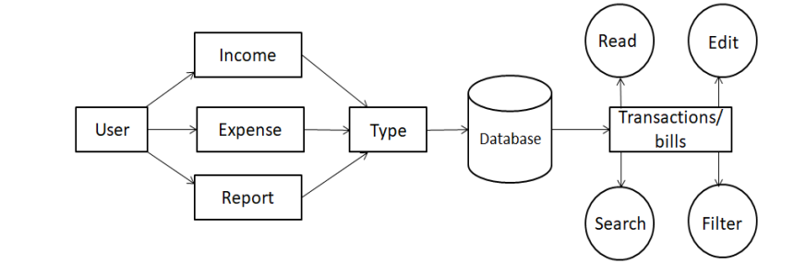

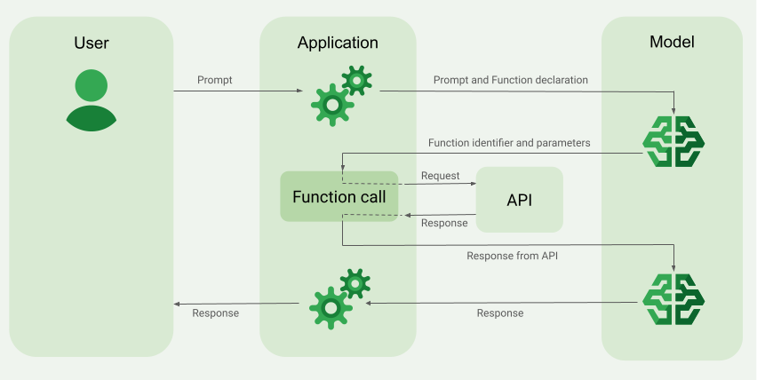

METHODOLOGY

**1. Data Collection**

* **SMS Integration**: Set up a service to automatically collect SMS transaction alerts from banks and payment services. Utilize permissions and APIs to access and read SMS messages securely.
* **User Input Mechanism**: Create an intuitive interface for users to manually enter expenses, ensuring fields for amount, category, date, and notes.
* **Feedback Collection**: Implement a feedback form or chatbot feature where users can provide insights on transactions, helping to refine the categorization process.

**2. Preprocessing**

* **Text Normalization**: Write functions to process incoming SMS data, converting all text to lowercase and removing extraneous symbols (like currency signs) to maintain consistency.
* **Regex Implementation**: Utilize Python's re module to construct regex patterns that accurately capture monetary values and transaction types.
* **Data Cleaning**: Establish protocols to filter out irrelevant messages and handle cases of incomplete or malformed data, ensuring the system processes only valid transaction messages.

**3. Feature Extraction**

* **NLP Techniques**: Implement regex or similar techniques from libraries like Scikit-learn to convert text data into numerical feature sets. This prepares the data for model training.
* **Keyword Identification**: Use the predefined categories and associated keywords to classify expenses. For instance, iterate through each message to identify matching keywords that determine the category.

**4. Model Development**

* **Transaction Type Detection**: Integrate keyword analysis within the same model to differentiate between debit and credit transactions, ensuring that the classification accounts for both aspects.

MODELS USED:

K MEANS CLUSTERING

CONFUSION MATRIX

Roc curve:

NAÏVE BAYES:

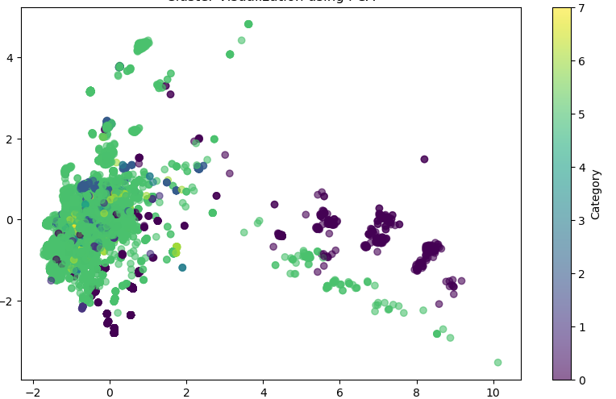

Confusion matrix  
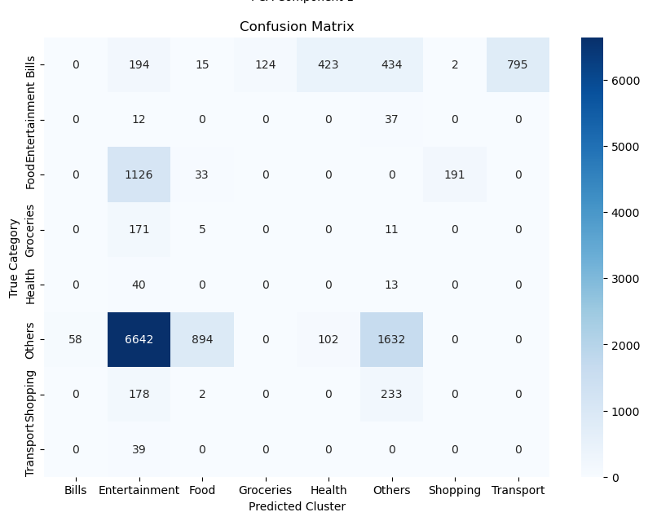

Roc curve:

USING HASHLIB

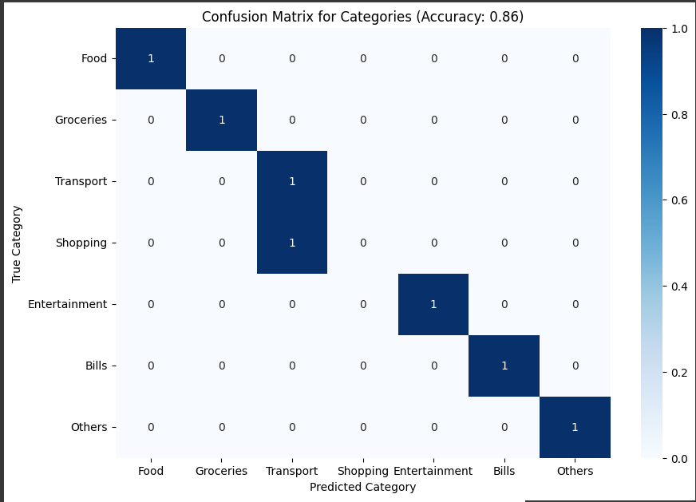

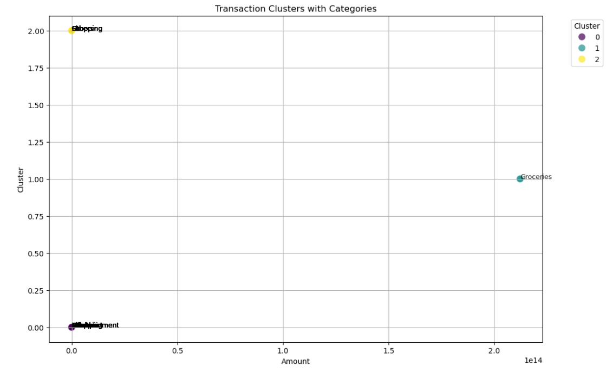

9O8PCA :

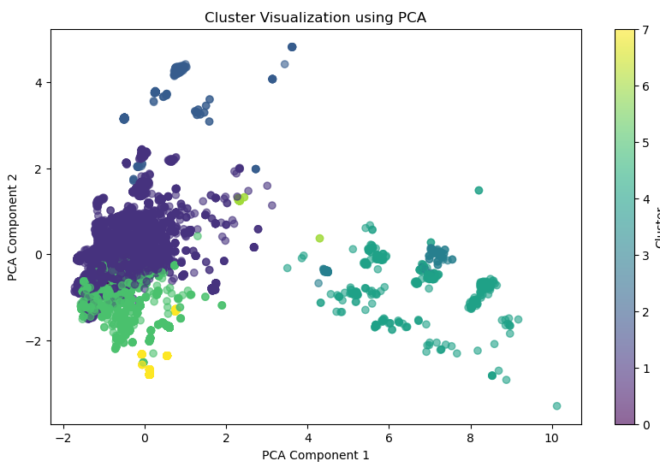

ACCURACY COMPARASION :

|  |  |
| --- | --- |
| Model | Accuracy |
| Naïve bayes | 94% |
| pca | 12.5% |
| K - means | 85% |
| Regex matching | 86% |

CHOSEN MODEL FOR APP:

We chose Regular Expressions (Regex) for the development of our Expense Tracker Application because it offers numerous advantages. Regex excels at searching and matching specific patterns within strings, which is ideal for extracting relevant information from expense messages, such as amounts, dates, and categories. Its flexibility allows us to handle various input formats, accommodating different bank message formats by creating adaptable patterns. Additionally, using Regex helps us write more concise code; a single pattern can often replace multiple lines of code typically needed for string manipulation, making our code easier to maintain. Moreover, Regex operations tend to be more efficient for string searches, especially when processing large volumes of text data like multiple SMS messages. It also allows us to validate user inputs, ensuring that entered expenses meet specific criteria and enhancing data integrity. Furthermore, Regex enables us to perform complex queries, such as finding all expenses within a certain date range or category. By integrating Regex into our application, we can improve its robustness and efficiency, ultimately enhancing the user experience in tracking and managing expenses.

USER INTERFACE:

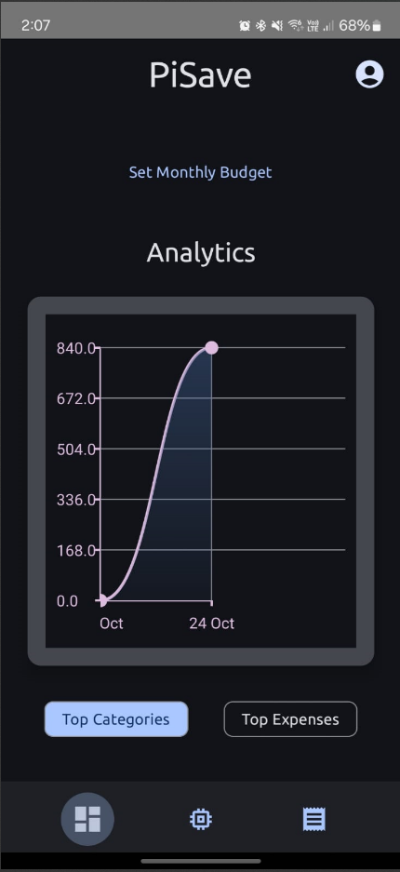 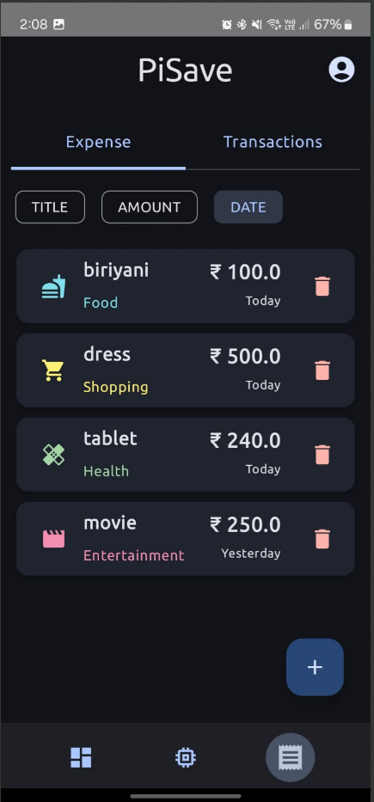

SIMILAR APPS:

|  |  |  |
| --- | --- | --- |
| ICON | NAME | FEATURES |
|  | **Expense.fyi** | * Expense tracking * Income tracking * Investment management * Subscription management * User authentication with magic links * Data security with encryption * User-friendly dashboard * Payment processing with LemonSqueezy * Open-source application |
|  | **MMAS: Money Tracker** | * Expense tracking * Dashboard for overview of income and expenses |
|  | EXPENSO | * Modern UI Design with day and dark mode support * Dashboard for overview of income and expenses * Transaction management (add, edit, view details) |
|  | BUCKOID | * Expense tracking * Income monitoring * Budget planner * Transaction history * Category management * Custom alerts * Savings goals |

FEATUERS INCLUDED IN OUR APP:

**Chatbot Integration**:

* A chatbot that tracks expenses by reading SMS messages.

**Expense Visualization**:

* A graphical representation of spending patterns.

**Transaction History**:

* A dedicated page displaying all transactions for easy reference.

**Automated Expense Detection**:

* Automatically identifies and records expenses from SMS notifications.

**User-Friendly Interface**:

* Intuitive design for easy navigation and interaction.

**Data Security**:

* Measures in place to ensure the security of sensitive financial data.

**Budgeting Tools**:

* Features to set budgets and monitor spending against set limits.

CONCLUSION :  
In conclusion, PiSave is an empowering personal finance management platform that simplifies the complexities of budgeting, expense tracking, and savings. By offering a user-friendly interface and robust features, it enables individuals to gain valuable insights into their financial habits and make informed decisions. With its focus on promoting financial awareness and discipline, PiSave helps users take control of their finances, ultimately guiding them toward achieving their financial goals and enhancing their overall financial well-being.