

**BTech/III Year CSE/V Semester**

**19CSE301/Computer Networks**

**Project Report**

**Case Study**

**<< Voice over IP- IP Telephony Networking >>**

**Group No:17**

|  |  |  |  |
| --- | --- | --- | --- |
| **Registration No** | **Name** | **Email ID** | **Contribution** |
| CB.EN.U4CSE21211 | Battula Lokesh Chandra Chowdary | Lokesh5222l@gmail.com | Implementation, Report writing |
| CB.EN.U4CSE21232 | K Rishith Pranav Kumar | kollepallirishith@gmail.com | Implementation, Report writing |
| CB.EN.U4CSE21256 | Sasidhar Maddali | maddalisasidhar9999@gmail.com | Implementation, Report writing |
| CB.EN.U4CSE21269 | Y G Ram Darshan Reddy | ygrdr31@gmail.com | Implementation, Report writing |

**Why Networking is required for the application:**

1.Packet Transmission:

VoIP requires a robust network to prevent packet loss, delays, and jitter, ensuring reliable and high-quality voice communication.

2.Quality of Service (QoS):

VoIP's paramount focus on voice quality is facilitated by networking through QoS mechanisms, prioritizing voice traffic for minimized latency and an enhanced communication experience.

3.Security:

Networking is vital for securing VoIP communications through encryption, secure configurations, and firewalls to safeguard voice data from unauthorized access, preserving confidentiality and integrity.

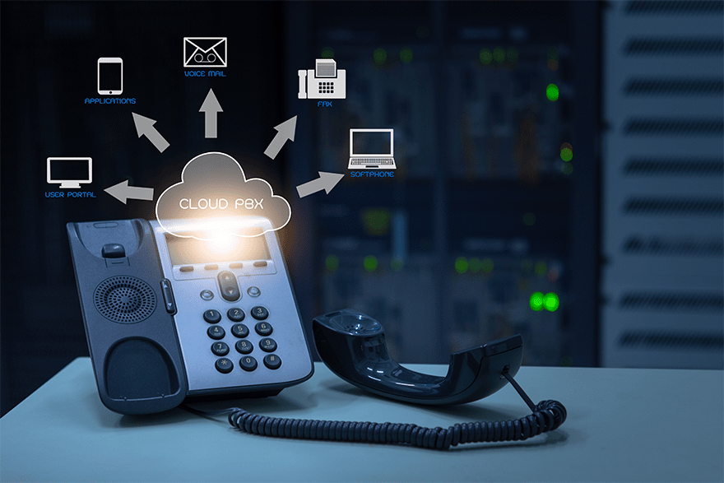

**Problem statement:**

**The project involves designing and implementing a VoIP network, with a focus on scalability and availability. The network is required to connect four departments, each with 20 phones, 20 PCs, and 1 printer. The network must use specific IP address ranges for data (192.168.100.0/24), voice (172.16.100.0/24), and router connections (10.10.10.0/24). Cisco 2811 routers and Cisco 2960 switches are specified for the project.**

**How VoIP works?**

1.Analog-to-Digital Conversion:

Voice signals are transformed from analog to digital format to enable transmission over the Internet.

2.Packetization:

The digitized voice data is divided into small packets for efficient transmission.

3.Packet Transmission:

Voice packets travel over the Internet, guided by routers and switches to reach their destination.

4.Digital-to-Analog Conversion:

At the receiving end, digital packets are reassembled and converted back to analog for playback.

5.Integration with Traditional Telephony:

VoIP systems can interface with traditional telephone networks through gateways, allowing communication between VoIP and landline users.

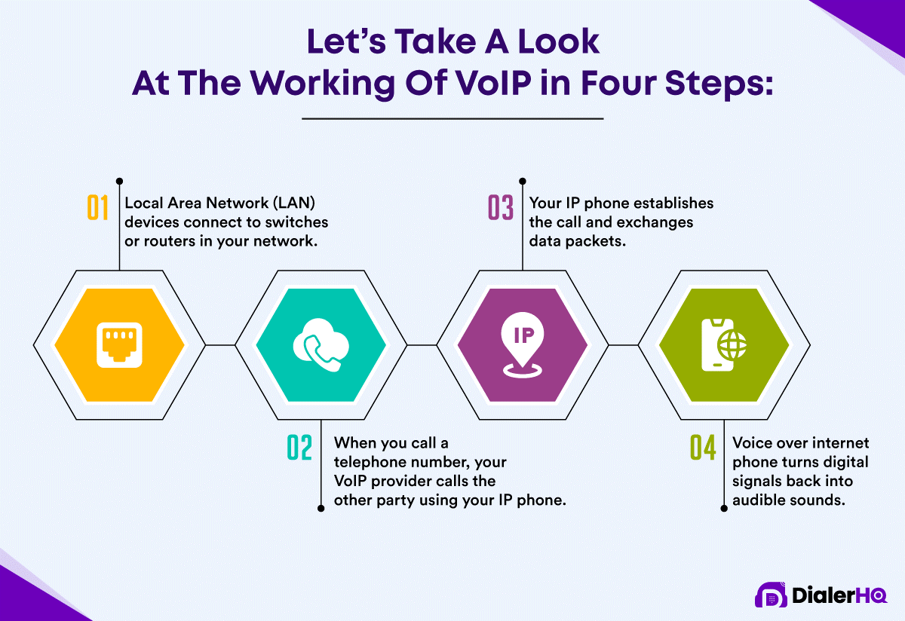

**Benefits of computer networks in VoIP:**

1. Saves Money:

VoIP lets businesses save money by using their existing computer networks for phone calls, avoiding the need for a separate phone system and reducing costs, especially for long-distance calls.

2. Works Anywhere:

VoIP allows people to make calls from almost anywhere with an internet connection, promoting flexibility and supporting remote work.

3. More Features:

VoIP goes beyond traditional calls, offering features like video calls, instant messaging, and file sharing, improving communication and collaboration.

4. Easy to Expand:

As businesses grow, VoIP systems can easily scale up to include more users or locations without requiring a complex setup.

5. Connects with Other Apps:

VoIP seamlessly integrates with other computer applications, such as email and customer management systems, streamlining workflows and making communication more efficient.

**Protocols in VoIP:**

1. The TCP/IP protocol suite serves as the foundation for communication within the network, ensuring reliable and standardized data flow. It operates through a layered architecture, allowing for efficient communication and troubleshooting.
2. For dynamic routing, OSPF is employed to calculate the shortest paths, adapting to network changes. Its scalability makes it suitable for a growing network, adjusting dynamically without manual reconfiguration.
3. SSH enhances security by encrypting remote access to routers, ensuring secure authentication and authorization processes to prevent unauthorized access.
4. In VoIP, SIP handles call setup, modification, and termination, while RTP ensures timely and synchronized delivery of voice data. DHCP automates IP address assignment, reducing administrative overhead, and preventing conflicts.
5. Dial-peering facilitates inter-router communication for VoIP, allowing IP phones from different routers to communicate efficiently. It also ensures a structured approach to numbering and routing for VoIP calls in different departments.

These protocols collectively contribute to the project's objectives of reliability, security, and efficient data and voice transmission.

**VoIP Statistics (in recent times):**

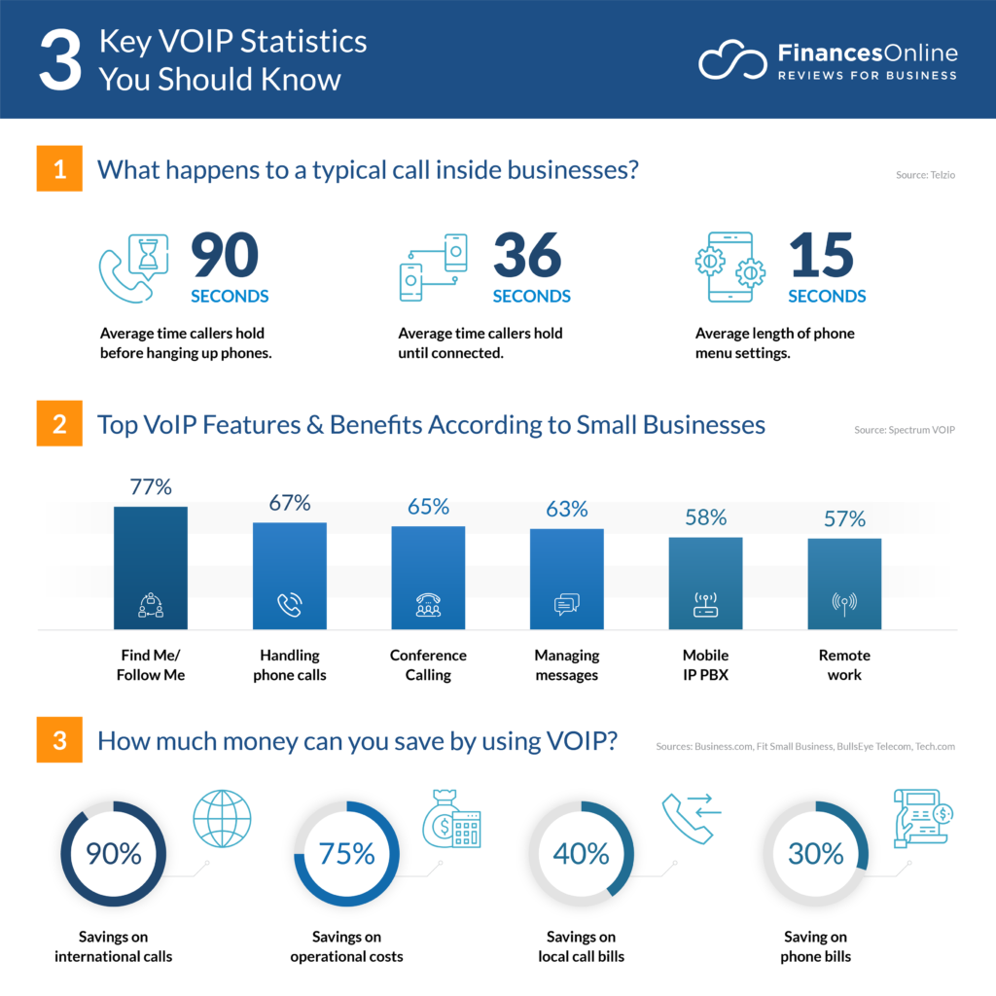



**Software/Operating System used:**

Packet Tracer:

Network Simulation and Visualization:

Packet Tracer is the chosen software for designing and implementing the network infrastructure. It provides a simulation environment that allows the visualization and testing of network configurations before actual implementation.

Educational Tool:

Packet Tracer is widely used in educational settings and professional training for networking. Its user-friendly interface and simulation capabilities make it a valuable tool for understanding and practicing network design.

Prototyping and Troubleshooting:

The software facilitates the creation of network prototypes, enabling Network Engineers to experiment with different configurations. It also aids in troubleshooting by simulating real-world scenarios to identify and resolve potential issues.

Device Operating Systems:

Cisco IOS (Internetwork Operating System):

Cisco IOS runs on Cisco routers and switches, providing the necessary operating system for configuring and managing network devices. It offers a command-line interface (CLI) for device configuration and management.

Stability and Reliability:

Cisco IOS is known for its stability and reliability, ensuring that the network devices operate efficiently. It supports a wide range of networking features and protocols required for the project.

**Hardware/Devices used:**

Cisco 2811 Routers:

VoIP-Enabled Routing: Cisco 2811 routers are selected for each department, providing the necessary capabilities for Voice over IP (VoIP) communication. These routers support the integration of voice services, making them suitable for handling both data and voice traffic.

Routing Protocol Support: The routers are capable of running OSPF (Open Shortest Path First) as the chosen routing protocol. OSPF enables dynamic routing, adapting to changes in the network topology efficiently.

SSH Configuration: The routers are configured to support SSH for secure remote access. This enhances the security of administrative access to the routers.

VoIP Configuration: The routers are configured to support VoIP services, including the allocation of dial numbers for each department. Dial-peering is implemented to allow communication between IP phones from different routers.

Cisco 2960 Switches:

Access Layer Switching: Cisco 2960 switches are designated for each department at the access layer. These switches connect end-user devices such as PCs, phones, and printers.

VLAN Implementation: The switches are configured to support Virtual LANs (VLANs), allowing the segmentation of the network into separate broadcast domains. Each department is assigned two VLANs—one for data and another for voice.

Interconnection with Routers: The switches are connected to the routers using straight-through cables, forming an integral part of the network connectivity between departments.

**Networking devices used in VoIP:**

Routers:

Cisco 2811 routers for VoIP and inter-VLAN routing.

Switches:

Cisco 2960 switches for connecting PCs, phones, and printers.

IP Phones:

Required for VoIP communication.

**Why measure network performance?**

Measuring network performance for Voice over IP (VoIP) is vital for ensuring clear and reliable voice communication. Here's why it's important:

1. Call Quality:

Monitoring factors like latency and packet loss helps maintain satisfactory call quality, preventing disruptions in voice clarity.

1. User Satisfaction:

Regular performance checks contribute to a positive user experience by addressing potential issues promptly and ensuring uninterrupted communication.

1. Troubleshooting:

Performance metrics serve as a valuable tool in quickly identifying and resolving issues, minimizing downtime in VoIP environments.

1. Bandwidth Management:

Monitoring helps understand the bandwidth demands of VoIP traffic, enabling effective allocation and preventing voice quality degradation.

1. Optimizing QoS:

Fine-tuning Quality of Service settings ensures effective prioritization of VoIP packets, enhancing the overall communication experience.

In essence, measuring network performance is a proactive approach to maintaining a reliable and efficient VoIP environment.

**Performance parameters:**

Certainly! Here's a breakdown of each performance parameter with its meaning and a suggested formula:

These formulas provide a general understanding of how each parameter can be calculated or assessed. Note that some parameters, like security and QoS, involve more qualitative assessments and may not have specific mathematical formulas. Adjustments to formulas may be needed based on the specific metrics and tools used for measurement in your network environment.

|  |  |  |
| --- | --- | --- |
| Parameter | Meaning | Formula |
| Latency | Time delay in data transfer. | Latency = (Time of Arrival at Destination) - (Time of Transmission) |
| Bandwidth | Maximum rate of data transfer. | Bandwidth = (Total Data Transferred) / (Time Taken) |
| Packet Loss | Percentage of transmitted packets that don't reach the destination. | Packet Loss Percentage = (Number of Lost Packets / Total Number of Packets Sent) * 100 |
| Jitter | Variation in the time it takes for packets to reach their destination. | Jitter = (Standard Deviation of Packet Arrival Times) / (Mean Packet Arrival Time) |
| Throughput | Actual data transfer rate achieved. | Throughput = (Total Data Transferred) / (Total Time Taken) |
| Reliability/Uptime | Percentage of time the network is operational. | Reliability Percentage = (Total Uptime) / (Total Time) * 100 |
| Security | Protection against unauthorized access and attacks. | No specific formula; it involves monitoring and implementing security measures such as firewalls, encryption, and access controls |
| Scalability | Network's ability to handle growth. | Scalability = (Current Performance Level) / (Expected Performance Level) |
| Capacity Planning | Estimating and preparing for future network requirements. | No specific formula; it involves analyzing historical data, growth patterns, and expected demands. |
| Quality of Service (QoS): | Managing and prioritizing network traffic for critical applications. | No specific formula; it involves configuring and monitoring QoS parameters such as priority levels and resource allocations. |

**Architecture diagram:**

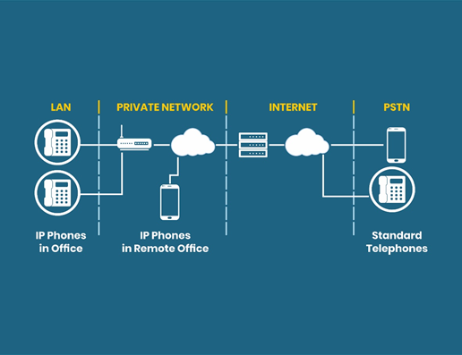

***Fig1.View on how VoIP works***

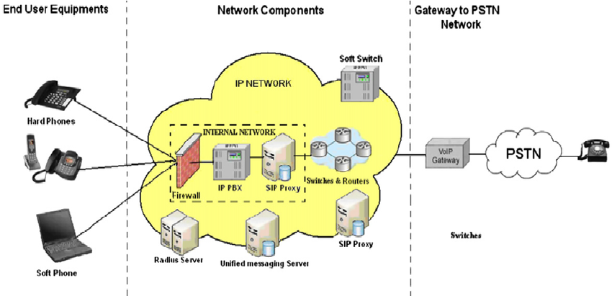

***Fig2.Scientific Diagram***

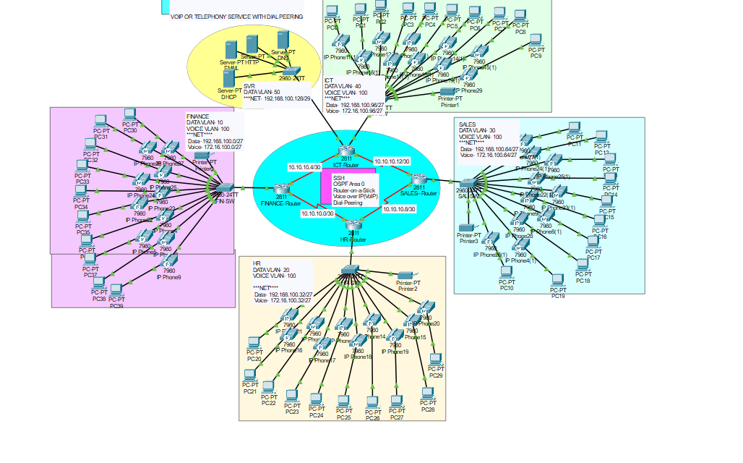

***Fig3.Implementation***

**Configuration Steps:**

1. Network Design and beautification.

2. Basic settings to all devices plus ssh on the routers.

3. VLANs assignment plus all access and trunk ports on the switches.

4. Subnetting and IP addressing

5. Static IP address to serverRoom devices.

6. DHCP server device configurations.

7. Configure DHCP for Voice.

8. Inter-VLAN routing on the Routers plus ip dhcp helper addresses

9. OSPF on the routers.

10. Configure VoIP configuration in all routers.

11. Dial peering configuration in all routers.

12. Verifying and testing configurations.

**Analytical questions:**

1. How does Quality of Service (QoS) impact VoIP performance, and what mechanisms can be implemented to ensure optimal voice quality?

QoS prioritizes VoIP traffic, minimizing latency and ensuring reliable transmission. Mechanisms include traffic prioritization, bandwidth management, and jitter buffering.

2. Explain the significance of SIP (Session Initiation Protocol) in VoIP communication, and how does it contribute to call establishment and termination?

SIP is a signaling protocol that initiates, modifies, and terminates multimedia sessions. It plays a crucial role in call setup, signaling, and facilitating communication between devices.

3.What security measures are essential for securing VoIP networks, and how can one protect against common VoIP security threats such as eavesdropping and unauthorized access?

Security measures include encryption, secure configurations, firewalls, and intrusion detection systems. Protecting against eavesdropping involves encrypting voice traffic, and access control mechanisms prevent unauthorized access.

4. In a distributed VoIP architecture, discuss the role of gateways and how they facilitate communication between different networks and protocols.

Gateways convert voice signals between different networks or protocols, enabling communication between VoIP and traditional telephony networks. They handle protocol conversion, media translation, and call routing.

5. How does jitter impact VoIP quality, and what strategies can be employed to mitigate its effects during voice transmission?

Jitter, variations in packet delay, can cause voice quality issues. Strategies include jitter buffers, traffic prioritization, and QoS implementations to manage and minimize jitter.

6.Explain the concept of Codecs in VoIP, and how does the choice of codec impact bandwidth utilization and voice quality?

Codecs compress and decompress voice signals. The choice of codec affects bandwidth consumption and voice quality. Higher compression may reduce bandwidth but can impact voice clarity.

7. In the context of VoIP network design, discuss the importance of redundancy and failover mechanisms to ensure continuous and reliable communication.

Redundancy involves backup systems to ensure continuous operation in case of failures. Failover mechanisms automatically switch to backup systems, minimizing downtime and ensuring uninterrupted communication.

8. How do Echo Cancellation and Echo Suppression technologies contribute to improving voice quality in VoIP calls, and what scenarios warrant their use?

Echo cancellation and suppression technologies identify and eliminate echo in voice communication, enhancing call quality. They are particularly useful in scenarios where network latency may introduce echo.

9. What role does DNS (Domain Name System) play in VoIP, and how can DNS-related issues impact the initiation and termination of VoIP calls?

DNS translates domain names to IP addresses. In VoIP, DNS is used for SIP server resolution. DNS issues can lead to call setup failures or misrouted calls.

10.Discuss the scalability challenges in large-scale VoIP deployments and the strategies to address these challenges for growing networks and user bases.

Scalability challenges in large VoIP deployments include increased traffic, signaling overhead, and resource requirements. Strategies involve load balancing, distributed architectures, and efficient resource management.

**Tabulation:**

**PCs + Printers**

**Base Network: 192.168.100.0**

|  |  |  |  |  |  |  |
| --- | --- | --- | --- | --- | --- | --- |
| Department | Network  Address | Devices  PCs + Printers | Number of Nodes | Subnet Mask | Host Address  Range | Broadcast  Address |
| Finance | 192.168.100.0 | 21 | 30 | 255.255.255.224/27 | 192.168.100.1  to  192.168.100.30 | 192.168.100.31 |
| HR | 192.168.100.32 | 21 | 30 | 255.255.255.224/27 | 192.168.100.33  to  192.168.100.62 | 192.168.100.63 |
| Sales | 192.168.100.64 | 21 | 30 | 255.255.255.224/27 | 192.168.100.65  to  192.168.100.94 | 192.168.100.95 |
| ICT | 192.168.100.96 | 21 | 30 | 255.255.255.224/27 | 192.168.100.97  to  192.168.100.126 | 192.168.100.127 |
| Serverside | 192.168.100.1284 | 4 | 6 | 255.255.255.248/29 | 192.168.100.129  to  192.168.100.134 | 192.168.100.135 |

**IP Phones**

**Base Network: 172.16.100.0**

|  |  |  |  |  |  |
| --- | --- | --- | --- | --- | --- |
| Department | Network  Address | Phones | Subnet Mask | Host Address  Range | Broadcast Address |
| Finance | 172.16.100.0 | 20 | 255.255.255.224/27 | 172.16.100.1 to  172.16.100.30 | 172.16.100.31 |
| HR | 172.16.100.32 | 20 | 255.255.255.224/27 | 172.16.100.33 to  172.16.100.62 | 172.16.100.63 |
| Sales | 172.16.100.64 | 20 | 255.255.255.224/27 | 172.16.100.65 to  172.16.100.94 | 172.16.100.95 |
| ICT | 172.16.100.96 | 20 | 255.255.255.224/27 | 172.16.100.97 to  172.16.100.126 | 172.16.100.127 |

**Between the Routers**

|  |  |
| --- | --- |
| No. | Network Address |
| Finance to HR | 10.10.10.0/30 |
| Finance to ICT | 10.10.10.4/30 |
| Sales to HR | 10.10.10.8/30 |
| Sales to ICT | 10.10.10.12/30 |

**Routing Algorithm:**

Open Shortest Path First (OSPF):

Algorithm Steps:

Initialization:

* Initialize the router with its own information (Router ID, IP address, etc.).
* Build a link-state database with information about neighboring routers and link costs.

Neighbor Discovery:

* Exchange Hello packets with neighboring routers to discover adjacent routers.
* Establish and maintain neighbor relationships.

Link-State Advertisement (LSA) Generation:

* Create Link-State Advertisements containing information about the router's links and associated costs.
* Include the router's own information in LSAs.

LSA Flooding:

* Flood LSAs throughout the network to ensure that all routers have a consistent view of the network's topology.
* Routers receive LSAs from neighbors and update their link-state databases.

Shortest Path Calculation:

* Use Dijkstra's algorithm to calculate the shortest path tree based on link costs in the link-state database.
* Determine the shortest path to every other router in the network.

Routing Table Calculation:

* Build the router's routing table using the calculated shortest path tree.
* Populate the routing table with next-hop information for each destination.

Periodic Update and Recalculation:

* Periodically update LSAs and flood the updated information to neighbors.
* Recalculate the shortest path tree and routing table in response to changes in the network.

Handling Changes:

* Detect changes in the network, such as link failures or additions.
* Trigger the recalculation of LSAs, shortest paths, and routing tables as needed.

Load Balancing (Optional):

* If desired, implement load balancing by distributing traffic across multiple paths.

Error Handling and Security Measures (Optional):

* Implement error handling mechanisms to address issues such as packet loss or network failures.
* Integrate security measures, like authentication, to ensure the integrity of routing information.

**CRC(Cyclic redundancy Check):**

Simulating a CRC (Cyclic Redundancy Check) for two voice calls with line numbers 102 and 304 involves creating a CRC for the data associated with each call. The CRC is typically generated based on the voice data to detect errors during transmission. Below is a simplified example:

Let's assume we have voice data for calls with line numbers 102 and 304:

Voice data for call with line number 102: 101010101

Voice data for call with line number 304: 110011001

CRC Calculation:

1.Choose a Generator Polynomial:

Let's use a simple 3-bit generator polynomial: 101.

2.Append Zeros (Equal to the Degree of the Generator Polynomial - 1):

Append two zeros to each set of voice data.

Voice data for call with line number 102: 10101010100

Voice data for call with line number 304: 11001100100

3.Perform CRC Division:

Perform a binary division of the extended voice data for each call by the generator polynomial.

Voice data for call with line number 102:

10101010100 (Voice Data + Zeros)

/ 101 (Generator Polynomial)

-----------------

101

-101

--------

100 (CRC)

Voice data for call with line number 304:

11001100100 (Voice Data + Zeros)

/ 101 (Generator Polynomial)

-----------------

101

-101

--------

010 (CRC)

4.Append CRC to the Original Data:

Append the calculated CRC to the original voice data for each call.

Voice data for call with line number 102: 10101010100 + 100 = 10101010100100

Voice data for call with line number 304: 11001100100 + 010 = 11001100100010

In this example, the CRC values 100 and 010 are calculated and appended to the original voice data for calls with line numbers 102 and 304, respectively. This process helps detect errors during transmission, ensuring the integrity of the voice data. In practice, more complex CRC polynomials and larger datasets would be used.

**Conclusion:**

In conclusion, this project delved into the intricate domain of Voice over IP (VoIP) and IP Telephony Networking, exploring fundamental concepts and technologies crucial for effective communication. The simulation of CRC (Cyclic Redundancy Check) for voice data in the context of VoIP added a layer of understanding regarding error detection mechanisms.

Key Findings:

VoIP Essentials:

The project highlighted the importance of Quality of Service (QoS), signaling protocols like SIP, security measures, and network design principles in ensuring a robust VoIP infrastructure.

CRC Simulation:

Through the CRC simulation, we demonstrated the practical application of error-checking mechanisms for voice data transmission. CRC plays a vital role in maintaining the integrity of voice communication by detecting and mitigating errors.

Scalability and Redundancy:

Discussions on scalability challenges and strategies, as well as the role of redundancy and failover mechanisms, emphasized the significance of planning for growth and ensuring uninterrupted communication.

Security Measures:

The project underscored the need for encryption, secure configurations, and firewalls to protect VoIP communications from security threats, including eavesdropping and unauthorized access.

Future Implications:

As VoIP continues to be a cornerstone of modern communication, the insights gained from this project pave the way for future advancements. The ever-evolving landscape of technology calls for ongoing exploration into emerging protocols, optimization strategies, and innovative solutions to enhance the efficiency and security of VoIP networks.

In conclusion, this project contributes to a deeper understanding of VoIP networking, providing a foundation for further research and development in this dynamic field.