Amrita Vishwa Vidyapeetham Amrita School of Computing, Coimbatore

Department of Computer Science and Engineering 19CSE446 – Internet of Things

Tutorial (Design Based)

Date:17-05-2024

Group No:18

|  |  |  |
| --- | --- | --- |
| SNo | Roll No | Name |
| 1 | CB.EN.U4CSE21232 | Kollepalli Rishith Pranav Kumar |
| 2 | CB.EN.U4CSE21237 | M Jaswanth Reddy |
| 3 | CB.EN.U4CSE21238 | Mathamgi Nair |

**Title**: Portable Weather Station

**Objective**:

The objective of a portable weather station is to provide real-time, accurate weather data for specific locations, enabling informed decision-making. It measures key parameters such as temperature, humidity, pressure, wind speed, and rainfall. This device enhances safety by alerting users to severe weather conditions, supports outdoor activities through reliable forecasts, and aids in research and education by collecting precise data. Its portability and ease of use make it a convenient tool for various users, from outdoor enthusiasts to professionals.

**Hardware Selection and Design:**

**Sensors Integration**

* **BMP280**: Connected via I2C to the ESP32.
* **DHT11**: Connected to a digital GPIO pin on the ESP32.
* **MQ-135**: Connected to an analog input pin on the ESP32.

**Controller Functionality**

* **ESP32**: Reads data from BMP280, DHT22, and MQ-135 sensors.
  + **Data Processing**: Filters and processes raw data.
  + **Local Storage**: Temporary storage of sensor data for edge processing.
  + **Decision Making**: Determines if an alert should be triggered.

**Communication Flow**

1. **End Devices**: Sensors collect data and send it to the ESP32.
2. **Edge Processing**: ESP32 processes data, stores it locally, and prepares it for cloud transmission.
3. **Cloud Communication**: ESP32 uses its Wi-Fi capability to send processed data to a cloud server using MQTT or HTTP/HTTPS protocols.

**Circuit Diagram:**

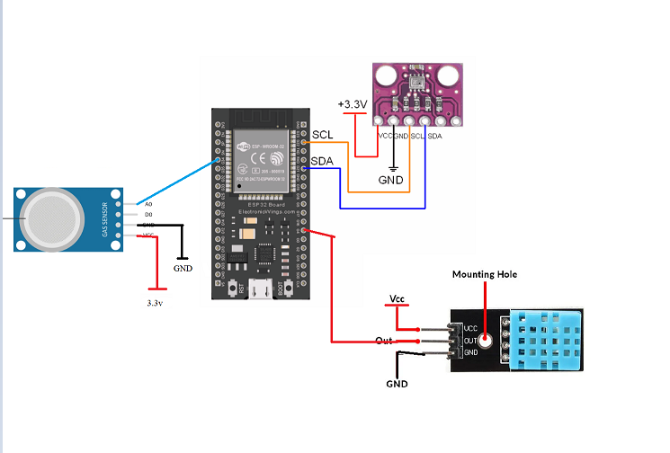

**Edge Analytics:**

The ESP32 can process sensor data (temperature, humidity, pressure, altitude) locally and display readings on the web application. This provides immediate insights into the surrounding environment without relying on external connections. By setting thresholds (e.g., high temperature, low pressure), the ESP32 can trigger alerts web application if environmental conditions exceed defined limits. This allows for quick decision-making based on real-time data. The ESP32 can perform basic data pre-processing and filtering to reduce the amount of data transmitted InfluxDB. This can be crucial for extending battery life, especially for portable applications.

**Cloud Analytics:**

Sensor data can direclty be stored on InfluxDB. This allows for historical analysis of weather patterns, trends, and long-term changes. InfluxDB can offer advanced data visualization tools and analytics capabilities. This can help users gain deeper insights into the collected data, such as identifying correlations between weather parameters. Users can remotely access and monitor the weather station data through a web application. This allows for checking weather conditions even when not physically present at the station location.

**Flowchart:**

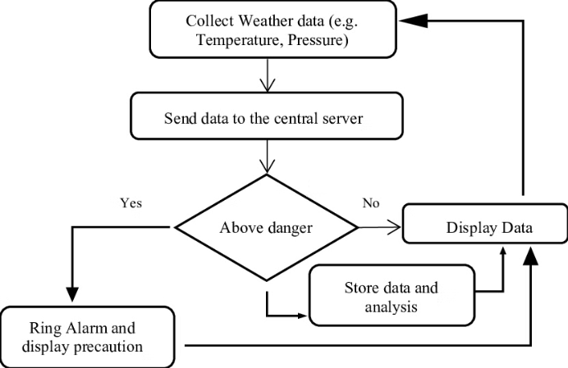

**Level 1 Data Flow Diagram:**

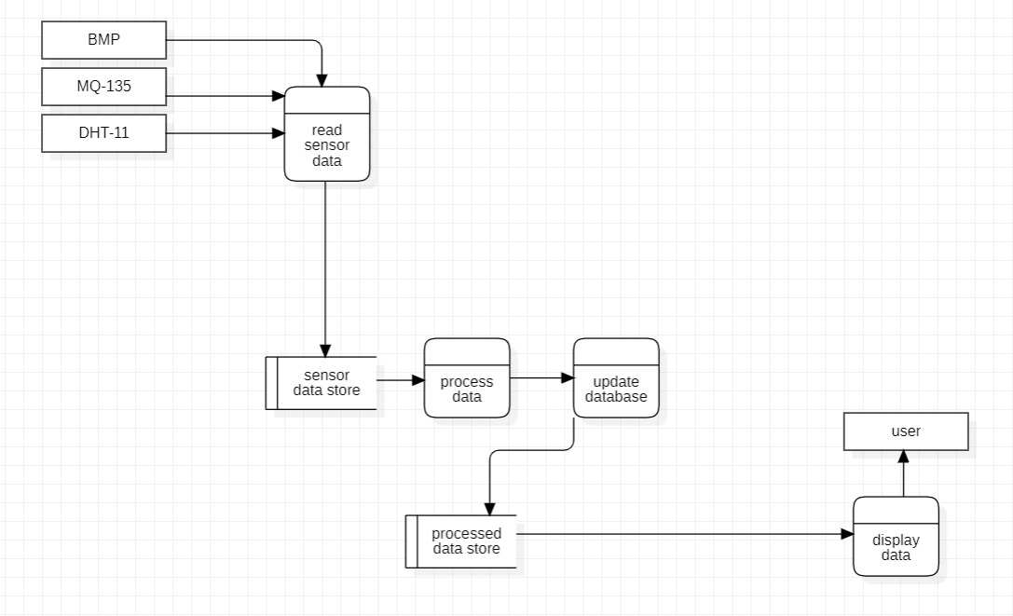

**Level 2 Data Flow Diagram:**

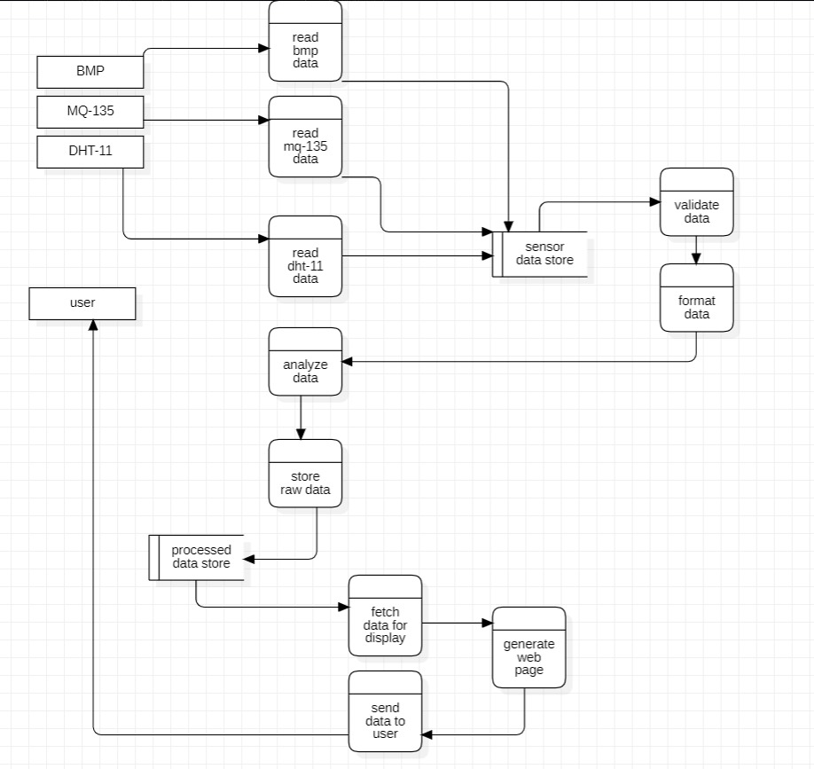

**IOT Level 5 Design:**

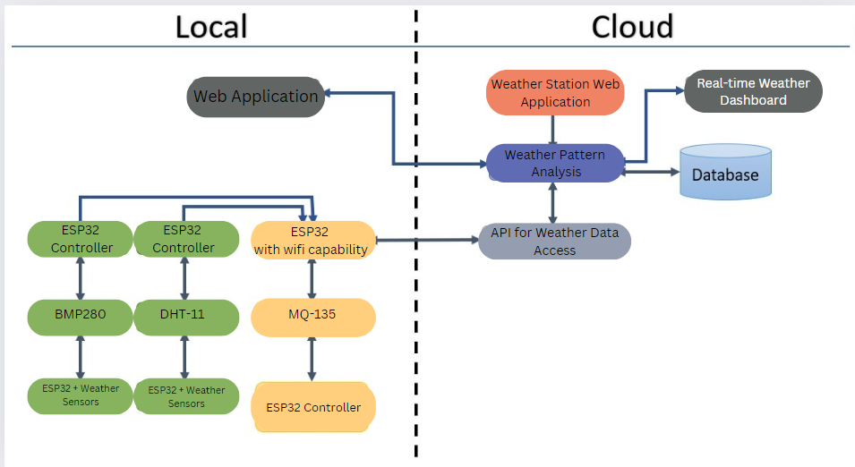

**Data Accumulation**:

* The ESP32 collects real-time data from the various sensors (BMP280, DHT22, and MQ-135) and temporarily stores it in its local storage for edge processing.
* After edge processing, the processed data is transmitted to a cloud server, likely using MQTT or HTTP/HTTPS protocols, leveraging the ESP32's Wi-Fi capability.
* The cloud server accumulates and stores the received data in a database system, such as InfluxDB, for long-term storage and historical analysis.
* InfluxDB, being a time-series database, is well-suited for storing and managing the continuous stream of sensor data collected over extended periods.

**Data Processing**:

* At the edge level, the ESP32 performs basic data processing tasks, such as filtering and preprocessing the raw sensor data.
* The edge processing helps reduce the amount of data transmitted to the cloud, which can be crucial for optimizing battery life and bandwidth usage in portable applications.
* The ESP32 can apply decision-making algorithms to the processed data, determining if any environmental conditions exceed defined thresholds and triggering alerts accordingly.
* In the cloud, InfluxDB offers advanced data processing and analytics capabilities, enabling users to perform historical analysis, identify patterns and trends, and gain deeper insights into the collected weather data.
* InfluxDB's data visualization tools and analytics features allow users to explore correlations between different weather parameters, conduct time-series analysis, and perform complex data processing tasks on the accumulated data.
* The processed and analyzed data can be presented through a web application, providing users with remote access and monitoring capabilities for the weather station data.

**Sample Test Cases And Reports :**

**Test case 1:Wifi connection and influxdb connection**

**Test case 2:Sensor readings**

**Test case 3 :InfluxDB writing**



**Test case 4 : Updating the UI**

**Outcomes:**

* **Portability and ease of setup:** Discuss how easy or difficult it is to transport and set up the weather station in different locations. Highlight any unique portability features it may have.
* **Accuracy of measurements:** Evaluate the accuracy and reliability of the weather data measurements taken by the portable station, such as temperature, humidity, wind speed, rainfall, etc. Compare it to stationary or professional-grade weather stations if possible.
* **Battery life and power options:** Describe the battery life or power sources required to operate the portable weather station for extended periods in the field. Note any solar or rechargeable battery options.
* **Connectivity and data transfer:** Explain how the weather data is transferred from the portable station, whether it's manual transfer, wireless connectivity to a computer/smartphone, or cloud uploading capabilities.
* **Durability and weather resistance:** Assess the ability of the portable weather station to withstand various outdoor conditions, such as rain, wind, extreme temperatures, etc. Mention any ruggedized or weatherproof features.
* **Additional sensors or capabilities:** Highlight any extra sensors or unique capabilities the portable weather station may have, such as UV index, soil moisture, or lightning detection.
* **User interface and data display:** Describe the user interface for setting up the station and viewing real-time or historical weather data, whether it's through a built-in display, computer software, or a mobile app.
* **Cost and value proposition:** Evaluate the overall cost of the portable weather station and whether it provides good value for its intended use, such as personal, educational, or professional applications.

**Conclusion**:

The IoT Portable Weather Station project successfully demonstrates the integration of various sensors and data processing techniques to provide accurate and real-time weather information. By utilizing the BMP, DHT, and MQ-135 sensors, the system effectively measures critical environmental parameters such as barometric pressure, temperature, humidity, and air quality. These measurements are processed, stored, and made accessible through a web-based interface, ensuring that users can easily access and utilize the data anytime and anywhere

**Future Scope:**

The IoT Portable Weather Station project has demonstrated its effectiveness in providing real-time and accurate weather data. However, to further enhance its capabilities and broaden its applications, several areas can be explored for future development and improvement. By focusing on these future scopes, the project can unlock greater potential and become an even more valuable tool for various users

**Advanced Sensor Integration**:

* **Additional Sensors**: Incorporate more advanced sensors to measure other environmental parameters such as UV index, soil moisture, solar radiation, and particulate matter (PM2.5 and PM10).

**User Interface and Experience:**

* **Mobile Application**: Develop a mobile app to provide users with easy access to weather data and alerts on their smartphones.
* **Customization**: Allow users to customize the data display and set personalized alerts for specific weather conditions.

**Energy Efficiency and Sustainability:**

* **Solar Power**: Incorporate solar panels to power the weather station, making it more sustainable and suitable for remote locations.
* **Low-Power Design**: Optimize the hardware and software to minimize power consumption, extending battery life and operational time.

**Data Security and Privacy**:

* **Encryption**: Implement robust encryption methods to secure data transmission and storage.
* **Access Control**: Develop access control mechanisms to ensure that only authorized users can access and modify the data.