**1. Connect to the Store Sales Data and do the following**: - −

1. Remove all the blank rows. –
2. Update the column header if they are not updated –
3. Create a text table and show the sales in terms of o Customers o Product Category o Regions

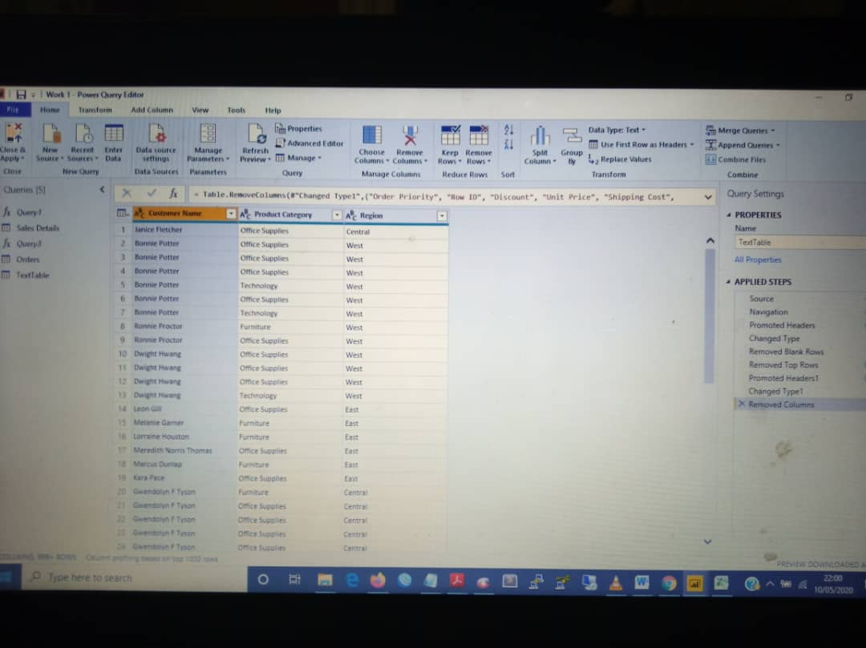

**2. Create a line and Clustered Column Chart showing the Sales and Discount as per the State or Province –**

**(a)Format the bars and line with different colors –**

**(b)Which state has the highest sales in terms Technology?**

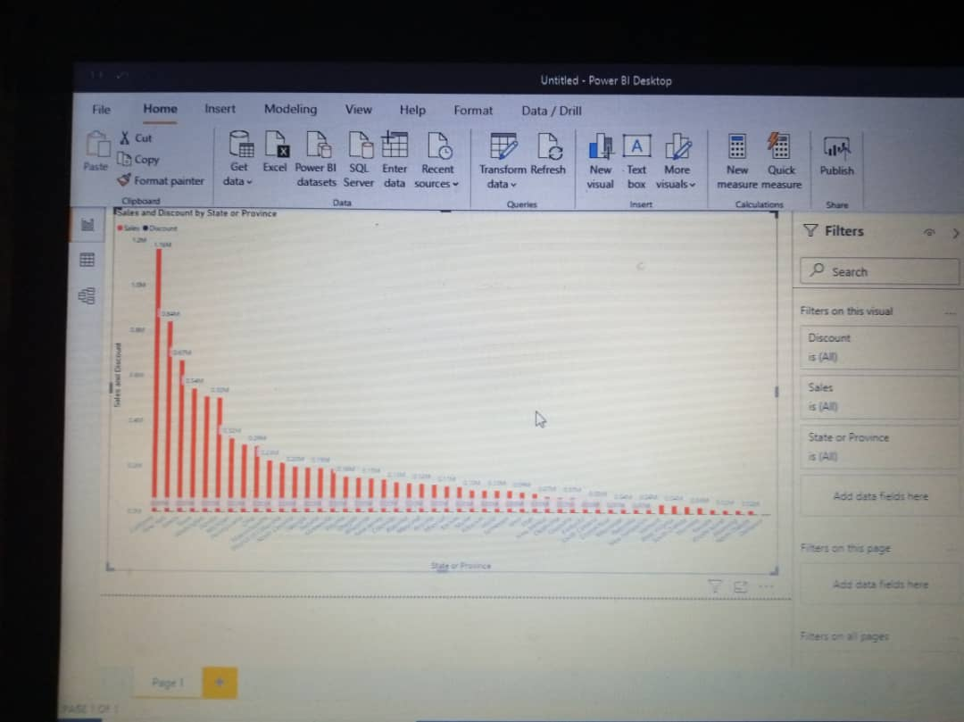

**(b) New York has the highest sales in technology**

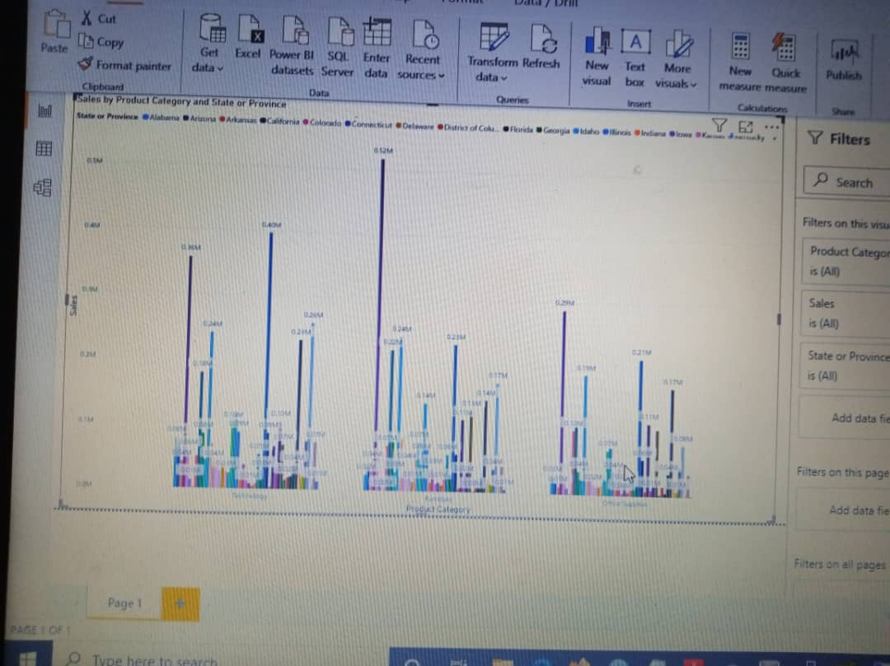

**3. Create a Donut Chart showing sales in terms of Product category**

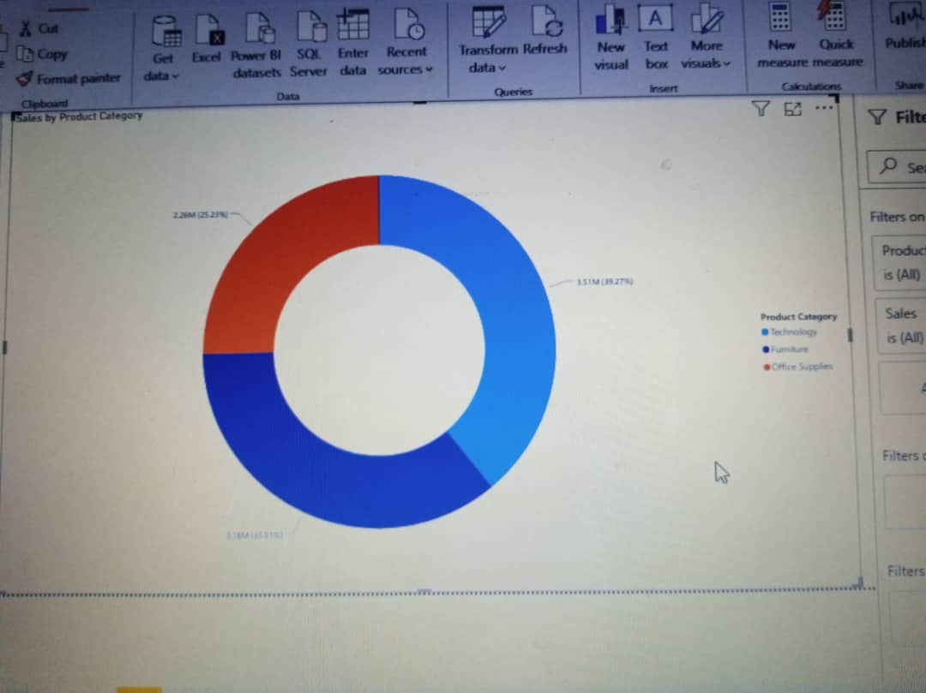

**4**. Create a Slicer and show the regions in dropdown. See how all the visuals mentioned above behaving when a particular region is selected