**1**

**Install Power BI Desktop and share the final screenshot of the report view page**

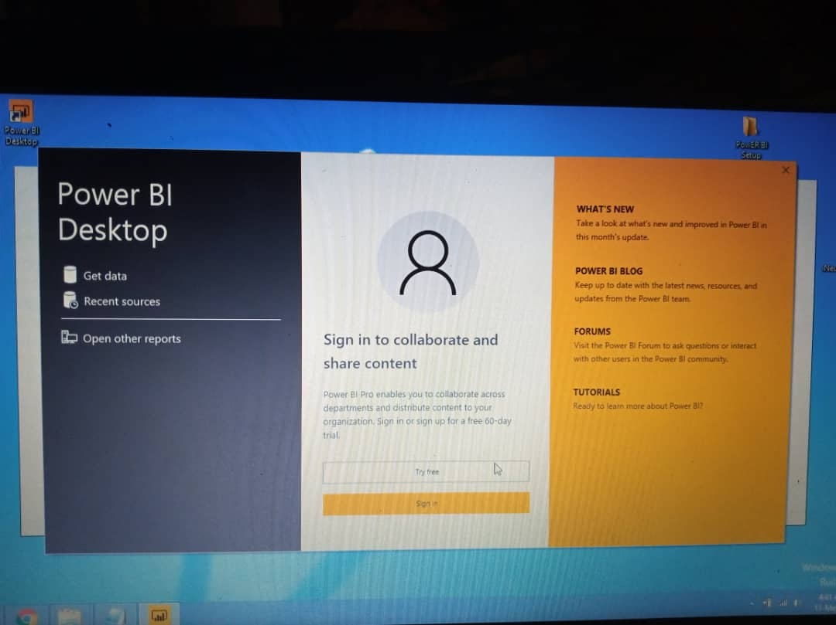

**(2)**

**(A) Report View:**

Is where you use queries you create to build compelling visualizations, arranged as you want them to appear, and with multiple pages, that you can share with others.

Power BI Desktop includes a Report view, where you can create any number of report pages with visualizations. Report view in Power BI Desktop provides a similar design experience to the report's editing view in the Power BI service. You can move visualizations around, copy and paste, merge, and so on.

When you first load data in Power BI Desktop, you'll see the Report view with a blank canvas. A report will have at least one blank page to start. Pages appear in the navigator pane just to the left of the canvas. You can add all sorts of visualizations to a page. You can add new pages to your report. Just click New Page on the ribbon

**(B) Data View**

Is where you see the data in your report in data model format, where you can add measures, create new columns, and manage relationships. Data view helps you inspect, explore, and understand data in your Power BI Desktop model. It's different from how you view tables, columns, and data in Power Query Editor. With Data view, you're looking at your data after it has been loaded into the model.

The Data view icon is not visible if all data sources are based on Direct Query.

When you're modeling your data, sometimes you want to see what's actually in a table or column without creating a visual on the report canvas. You might want to see right down to the row level. This ability is especially useful when you're creating measures and calculated columns, or you need to identify a data type or data category.

You have Data view icon, Data Grid, Modeling ribbon, formular bar, search, field list and filtering in data view.

**(C) Model view:**

Is where you get a graphical representation of the relationships that have been established in your data model, and manage or modify them as needed.

Model view shows all of the tables, columns, and relationships in your model. This view can be especially helpful when your model has complex relationships between many tables.

Select the Model icon near the side of the window to see a view of the existing model. Hover your cursor over a relationship line to show the columns that are used.

**(D) Power Query Editor:**

The Power Query Editor in Power BI is used to transform or edit data files before they are actually loaded into the Power BI. Power Query Editor appears once a data connection is established.

The ribbon in Power Query Editor consists of four tabs: Home, Transform, Add Column, and View.

The Query Editor plays the role of an intermediate data container where you can modify data by selecting rows and columns, splitting rows and columns, pivoting and unpivoting columns,

**(E) Advance Editor:**

The Advanced Editor lets you see the code that Power Query Editor is creating with each step. It also lets you create your own shaping code. To launch the advanced editor, select View from the ribbon, then select Advanced Editor. A window appears, showing the existing query code.

**(3)**

**(A) What is Power BI Desktop?**

Power BI Desktop is free application you install on your local computer that lets you connect to, transform, and visualize your data. With Power BI Desktop, you can connect to multiple different sources of data, and combine them (often called modelling) into a data model. This data model lets you build visuals, and collections of visuals you can share as reports, with other people inside your organization. Most users who work on business intelligence projects use Power BI Desktop to create reports, and then use the Power BI service to share their reports with others.

**(B) What is Power BI Pro?**

Power BI Pro is an individual user license that lets users read and interacts with reports and dashboards that others have published to the Power BI service. Users with this license type can share content and collaborate with other Power BI Pro users. Only Power BI Pro users can publish or share content with other users or consume content that's created by others, unless a Power BI Premium capacity hosts that content.it is a user-based licensing.

Power BI Pro currently retails price at $9.99 monthly price per user.

**(C ) What is Power BI PREMIUM?**

Power BI Premium is an immensely powerful Business Intelligence ecosystem that enables users to quickly connect to, analyze, and visualize a wide range of data. This enables your business to publish reports broadly across an enterprise without having to worry about if individual recipients are licensed Power BI users. Power BI Premium uses capacity-based licensing. With Power BI Premium, you pay for a dedicated power bi premium capacity for the month

Power Bi Premium is $4,995 Monthly price per dedicated cloud compute and storage resource with annual subscription.