Efficient Level-Wise Semantic Clustering for Scalable k-Anonymization Using Optimized Data Structures

4.Proposed Approach:

4.1 Problem Complexity and Motivation
Forming optimal k-anonymous clusters over quasi-identifiers is a well-known NP-hard problem, especially for datasets containing both categorical and numerical attributes. Existing anonymization techniques typically rely on aggressive strategies such as full Lowest Common Ancestor (LCA) generalization or top-down partitioning. Although these methods satisfy privacy requirements, they often incur substantial information loss, leading to poor data utility.
Most clustering-based anonymization approaches emphasize numerical distance metrics and handle categorical attributes either independently or through coarse-grained generalization. As a result, the semantic structure inherent in categorical domains is largely ignored, even when Domain Generalization Hierarchies (DGHs) are available. Moreover, attempts to incorporate semantic clustering in existing methods suffer from poor scalability and high computational overhead, making them impractical for large datasets.
The key limitation in current literature is the absence of a data-structure–driven semantic clustering framework that jointly addresses semantic preservation and scalability. Existing approaches neither exploit optimized algorithmic design nor leverage efficient data structures—such as HashMaps, PriorityQueues, two-pointer techniques, and bounded recursion—to enable scalable clustering over combinations of categorical attributes.

4.2 Overview of the Proposed Approach
To overcome the limitations of existing methods, we propose a level-wise semantic clustering framework for k-anonymization that is explicitly designed using optimized data structures and algorithmic techniques. The framework performs clustering based on combinations of categorical attributes, enabling semantically coherent groups, while numerical attributes are optimized within each categorical cluster rather than driving the clustering process.
The proposed framework integrates the following components:
- HashMaps to efficiently group tuples by categorical attribute combinations,
- PriorityQueues (min-heaps) to organize numerical attributes within each semantic group,
- Two-pointer techniques to separate finalized clusters from unprocessed tuples in-place, and
- Recursion to support controlled, level-wise generalization over Domain Generalization Hierarchies (DGHs).
By combining these structures, the framework achieves a time complexity of O(n log n) per anonymization process. Since the depth of level-wise generalization is bounded by the maximum height of the DGHs—which is independent of dataset size—the overall complexity remains O(n log n). This design enables the proposed approach to scale effectively to large datasets containing up to 10⁶ records, as confirmed by the complexity analysis and experimental evaluation.

4.3 Design Principles of the Proposed Approach

4.3.1 Semantic Clustering Based on Categorical Attribute Combinations
The proposed framework adopts a level-wise generalization strategy over categorical Domain Generalization Hierarchies (DGHs). In the initial iteration, clusters are formed using original (level-0) categorical values. In subsequent iterations, clustering is performed over progressively generalized categorical values (level-1, level-2, and higher), guided by the updated boundary pointer from the previous iteration.
At each level, the algorithm prioritizes sibling-based grouping, where categorical values sharing a common immediate parent in the DGH are clustered first. This strategy ensures (i) minimal categorical information loss, (ii) high semantic interpretability, and (iii) efficient cluster formation at the current generalization level.
The framework supports early termination when sufficient sibling frequencies are available at lower levels, avoiding unnecessary generalization to higher DGH levels. Early termination preserves data utility while still satisfying k-anonymity constraints.
The key novelty of the proposed approach lies not merely in semantic clustering, but in demonstrating that semantic clustering over categorical combinations can be made scalable and practical through a greedy, data-structure–optimized design. By combining DGH-based semantic reasoning with efficient algorithmic mechanisms, the framework achieves both semantic precision and computational efficiency—an integration not addressed by existing anonymization methods.
Unlike distance-driven approaches, clustering is performed first on combinations of categorical attributes, and numerical attributes are subsequently optimized within each semantic group. For example:
doctor + 243** + UG → { {age=24, salary=75k}, {age=34, salary=65k} }*
Here, designation, pincode, and education form the categorical combination, while age and salary are numerical attributes. Such clusters are semantically interpretable (e.g., “graduates working as doctors in a specific region”), enabling privacy preservation with minimal categorical generalization and controlled numerical anonymization.

4.3.2 Sibling-First Generalization Strategy
All categorical attributes are associated with predefined Domain Generalization Hierarchies (DGHs). The proposed framework follows a sibling-first generalization policy, where categorical values sharing the same immediate parent in the DGH are generalized before considering higher-level ancestors.
This strategy preserves semantic coherence, minimizes categorical information loss, and avoids premature generalization to coarse levels such as LCAs or root nodes. As a result, each iteration yields the most precise clusters possible at that generalization level.

4.3.3 Level-Wise Generalization over DGHs
The clustering process proceeds iteratively across DGH levels:
- Level 0: Original categorical values
- Level 1: Immediate parent values
- Level 2: Higher-level ancestors
- …
- Level maxlevel: Maximum DGH depth
At each level, the algorithm attempts to form k-anonymous clusters. The process does not enforce execution up to maxlevel; instead, it terminates as soon as sufficient k-sized clusters are formed. This adaptive progression reduces unnecessary generalization and directly contributes to improved data utility.

4.3.4 Detailed Working of the Proposed Approach
This section describes the execution flow of the proposed semantic-first k-anonymization framework, highlighting how categorical and numerical attributes are processed in a coordinated yet decoupled manner to achieve scalable anonymization with low information loss.

Step 1: Preprocessing and Numerical Distance Augmentation
After loading the dataset and constructing the quasi-identifier (QI) table, a one-time numerical preprocessing step is performed. For each numerical quasi-identifier, the global minimum of its domain is computed. For every tuple, an auxiliary distance value is calculated as the sum of deviations of its numerical attributes from their corresponding global minimum values.
Formally, for a tuple with numerical attributes
N={n1​,n2​,…,nm​}
and global minima
min(N)={min1​,min2​,…,minm​},
the distance is defined as:
Distance=i=1∑m​(ni​−imin​)
This distance value is appended as an auxiliary column to the QI table and serves only as an internal ordering signal during clustering. It does not participate in categorical generalization or privacy enforcement and remains unchanged throughout the execution of the algorithm.

Step 2: Recursive Cluster Generation
Algorithm 1 (generateClusters) is invoked on the augmented QI table. A pointer i=0i = 0i=0 marks the beginning of unprocessed tuples. The algorithm proceeds recursively, attempting to form k-anonymous clusters from index iii onward at the current categorical generalization level.

Step 3: Level-Wise Categorical Generalization
At each recursive iteration, categorical attributes of tuples in the range [i,n−1] are generalized to their immediate parent values using precomputed Domain Generalization Hierarchy (DGH) parent mappings (Algorithm 2). Tuples with indices less than iii, corresponding to finalized clusters, remain unchanged.
This index-based generalization minimizes unnecessary categorical distortion while enabling level-wise semantic clustering.

Step 4: Construction of Categorical Combination HashMap
Following categorical generalization, a HashMap is constructed over the range [i,n−1] (Algorithm 3). Each key represents a unique combination of categorical attribute values, while the associated value is a PriorityQueue storing numerical attribute lists belonging to that combination.
Each numerical list includes the precomputed distance value appended during preprocessing.

Step 5: Numerical Ordering within Semantic Groups
Within each categorical combination, numerical tuples are ordered using a PriorityQueue (min-heap) based on their precomputed distance values. Tuples with smaller numerical deviation are prioritized during cluster formation.
Importantly, numerical distances are not recomputed at this stage. The PriorityQueue operates directly on the auxiliary distance column generated in Step 1, preserving the semantic-first design and improving computational efficiency.

Step 6: Computation of Boundary Index
Algorithm 4 computes a boundary index jjj by analyzing the sizes of categorical groups relative to the k-anonymity requirement. Tuples that can form complete k-sized clusters are assigned to the range [i,j−1], while remaining tuples are deferred for further generalization.

Step 7: In-Place Dataset Rearrangement
Using a two-pointer strategy, Algorithm 5 rearranges the dataset in-place. Finalized k-anonymous clusters are written sequentially starting from index iii, while unresolved tuples are placed starting from index j. This guarantees that finalized clusters are never revisited in subsequent iterations.

Step 8: Recursive Progression
The algorithm proceeds recursively with updated parameters i=j and level=level+1. Each recursion operates on a strictly smaller suffix of the dataset, and the recursion depth is bounded by the maximum DGH height, ensuring scalability.

Step 9: Base Case Handling Using LCA
When either (n−i)<k or the maximum generalization level is reached, the algorithm enters its base case. Remaining categorical attributes are generalized using their Lowest Common Ancestors (LCAs) in the respective DGHs (Algorithms 6–8), ensuring k-anonymity under all termination conditions.

Step 10: Numerical Attribute Generalization
After categorical clustering is finalized, numerical attributes within each k-anonymous cluster are generalized using min–max interval ranges (Algorithm 9). This step is intentionally decoupled from clustering to preserve semantic coherence while ensuring numerical privacy.

4.4 Information Loss Measurement(Algorithms 11–14)
To quantitatively evaluate data utility after anonymization, the proposed framework incorporates a structured information loss measurement scheme. The evaluation consists of three complementary components:
- Numerical information loss, computed based on the relative width of generalized numerical intervals within each k-anonymous cluster
Let a finalized k-anonymous cluster c contain generalized numerical attributes represented as intervals.
For a numerical attribute a, generalized to interval [min_c^a, max_c^a], and global domain [min_g^a, max_g^a] , the normalized loss is defined as:
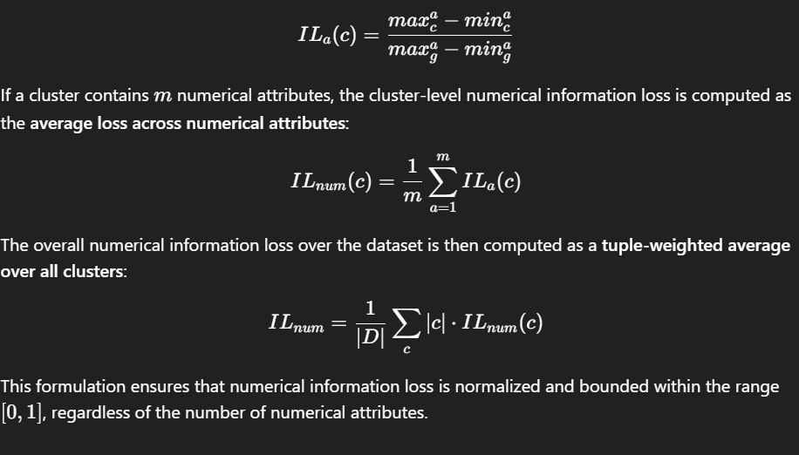
IL_a(c) = \frac{max_c^a - min_c^a}{max_g^a - min_g^a}
If a cluster contains mmm numerical attributes, the cluster-level numerical information loss is computed as the average loss across numerical attributes:
ILnum(c)=1m∑a=1mILa(c)
The overall numerical information loss over the dataset is then computed as a tuple-weighted average over all clusters:
ILnum=1∣D∣∑c∣c∣⋅ILnum(c)
This formulation ensures that numerical information loss is normalized and bounded within the range [0,1] , regardless of the number of numerical attributes.

- Categorical information loss, quantified using Domain Generalization Hierarchies (DGHs) by measuring the proportion of leaf nodes subsumed by the generalized categorical values, and 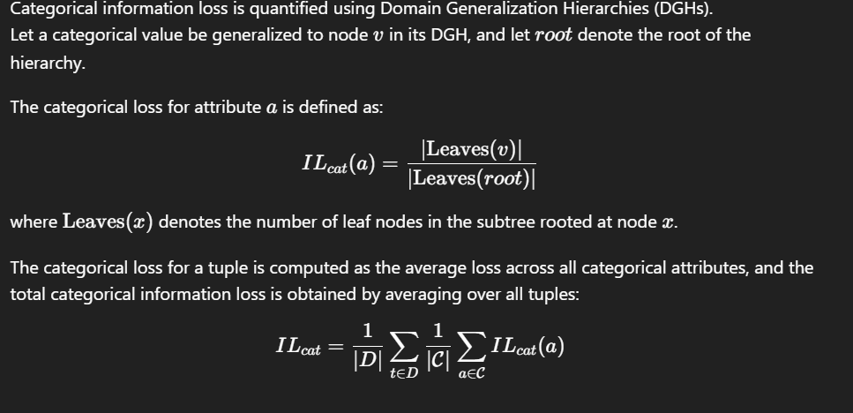
- Total information loss, obtained by combining numerical and categorical losses into a unified metric.
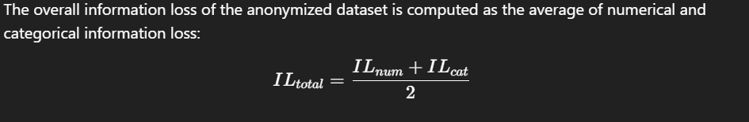
This formulation provides a rigorous and semantically interpretable assessment of data degradation, enabling fair comparison with existing anonymization approaches while accurately reflecting both numerical precision loss and categorical semantic distortion.

4.5 Algorithms Used in the Proposed Approach
The proposed framework is realized through a tightly coupled set of algorithms that collectively perform semantic-first clustering, controlled generalization, and utility-aware post-processing. Rather than relying on independent anonymization phases, the algorithms are designed to operate as a single recursive pipeline, where clustering decisions, generalization depth, and boundary detection are jointly optimized.
For clarity, the algorithmic roles are grouped according to their function within the framework.

4.5.1 Core Recursive Clustering Algorithm

Algorithm 1: Level-wise Semantic Cluster Generation
Input:
Dataset D, anonymity parameter k, DGH parent mappings, DGH roots, maximum generalization level maxLevel
Output:
k-anonymized dataset

Algorithm GenerateClusters(i, D, level)

1: if ( |D| − i ≤ k ) OR ( level = maxLevel ) then
2: U ← Algorithm 6: Extract unique categorical values from tuples [i … |D|−1]
3: L ← Algorithm 7: Compute LCA for each categorical attribute using U
4: Algorithm 8: Replace categorical values of tuples [i … |D|−1] with L
5: return
6: end if
7: Algorithm 2: Generalize categorical attributes of tuples [i … |D|−1] by one DGH level
8: H ← Algorithm 3: Construct semantic groups using categorical combinations
9: r ← Algorithm 4: Compute number of tuples that cannot form k-sized clusters
10: j ← |D| − r
11: Algorithm 5: Rearrange dataset to finalize clusters in range [i … j−1]
12: GenerateClusters(j, D, level + 1)

Algorithm 1 (GenerateClusters) is the central driver of the proposed approach. It implements a level-wise, semantic-first clustering strategy using a two-pointer mechanism and recursive control flow.
Starting from pointer i, the algorithm processes only the unfinalized portion of the dataset while preserving already formed clusters. At each iteration, categorical attributes are generalized by exactly one level using Domain Generalization Hierarchies (DGHs). The algorithm then attempts to form semantic clusters at the current generalization depth before proceeding to higher levels.
The recursion terminates under one of the following conditions:
- The number of remaining tuples becomes smaller than the anonymity parameter k, or
- The maximum DGH height is reached.
In both cases, a controlled fallback mechanism based on Lowest Common Ancestors (LCAs) is applied to ensure correctness. This design ensures that aggressive generalization is deferred until strictly necessary, which is a key distinction from conventional top-down anonymization methods.

4.5.2 Level-wise Categorical Generalization

Algorithm 2: Level-wise Categorical Generalization
Input:
Starting index i, dataset D, parent mappings from DGHs
Output:
Dataset generalized by one level
Algorithm GeneralizeCategorical(i, D)
1: for each tuple t in D from index i to |D|−1 do
2: for each categorical attribute c do
3: Replace value of c in t with its immediate DGH parent
4: end for
5: end for
Only unprocessed tuples are generalized, preserving finalized clusters.
Algorithm 2 (Generalise) performs incremental categorical generalization using immediate-parent mappings derived from DGHs. Unlike global generalization approaches, this algorithm applies generalization only to tuples beyond the current pointer i, ensuring that finalized clusters remain untouched.
Each iteration replaces categorical values with their immediate parents, enabling:
- Fine-grained control over semantic distortion
- Progressive relaxation of clustering constraints
- Minimal information loss in early iterations
This index-aware generalization mechanism is fundamental to the semantic-first design of the framework.

4.5.3 Semantic Group Construction with Numerical Ordering

Algorithm 3: Semantic Group Construction
Input:
Starting index i, dataset D
Output:
HashMap of semantic groups
Algorithm ConstructSemanticGroups(i, D)
1: Initialize empty HashMap H
2: for each tuple t in D from index i to |D|−1 do
3: key ← concatenation of categorical attribute values of t
4: value ← numerical attributes of t with precomputed distance
5: Insert value into H[key] using a min-heap (PriorityQueue)
6: end for
7: return H
Semantic groups are formed using categorical combinations, while numerical tuples are ordered by minimum deviation.
Algorithm 3 (ConstructHashMap) forms semantic groups using a HashMap keyed by ordered categorical attribute combinations. Each key uniquely represents a semantic category at the current generalization level.
For each semantic group, associated numerical attributes are stored in a PriorityQueue (min-heap) ordered by a precomputed distance metric. This distance represents the aggregated deviation of numerical attributes from their respective domain minima.
This dual structure achieves two goals simultaneously:
- Semantic purity through categorical grouping
- Numerical utility preservation by prioritizing tuples with minimal numerical deviation during cluster formation
This integration of semantic hashing with numerical ordering is a distinguishing feature of the proposed approach.

4.5.4 Cluster Boundary Detection

Algorithm 4: Boundary Index Determination
Input:
Semantic group map H, anonymity parameter k
Output:
Boundary index j
Algorithm GetBoundaryIndex(H, k)
1: remainder ← 0
2: for each semantic group g in H do
3: remainder ← remainder + ( size(g) mod k )
4: end for
5: return remainder
This determines how many tuples cannot yet form valid k-sized clusters.
Algorithm 4 (GetJIndex) determines the cluster boundary index j, which separates finalized clusters from unresolved tuples.
Rather than scanning the dataset sequentially, the algorithm analyzes the frequency of semantic groups by computing how many tuples in each group cannot form complete k-sized clusters. The aggregated remainder directly determines the number of tuples that must be deferred to subsequent iterations.
This frequency-aware boundary detection avoids unnecessary reprocessing and enables efficient in-place cluster finalization.
Let r denote the value returned by Algorithm 4, representing the number of tuples that cannot form complete k-sized clusters at the current generalization level. The boundary index is then computed as j=∣D∣−r. Tuples in the range [i,j−1]can be finalized into valid equivalence classes, while tuples in [j,∣D∣−1] are deferred for further generalization.

4.5.5 In-place Semantic Cluster Formation

Algorithm 5: Dataset Rearrangement for Cluster Finalization
Input:
Starting index i, boundary index j, semantic group map H, dataset D, parameter k
Output:
Reordered dataset with finalized clusters

Algorithm RearrangeDataset(i, j, H, D, k)
1: Sort semantic groups in H by descending frequency
2: writeNormal ← i
3: writeOverflow ← j

4: for each semantic group g in sorted H do
5: normalCount ← size(g) − ( size(g) mod k )
6: while normalCount > 0 do
7: Extract tuple with minimum distance from g
8: Place tuple at D[writeNormal]
9: writeNormal ← writeNormal + 1
10: normalCount ← normalCount − 1
11: end while

12: while g is not empty do
13: Extract remaining tuple from g
14: Place tuple at D[writeOverflow]
15: writeOverflow ← writeOverflow + 1
16: end while
17: end for
Valid k-anonymous clusters are finalized first; unresolved tuples are deferred.

Algorithm 5 (ArrangeOriginalList) rearranges the dataset in-place based on semantic group frequencies. Semantic groups are processed in descending order of size to maximize early cluster formation.
For each group:
- Tuples forming complete k-blocks are written contiguously starting from pointer i
- Residual tuples are placed beyond pointer j
This ensures that:
- Indices [i,j−1] contain finalized semantic clusters
- Indices [j,n−1] contain unresolved tuples for further processing
The use of dual write pointers enables efficient clustering without auxiliary data copies, contributing to the scalability of the framework.

4.5.6 Fallback Generalization Using Lowest Common Ancestors
For brevity, the pseudocode of Algorithms 6–14, which handle fallback generalization, numerical post-processing, and information loss computation, is provided in the Appendix, while their functional roles are explained here for completeness.
Algorithms 6–8 are invoked only when sibling-based semantic clustering becomes infeasible.
First, all remaining unique categorical values are collected independently for each domain. Next, the Lowest Common Ancestor (LCA) of these values is computed within the corresponding DGH. Finally, all remaining tuples are generalized to these LCA values.
This fallback mechanism guarantees k-anonymity under all termination conditions while ensuring that:
- LCA-based generalization is applied only once
- Semantic degradation is minimized and localized

4.5.7 Numerical Attribute Generalization and Cleanup
After categorical clustering is complete, Algorithm 9 performs numerical generalization within each finalized equivalence class. Numerical attributes are replaced with interval representations [min,max], preserving range information while preventing record linkage.
Algorithm 10 removes auxiliary computational attributes (e.g., distance columns) used during clustering, ensuring that the released dataset contains only original quasi-identifiers.

4.5.8 Information Loss Evaluation
Algorithms 11–14 collectively compute information loss:
- Numerical loss is quantified as the normalized width of generalized intervals relative to global attribute ranges.
- Categorical loss is computed using DGH leaf coverage, capturing semantic degradation rather than numeric distance.
- Total information loss is defined as the average of numerical and categorical losses.
This unified formulation provides an interpretable and balanced measure of anonymization utility.

4.6 Summary and Key Contributions
The algorithms presented in this section collectively form a semantic-first, level-wise k-anonymization framework that emphasizes categorical meaning, numerical utility, and scalability. The proposed pipeline is characterized by HashMap-based semantic clustering, PriorityQueue-driven numerical optimization, deferred LCA-based generalization, in-place cluster formation using a two-pointer strategy, and DGH-aware information loss measurement. Unlike conventional anonymization methods that rely on rigid partitioning or aggressive top-down generalization, the proposed design prioritizes semantic consistency and controlled generalization, making it well suited for large-scale datasets with mixed attribute types.
The key contributions of this work are summarized as follows:
- Semantic-first clustering: This work introduces the first k-anonymization framework that clusters tuples based on combinations of categorical attribute values rather than numerical distance alone.
- Sibling-first, level-wise generalization: Categorical attributes are generalized incrementally using sibling relationships within DGHs, substantially reducing categorical information loss.
- Early termination for utility preservation: Generalization halts as soon as valid semantic clusters are formed, preventing unnecessary escalation to higher DGH levels.
- Joint categorical–numerical optimization: Semantic clustering over categorical attributes is integrated with numerical proximity optimization within clusters using PriorityQueues.
- Scalability and efficiency: The framework scales to datasets with up to 10^6 records and achieves an overall time complexity of O(nlogn) through the use of bounded recursion, HashMaps, PriorityQueues, and a two-pointer strategy.
4.7 Time Complexity Analysis

This section analyzes the computational complexity of the proposed level-wise semantic clustering framework. Let n denote the total number of tuples in the dataset, k the anonymity parameter, and maxlevel the maximum height among all categorical Domain Generalization Hierarchies (DGHs).
- Recursion Depth Analysis
Algorithm 1 (generateClusters) is a recursive procedure that performs level-wise generalization of categorical attributes. The recursion depth is bounded by maxlevel, which represents the maximum generalization depth of the categorical DGHs. Since DGH heights are fixed and independent of the dataset size, maxlevel is treated as a constant.
Therefore, the recursive procedure executes at most maxlevel iterations, and the overall time complexity is determined by the cost of a single iteration multiplied by a constant factor.
- Per-Iteration Complexity Analysis
Within each iteration of Algorithm 1, the following algorithms are executed:

1)Algorithm 2: Immediate Parent Generalization
Algorithm 2 generalizes categorical attributes of tuples from index i to n − 1 by replacing each categorical value with its immediate parent using precomputed parent maps.
- Each tuple is processed once.
- Parent lookup for each categorical attribute is an O(1) operation.
Time Complexity:
O(n−i) ⊆ O(n)

2)Algorithm 3: HashMap Construction
Algorithm 3 traverses tuples from index i to n − 1 and constructs a HashMap where:
- Each tuple contributes to exactly one key-value pair.
- Key construction and insertion are constant-time operations.
- Each tuple is inserted once into a PriorityQueue.
Time Complexity:
O(n−I ) ⊆ O(n)

3)Algorithm 4: Boundary Index Computation
Algorithm 4 iterates over the HashMap entries to compute the boundary index j based on cluster size constraints.
- The number of HashMap entries is bounded by (n − i).
- Each entry is processed once.
Time Complexity:
O(n−i) ⊆ O(n)

4)Algorithm 5: Arrangement of Tuples
Algorithm 5 performs two main operations:
- Sorting HashMap entries based on frequency (PriorityQueue size), and
- Arranging tuples by polling from PriorityQueues.
Sorting the HashMap entries requires:
O(m log m),where m ≤ (n−i)
Polling and inserting tuples into the original list incurs a logarithmic cost per operation due to the PriorityQueue.
Overall Time Complexity:
O((n − i) log(n - i) ) ⊆ O(n logn)

Total Cost per Iteration
Combining the costs of Algorithms 2 through 5:
O(n) + O(n) + O(n) + O(nlogn) = O(nlogn)
Since the dominant term is O(nlogn), the cost of one iteration of Algorithm 1 is: O(nlogn)

Overall Time Complexity
As established earlier, Algorithm 1 executes for at most maxlevel iterations, where maxlevel is constant. Therefore, the total time complexity of the proposed framework is:
O(maxlevel × nlogn) = O(nlogn)

Base Case Handling Complexity
When the base condition (n−i) ≤ k or level = maxlevel is reached, Algorithms 6–8 are executed. These algorithms perform:
- Extraction of unique categorical values,
- Lowest Common Ancestor (LCA) computation, and
- Value replacement.
Each of these operations processes the remaining tuples linearly.
Time Complexity:
O(n−i) ⊆ O(n)
Since this occurs only once at termination, it does not affect the overall asymptotic complexity.

Scalability Discussion
For large datasets where n = 10^5 or n = 10^6, quadratic-time algorithms (O(n^2)) would require on the order of 10^{10} to 10^{12} operations, making them computationally infeasible.
In contrast, the proposed framework operates in O(nlogn) time. Even for n = 10^6, this results in approximately:
10⁶× log₂​(10⁶) ≈ 2×10⁷
operations, which is well within practical limits. This theoretical analysis is further validated by the experimental results presented in the Results and Performance Evaluation section.
The proposed approach achieves efficient and scalable semantic k-anonymization by combining level-wise generalization with optimized data structures. The use of HashMaps, PriorityQueues, two-pointer techniques, and bounded recursion enables the framework to scale to large datasets while maintaining low information loss and practical runtime performance.
- Complexity Summary
The proposed framework achieves efficient and scalable semantic k-anonymization by combining level-wise generalization with optimized data structures. The use of HashMaps, PriorityQueues, two-pointer techniques, and bounded recursion enables the framework to scale to large datasets while maintaining low information loss and practical runtime performance.

4.8 Overall Summary
This work presents a novel semantic clustering–based k-anonymization framework that explicitly prioritizes categorical meaning while satisfying privacy constraints. By forming clusters over categorical attribute combinations and subsequently optimizing numerical attributes within those clusters, the proposed method produces anonymized datasets that are both semantically interpretable and utility-preserving. The combination of semantic-first design, controlled generalization, and scalable algorithmic implementation makes the framework well suited for practical data publishing and large-scale privacy-preserving data analysis.

