Test Automation Exercise:
The following are the tools & libraries used
Tools/Libraries | Usage
Selenium (Java) | Open source Web application automation tool
Apache Poi (Excel Library) | To read test data from excel
Test NG | Testing Framework & Reports

Project Structure:

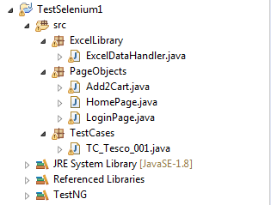

Assumptions:
- Selected Czech’s Tesco online.
- User is already a registered customer with Tesco
- User would login only when required.
- After adding two (2) most expensive items into card, take a screen shot and close the browser.
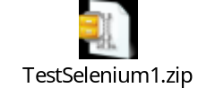
Coding Exercise:
Assumptions:

- Program takes number as argument to the process.

